Type of the Paper: Extended Abstract

Evaluating the handling of a tilting tricycle with variable stability
Floris van Willigen¹, Andrew Dressel²*, Jason Moore³
¹TU Delft; F.A.vanWilligen@student.tudelft.nl
²TU Delft; AndrewDressel@hotmail.com, ORCID 0000-0003-0322-9815
³TU Delft; J.K.Moore@tudelft.nl, ORCID 0000-0002-8698-6143
*corresponding author.

Name of Editor: Christoph Schmidt
Submitted: 01/03/2023
Accepted: 14/04/2023
Published: 26/04/2023
Citation: Dressel, A., van Willigen, F. & Moore, J. (2023). Evaluating the handling of a tilting tricycle with variable stability. The Evolving Scholar - BMD 2023, 5th Edition.
This work is licensed under a Creative Commons Attribution License (CC-BY).

Abstract:
To evaluate the handling of a tilting tricycle with variable stability and tadpole wheel configuration, described in detail in a separate submission, we select three handling metrics from the literature, develop a testing methodology, and combine the results into a single handling score. For simplicity of implementation and ease of transferring sensors from vehicle to vehicle, we choose metrics that only require kinematic data. Finally, we assess the handling only in low- and moderate-speed situations.
Here are the three metrics we select and the two maneuvers we perform to collect the data we use to calculate them:
- The maximum value of the so-called yaw factor (yaw rate / steer rate).
We compute this metric from the kinematic data recorded during a slalom maneuver.
A low maximum yaw factor indicates smooth turning in the slalom maneuver which correlates with better handling.
- The average magnitude of the steer angle.
We compute this metric from the kinematic data recorded during a low speed line following maneuver.
The magnitude of the steer angle is related to the difficulty of following the line correctly.
A low steer angle correlates with a low effort and good handling.
- The average time delay between the roll rate and the steer rate.
We compute this metric from the kinematic data recorded during a low speed line following maneuver.
A low time delay indicates a swift response to correct roll angle in low speed handling.
We combine the three metrics into a single handling performance score with a logarithmic scale to increase the influence of any single metric, as shown in equation (1). We also include scale factors to balance the values of each metric.
$$Score=\log\left(M_{1}∙α_{1}\right)+\log\left(M_{2}∙α_{2}\right)+log⁡\left(M_{3}∙α_{3}\right)$$ | (1)
We tested this method on three reference bicycles: a Batavus Verona as it comes from the factory (stock), the same bike with the front fork rotated 180° to dramatically increase trail, and a Gazelle Ami C7 as it comes from the factory. The latter is also the bicycle that we describe converting into a tilting tricycle in a separate submission.
This method of calculating a single handling performance score successfully discriminates between the vehicles with significant results. Table 1. shows the means and standard deviations of the three metrics for each vehicle after several test runs, and Figure 1. shows the total handling score for each vehicle.
Table 1. The means and standard deviations calculated for each metric and the combined score for each vehicle.
Vehicle | Batavus Verona 7 – Stock |  | Batavus Verona 7 – Flipped |  | Gazelle Ami C7 - Stock
Metric | Mean | Std Dev | Mean | Std Dev | Mean | Std Dev
Max yaw | 3.60 | 0.31 | 4.25 | 0.48 | 4.09 | 0.251
Steer angle | 3.66 | 0.39 | 7.28 | 0.88 | 3.94 | 0.59
Time delay | 0.235 | 0.028 | 0.330 | 0.032 | 0.227 | 0.023
Score | 1.51 |  | 0.987 |  | 1.43

We also collect data from two other tilting tricycles, but not in time to include the results in this abstract.
Future experiments will show the handling performance of the tilting tricycle with the variable stability. The hypothesis is that we will see advantages of the tricycle and that we will find the configuration where the handling is equivalent to that of the reference bicycle.
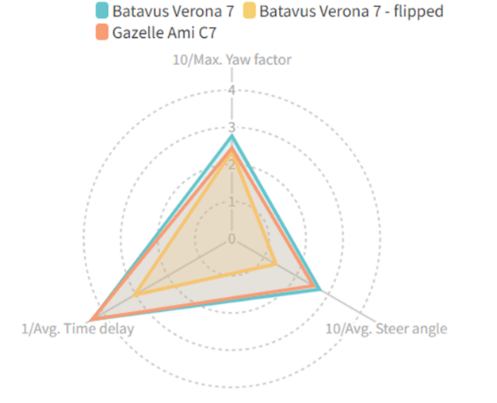
Figure 1. A radar chart showing the score of the three test vehicles with the scale factor for each score indicated at the vertex. The two bicycles as delivered from the factory have very similar performance, and the bicycle with the front fork reversed (flipped) has significantly worse handling performance.
This project was financed and supported by the TKI/ClickNL 'De Fiets van de Toekomst' grant and Royal Dutch Gazelle.

References
Cossalter, V., 2002. Motorcycle Dynamics. No. ISBN 09720514-0-6. Race Dynamics, Greendale, WI.
Cossalter, V., & Sadauckas, J. (2006). Elaboration and quantitative assessment of manoeuvrability for motorcycle lane change. Vehicle System Dynamics, 44(12), 903-920.
Kovácsová, N., de Winter, J. C. F., Schwab, A. L., Christoph, M., Twisk, D. A. M., & Hagenzieker, M. P. (2016). Riding performance on a conventional bicycle and a pedelec in low speed exercises: Objective and subjective evaluation of middle-aged and older persons. Transportation Research. Part F: Traffic Psychology and Behaviour, 42(Part 1), 28-43
McRuer DT, Jex HR. A review of quasi-linear pilot models. IEEE Trans Hum Factors Electron. 1967;HFE-8(3):231–249.
Pierson, A. M., Shortreed, A. K., Van Asten, P. D., Dressel, A. E. (2020, August 17–19), A Narrow-Track Tilting Tricycle With Variable Stability That the Rider Can Control Manually, Proceedings of the ASME 2020 International Design Engineering Technical Conferences and Computers and Information in Engineering Conference. Volume 4: 22nd International Conference on Advanced Vehicle Technologies, Virtual, Online
Schwab, A. L., & Meijaard, J. P. (2013). A review on bicycle dynamics and rider control. Vehicle system dynamics, 51(7), 1059-1090.

