- Introduction:
Water alternating gas (WAG) injection is the enhanced oil recovery technology referred to as the method of alternating gas slugs’ injection followed by water injection, repeated in several cycles. This technology has been used with success worldwide since 1957, when it was first applied in Canada (Christensen et al., 1998). Recovering oil from mature fields is becoming more and more vital as finding new oil is not easy. The growing need to increase the output and ultimate recovery by EOR methods has assumed great significance as far as mature oil fields are concerned (Kudal et al., 2010). WAG EOR has evolved to counter these challenges. WAG too early or too late will both result in lower oil recovery (Haifeng et al., 2012).
Oil recovery in WAG process is affected by two factors: the macro sweep efficiency and micro displacement efficiency. The macro sweep efficiency is largely affected by gas trapping, which has been experimentally demonstrated to be affected by CO₂ half cycle slug size (Nuryaningsih, et al., 2011). In gas injection processes, there are two main types of gas injection, the gas is injected at or above minimum miscibility pressure (MMP), which causes the gas to be miscible in the oil, making the reservoir fluid as one moveable hydrocarbon phase. On the other hand, in immiscible gas injection, flooding by gas is conducted below minimum miscibility pressure (MMP) (Mohammad, et al. 2016).
Miscible WAG injection is influenced by many factors; the mass transfer between CO₂ and oil, the gas trapping, and the oil trapping (Haifeng et al., 2012).
When WAG is injected in the secondary mode (too early), CO₂ becomes miscible with reservoir oil through multi-contact, and then mass transfer effects take place and increase the micro displacement efficiency. However, gas trapping will not be developed since the precondition for gas trapping is that the non-wetting phase (CO₂) and the wetting phase (water) are both available. In the secondary mode, oil is excessive compared to gas and there is no or very little amount of CO₂ available to be trapped, which results in a low macro sweep efficiency (Haifeng et al, 2012)
When WAG is injected in the tertiary mode, it first passes the water swept zone where the oil saturation has been lowered to a certain extent due to secondary water flooding. Since CO₂ becomes excessive compared to oil, gas trapping develops, and the macro sweep efficiency is enhanced. On the other hand, oil trapping is also developed when the water saturation increases in the water swept zone during water flooding, which lowers the chance of contact between CO₂ and oil, and thus lowers the micro displacement efficiency. As a result, injecting WAG too early (i.e., secondary mode) or too late (i.e., tertiary mode) will result in either low macro sweep efficiency or low micro displacement efficiency. The highest oil recovery is achieved when there is enough oil saturation to allow high CO₂-oil contact that enhances the micro displacement efficiency, and enough water saturation to allow gas trapping that enhances the macro sweep efficiency. Haifeng et al., (2012) concluded in their study, that best timing for WAG injection is when the flood front in water flooding passes roughly through the middle of the core, i.e., when water flooding recovers roughly half of the oil that can be flooded by secondary water flooding.
WAG performance is influenced by many factors, such as reservoir properties (including wettability and heterogeneity), the fluid properties (including reservoir fluid properties and injecting fluid properties), the injection techniques (including the timing of cyclic injections), and WAG parameters (including the WAG ratio, half cycle slug size, and total slug size) (Haifeng et al., 2012). There have been recommendations in the industry to use shorter cycles and even simultaneous water and gas injection to increase the size of the mixing zone (Kleppe et al. 2006). In WAG injection gas and water slugs are alternately injected in a fixed ratio called the WAG ratio (Mayowa et al., 2014). WAG ratio represents one important parameter to optimize during WAG process. Another variable that can be considered in optimizing WAG scheme includes the timing of switch from gas to water (WU, et al. 2004). The use of a simulator to determine the optimum WAG cycle was recommended by Pritchard (1992) as it permits a more rigorous analysis to be done (Mehdi et al., 2013).
WAG performance is largely affected not only by the injection parameters such as water-gas ratio, injection rate and cycle period, but also by production rate and bottom hole pressure (BHP) at the producer. Inappropriate selection of parameters for WAG process can lead to unstable pressure distribution, early gas breakthrough and low ultimate oil recovery (Chen et al., 2009).
However, optimum time for gas injection is essential in WAG EOR design, to mitigate the difficulty imposed by determining middle distance of flood front in a core or when the flood front is midway between the producer and injector. The knowledge of appropriate time to inject gas (miscible) will help to reduce gas fingering and breakthrough time, to maximize the effect of macroscopic sweep efficiency and microscopic displacement efficiency in oil recovery process.
The main objective of this study is to develop a model for estimating the optimum time for gas injection during a WAG enhanced oil recovery process (EOR). Reservoir Data (Table 2.1) for the simulation study was taken from Alwyn field, UK North Sea (Ani et al; 2010)

1.2 ALWYN Field Location
The Alwyn North Field was discovered in 1974 in the Southeastern part of the East Shetland Basin in the UK North Sea, about 140 km East of the near most Shetland Island and about 400 km North East of Aberdeen. The Alwyn field lies respectively 4 and 10 km south of Strathspey and Brent field, 7 km east of Ninians field, and 10 km north of Dunbar field (Figure 1.1).
The water depth is about 130 m. The field is in the UKCS Block 3/9 and extends northward into block 3/4.
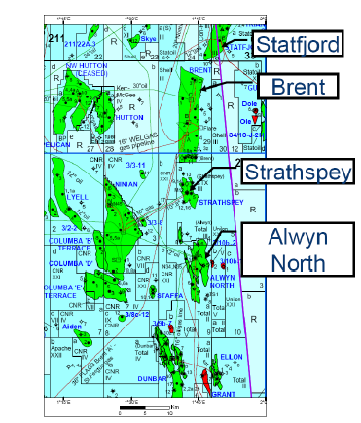
Figure 1.1: Alwyn North Field localization (Ani et al; 2010)

2. Methodology
To develop a model for estimating the optimum time for gas injection during a WAG enhanced oil recovery process, relevant tools/software used included: Eclipse 100 simulator and Microsoft Excel
2.1 Assumptions for the WAG model
- The injected gas is carbon iv oxide gas (CO₂)
- The injected gas is miscible with the reservoir fluid at 150 bar.
- Single phase flow was assumed throughout the simulation.
- Injection and production rate was constant in the various WAG scenario.
- The reservoir was assumed to be homogenous.

2.2 Reservoir Model descriptions
A simulation study was carried out using ECLIPSE black oil model to deepen the understanding of the effect of gas injection time on WAG EOR process. The structure of the model is a simple 3D model with uniform average properties populated across the grid. The 3D section of reservoir being modelled has dimensions 762m x 762m x 91.44m, and it is divided into ten layers of equal thickness. The number of cells in the x and y directions are 11 and 11 respectively. The reservoir rock and fluid properties used in the model is presented in table 2.1.

Table 2.1a: Reservoir Rock and Fluid Properties (Ani et al; 2010)
S/N | Reservoir Properties | Value | unit
1 | Reservoir depth | 3200.4 | m
2 | Oil density | 826.5527 | kg/m³
3 | Water density | 1012.367 | kg/m³
4 | Gas density | 0.9819318 | kg/m³
5 | Oil viscosity | 0.27 | cp
6 | Permeability | 1.35 | d
7 | Oil column thickness | 64 | m
8 | Well bore radius | 0.216 | m
9 | Porosity | 25 | %
10 | Water saturation | 15 | %
11 | Initial reservoir pressure | 480 | bar
12 | Bubble point pressure | 300 | bar
13 | Reservoir temperature | 172 | ºF
15 | API | 41.8 | º API
16 | Formation compressibility | 0.00005 | 1/bar
17 | Water compressibility | 0.00005 | 1/bar

2.3 Well description
The well model built in this case studies are loosely patterned after the reservoir properties of Alwyn field. The reservoir is modelled using 11*11*10 with a total of 1210 active cells for the well pattern. The well pattern used in the simulation is repeated direct line drive. All the injection and production wells are fully completed penetrating the ten layers of the reservoir. All the injectors are injecting water and gas alternately at a constant water rate and gas rate.
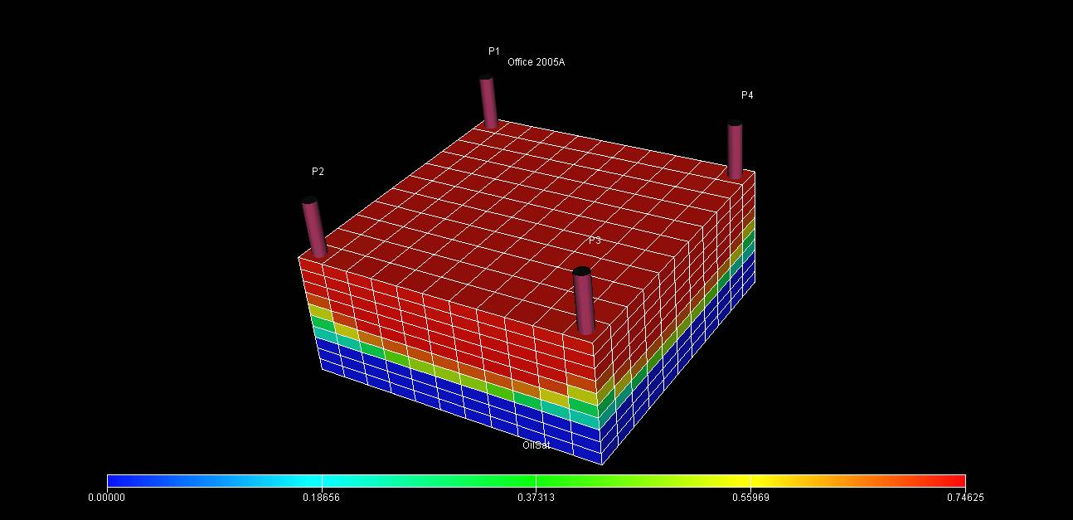
Figure 2.1: 3D view of the reservoir Model for natural depletion

2.4 Injection and production well parameters
Table 2.2: Injection and Production Well Parameters
WELL | INJECTION | PRODUCTION
BOTTOM HOLE PRESSURE | 480 bar | 150 bar
RATE | Gas = 800000m³/d Water = 1600 m³/d | Oil = 1800 m³/d  Liquid = 600 m³/d

2.5 Minimum miscibility pressure (MMP)
The minimum miscibility of the injected CO₂ gas was obtained using Mungan and Lasater correlation. The MMP obtained was 150 bar. The reservoir pressure was maintained between 480 bar (initial reservoir pressure) and 150 bar. The diagram of the model after repeated line drive injection pattern can be seen in figure 2.2.
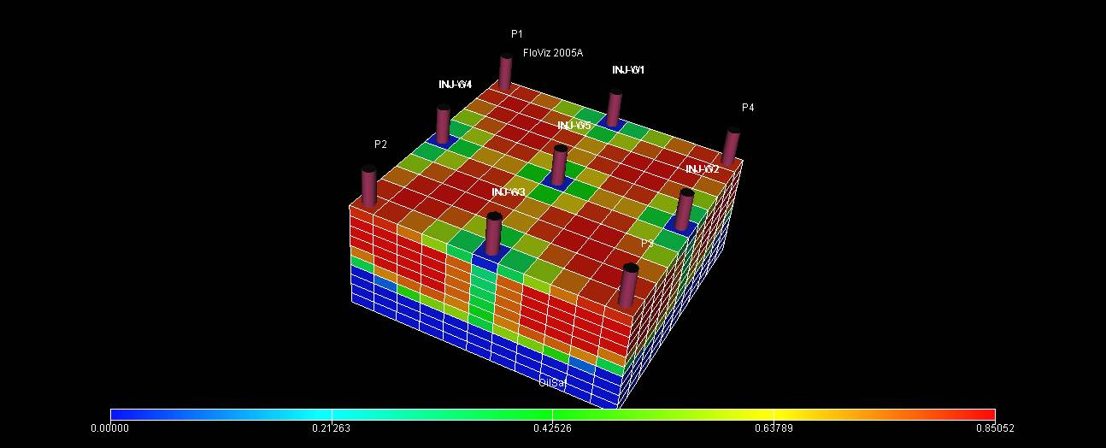
Figure 2.2: 3D view of the reservoir Model for WAG process

2.6 Model Formulation and Calculations
Regression variables were introduced to minimize the errors from the calculated and the observed values. FOPT was obtained from material balance calculation.

2.6.1 Model Formulation
$$FOPT∝Volume of Water Injected+Volume of Gas injected$$
  - $FOPT=\frac{Volume of Water Injected}{Time Factor for Water injection}+\frac{Volume of Gas injected}{Time Factor for Gas injection}$
Introducing regression constants, a, b
  - $FOPT={\left(\frac{V_{w}}{T_{w}}\right)}^{a}+{\left(\frac{V_{g}}{T_{g}}\right)}^{b}$
Where;
- FOPT is field oil production total.
The values of the regression constants a & b were computed by minimizing error value between FOPT calculated and FOPT obtained from Eclipse.
a = 0.429856
b= 0.95712
2.6.1.1 Formulated Model
Time factor for gas injection will be obtained from equation below.
$$T_{g}=\frac{V_{g}}{\sqrt[b]{FOPT-{\left(\frac{V_{w}}{T_{w}}\right)}^{a}}}$$

$V_{g}$ (Minimum Available gas injection Volume) = 800000 m³
$V_{w}$ (Minimum Available water injection Volume) = 1600 m³
$$Time Factor for Gas injection \left(T_{g}\right) is Dimensionless$$
$$Time Factor for Water injection \left(T_{w}\right) is Dimensionless$$
$T_{w}$ = 1 (assumed time factor for water injection)
2.6.2 Material Balance Calculations (MBE)
Assumption
- The reservoir has no gas cap and aquifer support is not strong.
- The main drive mechanism for production is solution gas.
- The reservoir is above bubble point pressure.

MBE for natural depletion drive by oil expansion
$N_{p}B_{o}=NB_{oi}\left[\frac{B_{o}-B_{oi}}{B_{oi}}+\left(\frac{C_{wS_{wc }+C_{f}}}{1-S_{wc}}\right)∆P\right]$ (3.1)
$N_{p}B_{o}={NB}_{oi}C_{e}∆P$ (3.2)
Where${ C}_{e}=$ $\frac{1}{1-S_{wc}}\left(C_{o}S_{o}+C_{w}S_{wc}+C_{f}\right)$ and $C_{o}=\left[\frac{B_{o}-B_{oi}}{∆PBoi}\right]$
Where,
$N_{p}$ = cumulative oil production in stock tank barrels.
$N$= Stock tank oil initially in place (STOIIP)
$C_{w}$ = compressibility of water
$∆P$ = Drawdown pressure
$C_{f}$= formation compressibility
$S_{wc}$ = connate (irreducible) water saturation
$B_{o}$ = Final Oil formation volume factor (at final pressure)
$C_{e}=$ Equivalent compressibility
$B_{oi}$ = Initial oil formation volume factor
Table 2.1b: Reservoir Rock and Fluid Properties (Ani et al; 2010)
S/N | Reservoir Properties | Value | Unit
1 | Connate water saturation (${ S}_{wc})$ | 15 | %
2 | Stock tank oil initially in place (N) | 3,484,986 | M³
3 | Compressibility of water ($C_{w})$ | 0.00005 | $$1/bar$$
4 | Formation compressibility ($C_{f})$ | 0.00005 | $$1/bar$$
5 | Final Oil formation volume factor ($B_{o})$ | 1.6994 | M³/Sm³
6 | Initial oil formation volume factor ($B_{oi})$ | 1.6418 | M³/Sm³

$$C_{o}=\left[\frac{B_{o}-B_{oi}}{∆PBoi}\right]$$
$$C_{o}= 0.000232626/bar$$
${ C}_{e}=$ $\frac{1}{1-S_{wc}}\left(C_{o}S_{o}+C_{w}S_{wc}+C_{f}\right)$
${ C}_{e}=0.000300272/bar$
Np = $\frac{N×B_{oi}×{ C}_{e}×∆P}{B_{o}}$
Np = $152,465.4 M$³
Recovery efficiency = Np/N
Recovery efficiency =$152,465.4 /$3,484,986
= 0.04375 = 4.38%
Therefore, FOPT = $152,465.4 M$³
$$T_{g}=\frac{V_{g}}{\sqrt[b]{FOPT-{\left(\frac{V_{w}}{T_{w}}\right)}^{a}}}$$

$$T_{g}=\frac{800000}{\sqrt[0.95712]{152,465.4 -{\left(\frac{1600}{ 1}\right)}^{0.429856}}}$$
$T_{g}$ = 3.0471
$T_{g}≅3$
0$<T_{w}<∞$ ; $T_{g}=3$ (for every positive value of $T_{w}, T_{g}$will be equal to 3)
When $T_{w}=1, T_{g}=3;→ T_{w}:T_{g}=1:3$
$T_{w}=2, T_{g}=3;→ T_{w}:T_{g}=2:3$
$T_{w}=3, T_{g}=3;→ T_{w}:T_{g}=3:3$
$T_{w}=4, T_{g}=3;→ T_{w}:T_{g}=4:3$

2.7.0: WAG cycle Time of 1 month (30 days)
WAG Ratio (W:G) | Time for gas Injection (Days)
1:3 | $$T_{g}=\frac{3}{4}×30 ≅ 22$$
2:3 | $$T_{g}=\frac{3}{5}×30=18$$
3:3 | $${ T}_{g}=\frac{3}{6}×30=15$$
4:3 | $$T_{g}=\frac{3}{7}×30≅13$$
Table 2.3: showing WAG cycle of 1 month (30days) and time for gas injection.

2.7.1 WAG cycle Time of 3 month (91.25days)
Table 2.4: showing WAG cycle of 3 month (91.25 days) and time for gas injection.
WAG Ratio (W:G) | Time for gas Injection (Days)
1:3 | $$T_{g}=\frac{3}{4}×91.25 ≅ 68$$
2:3 | $$T_{g}=\frac{3}{5}×91.25 ≅ 55$$
3:3 | $$T_{g}=\frac{3}{6}×91.25 ≅ 46$$
4:3 | $$T_{g}=\frac{3}{7}×91.25 ≅ 39$$

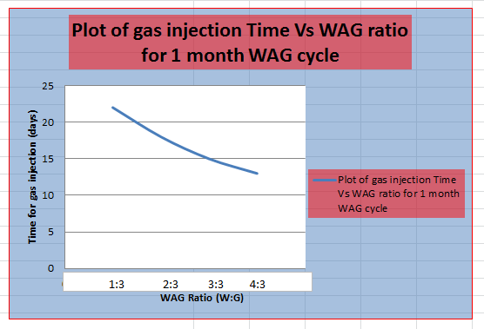
Figure 2.4A: showing plot of gas injection against WAG ratio.

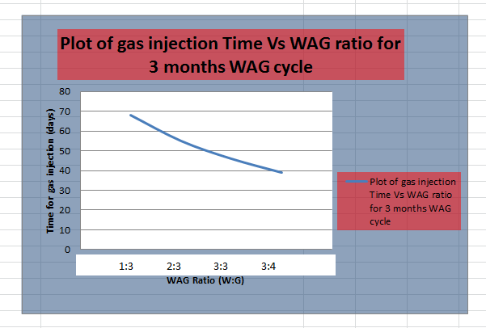 Figure 2.4B: showing plot of gas injection against WAG ratio.
Therefore, For WAG cycle of 1(one) month, the time for gas injection for WAG ratio 1:3, 2:3, 3:3 and 4:3, is 22days, 18 days, 15 days and 13days respectively. For three (3) months WAG cycle time for gas injection will be 68 days, 55 days, 46 days and 39 days for WAG ratio 1:3, 2:3, 3:3 and 4:3, respectively. New simulation will be run based on these WAG ratios and time for gas injection, to obtain the optimum time (T_{opt}) for gas injection.
3. Results
Results presented in figure 3.1 and table 3.1; shows field oil recovery efficiency (FOE) and summary of the simulation results respectively, which was obtained before the model that calculates optimum time for gas injection was developed. The result obtained in this scenario such as FOPT was used as one of the regression variables. Other variables used are injected water and gas volume as shown in figure 2.3. The maximum FOE obtained in this scenario is 64.7%.
3.1 Predicting oil recovery without the model.
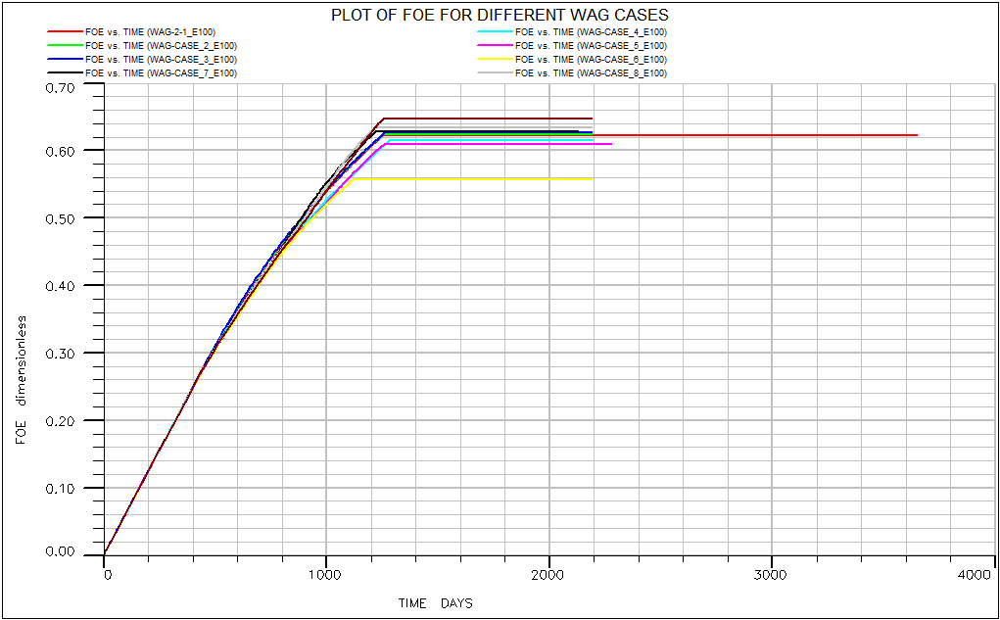
Figure 3.1: Plot of FOE against time for different WAG process

Table 3.1: summary of the simulation result of different WAG ratio
CASES | WAG RATIO  (W:G) | WAG CYCLES | TIME  (DAYS) | FOE | FOPT  (STB) | FWPT  (STB) | FGPT (SCF)
1 | 1.:1 | 1 month | 2,200 | 62.60% | 13616161.98 | 3510355.97 | 3784150070
2 | 1.:1 | 2 months | 2,200 | 62.30% | 13554805.03 | 3454944.46 | 3558894420
3 | 1.:1 | 3 months | 2,200 | 62.20% | 13518307.97 | 3483557.07 | 3360383262
4 | 2.:1 | 4 months | 2,200 | 61.50% | 13370302.1 | 4060857.89 | 2238933121
5 | 2.:1 | 5 months | 2,200 | 60.90% | 13235162.97 | 3844507.98 | 2235930155
6 | 2.:1 | 6 months | 2,200 | 55.70% | 12118388.72 | 3083855.12 | 1939402048
7 | 1.:2 | 7 months | 2,200 | 62.90% | 13653843.32 | 2929048.78 | 4848144067
8 | 1.:2 | 8 months | 2,200 | 63.30% | 13770366 | 2758007.37 | 5520259887
9 | 1.:2 | 9 months | 2,200 | 64.70% | 14058403.48 | 2923792.27 | 6225848163
10 | 4.:1 | 12 months | 2,200 | 53.60% | 11649720.03 | 3225835.68 | 1435088806

3.3 Predicting oil recovery with the model generated.
The time obtained from different WAG ratio was used to re-run the simulation under 1 (one) month cycle and 3 (three) months cycle, to determine the optimum time for gas injection.
Results presented in figure 3.2A and figure 3.2B; shows field oil recovery efficiency (FOE) for one month and three months WAG cycle respectively, which was obtained after the model has been developed. The FOE for one month and three months WAG cycle is 75% and 71% respectively.

3.3.1 Results of FOE in Eclipse based on the time obtained from the model.
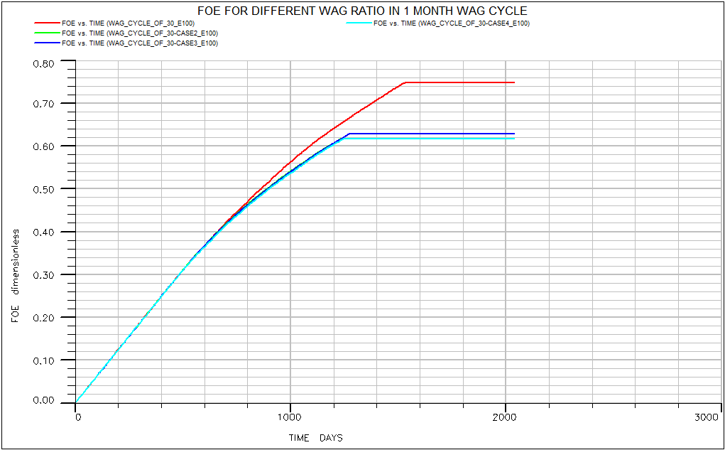Figure 3.2A: showing FOE plots in 1 month WAG cycle for different WAG ratio.
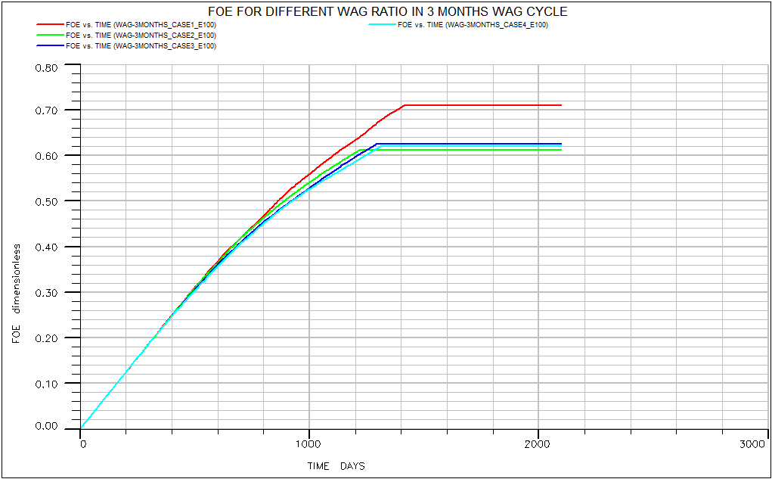 Figure 3.2B: showing FOE plots in 3 months WAG cycle for different WAG ratio.
    - Summary of the results obtained from the model in Excel plot
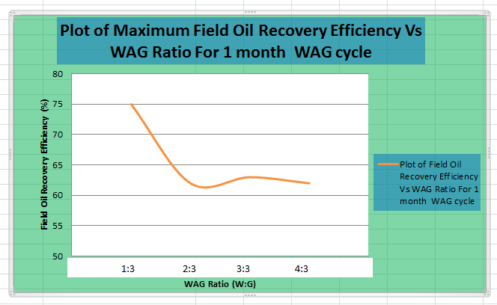 Figure 3.3A: showing plot of Maximum FOE against WAG ratio.
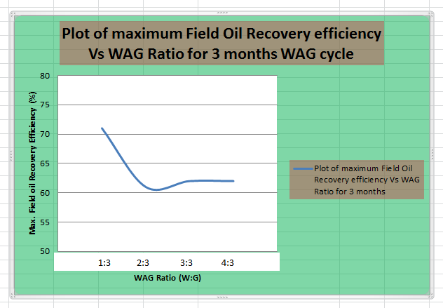 Figure 3.4B: showing plot of Maximum FOE against WAG ratio.

4.0 Discussion
Results obtained from simulation of several WAG scenario shows a total oil recovery between the ranges of 53.6% to 64.7%; this was because of inaccurate time to inject gas during a complete WAG cycle.
The oil recovery efficiency obtained after re-running the simulation based on the time calculated from the model generated shows that optimum oil recovery occurs at every time factor of water injection 1(one) and time factor of gas injection 3 (three) for both one month and three months WAG cycle. The oil recovery efficiency obtained for both one month and three months WAG cycle is 75% and 71% respectively.

5.0 Conclusion
The mathematical model generated to predict the optimum time for gas injection during water alternating gas (WAG) enhanced oil recovery process shows that maximum oil recovery can be achieved if the optimum time for gas injection is known. The model shows that at any time factor for water injection, the time factor for gas injection will be 3 (three). This is to allow complete mass transfer between the injected gas and the oil, as well as to enable gas trapping, such that microscopic displacement efficiency and volumetric sweep efficiency is maximized to achieve maximum oil recovery. The oil recovery efficiency obtained after re-running the simulation based on the time calculated from the model generated shows that maximum oil recovery occurs at every time factor of water injection 1(one) and time factor of gas injection 3 (three) for both one month and three months WAG cycle that was tested. The optimum time (T_{opt}) for gas injection based on the simulation result is 22 days for one month WAG cycle and 68days for three months WAG cycle. The oil recovery efficiency obtained for both one month and three months WAG cycle is 75% and 71% respectively. Hence the optimum time for gas injection is based on the WAG cycle and oil recovery efficiency decreases as WAG cycle increases. However, this model remains accurate to the highest degree once WAG ratio, WAG cycle and injection rates are the only limiting factor to WAG performance.

NOMENCLATURES
CO₂: Carbon (IV) oxide
EOR: Enhanced oil recovery
FGPT: Field gas production total
FOE: Field oil recovery efficiency
FOPT: Field oil production total
FWPT: Field water production total
SCF: Standard cubic feet
STB: Stock tank barrel
$$T_{g} : Time Factor for Gas injection$$
T_{opt} : Optimum time for gas injection
$T_{w}$: $Time Factor for Water injection$
$V_{g}$ : Minimum Available gas injection Volume
$V_{w}$ : Minimum Available water injection Volume
WAG: Water alternating gas

Appendix I: Table I: Excel interface for obtaining the constants a & b
WAG R. (W:G) | FOPT sim(STB) | Vg(SCF) |  | Vw(STB) | Tg(days) | Tw(days) |  | FOPT calc. | Error
1.:1 | 13616162 | 859228814 |  | 306082 | 30.4167 | 30.4167 |  | 13536944 | 79218.14234
1.:1 | 13554805 | 1.718E+09 |  | 612163 | 60.8334 | 60.8334 |  | 13536944 | 17861.19234
1.:1 | 13518308 | 2.578E+09 |  | 918245 | 91.2501 | 91.2501 |  | 13536944 | 18635.87018
2.:1 | 13370302 | 3.437E+09 |  | 2448654 | 121.6668 | 243.3336 |  | 13536944 | 166641.7377
2.:1 | 13235163 | 4.296E+09 |  | 3.1E+07 | 152.0835 | 304.167 |  | 13537033 | 301869.821
2.:1 | 12118389 | 5.155E+09 |  | 3672981 | 182.5002 | 365.0004 |  | 13536944 | 1418555.118
1.:2 | 13653843 | 1.203E+10 |  | 2142572 | 425.8338 | 212.9169 |  | 13536944 | 116899.4813
1.:2 | 13770366 | 1.375E+10 |  | 2448654 | 486.6672 | 243.3336 |  | 13536944 | 233422.1614
1.:2 | 14058403 | 1.547E+10 |  | 2754736 | 547.5006 | 273.7503 |  | 13536944 | 521459.6415
4.:1 | 11649720 | 1.031E+10 |  | 1.5E+07 | 365.0004 | 1460.002 |  | 13536944 | 1887223.808
 |  |  |  |  |  |  |  |  | 4761786.973
 |  | $$FOPT={\left(\frac{V_{w}}{T_{w}}\right)}^{a}+{\left(\frac{V_{g}}{T_{g}}\right)}^{b}$$
 | TOTAL SIMULATION TIME = 2200days |  |  |  |  |  |  |  |  | a | 0.429855505
 |  |  |  |  |  |  |  |  |  | b | 0.957122811
 | FOPT sim= FOPT obtained from simulation (observed)
 | FOPT calc. = FOPT obtained from the generated model

