Research misconduct investigations in China’s science funding system
Li TANG*, Linan WANG**, Guangyuan HU^{***1}

*tang006@gmail.com
ORCID: 0000-0003-4971-6192
Department of Public Administration, Fudan University, Shanghai 200433, China

**Shanghai Health Development Research Center, Shanghai 200040, China

***hu.guangyuan@shufe.edu.cn
¹Corresponding author, School of Public Economics and Administration
Shanghai University of Finance and Economics
Shanghai 200433, China

Abstract
Despite varying historical and social contexts, government funding agencies around the global shoulder the obligation and responsibility to uphold the integrity of funded research. With escalating concerns about research misconduct worldwide, unfortunately how these stewards of public money spot funding-relevant wrongdoing and what happens next to those responsible remains unexplored. In this paper we retrieved and analyzed all publicized investigation results from China’s largest basic research funding agency over the period from 2005–2021. Our findings reveal that the principal reasons for investigations are journal article retractions, whistleblowing, and plagiarism detection software. The most frequent administrative sanctions are debarment and recouping of grants. This article argues that more systematic research and cooperation among stakeholders is needed to cultivate research integrity. Specific training and education should be provided for young scientists and researchers in less-developed regions, both of whom make up a large share of funding-relevant research offences.

Keywords
Research ethics; science grant system; China; misconduct investigation

The three principal self-correcting mechanisms of science are replication of experimental work, peer review of proposals for funding, and merit review of articles before publication in scientific journals.
——Robert M. Anderson,1988

1. Introduction
In this era of funding scarcity, the impact of research funding on research output is of increasingly critical importance in science policy (Tang 2022). Over the period of 2009–2020, the global scientific community has seen a steady growth of funded publications in both quantity and proportion. For every 100 journal articles indexed in the Web of Science (WoS) Core datasets, 65 acknowledge the financial support of grants, regardless of type or number of funding agencies reported. The importance of funding in supporting basic science is even more salient in China. As illustrated in Figure 1, China consistently stands out against the other four most scientifically productive countries in terms of its WoS-indexed journal articles’ funding share. In 2019, nearly 90% of Chinese articles reported grant funding. Meanwhile, for all funded articles that have been retracted, China also takes a significant share. In the examined 12 years, more than 60% of retracted Chinese articles acknowledged funding support, accounting for more than two-fifths of global retracted funded research and 1.5 times that of the United States.

Figure 1: Funding ratios of global publications by top five most productive countries.

Figure 1 shows that China’s scientific advancement, measured by international publications, benefits greatly from the science grant system. Data were retrieved from WoS Core datasets of the Science Citation Index Expanded (SCI-EXPANDED), Social Sciences Citation Index (SSCI), and Arts & Humanities Citation Index (A&HCI) on October 3, 2021, via Fudan University Library. The search period is set from 2009 as the WoS began to systematically collect funding acknowledgement data in August 2008 (Tang et al., 2017; Liu et al., 2020; Paul-Hus et al.,2016). The document type is confined to research articles. The whole counting method is adopted in allocating country contributions. All limitations of using a bibliographic database and the whole counting method apply.

As the largest global contributor of basic science research, the country with the most populous science and technology workforce, and the second-largest research and development player, China’s research quality and academic integrity have tremendous effects in the global scientific community (NSB 2020; anonymous year 2019). Given the roles and responsibilities of funding agencies to society at large and the scientific community specifically, it is time to examine how science grant agencies curb scientific misconduct and cultivate research integrity. Unfortunately, very few studies investigate this issue. The study, within our best knowledge, is in an early group of empirical research exploring misconduct investigations and is the very first one specifically focusing on China. Using a novel dataset of misconduct investigation results from the National Natural Science Foundation of China, this article analyzes the types, identification mechanisms, and punitive actions of funding-related misconduct. Two specific research questions we aim to explore are as follows:

RQ1: What are the triggers initiating the misconduct investigation by funding agencies?
RQ2: How do Chinese funding agencies deal with validated misconduct?

The rest of the article is organized as follows. Section 2 introduces the data. Section 3 presents the main results and Section 4 concludes with policy suggestions.

Method

2.1 Case selection
The study selects the National Natural Science Foundation of China (NSFC) to explore how funding agencies may identify and respond to false results once exposed. Our choice for analysis is based on the following considerations. To begin with, NSFC is the premier Chinese funding agency supporting basic research (Zhou et al. 2020; Liu et al. 2021;). In 2020, more than two-thirds of WoS-indexed Chinese original research reported funding information from NSFC, suggesting its status as the leading investor in Chinese basic research.

Secondly, NSFC is a leading Chinese agency in promoting scientific research integrity. Since the establishment of the NSFC supervising committee in 2005, NSFC has issued a set of codes, measures, and regulations on curbing misconduct, separately or jointly with other agencies. The NSFC Office of Research Integrity oversees and rules on misconduct cases related to NSFC funding. In 2020 alone, NSFC launched three earmarked grants on research integrity in China. Strengthening scientific integrity is listed as a long-term commitment of NSFC in its ongoing ten-year reform (2018–2027). For instance, in its guide to program applications in 2019, NSFC explicitly requires that all grant applicants, participants, host institutions, and cooperative institutions cosign the Letter of Commitment to Scientific Integrity before application submission (NSFC 2018).

Finally, from 2013 onward NSFC has held regular press conferences and has publicized research misconduct investigation results related to NSFC funding on its official website, providing the public with both aggregated statistics and detailed information of each validated misconduct (Qiu 2014). This makes our microlevel analysis replicable.

2.2 Data
We collected public notices and investigation results publicly released by NSFC and cross-checked them against its annual reports. The data was downloaded in June 2019 and updated in June 2022. Each decision consists of the following content, of different length and detail:

- Individual information of the offender such as name and position held at the time of misconduct
- Name of offender’s affiliated organizations when the misconduct occurred
- Information on validated misconduct, including details on affected publication records and grant applications or awards, as well as the administrative punishments imposed by NSFC to individuals and their affiliations if applied.

With several rounds of discussion and trial and error, three researchers independently read these documents and coded texts into variables. For any discrepancies, authors checked and finalized the coding in consensus.

Analysis

3.1 General description
Over the period of 2005–2021, NSFC released 211 decision notices of proven misconduct on its website. Following a thorough review of these public investigation results, we identified 231 unique researchers for whom the NSFC made determination of research misconduct related to grants submitted or awarded between the period of 1999–2021 inclusive, involving 129 funded grants and 104 nonfunded applications. A significant portion of proven offenders (68%) are principal investigators, regardless of applicants or grantees.

Figure 2: NSFC misconduct investigations by grant types and fields
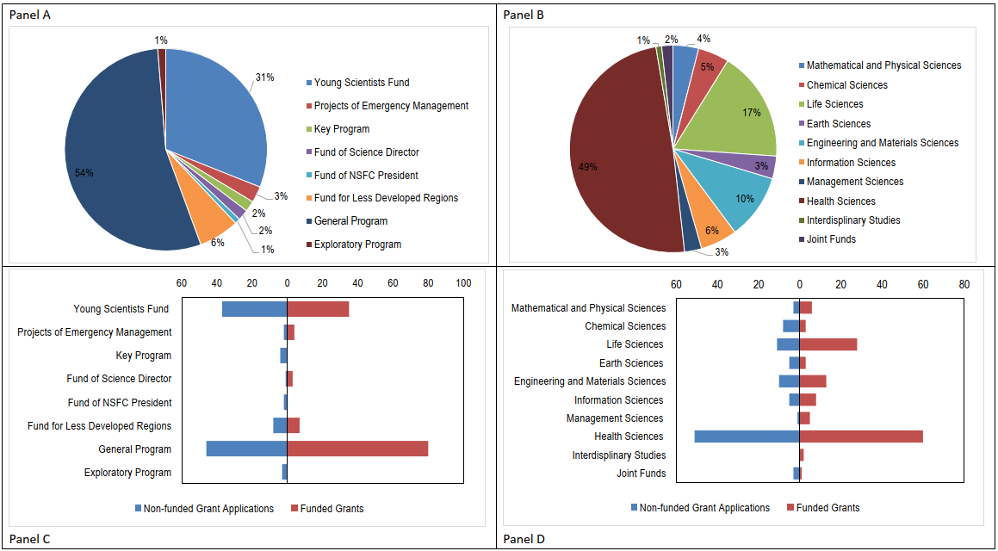
Note: The x-axis in Panel C represents the shares of different validated misconduct in NSFC grant types for grant applications (left panel) and awards (right panel); the x-axis in Panel D represents their respective shares of validated misconduct in different fields for grant applications (left panel) and awards (right panel).
When differentiated by funding types, 54% of validated misconduct occurs in the category of General Program, followed by 31% in the Young Scientists Fund and 6% in the Fund for Less-Developed Regions (Panel A of Figure 2). Their leading positions are significantly ahead of other funding types in both grant applications and awards (Panel C of Figure 2). By research field, most punitive actions concentrate on the Division of Health Sciences (49%) (Figure 2, panels B and D). This is consistent with retraction findings in previous literature (Foo 2011; Bosch et al 2012; Walsh et al. 2020).

3.2 Typology of funding-related misconduct
From the publicized investigation results, we identify and classify the following six types of funding-related misconduct: duplicate proposal submission, information fabrication/falsification in research proposal and supporting documents submitted, proposal plagiarism, funded paper or listed paper with validated misconduct, violation of award terms, and proposal ghostwriting.
We then differentiate and rank these funding-related misconducts by unfunded applications and awarded grants. The top reason for incurring punitive enforcement on both nonfunded grant proposals and funded grants is funded fraudulent paper (41% for nonfunded proposals and 71% for funded grants). This is different from the National Social Science Fund of China, that the long delay of project completion and the incapability of delivering research output account for nearly 80% of grant terminations (Tang and Wang 2019). A closer examination shows that some offenders were identified in more than one grant application and award and for multiple counts of misconduct, such as plagiarizing others’ proposals, duplicate proposal submission, and producing fraudulent research with government money.
It should be noted that we observe no cases of S&T ethics violations, such as required protection of human subjects and animal welfare reported and sanctioned, in our sample. Nor have fiscal misconducts such diversion of public funds, over-invoicing, or irregular public procurements been reported. This is contrary to the perception of weak S&T governance in China (Krimsky 2019; Cyranoski 2020). One speculation is that these investigations and punitive actions are presented in the format of internal warnings rather than publicized investigation results by NSFC. It is reasonable to believe the notices are not negligible lapses in ethics but rather intentional and material misconduct that needs to be publicized.

3.3 Punitive actions
The disclosed investigation and decision announcements are a prism reflecting Chinese funding agencies’ efforts in curbing misconduct. Despite its limited tools, NSFC has adopted a variety of remedies and punitive actions within its administrative jurisdiction. These sanctions imposed on offenders include terminating grant awards, recovering disbursed funds, issuing apology statements, and disqualifying eligibility of applying for, participating in, or reviewing NSFC grant applications for a fixed term—or permanently.

Among them, the most sweeping sanction is debarment of the individuals from receiving NSFC research grants and recoupment of grant money awarded. We found 228 researchers are subject to a time-limited prohibition from applying for NSFC funds. The median debarment period of receiving NSFC awards in our sample is five years. The research funding was revoked in 117 out of 129 cases in which it had been granted.

A closer analysis on the publicized decisions reveals that all proven funding-related misconducts that are publicly sanctioned feature three key elements: intent or “knowing and willful,” materiality, and preponderance of evidence. The offenders—in most cases, either the grant applicants or awardees—knew that what they did was wrong or unacceptable in the scientific community but still intentionally committed fraud. Additionally, it is reasonable to believe that the extent of their fraud potentially influenced grant reviewers’ judgment and, accordingly, the funding agency’s decision. Finally, the misconduct evidence is undisputable.

3.4 An overall Sankey view
The Sankey diagram (Figure 4) plots the relationships among different features of NSFC funding-related misconducts and their punitive actions.

Figure 4: Sankey view of NSFC misconduct investigations
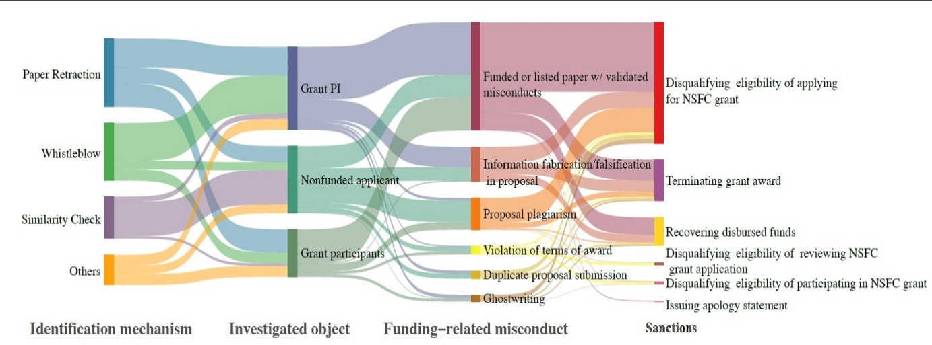

Whistleblowing mainly targets principal investigators (66% on awarded grants and 15% on nonfunded proposal applicants). Approximately half of misconduct investigations for grant participants are triggered by paper retractions. These underline the importance of the fire alarm approach in NSFC’s efforts to curb misconduct.

For nonfunded grant applications, which means the funding misallocation does not happen, a similarity check is the dominant mechanism of identifying research misconduct, and the main penalty for this category is debarment (i.e., disqualifying the wrongdoers from future NSFC grant applications). This suggests that the police patrol approach serves an important role of damage control in curbing misconduct. Note that in the Sankey graph, the unit of analysis is a pair of the offender and their grant. Another message conveyed by Figure 4 is that, in addition to punitive measures (i.e., disqualifying further research activities with the NSFC), a considerable amount of closed cases is remedial (e.g., terminating grants and recovering disbursed funds). Take the misconduct type of paper fraud for example. More than half of these types of offences led to defendants’ disqualification for future funding opportunities and 15% were required to pay back the falsely allocated funding.

Conclusion and Discussion

4.1 Summary
The paper delineates China’s progress in curbing research misconduct with laws and regulations involving funding agencies. Using a novel dataset of written decisions on funding-related misconduct released by NSFC, this study uncovers the triggers, types, and juxtaposed punitive actions of funding agencies on research misconduct by Chinese researchers. Within our best knowledge, this is first exploration using microlevel data to understand how funding agencies deal with funding-related research misconduct in this emerging science power.

Our research reveals that funding-related research misconduct in China cannot simply be ignored. Putting non-publicized investigations aside, about 230,000 researchers with more than 200 grant applications and awards involve validated misconduct by the NSFC alone. This suggests that China’s funding-related misbehavior is too common to be neglected. Among different grant-involved misconducts, those earmarked for young scientists and less developed regions are ranked the number two and three, which indicates more attention needs to paid to these two groups. On the one hand, the large number of cases exposed also indicates the NSFC’s commitment to curbing misconduct. We should not be too pessimistic or disheartened: most researchers are honest and strive for scientific rigor and research excellence. It is worth noting that, compared to the total number of grant applications and awards, the share of project terminations is low.

4.2 Future agenda

For future research, there are (at least) three further lines worthy of exploration. To begin with, it would be interesting to conduct a follow-up study to investigate whether and to what extent funding agencies’ sanctions affect wrongdoers’ post-misconduct career development. Secondly, this study uses public notices to uncover how funding agencies identify and cope with funding-related misconduct. As lamented by Fong et al (2020) little global research has investigated the legality of this behavior beyond the civil liability of the defendant. In the future, it is important to conduct in-depth interviews with misconduct investigators and research managers on the challenges and consequences of underenforcement misconduct response and potential solutions. Finally, the practices of misconduct curbing and integrity cultivation at public funding agencies reflect, at least to some extent, of the varying historical and social contexts in which government funding agencies operate and as a philosophy of research governance (Li and Cornelis 2020; Fink et al., 2022). More theoretical reasoning on ethical governance are needed from the perspectives of philosophy and management to better understand the behavior of researchers and practitioners under fierce competition for research funding.

Open science practices
These publicized research misconduct investigation results of NSFC are available on the NSFC official website. https://www.nsfc.gov.cn/publish/portal0/jd/04/
Author contributions
Li Tang: Conceptualization, Investigation, Formal analysis, and Writing; Linan Wang: Data curation, Formal analysis; Guangyuan Hu: Conceptualization, Methodology, Writing. We thank Dr. Hong Pan for her help in cross-checking the data coding. We are responsible for any errors.
Competing interests
The authors declare that they have no known competing financial interests or personal relationships that could have appeared to influence the work reported in this paper.
Funding information
This research was supported by the National Natural Science Foundation of China (#L2024009) and the Ministry of Education of China (#17YJAZH075). The views expressed herein are those of the authors and not necessarily those of the funders.

Selected References
Andersen RM (1988). The federal government's role in regulating misconduct in scientific and technological research. Journal of Law and Technology, 3, 121-148.
Azoulay, P., Bonatti, A., & Krieger, J. L. (2017). The career effects of scandal: Evidence from scientific retractions. Research Policy, 46(9), 1552-1569.

Bar-Ilan, J., & Halevi, G. (2018). Temporal characteristics of retracted articles. Scientometrics, 116(3), 1771-1783.

Bosch, X., Hernandez, C., Pericas, J. M., Doti, P., & Marusic, A. (2012). Misconduct Policies in High-Impact Biomedical Journals. Plos One, 7(12).

Fink, M., Gartner, J., Harms, R., & Hatak, I. (2022). Ethical Orientation and Research Misconduct Among Business Researchers Under the Condition of Autonomy and Competition. Journal of business ethics, 183(2), 619-636.

Fong EA, Wilhite AW (2021). The Impact of False Investigators on Grant Funding. Research Policy, 50(10).
Galbraith KL (2017). Life after research misconduct: Punishments and the pursuit of second chances. Journal of Empirical Research on Human Research Ethics, 12(1): 26-32.

Krimsky S. (2019). Ten ways in which He Jiankui violated ethics. Nature Biotechnology, 37(1),18-20.

Lupia A, & McCubbins MD (1994). Learning from oversight: Fire alarms and police patrols reconstructed. Journal of Law, Economics, & Organization, 10(1), 96-125.

Madlock-Brown CR, & Eichmann D. (2015). The (lack of) impact of retraction on citation networks. Science and Engineering Ethics, 21(1), 127-137.

Martin B. (2013). Whither research integrity? Plagiarism, self-plagiarism and coercive
citation in an age of research assessment. Research Policy, 42(5),1005–1014.

Mistry V, Grey A, & Bolland MJ (2019). Publication rates after the first retraction for biomedical researchers with multiple retracted publications. Accountability in Research, 26(5), 277-287.

Mongeon P, & Larivière V (2016). Costly collaborations: The impact of scientific fraud on co-authors' careers. Journal of the Association for Information Science and Technology, 67(3), 535-542.

Paul-Hus A, Desrochers N, & Costas R. (2016). Characterization, description, and considerations for the use of funding acknowledgement data in Web of Science. Scientometrics, 108(1), 167-182.

Oransky I. (2018). Volunteer watchdogs pushed a small country up the rankings. Science, 362(6413), 395-395.

Palla IA, Singson M, Thiyagarajan S. (2020). A comparative analysis of retracted papers in Health Sciences from China and India. Accountability in research, 27(7), 401-16.

Zhou P, Cai X, Lyu X. (2020). An in-depth analysis of government funding and international collaboration in scientific research. Scientometrics, 125(2), 1331-1347.

The data was retrieved and analyzed online on April 2, 2022, via the library at Shanghai University of Finance and Economics. The search query and retrieved image are available upon request from the corresponding author.
Except for NSFC, other Chinese national funding agencies such as National Social Science Foundation, the Ministry of Education, the National Health Commission and so on, are also involved in funding-related misconduct investigations. However, unlike NSFC, many institutions do not report sufficiently detailed information for analysis.
For more about the application of the Sankey diagram, please refer to Schmidt (2008).

