Landscape of intellectual property protection in plant varieties: From a network view

Pengfei Jia *, Weixi Xie **,Lichun Yin **, Meijing Lin **and Xianwen Wang***

* *jef@mail.dlut.edu.cn*

0000-0002-2060-435X

WISE Lab, Institute of Science of Science and S&T Management, Dalian University of Technology, Dalian, China

*\*\* xwxayguduqia@163.com; 308895957@qq.com; meijinglin@yeah.net*

0000-0003-2330-7980; 0000-0002-5510-1349; 0009-0005-1175-796X

WISE Lab, Institute of Science of Science and S&T Management, Dalian University of Technology, Dalian, China

College of Politics and Public Administration, Shandong Youth University of Political Science, Jinan, China

College of Humanities and Social Development, Nanjing Agricultural University, Nanjing, China

*\*\*\*Corresponding author: xianwenwang@dlut.edu.cn*

0000-0002-7236-9267

WISE Lab, Institute of Science of Science and S&T Management, Dalian University of Technology, Dalian, China

**Abstract**: Based on data from 196,622 UPOV member applications between 2011 and 2021, this study examined the landscape trend and evolution rule of new plant varieties protection worldwide. The findings indicate that international attention to new plant varieties is increasing. Both the number of innovations and the landscape of overseas new plant varieties are polarized, with developed countries being the main occupying subjects, and developing countries mostly serving as market subjects. The owner's landscape strategy gradually is increasingly spreading intellectual property rights to the market.

## Introduction

The importance of plants is reflected in various fields, especially as they are the first source of food and medicine, and have important biological significance in maintaining human and animal life(Mousseddek, 2022).Plants are related to food security, which is conducive to a country's fundamental master of the international discourse in the agricultural field. As a result, many countries have made substantial investments in the research and development of new plant varieties. Seeds are the first link in plant reproductive production and are responsible for the next generation of plants, maintaining germplasm, and guaranteeing species diversity and production capacity(Rifna, Ratish Ramanan, & Mahendran, 2019). New plant variety right, as the main form of intellectual property in the field of seed industry, is also an important part of the protection system of agricultural intellectual property, is exclusive right granted to the unit or individual that has completed the breeding.

This research is based on the data of applications for new plant variety protection (PVP) filed by UPOV members in recent ten years, and constructs a cross-border PVP application network with two main subjects (Occupying Subject and Market Subject) by using the method of complex network analysis. It also explores the flow mode and dynamic evolution of new plant varieties across countries from two dimensions of time and space, so as to understand the international landscape mode and change trend of new plant varieties more intuitively and meticulously.

## 2. Literature review

There are few studies on new plant varieties protection. However, due to the increasing international awareness of intellectual property protection and the attention on new plant varieties, some countries that have not yet joined the UPOV are considering to join the union. Some scholars have studied the impact and possible problems after the country's accession to UPOV (Supasiripongchai, 2020), as the UPOV now enforces mainly the 1978 act and the 1991 act of the International Convention for the Protection of New Varieties of Plants, the new member can only enforce the 1991 act, which has a higher intensity of protection. Higher intensity PVP does not seem to be beneficial for developing countries. For countries and organizations that have joined UPOV, developing countries have widespread problems with PVP management, enforcement, and demand for seed commercialization, often performing less well than developed countries(Tripp, Louwaars, & Eaton, 2007).(Campi & Nuvolari, 2015) even more found that the PVP intensity in developed countries was significantly positively correlated with increasing agricultural values but for developing countries, the intensity of protection did not significantly affect increasing agricultural values, from a study of PVP intensity in 69 countries. Based on the Convention on PVP, developed countries have had a significant impact on the seed industry, access to protected varieties, and development of related breeding technologies in developing countries through mergers and acquisitions of enterprises, resulting in a high concentration of six major crop varieties(Srinivasan, 2003). Anyway, the PVP Convention developed by UPOV were of great significance in promoting seed trade(Galushko, 2012).

Most research on PVP focus on the PVP system itself and its impact on various subjects. However, there are few studies on the innovation of new plant varieties and reveal the landscape and flow trends of new plant variety protection worldwide. However, IP rights in agriculture include not only patents, but also new variety rights.

## 3 Data and method

3.1 *Data*

The data of this study is collected from the UPOV official website and PLUTO Database. When compared with the application volume, the number of authorizations may be affected from many factors. However, application behaviour can more reflect the strategy intention of intellectual property. Therefore, this study is based on 196,622 data from UPOV members who applied for PVP between 2011 and 2021.

3.2 *Method*

Many natural systems can be represented as complex networks, and the cross-country application relationships for PVP among UPOV members can be represented as a directed network. The transmission path of new plant varieties is not random and irregular but follows a certain strategy intention, spreading among members in the form of intellectual property rights according to a certain pattern. As a result, the PVP application relationships among UPOV members self-organize to form a complex network with significant strategy properties.

3.2.1 *Attribute of nodes in the network*

Every UPOV member in the network has dual attributes. When it applies for PVP as the owner of a new plant variety to other countries, it is an "Occupying Subject" (OS) with an "occupying attribute". When it accepts PVP applications from other countries as a target market, it becomes a "Market Subject"(MS) with "market attributes".

3.2.2 *Attribute of* *edges in the network*

Attribute of edges in the network include direction and thickness. The UPOV member application network is a directed, weighted network, with a directed line segment that starts from the applicant member and points to the target member. The thickness of the edge depends on the number of PVP applications it represents. The length of the edge and the position of the node are calculated according to the spring algorithm in graph theory, which is determined by the similarity and elastic coefficient between the nodes：



In the formula, $E_{S}$ is the distance between nodes $ⅈ$ and $j$. $ⅈ$ and $\dot{J}$ represent OS and MS, and $d(i,j)$ represents the square of the Euclidean distance of the two subject nodes, $s(i,j)$ represents the natural length of the spring (ideal distance between nodes). $d(i,j)$  and $s(i,j)$ are calculated as follows：

$$s(i,j)=c\sqrt{\frac{\text{W*H}}{|V|}}$$

$W$ is the width of the display panel, $H$ represents the height of the panel, $|V|$ represents the number of nodes, $C$ is a constant, and $k$ is the elastance coefficient. Thus, in the network, members that are clustered together or closer together have greater similarity, close OS nodes meaning having similar landscape tactics to apply PVP to other countries/organizations, close MS nodes representing being applied by other countries/organizations with similar strategies.

3.2.3 *Structure of the application network*

In this study, the UPOV application network is a directional, adjacency-weighted matrix, with each member arranged as a node in rows and columns. Because the network is weighted, the relationship between nodes cannot be accurately expressed by the direction of the edges alone. Therefore, this paper innovatively reconstructs the matrix by separating the "occupying attribute" and the "market attribute " of the node into two nodes that represents the occupying attribute and market attribute of the same country/organization, respectively. This approach allows the network diagram to intuitively and vividly reflect the characteristics of the matrix. In this way, the " occupying attribute " and "market attribute" of the same node will be displayed in a network at the same time. The edges in the network are all from the OS to the MS, with one direction only. The thickness of the edges reflects the amount of PVP and provides more information, resulting the best visualization effect.

## Results

4.1 *International PVP applications and authorizations*

As shown in Figure 1, the number of global PVP applications and authorizations has generally shown an upward trend. From 2015 to 2021, the number of applications and authorizations increased significantly. In 2021, the number of PVP applications was 25,135, an increase of 12% over the previous year, and the number of authorizations was 15,081, an increase of 9%. These figures indicate that the attention paid to new plant varieties has increased significantly worldwide.

Figure 1: Number of PVP applications, titles issued and UPOV members (2000 – 2021).

Figure 2 displays the PVP status from 2000 to 2021 in each region, with the EU having the highest proportion of filings at 53% in 2000, followed by the Asia-Pacific region at 20%, and the Near/Middle East with a very small share of only 1 %. In 2010, the application of the EU decreased to 36%, followed by Asia at 29%, and the Near/Middle East still had the lowest share. Although the proportion of each region changed, the overall ranking did not change significantly. In 2021, the Asia-Pacific region rose to the first place, accounting for 58%, mainly due to the sharp increase in the number of plant variety rights applied for by China in this region. The Near/Middle East's share has decreased from 1% in 2000 and 0.7% in 2010 to 0.3% in 2021. It can be seen that the polarization of PVP applications in various regions is significant.

Figure 2: PVP application status by region.

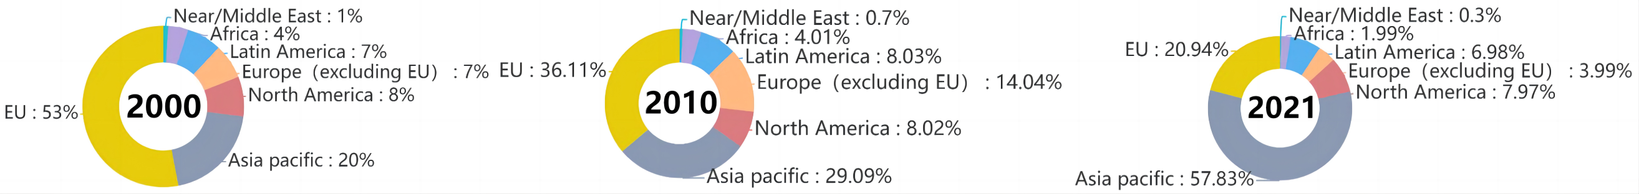

4.2 *Cross-border applications between UPOV members*

Table 1 lists the top 10 members transnational PVP（Input and Output）applications in 2021. It is noteworthy that all the TOPs that deployed PVP overseas are developed countries, with their applications accounting for 86.78% of the total number of cross-border applications (excluding EU, as the EU does not deploy to other countries/organizations). The United States of America and Netherlands filed significantly higher than other members, accounting for 54.5% of all foreign applications. The number of applications from the top 10 members that were deployed accounted for 77.81% of the total number of cross-border applications, and the EU Office for Plant Variety Protection (CPVO) received applications from many countries and regions such as the United States of America, Netherlands, Japan and Australia, as new plant varieties examined and authorized by the CPOV can obtain equally effective variety rights protection within the 27 member states of the European Union, and can be accessed throughout the European market through a single application. Among the top 10 members (input), China, Ukraine and Japan also belong to the top 10 in terms of application volume, with 5.86%, 65.89% and 38.92% of non-residents applying for each country respectively.

On the other hand, all of the top 10 countries/organizations with the most outputs are developed countries. In contrast, most of the top 10 countries/organizations with the largest input by other members are developing countries such as China, Ukraine, South Africa, and Russia, which have become the main MS.

Table 1 Top 10 member transnational PVP（Input and Output）applications in 2021.

|  |  |  |  |  |
| --- | --- | --- | --- | --- |
| **Rank** | **Country/ Region** | **No. of Outputs** | **Country/ Region** | **No. of Inputs** |
| 1 | USA | 1,531 | EU | 3,480 |
| 2 | Netherlands | 1,325 | China | 656 |
| 3 | Germany | 616 | USA | 652 |
| 4 | Switzerland | 531 | Ukraine | 622 |
| 5 | France | 485 | Japan | 302 |
| 6 | Australia | 226 | South Africa | 278 |
| 7 | Japan | 212 | Canada | 277 |
| 8 | Spain | 188 | UK | 240 |
| 9 | UK | 180 | Russia | 194 |
| 10 | Israel | 108 | Australia | 173 |
| SUM | 5,402 | | 6,874 | |
| World Total | 6,225（excluding EU） | | 8,834 | |
| Top 10% | 86.78% | | 77.81% | |

4.3 *International PVP Application Macro Network*

Taking a ten-year time period, the PVP applications network was selected in 2011 and 2021 to show the international flow, transmission patterns and changes of new plant varieties in the past decade (Figures 3,4). In order to facilitate analysis and comparison, the network diagram adopts a unified paradigm: the blue square node in the figure represents the MS, the red round node represents the OS, all the edges are pointed from the red round node to the blue square node. The size of the node is proportional to the number of edges it is connected to, and the thickness of the edge is proportional to the number of application relationships it represents. The network is drawn using a spring algorithm, and the position of nodes and the distance between nodes are determined by the similarity and elasticity coefficient between them, so the nodes that are clustered together will be more similar to each other than to other nodes.

In 2011(Figure 5), UPOV had 70 members. The MS are clustered around the core OS, forming three agglomeration areas and one core subject: the first area is composed of the United States, Ukraine, Australia, Russia, with nodes representing Ukraine being greater than other MS, which means the core OS consider Ukraine as the best place to apply. At the same time, Ukraine or Russia is the only choice for many Eastern European countries applying for PVP, such as Romania, Poland, the Czech Republic, Hungary, etc., which resulted in a long distance between this agglomeration area and other MS. The second agglomeration area is a cluster of South Korea, Canada, Israel and other countries. The third agglomeration consists of Germany, Mexico, Morocco and Peru; Another core MS is the European Union. Together, they form three agglomeration areas and a core MS.

The first OS core is composed of Germany, France, Netherlands and other countries, which have significant similarities in the number of regional outputs and regional selection, and their strategies focus more on the agglomeration areas of the first and second MS. From the number of outputs (thickness of the edges), it can be seen that France and Germany applied for more PVP in Ukraine.

The second core is composed of the United States, Australia, New Zealand and other countries, which have focused on the three market agglomeration areas and the European Union. Among them, the United States is more focused on the EU market. Italy is in a sub-core position on the periphery of this core area and mainly landscapes the first and third agglomeration areas.

Most of the non-core OS tend to choose geographically close MS when applying for PVP.

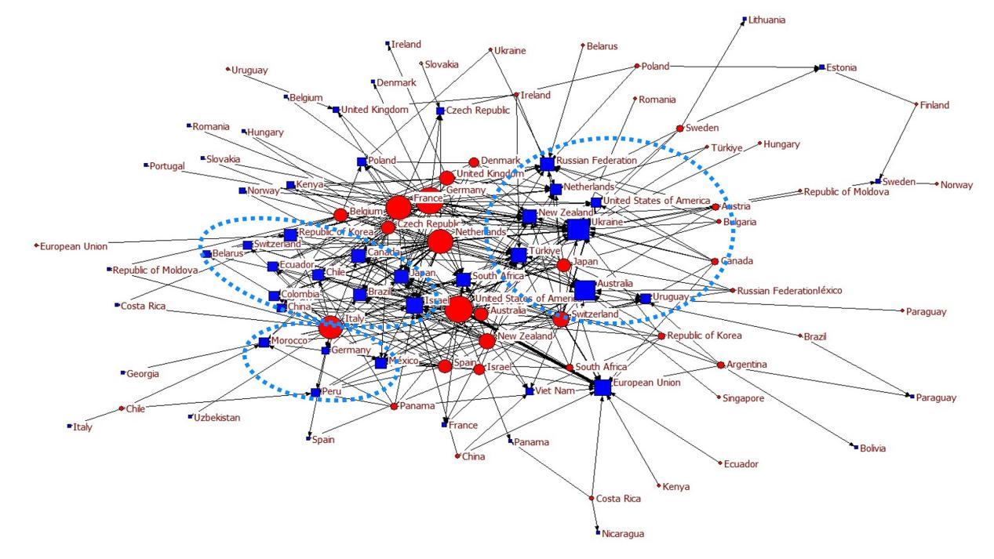

Figure 3: World PVP Application Network（2011）.

In the 2021 application network (Figure 4), MS are more evenly distributed around the OS compared to 2011. Almost all of the core OS are concentrated in one area. With Germany, France, Netherlands, Italy, the United States, Japan, the United Kingdom, Spain, Australia, and other countries forming the core of the network. In contrast, South Africa, Switzerland, Israel, South Korea, New Zealand and others have their own strategies and are further away from the core area of occupation. Although Ukraine remains a key focus area for traditional core OS, its dominant position as an MS has declined and the scale of MS in the network is increasingly balanced.

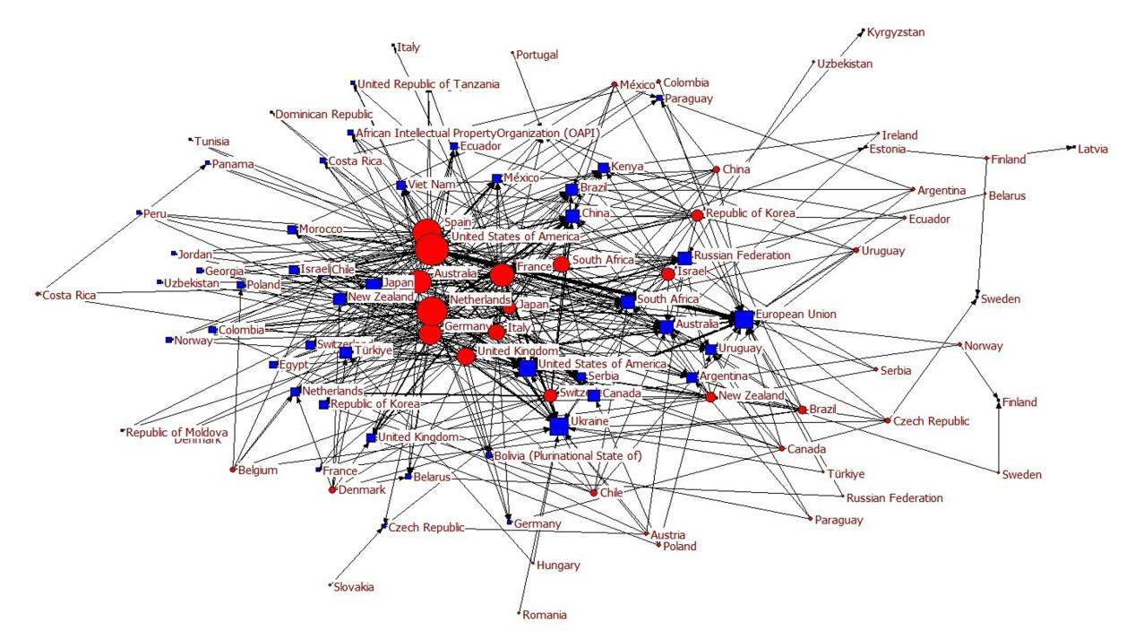

Figure 4: World PVP Application Network（2021）.

It's important to note that the international landscape of PVP is not only becoming more strategic but also more complex, as the number of countries and organizations involved continues to grow. The increasing polarization between OS and MS highlights the need for more effective communication and collaboration between them to ensure that the benefits of new plant varieties are shared more widely and equitably. Furthermore, the broad landscape strategy of core OS may also have implications for global food security and biodiversity conservation, as the development and dissemination of new plant varieties can have both positive and negative impacts on these issues. Therefore, it is crucial for policymakers and stakeholders to carefully consider the potential trade-offs and opportunities in this evolving landscape.

## 5. Conclusion

The overall trend of increasing applications for new plant varieties worldwide indicates a growing importance and interest in PVP among UPOV members. While Europe has historically had the largest number of applications, recent years have seen Asia overtake Europe as the region with the largest number of PVP applications due to the emergence of PVP in China. On the other hand, South America, Latin America, Africa, the Middle East, and other regions are experiencing a decreasing proportion of PVP applications, indicating regional polarization.

In the study of cross-border applications of UPOV members, it was found that the top 10 members with PVP deployed overseas are all developed countries. Among the countries/organizations where these PVP were deployed, developing countries in Asia, Africa, America, as well as other regions, have become the main MS in the landscape. In 2021, among the 78 members, the top ten countries/organizations outputs accounted for 86.78% of the total outputs, and the top ten countries/organizations where PVP were deployed accounted for 77.81% of the overall landscape. This indicates that there is not only polarization in the total number of applications, but also obvious polarization in the landscape of PVP across borders.

In the study of the network structure characteristics of international PVP applications, it was found that over time, MS gradually dispersed while OS gradually concentrate but also had their own tendencies. This suggests the international landscape of plant variety rights has become more strategic. OS are more polarized and are gradually adopting a broad deployingstrategy.

## 6. Discussion

The possession of a large number of high-quality plant variety rights is crucial for a country's food security. With the growing of international attention to plants and seeds, more and more new plant varieties are emerging. The internationalization of seed trade is also deepening, so the international PVP landscape is constantly adapting its strategy along with the international market pattern. From a comprehensive study, it is evident that the number of PVP worldwide is continuously increasing, but this growth is uneven and polarized, both in terms of regions and countries, as well as between developing and developed countries. Addressing the urgent issue of how to encourage regions and countries around the world to equally own new plant varieties and ensure food security through policies is essential.

On the other hand, the international seed market has established a PVP based intellectual property deploying strategy. The core OS gradually are gradually adopting a convergent strategy, while the core MS are being occupied by the core OS in a gradual and even manner. However, due to the increasing of polarization, most countries and organizations are gradually being been marginalized and lost their voice in the seed market.

**Open science practices**

The data is openly available, and the data of this study is sourced from the UPOV official website (https://www.upov.int/) PVP DATA&STATISTICS section and PLUTO Plant Variance Database.

**Author contributions**

Pengfei Jia: Conceptualization, Formal Analysis, Writing – original draft

Weixi Xie: Visualization, Investigation

Lichun Yin: Formal Analysis, Software

Meijing Lin: Data curation

Xianwen Wang: Writing – review & editing, Funding acquisition, Validation

**Competing interests**

No competing interests.

**Funding information**

National Natural Science Foundation of China (71974029).

**References**

Rifna, E. J., Ramanan, K. R., & Mahendran, R. (2019). Emerging technology applications for improving seed germination. Trends in Food Science & Technology, 86, 95-108.

Campi, M., & Nuvolari, A. (2015). Intellectual property protection in plant varieties: A worldwide index (1961-2011). Research Policy, 44(4), 951-964.

Galushko, V. (2012). Do stronger intellectual property rights promote seed exchange: evidence from US seed exports? Agricultural Economics, 43, 59-71.

Mousseddek, K. (2022). The legal protection of new plant varieties in Algerian and American system. The Journal of World Intellectual Property, 25(2), 375-390.

Rifna, E. J., Ratish Ramanan, K., & Mahendran, R. (2019). Emerging technology applications for improving seed germination. Trends in Food Science & Technology, 86, 95-108.

Srinivasan, C. S. (2003). Concentration in ownership of plant variety rights: some implications for developing countries. Food Policy, 28(5-6), 519-546.

Supasiripongchai, N. (2020). The legal protection of breeder's rights for new plant varieties in Thailand: The need for law reform considering the International Convention for the Protection of New Varieties of Plants 1991. Journal of World Intellectual Property, 23(3-4), 202-231.

Tripp, R., Louwaars, N., & Eaton, D. (2007). Plant variety protection in developing countries. A report from the field. Food Policy, 32(3), 354-371.