Dynamics of the disciplinary structure of research
in post-Soviet countries

Andrey Lovakov*

*lovakov@dzhw.eu
0000-0001-8644-9236
German Centre for Higher Education Research and Science Studies (DZHW), Germany

There was a bias in the thematic structure of research towards individual scientific fields in the USSR. The dynamics of the disciplinary structure of scientific research in the post-Soviet countries over the course of 30 years is analysed. The analysis shows that there are significant differences between the post-Soviet countries in the degree of specialisation/diversification of the disciplinary structure of scientific research. Countries that have fundamentally reformed their academic systems (Lithuania, Estonia, Latvia, and Kazakhstan) have the most diversified disciplinary profile. In the other countries, the structure of scientific research remains specialised, and in most of them it has decreased over time. All countries surveyed specialise in physics, but the share of publications in social sciences and humanities is also increasing.

1. Introduction
One of the characteristics of science in the last decades of the USSR was the shift of its thematic structure towards individual scientific fields. This was caused both by the need to serve the ideology of maintaining the political system of the country, and by the need to strengthen and develop the military-industrial complex (MIC). Research for the needs of the MIC occupied a huge place in the system of academic science (Nesvetailov, 1995; Piskunov & Saltykov, 1992) and accounted for about 75% of all resources (Graham, 1992; Graham & Dezhina, 2008; Piskunov & Saltykov, 1992). The most developed and internationally competitive were physics, mathematics, and chemistry, which were both useful to the MIC and the least influenced by ideology. At the same time, the social sciences and humanities were in a more difficult position. These scientific fields were not recognised as a priority for the state and the economy, so they received significantly fewer resources and were under strong ideological pressure from the state. As a result, the social sciences and humanities fields were less competitive. After the collapse of the USSR, the countries that were part of it went through complex processes of political, economic and social transformation. Their academic systems were also underwent a period of great change, as a result of which they were affected by multidirectional forces.

On the one hand, the residual influence of the Soviet system of science management persisted, which still manifests itself as a path-dependency (Karaulova et al., 2016; Klochikhin, 2012; Radosevic & Yoruk, 2014). The essence of this effect is that, despite new conditions, old processes and practices are reproduced through inertia. The disciplinary structure of research can also be reproduced through inertia. In particular, in many post-Soviet countries, the Academy of Sciences is still the main or one of the main producers of scientific knowledge (Lovakov et al., 2022), largely reproducing the same structure of research institutes that existed at the time of the collapse of the USSR. In some countries, not only the structure, but also the style of science management still exists, which significantly complicates research work, especially in the social sciences (Jonbekova, 2020).

On the other hand, many post-Soviet countries have significantly transformed their academic systems. Universities have become an important producer of scientific knowledge in the post-Soviet space. Estonia, Latvia, Lithuania, Georgia and Kazakhstan have carried out the most radical reforms, abolishing their academies of sciences in the form in which they existed during the Soviet period. In these countries, the Academy of Sciences has become a club of scientists, and its subordinate research institutes have been integrated into universities or have become independent. In other countries, the Academy of Sciences still has a status more or less similar to that of the Soviet period, but in most of them universities are actively involved in scientific research (Lovakov et al., 2022). Three groups of countries can be distinguished. (1) Countries with a dominant university sector, where the vast majority of publications are affiliated with universities, while the research sector makes a small contribution (Estonia, Georgia, Kazakhstan, Latvia, and Lithuania). (2) Countries with a dominant research sector, where research institutes produce a much larger share of output than universities (Armenia, Azerbaijan, and Tajikistan). (3) Countries with roughly equal sectors, where the university and research sectors produce roughly similar shares of research output (Belarus, Moldova, Russia, Ukraine, and Uzbekistan). In some countries, special government measures have been implemented to develop scientific research in universities. The development of scientific research in the university sector can contribute to a more balanced development of science in terms of disciplinary structure, as universities represent a wide range of scientific disciplines and fields in the form of faculties and departments. The accession of Estonia, Latvia, and Lithuania to the European Union has opened up new opportunities for training, collaboration and research funding in all scientific fields.

Thus, for almost thirty years, science in the post-Soviet countries has been under the influence of various forces that have affected its disciplinary and thematic structure in different ways. This study aims to find out how the disciplinary structure of scientific research in the post-Soviet countries has been transformed and also to what extent each of these countries has been able to overcome the disciplinary specialisation of science that it inherited after the collapse of the USSR.

2. Data and Method
For the analysis, the InCites database was chosen, which is an analytical tool of the Web of Science (WoS) database. The three indexes used in the study (SCIE, SSCI, and AHCI) reflect the most authoritative journals in the world, making it possible to analyze the strongest part of the country's scientific research. The advantage of the InCites data is the ability to use the Citation Topics classifier to separate publications by scientific field. This is a three-level system for classifying publications, grouping them into clusters based on citations. This classification has several advantages: 1) each article is classified, not the journal; 2) each publication relates to only one scientific field; 3) the classification is based on of the cited literature, and not on the opinion of an expert or editorial board. The classification has three levels: 10 fields at the macro-level, 326 fields at the meso-level, and 2457 fields at the micro-level. The macro- and meso-level fields were used in this study.

For each of the 15 post-Soviet countries, data on the number of affiliated publications (article and review types) in each research field at the macro- and meso-levels were downloaded from the InCites database. A publication was considered affiliated with a country if at least one affiliation of at least one author was associated with that country. The full counting method was used. Since the analysis of the disciplinary structure of research is based on the calculation of the shares of publications in different disciplines, interpretable results can only be obtained if there are a significant number of publications in different fields. Three countries (Kyrgyzstan, Tajikistan, and Turkmenistan) with a low number of publications were excluded from further analysis.

The Activity Index (AI) was used to analyze the disciplinary profiles of countries. This is a well-known and frequently used measure of the disciplinary specialization of countries (Aksnes et al., 2014; Li, 2017). he AI is defined as the ratio of the share of publications in a given field in the total volume of publications of the country to the share of publications in the same field in the total volume of publications of the world. The value of AI > 1 means that the share of publications in this field in the country is higher than the share of such publications in the world, i.e. the country "specialized" in this field, and AI < 1 means that the share of publications in this field in the country is lower than the share of such publications in the world. AI can take values from 0 to infinity. Values from 1 to infinity correspond to a situation where the country "specializes" in a particular field, and values from 0 to 1 correspond to a situation where the country "does not specialize" in that field. Thus, the distribution of AI is not symmetric, which makes it difficult to visually perceive and interpret. This problem can be solved by transforming AI into an alternative symmetric indicator - the Relative Specialisation Index (RSI), which is calculated as (AI - 1)/(AI + 1) and takes values from -1 to +1. Positive values indicate that the country has a larger share of publications in this field compared to the world, and negative values indicate that the country has a smaller share of such publications. A value of zero means that the country's share of articles in the field among the country's publications is equal to the share of such publications in the world. If there are no articles in a particular field, a RSI value of -1 has been assigned.

In order to quantify the degree of concentration/diversification of the country's disciplinary profile, the Gini coefficient, a well-known and frequently used indicator of concentration, was calculated based on the AI values of each individual field (Abramo et al., 2018, 2022). Since our study examines the dynamics of the thematic structure of research in countries, which becomes more diverse and balanced over time, it is more logical to speak not of the concentration of the country's disciplinary profile, but of its diversification and balance. For this reason, we will not analyse the value of the Gini coefficient itself, but its inverse transformation, calculated as 1 - the Gini coefficient. In this case, higher values indicate the diversification and balance of the country's disciplinary profile, while low values will indicate its concentration and imbalance.

3. Results
The values of the indicator of the balance of the disciplinary profile of the post-Soviet countries, calculated for the research fields at the macro- and meso-levels, are shown in Figure 1. The post-Soviet countries differ significantly in the degree of balance in the disciplinary profile. At the macro-level, Lithuania and Estonia have the most balanced disciplinary profile. Latvia and Kazakhstan have a slightly less balanced profile. The other post-Soviet countries have a much less balanced disciplinary profile, with publications are less evenly distributed across fields than in the world. The hierarchy of countries according to the balance of the disciplinary profile at the meso-level roughly repeats the hierarchy at the macro-level. However, in all post-Soviet countries there is a significant difference in the balance of the profile depending on which level of scientific fields is considered. At the meso-level, the profile of all post-Soviet countries is much less balanced than at the macro-level. This means that even countries with a relatively balanced profile at the level of major fields have smaller fields within the major fields that are either not developed at all or are underdeveloped.

Figure 1: Indicator of balance (1—Gini coefficient for AI) of the disciplinary profile of countries, which was calculated for research areas of the macro- and meso-level.
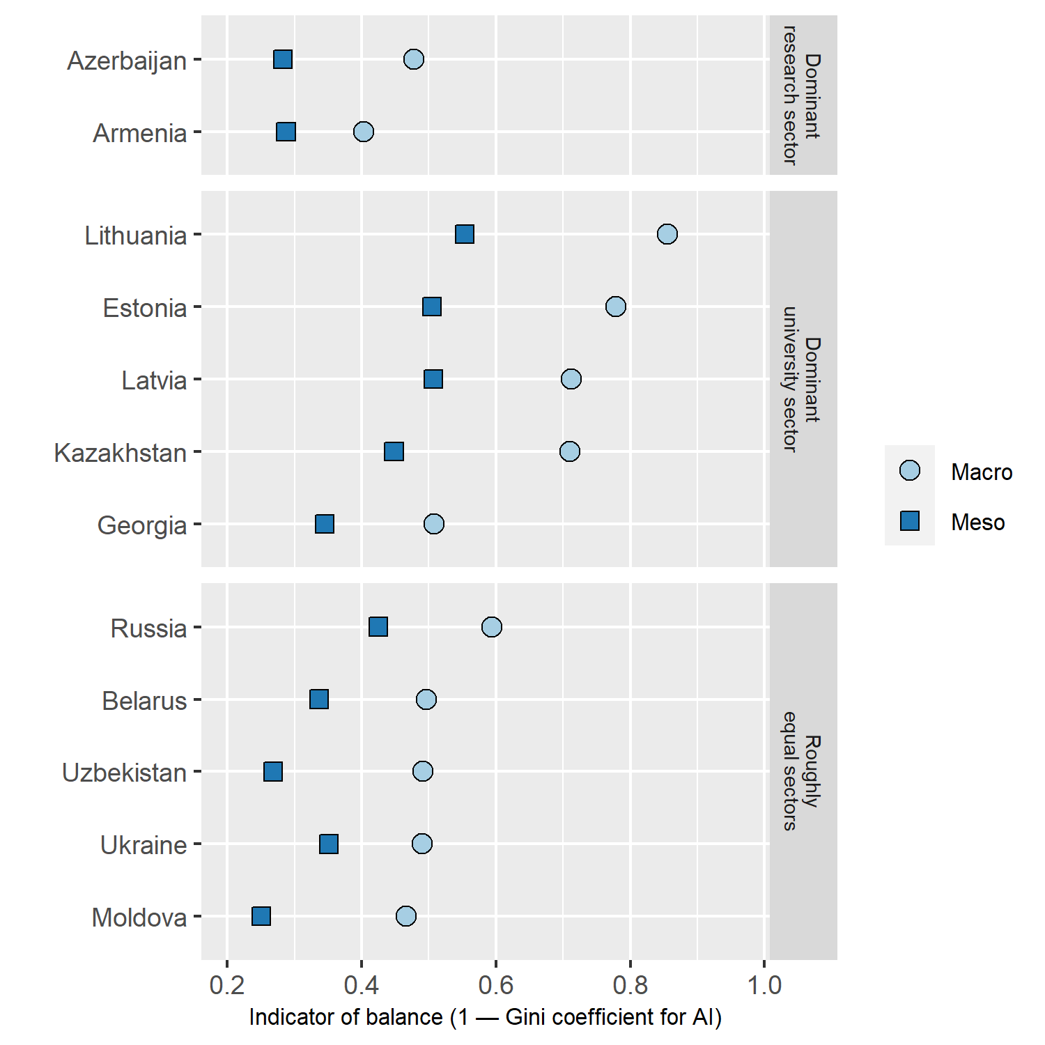

The post-Soviet countries differ in the pattern of the dynamics of the balance of disciplinary profiles indicator (Figure 2). In Armenia, Belarus, Georgia, and Moldova, the level of balance of the disciplinary profiles is relatively low throughout the period analysed. In the other countries, it increases over time. However, the countries differ both in the starting point and in the dynamics of the growth of the disciplinary profile. The largest increases are observed in Kazakhstan (from 0.41 to 0.71 at the macro-level and from 0.13 to 0.40 at the meso-level), Azerbaijan (from 0.38 to 0.56 at the macro-level and from 0.11 to 0. 20 at the meso-level), and Lithuania (from 0.45 to 0.67 at the macro-level and from 0.20 to 0.45 at the meso-level). Estonia shows only a slight increase in diversity, but has the most balanced profile over the period. The remaining countries show a moderate increase in their balance.

In order to understand the dynamics of individual fields, the RSI value was calculated for each of them for 6 periods (Figure 3). Absolutely in all post-Soviet countries there is an increase in this indicator in the social sciences and humanities. The share of publications in the social sciences increased most in Lithuania, Latvia, Azerbaijan, and Kazakhstan. However, despite the increase, it remains relatively low. Only in Estonia, Lithuania, and Kazakhstan the share of publications in the social sciences in the total number of publications in the country for 2016-2021 is equal to or slightly higher than the share of such publications in the world. In other countries, this share is lower than the world share. The lowest values are observed in Belarus, Ukraine, and Armenia. The share of publications in humanities increased most in Lithuania, Estonia, Kazakhstan, Moldova, Uzbekistan, Ukraine, and Russia. However, in most post-Soviet countries, the share of the humanities remains relatively low. Only in Estonia, Lithuania and Kazakhstan it is equal to or higher than the world share. At the same time, only in Estonia the share of the humanities is significantly higher than in the world. The share of articles in clinical and life sciences also increased in all countries except Uzbekistan. Growth was particularly strong in Moldova, Georgia, Kazakhstan and Latvia, but in all post-Soviet countries the share of publications in this field is still lower than in the world.
Figure 2: Dynamics of the balance indicator (1—the Gini coefficient for AI) of the disciplinary profile of countries, which was calculated for macro- and meso-levels.

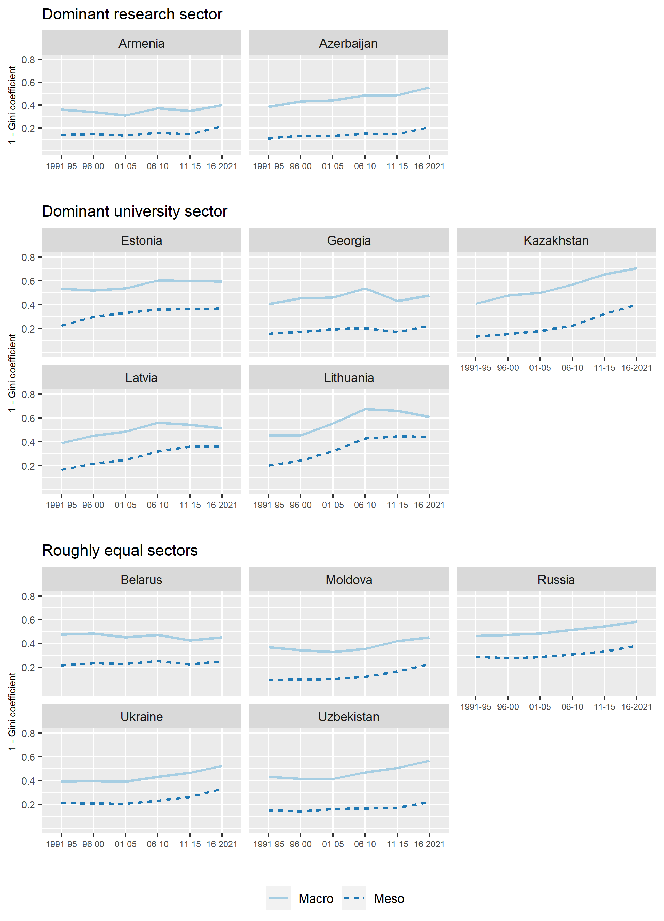

Figure 3: Dynamics of RSI for macro-level research areas.

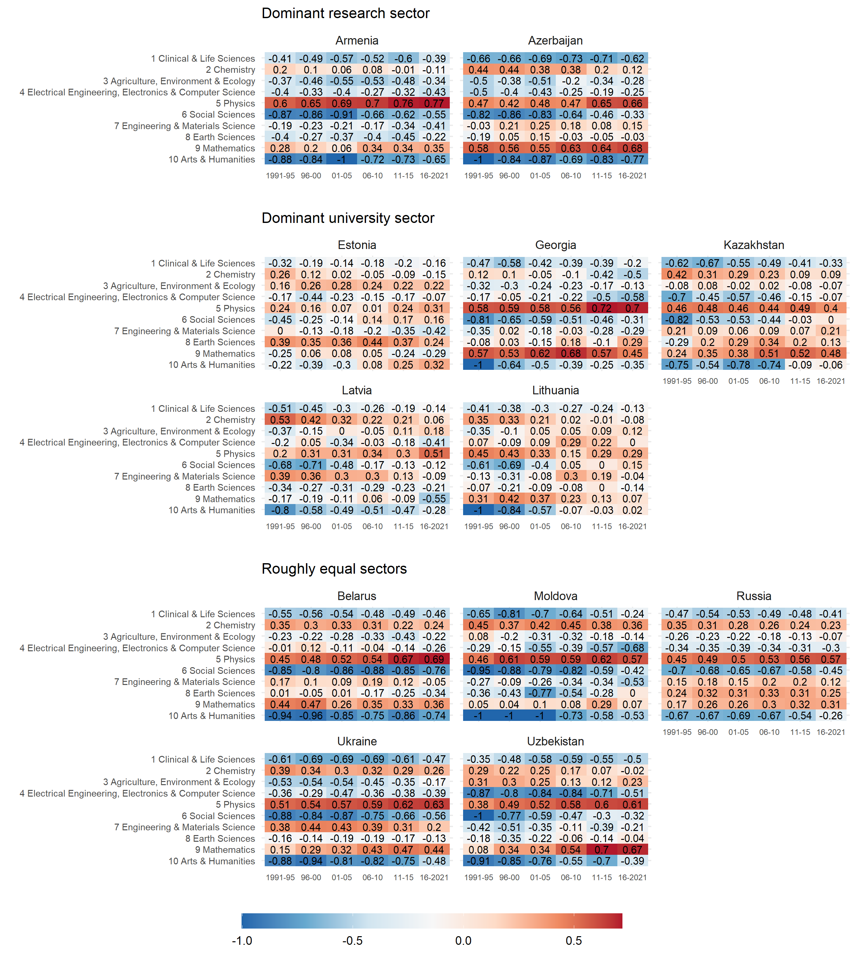

With the exception of Kazakhstan and Lithuania, the share of publications in physics is increasing in all countries of the post-Soviet space. The specialisation of research in the physics continues to increase, despite the general diversification. At the same time, the shares of publications in other natural sciences are declining. The share of publications in chemistry has decreased in absolutely all post-Soviet countries.

4. Conclusion
Despite the common past, there are significant differences between the post-Soviet countries in the degree of specialisation/diversification of the disciplinary structure of scientific research. Two groups of countries can be distinguished. The first group consists of Lithuania, Estonia, Latvia, and Kazakhstan, which have a relatively diversified disciplinary profile. The second group consists of the remaining countries, where the structure of scientific research remains more or less unbalanced, i.e. research is specialised in certain fields. Interestingly, all four countries with the most disciplinary balanced science are countries that have fundamentally reformed their academic systems. In particular, they have radically reformed their Academies of Science and universities have become the main producers of scientific research (Lovakov et al., 2022). At the same time, the countries with the least diversified profiles (Armenia, Moldova, and Azerbaijan) are also among those with a dominant research sector (Lovakov et al., 2022). Perhaps the active reform of academic systems and the development of scientific research in the university sector have helped to overcome the path-dependency effect and stimulate the development of scientific research in a more diversified range of scientific fields and disciplines.

Open science practices
The data supporting the results of this study are available from the InCites database. There are restrictions on the availability of these data, which have been used under licence for this study.

Competing interests
The author declares that he has no conflicts of interest.

Funding information
The study is based on data collected during the project supported by the Russian Science Foundation (project no. 20-18-00140).

References
Abramo, G., D’Angelo, C. A., & Di Costa, F. (2022). Revealing the scientific comparative advantage of nations: Common and distinctive features. Journal of Informetrics, 16(1), 101244. https://doi.org/10.1016/j.joi.2021.101244

Abramo, G., D’Angelo, C. A., & Zhang, L. (2018). A comparison of two approaches for measuring interdisciplinary research output: The disciplinary diversity of authors vs the disciplinary diversity of the reference list. Journal of Informetrics, 12(4), 1182–1193. https://doi.org/10.1016/j.joi.2018.09.001

Aksnes, D. W., van Leeuwen, T. N., & Sivertsen, G. (2014). The effect of booming countries on changes in the relative specialization index (RSI) on country level. Scientometrics, 101(2), 1391–1401. https://doi.org/10.1007/s11192-014-1245-3

Graham, L. R. (1992). Big Science in the Last Years of the Big Soviet Union. Osiris, 7(1), 49–71. https://doi.org/10.1086/368705

Graham, L. R., & Dezhina, I. (2008). Science in the New Russia: Crisis, Aid, Reform. Indiana University Press.

Jonbekova, D. (2020). Educational research in Central Asia: Methodological and ethical dilemmas in Kazakhstan, Kyrgyzstan and Tajikistan. Compare: A Journal of Comparative and International Education, 50(3), 352–370. https://doi.org/10.1080/03057925.2018.1511371

Karaulova, M., Gök, A., Shackleton, O., & Shapira, P. (2016). Science system path-dependencies and their influences: Nanotechnology research in Russia. Scientometrics, 107(2), 645–670. https://doi.org/10.1007/s11192-016-1916-3

Klochikhin, E. A. (2012). Russia’s innovation policy: Stubborn path-dependencies and new approaches. Research Policy, 41(9), 1620–1630. https://doi.org/10.1016/j.respol.2012.03.023

Li, N. (2017). Evolutionary patterns of national disciplinary profiles in research: 1996–2015. Scientometrics, 111(1), 493–520. https://doi.org/10.1007/s11192-017-2259-4

Lovakov, A., Chankseliani, M., & Panova, A. (2022). Universities vs. research institutes? Overcoming the Soviet legacy of higher education and research. Scientometrics, 127(11), 6293–6313. https://doi.org/10.1007/s11192-022-04527-y

Nesvetailov, G. (1995). Center-periphery relations and transformation of post-soviet science. Knowledge and Policy, 8(2), 53–67. https://doi.org/10.1007/BF02825968

Piskunov, D. I., & Saltykov, B. (1992). Transforming the basic structures and operating mechanisms of Soviet science. Science and Public Policy, 19(2), 111–118. https://doi.org/10.1093/spp/19.2.111

Radosevic, S., & Yoruk, E. (2014). Are there global shifts in the world science base? Analysing the catching up and falling behind of world regions. Scientometrics, 101(3), 1897–1924. https://doi.org/10.1007/s11192-014-1344-1

