Synergies across Innovations Obstacles and the Role of Government Aid: Evidence from Chile
Juan Carlos Castillo*, Nicholas S. Vonortas**

* juancast@unicamp.br
https://orcid.org/0000-0001-5805-2258
InSySPo, University of Campinas (UNICAMP), Brazil

** vonortas@gwu.edu
https://orcid.org/0000-0002-6745-4926
Center for International Science and Technology Policy & Department of Economics, The George Washington University, Washington, DC, USA
São Paulo Excellence Chair, University of Campinas, Campinas, Brazil

Abstract (148 words)

This research explores the effect of synergies across innovation obstacles on the inventive activity of Chilean manufacturers. Empirical analysis over the 2013-2018 period highlights the prevalence of two types of synergies: one comprising financial, network, knowledge and demand constraints and, another pairing regulatory obstacles to internal resistance to innovate. The presence of either set of obstacle synergy reduces the likelihood to innovate and weakens other innovation determinants such as R&D intensity, firm size, and the use of instruments for intellectual property protection. Firms accessing public support for innovation are found to respond differently from the rest. They tend to react to such constraints by tightening their scientific interaction with other private entities at the expense of links with public research institutions. Our results provide ample ground for policy making as they underscore avenues to jointly tackle innovation impediments while pointing out differences among various types of cooperative arrangements.

- Introduction
This research explores the extent through which interactions across innovation obstacles are likely to influence the inventive activity of Chilean manufacturers over the 2013-2018 period. Chile is herein regarded as a relevant case study given its outstanding performance as Latin America’s inventive economy. According to ECLAC (2022), this country has not only consistently reported one of the highest R&D investment in the region (as a proportion of GDP) but has also stood out as the economy with the greatest scientific productivity in relation to their peers.
Our logistic principal component analysis highlights the prevalence of two types of synergies among innovation barriers: one batch comprising financial, network, knowledge and demand constraints and, a second group pairing regulatory obstacles to factors pertaining internal resistance to innovate. In line with our probit estimation results, the presence of either obstacle synergy reduces likelihood to innovate and weakens other innovation determinants such as R&D intensity, firms’ size and the use of instruments for intellectual property protection.
Firms accessing public support for innovation are found to respond differently. When these constraints prevail, they appear to tighten their scientific interaction with other privately owned entities at the expense of discouraging links with public research institutions in the interest of further inventive outcome. Our results thus provide ample ground for policy making as these underscore avenues to jointly tackle innovation impediments, flag the presence of innovation deterrents stemming from rigid policy settings and even stress the urge for a better arrangement of cooperation incentives since these seem to progressively exclude public research institution from the inventive efforts of other private entities.
- Conceptual framework
Firm’s inventive outcome can be negatively affected by the presence of financial and non-financial constraints. Prohibitive costs and budgetary limitations on firms’ cash flow account for the set of financial impediments, while knowledge, demand, market an even regulatory related restrictions comprise the non-financial ones.
Given their specific features, innovation obstacles tend to reinforce and complement one and other (Galia and Legros, 2004; Savignon, 2008). For instance, the lack of qualified personnel can be tightly linked to insufficient financial funds. Such scarcity of knowledge and expertise can even allow for a growing uncertainty with respect to the potential resulting demand for the firms’ inventive outcome. Shedding light on these synergies across innovation barriers is of high relevance as it underscores the need to devise policy instruments that seek to jointly tackle their complementarities instead of approaching them individually.
To evaluate the effect exerted by those synergies, groups comprising various individual barriers can be formed conditional on their attributes and the specific nature of their interdependence (Mohnen and Rosa, 2002). Financial, knowledge and cooperation impediments might, for instance, be clustered around a single category since low cash flows tend to limit the acquisition of skilled labor thus eventually obstructing ability to cooperate with other enterprises. The same analogy results compatible for the rest of obstacles. The sole presence of such complementarities is herein foreseen to influence innovation activity by way of two channels; a direct impact over propensity to innovate and, an indirect one affecting other firm-level determinants of innovation (R&D intensity, size, instruments of intellectual property and, so forth). Following existing literature (Ortiz and Fernandez, 2022; Zahler et al. , 2022), we expect the direct impact to negative shape likelihood to innovate. With regard to the indirect one, we predict an ambiguous result. Depending upon the specific features of innovation determinants, the presence of obstacle synergies might either increase (or diminish) their importance over firms’ probability to pursue scientific outcome.
Access to public support for R&D is herein anticipated to act as an element mitigating the effects triggered by innovation constraints. These could be observed either by a reduction (or even suppression) of the above mentioned direct and indirect effects.
Endogeneity issues are to be reckoned and remedied within this framework given evident concerns of reverse causality between innovation activity and their respective obstacles. An instrumental variable approach is then deemed as highly necessary to properly validate the ideas and conclusions posed by this work. Figure (1) below briefly summarizes the main ideas governing the recently described conceptual framework.
Figure 1. Conceptual framework on the impact of obstacles synergies on innovation determinants and inventive outcome
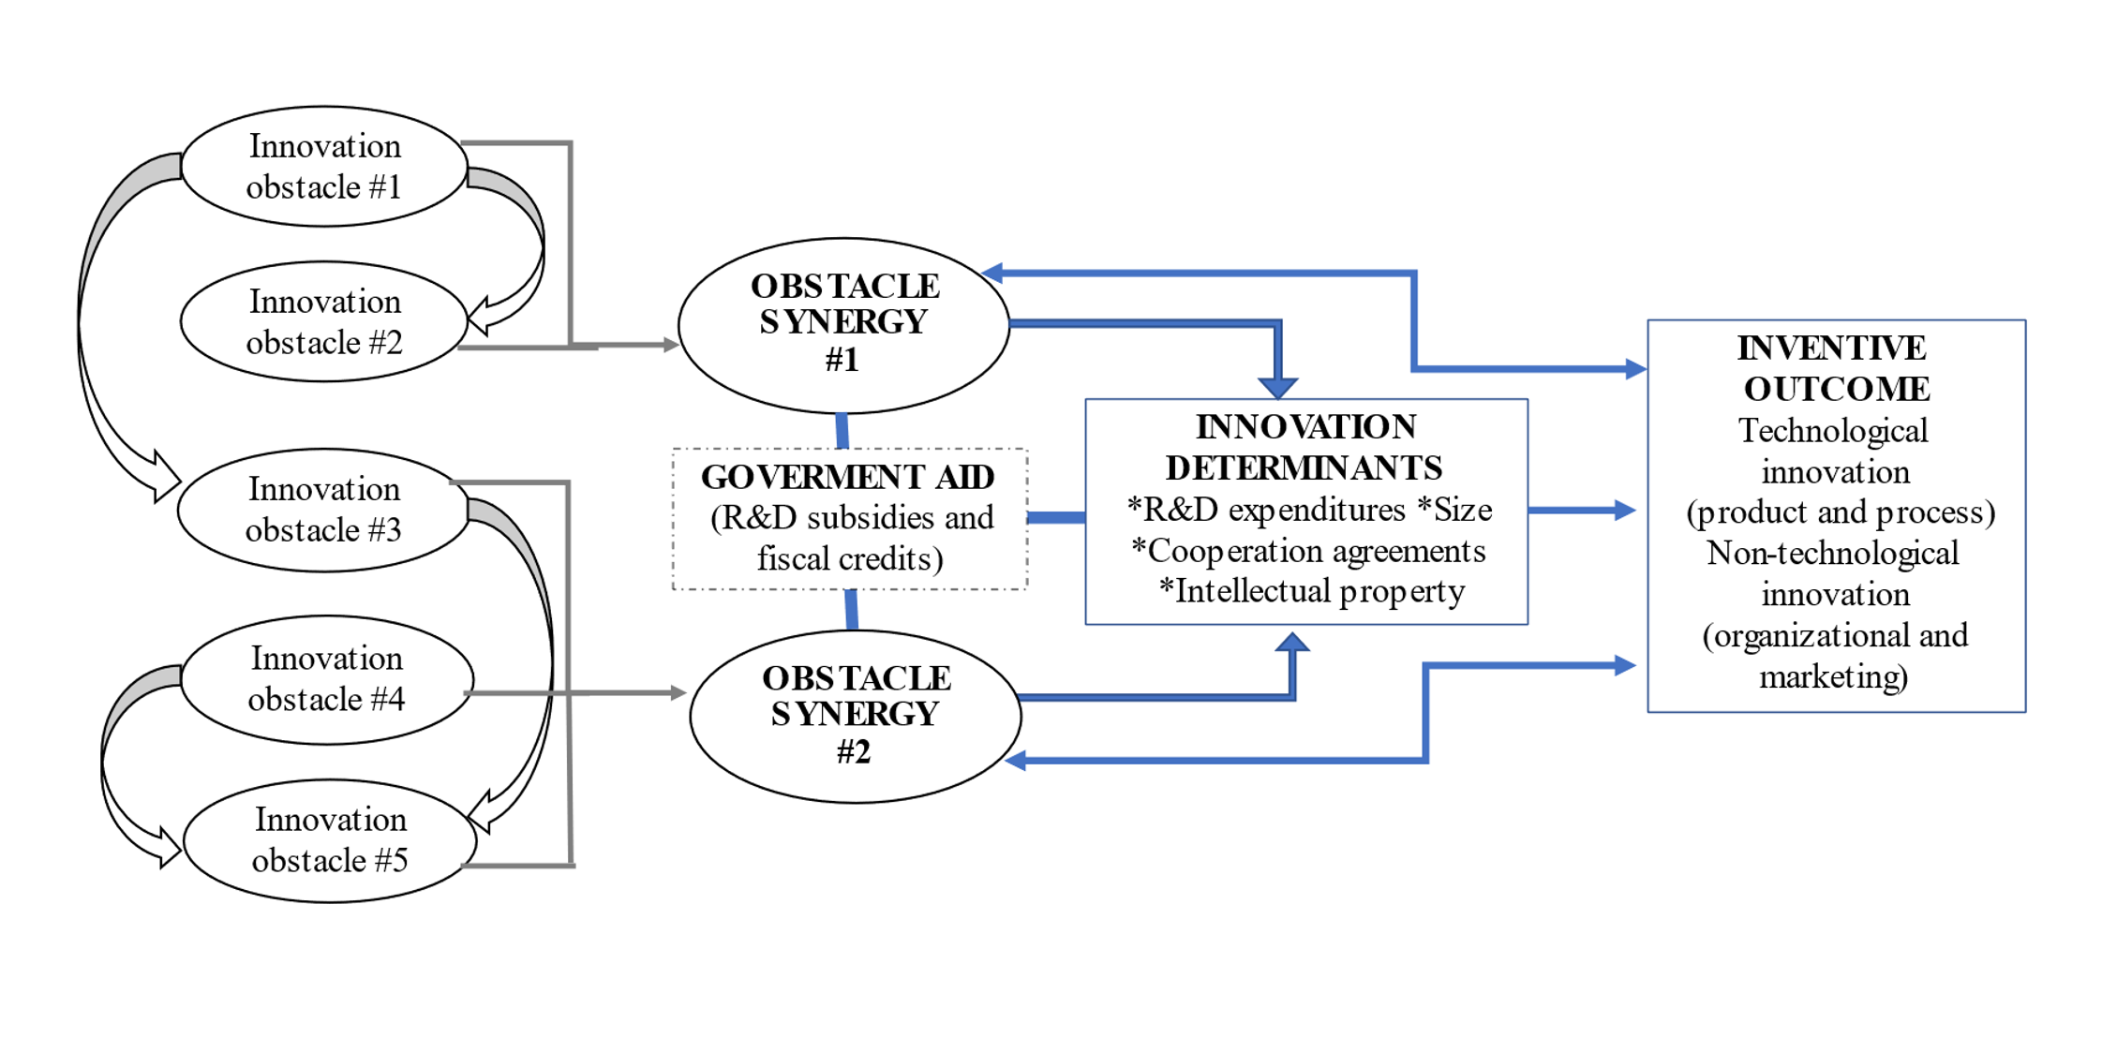
Source: Authors

- Data
Chilean innovation surveys biannually divulged by the country’s statistical office (Instituto Nacional de Estadísticas, INE) constitute our main source of micro-level information. Such datasets report a large number of innovation related variables including predominant type of innovation strategy being pursued (product, process, organizational and marketing), composition of R&D expenditures, availability of skilled workers, individual obstacles to innovate being faced by firms, policy instruments to support scientific activity, among others. Our research will rely on a recent pooled sample of firms (generated by INE) which contains standardized micro data from the 9th, 10th and 11th waves of the country’s innovation datasets and that range the period between 2013-2018.
In line with existing literature addressing obstacle to innovate at the micro-level, a subsample of inventive firms is hereby produced. Following Blanchard et al. (2012) and Pellegrino and Savona (2017) we filtered out the initial pooled of Chilean firms’ sample to solely consider those entities reporting innovation activities of any sort, that had ongoing or abandoned scientific projects and that have also faced at least one obstacle to innovate over time. Firms not meeting either of these criteria were then explicitly excluded from the analysis.
- Results
Following the outcome generated by our logistic principal component analysis, obstacles to innovate in Chile can be clustered around two groups: one batch highlighting interdependences across financial, knowledge, network and demand barriers (OBS1) and, a second one stressing complementarities between regulatory obstacles and factors linked to internal resistance to innovate (OBS2). Multivariate probit regressions and additional correspondence analysis further corroborated these latter groupings.
To describe the impact of innovation determinants and obstacles synergies over firms’ likelihood to innovate, we conducted a probit estimation. A dummy variable signaling either the presence of product or process innovation strategies (i.e., technological innovation) represents our dependent variable. As independent predictors, we include the following variables that typically configure firms’ inventive activity: R&D intensity, informal methods of intellectual property (IMIP), size, cooperation agreements with other private firms (COF), as well as the existence of collaborative projects with other research institutions (CREO).
Logistic principal component scores for components OBS1 and OBS2 are too included within our probit regression. Acknowledging issues of reverse causality, our instrumental variable approach includes (as an exogenous predictor) a firm-level indicator for the intensity of impediments to innovate. Within this regression, each obstacle synergy is observed to negatively influence likelihood to innovate. Other innovation determinants also included in the regression (such as size and the use of intellectual property rights) seem to weaken their relevance for firms’ inventive activity in the presence of either interrelation. Firm-level factors like R&D intensity and cooperative agreements with other private entities, on the other hand, are found to become inessential when the interdependence between financial, network, knowledge and demand barriers prevails.
Further insights are unfolded once we split our sample to separately consider firms with and without access to government aid for innovation. Despite the presence of synergies across obstacles, government funding and tax credits for R&D are empirically highlighted as pertinent policy tools nurturing private scientific interactions. Firms accessing these types of public support (SMEs with a lower-than-the-average R&D investment) and that face either group of impediments are able to heavily rely on cooperative projects with other private entities as a critical factor shaping its propensity for technological innovation. Nonetheless, additional room for policy intervention is here deemed as strongly necessary since, by the same token, cooperative agreements with public entities are found as an element negatively shaping probability to innovate regardless of obstacles synergies and access to government support.

- General conclusions
Beyond recommendations to jointly tackle innovation obstacles in accordance with the potential complementarities here outlined, this empirical work also underscores the need to better adapt existing policy incentives to not only target private agents but also other relevant public entities operating within the country’s national system of innovation. Government aid for innovation in Chile should not merely prioritize increasing collaboration across private entities but also aim for a closer interaction of these with public research institutions. As it the case for the average developing economy, such institutions produce and absorb the vast majority of highly qualified labor and execute most of the R&D investment in the country. Including incentives for scientific collaboration between public and privately owned entities as part the general conditions to access government aid will surely reinforce scientific research across wider segments of the national innovation system and even assist on the country’s efforts to boost private R&D investment.

Open science practices
Open science practices were particularly relevant for the successful competition of empirical work. On the one hand, our research could access official firm-level information directly from Chile’s Statistical Office (INE) without the need to submit a specific research proposal. This is greatly helpful for researchers seeking to analyze the micro-dynamics of innovation in the context of developing economies. On the other hand, our research also benefited from the use of open software (such as R) as well as from the availability of bult-in statistical packages that allow for the use of newly developed econometric techniques (such as the logistic Principal Component Analysis)
Author contributions (CRediT author statement)
Juan Carlos Castillo: Conceptualization, Methodology, Software, Data curation, Writing- Original draft preparation.
Nicholas Vonortas: Visualization, Investigation. Supervision, Validation, Writing- Reviewing and Editing.
Confict of interest
The authors declare that they have no confict of interest.
Funding information
The authors acknowledge funding from the São Paulo Research Foundation—FAPESP (Grant # PROCESSO 2021/09496-5)

References
Blanchard, P., Huiban, J.P., Musolesiz A., and P. Sevestre (2012), “Where There is a Will, There is a Way? Assessing the Impact of Obstacles to Innovation”, Industrial and Corporate Change, Vol. 22, Num. 3, pp. 679–710
ECLAC (2022), Innovation for development: the key to a transformative recovery in Latin America and the Caribbean (LC/CCITIC.3/3), Economic Commission for Latin America and the Caribbean, Santiago, Chile.
Galia, F. and D. Legros (2004), “Complementarities Between Obstacles to Innovation: Evidence from France”, Research Policy, 33, pp.1185–1199
Mohnen, P. and J. Rosa (2002), “Barriers to Innovation in Service Industries in Canada”. In: Feldman, M., Massard, N. (Eds.), Institutions and Systems in the Geography of Innovation. Kluwer Academic Publishers, Boston, pp. 231–250.
Ortiz, R. and V. Fernandez (2022), “Business Perception of Obstacles to Innovate: Evidence from Chile with Pseudo-Panel Data Analysis”, Research in International Business and Finance, 59.
Pellegrino, G. and M. Savona (2017, “No Money, no Honey? Financial versus Knowledge and Demand Constraints on Innovation”, Research Policy, 46, pp. 510–521
Zahler, A. Goya, D. and M. Caamaño (2022), “The Primacy of Demand and Financial Obstacles in Hindering Innovation”, Technological Forecasting & Social Change,174.

