Country shifts in the authorship of conference papers

Andrey Guskov * and Denis Kosyakov **

*guskov.andrey@gmail.com
ORCID: 0000-0002-1028-9958
Russian Research Institute of Economics, Politics and Law in Science and Technology,
Moscow, Russian Federation

** kosyakov@sciencepulse.ru
ORCID: 0000-0002-0495-9898
Russian Research Institute of Economics, Politics and Law in Science and Technology,
Moscow, Russian Federation

There are significant scatters in indexed conference papers quantity in different fields of science and countries that are of a different nature. This paper proposes a methodology for calculating disciplinary and institutional shifts of publishing in conference proceedings and its application to country analysis based on Scopus data. A disciplinary shift is the deviation of the conference paper share of a country from the world average, which is caused by the scientific specialization of this country. The institutional shift is the deviation of the conference paper share of a country from the world average, caused by the national specifics of the science policies, in particular, excessive stimulation of publication activity. The study confirms previously observed institutional shifts in the Czech Republic, Russia, and Indonesia, and identifies several more countries where there may also be distortions, caused by science policies.

1. Introduction
Conference papers (CP) play an important role in the system of scientific communications. Many studies are discussed for the first time through reports at conferences, and it is it is the way they are first introduced into scientific circulation. By hosting and participating in academic events, scholars maximize the uptake and circulation of research findings as well as promote knowledge-sharing and agenda-setting with potential impact on the academic community and society at large (Hansen & Budtz Pedersen, 2018). On the other hand, there are different attitudes towards this type of publications in the scientific community. Simplified review procedures, deadline-driven approach (submit before deadline, not after completing research) negatively affect the quality of conference proceedings (Franceschet, 2010), which depends on the source, where it is published.

Since it is noticeably more difficult to publish in scientific journals than in conference proceedings, the latter are increasingly being used to inflate scientometric indicators, which leads to ‘quality erosion’ (Kosyakov & Guskov, 2022) and can violate the scientific ethics.

Thus, a sharp increases of CP occurred in the Czech Republic in 2009 and in 2013–15 (Vanecek & Pecha, 2020). It started after the introduction of the performance-based research funding system, which awards proceedings relatively high scores, and the enormous growth of proceedings was the optimization strategy of researchers who sought maximal profit for minimal effort. Moreover, it affects bibliometric evaluation – according to standard bibliometric methods, the Czech Republic looks like quite a successful country, but detailed analysis has shown that one-third of the publications were proceedings, which receive very little attention from peers, receive very few citations, and have a very low impact on their fields.

Another evidence from Indonesia showed that CP share in was extremely high in 2018 and before – up to 80% according to Web of Science, and up to 60% according to Scopus. (Purnell, 2021) supposed that the local publishing guidelines and sometimes controversial credit-based assessment system might have provided the conditions and stimulus for Indonesian academics to increase their publication output and advance their careers partially through a preference for publishing CP and those same policies could have also incentivized scientists to host international conferences in Indonesia. Also, he noted that the proportion of conference papers published by authors in the Philippines in 2018 has approximately doubled since 2012.

The growth of conference proceedings coverage in the Web of science and Scopus has been shown to be partially responsible for the increased number of papers from Russian researchers (Moed et al., 2018). (Guskov et al., 2018) argued that publishing CP was one of the most successful strategies of top Russian universities for boosting research output. (Sterligov, 2021) analyzed differences between Russian and foreign publishing practice and conclude that it is necessary in the short term to recommend refusing to consider the proceedings of conferences in research evaluation and monitoring. Otherwise, while maintaining the current dynamics, Russia in the coming years risks becoming the world leader in the number of conferences without external citation and foreign participation.

Concerning the whole flow of CP, (Michels & Fu, 2014) made a systematic analysis of its coverage and usage, but it used only Web of Science data that is outdated and there was gaps in the coverage of important conferences. Thus, there is little known about the coverage of conference proceedings in WoS, Scopus, and Google Scholar (Waltman, 2016) and the impact of academic events is currently underexplored (Hansen & Budtz Pedersen, 2018). The COVID-19 pandemic has forced research society to reexamine both the format and value of scientific conferences (Jarvis et al., 2020), which is heightened the need for such studies.

Thus, the purpose of this study is to study trends and disproportions in the flow of conference papers indexed in Scopus, in the context of disciplines and countries. Special attention will be paid to the methodology for identifying deviations in number of CP at the country level. It will be used to analyze the cases in Czech Republic, Indonesia, Philippines, Russia Federation, and to reveal the other countries with the similar peculiarities.

2. Method
The study was conducted on an array of 2017–2019 publications of the Article, Review and Conference Paper types indexed in Scopus at the end of July 2022. The main indicator for the analysis was the percentage of articles in conference proceedings among publications of these types: CPP = CP / (AR + RE + CP) * 100. An increase in this indicator reflects a faster growth of publications in conference proceedings over other types, which indicates changes in the structure of scientific communications.

A country-by-country analysis was performed to identify disciplinary and institutional shifts in the share of conference materials. A disciplinary shift is the deviation of the CPP indicator from the world average, which is caused by the scientific specialization of this country. The institutional shift is the deviation of the CPP indicator from the world average, caused by the national specifics of the structure of science.

For the shifts calculation the parameter CPest(C) is introduced - the expected number of Conference Paper publications for country C, in accordance with the average values for each discipline:
$${CP}_{est}\left(C\right)= \sum_{D}{P\left(C,D\right)*CPP(D)}$$
where P (C, D) – is the sum of publications of types AR + RE + CP of country C in discipline D, and CPP(D) = CP / (AR + RE + CP) – world average share of articles in conference proceedings in discipline D.

Next, three country shifts are calculated - general (gen_shift), disciplinary (subj_shift) and institutional (inst_shift) according to the following formulas:

gen_shift = CP(C) / P(C) – CPPw
subj_shift = CP_est(C) / P(C) – CPPw
inst_shift = gen_shift – subj_shift

where P(C, D) – is the sum of publications of types AR + RE + CP of country C; CP(C) – number of Conference Paper publications for country C; CPPw – world average share of papers in conference proceedings.

When calculating shifts, it is necessary to take into account the fact that one article can simultaneously belong to several thematic categories, and its authors can be from different countries. Multiple counting of the same publication in two or more disciplines (or countries) unreasonably overestimates the CP_{est} values and leads to incorrect estimates of shifts. To overcome the problem of multiple counting, a double fractional counting was used, in which a full fractional counting is first performed to calculate the share of each country's contribution (Guskov & Kosyakov, 2020), and then this share is distributed in equal parts among the disciplines to which this publication was assigned.

3. Results and discussion

3.1. Disproportions by subject areas and countries
There are significant differences between CP publishing practices across disciplines, with CPP ranging from 0.3% to 62% in 2017-2019 (Table 1). The sum of publications in all disciplines (1,087,736) is approximately 2 times higher than the total number of such publications in the world due to multidisciplinary attribution, when one publication can be attributed to several disciplines (this should not be confused with a separate discipline Multidisciplinary).

High CPP values of more than 20% are recorded mainly in STEM sciences, with the exception of Chemistry. The social sciences and humanities are characterized by moderate values in the range of 5-15%, and in "Economics, Econometrics and Finance" it is even lower (3%). In the biomedical sciences, the share of publications in conference proceedings is the lowest and, as a rule, does not exceed 3.5%.

The distribution of CP across countries is also very uneven (Figure 1). In 2019, for most countries, the CPP indicator was in the range from 10% to 25%, and this range itself is quite wide. At the same time, more than 20% of countries were not included in it, and the overall spread differs very significantly: in Iran CPP=6%, and in Indonesia CPP=55%. These differences are influenced by many factors, including national scientific policy, which can create incentives to increase publication activity through CP. The previously noted disciplinary specialization of the country is also important. If research in a country dominates in the areas of Physical Sciences (especially Computer Sciences and Engineering), then there will be a natural increased CPP for them. In countries specializing in the field of Health Sciences and Life Sciences, on the contrary, the share of publications in conference proceedings will be low.

Table 1. Average annual number of publications by fractional count in conference proceedings (CP) for the period 2017–2019 (HS – Health Sciences, LS – Life Science, PS – Physical Sciences, SSH – Social Sciences & Humanities)
ASJC, level 1 | Code | ASJC, level 2 | CP | CPP, %
PS | COMP | Computer Science | 271 797 | 62.2
SSH | DECI | Decision Sciences | 33 526 | 58.0
PS | MATH | Mathematics | 107 015 | 44.6
PS | ENGI | Engineering | 257 039 | 39.3
PS | ENER | Energy | 58 326 | 38.5
PS | PHYS | Physics and Astronomy | 109 892 | 29.3
PS | EART | Earth and Planetary Sciences | 40 220 | 26.3
PS | MATE | Materials Science | 79 336 | 23.0
SSH | BUSI | Business, Management and Accounting | 11 705 | 14.4
PS | ENVI | Environmental Science | 27 308 | 14.0
SSH | SOCI | Social Sciences | 28 399 | 10.8
PS | CEMG | Chemical Engineering | 10 560 | 7.0
HS | HEAL | Health Professions | 17 91 | 5.2
SSH | ARTS | Arts and Humanities | 5 748 | 4.9
 | MULT | Multidisciplinary | 2 834 | 4.8
HS | MEDI | Medicine | 22 347 | 3.5
PS | CHEM | Chemistry | 8 521 | 3.3
SSH | ECON | Economics, Econometrics and Finance | 1 596 | 3.1
LS | AGRI | Agricultural and Biological Sciences | 5 521 | 2.6
LS | NEUR | Neuroscience | 1 218 | 1.8
SSH | PSYC | Psychology | 697 | 1.1
HS | NURS | Nursing | 474 | 1.0
LS | BIOC | Biochemistry, Genetics and Molecular Biology | 2 846 | 0.9
HS | DENT | Dentistry | 105 | 0.7
LS | PHAR | Pharmacology, Toxicology and Pharmaceutics | 395 | 0.4
HS | VETE | Veterinary | 79 | 0.4
LS | IMMU | Immunology and Microbiology | 232 | 0.3

Figure 1. Distribution of countries by CPP value in 2019
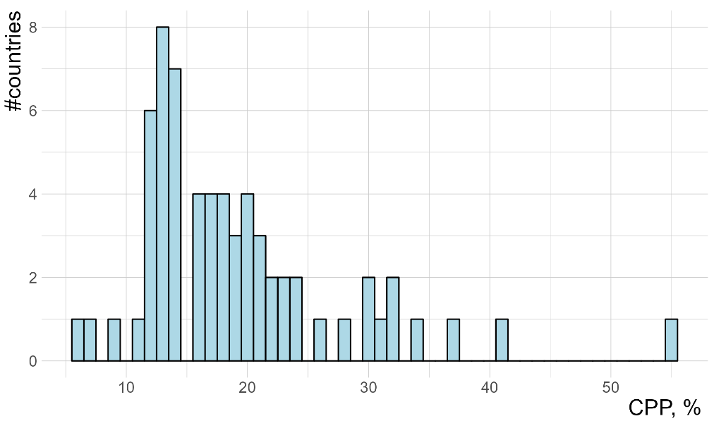
The methodology proposed in this paper makes it possible to separate the influence of the disciplinary specialization of countries from other factors that systemically affect the relative volume of conference materials. Let’s consider the results of its application.

4.2. Disciplinary and institutional shifts

For the analysis, a sample of 64 countries with the largest number of publications in 2017-2019 was formed, the total publication flow of which was 98% of the world (fractional account), including 29 of the 39 countries with advanced economies (according to International Monetary Fund) and all 5 BRICS countries. For each country, the inst_shift, sub_shift and gen_shift indicators were calculated (Figure 2).

The vast majority of the advanced economies (25 out of 29) fell into the zone with low institutional shifts and pronounced specialization in the areas of Life Sciences and Health Sciences, where conference proceedings are rarely published. We note the countries of Latin America (Argentina, Brazil, Chile), which have the smallest disciplinary shift, as well as a negative institutional shift, which can be explained by transport remoteness.

In the area with a high disciplinary shift, there were countries with a pronounced specialization in disciplines in STEM sciences. It should be noted that for small countries with an actively developing research sector, it is quite natural to shift towards Engineering and Computer Sciences, since science can develop in them without significant investments in infrastructure. In the first discipline, the material base from the industrial sector can be actively used for research. In the second, modest expenditures on computer technology are often quite enough to organize research that cannot be compared with the organization of a modern biological laboratory or medical clinic.

A high institutional shift is a sign of the presence in the state scientific policy of systemic incentives for the publication of conference proceedings, for example, the excessive use of managerial practices in the style of "Publish or Perish". The maximum such shift is observed in Indonesia (33%), another high shift registered in the Czech Republic (8.6%), Russian Federation (8.5%), and Philippines (13.2%). Given the above studies for these four countries, it must be assumed that they introduced such science policies or created conditions that led to a disproportionate increase in conference proceedings. We could not find similar studies for other countries, but these results indicate a high probability of applying similar scientific policies in them. Particular attention is drawn to a group of countries from Eastern Europe - Bulgaria, the Czech Republic, Russia, Romania and Slovakia, which, thanks to close neighboring scientific ties, have similar features in the structure of scientific communications. An exceptional example of a country with the lowest institutional shift is Iran, where due to political sanctions, researchers are limited in traveling abroad and in organizing international conferences.

In the future, it is planned to study changes in institutional and disciplinary shifts over time and analyze the factors influencing them.

Figure 2. Institutional and disciplinary shifts of countries in 2017-2019

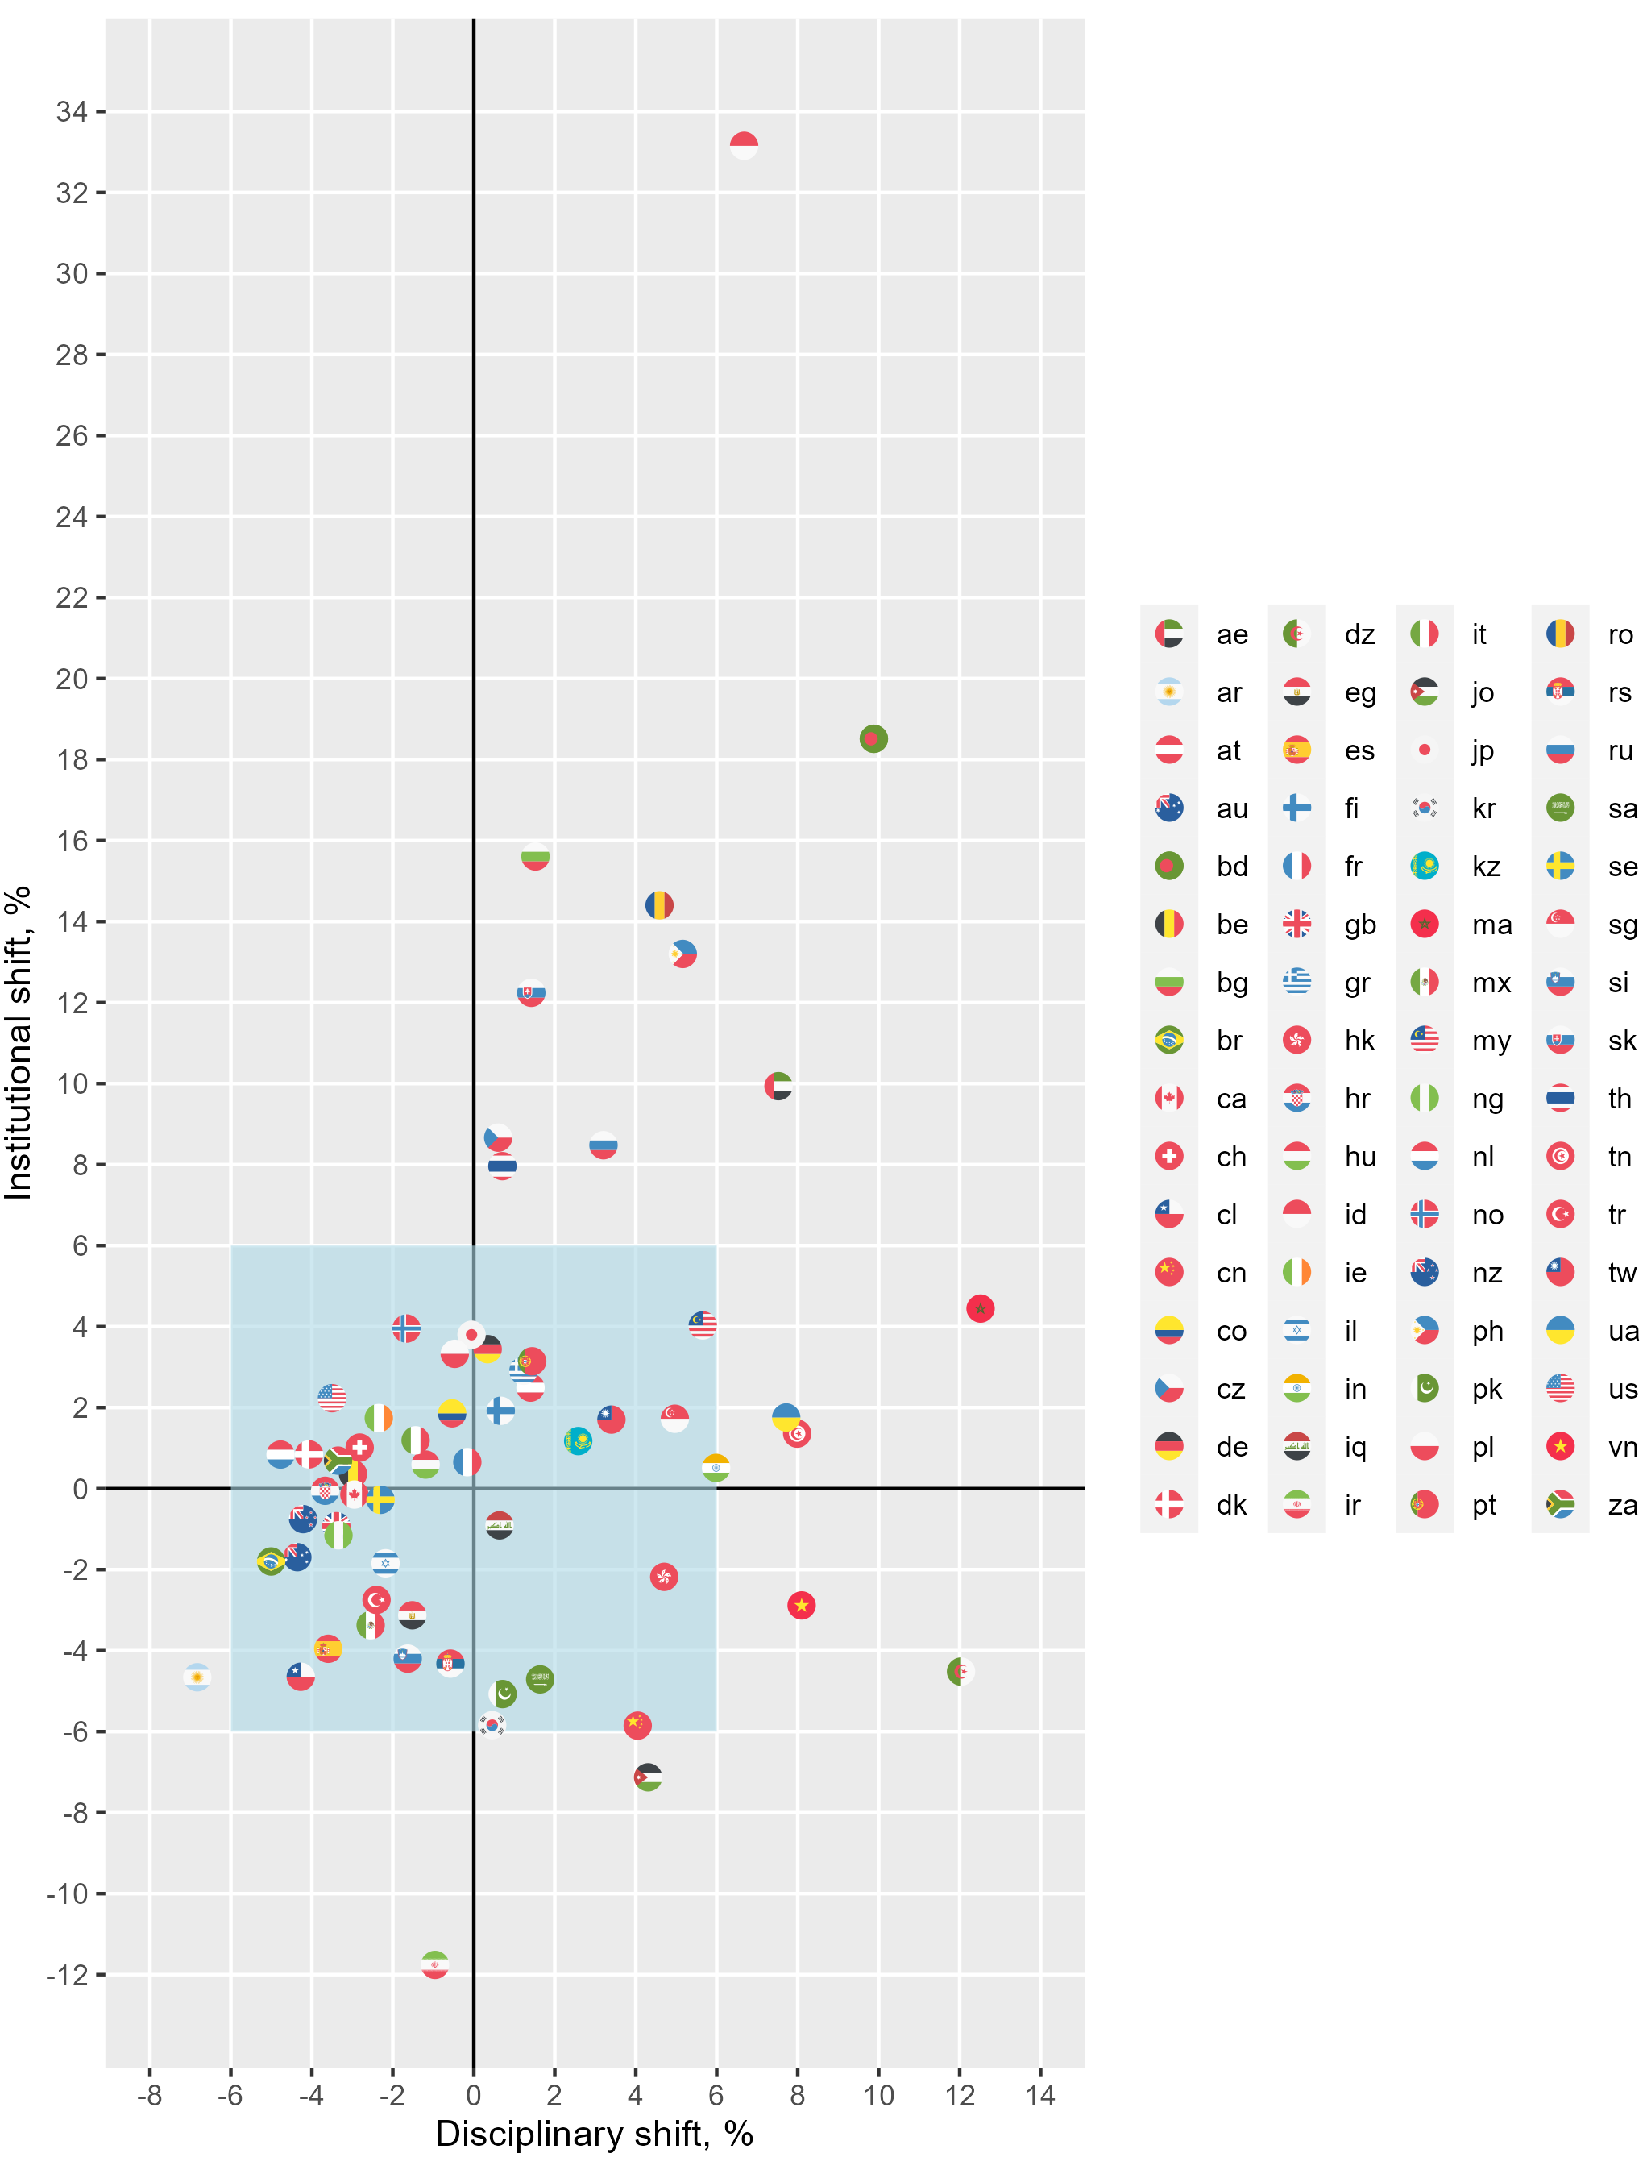

3. Conclusion
The purpose of this work was to study trends and deviations in the flow of papers in conference proceedings. It showed that the share of conference materials differed significantly in different fields of science. The largest volume of such publications is found in the Physical Sciences, especially in Computer Sciences, Engineering, Mathematics and Energy, where their share is more than 38%. In Health Sciences and Life Sciences, conference materials are much rarer, and their share is less than 5%. Significant differences are also observed across countries.

To study the structure of these differences, a methodology for determining disciplinary and institutional shifts in the number of conference paper publications was developed. Using this methodology, it is possible to identify groups of countries without features, countries with a high disciplinary shift that specialize in STEM sciences, as well as countries with a high institutional shift, i. e. those countries in which a high proportion of conference articles is caused by other systemic factors. For example, these may be changes in research evaluation procedures, leading to excessive stimulation of publication in conference proceedings. The analysis confirmed the assumptions about the presence of such shifts in the Czech Republic (Vanecek & Pecha, 2020), Russia (Sterligov, 2021), Indonesia and Philippines (Purnell, 2021). The performed analysis made it possible to identify other countries with a high institutional shift: Bangladesh, Bulgaria, Romania, Slovakia, Thailand, United Arab Emirates. A prime example of a negative institutional shift is Iran, where the participation of researchers in international conferences is likely caused by sanctions.

The most significant limitation of this study is that it only takes into account those conferences that are indexed in Scopus. Other databases (WoS, Dimensions) may use different criteria for selecting conferences for indexation, which will lead to different results of such analysis. We believe that in general they will differ slightly, although for individual countries whose scientific policy stimulated indexing in a particular database (for example, WoS in China), the differences may be more significant.

The principles and quality of the thematic classification of conferences also significantly affect the results of the methodology. A significant disadvantage of Scopus is the assignment for each publication all the thematic categories of the conference. This can essentially distort the distribution of publications by subject, especially for large multidisciplinary conferences, and increase the error in determining the disciplinary shift.

Open science practices
Intermediate and final data, as well as the corresponding processing algorithms, are planned to be posted on GitHub after the completion of the study.

Author contributions
Andrey Guskov: Methodology, Investigation, Visualization, Writing – original draft
Denis Kosyakov: Conceptualization, Methodology, Investigation, Writing – review & editing

References
Franceschet, M. (2010). The role of conference publications in CS. Communications of the ACM, 53(12), 129–132. https://doi.org/10.1145/1859204.1859234
Guskov, A. E., & Kosyakov, D. V. (2020). National fractional calculations and evaluating organization’s science efficiency. Scientific and Technical Libraries, 1(9), 15–42. https://doi.org/10.33186/1027-3689-2020-9-15-42
Guskov, A. E., Kosyakov, D. V., & Selivanova, I. V. (2018). Boosting research productivity in top Russian universities: The circumstances of breakthrough. Scientometrics, 117(2), Article 2. https://doi.org/10.1007/s11192-018-2890-8
Hansen, T. T., & Budtz Pedersen, D. (2018). The impact of academic events—A literature review. Research Evaluation, 27(4), 358–366. https://doi.org/10.1093/reseval/rvy025
Jarvis, T., Weiman, S., & Johnson, D. (2020). Reimagining scientific conferences during the pandemic and beyond. Science Advances, 6(38), eabe5815. https://doi.org/10.1126/sciadv.abe5815
Kosyakov, D., & Guskov, A. (2022). Reasons and consequences of changes in Russian research assessment policies. Scientometrics, 127(8), 4609–4630. https://doi.org/10.1007/s11192-022-04469-5
Michels, C., & Fu, J.-Y. (2014). Systematic analysis of coverage and usage of conference proceedings in web of science. Scientometrics, 100(2), 307–327. https://doi.org/10.1007/s11192-014-1309-4
Moed, H. F., Markusova, V., & Akoev, M. (2018). Trends in Russian research output indexed in Scopus and Web of Science. Scientometrics, 116(2), 1153–1180. https://doi.org/10.1007/s11192-018-2769-8
Purnell, P. J. (2021). Conference proceedings publications in bibliographic databases: A case study of countries in Southeast Asia. Scientometrics, 126(1), 355–387. Scopus. https://doi.org/10.1007/s11192-020-03773-2
Sterligov, I. (2021). Russian conference explosion: Scale, causes, further actions. Science Management: Theory and Practice, 3(2), 222–251. https://doi.org/10.19181/smtp.2021.3.2.10
Vanecek, J., & Pecha, O. (2020). Fast growth of the number of proceedings papers in atypical fields in the Czech Republic is a likely consequence of the national performance-based research funding system. Research Evaluation, 29(3), Article 3. https://doi.org/10.1093/reseval/rvaa005
Waltman, L. (2016). A review of the literature on citation impact indicators. Journal of Informetrics, 10(2), 365–391. https://doi.org/10.1016/j.joi.2016.02.007

