Do men commit more scientific misconduct than women? Evidence from retracted articles

Er-Te Zheng*, Hui-Zhen Fu**, Zhichao Fang*,***

* zhengerte@ruc.edu.cn; z.fang@cwts.leidenuniv.nl
0000-0001-8759-3643; 0000-0002-3802-2227
School of Information Resource Management, Renmin University of China, China

** fuhuizhen@zju.edu.cn
0000-0002-1534-9374
Department of Information Resources Management, Zhejiang University, China

*** z.fang@cwts.leidenuniv.nl
0000-0002-3802-2227
Centre for Science and Technology Studies (CWTS), Leiden University, The Netherlands

The gender disparity in scientific research has sparked extensive discussion, yet there is currently no consensus on the prevalence of scientific misconduct across genders. This study investigates this issue by collecting 5,256 retracted articles with the gender of their first authors based on the Web of Science and Retraction Watch databases. Considering the overall research productivity of both genders, our results demonstrate that male researchers generally exhibit higher retraction rates than their female counterparts in all disciplines. Female researchers retract slightly more due to falsification, while male researchers tend to retract more due to ethical issues, plagiarism, and authorship issues. In most countries with high numbers of retractions, male researchers exhibit higher retraction rates, with Iran being particularly severe. From the perspective of gender disparity, this study emphasizes the importance of addressing scientific misconduct and its underlying causes, to create a climate of accountability in the scientific community.

1. Introduction
The veracity of research findings is contingent on the integrity of the research process, which encompasses data collection, analysis, and reporting (Fanelli, 2009). Regrettably, some researchers partake in unethical conduct that undermines the credibility of their research, ultimately leading to the retraction of published articles. Scientific misconduct is a grave concern for the scientific community, as it has the potential to diminish public trust in science and waste valuable resources (Grieneisen & Zhang, 2012).

Previous research has shown that gender disparities are present in multiple aspects of scientific research, such as research outputs (Huang et al., 2020), citations (King et al., 2017), funding (Larivière et al., 2011), and peer review (Lerback & Hanson, 2017). However, little is known about whether gender disparities exist in scientific misconduct and article retractions, which could reflect differences in the ethical behavior and research quality between male and female researchers. Understanding such gender disparities is critical in promoting gender equality in science and guaranteeing the reliability of scientific knowledge.

The objective of this study is to investigate the gender disparities in article retractions. Specifically, our research question is:
Do men commit more scientific misconduct than women, regarding the reasons behind article retractions among researchers from diverse fields and countries?

2. Literature Review

2.1 Gender disparities in scientific research
Gender disparities in scientific research have been widely discussed. In terms of academic productivity, there is a general consensus that women publish less articles than men across almost all disciplines and countries (Aksnes et al., 2011; Fox, 2005). On average, male researchers produce 16.8% to 31.6% more outputs than their female counterparts (Abramo et al., 2009; Huang et al., 2020; Larivière et al., 2011). As researchers progress in their careers, their productivity tends to increase. Since a higher proportion of men occupy senior positions than women, men tend to have higher average outputs (Bordons et al., 2003). Despite significant research on the outputs of male and female researchers, there is a paucity of comparative studies on retractions.

2.2 Gender disparities in retractions
As for retraction, most studies suggested that men had more retractions than women. Male researchers retracted more due to falsification and plagiarism, while female researchers retracted more due to errors (Decullier & Maisonneuve, 2021; Fang et al., 2013). However, some argue that having more retractions does not necessarily indicate that men are more inclined to commit scientific misconduct (Fanelli, 2013). It is possible that women are less likely to be caught and more skilled and effective in defending themselves during negotiations. Additionally, men are often viewed to be prone to risk-taking and criminal behavior, which may result in accusations and negative judgments (Kaatz et al., 2013). There are also studies that report no significant differences in retraction between male and female researchers (Fanelli et al., 2015). Female researchers are even found to retract more due to image duplication (Fanelli et al., 2019). Therefore, more evidence is necessary to examine whether male researchers are more likely to engage in misconduct than female researchers.

3. Data and methods

3.1. Data
This study collected data on retracted articles from two databases, namely, the Web of Science (WoS) and Retraction Watch. Retraction Watch is the most prominent database of retracted articles today (Brainard, 2018). Our search process involved three main steps: (i) searching for retracted articles and retraction notices in WoS between 2007 and 2021; (ii) matching the records of retracted articles and retraction notices based on their titles; (iii) searching for retraction reasons in the Retraction Watch database for the retracted articles retrieved. We further extracted the bibliometric information of retracted articles from the CWTS in-house WoS database, including the title, authors, journal, publication year, author affiliations, and disciplines. As a result, a total of 8,655 retracted articles were found.

3.2. Gender estimation
This study made use of a customized version of the WoS database with the gender of authors identified, which is hosted by the Centre for Science and Technology Studies (CWTS) at Leiden University. This version of the database supports SQL-based queries and incorporates an author-disambiguation algorithm (Caron & van Eck, 2014) that is well-suited to our analysis. Previous studies have demonstrated that the algorithm has a high level of precision (97%), although it may miss some articles (recall = 90% to 91%) (Andersen & Nielsen, 2018; Caron & van Eck, 2014). We used the algorithm to estimate the gender of the first author in each retracted article, since the first author is typically the person who makes the most significant contribution to the work and is more likely to be responsible for scientific misconduct (Hussinger & Pellens, 2019; Larivière et al., 2016).

Therefore, we identified the gender of the first author of each article and excluded the articles where the gender of the first author cannot be identified. In total, 5,256 retracted articles (accounting for 60.7%) were obtained for further analysis.

3.3. Retraction reasons
According to Zhang et al. (2020), retraction reasons classified by the Retraction Watch database could be further grouped into six main categories. The numbers of retractions in each of these categories are:
- Error (2,193)
- Self-plagiarism (1,536)
- Falsification (896)
- Ethical issues (824)
- Plagiarism (572)
- Authorship issues (275)
Note that the sum exceeds the total number of retracted articles in our dataset, as some articles may have been retracted for multiple reasons.

3.4. Indicators

3.4.1. Retraction rate
For each gender, retraction rate refers to the ratio of the number of retracted articles authored by the gender to the total number of published articles by the gender. Based on the aforementioned WoS database with gender information, we retrieved the total number of articles published by male and female researchers as the first author during the observation time window (2007-2021), respectively. Retraction rate is calculated for male and female researchers to unravel how many first-authored articles published by different genders have been retracted.

3.4.2. Male/female retraction ratio (MFRR)
Male/female retraction ratio (MFRR) refers to the ratio of the retraction rate of male researchers to that of female researchers. Previous research has compared gender disparities using the absolute number of retractions, without considering the differences in the number of articles published by male and female researchers. The use of MFRR allows for a more objective comparison of retraction rates between male and female researchers. An MFRR value greater than 1 indicates a higher retraction rate for men compared to women, while a value less than 1 indicates a higher retraction rate for women compared to men. When the MFRR value equals to 1, it implies that there is no discernible difference in retraction rates between the genders.

3.5. The LR classification of subject fields
For disciplinary analysis, we took the disciplinary classification of Leiden Ranking (https://www.leidenranking.com/information/fields) as the reference, which has the advantage of assigning each article to a single discipline and allows for better comparison across disciplines (Waltman et al., 2012; Waltman & Van Eck, 2012). The Leiden Ranking classification (hereinafter the LR classification) divides all disciplines into five main categories. The numbers of retractions in each of these five categories are:
- Biomedical and health sciences (2,845)
- Physical sciences and engineering (1,178)
- Life and earth sciences (612)
- Mathematics and computer science (303)
- Social sciences and humanities (298)

4. Results
The overall retraction rate of male researchers is 3.43‱, while that of female researchers is 2.64‱. This results in an MFRR of 1.30, indicating that, on the whole, male researchers have a higher retraction rate. In the following parts of the Results section, we further investigate MFRR in terms of temporal trend, retraction reasons, and distribution by country and discipline.

4.1. Temporal trend of retraction by gender
Figure 1a depicts the annual number of retracted articles and the corresponding retraction rate by gender. In general, male researchers have a higher number of retractions and retraction rates compared to their female counterparts throughout the entire observation period.

Figure 1: (a) Annual number of retractions and retraction rate by gender and (b) trend of MFRR.
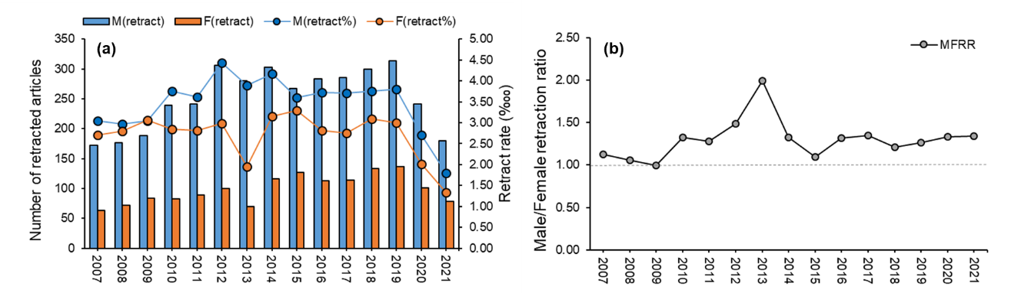

It can be observed in Figure 1b that the MFRR has an increasing trend, followed by a decreasing trend. The year 2009 shows the smallest difference in retraction rates between male and female researchers, with an MFRR of approximately 1. The largest gender gap occurs in 2013, with an MFRR of approximately 2, which is the peak of the curve. This is mainly caused by that, all authors who had multiple retractions in 2013 were male, with one of the male researchers leading the way with 14 articles got retracted that year. In recent years, the MFRR has been fluctuating between 1.20 and 1.35, showing a stable pattern.

4.2. Retraction reasons by gender
Figure 2 shows a double donut chart to illustrate the gender disparities by retraction reason. The inner circle represents the proportion of published articles across genders, the outer circle represents the proportion of retracted articles across genders. The part contributed by male researchers is in blue, while that of female researchers is in orange. The MFRR is calculated in relation to each retraction reason and displayed above each donut chart. The values of MFRR reveal that in cases of plagiarism and authorship issues, male researchers have notably more retractions than female researchers. As for ethical issues, self-plagiarism, and error, male researchers have slightly higher retraction rates than their female counterparts. Female researchers only slightly outnumber male researchers in retractions due to falsification.

Figure 2: MFRR by retraction reason.
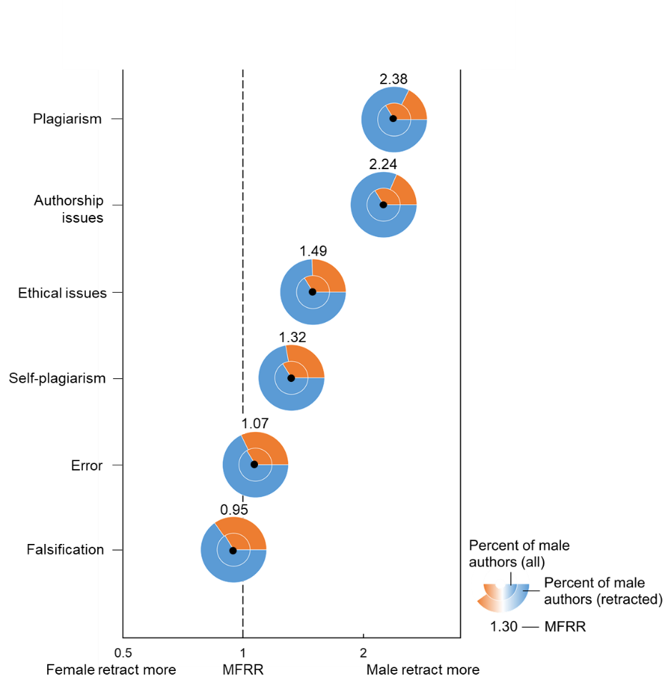

4.3. Country distribution of retractions by gender
Figure 3 shows the number of retractions across different countries and the double donut charts of "Retraction-Publication" by gender for the top ten countries with the highest number of retractions.

During the observation period, the top ten countries with the highest number of retractions are China, United States, India, Iran, Japan, South Korea, Italy, United Kingdom, Germany, and Spain. These countries have retracted over 100 articles each, with China having the highest number of retractions (1,303) and Spain having the lowest (109).

Figure 3: Country distribution of retractions by gender.
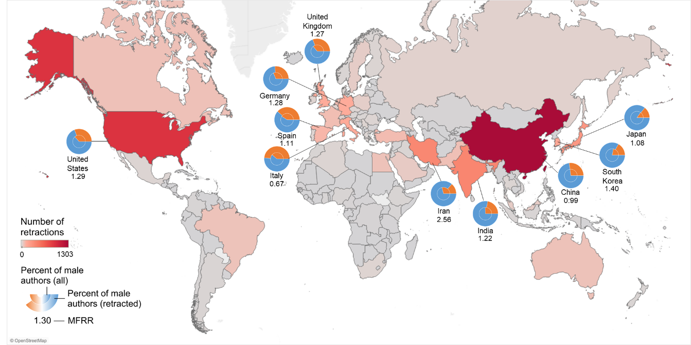

After controlling for the number of articles published, male researchers still exhibit higher retraction rates than their female counterparts in most countries. Iran has the largest gender disparity in retraction rate, with male researchers retracting more than 2.5 times as many articles as female researchers. In China and Japan, the retraction rates of male and female researchers are relatively similar. Female researchers in Italy, however, show a higher retraction rate than male researchers.

4.4. Disciplinary distribution of retractions by gender
Based on the LR classification of subject fields, we analyzed the disciplinary distribution of retractions by gender and presented the findings in Figure 4. The figure includes double donut charts of retracted articles and published articles across genders, as well as the MFRR by the five main disciplines. The visualization follows the same rules as in Figure 2.

Male researchers have higher retraction rates than female researchers in all disciplines, as indicated by MFRR > 1 in all cases. The largest gender disparity in retraction rates is observed in biomedical and health sciences, while the smallest disparity is observed in mathematics and computer science.

In terms of the number of published articles, male researchers in mathematics and computer science, as well as physics and engineering, have a significantly higher research productivity than their female counterparts, with a male to female ratio of approximately 8:2. Male researchers in physical sciences and engineering have a higher retraction rate than those in mathematics and computer science. In biomedical and health sciences, life and earth sciences, and social sciences and humanities, the male to female publication ratio is approximately 6:4. However, the male researchers in the former two fields have a significantly higher retraction rate than those in social sciences and humanities.
Figure 4: MFRR across discipline.
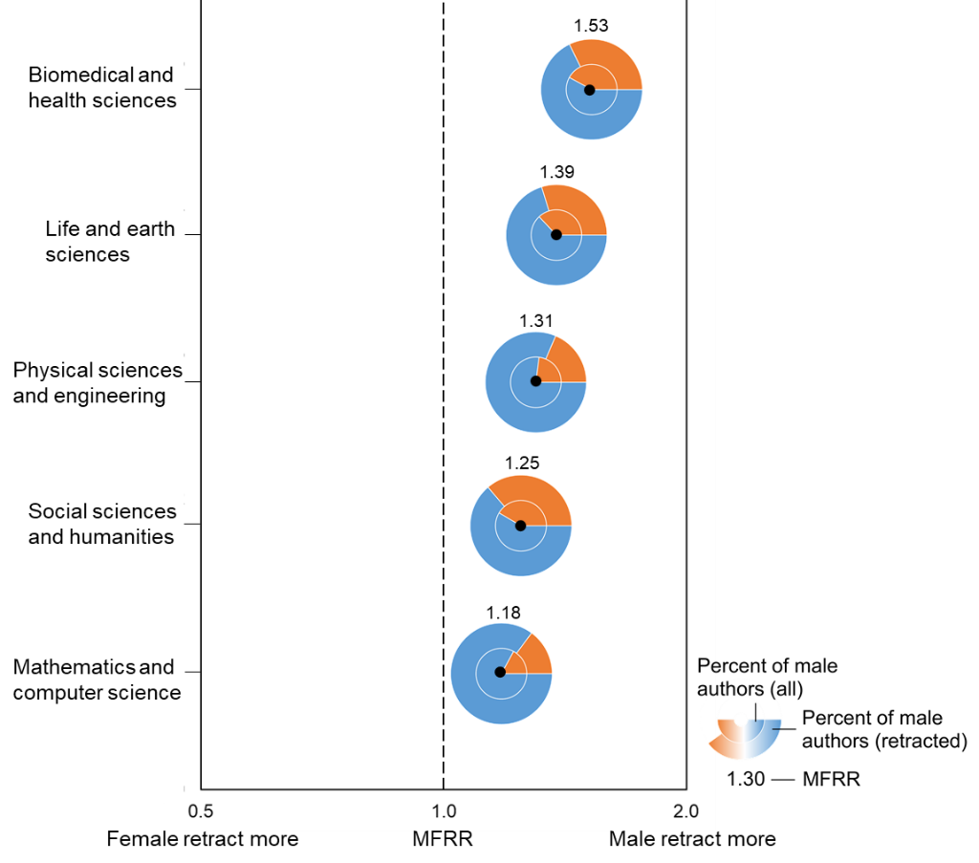

5. Discussion and conclusions
This study found that, overall, male researchers have higher retraction rates than female researchers across most reasons for retraction, with the exception of falsification where female researchers have slightly more retractions than male researchers. In general, female researchers have a significantly higher proportion of retractions due to issues that are difficult to detect, such as falsification. This corresponds to the results of a previous study by Fanelli et al. (2019). In contrast, male researchers have more retractions due to issues that are less difficult to detect, such as plagiarism, ethical issues, and authorship issues. This may indicate that female researchers are more cautious about engaging in scientific misconduct, which may be related to the fact that men are more likely to take part in risky behaviors than women (Harris & Jenkins, 2006). And men may have a higher threshold for what constitutes a scientific misconduct, while female researchers are more attuned to violations of justice (Martinson et al., 2006; Schumann & Ross, 2010).

Regarding the country distribution of retractions, male researchers have more retractions than female researchers in most countries with high numbers of retractions, with Iran being particularly severe. In China and Japan, the retraction rates for men and women are relatively similar, while in Italy, female researchers have significantly more retractions than male researchers. This gender disparity in retractions may be related to the gender imbalance situation in each country.

In terms of the disciplinary distribution of retractions, male researchers have higher retraction rates than female researchers across all the five disciplines, with the largest gender gap in biomedical and health sciences, and the smallest in mathematics and computer science. This difference may be related to the gender imbalance in funding allocation within each discipline. Previous research has shown that male researchers have an advantage in funding applications (Beck & Halloin, 2017; Ley & Hamilton, 2008; Pohlhaus et al., 2011), which may increase the possibility that they will engage in scientific misconduct under the pressure of "publish or perish" (Kaatz et al., 2013). Disciplines that heavily rely on funding, such as biomedical and health sciences, life and earth sciences, and physical sciences and engineering, have a higher disparity in retraction rates between men and women, while those with a relatively low degree of funding dependence, such as social sciences and humanities, and mathematics and computer science, have a relatively smaller gender gap in retraction rates (Huang & Huang, 2018; Xu et al., 2015).

The findings of this study have several implications that warrant further discussion and exploration. First, the association between disciplinary differences and gender disparities in retraction rates suggests that the scientific community should examine and address systemic issues related to gender and funding across academic fields. Disciplines that rely heavily on funding may be more susceptible to scientific misconduct due to the pressure to produce results, which could disproportionately affect male researchers. Moreover, the gender disparity in retraction rates among researchers underscores the need to address gender inequality in academia. To mitigate the gender gap in retraction rates, the scientific community should foster a culture of transparency and accountability in research that discourages all researchers, regardless of gender, from engaging in scientific misconduct.

This study has some limitations. First, we only examined the discrepancies in retraction rates between male and female researchers by analyzing the first author of the retracted article. Second, we did not consider other variables like age and academic rankings of authors, which may also affect the behavior of researchers and explain for the gender disparities we observed. Future research is needed to conduct more in-depth investigations.

Competing interests
The authors have no conflicts of interest to declare.

Funding information
This study was supported by the Soft Science Research Program of the Zhejiang Provincial Department of Science of Technology (No. 2021C35040).

References
Abramo, G., D’Angelo, C. A., & Caprasecca, A. (2009). Gender differences in research productivity: A bibliometric analysis of the Italian academic system. Scientometrics, 79(3), 517-539.
Aksnes, D. W., Rorstad, K., Piro, F., et al. (2011). Are female researchers less cited? A large‐scale study of Norwegian scientists. Journal of the American Society for Information Science and Technology, 62(4), 628-636.
Andersen, J. P., & Nielsen, M. W. (2018). Google Scholar and Web of Science: Examining gender differences in citation coverage across five scientific disciplines. Journal of Informetrics, 12(3), 950-959.
Beck, R., & Halloin, V. (2017). Gender and research funding success: Case of the Belgian FRS-FNRS. Research Evaluation, 26(2), 115-123.
Bordons, M., Morillo, F., Fernández, M. T., et al. (2003). One step further in the production of bibliometric indicators at the micro level: Differences by gender and professional category of scientists. Scientometrics, 57(2), 159-173.
Brainard, J. (2018). Rethinking retractions. Science, 362(6413), 390-393.
Caron, E., & van Eck, N. J. (2014). Large scale author name disambiguation using rule-based scoring and clustering. Proceedings of the 19th international conference on science and technology indicators (pp. 79-86), CWTS-Leiden University, Leiden.
Dal-Ré, R., & Ayuso, C. (2019). Reasons for and time to retraction of genetics articles published between 1970 and 2018. Journal of medical genetics, 56(11), 734-740.
Decullier, E., & Maisonneuve, H. (2021). Retraction according to gender: A descriptive study. Account Res, 1-6.
Fanelli, D. (2009). How many scientists fabricate and falsify research? A systematic review and meta-analysis of survey data. Plos One, 4(5), e5738.
Fanelli, D. (2013). Why growing retractions are (mostly) a good sign. PLoS medicine, 10(12), e1001563.
Fanelli, D., Costas, R., Fang, F. C., et al. (2019). Testing Hypotheses on Risk Factors for Scientific Misconduct via Matched-Control Analysis of Papers Containing Problematic Image Duplications. Sci Eng Ethics, 25(3), 771-789.
Fanelli, D., Costas, R., & Lariviere, V. (2015). Misconduct Policies, Academic Culture and Career Stage, Not Gender or Pressures to Publish, Affect Scientific Integrity. Plos One, 10(6), e0127556.
Fang, F. C., Bennett, J. W., & Casadevall, A. (2013). Males are overrepresented among life science researchers committing scientific misconduct. mBio, 4(1), e00640-00612.
Fox, M. F. (2005). Gender, family characteristics, and publication productivity among scientists. Social Studies of Science, 35(1), 131-150.
Gerber, P. (2006). What can we learn from the Hwang and Sudbø affairs? Medical Journal of Australia, 184(12), 632-635.
Grieneisen, M. L., & Zhang, M. H. (2012). A Comprehensive Survey of Retracted Articles from the Scholarly Literature. Plos One, 7(10), e44118.
Harris, C. R., & Jenkins, M. (2006). Gender differences in risk assessment: why do women take fewer risks than men? Judgment and Decision making, 1(1), 48-63.
Huang, J. M., Gates, A. J., Sinatra, R., et al. (2020). Historical comparison of gender inequality in scientific careers across countries and disciplines. Proceedings of the National Academy of Sciences of the United States of America, 117(9), 4609-4616.
Huang, M.-H., & Huang, M.-J. (2018). An analysis of global research funding from subject field and funding agencies perspectives in the G9 countries. Scientometrics, 115(2), 833-847.
Hussinger, K., & Pellens, M. (2019). Scientific misconduct and accountability in teams. Plos One, 14(5), e0215962.
Kaatz, A., Vogelman, P. N., & Carnes, M. (2013). Are men more likely than women to commit scientific misconduct? Maybe, maybe not. mBio, 4(2).
King, M. M., Bergstrom, C. T., Correll, S. J., et al. (2017). Men set their own cites high: Gender and self-citation across fields and over time. Socius, 3, 2378023117738903.
Larivière, V., Desrochers, N., Macaluso, B., et al. (2016). Contributorship and division of labor in knowledge production. Social Studies of Science, 46(3), 417-435.
Larivière, V., Vignola-Gagné, E., Villeneuve, C., et al. (2011). Sex differences in research funding, productivity and impact: an analysis of Québec university professors. Scientometrics, 87(3), 483-498.
Lerback, J., & Hanson, B. (2017). Journals invite too few women to referee. Nature, 541(7638), 455-457.
Ley, T. J., & Hamilton, B. H. (2008). The gender gap in NIH grant applications. Science, 322(5907), 1472-1474.
Martinson, B. C., Anderson, M. S., Crain, A. L., et al. (2006). Scientists' perceptions of organizational justice and self-reported misbehaviors. Journal of empirical research on human research ethics, 1(1), 51-66.
Pohlhaus, J. R., Jiang, H., Wagner, R. M., et al. (2011). Sex differences in application, success, and funding rates for NIH extramural programs. Acad Med, 86(6), 759-767.
Schumann, K., & Ross, M. (2010). Why women apologize more than men: gender differences in thresholds for perceiving offensive behavior. Psychol Sci, 21(11), 1649-1655.
Trikalinos, N. A., Evangelou, E., & Ioannidis, J. P. (2008). Falsified papers in high-impact journals were slow to retract and indistinguishable from nonfraudulent papers. Journal of clinical epidemiology, 61(5), 464-470.
Waltman, L., Calero‐Medina, C., Kosten, J., et al. (2012). The Leiden Ranking 2011/2012: Data collection, indicators, and interpretation. Journal of the American Society for Information Science and Technology, 63(12), 2419-2432.
Waltman, L., & Van Eck, N. J. (2012). A new methodology for constructing a publication‐level classification system of science. Journal of the American Society for Information Science and Technology, 63(12), 2378-2392.
Xu, X., Tan, A. M., & Zhao, S. X. (2015). Funding ratios in social science: the perspective of countries/territories level and comparison with natural sciences. Scientometrics, 104, 673-684.
Zhang, Q., Abraham, J., & Fu, H.-Z. (2020). Collaboration and its influence on retraction based on retracted publications during 1978–2017. Scientometrics, 125(1), 213-232.

