WeChat Presence of Chinese Scholarly Journal:

An Analysis of CSCD-indexed Journals
Ting Cong¹, Dangqiang Ye², Zhichao Fang³ and Rodrigo Costas⁴
¹ congting13@163.com
University of Shanghai for Science & Technology, Dept of Publishing, Jungong Road 516, Shanghai City (China)
² wayne_white@163.com
University of Shanghai for Science & Technology, Dept of Publishing, Jungong Road 516, Shanghai City (China)
³ z.fang@cwts.leidenuniv.nl
School of Information Resource Management, Renmin University of China, Beijing, China
Centre for Science and Technology Studies (CWTS), Leiden University, Leiden (Netherland)
⁴ rcostas@cwts.leidenuniv.nl
Centre for Science and Technology Studies (CWTS), Leiden University, Leiden (Netherland)
Abstract
The study of how science is discussed and how scholarly actors interact on social media has increasingly become popular in scientometrics in recent years. Following our previous study on WeChat (a Chinese social network app) uptake of Chinese scholarly journals in social science area, this study investigates the WeChatuptake by the Chinese scholarly journals indexed by the China Science Citation Database (CSCD). The results show that 83.99% of CSCD-indexed journals have created WeChat public accounts much higher than 65.3% of CSSCI and posted over 575 thousand posts. At the journal level, bibliometric indicators (e.g., citations, downloads, and journal impact factors) and WeChat indicators (e.g., clicks, likes, replies, and recommendations) are weakly correlated with each other. As we divided CSCD-indexed journals into three categories, bibliometric and WeChat indicators have the strongest correlation in the category of Medical Science. In contrast to Natural Science and Engineering category, the journals in medical science category show better performance in all WeChat activity indicators

- Introduction

1.1 Social media uptake by scholarly journals

Examining how science is discussed on social media has become an increasingly popular topic in scientometrics in recent years. Not only individual researchers, but also scholarly journals and publishers are using social media by various stakeholders in the scientific community. Many journals have created social media accounts on platforms such as Twitter, and Facebook to promote their articles, engage with readers, and increase their visibility. According to previous studies, scholarly journals with Facebook accounts from AHCI, SCIE, and SSCI only account for 14.2%,7.7%, and 7.2% of the total number of journals in their own discipline respectively (Zheng et al, 2019). Findings show that publications from G12 countries, covering social media topics and published open access tend to be mentioned more on Twitter (Chan et al, 2022).

1.2 WeChat as a potential altmetric data source

To date, altmetric data providers mostly track events and metrics from global social media platforms such as Twitter, Facebook, or Mendeley. However, local social media platforms like WeChat—one of the most used social media platforms in China, which provides users with a platform for not only entertainment but also professional usage—has seldom been studied in altmetrics. In a 2019 Springer Nature survey, 94% of the 528 respondents in China indicated that they had used WeChat in a professional context (Nature Methods, 2020). Therefore, it can be argued that WeChat has the potential to become a relevant local altmetric data source. WeChat Public Account (WPA) is one of the most important services embedded in WeChat, which was launched in August 2012. For example, the Journal of Huazhong Agricultural University WPA (see Fig. 1A) published a total of 346 WeChat posts since 2022. Figure 1B shows an example of one of the Journal of Huazhong Agricultural Universitys WeChat posts, while Figure 1C captures some user engagement metrics related to this WeChat post example, including the numbers of "readers" “likes”, and "recommendations".

Figure 1. (A) the homepage of Journal of Huazhong Agricultural University’s WeChat Official Account, (B) a WeChat post of the journal, and (C) the user engagement metrics of the WeChat post.
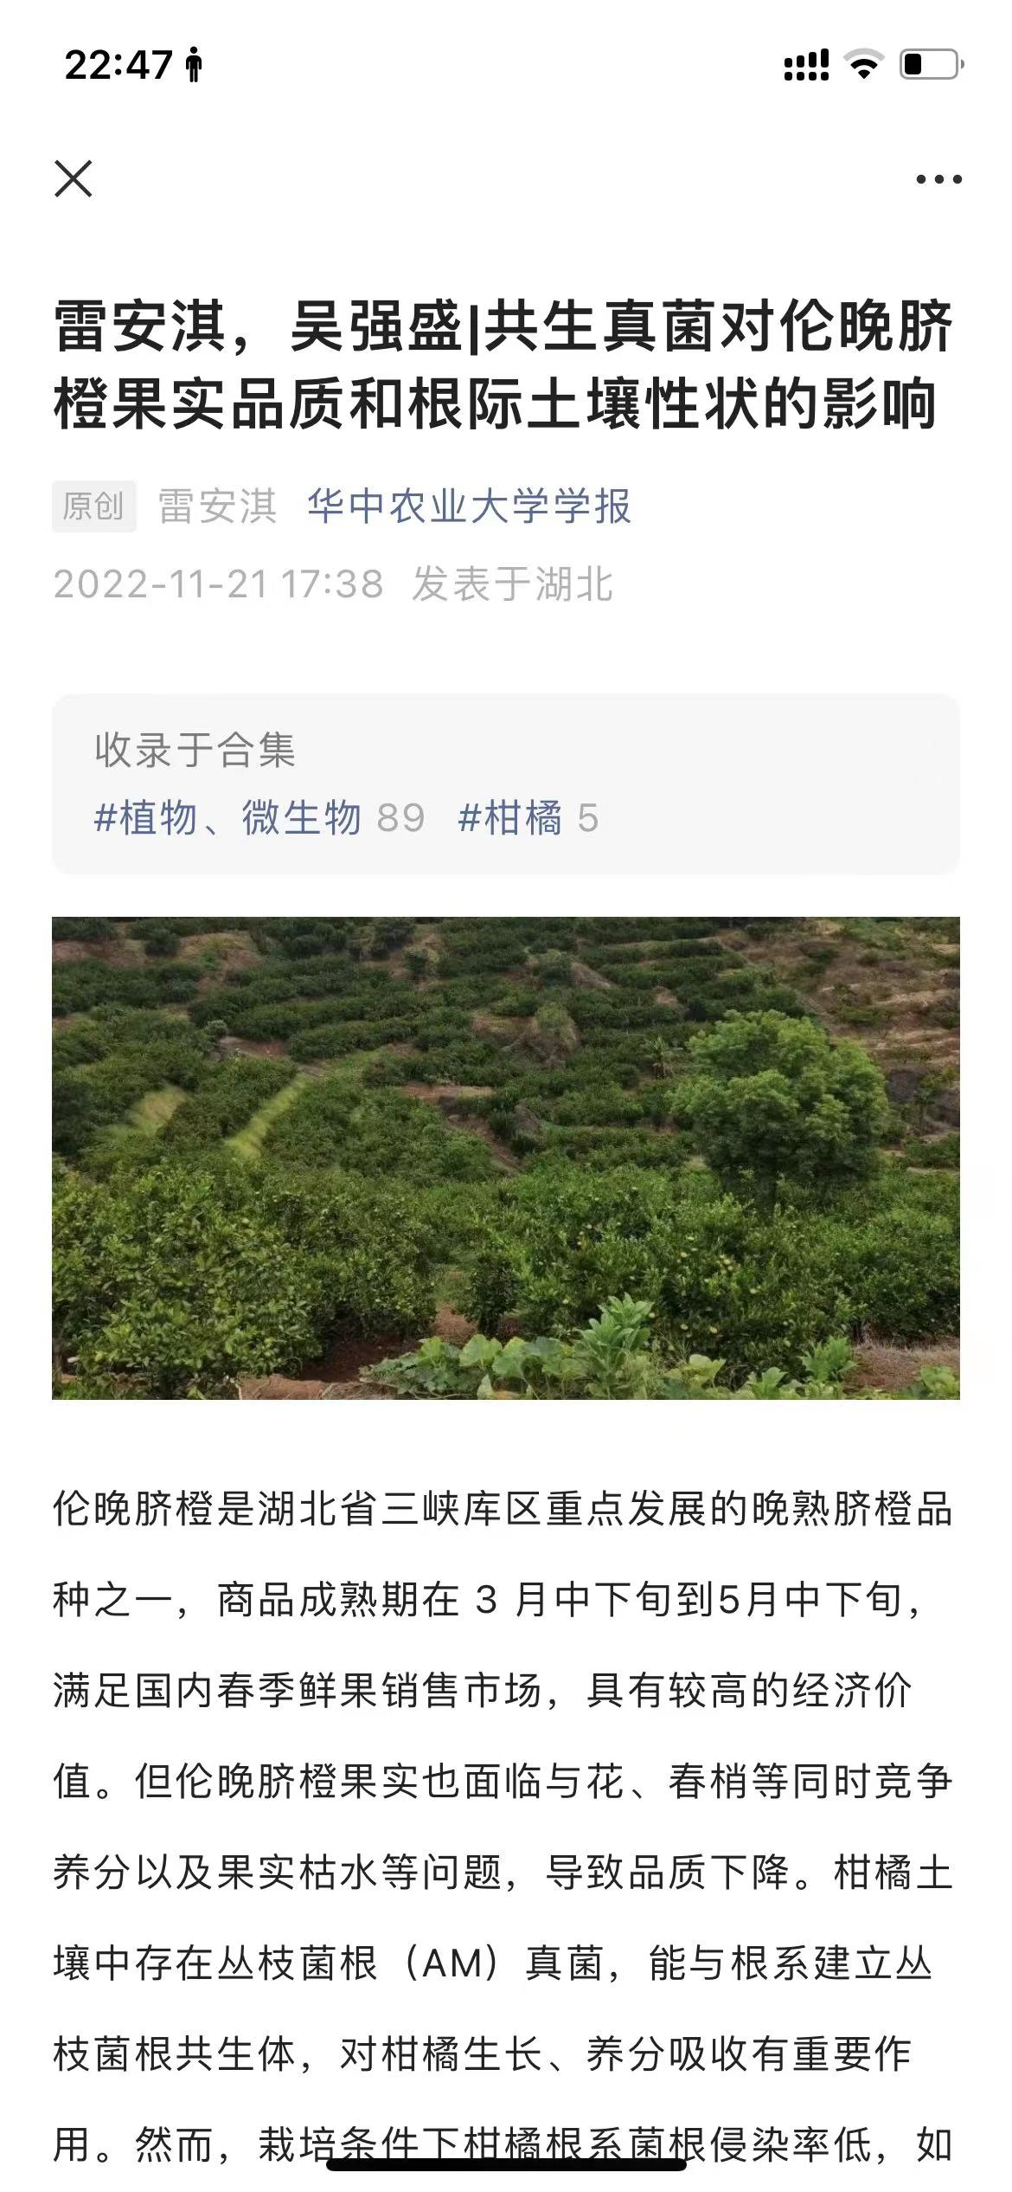
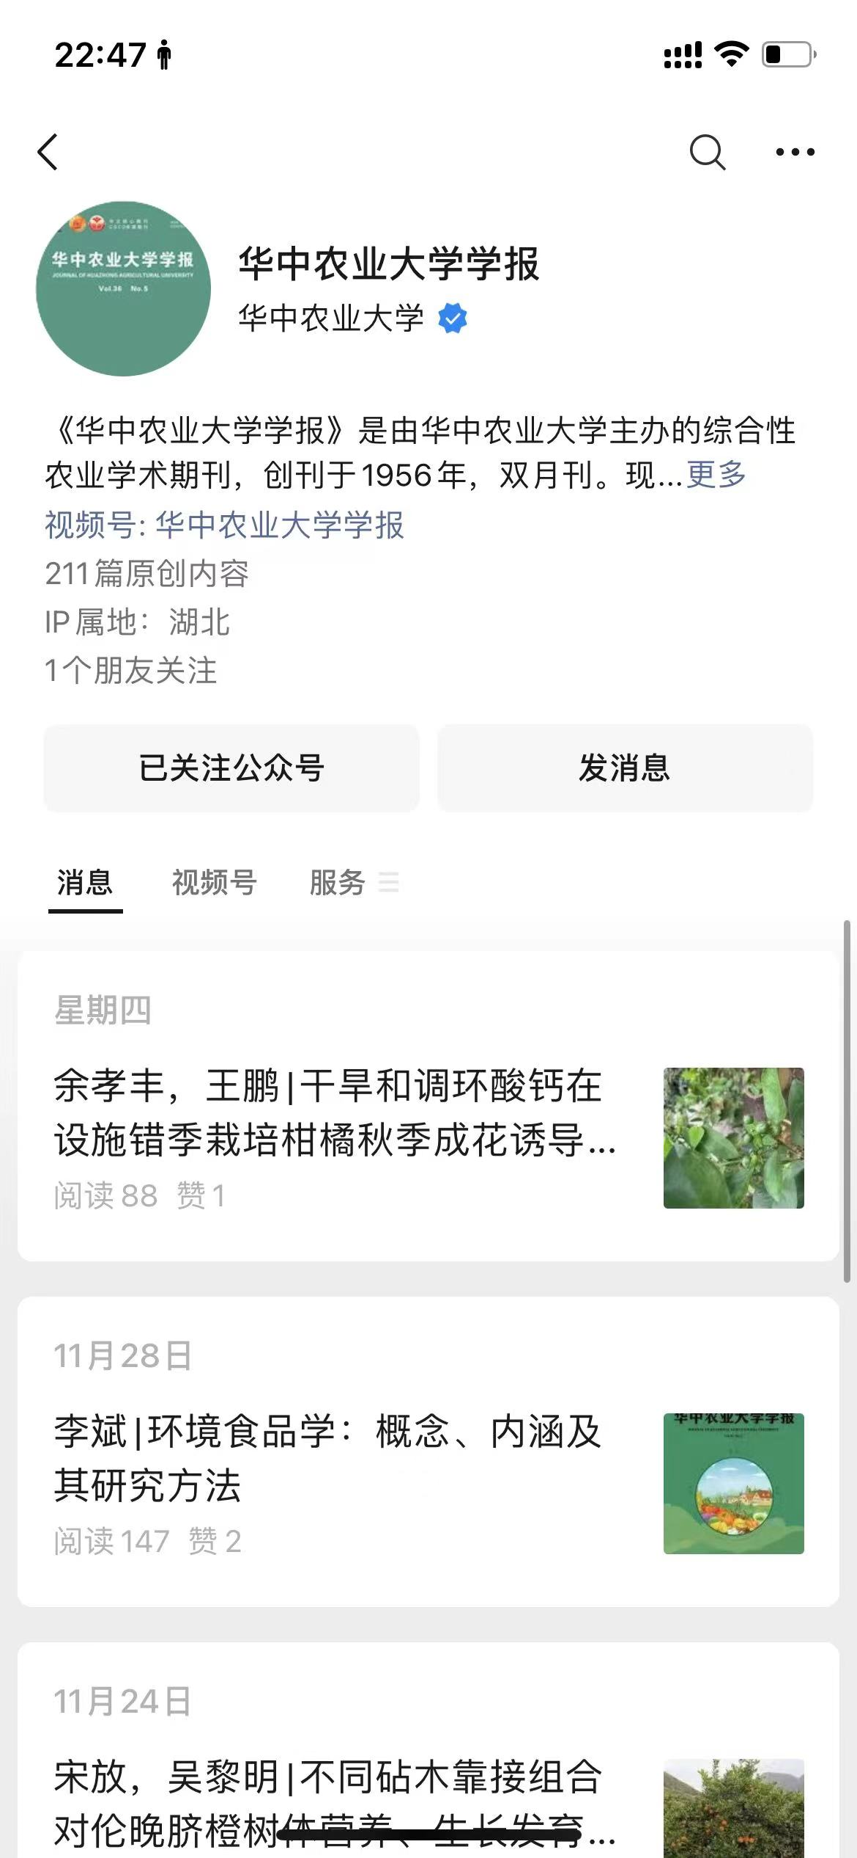
2. Number of likes
3. Number of shares
1. Number of readers
1.3 WeChat uptake by scholarly journals
Previous research on the social media uptake by scholarly journals had a focal point on global social media platforms, such as Twitter and Facebook (Boulos & Anderson, 2012; Nason et al., 2015). Given the popularity of WeChat in China, and the fact that it provides relevant analytical social media features (e.g., posts, readers, likes, recommendations), very similar to those of other global platforms like Twitter or Facebook, it can be fairly argued that WeChat is a strongly relevant platform for altmetric research in the Chinese context. Our previous studies focusing on WeChat uptake of Chinese scholarly journals indexed by the Chinese Social Sciences Citation Index (CSSCI), showed that 65.3% of CSSCI-indexed journals have created WeChat public accounts and posted over 193 thousand WeChat posts in total (Cong et al, 2022). More studies demonstrate that promotion of WeChat official accounts can influence the academic impact of individual papers, but further study is needed to clarify the exact thresholds and influential factors(Zhang et al., 2022). Therefore, our object of study is scholarly journals instead of scientific articles.

However, the use of social media by academic journals can make researchers' achievements spread more directly and widely, and increase the cooperation and contact between researchers and journals. In addition, social media can provide journals with access to a wider and more diverse audience, including audiences outside academia. But still, there are concerns about the potential risks and challenges of social media adoption by scholarly journals.

Objectives of this study
At present, there are still not many studies on WeChat Public accounts of scholarly journals, especially in the field of Science, Technology and Medicine (STM), so the objectives of this study are:
    - Investigate the overall use of WeChat in Chinese scholarly journals in the field of STM.
    - To discuss the relationship between the traditional bibliometric indicators and WeChat indicators at the journal level.

Data and methods
3.1 Data collection
In this study, we used the list of academic journals included in the Chinese Science Citation Database (CSCD) as our primary dataset. CSCD is a select citation index of Chinese academic journals mainly in the field of natural sciences, engineering technology, and medical. As the counterpart of SCI in China, the journals listed in the index can usually be regarded as the source of cutting-edge research in the field of natural sciences, engineering technology, and medical in China, with 1,262 Chinese academic journals included in the 2021-2022 edition. For the 1,262 journals included in CSCD, we collected data from CNKI. The CNKI is the most comprehensive knowledge portal in China. We collected their total number of published papers (NP), total citations (TC), total downloads (TD), and journal impact factor (JIF).

Figure 2. Bibliometric data of a specific journal from the database of CNKI
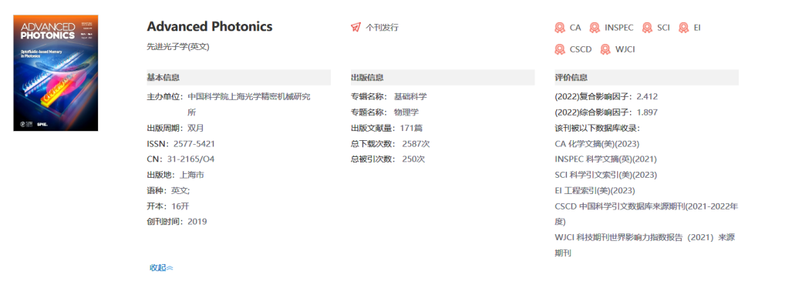
Journal Title
4. Combined IF
5. Comprehensive IF
1. Number of papers
2. Number of downloads
3. Number of cites

To retrieve our dataset, whether the CSCD-indexed journals created WeChat Public accounts, we manually retrieved journal titles by using a search engine built in WeChat. The retrieved WeChat Public accounts were reviewed to ensure that they did belong to the collected journals. In addition, for the WeChat Public accounts of those published journals, we climbed up the details of each article (for example, the number of articles, clicks, likes and replies). Wechat data collection was carried out between July 19,2022 and December 31,2022.

3.2 Indicators and analytic approaches
The following table lists the bibliometric and wechat metrics summarized at the journal level and analyzed in this study. The bibliometric metrics of the journal include the number of papers (P), citation number (TC), download number (TD), comprehensive IF (CJIF) and comprehensive IF (CoJIF). The wechat indicators of the journal WeChat Public account include wechat post (t posts), click (TClicks), like (TLikes), recommendation (TRecomm), and reply (TReplies).

Table 1. Analyzed bibliometric and WeChat indicators in this study

Category | Indicator | Abbr | Concept
Bibliometric indicators | Number of papers | P | Total number of CNKI-indexed scholarly papers published by a journal until the year 2022.
 | Number of citations | TC | Total number of citations (captured by CNKI) of all the papers published by a journal until the year 2022.
 | Number of downloads | TD | Total number of downloads (captured by CNKI) of all the papers published by a journal until the year 2022.
 | Combined IF | CJIF | Journal impact factor computed based on the citations contributed by journal papers, conference papers and dissertations indexed by CNKI from 2021-2022.
 | Comprehensive IF | CoJIF | Journal impact factor computed based on the citations contributed by only journal papers indexed by CNKI from 2021-2022.
WeChat activity indicators | Number of WeChat posts | TPosts | Total number of posts posted by a journal on its own WeChat public account until the data collection period.
 | Number of clicks | TClicks | Total number of clicks received by all WeChat posts posted by the WeChat public account of a journal until the data collection period.
 | Number of likes | TLikes | Total number of likes received by all WeChat posts posted by the WeChat public account of a journal until the data collection period.
 | Number of recommendations | TRecomm | Total number of recommendations (by clicking “I’m reading it”) received by all WeChat posts posted by the WeChat public account of a journal until the data collection period.
 | Number of replies | TReplies | Total number of replies received by all WeChat posts posted by the WeChat public account of a journal until the data collection period.

The following diagram illustrates the study workflow of this study. This study first collects WeChat and bibliometric data from CSCD-indexed journals, and then collects WeChat data at the journal level. Finally, three types of analyses were conducted: general descriptive analysis, correlation and factor analysis on IBM SPSS 29, and comparative analysis of academic influence between journals with and without WeChat Public accounts.

Figure 3. Research workflow

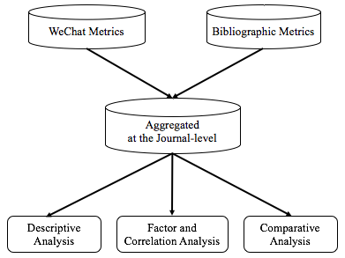

4 Results
4.1WeChat uptake by CSCD-indexed journals
Among the 1262 CSCD journals, 1060 journals have WeChat Public accounts (accounting for 83.99%, much higher than 65.3% of CSSCI). The following table shows the overall descriptive statistics for the five bibliometrics.

Table 2.Descriptive statistics of the Bibliographic indicators(N =1200)

Indicator | Sum | Min | Max | Median | Mean | SD
P | 7,920,725 | 129 | 44,536 | 5,445 | 6,622.68 | 5,094.9
TC | 96,758,219 | 28 | 3,980,122 | 50,528.5 | 80,631.85 | 185,004.71
TD | 1,822,758,328 | 21 | 15,001,949 | 1,046,938.5 | 1,518,965.27 | 1,741,546.38
CJIF |  | 0.07 | 7.52 | 1.03 | 1.21 | 0.79
CoJIF |  | 0.08 | 10.14 | 1.29 | 1.54 | 1.03

From 1060 journals, 32 journals created WeChat Public Accounts, but did not publish the WeChat posts before data collection, 5 journals published only one article, and 47 accounts were shared accounts which belong to more than 2 journals . Therefore, we collected a total of 1023 journals. The following table presents the descriptive statistics of the five WeChat indicators. The total number of WeChat posts produced by the 1023 CSCD journals was 575,260. These posts each received a total of 6.35 billion clicks and 2.95 million likes. These numbers indicate that a large number of interactions occur around the content that the academic journals publish on WeChat. Another important aspect to be emphasized is the strong bias of the wechat indicator. This is shown by the centiles in the table, except for the total number of WeChat posts, the mean of all indicators is always higher than P75 (quartile 3 (Q3)).

Table 3. Descriptive statistics of the five WeChat indicators (N =1023)

Indicator | Sum | Min | Max | Q1 | Median | Q3 | Mean | SD
TPosts | 575,260 | 1 | 11,754 | 63.25 | 186 | 595 | 542.7 | 976.66
TClicks | 635,660,486 | 0 | 50,175,109 | 14,590.5 | 57,561 | 252,160.25 | 599,679.7 | 2,687,538.65
TLikes | 2,956,214 | 0 | 293,247 | 101 | 366.5 | 1,307.75 | 2,788.88 | 15,099.81
TRecomm | 1,819,916 | 0 | 132,744 | 39 | 172 | 773.25 | 1,716.9 | 7,739.08
TReplies | 523,406 | 0 | 57,620 | 0 | 13 | 121 | 493.78 | 2,920.90

4.2 Factor analysis and correlation analysis of bibliometric and WeChat indicators

In this section, we will focus on the factor and correlation analysis of the bibliometric and WeChat metrics. The following table shows the factor analysis results of the summary analysis indicators at the journal level. Using a principal component analysis (PCA), the three main components were found. The first component is related to the WeChat indicators, including all the WeChat indicators extracted from the WeChat platform. The second component is related to the academic impact indicators, such as the journal impact factor and the number of citations (the downloads are also substantially related to this component). The third component is related to the overall academic activity indicators, that is the number of published papers records in the CNKI database.

Table 4. Factor analysis of the variables (N=1060)

Variable | Component
 | 1 | 2 | 3
TClicks | 0.9 | -0.323 | -0.029
TLikes | 0.888 | -0.359 | -0.006
TReplies | 0.876 | -0.359 | -0.023
TRecomm | 0.865 | -0.341 | -0.013
TPosts | 0.713 | -0.186 | -0.037
TD | 0.46 | 0.744 | 0.313
TC | 0.396 | 0.742 | 0.289
CoJIF | 0.368 | 0.733 | -0.558
P | 0.368 | 0.51 | 0.663
CoIF | 0.362 | 0.711 | -0.573

Note: Principle Component Analysis (PCA) used as extraction method.Oblimin oblique rotation.Factor loadings higher than 0.400 are highlighted in italic , and those higher than 0.600 are highlighted in bold.
To further test the relationship between WeChat and bibliometric indicators, Spearman, correlation analysis, as shown in Figure 4, (N = 1023). In the bibliometric and WeChat indicators, the indicators are usually moderate to highly correlated. However, the correlation between bibliometric and WeChat metrics is generally weak or negligible. Even considering the journals without WeChat Public accounts and assigning zero values for their WeChat indicators for analysis, the correlation results remained consistent. Factor analysis and Spearman correlation analysis show that bibliometry and WeChat metrics capture essentially different types of interactions and influences.

Figure 4. Spearman correlation analysis among bibliometric and WeChat indicators (N = 1023)
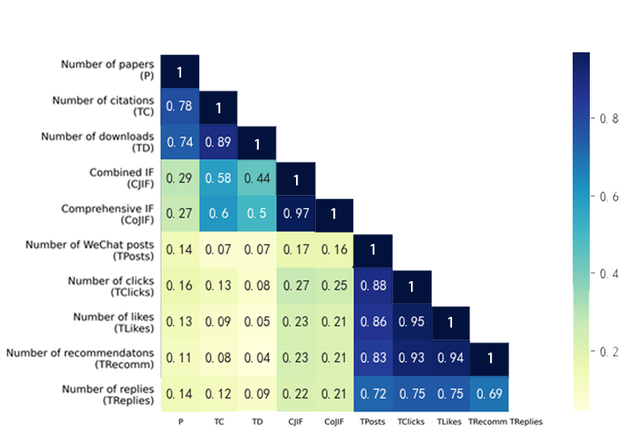

4.3 Comparison of bibliometric indicators between journals with and without WeChat public accounts

Due to the weak correlation between bibliometry indicators and WeChat indicators, in this section, we will explore whether those journals with WeChat Public accounts are associated with higher bibliometric index values. The Figure 5 draws the biometric indicators of journals with and without WeChat Public accounts from the perspective of (A) number of published papers, citations, downloads, and (B) the two journal impact factors. In general, journals with WeChat public accounts tend to have slightly higher bibliometric scores than those without WeChat public accounts, this result is similar to the journals indexed by CSSCI.

Figure 5. Bibliometric indicators of journals with (N=1060) and without (N =202) WeChat public accounts
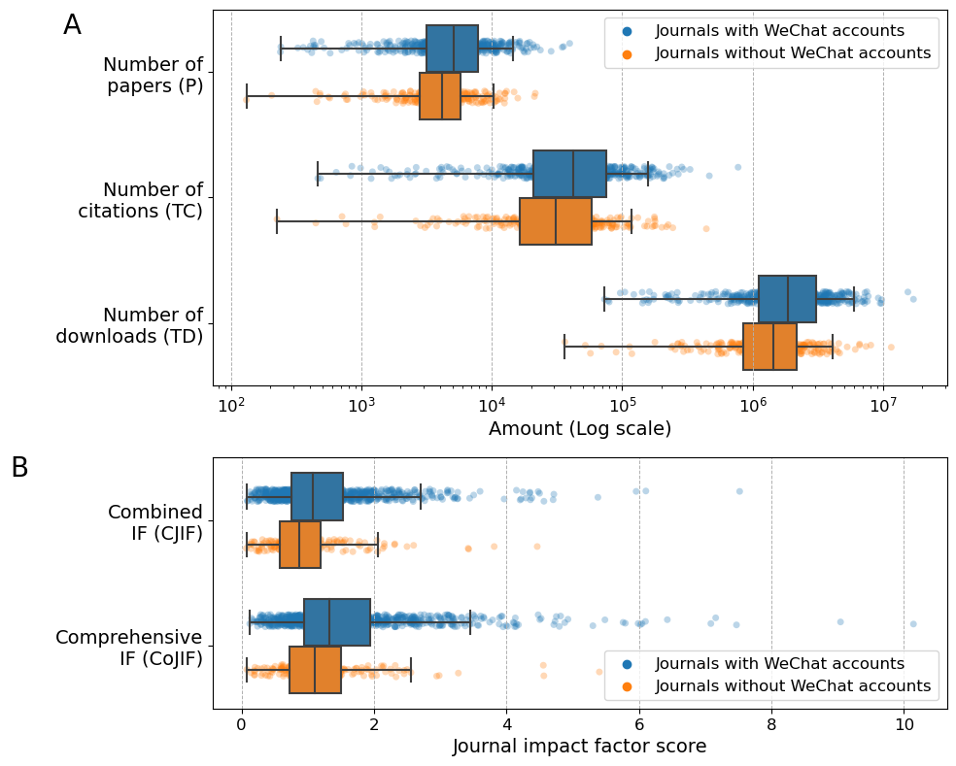

4.4 Comparison of WeChat and bibliometric indicators of journals across disciplines

In order to compare the WeChat activities of journals of different disciplines, according to the selection report of the source journals of the Chinese Science Citation Database provided by the official website. We divided 1,060 CSCD journals with WeChat posts into 3 categories: Natural Science, Engineering and Medical Science (Table 5). According to statistics, the Engineering category not only has the highest number of journals, but also has the highest number of journals with official accounts, accounting for 85.6%.

Table 5. Three Types of Categories among CSCD-indexed Journals

Types of Categories | Subject | Number of journals | Number of journals with WPAs
Natural Science | Acoustics, Agriculture, Biochemistry Molecular Biology, Biotechnology Applied Microbiology, Cell Biology, Chemistry, Entomology, Fisheries, Forestry, Genetics Heredity, Geography, Geology, Mathematical Computational Biology, Mathematics, Mechanics, Meteorology Atmospheric Sciences, Microbiology, Mineralogy, Oceanography, Paleontology, Physics, Plant Sciences, Psychology, Zoology | 400 | 340
Engineering | Metallurgy Metallurgical Engineering, Mining Mineral Processing, Astronomy & Astrophysics, Automation & Control Systems, Computer Science, Construction & Building Technology, Energy & Fuels, Environmental Sciences & Ecology, Food Science & Technology, Materials Science, Mining Mineral Processing, Nuclear Science Technology, Remote Sensing, Science Technology, Transportation | 522 | 447
Medical Science | Dentistry Oral Surgery Medicine, General & Internal Medicine, Life Sciences Biomedicine, Life Sciences Biomedicine, Neurosciences Neurology, Obstetrics Gynecology, Oncology, Ophthalmology, Otorhinolaryngology, , Pediatrics, Pharmacology Pharmacy, Public, Environmental & Occupational Health, Surgery | 319 | 259

After classifying the three Categories, the Spearman and correlation analysis of each Category were analyzed. The following Figure 6-8 are the Spearman correlation analysis results of Natural Science, Engineering, and Medical Science. It can be seen that among the three categories, bibliometric and WeChat indicators have the strongest correlation in Medical Science. The correlation between WeChat indicators and bibliometric indicators is more obvious among TClicks, TRecomm, TReplies and TD, but even so the value is lower than 0.35, which does not constitute strong correlations.

Figure 6. Spearman correlation analysis in Natural Science among bibliometric and WeChat indicators (N = 401)
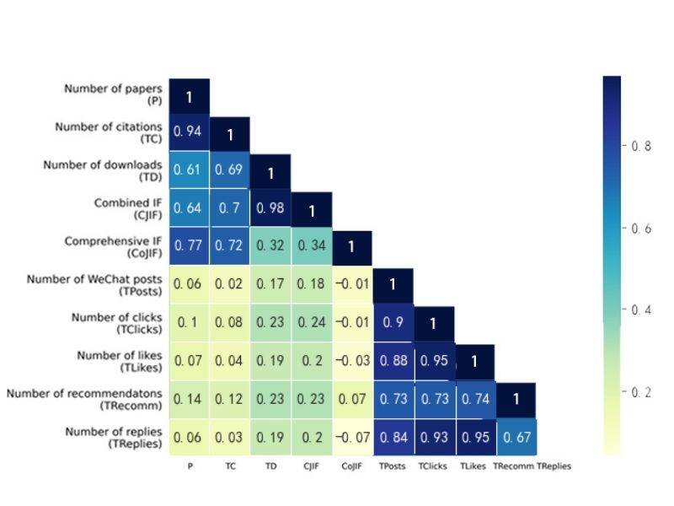

Figure 7. Spearman correlation analysis in Engineering among bibliometric and WeChat indicators (N = 522)
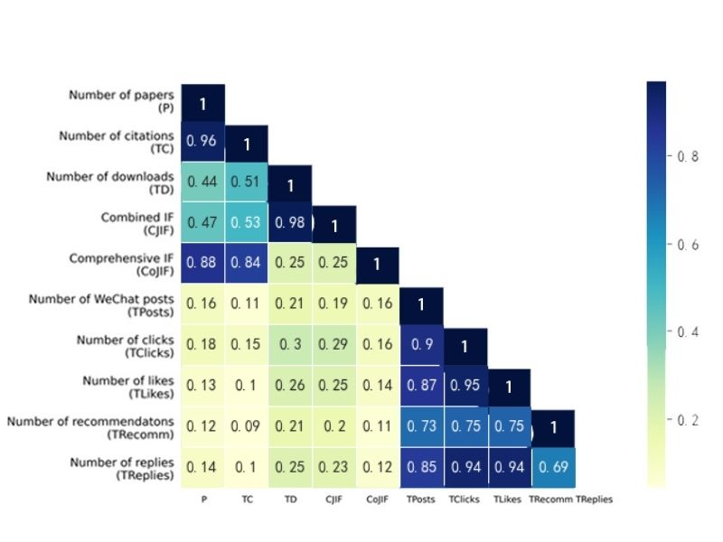
Figure 8. Spearman correlation analysis in Medical Science among bibliometric and WeChat indicators (N = 401)
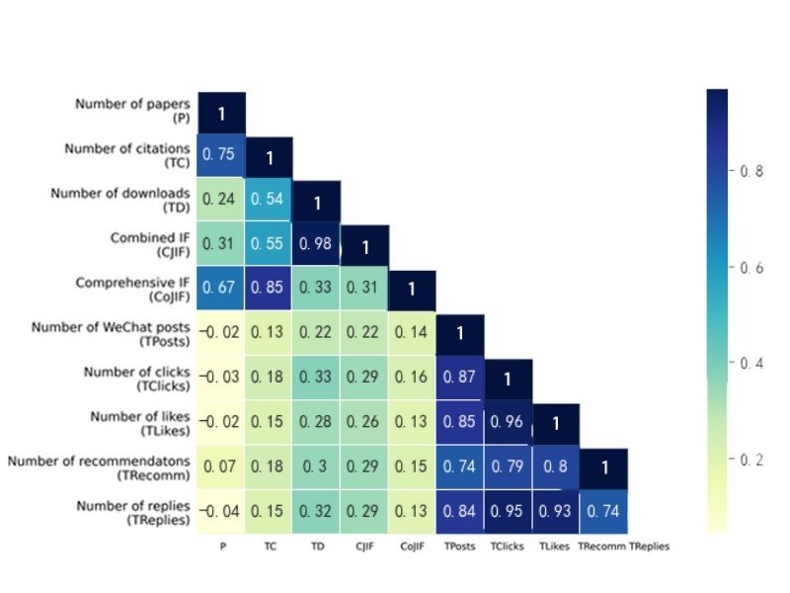
The data about the three categories were analyzed and the results showed that the Engineering category has the highest TPosts sum, followed by Medical Science, then Natural Science. The Medical Science field has the highest TClicks sum by a large margin, and also has the highest TLikes and TRecomm sums. The standard deviation values for TPosts, TClicks, and TLikes are quite high, indicating that there is a lot of variation in these indicators across the different fields.

The Figure 9 depicts the distribution of the total number of WeChat posts, clicks, likes, recommendations, and responses for journals in different subject categories of journals. Overall, journals from the three subject categories exhibit a quite similar degree of activity in posting WeChat posts (TPosts). At most through the lens of the medians displayed in the boxplots, it can be highlighted that WeChat posts from the WPAs owned by journals from the Medical Science category achieved slightly higher levels of user engagement (i.e., TClicks, TLikes, TRecomm, and TReplies) in contrast to journals in the Natural Science and Engineering category.

Figure 9. WeChat indicators of journals across the three subject categories
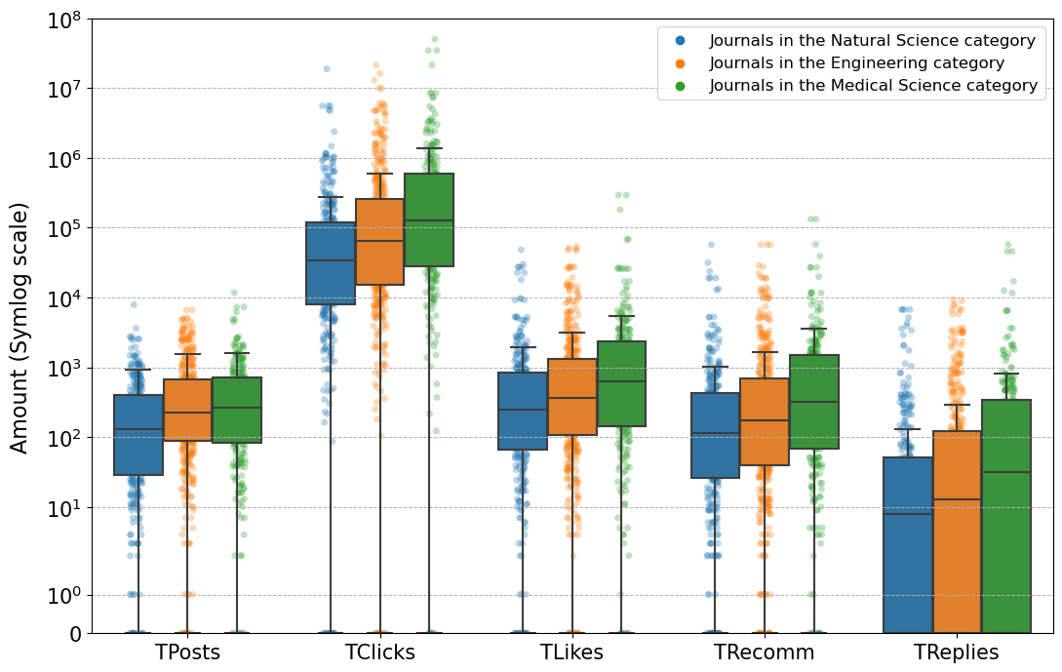

5 Discussion and conclusion
This study empirically studied the presence of CSCD-indexed journals on the Chinese WeChat platform. As such, it represents a proof of concept of how local social media sources can be incorporated in the altmetric study of scholarly journals.

First of all, we found that the frequency of using WeChat in CSCD journals is quite high. More than 84% of the analyzed journals have WeChat public accounts, which is even higher than the proportion of CSSCI journals (65%)(Cong et al, 2022¹⁰). In contrast, according to previous research (Raamkumar et al. 2019), among 8,827 SCI journals, it was found that 857 had Twitter accounts, accounting for about 9.7%, which was significantly lower than our research. This conclusion also strongly supports the relevance of WeChat as an important platform in the context of altometrics in China, and fundamentally supports previous calls for consideration of local perspectives in altmetrics (Zahedi, 2017; Liu et al. , 2020; Cong et al, 2022¹⁰).

Secondly, the lack of correlation between bibliometric and WeChat indicators was identified, consistent with indicators of empirical differences between these two groups. Although there is only a weak relationship between bibliometric indicators and WeChat indicators, in terms of all analyzed bibliometric indicators, similar to CSSCI-indexed journals, CSCD-indexed journals with WeChat accounts tend to perform slightly better as well.
Thirdly, we divide all CSCD journals into three categories with the definition of CSCD official instructions, which are natural science, engineering, and medical science. Among the three categories, bibliometric and WeChat indicators have the strongest correlation in the category of Medical Science. And according to statistics, the journals in medical science category show better performance in all WeChat activity indicators than those journals in other categories.

Finally, as an illustrative study, this study has some limitations. Due to the CSCD core collection in Web of Science, some journals may correspond to multiple research areas. Although we selected the most common research area of these journals as their disciplines, there are still journal research areas that may appear in the field of social science and humanities (eg Government & Law, Business & Economics, Sociology, Architecture). In future research, based on our previous study of WeChat presence of Chinese journals, covering both CSSCI-indexed and CSCD-indexed journals, it would be much more interesting since it would help us to argue about epistemic global patterns of WeChat that we will compare with Twitter.

Funding information
This paper is supported by Shanghai Philosophy and Social Science Foundation (2022BTQ001).

Reference

Selection Report of Source Journals of China Science Citation Database (CSCD): http://sciencechina.cn/style/report21_22.pdf (Accessed April 07, 2023).
Welcome to the China Science Citation Database Source Journal Literature Search System: http://sciencechina.cn/cscd_source.jsp (Accessed April 07, 2023).
Zheng, H., et al. (2019). Social media presence of scholarly journals. Journal of the Association for Information Science and Technology, 70(3), 256–270.
Chan, CH., Zeng, J., Schafer, MS., (2022). Whose research benefits more from Twitter? On Twitter-worthiness of communication research and its role in reinforcing disparities of the field, Plos one, 17(12), 1-18.
Science on WeChat. (2020). Nature Methods, 17(September), 863. https://doi.org/10.1038/s41592-020-0954-1
Boulos, M. N. K., & Anderson, P. F. (2012). Preliminary survey of leading general medicine journals’ use of Facebook and Twitter 1. Journal of the Canadian Health Libraries Association, 33(2), 38–47.
Nason, G. J., Kelly, F. O., Kelly, M. E., Phelan, N., Manecksha, R. P., Lawrentschuk, N., & Murphy, D. G. (2015). The emerging use of Twitter by urological journals. Surgical Education, 115(3), 486– 490. https://doi.org/10.1111/bju.12840
Cong, T., Fang, ZC., Costas, T. (2022). WeChat uptake of chinese scholarly journals: an analysis of CSSCI-indexed journals. Scientometrics, 127(12), 7091-7110.
Zhang, B., Sun, J., Zhang, HQ., Xu, CT. (2022). Can promotion on WeChat official accounts improve scholarly journals' academic impact? A micro-level correlation comparison study. Learned Publishing. 35(2), 163-174.
Raamkumar, AS., Erdt, M., Vijayakumar, H., Nagarajan, A ., Theng, YL. (2019). Understanding the Twitter Usage of Science Citation Index (SCI) Journals. Lecture Notes in Artificial Intelligence. 11853, 54-60.
Zahedi, Z. (2017) What explains the imbalance use of social media across diferent countries? A cross country analysis of presence of Twitter users tweeting scholarly publications. 4:AM Conference (Altmetrics). https://doi.org/10.6084/m9.fgshare.5454475.v2
Liu, C., Shu, F. (2020). Local Altmetrics in China: a review of the literature. https://pdfs.semanticsc holar.org/17c1/969d7a57616cdd532ea7c4479717cd07444d.pdf?_ga=2.47940071.1701987754. 1611475255-1290598388.1611475255

