Gold Open Access output and expenditures in the United States in the past decade

Gali Halevi*, Thed van Leeuwen** Nemanja Milićević, *** Ryan Fry****

*Gali.halevi@clarivate.com
0000-0003-3478-8804
Institute for Scientific Information, Clarivate, United States
** leeuwen@cwts.leidenuniv.nl
0000-0001-7238-6289
The Centre for Science and Technology Studies, Leiden University, Leiden, NL
*** Nemanja.Milicevic@clarivate.com
Institute for Scientific Information, Clarivate, Serbia
0009-0005-9674-8842
****ryan.fry@clarivate.com
Institute for Scientific Information, Clarivate, United States
000-0002-2388-7359

Abstract
Open access publishing has quite a significant cost associated with it. Article Processing Charges (APCs) are fees charged by publishers to authors for the publication of their articles in open access journals. These fees can present a new type of “paywall” to researchers and institutions who cannot afford to pay these amounts. Considering previous studies that showed barriers to publishing open access between countries as a result of high costs, in this study, we aimed to examine whether there are differences in open access publishing, expenditure and overall participation within universities in the United States. Our analysis shows that the majority of states published between 1,000 – 7,000 Gold Open Access publications and spent up to 6million dollars in the past 10 years. However, there are some noteworthy outliers’ states that publish a high number Gold Open Access papers but pay significantly less than other states that publish a lower number of Gold Open Access papers and pay significantly more.

Introduction
In March 2022, the Office of Science and Technology Policy (OSTP) in the United States issued a memorandum titled "Increasing Access to Federally Funded Research Results." The memorandum provides guidance to federal agencies on how to increase access to research results funded by the federal government. (OSTP Issues Guidance to Make Federally Funded Research Freely Available Without Delay | OSTP, 2022). The guidance requires that federally funded research articles and data be made openly accessible to the public upon publication, without embargo or delay. Overall, the guidance emphasizes the importance of open access to federally funded research, both for advancing scientific progress and for the public good.
Yet, as many in the research community are aware, open access publishing has quite a significant cost associated with it. Article Processing Charges (APCs) are fees charged by publishers to authors for the publication of their articles in open access journals. These fees can vary widely depending on the publisher, the journal, and the discipline, but they typically range from a few hundred to a few thousand dollars per article. Author's attitudes towards Article Processing Charges (APCs) reveals mixed opinions. Some authors view APCs as a necessary cost to make their research open access and increase its visibility and impact. For example, a study by Björk et al. (2010) found that authors who had published in open access journals were more likely to view APCs positively and see them to reach a wider audience. However, other authors are critical of APCs, particularly those from low-middle income countries who may not have access to funding to cover the costs. A study by Solís-Lemus and Aguado-López (2018) found that authors from Latin America perceived APCs as a significant barrier to publishing in open access journals. Similarly, a study by Zhang et al. (2021) found that researchers from low- and middle-income countries were more likely to perceive APCs as a financial burden and were less likely to publish in open access journals as a result. Some authors have also raised concerns about the transparency and fairness of APC pricing. A study by Spezi et al. (2017) found that authors were more likely to perceive APCs as reasonable if they believed that the fees reflected the actual cost of publishing, and if there were policies in place to reduce or waive APCs for authors from low- & middle-income countries. Therefore, the costs of APCs which can reach thousands of dollars per article, present a new type of “paywall” to researchers and institutions who cannot afford to pay these amounts. This is especially true for low-middle income countries where the costs of APCs can sometimes represent the equivalent of an annual salary of a researcher (Fontúrbel & Vizentin-Bugoni, 2020). As a result, there is a growing body of literature that examines the increase in APCs costs and the exorbitant amounts charged by legitimate publishers (Brasil Varandas Pinto & van Leeuwen, 2022; Gorelick & Li, 2021; Krauskopf, 2021; Lovén, 2019).

Focus on the Unites States
Opinions among authors in the United States about Article Processing Charges (APCs) are mixed (Tenopir, et.al, 2019; Swauger, S., & Dunn, A. G., 2019; Park, J., & Qin, J., 2020). On one hand, some authors see APCs as a necessary cost for open access publishing and believe that the benefits of increased visibility and impact of their research justify the expense. On the other hand, other authors are critical of APCs, arguing that they create financial barriers to publishing and can lead to a situation where only the wealthiest institutions and researchers are able to publish in high-impact open access journals. Some authors have also raised concerns about the transparency of APC pricing and have called for greater accountability and oversight from publishers to ensure that fees are reasonable and reflect the actual cost of publishing. Overall, there is a growing recognition among authors, funders, and institutions of the need to develop more equitable and sustainable models for open access publishing that take into account the diverse needs and perspectives of researchers around the world. Considering previous studies that showed barriers to publishing open access between countries as a result of high costs, in this study, we aimed to examine whether there are differences in open access publishing, expenditure and overall participation within universities in the United States.

Methodology
In order to capture the output of Gold Open access publications from United States institutions, we retrieved all the papers indexed in 5,176 journals in Directory of Open Access Journals (DOAJ). The DOAJ includes APCs costs for Gold Open Access publications. Limiting the date range to 2010-2022 papers we were able to identify 842,927 USA papers with APCs data, out of which 548,571 papers had USA affiliation address. The second step was to convert all currencies to USD using the https://www.xe.com/currencyconverter/ website as an online currency converter on July 14, 2022. We unified all of the institutions’ names and aggregated them to their corresponding USA states. We then calculated APC expenditure for each institution based on the APCs calculated for 2010-2022. In order to capture the actual costs of APCs in each state, it was important to adjust the expenditure to Purchasing Power Parity rates (PPP). PPP rates are exchange rates that take into consideration the relative purchasing power of different currencies and are used to compare the economic performance and standard of living of different countries. In our case, we used PPP rates to regulate the purchasing power in the various states since the cost of living is not homogeneous across the Unites States. For example: if the relative value of $100 in some state is $117, the costs of that institution are multiplied by a factor of 1.17 in order to get an actual costs of APCs per state. Finally, we retrieved the US News & World Report ranking data for 2021 for USA institutions. This allowed us to draw correlations between university rankings, research power and Gold Open Access publishing and their corresponding APCs expenditures.

Research Power and APCs Expenditure
US News & World Report calculates "research power" using a formula that considers both the total research expenditures of an institution and the number of research doctorate degrees awarded. The formula is designed to provide a measure of the research productivity of an institution relative to its size. The formula used by US News & World Report to calculate research power:

Research Power = (Total Research Expenditures / Number of PhDs Awarded)
The total research expenditures are typically provided by the National Science Foundation (NSF) and include all research and development expenditures for science and engineering, as well as other research fields, such as social sciences and humanities. The number of PhDs awarded is typically provided by the National Center for Education Statistics (NCES) and includes all research doctorate degrees awarded in a given year. US News & World Report calculates research power rankings for each institution based on this formula, and then ranks institutions accordingly. Figure one shows the correlation between the top 50 universities by their research power and their corresponding APCs expenditures. As can be seen from the figure below, the general trend points to a correlation between a higher the rank in research power and a higher APCs related expenditures. There are some outliers to notice, among which is the “University of Washington Seattle” which is ranked 7 in research power in the USA and spent the most noticeable amount of over 24million dollars over 10 years which is significantly more than Harvard University which is ranked 1st with approximately 14million dollars, Stanford which is ranked 2nd with approximately 16million dollars and Johns Hopkins University ranked 3rd with close to 20million dollars expenditure. At the lower end of the research power rankings, although still at the top 50, are University of Minnesota Twin Cities and University of North Carolina Chapel Hill that spent less than 2million dollars in APCs in the past 10 years.
These could be explained by the strong open access policies in these institutions.

Figure 1: Research Power and APCs Expenditures
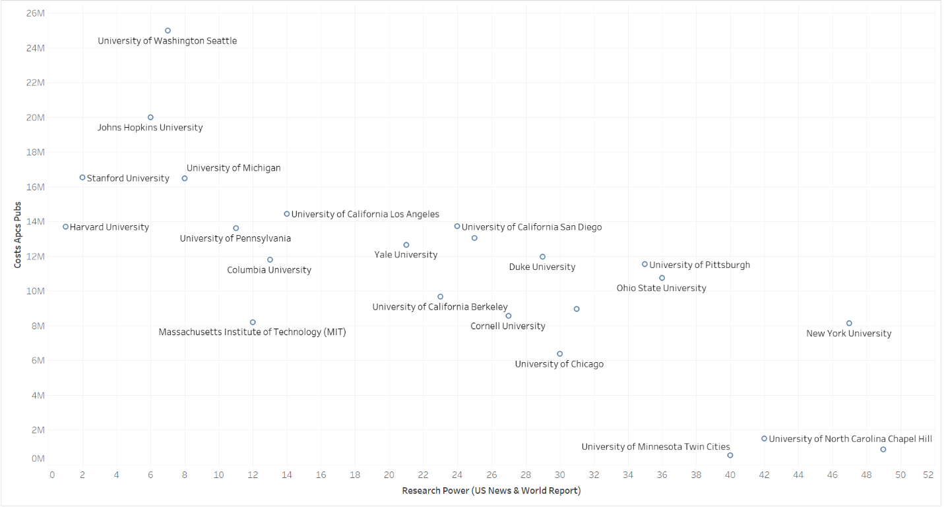

Participation in Gold Open access
According to the September 2021 data from the National Science Foundation Center for Science and Engineering Statistics (https://ncses.nsf.gov/indicators/data), the following table shows the proportion of researchers (defined as individuals engaged in research and development activities, including those working in science and engineering occupations) to population by state:

Table 1: Researchers per 1,000 Population per state. Source NSF data

State | Researchers per 1,000 Population | State | Researchers per 1,000 Population | State | Researchers per 1,000 Population | State | Researchers per 1,000 Population | State | Researchers per 1,000 Population
District of Columbia | 19 | Virginia | 7.7 | Utah | 6.5 | Ohio | 5.5 | Mississippi | 3.6
Massachusetts | 12.8 | Rhode Island | 7.6 | Michigan | 6.4 | Florida | 5.2 | West Virginia | 3.3
Delaware | 11.9 | New York | 7.5 | North Carolina | 6.4 | Missouri | 5.1 | New Mexico | 3
Maryland | 10.3 | Oregon | 7.1 | Wisconsin | 6.3 | Tennessee | 5.1 | Idaho | 2.8
Colorado | 9.7 | Vermont | 7.1 | Texas | 6 | Kentucky | 4.6 | Montana | 2.7
California | 9.1 | Minnesota | 7 | Iowa | 5.8 | Nevada | 4.4 | South Dakota | 2.4
Connecticut | 8.8 | Illinois | 6.9 | Kansas | 5.6 | Arkansas | 4.2 | North Dakota | 2.1
Washington | 8.3 | Pennsylvania | 6.8 | Nebraska | 5.6 | Oklahoma | 4.2 | Wyoming | 2
New Hampshire | 7.9 | Arizona | 6.5 | South Carolina | 5.6 | Louisiana | 3.9
New Jersey | 7.8 | Georgia | 6.5 | Indiana | 5.5 | Alabama | 3.8

Our data indicates that there is some correlation between the proportion of researchers per 1,000 population and the numbers of open access papers published in that state (see figure 2). There are some distinct outliers including Ohio, Texas, New York, and California. While having lower researchers per 1,000 population, these states publish a relatively high number of Gold Open Access papers. This is especially true for New York with the highest number of papers and California with a range of 8-10 researchers per 1,000 population and over 14K papers. States such is Washington DC, Delaware and Massachusetts have higher proportion of researchers to population but do not publish more OA papers than other states.

Figure 2: Researchers per 1,000 population and number of Gold open access papers per state
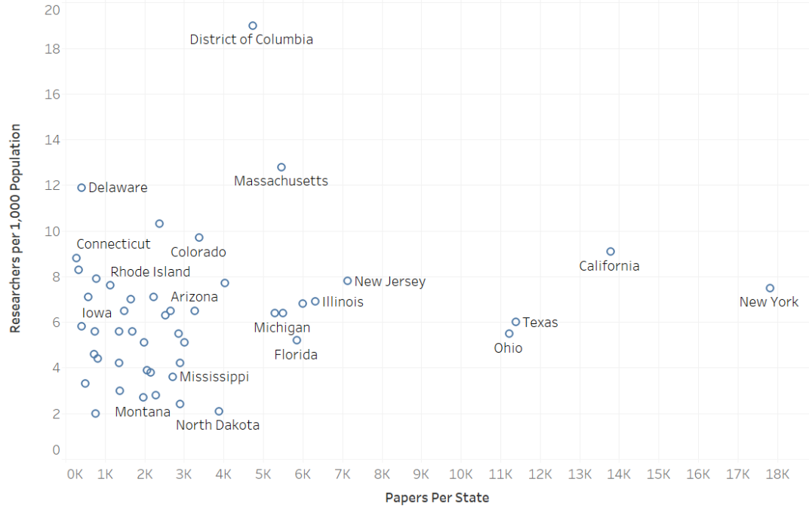

However, when examining the relationships between the proportion of researchers to the population and overall costs of APCs by state we see that most states are clustered around the 3million dollars mark with clear exceptions of Minnesota, Maryland, and Washington state which higher expenditure on APCs regardless of a lower percentage of researchers per population (see figure 3).

Figure 3: Researchers per 1,000 population and overall costs of Gold OA APCs
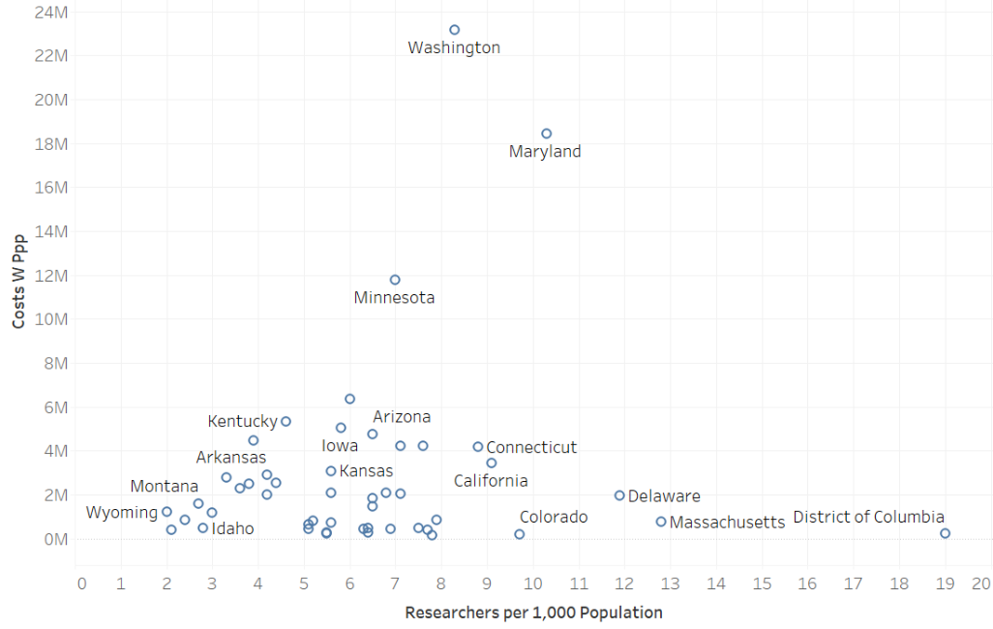

When examining the costs of APCs per state by the number of publications we see different trends. Figure 3 shows that Washington, Maryland, and Minnesota are at the top expenditures on APCs, ranging from10 to over 23 million dollars. Yet, the number of gold OA papers these states publish, did not exceed 3K over the past 10 years. Ohio, Texas, California and New York should be noted again here as states that publish exceedingly high number of gold OA papers, but their expenditures are relatively lower (see figure 4).

Figure 4: Costs of Gold Open Access APCs and number of papers per state

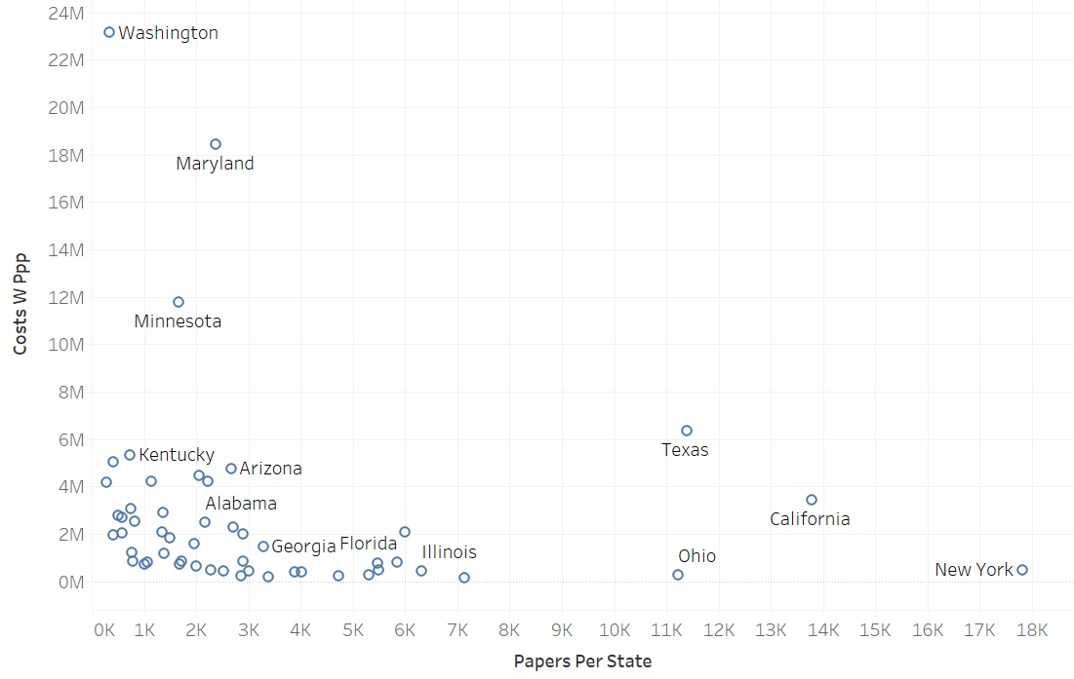

Discussion
The United States Gold OA output and expenditures demonstrate slightly different patterns than those seen in the global stage. While the number of Gold Open Access papers keeps growing and with it, the total amount of money spent, our data shows that most states spent between 1-6million dollars for Gold Open access papers and published between 1-7 thousand papers in this time period. This means that the average cost per paper was approximately $1,000 more or less. There are a few states that are exceptions to this trend. Washington, Minnesota, and Maryland published relatively low number of Gold Open Access papers compared to other states but have paid the highest rates for these publications which in some cases exceeds the overall national expenditure. On the other hand, states such as New York and Ohio publish much more Gold Open access papers but are able to keep their expenditures very low. This is particularly true for New York which has the highest number of Gold Open access papers and the lowest rates. Other states to notice are California and Texas with relatively high number of papers published and lower expenditures. Interestingly when we examine the ratio of researchers per 1,000 population and its effect on Gold Open Access papers publications and costs, the picture is quite complex. On the one hand states such as Washington DC, Delaware and Massachusetts have higher proportion of researchers to population but do not publish more OA papers than other states and therefore have lower expenditures while Ohio, Texas, New York, and California. While having lower numbers of researchers per 1,000 population, these states publish a relatively high number of Gold Open Access papers but pay much less in APCs than other states.
It is difficult to understand why Washington, Maryland and Minnesota spend a significantly higher amount of money of APCs even though their output overall is average. It is also difficult to understand why states like New York, Ohio, California, and Texas publish much more Gold Open Access papers but pay the least in APCs. This could be a result of better negotiation and purchasing power, sheer amount of output, and funding. Some states may have a higher concentration of institutions that have negotiated deals with publishers to provide discounts or waivers on APCs. These deals could be based on factors such as the volume of articles published or the overall institutional budget for publishing. Some states may have a higher number of researchers who receive funding from organizations that provide grants to cover the costs of APCs.

Conclusions
In this study we demonstrated some of the main differences in Gold Open Access publications and expenditures across various states and institutions in the United States. Our data shows that the majority of states published between 1,000 – 7,000 Gold Open Access publications and spent up to 6million dollars in the past 10 years. However, there are some noteworthy outliers such as Washington, Minnesota and Maryland with relatively low number of publications and high expenditures while states such as California, Ohio and especially New York which published relatively high number of Gold Open Access papers with relatively low costs comparatively.
These differences could be the result of several factors. For example, some institutions have robust open access policies and initiatives in place, while others may have limited or no policies at all. Some of the factors that contribute to these differences could also include:
- Funding: Institutions that receive more funding may be able to invest more resources into open access publishing initiatives.
- Research output: Institutions with larger research output may have greater incentive to promote open access publishing in order to increase visibility and impact of their research.
- Institutional culture: Some institutions may have a strong culture of openness and collaboration, while others may be more conservative and risk-averse.
- Institutional structure: The structure of an institution can also impact its approach to open access publishing. For example, a university with a medical school may prioritize open access publishing in biomedical research, while a liberal arts college may focus on open access in humanities and social sciences.
- Faculty attitudes: The attitudes of faculty members can also influence an institution's approach to open access publishing. Some faculty members may be enthusiastic about open access, while others may be more skeptical or resistant to change.

References
Beall, J. (2011). Predatory publishers are corrupting open access. Nature, 489(7415), 179. doi: 10.1038/489179a
Björk, B. C., Welling, P., Laakso, M., Majlender, P., Hedlund, T., & Guðnason, G. (2010). Open access to the scientific journal literature: Situation 2009. PLoS ONE, 5(6), e11273. https://doi.org/10.1371/journal.pone.0011273
Brasil Varandas Pinto, A., & van Leeuwen, T. (2022). The unseen costs of article processing charges: The different realities of Brazil and the Netherlands.
Fontúrbel, F., & Vizentin-Bugoni, J. (2020). A Paywall Coming Down, Another Being Erected: Open Access Article Processing Charges (APC) may Prevent Some Researchers from Publishing in Leading Journals. The Bulletin of the Ecological Society of America, 102. https://doi.org/10.1002/bes2.1791
Gorelick, D., & Li, Y. (2021). Reducing open access publication costs for biomedical researchers in the USA. MIT Science Policy Review, 2.
Krauskopf, E. (2021). Article processing charge expenditure in Chile: The current situation. Learned Publishing, 34(4), 637–646.
Lovén, L. (2019). Monitoring open access publishing costs at Stockholm University. Insights, 32(1).
OSTP Issues Guidance to Make Federally Funded Research Freely Available Without Delay | OSTP. (2022, August 25). The White House. https://www.whitehouse.gov/ostp/news-updates/2022/08/25/ostp-issues-guidance-to-make-federally-funded-research-freely-available-without-delay/
Zhang, X., Sun, S., & Xia, J. (2021). Investigating the attitudes of researchers towards open access publishing in low- and middle-income countries. Learned Publishing, 34(1), 49-59. https://doi.org/10.1002/leap.1334

