Gender, Parenthood, and Academic Performance: Work-life and Work-work Balance in Russian Academia

Elena Chechik*

*elenachechik@gmail.com
0000-0002-2277-0490
Center for Institutional Analysis of Science & Education,
European University at St.Petersburg, Russia

This article explores the gender aspects of careers in Russian academia regarding work-life and work-work balance. We drew on data from a survey of 2,076 academic economists conducted in January 2021. Under the concept of work-work balance (Griffin, 2022), we discuss the gender imbalances that arise within the profession. We relate work-life balance (Lester, 2015) primarily to parenthood. We combined survey data with bibliometric data from the national citation base to see how different “work-life” and “work-work” factors are associated with publication productivity. The results did not show a statistically significant correlation between having children and the number of publications for men and women at this stage of research. We also discuss possible reasons for this result.

1. Introduction
Studies have shown that women in academia are more likely to face challenges with work-life and work-work balances. One possible explanation for the publication gap lies in the work-life balance framework, specifically the unequal impact of parenthood on mothers and fathers. Perceptions within the academic community persist that the absence of children is an essential factor in academic success (Morgan et al., 2021). Parenthood creates a new need to devote time to child care, but it does not imply an equal workload for women and men due to different socialization factors. On average, women have more childcare responsibilities than men (Misra et al., 2012), making it less likely for them to reallocate time funds in ways that combine motherhood and conform to notions of being a “successful scientist” (Wolf-Wendel & Ward, 2016).

Persistent gender gaps in publication productivity have been documented in Russian academia. Despite being more widely represented in many scientific fields, women publish fewer papers than men (Krasnyak, 2017; Lewison & Markusova, 2011; Paul-Hus et al., 2015; Pilkina and Lovakov, 2022). The field of economic sciences is relatively more gender-balanced in Russia, as demonstrated by specialized bibliographic databases of economic sciences (RePEc, 2023). As such, academic economists were selected to study the gender aspects of parenthood in Russia to compare differences in parenthood between men and women in a relatively balanced sample of academic environments. The interview data show that women in Russia consider the lack of children to be an important factor in academic success. Choosing between pursuing a career or starting a family is cited as an obstacle to a woman's academic career (Tarakanovskaya, 2022).

To gain a better understanding of the challenges that women face in academia, we examine gender differences in parenthood, disparities in professional responsibilities and academic positions, and their impact on academic productivity among economists in Russia.

2. Data
In January 2021, a survey was conducted among academic economists in Russia. The main objective of the survey was not to explore parenthood but rather to gather information on various aspects of the respondents' academic careers. A block of questions about parenthood was included in 18,372 letters and answered by 2,076 respondents whose primary affiliation was with a Russian university (more about sample selection, see Table S1). The parenthood section was one of several blocks of questions in the questionnaire, which also covered topics such as the number and birth years of children, as well as the use of maternity leave. Additionally, the survey contained questions about the respondents' age, year of the dissertation, position, and other relevant information.

The bibliometric data of the 2,076 respondents were collected from the Russian Index of Science Citation (RISC), which is a bibliographic database of scientific publications in Russian (Moskaleva et al., 2018). The rationale for using this database was to examine not only publications in indexed, peer-reviewed journals but also those in a wider range of Russian-language journals.

3. Results

3.1. Work-work balance: gender differences in university activities
Gender disparities in academic positions have been a long-standing issue, and our survey shows the unequal distribution of men and women in various academic roles, particularly in the context of leading universities. Among the participants in our sample, men are relatively more likely to occupy higher positions, such as full professorships and graduate department roles, while women are more likely to hold positions as lecturers and assistant professors (Figure 1). Also, in the university sector, there exists a group of leading institutions that includes 23 universities (Table S2). The representation of women in these leading universities is lower compared to that of men.

Figure 1: Gender representation in (A) academic positions and (B) university types.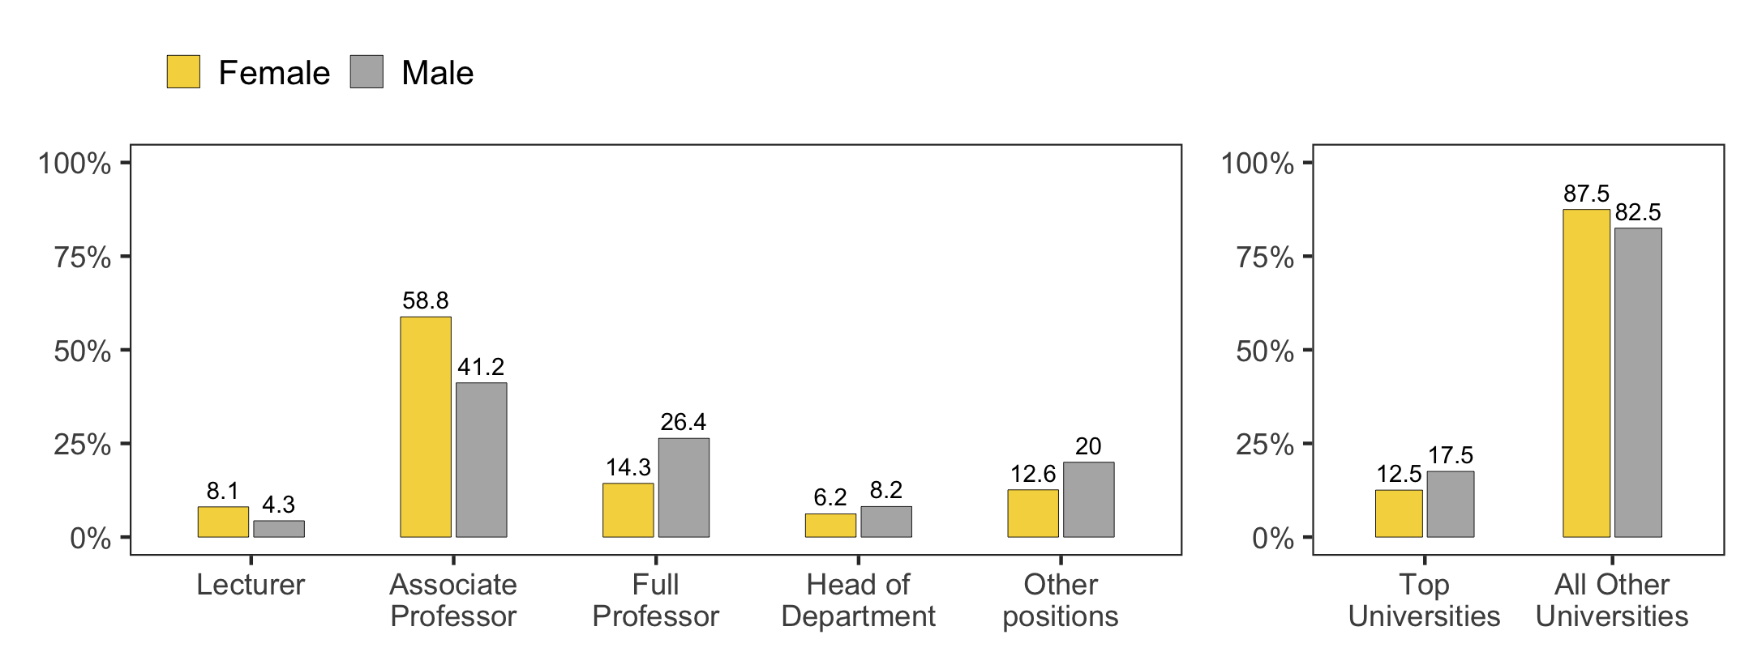
Our study looked at gender differences in the professional activities of academic economists (Figure 2). We found that women are more likely to teach at the university than men. Some activities, like managing a department and working on business contracts, showed no significant gender differences. However, certain activities, like researching and reviewing for Russian journals, were more common among men.

Figure 2: Professional Activities of respondents during the year.
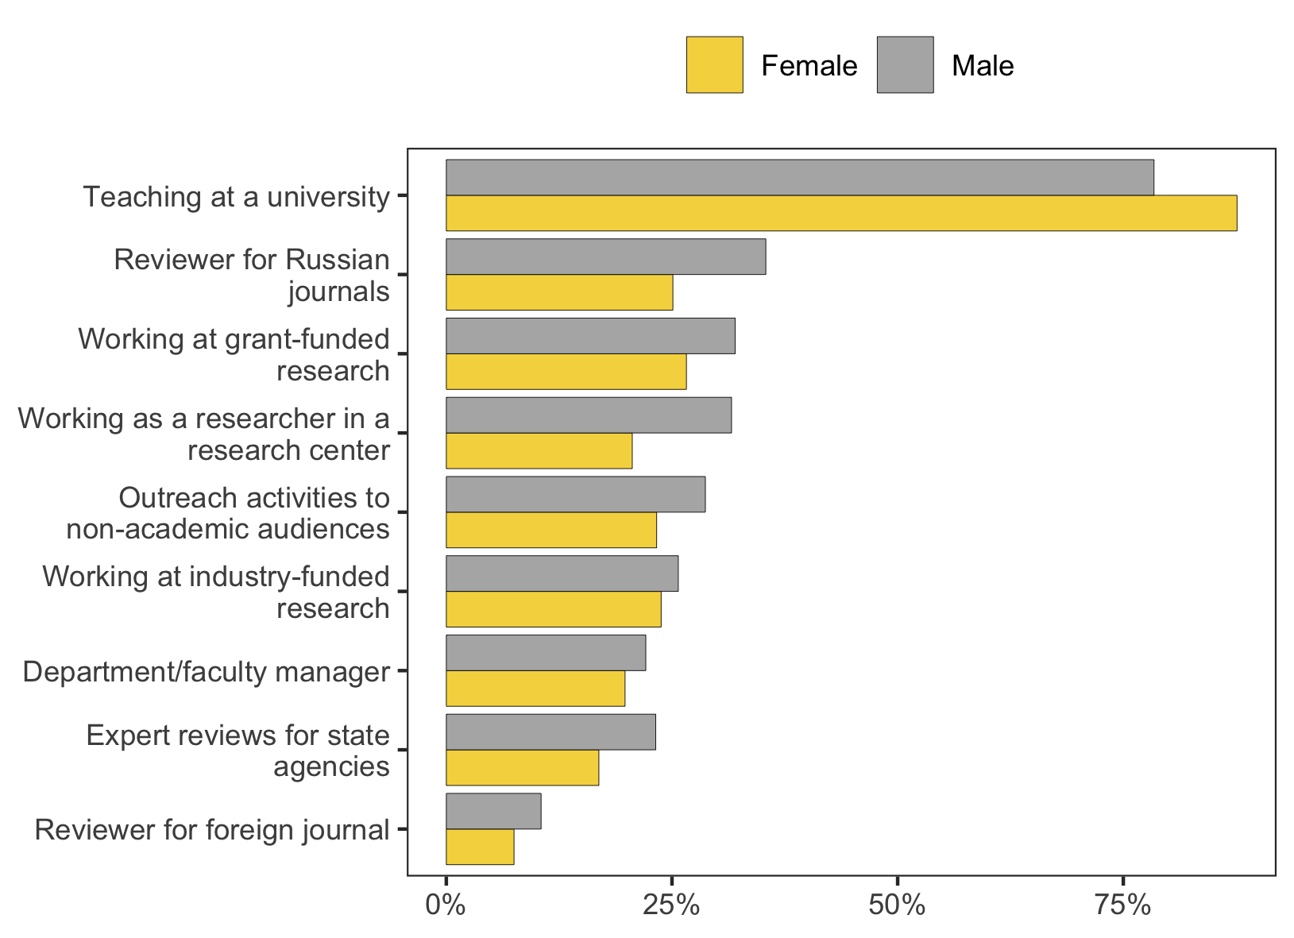
Furthermore, the gender disparities in academic roles and responsibilities also extend to the supervision of higher-level papers. As shown in Figure 3, men were found to supervise Ph.D. and DS theses more frequently than women. However, at the BA/MA level, there were no significant gender differences in the number of theses currently supervised. These findings are in line with the observations made in the previous paragraph, highlighting the gender-specific trends that persist in academia. Specifically, women in our sample supervised significantly fewer higher-level papers compared to men, with an average of 2.25 PhDs and 0.26 DS, while men supervised 4.22 PhDs and 0.59 DS (p-value < 0.01).

Figure 3: Mean student enrollment per respondent, by gender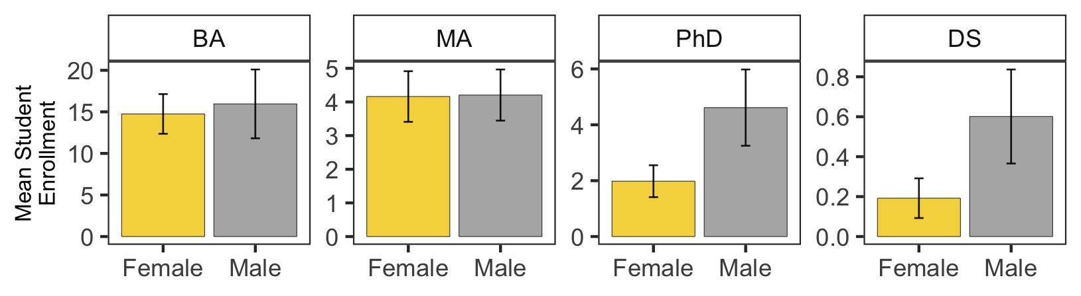

3.2. Work-life balance: Parenthood and the academic career
Parenthood is a crucial aspect of studying work-life balance and gender imbalances. In this section, we explore the intersection of parenthood and academic careers. The survey results indicate that a significant proportion of academic economists have children, with notable gender disparities in the number of children per parent. Specifically, our analysis shows that men, on average, have more children than women. According to the survey, 76% of academic economists have at least one child. Women commonly reported having one child (41%), while men reported having two children (35%). (Fig 4) On average, men have 1.48 children, while women have 1.21 children (t = -5.68 ; p < 0.001) (Table 1).

Table 1: Distribution of women and men by parenthood status.

 | Women  (N=1340) | Men  (N=736) | P-value
Number of Children
Mean (SD) | 1.21 (0.890) | 1.48 (1.16) | <0.001
Median [Min, Max] | 1.00 [0, 6.00] | 1.00 [0, 6.00]
No answer | 7 (0.5%) | 9 (1.2%)
Age of First Child's Appearance
Mean (SD) | 26.5 (4.79) | 28.0 (5.57) | <0.001
Median [Min, Max] | 25.0 [17.0, 45.0] | 27.0 [17.0, 54.0]
No answer | 348 (26.0%) | 210 (28.5%)

Figure 4: Gender representation by number of children.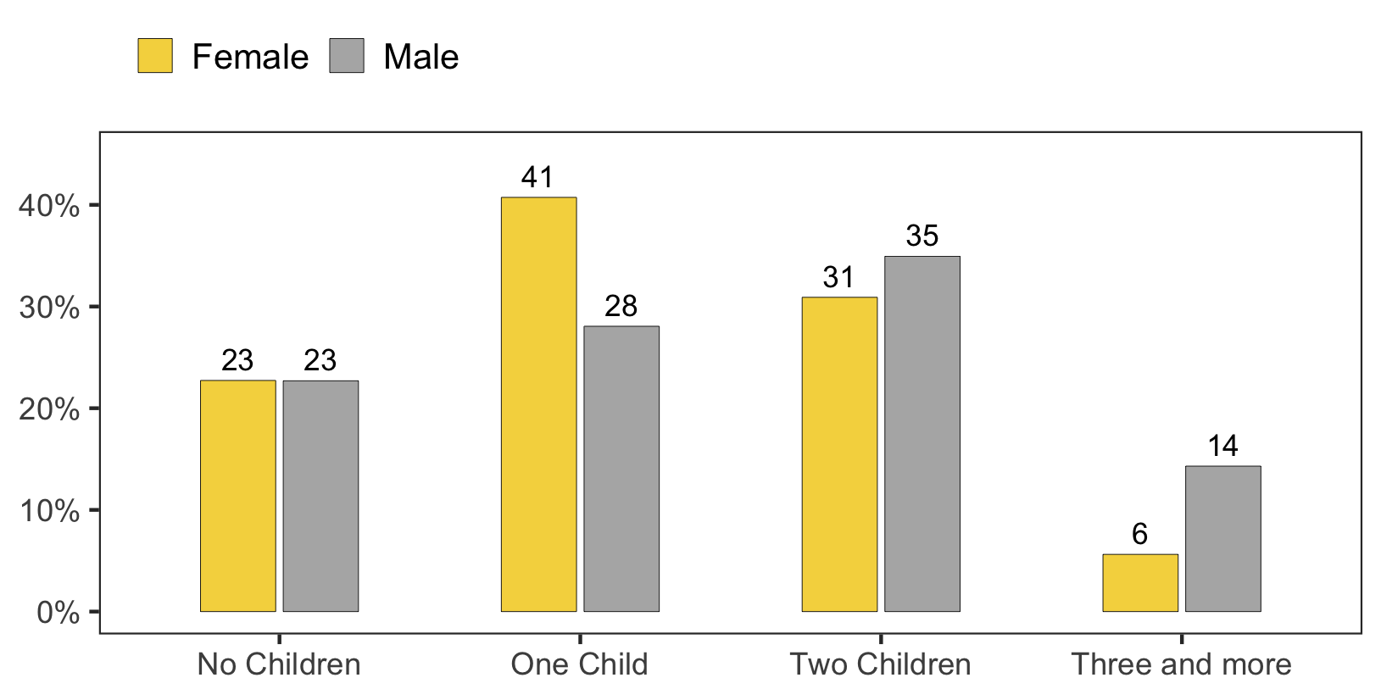
In our sample, women and men, on average, became parents for the first time at the age of 27, with women being slightly younger at 26.5 years and men at 28.1 years (t = -5.95, p < 0.001) (Table S3). Notably, the average age of having a first child in the general population in Russia has shifted towards later ages in recent years (see Fig S1). Moreover, we found that the age at which academic economists become parents for the first time is also increasing, as shown in Figure 5A.

Although women, on average, became parents earlier than men, the age at which they obtained their Ph.D. did not differ significantly, with women and men being 32.2 years and 31.8 years old, respectively (t = 1.22, p = 0.224). However, we observed that the age at which respondents defended their Ph.D. varied across different generations, with younger respondents defending their Ph.D. earlier than more mature respondents, as illustrated in Figure 5B.

Figure 5. Age of first child and age of Ph.D. defense in economist generations.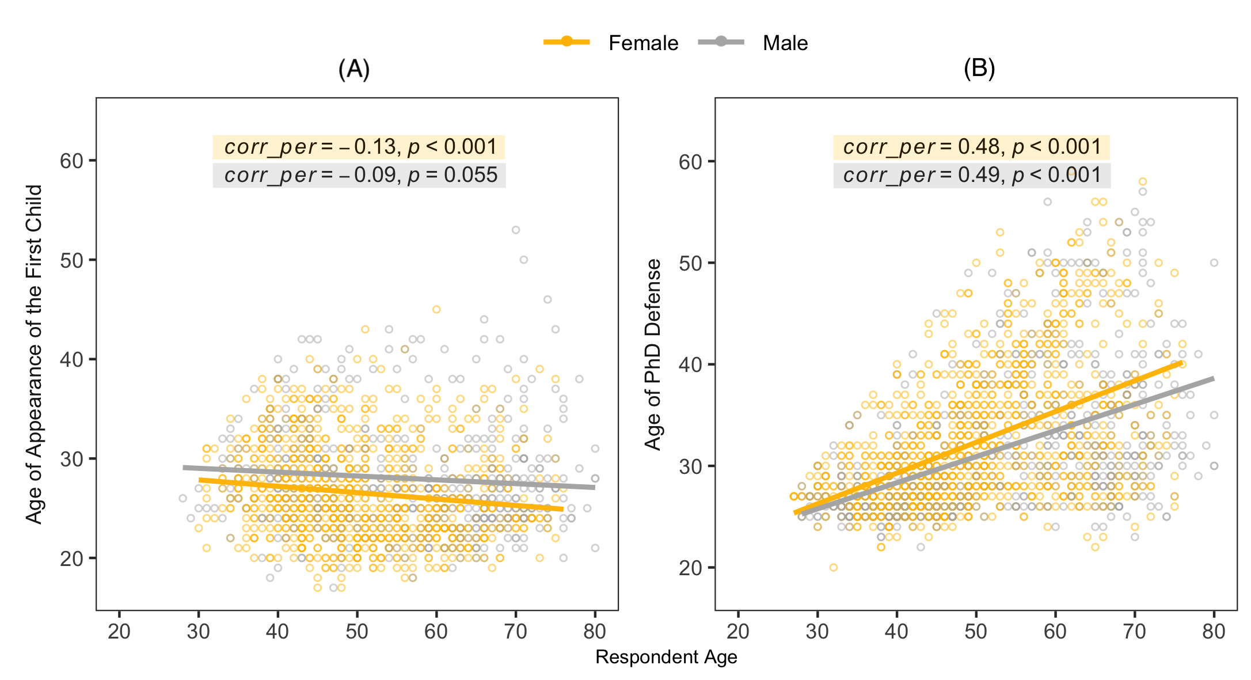
For women, the defense of the Ph.D. and the appearance of the first child are separated, on average, by six years: the baby and, after that – Ph.D. The order is the same for men, but the events are, on average, separated by four years. The average value for women tells us more about the age structure of the sample – more women preferred to become parents first and then defend their Ph.D. than those who postponed parenthood. If we move away from the average value, we see a two-humped distribution for women (Fig 6). There is a drop in the area around the first child's appearance – there are very few women who defended their Ph.D. in the first few years after having a child, but there is a peak of defense for 2–3 years before the baby and a second peak of defense 4–5 years after the baby. For men, we see a distribution with one peak – in the area of the appearance of the first child.

Figure 6: Time separation between Ph.D. defense and first child appearance.
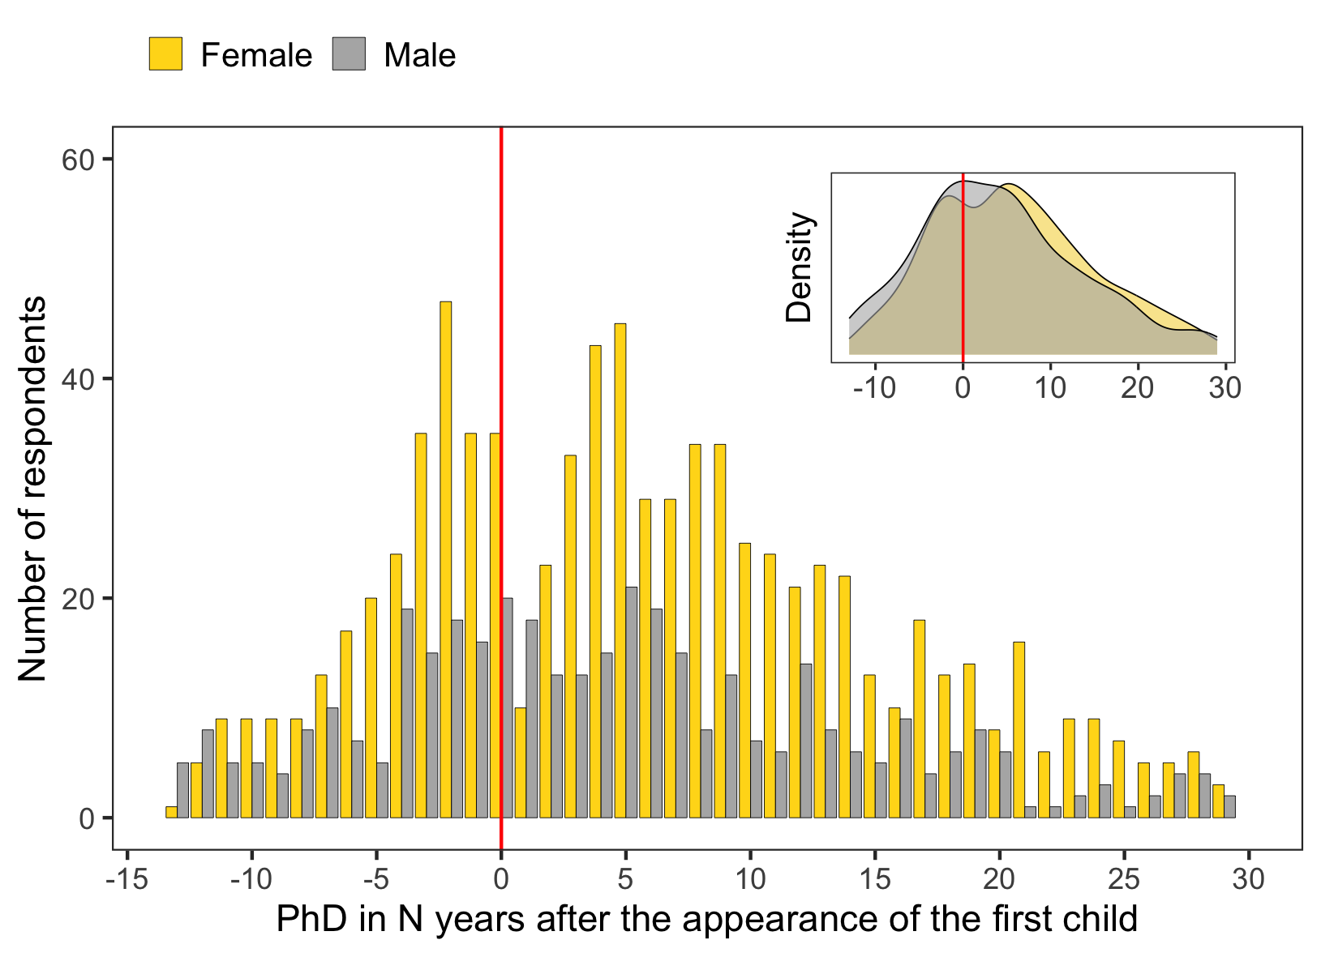

3.3. Academic Performance and its determinants
In terms of academic performance, we will use two types of publication metrics:

- Total publications in the RISC base: This indicates the total number of publications recorded in the RISC database, ranging from publications in national journals with different reputations to publications in journals indexed in international citation databases such as WoS/Scopus. This is a broad indicator that shows all publication activity, regardless of its quality.
- RISC core publications: This is a stricter indicator of publication productivity and includes only publications in journals indexed on the Web of Science Core Collection, Scopus, and a selected list of Russian-language journals, books, and conference proceedings.

According to our sample data, men outperformed women on both the Total RISC and RISC Core indicators. On average, men published 18 more papers than women in the Total RISC indicator (85.1 papers for men compared to 68.3 for women; t = -5.37; p < 0.001), which translates to a 20% lower publication rate for women. In the RISC Core indicator, women published 51% fewer papers than men, with an average of 5.25 papers for women and 10.3 papers for men.

Table 2: Distribution of women and men by publication performance.

 | Women  (N=1340) | Men  (N=736) | P-value
Total publications in RISC
Mean (SD) | 68.3 (58.1) | 85.1 (88.2) | <0.001
Median [Min, Max] | 51.0 [3.00, 431] | 59.0 [4.00, 1090]
RISC Core publications
Mean (SD) | 5.25 (7.91) | 10.3 (19.2) | <0.001
Median [Min, Max] | 2.00 [0, 98.0] | 4.00 [0, 227]

There is a significant difference between men and women without children, with women publishing an average of 15% fewer Total RISC publications as compared to men. The gap becomes even wider when considering the number of articles in the RISC Core, where women without children have 50% fewer articles on average than men without children (Figure 7, Table S4). Although age and the number of articles are weakly correlated, the age difference between women and men without children cannot account for the significant gender gap observed. Furthermore, the gap persists for women and men with one or two children, with women consistently publishing fewer articles in the RISC Core compared to men.

Figure 7: Publication metrics and parenthood status.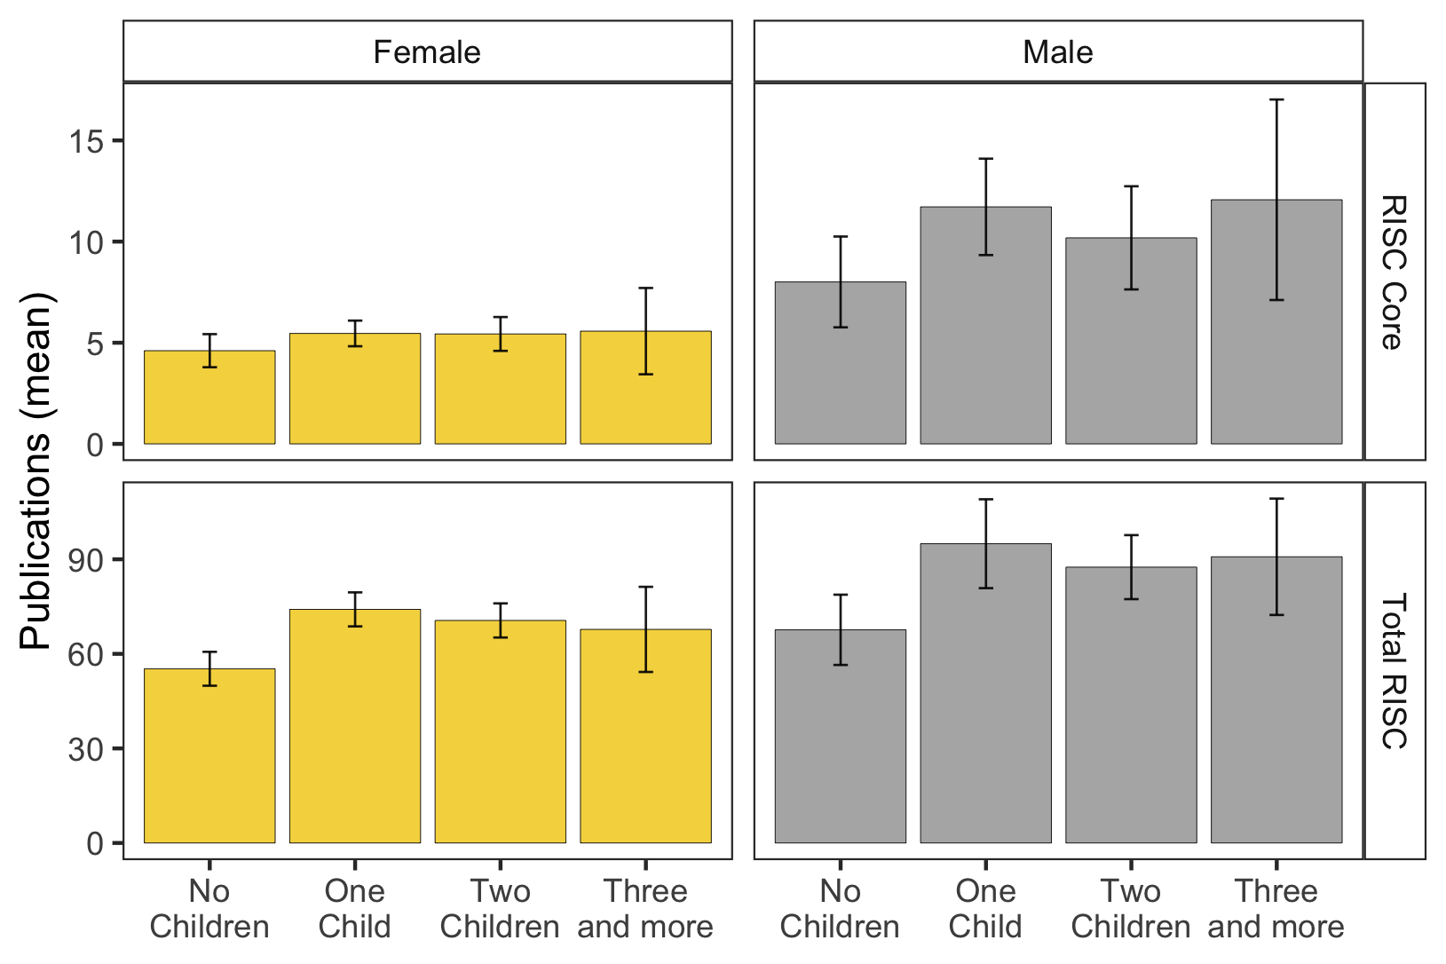

We conducted a regression analysis to test various models, where the independent variable was the number of publications, in order to determine whether having a child would be a significant factor when other independent variables were taken into account. Figure 8 shows the coefficient plot for one of the baseline models (Table S5). The results are consistent with the previous analysis for several coefficients – men tend to have more publications than women, and individuals in top universities tend to have more core publications than those in other universities. We also observe the significant impact of position and the insignificance of age when considering other factors. However, most notably, we do not observe a statistically significant relationship between having children and the number of publications in such a simple model. Similar results are obtained for the various model specifications presented in Supplementary Materials Table S5.

Figure 8. Coefficients plot for linear regression model of academic performance.
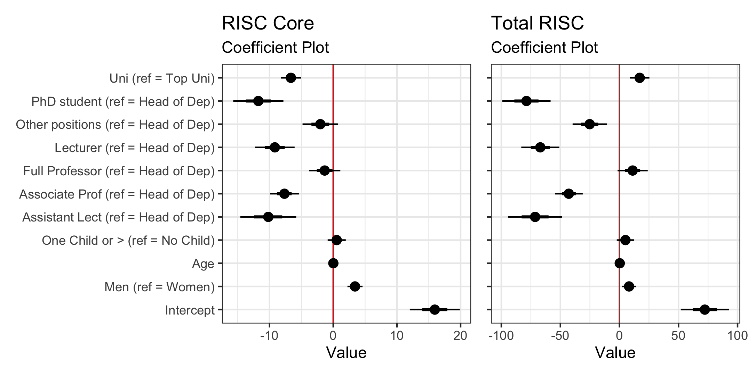
3.4. Reflection on the results
In order to explore alternative explanations, we are collecting panel publication data for each respondent and will continue the study. For now, we would like to highlight two observations that could potentially shed light on the observed publication gap.

Within our sample, the majority of respondents have both teaching and publication experience, with 83% reporting teaching experience (see Fig 2) and 100% having publication experience (a condition for being included in the sample). However, when asked whether they consider themselves “rather as a researcher who also does teaching” or “rather as a teacher who also does research,” women and men responded differently. On average, 66% of women chose the characteristic “rather as a teacher,” as well as the closest characteristic to it (as shown in Fig 9A). Meanwhile, only 19% of women gave a neutral response, while the remaining 16% chose the characteristic “rather as a researcher” or the closest to it. Among male economists, the proportion who consider themselves “rather as a researcher” (42%) is similar to those who consider themselves “rather as a teacher” (34%).

Further insight is provided by looking at how women and men responded to this question in regard to having children. For those without children, the gender bias in responses becomes less pronounced: 54% of women and 51% of men without children consider themselves “rather as a teacher” (as shown in Fig 9B). Additionally, in the same group, there is a maximum convergence in the proportion of people who consider themselves “rather as a researcher” (18% of women and 26% of men).

Figure 9: Self-identification “rather as a teacher” or “rather as a researcher”. (Q: Do you think of yourself more as a scientist who also does teaching or as a teacher who does science?).
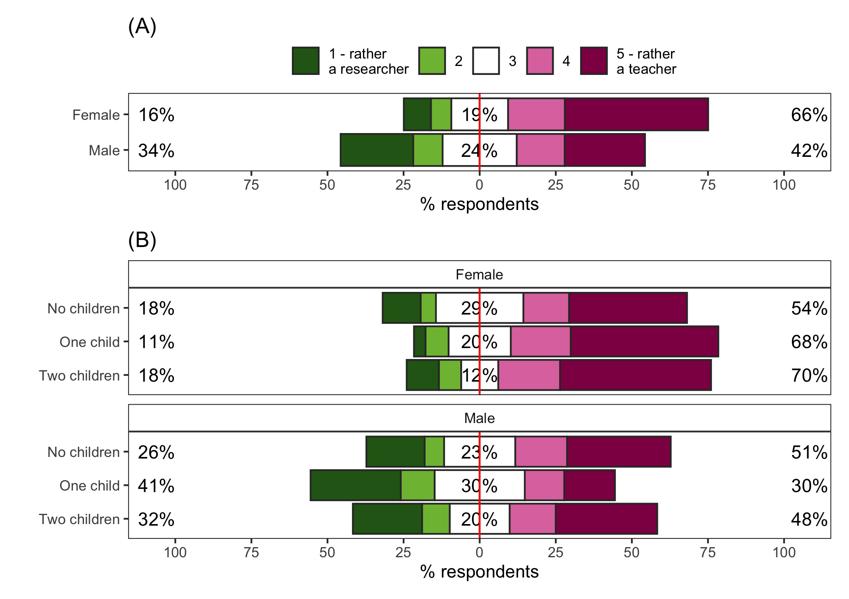

In light of the above, we are particularly interested in how women and men explain gender imbalances in Economics field. In our survey, we asked respondents about this, but we cannot exclude the possibility that their answers may have been influenced by social desirability bias (as shown in Fig 10).

Figure 10. Personal evaluation of gender disparities. Q: There are significantly more men than women among famous economists. What do you think is the role of each factor in explaining this phenomenon? (If you take the influence of all factors as 100%).

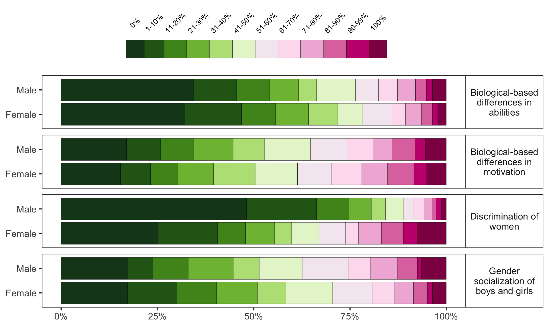

The option that there are fewer famous economists among women due to “biological-based differences in abilities” is understandably unpopular. However, on average, men tend to prefer this explanation more frequently than women. Nonetheless, the difference between women and men in this item is insignificant. On the other hand, we observed an interesting pattern in the item “Discrimination of women” – men tend to deny its impact more often, while women tend to note its importance more frequently. This suggests that women may experience discrimination within their organizations, although we cannot ascertain how it specifically manifests in practice.

4. Conclusions
Our study highlights the persistent gender disparities in academic positions, with men being more likely to occupy higher positions compared to women. We also found that women were more likely than men to participate in teaching at the university, while certain activities, such as research, were more prevalent among men. Furthermore, our results show that men were found to supervise higher-level papers. These findings provide insights into the gender-specific trends in work-work balance in academia, specifically among Russian economists.

The study revealed that, on average, women in economics publish fewer articles than men. Even after accounting for other factors like age and academic position, the gender gap in publication productivity remains. However, the study did not discover a statistically significant correlation between having children and the number of publications. Consequently, we will continue our research by collecting panel data on publications.

On average, women are more likely to define themselves as “teachers.” There are several possible explanations for why the gender structure of academic employment looks this way, and it hinges on the question of cause and effect. If internal causes are primary, women initially understand the academic profession as predominantly teaching-oriented, more often than men. As a result, they purposefully pursue academia to realize themselves as teachers. In this case, research activities become incidental to them and are only needed to fulfill contractual requirements. Additionally, women may find fulfillment in parenthood and choose academia because it provides relatively more flexible employment. Thus, research will not be a priority for them, and they may be more likely to select the answer “teacher” when asked about their career choice.

Alternatively, one might suggest that external reasons are primary, i.e., that the environment in their organization pushes women towards teaching instead of research. In this scenario, women initially aim for research activities, but they may be relatively more likely to encounter barriers that push them out of the research track and into teaching. These barriers can be related to relatively higher administrative burdens and invisible work, parenting that penalizes mothers more than fathers, relatively less grant funding, and possible discriminatory practices in hiring and career advancement.

Open science practices

The source code used in this study is publicly available on Github (https://github.com/hellche/parenthood_HEI) and can be accessed by anyone interested in reproducing this work. I also provide a detailed description of the data collection process in the supplementary materials (https://hellche.github.io/parenthood_HEI/). However, I am unable to provide access to the full survey data used in this study at this stage. As a junior researcher, I recognize the responsibility to protect the privacy of our participants and ensure the ethical use of data. I plan to seek guidance on best practices for making survey data anonymous and aim to make it available in the future.

As someone who uses open-source software such as R and Python, along with their packages/libraries developed by other people for general use, I strongly support the {softbib} initiative (Arel-Bundock, 2023). The {softbib} scans a project folder, identifies the software used, and automatically generates software bibliographies. This initiative highlights the importance of acknowledging the contributions of software developers to scientific research. With your permission, I would like to add a section of software bibliography, collected using the {softbib} package, to the reference section.

Acknowledgments

The author would like to express gratitude to their colleagues at the Center for Institutional Analysis of Science and Education for their valuable input and support during the preparation of this paper.

Competing interests

The author declares no competing interests.

Funding information

This work was supported by RSCF – Russian Science Foundation, grant #21-18-00519.

References

Griffin, G. (2022). The ‘Work-Work Balance’ in higher education: Between over-work, falling short and the pleasures of multiplicity. Studies in Higher Education, 47(11), 2190–2203. https://doi.org/10.1080/03075079.2021.2020750

Derrick, G. E., Chen, P.-Y., van Leeuwen, T., Larivière, V., & Sugimoto, C. R. (2022). The relationship between parenting engagement and academic performance. Scientific Reports, 12(1), 22300. https://doi.org/10.1038/s41598-022-26258-z

Huang, J., Gates, A. J., Sinatra, R., & Barabási, A.-L. (2020). Historical comparison of gender inequality in scientific careers across countries and disciplines. Proceedings of the National Academy of Sciences, 117(9), 4609–4616. https://doi.org/10.1073/pnas.1914221117

Joecks, J., Pull, K., & Backes-Gellner, U. (2014). Childbearing and (female) research productivity: A personnel economics perspective on the leaky pipeline. Journal of Business Economics, 84(4), 517–530. https://doi.org/10.1007/s11573-013-0676-2

Larivière, V., Ni, C., Gingras, Y., Cronin, B., & Sugimoto, C. R. (2013). Bibliometrics: Global gender disparities in science. Nature, 504(7479), 211–213. https://doi.org/10.1038/504211a

Lester, J. (2015). Cultures of work–life balance in higher education: A case of fragmentation. Journal of Diversity in Higher Education, 8(3), 139–156. https://doi.org/10.1037/a0039377

Mason, M. A., Wolfinger, N. H., & Goulden, M. (2013). Do babies matter? Gender and family in the ivory tower. Rutgers University Press.

Misra, J., Lundquist, J. H., & Templer, A. (2012). Gender, Work Time, and Care Responsibilities Among Faculty1: Gender, Work Time, and Care Responsibilities Among Faculty. Sociological Forum, 27(2), 300–323. https://doi.org/10.1111/j.1573-7861.2012.01319.x

Morgan, A. C., Way, S. F., Hoefer, M. J. D., Larremore, D. B., Galesic, M., & Clauset, A. (2021). The unequal impact of parenthood in academia. Science Advances, 7(9), eabd1996. https://doi.org/10.1126/sciadv.abd1996

Moskaleva, O., Pislyakov, V., Sterligov, I., Akoev, M., & Shabanova, S. (2018). Russian Index of Science Citation: Overview and review. Scientometrics, 116(1), 449–462. https://doi.org/10.1007/s11192-018-2758-y

Prakhov, I. (2019). The determinants of academic salaries in Russia. Higher Education, 77(5), 777–797. https://doi.org/10.1007/s10734-018-0301-y

Prakhov, I., & Rudakov, V. (2018). The Determinants of faculty pay in Russian universities: Incentive contracts. Higher School of Economics Research Paper No. WPBRP, 47. SSRN Electronic Journal. https://doi.org /10.2139/ssrn.3247107

RePEc. (2023, March). Female representation in Economics. Retrieved from https://ideas.repec.org/top/female.html#

Rudakov, V. N., & Prakhov, I. A. (2021). Gender differences in pay among university faculty in Russia. Higher Education Quarterly, 75(2), 278–301. https://doi.org/10.1111/hequ.12277

Sheltzer, J. M., & Smith, J. C. (2014). Elite male faculty in the life sciences employ fewer women. Proceedings of the National Academy of Sciences, 111(28), 10107–10112. https://doi.org/10.1073/pnas.1403334111

Sterligov I. (2017) Gender and Income Disparities Among Russian Academic CEOs. HERB Issue Women in Academia. 4(14). 12–14.

Tarakanovskaya, K. S. (2022). Gender Imbalance in Science: Objective Statistics and Subjective Meanings. The Journal of Social Policy Studies, 20(1), 53-66. https://doi.org/10.17323/727-0634-2022-20-1-53-66

Witteman, H. O., Hendricks, M., Straus, S., & Tannenbaum, C. (2019). Are gender gaps due to evaluations of the applicant or the science? A natural experiment at a national funding agency. The Lancet, 393(10171), 531–540. https://doi.org/10.1016/S0140-6736(18)32611-4

Wolf-Wendel, L., & Ward, K. (2015). Academic Mothers: Exploring Disciplinary Perspectives. Innovative Higher Education, 40(1), 19–35. https://doi.org/10.1007/s10755-014-9293-4

Software Bibliography

Allaire, J. J., Xie, Y., McPherson, J., Luraschi, J., Ushey, K., Atkins, A., Wickham, H., Cheng, J., Chang, W., & Iannone, R. (2022). rmarkdown: Dynamic Documents for R. https://github.com/rstudio/rmarkdown

Arel-Bundock, V., (2023). Softbib: Software Bibliographies for r Projects. https://CRAN.R-project.org/package=softbib.

Bryer, J. & Speerschneider, K. (2016). Likert: Analysis and Visualization Likert Items. https://CRAN.R-project.org/package=likert.

Gagolewski, M. (2022). stringi: Fast and portable character string processing in R. Journal of Statistical Software, 103(2), 1–59. https://doi.org/10.18637/jss.v103.i02

Lander, J. P. (2022). coefplot: Plots Coefficients from Fitted Models. https://CRAN.R-project.org/package=coefplot

R Core Team. (2021). R: A Language and Environment for Statistical Computing. R Foundation for Statistical Computing. https://www.R-project.org/

Rudis, B., Bolker, B., & Schulz, J. (2017). ggalt: Extra Coordinate Systems, ‘Geoms’, Statistical Transformations, Scales and Fonts for ‘ggplot2’. https://CRAN.R-project.org/package=ggalt

Slowikowski, K. (2021). ggrepel: Automatically Position Non-Overlapping Text Labels with ‘ggplot2’. https://CRAN.R-project.org/package=ggrepel

Wickham, H. (2022a). stringr: Simple, Consistent Wrappers for Common String Operations. https://CRAN.R-project.org/package=stringr

Wickham, H., Averick, M., Bryan, J., Chang, W., McGowan, L. D., François, R., Grolemund, G., Hayes, A., Henry, L., Hester, J., Kuhn, M., Pedersen, T. L., Miller, E., Bache, S. M., Müller, K., Ooms, J., Robinson, D., Seidel, D. P., Spinu, V., … Yutani, H. (2019). Welcome to the tidyverse. Journal of Open Source Software, 4(43), 1686. https://doi.org/10.21105/joss.01686

Xie, Y. (2014). knitr: A Comprehensive Tool for Reproducible Research in R. In V. Stodden, F. Leisch, & R. D. Peng (Eds.), Implementing Reproducible Computational Research. Chapman and Hall/CRC. http://www.crcpress.com/product/isbn/9781466561595

Xie, Y. (2022). knitr: A General-Purpose Package for Dynamic Report Generation in R. https://yihui.org/knitr/

