Survey Result of Career Awareness and Financial Assistance to 1st year of Doctoral Students in Japan

Keiji SAITO*

\**ksaito@nistep.go.jp*

0009-0000-1939-0131

1st Policy-Oriented Research Group, National Institute of Science and Technology Policy, Japan

NISTEP in MEXT of Japan conducted "Survey on Career Awareness and Financial Assistance to 1st year of Doctoral Students" from December 2022 to January 2023. NISTEP asked all universities with doctoral programs in Japan to distribute all first-year doctoral students in FY2022. Survey participants responded via the web regarding their impression about research environment, career awareness, and financial support status etc. This paper shows simple results and indicates a direction for future analyses.

## 1. Survey Overview

NISTEP (National Institute of Science and Technology Policy) in MEXT (Ministry of Education, Culture, Sports, Science and Technology) of Japan conducted "Survey on Career Awareness and Financial Assistance to 1st year of Doctoral Students" from December 2022 to January 2023. NISTEP asked all 460 universities with doctoral course in Japan to distribute all first-year doctoral students in FY2022. Survey targets who received a survey request letter from each university office were asked to access the survey website and answered either in the Japanese or English version of web questionnaire. Survey participants answered regarding their impression about research environment, career awareness, and financial support status etc.

The number of completely valid response to all required questions is 6,153. The completely valid response means answered all required questions in the web-based survey form. Although NISTEP collects data on interrupted responses up to the answered web page, this paper shows the results based on 6,153 complete valid responses. Based on the responses from offices of universities, the total number of first-year doctoral students are 17,218. The completely valid response rate is 35.7% by the population number of the offices of universities.

On the one hand, NISTEP has been conducting two surveys of the career paths of doctoral graduates. Each survey is called JD-Pro (Japan Doctoral Human Resource Profiling)[1] and JGRAD (Japan Graduates Database)[2]. Importance of tracking doctoral graduates and international comparisons are mentioned in Auriol et al. (2013) and Hancock et al. (2019). The motivations of surveys in Japan are similar to the SDR (Survey of Doctorate Recipients) of NSF (National Science Foundation) in the U.S. and Graduate Outcomes of HESA (Higher Education Statistical Agency) in the U.K. Opsomer et al (2023) indicates the area of residence etc. of doctoral graduates based on SDR data. Hancock (2021) mentioned limitations and improvement measures of the survey in the U.K. On the other hand, Japanese government had not conducted a large-scale survey on career awareness and research environment for first-year doctoral students. NISTEP plans to combine career awareness data of 1st year doctoral students with career path data of graduates for in-depth analyses.

## 2. Survey Results

### 2.1 Basic Attributes (Gender, Member of Society, International Students)

Figure 1 shows ratio of males to females by research field. 65 percent of respondents were male and 34% were female. The male ratio is comparative higher in "Natural Science" and "Engineering"

Figure 1. ratio of males to females by research field

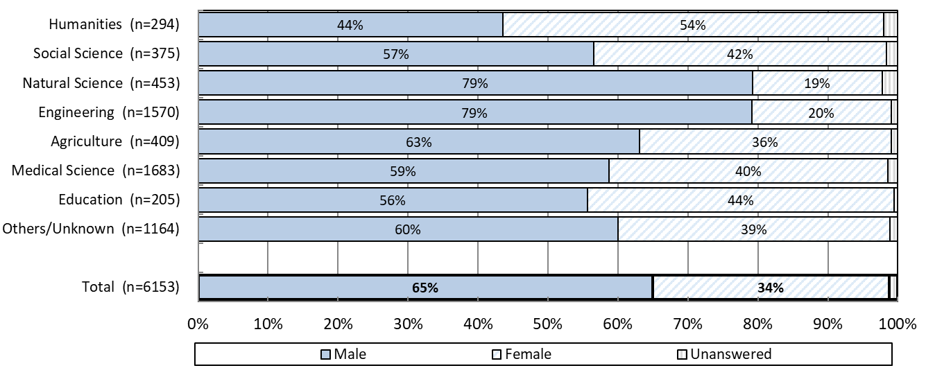

Figure 2 shows ratio of members of society and international students by research field. The definition of “members of society” in this survey, generally corresponds to having/had a full-time job. 35 %of respondents were neither members of society nor international students, 30% were members of society (excluding members of society and international students), and 35% were international students (including members of society). The ratio of students who are neither members of society nor international students is comparative higher in "Natural Science".

Figure 2. ratio of members of society and international students by research field

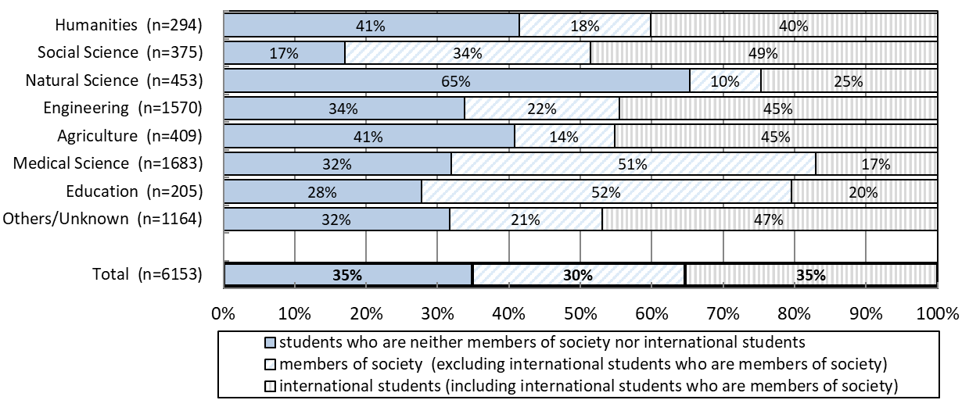

### 2.2. Ratio of the Same University / Main Academic Advisor with Last Academic Background

NISTEP asked the same university / main academic advisor with last academic background in the survey. This question was asked to confirm regarding academic imbibing and contact with diversity. And, the answer also allows us to control for the difference of the expectations of the research environment, which will be discussed later. Figure 3 shows ratio of the same university with the last academic background. The percentage of same university in all respondents was 61%. The percentages are relatively higher in “Humanities” and “Natural Science”.

Figure 3. ratio of the same university with the last academic background

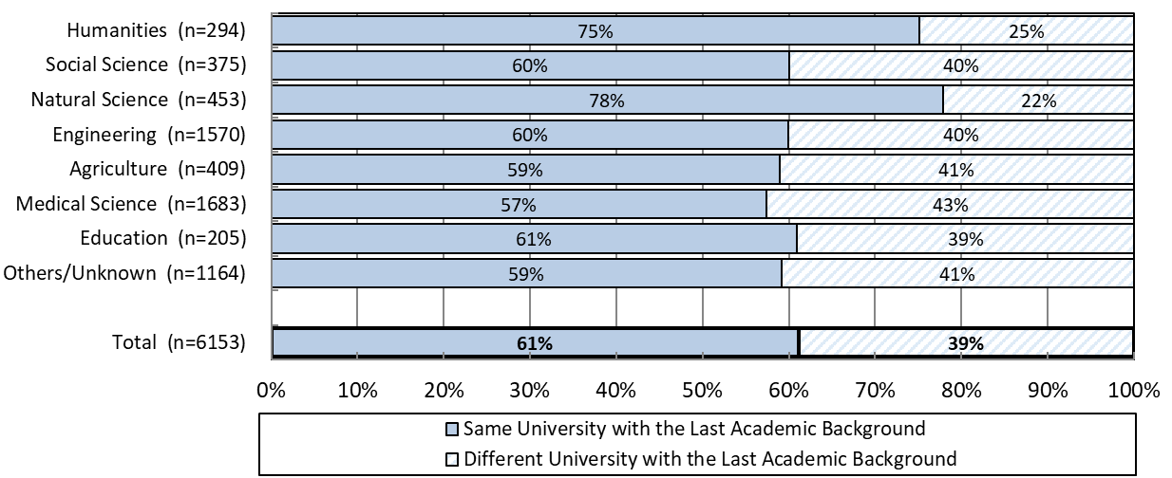

Figure 4 shows ratio of the same main academic advisor with the last academic background. The percentage of same university in all respondents was 50%. The percentages are also relatively higher in “Humanities” and “Natural Science”.

Figure 4. ratio of the same main academic advisor with the last academic background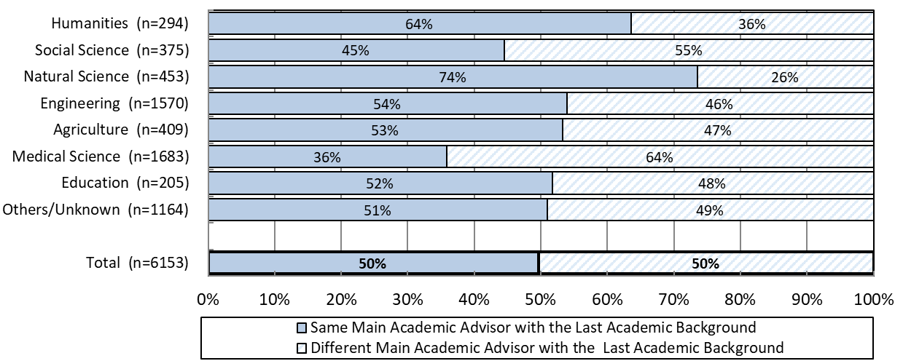

### 2.3. Impression of the Research Environment Compared to what Respondents expected

In the survey, NISTEP asked current impression of the research environment compared to what respondents expected when respondents had decided entering doctoral course. NISTEP asked 7 aspects of research environment such as “[1] secure time for research”, “[2] opportunity (frequency) for research guidance”, “[3] quality of research guidance”, “[4] interaction related to research with non-faculty members”, “[5] research facilities and equipment”, “[6] (public) financial support”, “[7] comprehensive research environment”.

Figure 5 shows the ratio of impression about [3] quality of research guidance. The total percentage of "very good and rather good" was the highest among the seven aspects at 61%. Figure 6 shows the ratio of impression about [6] (public) financial support. The total percentage of "very good and rather good" was the lowest among the seven aspects at 32%.

Figure 5. impression about the quality of research guidance



Figure 6. impression about the public financial support

### 2.4. Preferred Career after completing doctoral course

Figure 7 shows preferred working sector/professional job after completing doctoral course. The ratio of “University / Education” is highest in each research field. However, there are significant differences among research field with respect to percentages.

Figure 7. preferred working sector/professional job after completing doctoral course

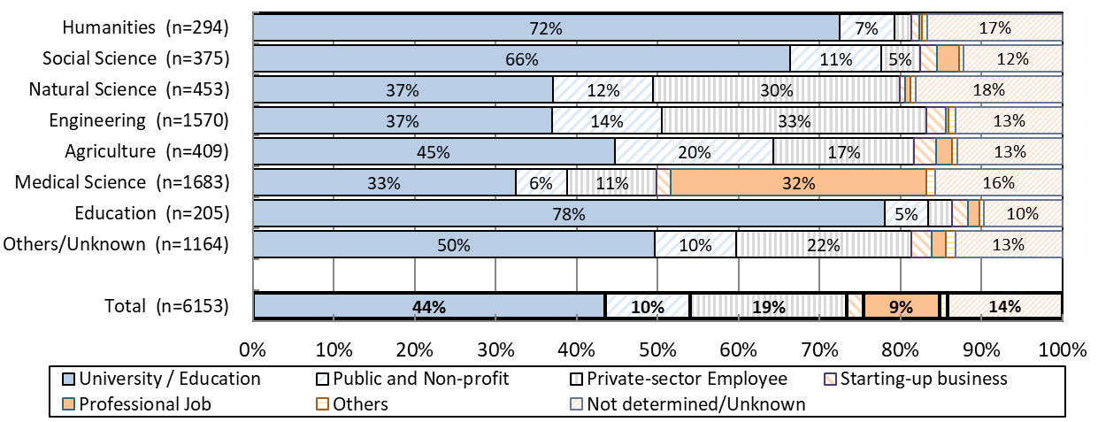

Figure 8 shows preference for educational/research positions after completing doctoral course. The ratios also have significant differences among research. The ratios of preference for educational/research positions are relatively higher in “Humanities”, “Social Sciences”, and “Education”.

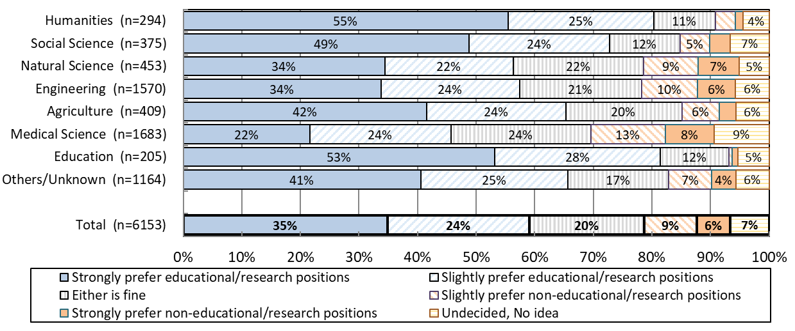

## 3.Concluding Remarks

In this paper, I have shown simple results of "Survey on Career Awareness and Financial Assistance to 1st year of Doctoral Students" by large research fields. NISTEP analyse the survey data by groups of universities in Japan, and detailed research fields. NISTEP will analyse relationship between “research environment and career awareness in 1st year of doctoral students” and “career paths after completing doctoral course” in the future.

**References**

Auriol, L., Misu, M., & Freeman, R. A. (2013). Careers of doctorate holders: Analysis of labour market and mobility indicators. <https://www.oecd-ilibrary.org/content/paper/5k43nxgs289w-en>

Hancock, S. E., Wakeling, P. B. J., & Chubb, J. A. (2019). "21st Century PhDs: Why we need better methods of tracking doctoral access, experiences and outcomes." (RoRI Working Paper No.2). Research on Research Institute. Report. <https://doi.org/10.6084/m9.figshare.9917813.v3>

Hancock, S. (2021). What is known about doctoral employment? Reflections from a UK study and directions for future research. Journal of Higher Education Policy and Management, 43(5), 520-536.

<https://doi.org/10.1080/1360080X.2020.1870027>

Opsomer J, Chen A, Chang W-Y, and Lan F (2023) “U.S. Residing Doctoral Scientists and Engineers Report Modest Professional Impacts from the Coronavirus Pandemic: Findings from the 2021 Survey of Doctorate Recipients.” NSF 23-318. Alexandria, VA: National Science Foundation. <https://ncses.nsf.gov/pubs/nsf23318>

1. JD-Pro (Japan Doctoral Human Resource Profiling) <https://www.nistep.go.jp/jdpro/en/>
2. JGRAD (Japan Graduates Database) <https://jgrad.nistep.go.jp/home_e.html>