Potentials for reducing spatial inequalities in innovation: A spatial econometric perspective
Theresa Bürscher* and Thomas Scherngell**

*theresa.buerscher@ait.ac.at
0009-0007-8399-247X
Austrian Institute of Technology, Austria

**thomas.scherngell@ait.ac.at
0000-0003-4592-4103
Austrian Institute of Technology, Austria

Capabilities of regions to create new knowledge are a major source of regional inequalities in innovation and, thus, economic competitiveness in the long run. Aiming to identify potentials for reducing such inequalities, we analyse the extent to which disparities in regional technological knowledge stocks can be explained by specific characteristics of regional knowledge bases. Specifically, we shift attention to characteristics recently discussed in the context of regional innovation capabilities, among them, indicators capturing the relatedness of the technological fields in which a region is active in, a region’s knowledge complexity, and the technological complementarity of neighbouring regions. We implement a spatial Durbin model for 430 European regions. While high spatial complementarity and relatedness of the region’s technological capacities are conducive to regional innovation, knowledge complexity exhibits a negative indirect effect. In illustrative convergence scenarios, we demonstrate the potential of increasing regional relatedness and complementarity values for reducing inequalities in Europe.

1. Introduction
The investigation of the geographical dynamics of innovation has recently attracted increasing interest in STI studies. Combined with considerations from economic geography, attention has shifted to the exploration of regional inequalities, which has also become a central issue of concern in the public policy debate (see, e.g., Cörvers & Mayhew, 2021; McCann, 2020). Regional innovation capabilities are thought to be strongly related to the underlying characteristics of a region’s knowledge endowments and knowledge production capacities. Understanding how to reduce disparities in knowledge production capacities as a basis for regional innovation, is therefore essential for identifying potentials to reduce interregional disparities in terms of economic performance and welfare (see e.g. Autant-Bernard et al., 2007).

The objective of this study is (i) to identify drivers of disparities in terms of regional knowledge creation, and (ii) to illustrate under which conditions potentials for convergence may be leveraged. While the investigation of drivers of regional knowledge production is by no means new to the literature (see, for instance Wanzenböck & Piribauer, 2018; Wanzenböck et al., 2020), this article shifts attention to the technological knowledge stock, and on the role of three determinants of knowledge creation that came into debate recently, namely, technological relatedness density, knowledge complexity and complementarity of technological knowledge bases of surrounding regions. Following Miguelez and Moreno (2018), we argue that a high cognitive proximity of technologies present in a region – here defined as average relatedness density of technologies a region is specialized in – facilitates the recombination of knowledge and, thus, stimulates regional innovation. Complementarity of spatially close regions, in the following referred to as spatial complementarity, captures technological capabilities in neighbouring regions that are not present in the own technological portfolio yet and related to these missing technologies. By considering spatial complementarity, we acknowledge that access to non-local capabilities, in the form of geographically bounded knowledge spillovers, may compensate for a lack of relevant region-internal capabilities (Balland & Boschma, 2021; Jaffe et al 1993; Fischer et al., 2009). Knowledge complexity indicates the ability of a region to create a diversified portfolio of knowledge, and at the same time export rare and specialised knowledge available only in a few other places (Balland et al., 2019; Pintar & Scherngell, 2021).

While these concepts have been used to describe paths of regional technological diversification (see e.g., Boschma et al., 2015; Balland & Rigby 2017; Balland et al., 2019), and were linked to economic indicators, such as employment growth and growth of gross domestic product (see e.g., Pintar & Scherngell, 2021; Rigby et al., 2022), their connection to a region’s overall technological knowledge output, and thereby their potential for reducing regional inequalities in innovation, is still understudied. Moreover, spatial spillover effects emanating from these drivers are yet neglected in empirical research. To close this gap, we employ a spatial econometric framework in form of a spatial Durbin model (SDM) to account for such spatial effects. Conceptually our empirical model is inspired by the literature stream using a Knowledge Production Function (KPF) framework to establish the link between inputs into the knowledge creation process and respective knowledge outputs.

2. Method, Data & Variables
To identify potentials for reducing regional inequalities, we initially investigate drivers of regional knowledge creation, employing a spatial Durbin model (SDM) inspired from a regional KPF framework. For a set of regions i,j = 1, … , n, the basic model is specified as:

$$y= ρWy+Xβ+γZ+ ψ∑(W⊙C)+ WXθ+ WZλ+u$$ | (1)

with $u\sim Ν(0, σ^{2}I_{N})$. $y$ is an n-dimensional vector reflecting technological knowledge production measured as the log of a region’s knowledge stock. $Wy$ is the dependent variable lagged in space, with $ρ$ representing the spatial dependence parameter, and $W$ the n-by-n row standardized spatial weight matrix that describes the connectivity of spatial units. $X$ is the n-by-m matrix of the main variables under consideration. $∑(W⊙C)$ is an n-dimensional vector capturing average complementarity of neighbouring regions, where $C$ is an n-by-n complementarity matrix, with $c_{ij}$ reflecting the complementary capacity that region j holds for region i. $Z$ captures control variables, $WX$ and $WZ$ represent the spatial lags of explanatory and control variables, respectively.

The analysis covers 430 regions of current EU-27 countries, as well as Norway and the UK, using the NUTS adapted regional classification developed by Lepori et al. (2019) . We use data spanning the period 2010-2014 for explanatory variables and 2010-2019 for the dependent variable. The latter is defined as logged regional knowledge stock and calculated using patent data, assuming a constant yearly depreciation rate of 12%, with data spanning the years 2010-2019. We only considered regions that produced at least 50 fractionally counted patents in period 2010-2014. Patent data is obtained from the OECD’s REGPAT database, also building the base for relatedness, knowledge complexity and complementarity indicators. For these measures, we follow Pintar and Scherngell (2022) and use technological classification as proposed by Schmoch (2017), where International Patent Classification (IPC) classes are mapped onto 35 technology fields.

Our three indicators of core interest are defined as follows:

- To capture the effect of relatedness of a region’s knowledge base, we construct a relatedness density measure for each region i and technology k, closely following Balland et al. (2019). Relatedness density for technology k and region i is defined as the sum of relatedness between technology k and all technologies region i has revealed technological advantage (RTA) in, in relation to the sum of technological relatedness of technology k and all technologies present in the sample. We then calculate the average relatedness density for all technologies present in a region. For the sake of brevity, we will refer to the first specification of relatedness as relatedness density
- To proxy spatial complementarity, i.e., the extent to which neighbours of region i’s have RTA in technologies k that are both related to the technologies l missing in region i and not present in region i yet, we employ the technology specific complementarity measure of Balland and Boschma (2021). We calculate the complementarity value for all neighbouring regions for all technologies l missing in a region, i.e., technologies where RTA = 0, and take the average.
- Regional knowledge complexity (KCI) is calculated following Pintar and Scherngell (2022). It captures both the regional breadth and depth of knowledge, as well as the interconnections and interactions among different knowledge domains. We define a regional knowledge complexity index (see Pintar & Scherngell 2022 for the formal definition) that relies on the diversity of a region's patent portfolio in terms of the technological fields the patents are applied in, and its ubiquity within a network of technologies recorded in patents. A region with a high KCI is therefore not only able produce knowledge in a diversified set of technological domains, but also in rare domains assumed of high value for economic exploitation in the future.

In addition, we add different control variables to test the robustness of the estimates for our main independent variables, such as (i) logged degree centrality, reflecting R&D network effects, (ii) human resources, (iii) population, controlling for a region’s size, and (iv) a metro-dummy variable, reflecting agglomeration effects. Logged degree centrality is defined as the logged number of a region’s network links (see Wasserman & Faust 1994) and constructed based on data on collaborative projects of the European Framework Programme (FP), retrieved from the EUPRO database, available via RISIS (risis2.eu). Data for the remaining control variables is drawn from Eurostat’s regional database. Human resources are proxied by the share of persons with tertiary education and/or employed in science and technology (HRTS). Population is defined as the logged number of inhabitants. The metro-dummy takes the value of 1 if a region represents a metro region according to the NUTS-adapted classification. Summary statistics of the variables are shown in the Appendix in Table A1.

3. Empirical Results
Table 1 presents the impact effects of the estimated SDM. The first column part contains the direct effects of the SDM referring to the impact of a change in a certain explanatory variable in region i on its own logged knowledge stock. The indirect effect, given in the second column, captures how region i is affected by a change in the independent variable of interest in neighboring regions. The total effect is the sum of the direct and the indirect effect. Table A2 in the Appendix presents the respective estimated coefficients for different specifications of our model.

Table 1. Impact estimates of the SDM

Dependent variable: Knowledge Stock (log), 2010-2019
 | Direct effects | Indirect effects | Total effects
Relatedness density | 0.012 *** | 0.081 *** | 0.093 ***
 | (0.004)^^ ^ | (0.025) ^^ ^ | (0.027)^^ ^
Spatial complementarity | 0.025 *** | 0.066 *** | 0.090 ***
 | (0.009)^^ ^ | (0.021)^^ ^ | (0.030)^^ ^
Complexity | -0.002 xc | -0.061 *** | -0.063 ***
 | (0.002)^^ ^ | (0.014)^^ ^ | (0.015)^^ ^
Degree centrality (log) | 0.261 *** | -0.266 ^ ^ | -0.005^ ^ ^
 | (0.052)^^ ^ | (0.308)^^ ^ | (0.336)^^ ^
Human Resources (HRST) | 0.042 *** | 0.039 ^ | 0.081 **^
 | (0.006)^^ ^ | (0.032)^^ ^ | (0.034)^^ ^
Population (log) | 0.751 *** | -1.137 *** | -0.386^ ^^
 | (0.064)^^ ^ | (0.421)^^ ^ | (0.467)^^ ^
Metro Region | 0.159 **^ | 0.893^ ^^ | 1.052^ ^^
 | (0.097)^^ ^ | (0.630)^^ ^ | (0.757)^^ ^
ρ (spatial parameter) | 0.757 *** | °
 | (0.678) °
Notes: ρ is the spatial dependence coefficient (not impact estimate); Impacts are significant at the p<0.1*, p<0.05**, p<0.01*** level. Standard errors are shown in parentheses. Impacts are determined according to LeSage and Pace 2009; statistical significance is based on 1,000 simulation runs. The number of observations is 430. The spatial weights matrix W is constructed using 8-nearest neighbours.

The results are highly interesting in the context of current debates on the drivers of regional knowledge production. First, as expected, we find that relatedness density is significantly positively associated with a region’s logged knowledge stock. This result supports the view that being specialized in related technologies facilitates the recombination of existing knowledge pieces, and thus stimulates regional technological knowledge creation. This is in line with previous literature (see, for example, Miguelez & Moreno, 2018, Tavassoli & Carbonara, 2014; Castaldi et al., 2015), despite using a different estimation method, a different operationalization of the relatedness measure and different geographic scope. Besides the significant and positive direct effect, we also find a significantly positive indirect effect, indicating that regions benefit not only from region-internal relatedness, but also from neighbouring regions with a related knowledge base.

Second, the results also point to a positive effect of spatial complementarity on technological knowledge production. This indicates that regional innovative output benefits from extra-regional knowledge that is complementary, and not necessarily similar to, the existing knowledge base, suggesting that knowledge flows from neighbouring regions that provide access to technological knowledge in a field not present in a region, may stimulate regional knowledge production, and may prevent the region from a potential lock-in situation (Balland & Boschma, 2021).

Third, interestingly, we find a significantly negative total effect of knowledge complexity on a region’s knowledge stock, which is mainly driven by the negative indirect effect, i.e., the negative spatial spillover effects of knowledge complexity. These negative indirect effects are in line with the notion that complex knowledge is characterized by low accessibility, a high degree of tacitness and, consequently, a pronounced spatial stickiness (Pintar & Scherngell, 2022), suggesting that regions cannot successfully tap complex knowledge sources from neighbouring regions, which could eventually stimulate additional innovation outcome.

The ρ coefficient, indicating spatial spillovers of the dependent variable, is highly significant and high in magnitude. This highlights the importance of spatial proximity, confirming that the knowledge stock of a region is positively determined by the knowledge stocks of surrounding regions. This is in line with the literature (see e.g. Neuländtner & Scherngell, 2022; Wanzenböck & Piribauer, 2018) and suggests that there is a geographical bias in knowledge spillovers. The importance of neighbourhood effects and external knowledge flows is also highlighted by the positive effect of spatial complementarity and the indirect effect of relatedness density. These impact estimates further suggest that the effect of spatial knowledge spillovers on a region’s knowledge creation is not only determined by the size of the knowledge stock of surrounding regions, but also depends on the technological knowledge structure of these surrounding regions, i.e., the composition of knowledge fields present in the regions (Boschma et al., 2017).

As what concerns the control variables, our estimates are expected in relation to previous work (see e.g. Wanzenböck & Piribauer, 2018; Autant-Bernard et al., 2007).We find positive direct effects for both degree centrality and human resources. The negative indirect effect associated with degree centrality – indicating that being located near regions that are well embedded in collaborative R&D links hinders, rather than stimulated, one’s own regional patenting activity – is counterintuitive to the idea of spatial spillovers. However, it can be explained by the presence of outliers, in the form of individual regions with both particularly high knowledge stocks and high embeddedness in the R&D network that are surrounded by regions with low levels of knowledge stock and a low degree centrality. As expected, we find positive and significant direct effects for both human resources and population. The latter serves as an agglomeration measure to control for the size of a region. We also find significantly positive direct effects for the metro region dummy variable.

4. Illustrating convergence potentials
The empirical results described in the previous section pave the way for using these estimates to illustrate potentials for reducing inequalities in regional innovation capacity across Europe. Using the direct and indirect impact estimates of the SDM as presented in the first column of Table 1, we try to capture the potentials of the explanatory variables to reduce spatial inequalities across regions. As our results suggest that there is no positive association between knowledge complexity and knowledge stock, we shift our attention to the effects of relatedness density and spatial complementarity. To demonstrate their relevance in explaining the observed disparities in regional knowledge stocks, and thus to illustrate potential convergence pathways, we calculate the predicted regional knowledge stock per million inhabitants, while synthetically increasing the values of the variables of interest in lagging regions.

Figure 1 Predicted Gini Coefficient across regions in terms of knowledge stock per million if lagging regions close x% of their gap to highest observed value in the respective explanatory variable.

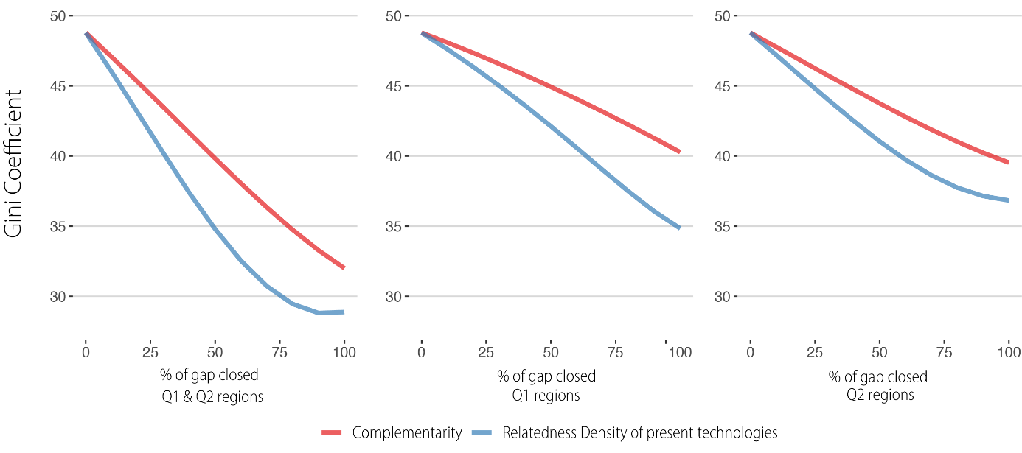

Figure 1 illustrates the evolution of overall regional inequality – measured by the Gini index across regions in terms of the predicted stock of knowledge per million inhabitants – assuming that all lagging regions gradually increase their value in the variable of interest, until the lagging regions reach the highest empirically observed value of relatedness density or complementarity respectively or put differently, until they close 100% of the gap in the respective variable. We specify different groups of lagging regions; Q1 regions include all regions in the lowest quartile of knowledge stock per million inhabitants, Q2 regions refer to all regions above the first quartile but below the median, while Q1& Q2 regions include all regions below the median. These groups of lagging regions are shown on a map in Figure A1 in the Appendix. As implied by their positive impact estimates, both variables of interest yield a potential to reduce regional disparities. However, this potential appears to be stronger for relatedness density than for complementarity. For both Q2 and Q1 & Q2 regions, the decrease in the Gini coefficient starts to decline for the relatedness-simulation, suggesting that as the explanatory variables change, some formerly lagging regions overtake the non-lagging regions in terms of their population adjusted knowledge stock.

Figure 2 Spatial distribution of predicted regional knowledge stock per million in relation to the regional knowledge stock per million averaged over all observations, when Q1 and Q2 regions close the gap to the highest observed value of spatial complementarity

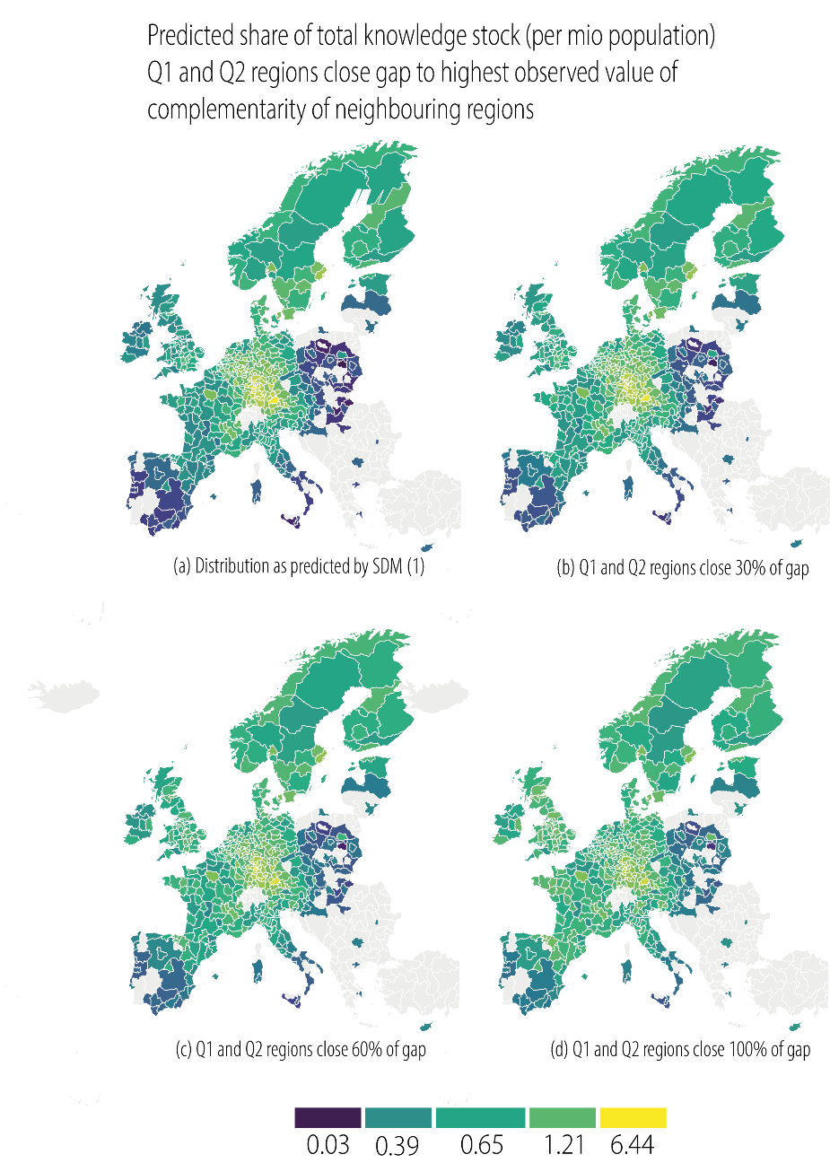

Figure 3 Spatial distribution of predicted regional knowledge stock per million in relation to the regional knowledge stock per million averaged over all observations, when Q1 and Q2 regions close the gap to the highest observed value of relatedness density

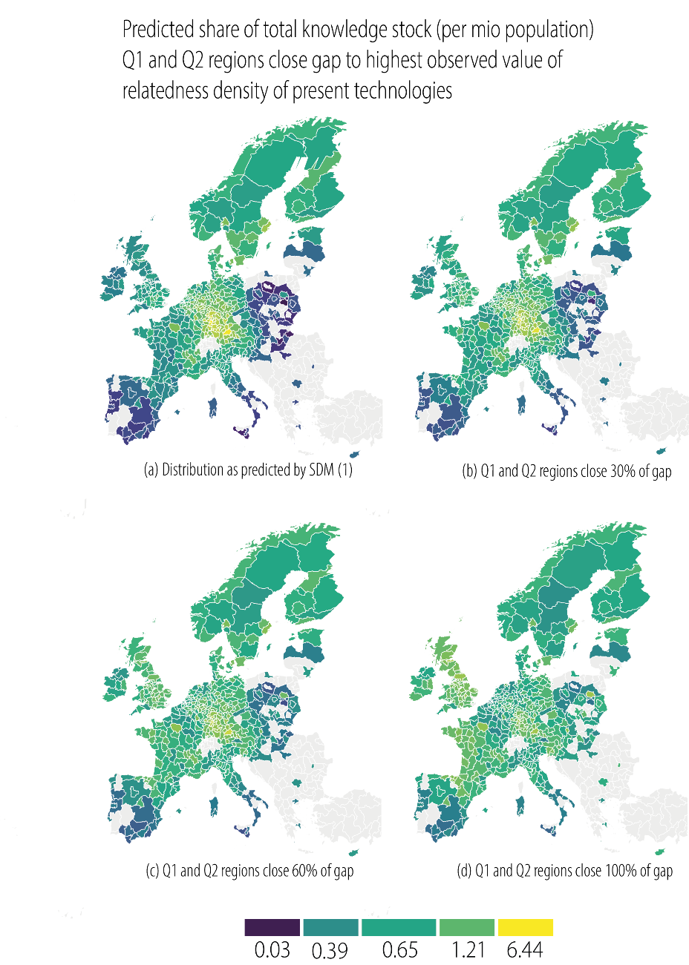

Figure 2 for spatial complementarity and Figure 3 for relatedness density, show the spatial distribution of the regional knowledge stock per million in relation to the average knowledge stock per million inhabitants across all regions, (a) based on the observed empirical values of the explanatory variables, (b) after the regions have closed 30%, (c) 60% and (d) 100% of the gap to the highest observed value of the respective variable. Map (a) confirms that the predicted stock of knowledge per million, based on empirical explanatory variables, tends to be low in southern and eastern European regions, while central European regions – particularly regions in southern Germany – are characterized by predicted values of knowledge stock per million that are up to six times as high as the European average. When the explanatory variable of interest is synthetically increased step by step, lagging regions gradually catch-up with stronger regions. This convergence process is particularly visible in Figure 3, where we assume that lagging regions manage to increase the relatedness of their knowledge base; while the predicted regional share of the average knowledge stock per million is as low as 0.03 times the European average for some Polish and southern Italian regions in the baseline scenario (a), all lagging regions reach a knowledge stock equivalent to at least one third of the European average in scenario (d).
We want to stress that the simulations only represent descriptive scenarios to explore the impact of the observed variables on regional inequality in terms of technological knowledge creation. In particular, the complementarity value, which is given externally by the location of the region, is nothing the region itself can change.

5. Conclusion
Local knowledge endowments are widely regarded as the fundamental basis of a region’s innovative capacity, and accordingly, viewed as a major source of spatial inequalities in innovation and, hence, economic competitiveness in the long run. While the concepts of knowledge complexity, technological relatedness and complementarity of external knowledge bases have been widely discussed conceptually (e.g., Balland & Rigby, 2017; Boschma et al., 2015) and have recently also been studied empirically, mostly to explain regional paths of technological development (e.g., Balland & Boschma, 2021; Balland et al., 2019), there is still little understanding of how relevant they are for explaining regional disparities in terms of regional knowledge production.

In an attempt to fill this gap, we estimated a spatial Durbin model for 430 European regions, investigating the effects of both region-internal and spatially lagged average technological relatedness density, and knowledge complexity, such as the effects of complementarity of the technological knowledge base of neighbouring regions. As expected, regional knowledge stocks are positively associated with relatedness density for the observed European regions. Regarding spatial spillovers, we find positive effects of spatial complementarity, i.e., technological complementarity of surrounding regions. In contrast, knowledge complexity shows a negative indirect effect, supporting the idea of its spatially sticky nature (Balland et al., 2019; Maskell, 1999). This indicates that, even if both knowledge complexity and the overall volume of knowledge production are important drivers of regional economic growth (Pintar and Scherngell 2022), it is not necessarily the regions with the highest amount of patents that have capabilities in the most complex knowledge domains, pointing to different pathways for leveraging potentials to reduce inequalities. Lagging regions that have the capacity to diversify into complex technologies do not necessarily need to widen their overall knowledge base and volume of knowledge production in terms of patents. However, given their existing knowledge base, many lagging regions do not have potential to directly diversify into complex technologies (Balland et al., 2019).
The estimated effects point to different convergence scenarios, i.e., potential pathways for lagging regions to catch-up and to strengthen their overall innovative capacity. One promising pathway clearly lies in the development of strategic links with regions with technologically complementary capabilities. An even higher potential for catching-up could be generated by a more targeted development of capacities in technologies related to the current knowledge base. A combination of both, i.e., increasing complementarity and regional-internal technological relatedness, generates the highest convergence potential.

The positive effects of spatial complementarity but also the positive indirect effects identified for relatedness density, have important implications for the European Union’s Smart Specialization Strategy; they suggest that considering the technological capacities of neighbouring regions could prove beneficial in the implementation of smart specialization policies.

6. References
Autant-Bernard, C., Mairesse, J., & Massard, N. (2007). Spatial knowledge diffusion through collaborative networks. Papers in Regional Science, 86(3), 341–350. https://doi.org/10.1111/j.1435-5957.2007.00134.x

Balland, P.A., Economic Geography in R: Introduction to the EconGeo Package (April 27, 2017). Available at SRN: https://ssrn.com/abstract=2962146 or http://dx.doi.org/10.2139/ssrn.2962146

Balland, P.‑A., & Boschma, R. (2021). Complementary interregional linkages and Smart Specialisation: an empirical study on European regions. Regional Studies, 55(6), 1059–1070. https://doi.org/10.1080/00343404.2020.1861240

Balland, P.‑A., Boschma, R., Crespo, J., & Rigby, D. L. (2019). Smart specialization policy in the European Union: relatedness, knowledge complexity and regional diversification. Regional Studies, 53(9), 1252–1268. https://doi.org/10.1080/00343404.2018.1437900

Balland, P.‑A., & Rigby, D. (2017). The Geography of Complex Knowledge. Economic Geography, 93(1), 1–23. https://doi.org/10.1080/00130095.2016.1205947

Boschma, R., Balland, P.‑A., & Kogler, D. F. (2015). Relatedness and technological change in cities: the rise and fall of technological knowledge in US metropolitan areas from 1981 to 2010. Industrial and Corporate Change, 24(1), 223–250. https://doi.org/10.1093/icc/dtu012

Boschma, R., Martín, V., & Minondo, A. (2017). Neighbour regions as the source of new industries. Papers in Regional Science, 96(2), 227–245. https://doi.org/10.1111/pirs.12215

Castaldi, C., Frenken, K., & Los, B. (2015). Related Variety, Unrelated Variety and Technological Breakthroughs: An analysis of US State-Level Patenting. Regional Studies, 49(5), 767–781. https://doi.org/10.1080/00343404.2014.940305

Cörvers, F., & Mayhew, K. (2021). Regional inequalities: Causes and cures. Oxford Review of Economic Policy, 37(1), 1–16. https://doi.org/10.1093/oxrep/graa067

Fischer, M. M., Scherngell, T., & Reismann, M. (2009). Knowledge Spillovers and Total Factor Productivity: Evidence Using a Spatial Panel Data Model. Geographical Analysis, 41(2), 204–220. https://doi.org/10.1111/j.1538-4632.2009.00752.x

Jaffe, A.B., Trajtenberg, M., Henderson, R., (1993). Geographic localization of knowledge spillovers as evidenced by patent citations. Q J Econ 108:577–598. doi:10.2307/2118401

Lepori, B., Guerini, M., Scherngell, T., & Laredo, P. (2019). The spatial distribution of knowledge production in Europe. Evidence from KET and SGC. In ISSI 2019 - 17th International Conference On Scientometrics & Informetrics

Maskell, P. (1999). Localised learning and industrial competitiveness. Cambridge Journal of Economics, 23(2), 167–185. https://doi.org/10.1093/cje/23.2.167

McCann, P. (2020). Perceptions of regional inequality and the geography of discontent: insights from the UK. Regional Studies, 54(2), 256–267. https://doi.org/10.1080/00343404.2019.1619928

Miguelez, E., & Moreno, R. (2018). Relatedness, external linkages and regional innovation in Europe. Regional Studies, 52(5), 688–701. https://doi.org/10.1080/00343404.2017.1360478

Neuländtner, M., & Scherngell, T. (2022). R&D networks and their effects on knowledge exploration versus knowledge exploitation: Evidence from a spatial econometric perspective. Industry and Innovation, 1–32. https://doi.org/10.1080/13662716.2022.2063110

Pintar, N., & Scherngell, T. (2021). The complex nature of regional knowledge production: Evidence on European regions. Research Policy, 104170. https://doi.org/10.1016/j.respol.2020.104170

Rigby, D. L., Roesler, C., Kogler, D., Boschma, R., & Balland, P. A. (2022). Do EU regions benefit from Smart Specialisation principles?. Regional Studies, 56:12, 2058-2073, DOI: 10.1080/00343404.2022.2032628

Schmoch, U. (2017). Concept of a technology classification for country comparisons (Final report to the World Intellectul Property Organization). WIPO. http://www.world-intellectual-property-organization.com/edocs/mdocs/classifications/en/ipc_ce_41/ipc_ce_41_5-annex1.pdf

Steijn, M. P. A. (2020). Improvement on the association strength: implementing a probabilistic measure based on combinations without repetition. Papers in Evolutionary Economic Geography (PEEG), 2020.

Tavassoli, S., & Carbonara, N. (2014). The role of knowledge variety and intensity for regional innovation. Small Business Economics, 43(2), 493–509. https://doi.org/10.1007/s11187-014-9547-7

Wanzenböck, I., Neuländtner, M., & Scherngell, T. (2020). Impacts of EU funded R&D networks on the generation of key enabling technologies: Empirical evidence from a regional perspective. Papers in Regional Science, 99(1), 3–24. https://doi.org/10.1111/pirs.12473

Wanzenböck, I., & Piribauer, P. (2018). R&D networks and regional knowledge production in Europe: Evidence from a space-time model. Papers in Regional Science, 97, S1-S24. https://doi.org/10.1111/pirs.12236

Wassermann, S., & Faust, K. (1994). Social Network Analysis: Methods and Application. Cambridge, University Press

Open science practices
All calculations were done in R. The source code is available upon request. The data are openly available. Data on the socio-economic control variables was retrieved from Eurostat’s regional database. Data on network centrality is obtained from RISIS (rcf.risis2.eu/datasets). The calculation of the technology indicators is based on data drawn from the OECD’s REGPAT database.

Author contributions
Theresa Bürscher: Conceptualization, Methodology, Formal analysis, Data curation, Writing, Visualization. Thomas Scherngell: Conceptualization, Methodology, Validation, Writing, Supervision.

Competing interests
The authors declare that they have no competing financial interests or personal relationships that could have appeared to influence the work reported in this paper.

Funding information
This work has been partly funded by RISIS (risis2.eu) under the Horizon2020 Research and Innovation Programme Grant Agreement n°824091.

Appendix
Table A1: Summary statistics

 | N | Min | Mean | Median | Max | SD | Period
Knowledge stock (log) | 430 | 4,15 | 6,48 | 6,49 | 10,47 | 1,22 | 2010-2019
Average relatedness density | 430 | 10,94 | 39,86 | 39,76 | 64,87 | 10,53 | 2010-2014
Spatial complementarity | 430 | 9,13 | 20,10 | 19,92 | 36,85 | 4,74 | 2010-2014
Complexity | 430 | 0,00 | 29,69 | 28,22 | 100,00 | 17,18 | 2010-2014
Diversification | 430 | 3,00 | 12,00 | 12,00 | 19,00 | 2,77 | 2010-2014
Degree centrality (log) | 430 | 0,00 | 5,20 | 5,40 | 6,20 | 0,80 | 2010-2014
Human Resources (HRST) | 430 | 15,00 | 31,68 | 32,24 | 51,64 | 6,57 | 2010-2014
Population (log) | 430 | 11,48 | 13,56 | 13,50 | 16,41 | 0,72 | 2010-2014

Table A2: Coefficients of different model specifications

 | OLS | SAR | SDM
Relatedness density | 0.026*** | 0.008**^ | 0.009***
 | (0.005)^^^ | (0.003) ^^ | (0.003)^^^
Spatial complementarity | 0.027**^ | 0.010^^^ | 0.022***
 | (0.011) ^^ | (0.008)^^^ | (0.007) ^^
Complexity | -0.019*** | -0.006*** | 0.001^^^
 | (0.003) ^^ | (0.002) ^ ! | (0.002) ^ ^
Degree centrality (log) | 0.302*** | 0.256*** | 0.272***
 | (0.070) ^^ | (0.049) ^^ | (0.045)^^^
Human Resources (HRST) | 0.077*** | 0.050*** | 0.040***
 | (0.008)^^^ | (0.005) ^^ | (0.006)^^^
Population (log) | 0.451*** | 0.757*** | 0.798***
 | (0.071)^^^ | (0.050) ^ ^ | (0.047)^^^
Metro Region | 0.231**^ | 0.210*** | 0.122**^
 | (0.096) ^^ | (0.068)^^^ | (0.06)^^^
SL: Relatedness density | - | - | 0.014 *
 |  |  | (0.007) ^^^
SL: Complexity | - | - | -0.016 ***
 |  |  | (0.004) ^^^
SL: Degree centrality (log) | - | - | -0.273***
 |  |  | (0.086)^^^
SL: Human Resources (HRST) | - | - | -0.021**^
 |  |  | (0.010)^^^
SL: Population (log) | - | - | -0.892***
 |  |  | (0.108)^^^
SL: Metro Region | - | - | 0.134^^^
 |  |  | (0.172)^^^
Constant | -4.800*** | -12.490*** | 1.138^^^
 | (0.956)^^^ | (0.672)^^^ | (1.555)^^^
ρ (spatial lag) | - | 0.814 *** | 0.757***
 |  | (0.020) ^^^ | (0.039)^^^
R2 | 0.393
Akaike Inf. Crit. |  | 913.506 | 808.670
Log Likelihood |  | -446.753 | -388.335
Notes: Data on explanatory variables are significant at the p < 0.1*; p < 0.05**; p < 0.01*** level. Standard errors are shown in parentheses. SL refers to the spatial lag of the respective variable. The number of observations for each model is 430. The spatial weights matrix W is constructed using 8-nearest neighbours

Table A3: Impact estimates SDM

 | Direct Effect | Indirect Effect | Total Effect
Relatedness density | 0.0226*** | 0.0838*^^ | 0.1064**^
 | (0.006)^^^ | (0.042)^^^ | (0.046)^^^
Complementarity | 0.0032^^^ | 0.0092^^^ | 0.0125^^^
 | (0.011)^^^ | (0.025)^^^ | (0.036)^^^
Complexity | -0.0002^^^ | -0.0516*** | -0.0517***
 | (0.003)^^^ | (0.015)^^^ | (0.016)^^^
Diversification | -0.0626*** | 0.0547^^^ | -0.008^^^
 | (0.025)^^^ | (0.177)^^^ | (0.194)^^^
Degree centrality (log) | 0.2599*** | -0.3764^^^ | -0.1165^^^
 | (0.052)^^^ | (0.313)^^^ | (0.340)^^^
Human Resources (HRST) | 0.0436*** | 0.043^^^ | 0.0865**^
 | (0.007)^^^ | (0.032)^^^ | (0.034)^^^
Population (log) | 0.7571*** | -1.0632** | -0.3061^^^
 | (0.062)^^^ | (0.423)^^^ | (0.465)^^^
Metro Region | 0.1751**^ | 10.801^^^ | 12.551^^^
 | (0.093)^^^ | (0.697)^^^ | (0.772)^^^
ρ (spatial parameter) | 0.771***
 | 0.038
Notes: ρ is the spatial dependence coefficient (not impact estimate); Impacts are significant at the p < 0.1*, p < 0.05**, p < 0.01*** level. Standard errors are shown in parentheses. Impacts are determined according to LeSage and Pace 2009; statistical significance is based on 1,000 simulation runs. The number of observations is 430. The spatial weights matrix W is constructed using 8-nearest neighbours. Diversification is measured as the number of technologies a region has RTA in.

Figure A1: Regions in the first (Q1) and second quartile (Q2) with respect to their knowledge stock per million inhabitants.

We use an 8 nearest neighbour neighbourhood definition, but also controlled for robustness of the results estimating the model with 4-12 nearest neighbour matrixes.
The classification scheme builds on Eurostat’s metropolitan regions (MR), grouping all remaining non-urban NUTS3 regions within the same NUTS2 region in a single region. A few NUTS3 regions with sizeable knowledge production (not included in the MRs) are singled out and enter on NUTS3 level.
The data is aggregated to smoothen yearly variation of patent data. Using the lag of the independent variable reduces the risk of endogeneity.
For details on the calculation of the knowledge stock variable, see Fischer et al. (2009).
A region has RTA in technology k if the share of the regions knowledge production in technology k is higher than the share of technology k in the whole sample. To ensure that a region does not have a RTA based on a small number of patents, we only allow a region to have RTA in a certain field, if it has at least 5 fractionally counted patents in this field.
Technological relatedness is calculated as a standardized measure of the number of co-occurrence of technology classes on the same patent, using the standardization method of Steijn (2020) and the Econ Geo R package P. A. Balland (2017). The results are robust to different standardization methods.
HRTS data is only available on NUTS2 level and was transformed to NUTS-adapted level assuming that all NUTS3 regions within a NUTS2 region share the same value with respect to HRTS.
Due to feedback effects from neighbouring regions, the interpretation of the estimated coefficients is not straightforward. Taking these feedback effects into account, we present the results of SDM model in direct, indirect, and total effects, as suggested by LeSage and Pace (2009).
Note that the relatedness measure is by construction positively correlated with the overall diversification of a region’s knowledge space, i.e., the number of technologies the region has RTA in. To control for the possibility that our results are solely driven by a regions overall diversification, we estimate an additional model confirming that the effects are robust to the inclusion of diversification (see Appendix Table A3).
Adjusting for population when analysing heterogeneity of regional knowledge stocks allows to control for differences in size.
By construction, all regions would take a value of one if knowledge stock per million was equally distributed across regions.

