From STEM to STEAM? Exploring the connections
between Arts and Sciences

Kamila Lewandowska*, Alfredo Yegros**

* k.lewandowska11@uw.edu.pl
ORCID: 0000-0002-2189-239X
Science Studies Laboratory, Centre for European Regional and Local Studies (EUROREG),
University of Warsaw, Warsaw, Poland

** a.yegros@cwts.leidenuniv.nl
ORCID: 0000-0002-0544-7878
Centre for Science and Technology Studies,
Leiden University, Leiden, Netherlands

Abstract
This study explores the interconnections between Arts and Sciences. It uses two different analytical approaches: first, it explores the Arts-Sciences connections by analysing the disciplinary assignment of journals in the WoS database; second, it investigates knowledge flows between Arts and Sciences at two levels of aggregation (scientific fields and disciplines) in 2000-2021. The results suggest a growing, albeit small trend towards Arts-Sciences interdisciplinarity and demonstrate that Art and Sciences increasingly rely on each other in the process of new knowledge creation. The analysis also reveals a number of specific reciprocal links between particular Arts and Sciences disciplines (e.g. between Music and Medical Sciences or Visual Arts and Engineering & Technology).

1. Introduction

There is a vast scientometric research on interdisciplinarity and knowledge flows between disciplines (e.g., Yan et al. 2013; Yergos-Yergos et al. 2015). While some studies have analysed the relationship between social sciences and humanities (SSH) and natural or hard sciences (e.g., Nishikawa 2023), very few have focused uniquely on the Arts subdiscipline and its convergence with the scientific fields (Santi et al. 2021).
Meanwhile, studying the patterns of knowledge dissemination between the field of Arts and different fields of science is relevant and should receive more scholarly attention, given the upsurge of interest in the integration of science and technology with the arts (Santi et al. 2021). The shift “from STEM to STEAM ” – i.e. the inclusion of art (music, visual arts, and drama) within the STEM (science, technology, engineering and math) fields – has been identified by researchers who emphasized the need for more interdisciplinary and human-centred models in industry, business, and science education (e.g. Boy 2013; Stewart et al. 2019; Videla et al. 2021). Scholars have demonstrated that art helps science students become more creative, motivated and self-confident (Conradty & Bogner 2019; Pfeiffer et al. 2017), improves their learning abilities, problem-solving skills, analytical thinking, and many more (Bicer et al. 2017; Sousa & Pilecki 2013). At the same time, the existing research focuses almost exclusively on the instrumental use of art-making and we still know very little about the citation and knowledge flow between art and science: that is, if and how knowledge produced within the Arts field is used by science scholars, and vice versa.
In this study we set out to explore the relationship between arts and science by analysing if and to what degree the field of Art and other science fields are interconnected. We study the integration of Arts and Sciences by analysing the disciplinary coverage of journals in the WoS database. We also examine the citation flow between Arts and science fields to see how they rely on each another in the process of new knowledge creation.

2. Data and method

2.1. Data source and selection of documents

We used the CWTS in-house version of the Web of Science (WoS). We selected all publications in the period 2000-2021 in three editions of the database: Arts and Humanities, Sciences and Social Sciences.

2.1. Fields of science covered in the study

In order to study the relationship between Arts and other fields of science, we consider two levels of thematic aggregations: (1) Fields of science, which we classify using the OECD’s Fields of Science and Technology (FOS) classification, and (2) Scientific disciplines, which we select using WoS Subject Categories (WoS SCs). We use the existing mapping between WoS Subject Categories (WoS SCs) and the FOS classification to consider specific disciplines within these broad fields.

We analyse the relationship between Arts and four broad areas in the FOS classification: 1) Natural Sciences; 2) Engineering and Technology; 3) Medical and Health Sciences; 4) Agricultural Sciences; 5) Social Sciences. As neither WoS nor FOS has a separate “Arts” field/category, we developed this category by selecting a number of WoS SCs (Table 1). We further classified the selected SCs (disciplines) as “only”- or “partial” Arts (Table 1). This binary classification was applied to distinguish between the “purely” artistic disciplines (such as visual and performing arts) and disciplines related to Arts but also associated with other fields (such as Literature or Medieval & Renaissance Studies associated with the general Humanities). The selection of Arts disciplines and the binary classification was determined by the Authors.

Table 1. SCs in WoS classified as Arts.
WoS Subject Category | Arts
Art | only
Dance | only
Film, Radio, Television | only
Literary Reviews | only
Music | only
Poetry | only
Theater | only
Architecture | partial
Asian Studies | partial
Classics | partial
Cultural Studies | partial
Folklore | partial
Humanities, Multidisciplinary | partial
Literary Theory & Criticism | partial
Literature | partial
Literature, African, Australian, Canadian | partial
Literature, American | partial
Literature, British Isles | partial
Literature, German, Dutch, Scandinavian | partial
Literature, Romance | partial
Literature, Slavic | partial
Medieval & Renaissance Studies | partial

Note that most of the disciplines we considered only or partially related to Arts, are classified in the FOS classification within the Humanities, with the exception of Asian Studies and Cultural Studies, which are classified under the Social Sciences. In our study, all these selected disciplines (Table 1) are only considered in the “Arts” category we designed, and not in FOS Humanities or Social Scienes.

2.3. Exploring the interconnections between Arts and other fields of science

We explore the relationship between Arts and other fields of science from two different perspectives. First, we study the integration of Arts with other fields by analysing the disciplinary coverage of journals. WoS assigns to each journal one or several SCs. These SCs are intended to describe the disciplinary scope of the research published in a given journal. As journals often publish research across a variety of disciplines, WoS often assigns more than one SC to a given journal. The assignment of a SC to a journal is done according to several criteria: the subject matter and scope of the journal; the affiliations of the editorial board and authors; funding bodies supporting the research; direct citation relations (citing/cited); journals’ sponsors as well as how the journal has been categorized in other databases.

To study the integration of Arts with other fields, we identify and analyse journals covered in the WoS database and assigned simultaneously to Arts (as defined in Table 1) as well as to one or more non-Arts SCs.

Second, we examine the knowledge flow (following the definition introduced by Yan et al. 2013) between Arts and science fields and disciplines. In WoS, all the articles included in the database inherit the SCs of the journals where they were published. We look at the articles cited in the reference list of scientific publications to analyse how Arts and science fields and disciplines rely on each other in the process of new knowledge production.

4. Results

4.1. Disciplinary coverage of Arts-Sciences journals

We found 1,111 journals in WoS assigned to Arts-related WoS SC (Table 1) during the period 2000-2021. Out of all these journals, there are 84 Arts-Sciences journals – that is, journals assigned to Arts disciplines and at least one other science-related WoS SC.

Table 2. shows how many journals assigned in WoS to “only” and “partial” Arts are also assigned to scientific disciplines. Here we can observe that disciplines considered as “only” Arts (e.g. music, performing and visual arts) are much more frequently combined with distant cognitive areas such as Engineering and Technology, Medical and Health Sciences and Natural Sciences as compared to more humanities-related, “partial” Arts (e.g. literature, cultural studies, etc.). This suggests that, while Arts are typically classified as a subdiscipline of the Humanities, they seem to have more connections with the sciences-related areas that other disciplines in the Humanities. However, the absolute number of journals spanning distant cognitive areas is rather small as compared to the number of journals linked to the more proximal area of Social Sciences, both for disciplines considered as only and partial arts.

Table 2. Art-Sciences journals in the WoS database: A disciplinary matrix
Fields of science | only Arts | partial Arts | unique journals
Agricultural Sciences | 0 (0%) | 0 (0%) | 0
Engineering and Technology | 3 (12%) | 3 (5%) | 6
Medical and Health Sciences | 2 (8%) | 0 (0%) | 2
Natural Sciences | 5 (19%) | 4 (7%) | 9
Social Sciences | 16 (62%) | 53 (88%) | 67
Unique journals | 26 | 60

Both rows and columns in Table 2 contain some duplicate journals. For instance the journal Rhetoric Society Quarterly is assigned to Arts (WoS SC = Literature) and Social Sciences (WoS SC = Communications). Likewise, given the assignment of WoS SCs some journals are considered to be both “only” and “partial” Arts, such as Plainsong & Medieval Music which is assigned to: Medieval & Renaissance Studies (partial Arts) and Music (only Arts).

Figure 1. Number of Arts-Sciences journals in 2000-2021.
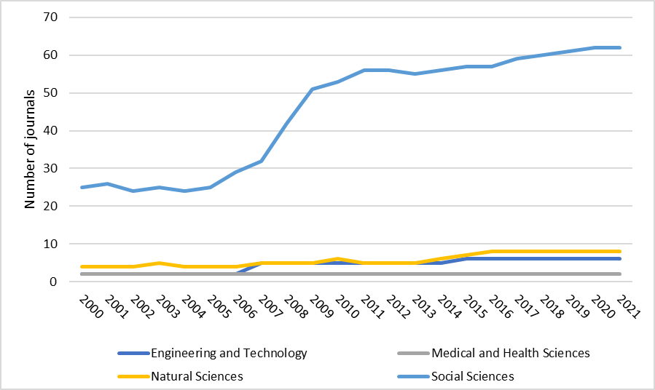 | 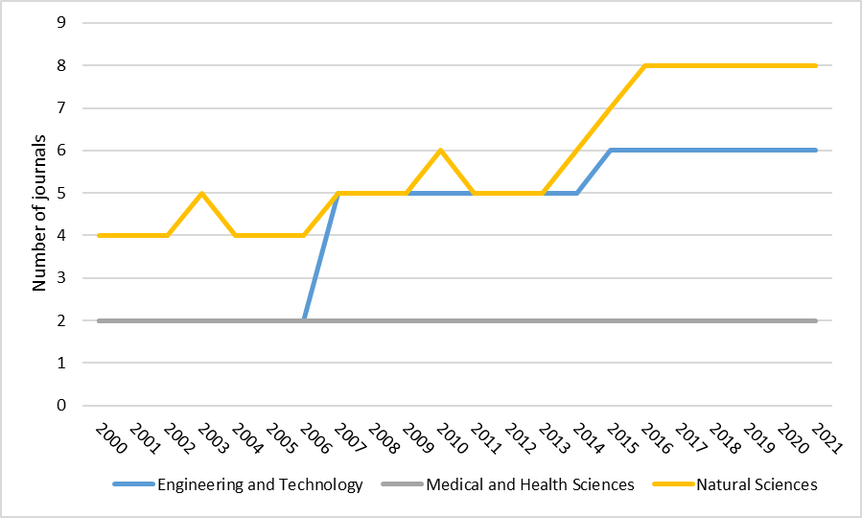

Figure 1. shows that the number and percentage of Arts–Sciences journals has increased over time. This is particularly (and unsurprisingly) the case of Arts – Social Sciences journals which constitute the vast majority of Arts-Sciences journals. The increase can be noticed especially during the period 2007-2009, which was probably due to an increase of the coverage of regional journals in WoS. The number of journals assigned to Arts and other science fields have also increased over time (e.g. the number of Arts – Natural Sciences journals have doubled and Arts – Engineering and Technology have tripled); however, there are still only a few journals that combine those fields (6 in Arts – Engineering and Technology; 2 in Arts – Medical and Health Sciences and 8 in Arts – Natural Sciences).

4.2. Knowledge flow from Sciences to Arts

Next, we focus on the knowledge flow from science fields to Arts. In other words, we analyse which science fields are the most prominent sources of knowledge for the Arts scholars. We do this by analysing the citation flows between publications in Arts and science fields. By obtaining the number and percentage of citations from Arts publications to publications in other fields, we observe that Social Sciences (35.8%) represent the main source of knowledge. Natural Sciences (14.1%) and Medical and Health Sciences (11.8%) represent relatively important areas, while we find that Arts researchers tend to rely less often on Engineering and Technology (7.3%) and even less on Agricultural Sciences (0.9%). The analysis covers the period 2000-2021.

Table 3. Citations from Arts to science fields.
Fields of science | Number of citations (%)
Agricultural Sciences | 14,285 (0.9%)
Engineering and Technology | 113,145 (7.3%)
Medical and Health Sciences | 184,587 (11.8%)
Natural Sciences | 219,392 (14.1%)
Social Sciences | 557,758 (35.8%)

Figure 2. Number and percentage of citations from Arts to Sciences.
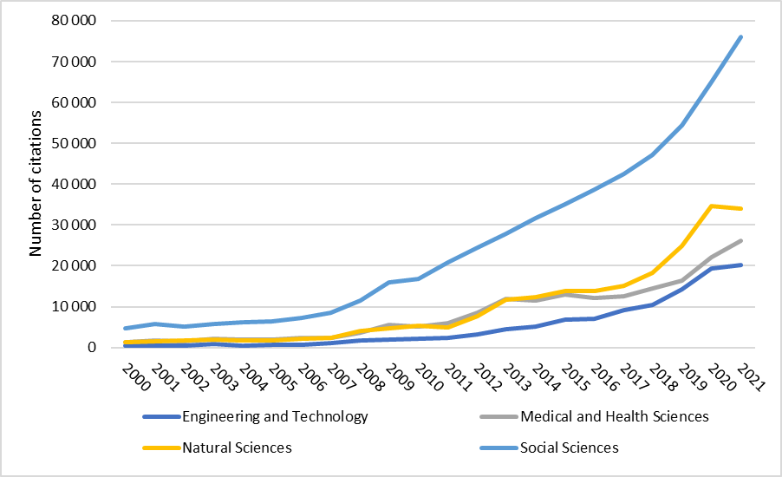 | 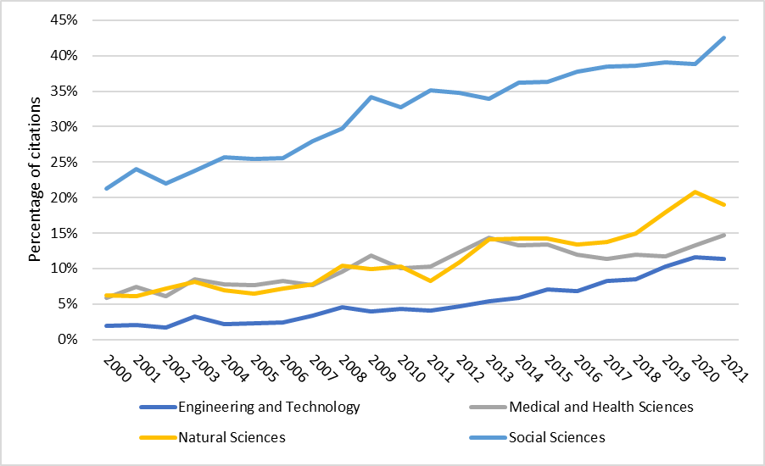

We also analysed the knowledge flow from Sciences to Arts from a more granular perspective – that is, looking at specific disciplines instead of broad science fields. Figure 3 shows the knowledge flow from Medical and Health Sciences to Arts disciplines. It demonstrates that publications in Neurosciences; Clinical Neurology; Audiology & Speech-Language Pathology; Rehabilitation; and Public, Environmental & Occupational Health are amongst the most highly cited by the Arts scholars, particularly from the Music; Multidisciplinary Humanities; and Film, Radio, Television disciplines.

Figure 3. Knowledge flow from disciplines in Medical and Health Sciences to Arts disciplines

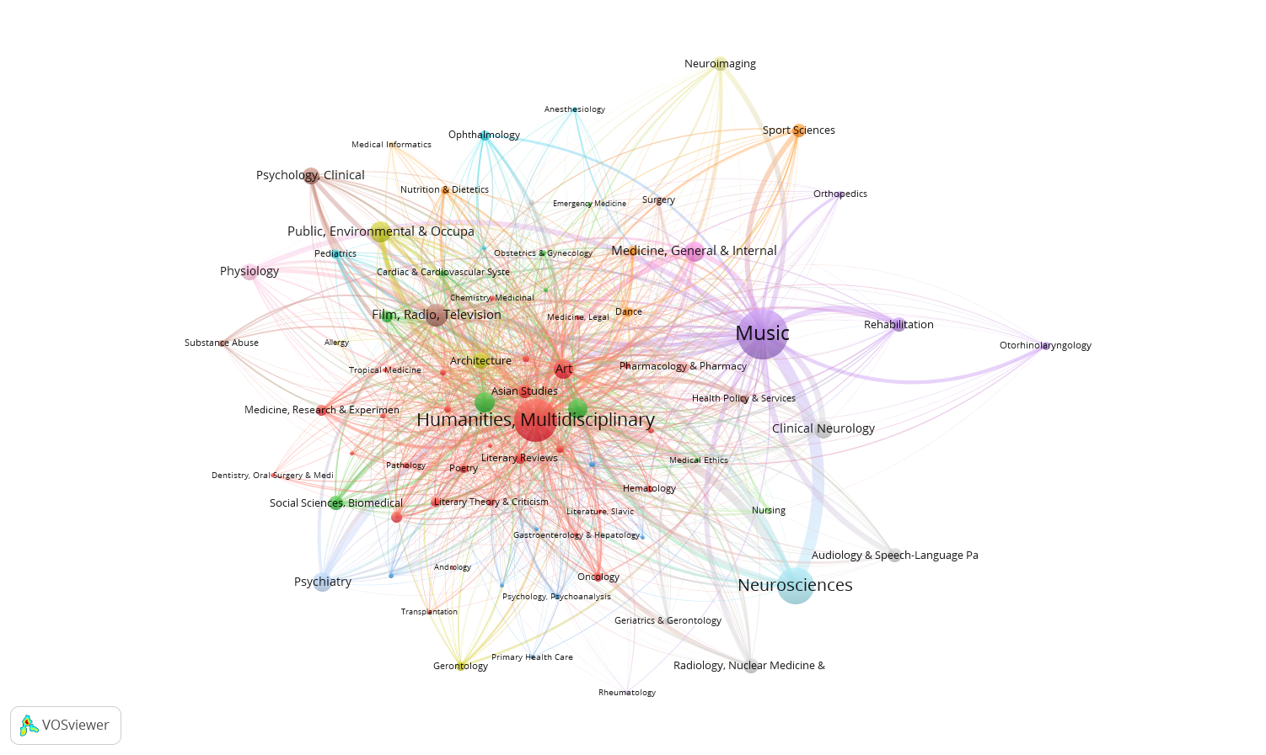

Figure 4. Knowledge flow from disciplines in Engineering and Technology to Arts disciplines

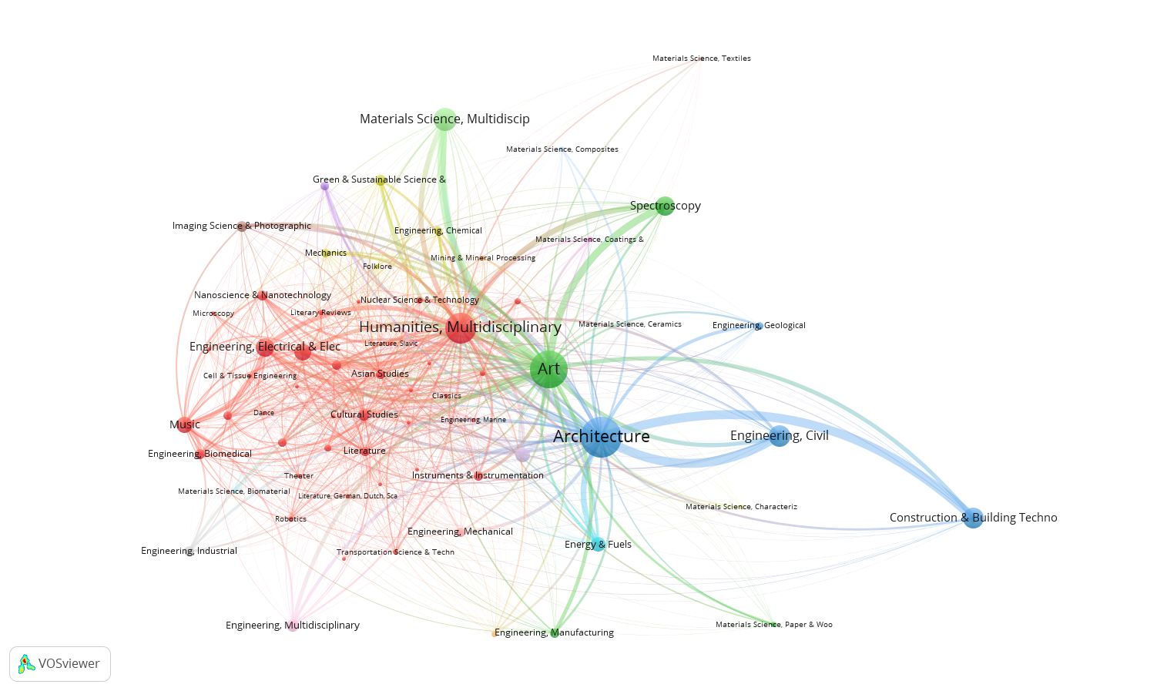

It demonstrates that Civil Engineering; Construction & Building Technology; Multidisciplinary Materials Science; and Spectroscopy are the most prominent sources of knowledge for the Arts, and particularly for Architecture; Art; and Multidisciplinary Humanities.

4.3. Knowledge flow from Arts to Sciences

We also take the opposite approach to examine how often scholars in the science fields rely on knowledge generated in Arts. At this level of aggregation we observe that, while in absolute numbers most of the fields cite Arts publications more than one hundred times, in relative terms these numbers are basically negligible (Table 4). These small numbers are most likely caused by both the relative big size of these areas (i.e. the high number of articles in the database in these areas) and also due to the “citation density” as defined by Garfield, that is, the “average number of references cited per source article” (Garfield, 2007). Figure 5, which shows the number and percentage of citations from science fields to Arts, demonstrates a positive trend.

Table 4. Citations from science fields to Arts
Fields of Science | Number of citations (%)
Agricultural Sciences | 14,434 (0.03%)
Engineering and Technology | 103,760 (0.05%)
Medical and Health Sciences | 135,191 (0.04%)
Natural Sciences | 187,463 (0.04%)
Social Sciences | 438,243 (0,59%)

To explore the knowledge flow from Arts to Sciences from a granular (discipline-focused) perspective, we analysed knowledge flow from Arts to Medical and Health Sciences disciplines (Figure 6) as well as Engineering and Technology disciplines (Figure 7). Figure 6 shows again that the Arts (and particularly Music; Multidisciplinary Humanities; and Film, Radio, Television) have the strongest connection to: Neurosciences; Rehabilitation; Clinical Neurology; Audiology & Speech-Language Pathology; Public, Environmental & Occupational Health. This suggests that there is a reciprocal, two-way knowledge flow between specific disciplines in Arts and Sciences. Figure 7 confirms this finding by demonstrating a similar relationship between Arts and the Engineering and Technology field.

Figure 5. Number and percentage of citations from science fields to Arts.
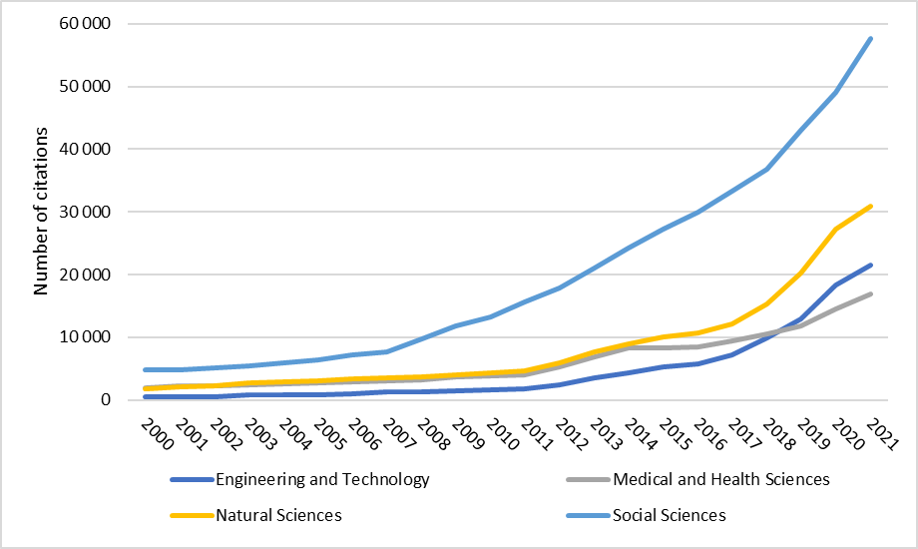 | 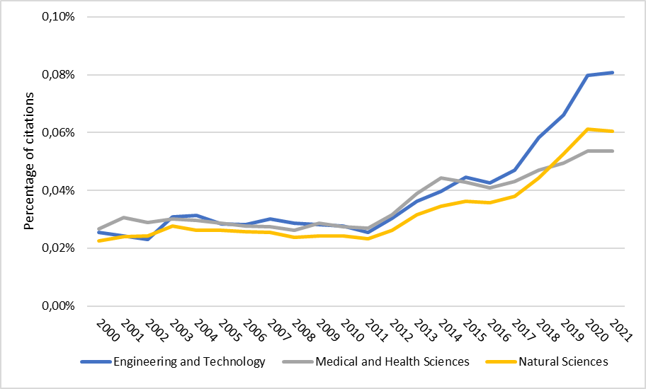

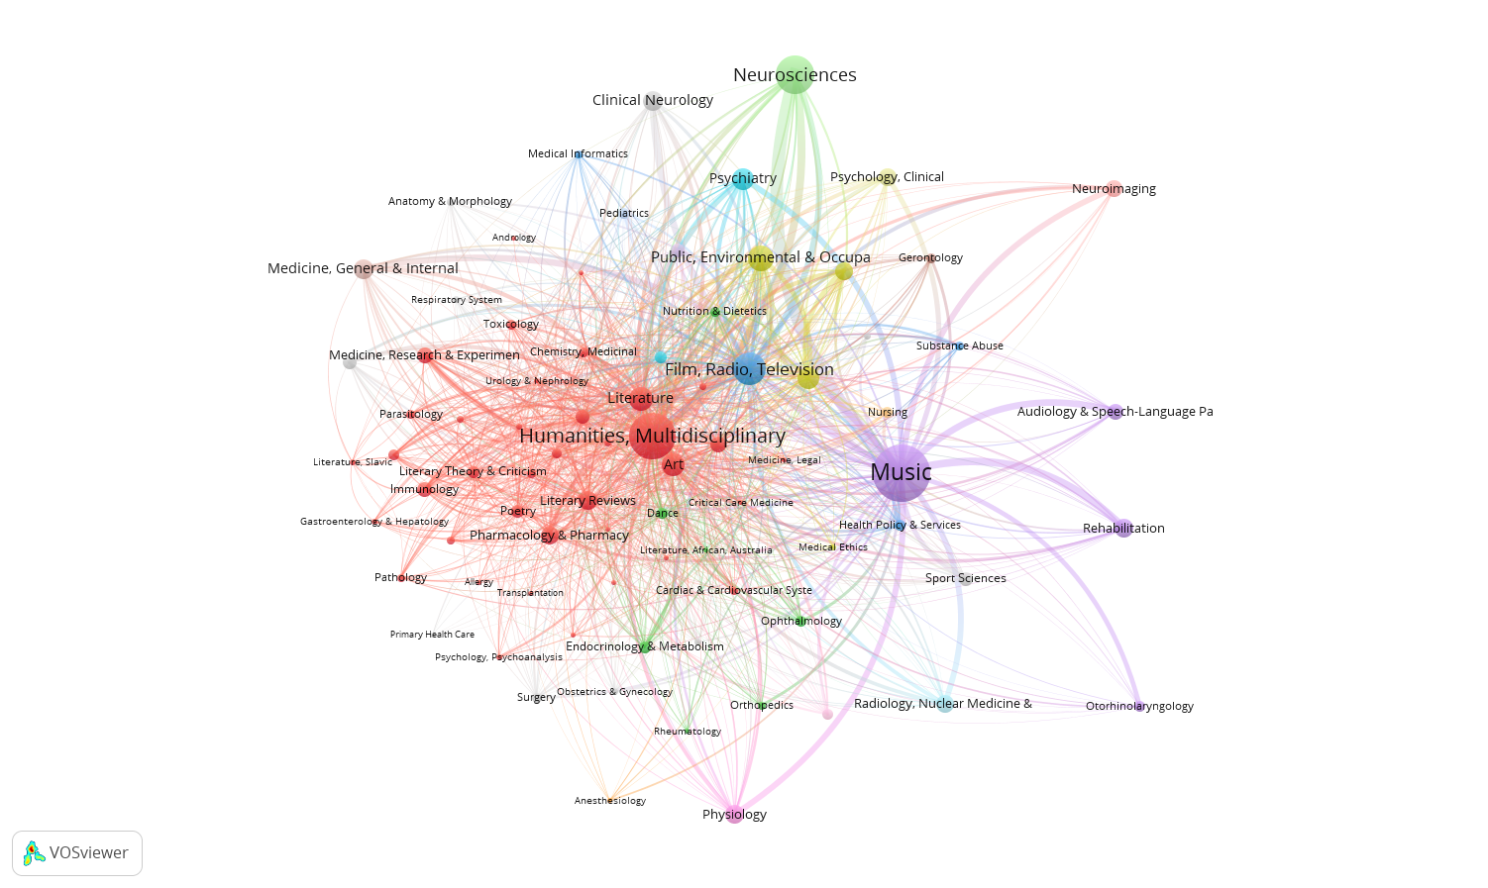Figure 6. Knowledge flow from Arts disciplines to Medical and Health Sciences disciplines

Figure 7. Knowledge flow from Arts disciplines Engineering and Technology disciplines

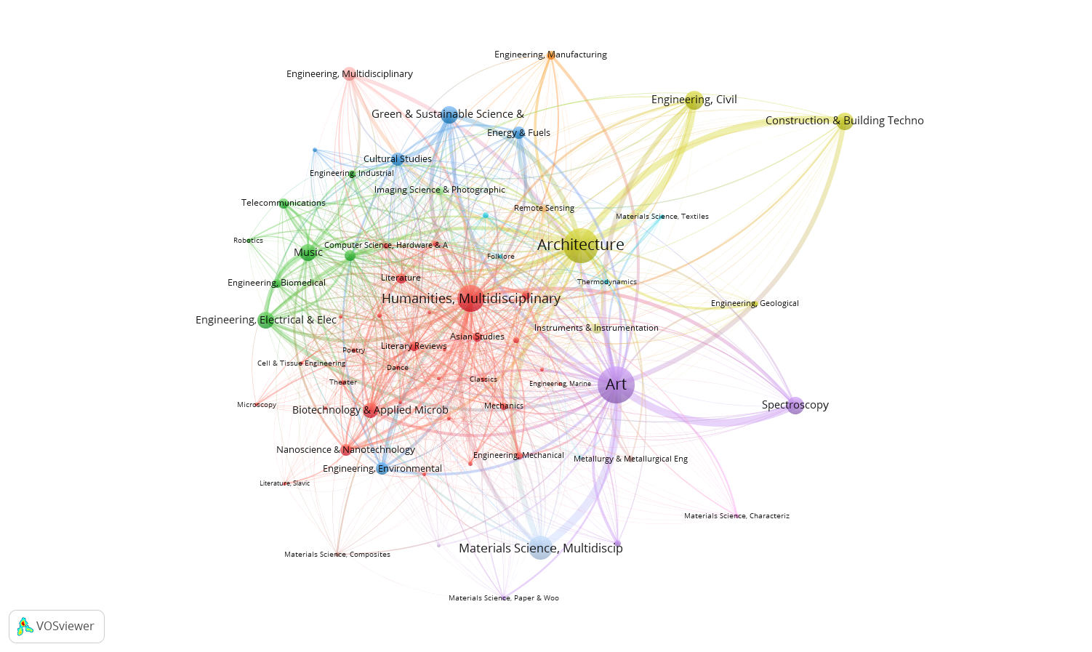

4. Discussion and conclusions

This paper examined the interconnections between Arts and Sciences from two perspectives: first, we explored the Arts-Sciences integration by analysing multidisciplinary journals in the WoS database; second, we investigated the two-way knowledge flow between Arts and science fields and disciplines.
We found that there has been a growing trend towards Arts-Sciences interdisciplinarity but the integration between Arts with more STEM-related fields (Engineering and Technology; Medical and Health Sciences; Natural Sciences) is still quite low. At the same time, the analysis of knowledge flow suggests that Art and Sciences has increasingly relied on each other in the process of new knowledge creation.
The analysis of data at the higher level of thematic aggregation (fields of science) suggests that Art relies on the scientific fields (such as Natural Sciences or Medical & Health Sciences) to a much higher degree than vice versa; however, this result might be influenced by the significant differences between Arts and Sciences in terms of field size (i.e. Arts is much smaller than any of the science fields) and citation density (e.g. art scholars cite, on average, much less papers than natural science scholars; see Ioannidis et al., 2019). The analysis of data at the lower level (disciplines) reveals a number of strong reciprocal links between particular Arts and Sciences disciplines. It demonstrates that scientific disciplines most highly cited by arts scholars are also those that most strongly rely on the knowledge from Arts.
We suggest that future research explores those reciprocal links in more depth. Also, our results indicate that studying the Arts-Sciences relationship at the level of disciplines (rather than fields) can lead to more meaningful results. It seems that some Arts disciplines (e.g. Music, (Visual) Arts) seem to be much more connected to science fields than others (e.g. Literature) and that visual and performing arts (classified in this paper as “only”-Arts) are more connected to sciences than disciplines related to the general Humanities (“partial”-Arts). Also, our results suggest that there are some specific disciplinary connections, e.g. between Music and Medical & Health Sciences as well as Visual Arts and Engineering & Technology; further studies could investigate those links more systematically.

References

Bicer, A., et al. (2017). Moving from STEM to STEAM: The effects of informal STEM learning on students' creativity and problem solving skills with 3D printing. Proceedings of the 2017 IEEE Frontiers in Education Conference. doi: 10.1109/FIE.2017.8190545
Boy, G.A. (2013). From STEM to STEAM: toward a human-centered education. Proceedings of the 31st European Conference on Cognitive Ergonomics. Article No. 3: 1–7. https://doi.org/10.1145/2501907.2501934
Conradty, C., Bogner F. X., (2019). From STEM to STEAM: cracking the code? How creativity & motivation interacts with inquiry-based learning. Creativity Research Journal, 31(3), 284–295. https://doi.org/10.1080/10400419.2019.1641678
Garfield, E. (2007). The evolution of the science citation index. International Microbiology, 10:65-69. DOI:10.2436/20.1501.01.10
Ioannidis, J.P.A., Baas, J., Klavans, R., Boyack, K.W. (2019). A standardized citation metrics author database annotated for scientific field. PLoS Biology 17(8): e3000384. https://doi.org/10.1371/journal.pbio.3000384
Nishikawa, K. (2023). How and why are citations between disciplines made? A citation context analysis focusing on natural sciences and social sciences and humanities. Scientometrics. https://doi.org/10.1007/s11192-023-04664-y
Pfeiffer F.M., et al. (2017). When theater comes to engineering design: oh how creative they can be. Journal of Biomechanical Engineering. 139 (7): 071004.
https://doi.org/10.1115/1.4036793
Santi, K., et al. (2021). STEAM in environment and science education: Analysis and bibliometric mapping of the research literature (2013-2020). Journal of Physics: Conference Series, 1796 (012097). DOI 10.1088/1742-6596/1796/1/012097
Sousa, D. A., & Pilecki, T. (2013). From STEM to STEAM: Using Brain-Compatible Strategies to Integrate the Arts. Thousand Oaks, CA: Sage.
Stewart, A.J., Mueller, M.P., & Tippins D.J. (Eds.). (2019). Converting STEM into STEAM Programs: Methods and Examples from and for Education. Switzerland, Cham: Springer Nature.
Videla, R., Aguayo, C., & Veloz, T. (2021). From STEM to STEAM: An Enactive and Ecological Continuum. Frontiers in Education, 6:709560. doi: 10.3389/feduc.2021.709560
Yan, E., Ding, Y., Cronin, B., & Leydesdorff, L. (2013). A bird’s-eye view of scientific trading: Dependency relations among fields of science. Journal of Informetrics, 7(2), 249–264. https://doi.org/10.1016/j.joi.2012.11.008
Yegros-Yegros, A., Rafols, I., D’Este, P. (2015). Does interdisciplinary research lead to higher citation impact? The different effect of proximal and distal interdisciplinarity. PLoS ONE, 10(8): e0135095. doi:10.1371/journal.pone.0135095

Open science practices

The data used in this study was obtained from a proprietary database, thus it is not possible to share detailed information on all the scientific publications analysed in our study. Aggregated information can be shared. This will be done at a later stage, as this conference contribution is the first result of our research.
We decided to use a proprietary database because of practical reasons. Namely, it is ready available for the authors to perform large-scale analyses as the one presented here. The authors are not aware of any other freely available database which could allow to perform a similar analysis in terms of completeness and scale.

Author contributions
Conceptualization: KL AY
Formal analysis: KL AY
Investigation: KL AY
Methodology: KL AY
Software: KL AY
Visualization: KL AY
Writing – original draft: KL AY
Writing – review & editing: KL AY

http://help.prod-incites.com/inCites2Live/filterValuesGroup/researchAreaSchema/oecdCategoryScheme.html
https://support.clarivate.com/ScientificandAcademicResearch/s/article/Web-of-Science-Core-Collection-Web-of-Science-Categories?language=en_US

