Who Funds Whom? An Exploratory Survey of Top Journal Papers of the Small Post-Soviet Countries
Nataliya Matveeva*, Anna Panova**, Ivan Sterligov***
* https://orcid.org/0000-0002-6378-7088 nmatveeva@hse.ru, HSE University, Russia
** https://orcid.org/0000-0001-7274-9350 apanova@hse.ru, HSE University, Russia
** https://orcid.org/0000-0001-9736-4713 ivan.sterligov@gmail.com, HSE University, Russia

Abstract

We analyze funding sources of the most visible part of science in small post-Soviet countries. For this purpose, we develop a classification of sources and manually link these sources to local authors. Our approach accounts for both country of origin and types of sources (intramural, state agencies, business etc.). Papers of small post-Soviet countries in top journals are rarely funded only locally and more often result from complex amalgamations of sources from various countries. State grants are by far the leading type of both domestic and foreign sources, along with the international\EU-wide programs. Our approach reveals marked differences between linking funding sources to papers and linking them to authors and yields a nuanced picture of post-Soviet funding landscapes.

1. Introduction
The importance of research funding is highlighted by many studies (Gök et al., 2016, Wang et al., 2012, Wang et al., 2020, Álvarez-Bornstein & Montesi, 2020, Costas & van Leeuwen, 2012). Funding is a crucial component in the process of knowledge production. As the part of R&D funding leads to results in the form of academic publications, the funding acknowledgements (FA) they contain are a vital source for science studies, research evaluation and neighboring disciplines. They allow us to link inputs to outputs, and such an analysis is much sought after by funding bodies of different types, governments and the general public.
Despite the growing availability of information on sources of funding in publications, the topic remains problematic (Aagaard et al., 2021). Using FA as a tool linking funding and published results presents many difficulties, specifically when it is based not on internal databases of funders or closed commercial services like ResearchFish, but on the publicly available bibliometric data sources, be it the WoS, Scopus, etc. (Alvarez-Bornstein & Montesi, 2020, Paul-Hus et al., 2016, Grassano et al., 2017, Rigby, 2011, Tang et al., 2017). Essentially, many of them are due to the lack of proper standardization of FAs.
There are recent advances enabled by named entity recognition and other ML-based methods (see Smirnova and Mayr (2023)). However, to the best of our knowledge, up until now one of the crucial links is largely missing in bibliometric-based funding studies: who funds whom exactly? While the vast majority of such studies (i.e. Chankseliani (2023) for the Post-Soviet region) link papers to funding sources, we argue that this is not enough (Aagaard et al., 2021) and actually can be misleading, especially when investigating contemporary cutting edge research, which often involves complex international collaboration between many participants with different research capacities, participants may have multiple affiliations and access to different funding sources. We propose linking authors to funding sources, similar to what is increasingly done in studies of non-funding acknowledgements (Petrovich, 2022, Rose & Georg, 2021).
We investigate FAs of internationally visible papers by authors from relatively small and very diverse countries, as for them such a distinction is even more important. Our sample includes 12 post-Soviet countries with a modest yearly publication output (Matveeva et al., 2022). Small countries have less capacity for funding research on their own than big countries (Kyvik & Larsen, 1997). As the world-class studies need greater resources and access to advanced technology, sourcing them for scholars from such countries presents a vital task. The solutions are country-specific and depend on historical, cultural and economic features and links of the country.
For countries that were formerly part of the USSR, the structure of science funding was specific from the beginning of their independence. Theу inherited the planned and centralized system with its primacy of "themes'' and state assignments (Graham, 1993). There was no NSF-style grant system and, in fact, the financing of research depended on the actions of scientists to a lesser degree (Schott, 1992). Research management and distribution of the resources was administrative and centralized. The majority of fundamental research was done in the institutes of the USSR Academy of Sciences which were mostly located in Russia (Rabkin & Mirskaya, 1993, Sterligov, 2023).
With the collapse of the USSR, the post-Soviet countries were finally able to organize and develop national science in their own way, but also experienced a sharp decline in state R&D funding. In the transition period, researchers were forced to seek additional funding on their own, or to change their occupation or to go abroad (Ganguli, 2014). Foreign research funds have played an important role in supporting the R&D activities of individual researchers and research groups (Ball & Gerber 2005, Ganguli, 2017). In countries with low spending on R&D (Annex, tab 1), foreign grants continue to play a significant role, for example in Tajikistan (Kataeva & DeYoung, 2018). In addition, national grant systems have started to emerge and a shift from funding of institutions to competitive project funding has begun (Masso & Ukrainski, 2009, Kazakevich & Goroshko, 2019, Tõnismann, 2019, Kuzhabekova & Mukhamejanova, 2017, Ashurov, 2020, Sabzalieva 2020, Shamshieva, 2022). Despite the fact that most countries have declared a transition to сompetition-based funding, the degree of implementation of competition-based funding varies greatly from country to country. For example in Estonia more than 70% of public funds had been allocated through competitive mechanisms by 2011, in contrast, in Belarus by 2018 only 10% of the funds were allocated in such a way. Also the role of the private sector has grown. Some countries began actively developing intergovernmental integration projects (Allik, 2003), and all of them intensified international collaboration measured via publications (Matveeva et al., 2022).
Over the 30 years after the collapse of the USSR, the situation in the countries has changed dramatically and now they are not only independent, but also completely different in terms of the scale, organization and effectiveness of R&D (Chankseliani et al., 2021).
Collaboration with other countries may be a way to acquire additional sources. Indeed, post-Soviet countries from Caucasus and Central Asia with a high level of internationally co-authored papers receive much support from abroad (Chankseliani, 2023). Baltic countries are an example of rapid scientific integration with the European Union (Allik, 2003).
It is reasonable to assume that due to the size and research capacity, the role of external sources will be great for small post-Soviet countries, and the configuration of sources may reflect geography and geopolitics best explored via linking sources to local authors. Our study deals with the following questions: how is the funding of cutting-edge research sourced in the post-Soviet countries, how similar are the funding models, which types of sources prevail in each country, and how dependent is this research on foreign funding.
Accordingly, we developed and applied a classification of funding sources that includes not only country affiliation of funding sources, but also provides information about authors’ funding links, government or institutional funding. We focus on the internationally visible subset of countries’ publications, which is not only more robust in terms of academic quality and integrity, but also depends on complex funding amalgamations in terms of Aagaard and coauthors (2021). This justifies a more granular approach.

2. Data and Methodology

2.1 Data
The need for manual analysis and classification of FAs to achieve desired granularity determines the relatively modest size of the dataset, which comprises 1846 publications in the most prominent science journals.
We use the Nature Index (NI) as a proxy of such prominence. It is a well-known selective (82 titles) list composed not by formulaic bibliometrics, but using an expert judgment of panels of top independent scholars complemented by a broad survey. It is intended that the list of journals “amounts to a reasonably consensual upper echelon of journals in the natural sciences”, including both multidisciplinary journals and the most highly selective journals within the main disciplines of the natural sciences. Nature Index is used in bibliometrics (Bendels et al., 2018), and also in FA studies (Sterligov et al., 2020).
We choose journal-based approach instead of the citation percentile approach because this leads to a more robust and uniform dataset in a sense that the surveyed papers have undergone rigorous peer review, and the editorial standards were high. Also, NI journals on average have better metadata quality and are better indexed in the databases, including FA fields, which is important for our case. NI excludes medicine and SSH fields, which are quite different to natural sciences with regard to funding, and are not covered by this study.
The surveyed countries are: Kyrgyzstan, Tajikistan, Estonia, Armenia, Belarus, Kazakhstan, Uzbekistan, Moldova, Latvia, Lithuania, Georgia, and Azerbaijan. We exclude Russia and Ukraine due to their much bigger size.
Our dataset comprises all NI articles and reviews published in 2017-2021 and affiliated with at least one of the surveyed countries in Scopus database, excluding papers by large (>20 authors) teams. Such exclusion limits our focus to the papers where it is reasonable to expect significant input from all the participants, as opposed to “hyperauthored” papers severely skewing metrics for smaller countries of the region (Tarkhan-Mouravi, 2020).
We use full FA texts exported from Scopus when possible. If Scopus had no FA for a paper or FA seemed to be abridged, FAs were manually added from the PDFs of the articles, this occurred in ca. 10% of cases.
Surveyed countries vary in terms of the publication counts. Estonia has the highest number of publications (599) over the observed period, while Kyrgyzstan and Tajikistan have the lowest (21 each) (Table 1).

Table 1. Descriptive statistic.

 | Number of publications | Average number of authors | Average number of affiliations | Average number of countries per paper
Armenia | 154 | 4.6 | 3.5 | 2.6
Azerbaijan | 41 | 6.8 | 6.1 | 3.5
Belarus | 167 | 5.8 | 4.2 | 2.9
Estonia | 599 | 7.2 | 4.9 | 3.3
Georgia | 168 | 6.2 | 5.6 | 3.3
Kazakhstan | 206 | 4.9 | 4.5 | 3.0
Kyrgyzstan | 21 | 4.8 | 3.6 | 3.4
Latvia | 76 | 7.9 | 4.4 | 3.0
Lithuania | 274 | 7.7 | 4.4 | 2.9
Moldova | 80 | 9.4 | 5.5 | 3.5
Tajikistan | 21 | 7.8 | 5.0 | 3.6
Uzbekistan | 93 | 4.7 | 4.9 | 2.8

2.2 FA classification

We use a simple case-driven classification schema in order to reveal both the geographical sources of funding and their types. It distinguishes between local (in terms of countries surveyed) and external sources, which are further classified by country of origin. EU-wide and international funders (CERN, UNESCO etc.) are also identified. Sources are further classified into intramural, state agency\grant program, charity and business (Annex, table 2). Importantly, for each paper and surveyed country we discriminate between funding that is linked to the authors from this country, and funding acknowledged by their foreign coauthors. This is done manually using author initials. If there are no links for a specific source in FA to individual authors, we assume that all the authors benefited from that source. As this clearly can lead to inflated counts, we also provide breakdowns of the shares of such papers for each country.

3. Results

3.1 Types of funding acknowledgment
We analyze funding based on where it came from (Figure 1). We calculate the proportions from the total number of publications having financial support. Clearly, NI papers are rarely funded by only domestic sources. The highest share of local funding was observed in Armenia, Lithuania and Kazakhstan. Publications of Azerbaijan, Kyrgyzstan, and Tajikistan are mostly financed by foreign sources. The highest shares of both types of funding were observed in Estonia, Uzbekistan and Kazakhstan. Azerbaijan, Kyrgyzstan, Moldova and Tajikistan have no publications supported solely by domestic funding sources. For these countries, external sources have especially high importance.

Figure 1. Share of publications with domestic and foreign funding sources (left axis) and their totals (right axis)

State funding prevails amongst local sources (Table 2). In Estonia, Uzbekistan, and Kazakhstan the most part of internal funding is associated with government. Kyrgyzstan and Tajikistan do not have this funding type. Their domestic financing is mostly provided by intramural projects. The share of intramural projects in the domestic funding is the highest in Kazakhstan, known for actively developing modern research universities, and Latvia. Commercial and charity sources are almost absent in local funding.

Table 2. Types of local funding.

Countries | State agency grant | Commercial | Charity | Intramural project | Total
Armenia | 55.1% |  |  | 4.4% | 136
Azerbaijan | 25.8% |  |  | 3.2% | 31
Belarus | 37.4% |  |  | 1.3% | 155
Estonia | 69.2% | 0.5% | 0.2% | 4.2% | 572
Georgia | 31.5% | 0.6% | 0.6% | 1.9% | 162
Kazakhstan | 51.0% |  | 0.5% | 36.6% | 194
Kyrgyzstan | 0.0% |  |  | 4.8% | 21
Latvia | 44.6% | 1.4% |  | 21.6% | 74
Lithuania | 38.5% |  |  | 10.2% | 265
Moldova | 29.5% |  |  | 3.8% | 78
Tajikistan | 0.0% |  |  | 10.0% | 20
Uzbekistan | 66.3% |  |  | 5.4% | 92

We analyze foreign sources which are attributed to local authors or to the whole paper. The sources of foreign funding are more varied than domestic (Table 3). State financing prevails, although for some countries interstate programs have a crucial role. Organization-level sources (intramural projects) are important in Azerbaijan, Uzbekistan and Georgia. Georgia has also quite a high level of financial support from foreign commercial sources. International funds are valuable for Uzbekistan and charity foreign sources are significant for Armenia.

Table 3. Types of foreign funding sources.

Countries | State agency grant | Commercial | Charity | Intramural project | EU | INT | Total
Armenia | 39% | 2.9% | 17.6% | 15.4% | 14% | 13.2% | 136
Azerbaijan | 90.3% |  |  | 35.5% | 3.2% |  | 31
Belarus | 82.6% |  | 4.5% | 13.5% | 25.8% | 2.6% | 155
Estonia | 46% | 1% | 8% | 7.2% | 61.2% | 4.4% | 572
Georgia | 84% | 22.2% | 3.7% | 33.3% | 17.9% |  | 162
Kazakhstan | 59.8% |  | 7.2% | 14.4% | 6.7% | 5.2% | 194
Kyrgyzstan | 100% |  |  | 9.5% | 9.5% |  | 21
Latvia | 47.3% | 1.4% | 10.8% | 8.1% | 45.9% | 2.7% | 74
Lithuania | 66% | 0.4% | 4.9% | 14.7% | 31.3% | 1.5% | 265
Moldova | 87.2% |  | 5.1% | 10.3% | 19.2% | 3.8% | 78
Tajikistan | 100% |  |  | 20% |  | 5 % | 20
Uzbekistan | 77.2% | 2.2% | 5.4% | 34.8% | 27.2% | 23.9% | 92

We also estimate the role of different countries in scientific production of small post-Soviet countries. The European projects (EU), the United States (US), Germany, China, and Russia are the main foreign funders (Figure 2). The EU and US are important sources of financial support for almost all analyzed countries. Baltic States are mostly financed by their local and EU sources. Germany's financial support is tangible for Kyrgyzstan, Moldova, Georgia, and Tajikistan. China is an important financing partner of Uzbekistan, Georgia, Kazakhstan and Tajikistan. Russia is prominent in Belarus, Azerbaijan, and Tajikistan. In Kazakhstan, Uzbekistan and Armenia their own funding sources are more often mentioned in the publications.

Figure 2. Percentage of country’s publications that mention a funding country in their FAs, for top 20 mentioned source countries.

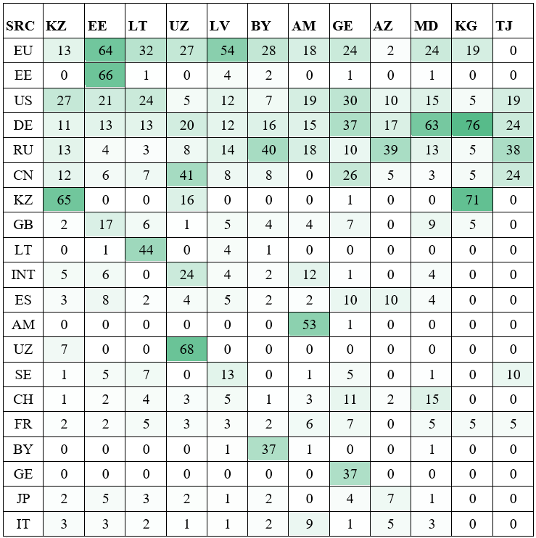

3.2 Attributing funding sources to authors
We analyzed the authors' funding attribution to a particular source (Figure 3). We calculated the proportions of publications where: 1) funding is linked to the authors from the countries under study (local country) 2) funding is only linked to foreign co-authors 3) no funding is acknowledged 4) it is not known which of the co-authors received funding. The highest percentage of publications tied to local authors is observed in Estonia, Armenia, Latvia, and Uzbekistan. With that, Azerbaijan and Tajikistan have the highest proportion of funding tied to foreign authors. Kyrgyzstan has the highest percentage of papers with no linkage of funding sources to individual authors. Azerbaijan has the highest values of papers where financial support is not mentioned.

Figure 3. Distribution of funding sources linked to authors in publications.

We also analyze funding countries of sources attributed to authors (Figure 4.). EU, US and Germany financial support play important role in knowledge production. Russian and Chinese funding sources have also significant value for some countries. With that, the share of publications where concrete authors were supported by these countries is lower than for ‘whole’ publications (see Figure 2). Notably, authors from analyzed countries rarely mentioned their own countries. For example, ‘whole’ publications of Estonia have approximately equal financing by EU and Estonia and do not have Estonian sources attributed to concrete authors.

Figure 4. Percentage of country’s publications that mention a foreign funding source in their FAs linked to the authors from the surveyed country, for top20 mentioned source countries.

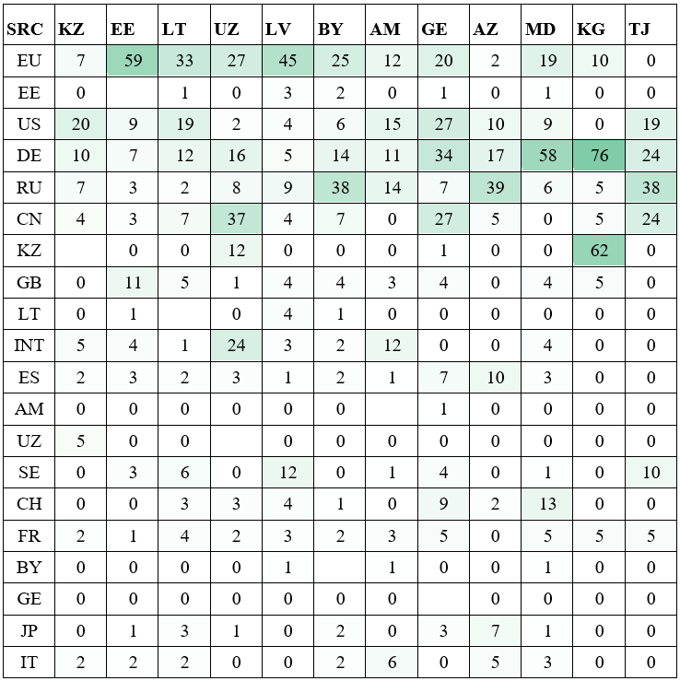

4. Discussion and Conclusion
Our preliminary findings are useful both from the methodological and cross-country\area studies perspectives. We observe that high-performing science in small post-Soviet countries are rarely funded by solely local sources. Foreign and international grants and programs have an important role. The share of commercial and charity sources is minimal, state grants prevail in domestic and foreign funding sources. We note the important role of EU, US, Germany, Russian and Chinese grants and programs.
We reveal that each analyzed country has its own profile of science funding conditioned social, economic and geography specific. For example, Kazakhstan and Latvia have quite a high share of intramural projects in domestic financing. Georgia has a high share of foreign commercial funding. EU grants and projects have an important role not only for the Baltic States but also for Belarus, Uzbekistan, Moldova, and Georgia. Chinese financing has a significant impact in high-performance papers of Uzbekistan, Georgia and Tajikistan. Tajikistan and Azerbaijan have the lowest values of funding linked to local authors. Azerbaijan has the highest share of funding attracted by foreign authors (48.8%). As expected, the role of foreign funding is usually higher for countries with lower relative GERD (Annex, tab. 1).
With that, our methodology approach reveals there are marked differences between linking funding sources to papers and linking them to authors from a studied country (Figure 2 vs 4). For example, for Kazakhstan the shares of papers mentioning funding from EU, US, DE, RU and CN are 13%, 27%, 11%, 13% and 12% respectively, but when we restrict this to funding linked to authors with Kazakh affiliations, figures drop to 7%, 20%, 10%, 7% and 4%, and even this is an overestimate because we treat unlinked sources as those linked to all authors. Such comparison yields a much more nuanced picture of funding amalgamations than the one recently presented for the same region using a traditional approach (Chankseliani, 2023). We argue that this distinction is vital when making claims about funding sources especially for smaller countries with lower research capacity.
Our study is exploratory and based on papers in top journals, which means that we focus on a part of the national research landscape, which, although very important and visible, does not paint the whole picture. Omission of many-authored papers and papers in medical and SSH fields is also a limitation. We plan to build upon this investigation using a much larger dataset and ML-assisted NER tools to further study the complex interplay of funding and those who receive it.

Author roles
Ivan Sterligov, Anna Panova, Natalia Matveeva: Conceptualization, Data curation, Methodology, Writing – original draft, Writing – review & editing. All authors contributed equally.

Competing interests
The authors declare no competing interests.

Open Access and Data Availability
The detailed classification of all papers along with their Scopus IDs is presented in the Annex, which is freely available at Zenodo: https://doi.org/10.5281/zenodo.7850131
We do not disclose the FAs of individual papers because of the different policies and copyrights of various publishers.

Funding information
Data collection was supported by the Russian Science Foundation (Grant 20–18-00140). Anna Panova and Natalia Matveeva acknowledge the support of the HSE University Basic Research Program.

References
Aagaard, K., Mongeon, P., Ramos-Vielba, I., & Thomas, D. A. (2021). Getting to the bottom of research funding: Acknowledging the complexity of funding dynamics. Plos one, 16(5), e0251488. https://doi.org/10.1371/journal.pone.0251488
Allik, J. (2003). The quality of science in Estonia, Latvia, and Lithuania after the first decade of independence. Trames, 7(1), 40-52.
Álvarez-Bornstein, B., & Montesi, M. (2020). Funding acknowledgements in scientific publications: A literature review. Research Evaluation, 29(4), 469-488.
Ashurov, D. (2020). The Problem of Financing Science and Its Effect on Brain Drain in Uzbekistan: A Retrospective View and the Perspectives for Solving. Brain Drain vs Brain Circulation (Central Asia)./Ed.: M. Olimov, J. Grote & B. Gharleghi.–Hauppauge, NY, USA: Nova Science Publishers, Inc.
Ball, D. Y., & Gerber, T. P. (2005). Russian Scientists and Rogue States: Does Western Assistance Reduce the Proliferation Threat?. International Security, 50-77.
Bendels, M. H., Müller, R., Brueggmann, D., & Groneberg, D. A. (2018). Gender disparities in high-quality research revealed by Nature Index journals. PloS one, 13(1), e0189136., e0189136. https://doi.org/10.1371/journal.pone.0189136
Chankseliani, M. (2023). Who funds the production of globally visible research in the Global South?. Scientometrics, 128(1), 783-801. https://doi.org/10.1007/s11192-022-04583-4
Chankseliani, M., Lovakov, A., & Pislyakov, V. (2021). A big picture: bibliometric study of academic publications from post-Soviet countries. Scientometrics, 126(10), 8701-8730.
Costas, R., & van Leeuwen, T. N. (2012). Approaching the “reward triangle”: General analysis of the presence of funding acknowledgments and “peer interactive communication” in scientific publications. Journal of the American Society for Information Science and Technology, 63(8), 1647-1661.
Ganguli, I. (2017). Saving Soviet science: The impact of grants when government R&D funding disappears. American Economic Journal: Applied Economics, 9(2), 165-201.
Ganguli, I. (2014). Scientific brain drain and human capital formation after the end of the Soviet Union. International Migration, 52(5), 95-110.
Gök, A., Rigby, J., & Shapira, P. (2016). The impact of research funding on scientific outputs: Evidence from six smaller European countries. Journal of the association for information science and technology, 67(3), 715-730.
Graham, L. R. (1993). Science in Russia and the Soviet Union: A short history. Cambridge University Press.
Grassano, N., Rotolo, D., Hutton, J., Lang, F., & Hopkins, M. M. (2017). Funding data from publication acknowledgments: Coverage, uses, and limitations. Journal of the Association for Information Science and Technology, 68(4), 999-1017.
Kataeva, Z., & DeYoung, A. J. (2018). Faculty challenges and barriers for research and publication in Tajik higher education. European Education, 50(3), 249-265.
Kazakevich A. & Goroshko K. (2019) Reform of the Research & Development sector in Belarus: Challenges and possible solutions. Report. https://palityka.org/wp-content/uploads/2019/05/Research-and-Development_2019_ru.pdf
Kuzhabekova, A., & Mukhamejanova, D. (2017). Productive researchers in countries with limited research capacity: Researchers as agents in post-Soviet Kazakhstan. Studies in Graduate and Postdoctoral Education, 8(1), 30-47.
Kyvik, S., & Larsen, I. M. (1997). The exchange of knowledge: A small country in the international research community. Science Communication, 18(3), 238-264.
Masso, J., & Ukrainski, K. (2009). Competition for public project funding in a small research system: the case of Estonia. Science and Public Policy, 36(9), 683-695.
Matveeva, N., Sterligov, I., & Lovakov, A. (2022). International scientific collaboration of post-Soviet countries: a bibliometric analysis. Scientometrics, 127(3), 1583-1607.
Paul-Hus, A., Desrochers, N., & Costas, R. (2016). Characterization, description, and considerations for the use of funding acknowledgement data in Web of Science. Scientometrics, 108, 167-182.
Petrovich, E. Acknowledgments-based networks for mapping the social structure of research fields. A case study on recent analytic philosophy. Synthese 200, 204 (2022). https://doi.org/10.1007/s11229-022-03515-2
Rabkin, Y. M., & Mirskaya, E. Z. (1993). Science and scientists in the post-Soviet disunion. Social Science Information, 32(4), 553–579. https://doi.org/10.1177/053901893032004002
Rigby, J. (2011). Systematic grant and funding body acknowledgement data for publications: new dimensions and new controversies for research policy and evaluation. Research Evaluation, 20(5), 365-375.
Rose, M. E., & Georg, C. P. (2021). What 5,000 acknowledgements tell us about informal collaboration in financial economics. Research Policy, 50(6), 104236.
Sabzalieva, E. (2020). Negotiating international research collaborations in Tajikistan. Journal of Studies in International Education, 24(1), 97-112.
Schott, T. (1992). Soviet science in the scientific world system: Was it autarchic, self-reliant, distinctive, isolated, peripheral, central?. Knowledge, 13(4), 410-439.
Shamshhieva, R. (2022). Building research capacity in higher education: Perceptions of Faculty working in a state university in Kyrgyzstan. https://nur.nu.edu.kz/bitstream/handle/123456789/6559/Thesis%20-%20Rakhat%20Shamshieva.pdf?sequence=1&isAllowed=y
Smirnova, N., Mayr, P. A comprehensive analysis of acknowledgement texts in Web of Science: a case study on four scientific domains. Scientometrics 128, 709–734 (2023). https://doi.org/10.1007/s11192-022-04554-9
Sterligov, I. (2023) Before and After the Fall: Geography of Soviet and Post-Soviet Physics Surveyed via Leading Journals. Physics in Perspective (forthcoming)
Sterligov, I. A., Savina, T. F., & Chichkova, A. O. (2020). A Study of Grant Support from Russian Scientific Foundations to Domestic Publications in Leading International Journals (based on Data from Scopus and Web of Science, the Russian Foundation for Basic Research, and the Russian Science Foundation). Scientific and Technical Information Processing, 47, 36-55. https://doi.org/10.3103/S0147688220010074
Tang, L., Hu, G., & Liu, W. (2017). Funding acknowledgment analysis: Queries and caveats. Journal of the Association for Information Science and Technology, 68(3), 790-794.
Tarkhan-Mouravi, S. (2020). Traditional indicators inflate some countries’ scientific impact over 10 times. Scientometrics, 123(1), 337-356. https://doi.org/10.1007/s11192-020-03372-1
Tõnismann, T. (2019). Paths of Baltic States public research funding 1989–2010: Between institutional heritage and internationalisation. Science and Public Policy, 46(3), 391-403.
Wagner, C. S., Whetsell, T. A., & Leydesdorff, L. (2017). Growth of international collaboration in science: revisiting six specialties. Scientometrics, 110, 1633-1652.
Wang, L., Wang, X., Piro, F. N., & Philipsen, N. J. (2020). The effect of competitive public funding on scientific output: A comparison between China and the EU. Research Evaluation, 29(4), 418-429.
Wang, X., Liu, D., Ding, K., & Wang, X. (2012). Science funding and research output: a study on 10 countries. Scientometrics, 91(2), 591-599.

