Academic careers in sociology and peer recognition

Angelika Tsivinskaya*

*atsivinskaya@eu.spb.ru
0000-0002-3261-7393
European University at St. Petersburg, Russia

Many researchers are seeking strategies to become salient in the eyes of others and join the club of elite scientists. Some groups are disadvantaged in this race despite their efforts. Comparing to natural sciences the structure of the coauthorship network in social sciences is less stable and collaborations are smaller and last shorter, which makes it harder to become a part of the disciplinary core. Our contribution intends to add new empirical evidence about the impact of collaborations on recognition among peers and research productivity in sociology. In our research we would like is to compare the publication strategies of the researchers occupying important positions in terms of the collaboration network and named as highly estimable scholars. We hope that our research can enlighten our understanding of whether chosen publication strategies affect your position in the community.

1. Introduction
Could you be more successful as “a lone wolf” or breakthroughs in science always require collaborative efforts? Scientists could seek strategic behaviour to become important actors in the network and yield benefits from their collaborations to advance their career and gain recognition. There are a number of studies devoted to the collaborations defined through coauthorship (Abbasi, Altmann, & Hossain, 2011; Akbaritabar, Traag, Caimo, & Squazzoni, 2020; Cugmas, Ferligoj, & Kronegger, 2016; Ebadi & Schiffauerova, 2015; Hâncean, Perc, & Lerner, 2021). We would like to focus on network analysis perspective of collaborations on performance, career development and gender inequality.
Social network analysis measures in conjunction with g-index for scholars in information schools of five universities were investigated by Abbasi et al. (2011). Results of this paper indicate that scholars who are connected to more distinct scholars, have a better citation-based performance than scholars with fewer connections. In addition, the repeated coauthorships support better research performance compared to those with weaker ties. They observed negative effect of the normalized eigenvector on g-index suggesting that better strategy is to collaborate with new authors that with other successful colleagues. Working with collaborators who have good performance tends to promote the formation of positive relative role growth and researchers who own stronger collaborative ability have better research performance (Lu, Ren, Huang, Bu, & Zhang, 2021). However, the researchers with great influence do not necessarily publish high quality works as revealed by the collaboration network among Canadian researchers (Ebadi & Schiffauerova, 2015). They also found that the younger researchers tend to collaborate more and the researchers with high betweenness centrality are crucial for scientific collaborations. The elite affiliation for young scholars gives the better capability to use social capital from research collaboration networks and their choice of PhD supervisor is one of the major factor of success shown with China’s Project 985 universities in the chemistry field (Liu, Zhang, Zhang, & You, 2022).
Along with productivity, another big topic which we would like to touch on is what gives rise and sustain the observed gender inequality in science. Men often considered to be more aggressive in their promotion practices. However, men and women scientists do not always differ in their practice (Azoulay & Lynn, 2020). Could be some explanation found if their network positioning and collaboration practices or is it the same? Social closure in journals and in citation practices and resulting homophily can put minority groups at a disadvantage by restricting their ability to establish links with a majority group (Karimi, Génois, Wagner, Singer, & Strohmaier, 2018). Paper by Hâncean and Perc (2016) showed for sociology departments of Poland, Romania, and Slovenia that the mean score of co-authors’ citations substantially predicts the citation counts on the authors’ citation counts indicative of homophily. Top sociological journal published disproportionally more papers by male authors and their coauthors (Akbaritabar & Squazzoni, 2021). Prestige signalling by elite affiliations for higher publication opportunities only significantly benefits male authors.
In our research we have an opportunity to compare bibliometric indicators, social network measures with surveyed data for peer recognition of Russian sociologists. Previously, we investigated how bibliometric indicators with being recognised as notable scholar (Guba & Tsivinskaya, 2022). In this paper we show the structure of coauthosrhip network based on national data which give better insight on how than especially in case of sociology where many papers produced knowledge primarily for consumption om local market. Particularly, we take a social network analysis perspective to find what makes a scholar to become someone worth to be in the limelight.

2. Data and Methods
We analysed two sources of data jointly collected in 2020. The first source is the coauthored publication network among Russian sociologists based on the data from the national bibliometric database (RISC) (Moskaleva, Pislyakov, Sterligov, Akoev, & Shabanova, 2018). We have collected bibliometric data for 7,846 authors, which have publications in sociology or considered themselves as sociologists.
The second source is the results of a disciplinary survey of 3,689 Russian sociologists carried out to establish the group of scholars that were named notable researchers. Those surveyed authors are active sociologist as they published at least three papers in the last five years. In the survey they nominated authors as prominent scholars which we successfully matched with the profiles in RICS.
We have collected publications for all sociologists which were written in coathourship resulting in dataset of 32,956 publications. 4,978 authors have papers with coauthors in our data and around 20% have only solo papers or collaborate in other forms (conference proceedings, chapters in book) but not in publications. We constructed coathoriship network from papers as undirect ties. Ties were weighed for repeated caothrships.

3. Preliminary results
First, we focus on the coauthorship network structure. The main characteristics of the coauthorship network of Russian sociologist are presented in Table 1. This coauthorship network has 4,978 nodes and 7941 edges. The average degree is 3.19. Coauthorship network has the core-periphery structure (Figure 1). We should note that isolated nodes not shown. It has overall 339 components and the giant component consists of 4,011 nodes, so most smaller components have size of 2-3 authors. The giant component with only active sociologist consists of 1,856 nodes. Number of communities is 358 detected using Leuven algorithm with selected resolution at 5 with weighted edges. Average size of detected communities is 13.9 with standard deviations of 57.67.
The yellow nodes on Figure 1 represent scholars that were mentioned in the survey as esteemed figures. The size of nodes is the degree that corresponds to the number of coauthors. Most of mentioned scholars have a central positions or focal points in the smaller clusters of authors.
Figure 1: Coauthorship network for Russian sociologists.
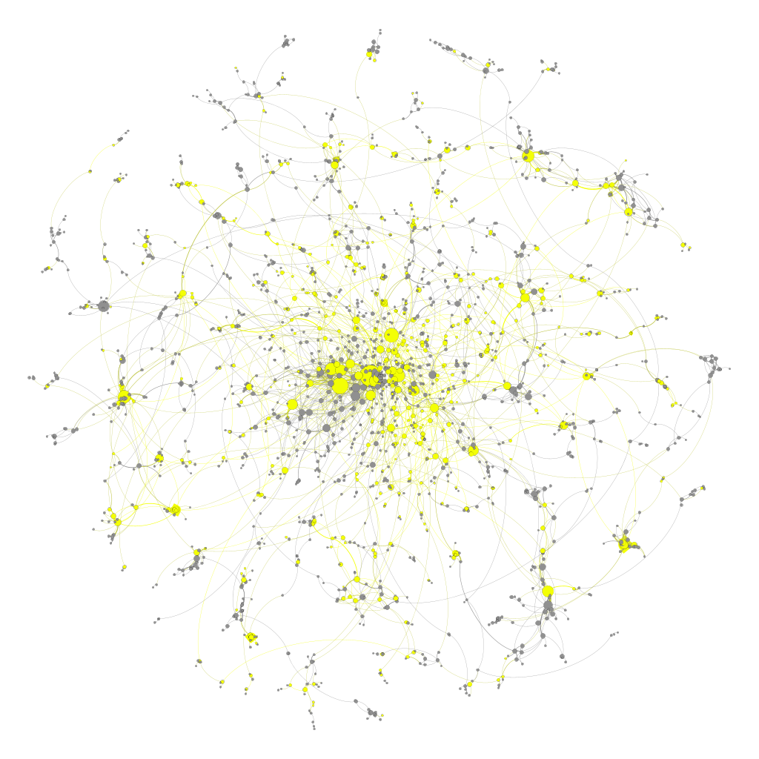
Table 1. The main characteristics of the coauthorship network of Russian sociologists and its giant component.

Network metric | Value
All sociologists network
Number of nodes (excluding isolated nodes) | 4978 (2868)
Number of edges | 7941
Mean degree | 3.19
Giant component (GC)
Number of nodes | 4011
Number of edges | 7222
% nodes in Giant component | 80.57%
% edges in Giant component | 90.95%
Density | 0.001
Diameter | 24
Active sociologists network
Number of nodes (excluding isolated nodes) | 2622 (1067)
Number of edges | 3743
Mean degree | 6.58
Giant component of active sociologists (GC active)
Number of nodes | 1856
Number of edges | 3389
% nodes in Giant component | 70.79%
% edges in Giant component | 90.54%
Density | 0.002
Diameter | 23
Let us have closer look on the gender distribution for nodes and ties in the network. The 35.57% of nodes in the network are male authors. Distribution of ties by gender is stable across different subsets as seen in Figure 2. Around 43% of coathourship ties are between female authors, 44% are mixed and only 13% are between male authors. There is no big observable differentiation in time as active sociologists network have the same distribution as all sociologists network. The same pattern is prevalent both and core and in the periphery as the giant component have almost the same distribution as the whole network.

Figure 2: Gender ties in coauthorship network of Russian sociologists.

The networks characteristics for authors are shown in Table 2. Mentioned scholars have twice as many numbers of coauthors compared to others sociologists in the coauthorship network. There is not big difference in nature of ties between female and male authors except that female authors have the higher percentage of same gender collaborations in comparison with men. The mentioned sociologists have the higher eigenvector centrality but similar between female and male authors. Average repeated collaborations are quite low for all and around two papers which can be interpreted that recognised scholars have more collaborations. Overall, for sociologists in observed network they connections do not last long on average, and they maybe have one or two authors they write papers together. It could be possibly explained that recognised scholars have students with whom their write papers and then quickly move on to other topics and write their influential papers as solo authors.

Table 2. Being mentioned and network characteristics.

 | Mentioned |  | Not mentioned
 | male | female | male | female
Average number of coauthors (degree) | 7.33 | 6.12 | 2.65 | 2.71
Average repeated collaborations (weight) | 2.30 | 2.53 | 2.13 | 2.21
Average weighted degree | 16.66 | 15.79 | 5.59 | 5.82
Average % same gender ties | 38.83 | 67.05 | 41.11 | 66.92
Eigenvector centrality | 0.032 | 0.034 | 0.012 | 0.012
The 35.57% of nodes in the coauthorship network of Russian sociologists are male authors and the percentage of mentioned ones is 31.16%. However, if you investigate the number of nominations closer, 6 are men in the top-10, 35 are in top-50 and 64 are in top-100. Despite the similar standing in the network in terms of centrality, number of collaborations and its structure, female authors gain less recognition in the scientific community and rarely considered to be top figures in prestige. It requires deeper investigation for what can shed some light on this phenomenon. We plan to continue further examination of publications characteristics, journal selection for collaborations and topics of papers. Of those female authors who are the notable exceptions whether they have the support from the community of women researchers and specialized in areas that are dominated by female researchers such as sociology of health, family etc.

Open science practices
The data that support the findings of this study are available on request from the corresponding author on OSF https://osf.io/47ar8/. After final publication the data will be available openly.

Competing interests
The author declares no competing interests.

Funding information
This work was supported by RSCF – Russian Science Foundation, grant #21-18-00519.

References
Abbasi, A., Altmann, J., & Hossain, L. (2011). Identifying the effects of co-authorship networks on the performance of scholars: A correlation and regression analysis of performance measures and social network analysis measures. Journal of Informetrics, 5(4), 594–607.
Akbaritabar, A., & Squazzoni, F. (2021). Gender Patterns of Publication in Top Sociological Journals. Science, Technology, & Human Values, 46(3), 555–576.
Akbaritabar, A., Traag, V. A., Caimo, A., & Squazzoni, F. (2020). Italian sociologists: a community of disconnected groups. Scientometrics, 124(3), 2361–2382.
Azoulay, P., & Lynn, F. (2020). Self-Citation, Cumulative Advantage, and Gender Inequality in Science. Sociological Science, 7, 152–186.
Cugmas, M., Ferligoj, A., & Kronegger, L. (2016). The stability of co-authorship structures. Scientometrics, 106(1), 163–186.
Ebadi, A., & Schiffauerova, A. (2015). How to become an important player in scientific collaboration networks? Journal of Informetrics, 9(4), 809–825.
Guba, K., & Tsivinskaya, A. (2022). Expert judgments versus publication-based metrics: do the two methods produce identical results in measuring academic reputation? Journal of Documentation, 10(2), 646.
Hâncean, M.-G., & Perc, M. (2016). Homophily in coauthorship networks of East European sociologists. Scientific reports, 6, 36152.
Hâncean, M.-G., Perc, M., & Lerner, J. (2021). The coauthorship networks of the most productive European researchers. Scientometrics, 126(1), 201–224.
Karimi, F., Génois, M., Wagner, C., Singer, P., & Strohmaier, M. (2018). Homophily influences ranking of minorities in social networks. Scientific reports, 8(1), 11077.
Liu, Y., Zhang, M., Zhang, G., & You, X. (2022). Scientific elites versus other scientists: who are better at taking advantage of the research collaboration network? Scientometrics, 127(6), 3145–3166.
Lu, W., Ren, Y., Huang, Y., Bu, Y., & Zhang, Y. (2021). Scientific collaboration and career stages: An ego-centric perspective. Journal of Informetrics, 15(4), 101207.
Moskaleva, O., Pislyakov, V., Sterligov, I., Akoev, M., & Shabanova, S. (2018). Russian Index of Science Citation: Overview and review. Scientometrics, 116(1), 449–462.

