Temporary employment in the Norwegian higher education sector

Paper to be submitted to the STI 2023 conference, Improving scholarly evaluation practices in light of cultural change,
27-29 September, Leiden

Topics: Healthy academic culture, in the light of responsible research assessment and academic careers, equity, diversity and inclusion, funding impact assessment, science policy, science indicators

Kaja Wendt* and Anne Espeland Berg**

* kaja.wendt@ssb.no
ORCID; ID: https://orcid.org/0000-0002-2430-9067
Statistics Norway, R&D, technology and business development, Norway

** anne.berg@ssb.no
ORCID; ID: https://orcid.org/0000-0001-6717-9808
Statistics Norway, R&D, technology and business development, Norway

Abstract

Ensuring attractive academic careers is high on the international policy agenda. Favourable working conditions is important both to retain the best talents and to ensure the quality, performance, and competitiveness of academic research. In Norway, as in many other western countries there is an ongoing discussion about precarious working conditions and temporary employment in the higher education sector as a major hampering factor for recruiting and retaining talents to an academic career. Effective measures to cope with the problem of temporary contracts are dependent on increased knowledge, and this article aim to provide knowledge on how different sources of funding influence employment, and how immigration status relates to temporary positions. We use data from Statistics Norway’s unique register of research personnel with data on all researchers in the higher education sector where data on employment have recently been added and we connect this with information on immigration status.

1. Introduction

Across European academia, there is an ongoing debate on precarious working conditions, both in the research literature (e.g.: Castellacci and Viñas-Bardolet, 2021; Waaijer, et al., 2017, and Frøhlich et al., 2018) and in national and international policymaking (e.g. OECD, 2021; European Commission, 2020). The article addresses this issue with a particular focus on temporary employment in the higher education sector in a Norwegian context.

The Norwegian society is characterized by a regulated working life and favorable working conditions, and the Norwegian Working Environment Act (§ 14-9 (1)) state that the main rule is to employ permanently. Data show that Norway has a somewhat lower share of temporary employment (9.3 per cent in 2021), compared to both the OECD-average (11.8 per cent) and the other Nordic countries for total employment (OECD, 2023). However, over the last decade it has become evident that the proportion of temporary employment is much higher within the higher education sector than the Norwegian average (Statistics Norway, 2023). Despite the Norwegian government’s efforts to reduce the use of temporary positions in the sector, the share of temporary positions has remained stable.

The high share of temporary positions within the higher education sector can be a challenge, both for the individual researcher, the research communities and the society. Castellaci and Viñas-Bardolet (2021) have studied academic researchers and find that having a permanent contract is an important factor supporting well-being (see also Fontinha et al., 2018; Waaijer et al., 2017). Young academics argue that temporary employment has negative effects on the research quality (The Young Academy of Norway, 2018). It is often perceived as “smarter” to work on projects that end in publications, rather than engaging in innovative and complex projects where publication lies far ahead. Several organizations have also raised concerns regarding the negative effects temporary employment have on academic freedom. If temporary contracts contribute to uncertainty, reduced job security and weak career prospects, it is also likely that academia will become an unattractive career path for young talents. In the long run, this can weaken the quality, performance, and competitiveness of academia (Castellacci and Viñas-Bardolet, 2021), which in turn will have negative effects on the development of the society and its ability to face the great challenges of our time.

The causes of the high share of temporary employment within the higher education (HE)-sector in Norway has been heavily debated over the last years. Firstly, it is important to note that the Norwegian HE institutions have admission to appoint some specific positions for a fixed-term up to four years, such as PhD- and post-doctoral positions. It is widely agreed upon that the PhD-positions should be based on a fixed-term (Proba samfunnsanalyse [Proba], 2023, p. 15). The purpose of the post-doctoral position is to qualify for work in top scientific positions. However, it is well documented that it is often used contrary to its purpose – as a temporary researcher position without real qualification opportunities (Proba, 2023, p. 25; Gunnes et al., 2020). A large proportion of the temporary positions in the Norwegian HE-sector is thus caused by a large number of PhD- and post-doctoral positions. When including all positions, the share of temporary employment in the sector is as high as 43 per cent, while the share is 15 per cent when excluding research assistants, PhD- and post-doctoral positions.

Further, there seems to be broad agreement that project organization and external funding is one of the most significant contributors to the high proportion of temporary contracts (Proba, 2023, p. 5-6; Ministry of Education and Research, 2021). However, most of the HE-institutions’ funding comes from the general university funds (basic funding) provided by the Norwegian government (nearly 70 per cent). Based on the high numbers of temporary contracts in the sector we suspect that funding of temporary contracts through the basic funding is a bigger problem than it is portrayed as in the public debate – where external funding is mostly to blame. In this paper we seek to answer the following research question:

R1: How do temporary positions in Norwegian higher education institutions relate to the source of funding?

In addition to research on the effects of temporary contracts as shown above, there are also studies that target the effects precarious work and temporary contracts on early academic careers (e.g. Hollywood et al., 2020; Herscberg et al., 2018), and precarious work and gender (e.g. O’Keefe and Courtois, 2019; Bozzon et al., 2017). However, as Arday (2022) points out, there seems to be a need for more research that explores ethnicity and precarious work. This articleaim to cover some of this gap by investigating the link between immigrants and temporary employment in Norwegian HE-institutions.

A Swedish study (Saxonberg and Sawer, 2006) concludes that there are existing institutional mechanisms that limit the opportunities foreign born academics have to obtain permanent positions in academia. Further, the recruitment procedures are to some extent based on subjective judgements, and the authors find examples of the assessment of educational merits being (ab)used to exclude meritorious foreign candidates in favor of internal applicants. In Norway, one third of research personnel have an immigrant background (Steine, 2023), and the aim of this article is to investigate whether this group differs from the remaining population regarding temporary contracts.

Previous studies have shown that immigrants have a lower probability of obtaining a permanent position in the Norwegian working life in general, even when they have a higher education from a Norwegian HE-institution (Brekke and Mastekaasa, 2008; Drange, 2009; Villund, 2008; Støren, 2010). Maximova-Mentzoni et al. (2016) also finds that this is the case for researchers with an immigrant background. The authors conclude that there is a need for, among others, i) more empirical data on immigrants and academic careers, and studies that investigates whether immigrants and descendants of immigrants obtain permanent positions in academia, and ii) research that takes national and political contexts into consideration, so that the knowledge can be used as basis for further policy development. This article follows up on these recommendations and by connecting different sources of empirical data from the Norwegian context, we seek to answer the following research question:

R2: How is immigrant status related to temporary employment within the Norwegian higher education sector?

2. Data and methods
To answer our research questions, we use data from Statistics Norway´s register of research personnel. The register contains information on all academic positions at HE-institution, research institutes, and health trusts. This is an individual register where the social security number contains information on age and gender and enables the track of individuals. Non-Norwegian citizens receive fictive personal numbers. The register is based on regularly reports from the institutions to Statistics Norway and includes information on employed personnel and position, educational background, and workplace (institution/faculty/ department) and field of R&D. The register is part of the national R&D statistics. In 2021, data on employment were included in the register with data back to 2015/2016. To be able to distinguish between immigrants and the remaining population, we have coupled data on immigration status from Statistics Norway’s system for personal data with data from the register of research personnel.

3. Preliminary findings and analysis

In the following sections we will present our preliminary findings and discuss how the findings relate to our two research questions.

We find support for the expectation that also the basic funding is being used to finance temporary positions (see Table 1). When excluding research assistants, PhD- and post-doctoral positions, we still find that as many as 13 per cent of the basic funded positions are temporary. The share for external funded positions is 30.9 per cent.

A study done by Proba (2023) finds a widespread opinion within the HE- institutions, that to reduce the use of temporary contracts, the dependence on external funding must be reduced. As Table 1 illustrates, this seems to be a misconception, as a high share of the basic funded positions also are temporary. The findings of the same report suggest that the HE-institutions appear to be unwilling to take financial risks (p. 43). This might be an explaining factor to the high share of temporary positions with basic funding. Many externally funded research projects require that the institution provide own funding and it might be difficult to make a clear cut between the different sources. However, this could also be caused by other cultural or structural factors, and further research on this matter is necessary – both to broaden or understanding of the matter, but also to make it possible to enable effective measures to cope with the problem.
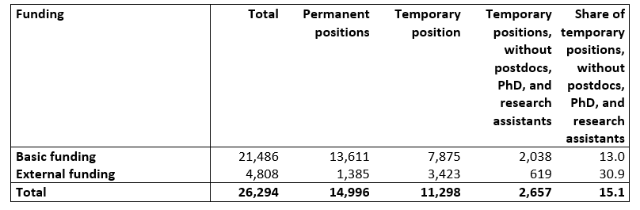
Table 1 Share of permanent and temporary employment by funding category (without postdoc, PhD, and research assistants) in Norwegian higher education sector 2021.
N= 26,294
Source: Statistics Norway
The actual share of temporary employment is even higher than Table 1 shows. In the group reported as permanently employed researchers with external funding the positions are only permanent if the researchers keep finding external funding. The Trade union for researchers call it “hidden temporality” and fudging the statistics. It is clearly a challenge to find robust statistics on the actual share of permanent employment which goes out of scope of our article.

Our second research question addresses the relationship between immigrant status and temporary employment within the Norwegian HE-sector. As Table 2 illustrates, it is evident that a higher share of immigrants holds a temporary position than the remaining population.

Many internationally mobile researchers come to Norway for short term career opportunities without intentions of staying on a long-term basis (Gunnes et al., 2020; Proba, 2023). The majority (nearly 80 per cent) of the researchers with an immigrant background are internationally mobile researchers that have already obtained a masters or doctoral degree from abroad (Steine, 2023). It is likely that these researchers are more inclined to accept a temporary position, and this might be one explanation as to why the share is higher among immigrants, in addition to structural mechanisms and implicit discrimination as outlined in the introduction. However, the causes are most likely even more complex. In the following sections (Table 2-5), we break down data on temporary employment and immigration status by gender, position, country of origin and field of R&D, to shed light on other possible explanations.

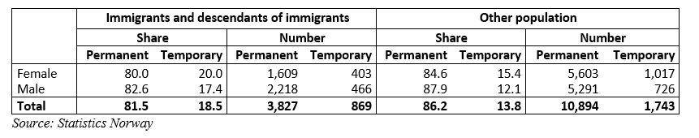
Table 2 Share of permanent and temporary employment by gender and immigrant status (without postdoc, PhD, and research assistants) in Norwegian higher education sector 2021. N=17,333

Table 2 also includes gender, and we see that for women, both among immigrants and the remaining population, the share of temporary employment is even higher. Mählck (2012; 2015) have found that in a Swedish context, women of color who have immigrated from Western countries are more exposed to discrimination in academia than white women. Our findings show that female immigrants have the highest share of temporary employment of all groups (Table 2). As shown in Table 4, there is a higher share of immigrants from Asia, Africa and America and Oceania that holds a temporary position than immigrants from Europe. These findings suggest that there might be connections between gender, ethnicity, and temporary positions, and this is something that requires further investigation in the future.

Table 3 shows the share of permanent and temporary employment by immigrant status and selected positions. The degree of permanent positions is particularly high among full and associate professors; both with more than 90 per cent. A higher share of both university/college lecturers and researchers with an immigrant background hold a temporary position. The differences between those with an immigrant background and the remaining population are less prominent among professors and associate professors. This supports the previous findings regarding internationally mobile researchers and short-term stays (Gunnes et al, 2020).
Gujord, Molde, Olsen and Wunderlich (2022) suggest that temporary employment is a contributing factor as to why many of the international employees do not prioritize to learn Norwegian. However, there is also a possibility that language skills affect employment. Research from a Swedish context (Mählck and Thaver, 2010) finds that language contributes to cultures of inclusion and exclusion at higher education institutions. A potential topic for further research is thus whether lack of language skills (in this case Norwegian) contributes to exclusion of immigrants in permanent positions, and whether language is a mechanism that contribute to or maintain the high share of temporary employment among this group.

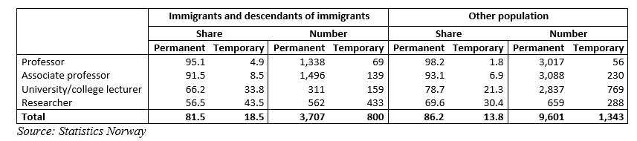
Table 3 Share of permanent and temporary employment by immigrant status and selected positions in Norwegian higher education sector 2021. N= 15,451

We also find what seem to be some patterns regarding country of origin and employment status (Table 4). A larger share of the European researchers is permanently employed than researchers from Africa, America and Oceania and Asia. Previous studies (Maximova-Mentzoni, et al., 2016) have found that immigrants from Europe and western countries have larger probability to obtain a relevant position in Norwegian academia than immigrants from Asia, Africa and South- and Central-America. Even though the division of regions differs a bit from our data, our findings suggest a similar pattern regarding temporary positions. There is, however, a need for more knowledge on the causes of these potential patterns.

Table 4 Share of permanent and temporary employment among immigrants and descendants of immigrant by country of origin (without postdoc, PhD, and research assistants) in Norwegian higher education sector 2021. N= 4,696
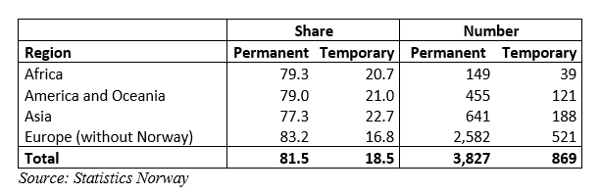

When we look at temporary positions among different fields of R&D, we find that the difference between researchers with an immigrant background and the remaining population is particularly high within natural sciences and medical and health sciences (nearly 8.5 percentage points). The higher education sector is competing with other sectors when it comes to recruitment of talents, and data on recruitment of researchers provided by Statistics Norway show that PhD students (obtaining their degree in Norway) within these fields have a higher tendency to work outside academia upon completion of their doctoral degree. This might be because these candidates are particularly attractive for other sectors, and because the working conditions outside of academia are more attractive than relying on temporary contracts inside academia. Hence, our findings suggest that the higher education institutions might be more dependent on international recruitment for positions within these fields.

The difference between the two groups is also quite large within agricultural sciences (21.2 percentage points), but the number of researchers holding a position within this field is quite low and must therefore be interpreted with caution. For the remaining fields the difference is lower and varies between 1.4 and 2.3 percentage points, with immigrants holding a larger share of temporary positions within all fields.

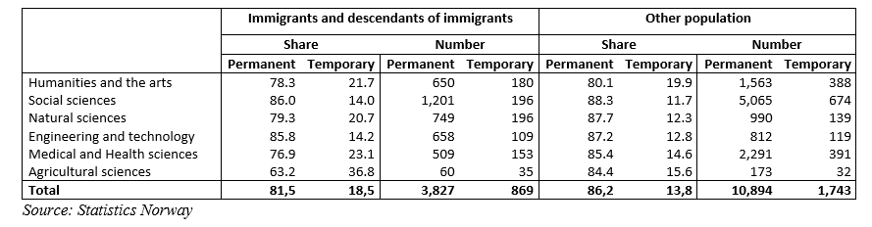
Table 5 Share of permanent and temporary employment by immigrant status and field of R&D (without postdoc, PhD, and research assistants) in Norwegian higher education sector 2021. N = 17,333

5. Implications for further research

In this article, we have investigated how temporary positions in the Norwegian higher education sector differ with source of funding, and how immigration status, combined with gender, country of origin and field of R&D, is related to temporary positions.

Through our findings it has become evident that the basic funding is being used to finance temporary positions, even though external funding often is portrayed as the main cause of the high share of temporary positions. Future research should aim to better understand the causes of the continued use of temporary positions to broaden or understanding of the matter, but also to make it possible to enable effective measures to cope with the problem.

Our findings show that the share of temporary employment is higher among immigrants than among the remaining population. Effective measures to cope with the problem of temporary contracts are dependent on increased knowledge on what barriers and challenges the different groups are facing when competing for permanent positions. Our findings show that more women are temporarily employed than men – both among immigrants and the remaining population. Previous research has shown that internationalization of the academic workforce has had a positive impact on gender balance (Wendt et al., 2022), but we need more knowledge on how internationalization affects temporary employment and precarious working conditions, and particularly the connection between gender, immigration and temporary employment. We also found that temporary contracts are more common for researchers from outside of Europe and there is a need for more knowledge on the causes of the potential patterns regarding country of origin and temporary positions.

6. Bibliographic references

Arday, J. (2022). 'More to prove and more to lose': race, racism and precarious employment in higher education. British Journal of Sociology of Education, 43(4), 513–533. https://doi.org/10.1080/01425692.2022.2074375

Brekke, I. and Mastekaasa, A. (2008) Highly educated immigrants in the Norwegian labour market: permanent disadvantage? Work, employment and society, 22(3): 507-526.
Bozzon, R., Murgia, A., Poggio, B., & Rapetti, E. (2017). Work–life interferences in the early stages of academic careers: The case of precarious researchers in Italy. European Educational Research Journal EERJ, 16(2-3), 332–351. https://doi.org/10.1177/1474904116669364

Castellacci, F. & Viñas-Bardolet, C. (2021) Permanent contracts and job satisfaction in academia: evidence from European countries, Studies in Higher Education, 46:9, 1866-1880, DOI: 10.1080/03075079.2019.1711041

Drange, I. (2009) Sysselsatt eller tilsidesatt? Heltidstilpasning blant høyt utdannede majoritetskvinner. In Birkelund, G.E. and Mastekaasa, A. (eds). Integrert? Innvandrere og barn av innvandrere i utdanning og arbeidsliv. Oslo: Abstrakt forlag.

European Commission (2020) A new ERA for Research and Innovation. European Commission. COM(2020) 628. URL: https://eur-lex.europa.eu/legal content/EN/TXT/?uri=COM%3A2020%3A628%3AFIN (Accessed on 20 April 2023)

Fontinha, R., van Laar, D. and Easton, S. (2018) Quality of Working Life of Academics and Researchers in the UK: The Roles of Contract Type, Tenure and University Ranking. Studies in Higher Education 43 (4): 786–80

Frølich, N., Wendt, K. K., Reymert, I. S., Tellmann, S.M., Elken, M., Kyvik, S., Vabø, A. and Larsen, E. H. (2018) Academic career structures in Europe : Perspectives from Norway, Denmark, Sweden, Finland, the Netherlands, Austria and the UK, NIFU Rapport 2018:4. URL: https://nifu.brage.unit.no/nifu-xmlui/bitstream/handle/11250/2487666/NIFUreport2018-4.pdf?sequence=1&isAllowed=y (Accessed April 19 2023)

Gujord, A. K. H., Molde, E. B., Olsen, A. M. K., & Wunderlich, I. (2022). Individuelle valg og kollektive forestillinger om norsk språk i akademia. Dybdeintervjuer med internasjonalt ansatte forskere. Nordand, 17(1), 1-15. https://www.idunn.no/doi/10.18261/nordand.17.1.1

Gunnes, H., Madsen, A.A., Ulvestad, M. E. S., Wendt. K. & Langfeldt, L. (2020). Kartlegging av postdoktorstillingen: Mål, praksis og erfaringer. (Mapping of postdoctoral positions). NIFU-rapport 2020: 31. NIFU. Oslo.

Herschberg, C., Benschop, Y., & van den Brink, M. (2018). Precarious postdocs: A comparative study on recruitment and selection of early-career researchers. Scandinavian Journal of Management, 34(4), 303–310. https://doi.org/10.1016/j.scaman.2018.10.001

Hollywood, A., McCarthy, D., Spencely, C., & Winstone, N. (2020). 'Overwhelmed at first': the experience of career development in early career academics. Journal of Further and Higher Education, 44(7), 998–1012. https://doi.org/10.1080/0309877X.2019.1636213

Ministry of Education and Research (2019) Tiltak for reduksjon av midlertidighet i UH-sektoren. Ministry of Education and Research. URL: https://www.regjeringen.no/contentassets/b28061b66ee44140b3c80ea8b4e5df97/rapport-midlertidighet-311219.pdf (Accessed on 19 April 2023)

Ministry of Education and Research (2021) Strategi for forskerrekruttering og karriereutvikling. Ministry of Education and Research. URL: https://www.regjeringen.no/contentassets/58a8bb9fecac4dd6aaf9ead1a6e3c1cd/strategi-forskning-web_uu.pdf (Accessed on 19 April 2023)

OECD (2021) Reducing the precarity of academic research careers. OECD Science, Technology and Industry Policy Papers, No. 113, OECD Publishing, Paris, https://doi.org/10.1787/0f8bd468-en.

OECD (2023), Temporary employment (indicator). doi: 10.1787/75589b8a-en (Accessed on 19 April 2023)

Official Norwegian Reports NOU 2022: 2 (2022) Academic freedom of expression. Ministry of Education and Research.

O’Keefe, T., and A. Courtois. 2019. “‘Not One of the Family’: Gender and Precarious Work in the Neoliberal University.” Gender, Work & Organization 26 (4): 463–479. doi:10.1111/gwao.12346.

Proba samfunnsanalyse (2023) Analyse av ekstern finansiering og midlertidighet i universitets- og høyskolesektoren. Proba-rapport 2023-7. URL: https://proba.no/wp-content/uploads/Rapport-2023-7-Ekstern-finansiering-og-midlertidighet.pdf (Accessed on 19 April 2023)

Saxonberg, S. & Sawer, L. (2006). Uteslutningsmekanismer och etnisk reproduktion innom Akademin. I L. Sawer & M. Kamali (red.) Utbildningens dilemma: Demokratiska ideal och andrafierande praxis. SOU 2006:40. Stockholm.

Statistics Norway (2023): https://www.ssb.no/en/statbank/table/13878

Steine, F. S. (2023) Hver tredje forsker i norsk akademia er innvandrer. Statistisk sentralbyrå. URL: https://www.ssb.no/teknologi-og-innovasjon/forskning-og-innovasjon-i-naeringslivet/statistikk/forskerpersonale/artikler/hver-tredje-forsker-i-norsk-akademia-er-innvandrer (Accessed on 20 April 2023)

The Young Academy of Norway / Akademiet for yngre forskere (2018). Unge forskere i Norge. Karriereveier og ambisjoner. Oslo: Akademiet for yngre forskere. URL: https://akademietforyngreforskere.no/wp-content/uploads/2018/05/Ayf-UngeForskereiNorge2018.pdf (Accessed on 19 April 2023)

Villund, O. (2008) Riktig yrke etter utdanning? En registerbasert undersøkelse om kompetanse og arbeidsoppgaver hos ansatte med innvandrerbakgrunn. Rapport 2008/27. Oslo-Kongsvinger: Statistisk sentralbyrå.

Waaijer, C. J. F., Belder, R., Sonneveld, H., van Bochove, C. A. and van der Weijden, I. C. M. (2017) Temporary Contracts: Effect on Job Satisfaction and Personal Lives of Recent PhD Graduates. Higher Education 74 (2): 321–339.

Wendt, K., Gunnes, H, Aksnes, D. W. (2022): International migration of researchers and gender imbalance in academia—the case of Norway. Scientometrics, 127, 7575–759. URL: https://link.springer.com/article/10.1007/s11192-022-04365-y,

Open science practices
The article is based on data that are partly openly available at the Statistics Norway (StatBank Norway). We have in addition run some extra coupling of data that has not been published before. We plan to publish the article in an open access journal. Data that is not published in the statistical bank is available per request.

Author contributions
Both authors have contributed to analysis of the relevant data and to writing of the article.

Competing interests
Authors declare of having no competing interests.

Funding information
This work is funded by Statistics Norway (internal funds).

See for example the OECD Job Quality Database: https://stats.oecd.org/Index.aspx?DataSetCode=JOBQ
E.g. reducing the share of temporary contracts has been a stated goal in the government’s letters of allocation to the higher education institutions since 2010. A working group has suggested measures to reduce the use of temporary contracts, and it is a central theme in the government’s strategy for researcher recruitment and career development from 2021.
See for example NOU 2022:2 Academic Freedom of expression, p. 83-84.
See The University and University Colleges Act § 6-4 (1).
See Regulations on terms of employment for positions such as postdoctoral fellow, research fellow, scientific assistant and specialist candidate.

