On the relationship between previous international collaboration and international mobility of scientific researchers

Huilin Ge*, Rodrigo Costas**

*h.ge@cwts.leidenuniv.nl
0009-0008-3966-5727
Centre for Science and Technology Studies (CWTS), Leiden University, Netherlands

**rcostas@cwts.leidenuniv.nl
0000-0002-7465-6462
Centre for Science and Technology Studies (CWTS), Leiden University, Netherlands
DSI-NRF Centre of Excellence in Scientometrics and Science, Technology and Innovation Policy (SciSTIP), Stellenbosch University, South Africa

Abstract
In this study we explore the relationship between previous international collaborations and researchers’ first mobility destinations. Mobility in this study is observed when researchers are affiliated for the first time to a new country different from their country of origin. Previous international collaborations refer to co-authorships across borders that a researcher had before moving for the first time to a new country. Publication records in Dimensions from 1990 to 2020 were used to collect collaboration and mobility information of individual researchers. Of all researchers with mobility, 55.2% had international collaborations before their first move, but only 29.1% had some previous collaborations with their country of destination before their first move. There are differences in the relationships between previous international collaboration and mobility depending on the direction of movement between countries, and the relationship between collaboration and mobility is stronger as researchers advance in their career stages.

1. Introduction
The globalization of academia is gradually taking place, manifested in increasing scientific collaboration and international mobility. Academic collaboration is crucial for advancing research and innovation in various fields. It allows researchers to bring their expertise and knowledge together, exchange ideas, and work towards common goals. Many studies have shown that international collaboration can promote high-quality academic output (Royal Society, 2011). The benefits of collaboration extend beyond the advancement of research as it also leads to increased scientific productivity and visibility of countries (Ronda-Pupo, 2023).

The positive correlation between collaboration and the number of publications and citation impact has been well established. He et al. (2009) found that collaboration is related to a significant increase in the number of publications and impact, and the relationship is more significant in international collaborations. Lee and Bozeman (2005) also found that international collaboration has a positive effect on citation rates.

International mobility of scientists has several benefits, including enhancing scientific capabilities, promoting the exchange of knowledge and ideas, and advancing individual researchers' careers. Studies have demonstrated that mobility can lead to higher productivity and citation rates for scholars. For instance, De Filippo et al. (2009) found that mobility has positive effects on productivity, while Sugimoto et al. (2017) reported that mobile scholars have a citation rate that is 40% higher than non-mobile scholars, on average.

The impact of mobility on the collaboration of researchers has been a topic of interest in the academic community. Liu and Hu (2022) have found that mobility leads to increased collaboration with new partners without dampening scientists' collaboration with previous collaborators. This suggests that mobility can bring new collaboration opportunities and networks, while still maintaining existing collaborations.

Dahlander and McFarland (2013) have also studied the impact of mobility on collaboration and found that continued collaboration with previous partners requires fewer startup costs and can result in higher productivity and performance than establishing new collaborations. However, global mobility problems such as a change in geographic location and a loss of stable co-authors can reduce the productivity of mobile researchers (Borjas and Doran, 2015).

While much research has focused on the impact of scientific mobility on collaboration (Netz et al., 2020), less is known about the relationship and previous influence of previous collaboration on future mobility flows of researchers. This study aims to explore the relationship between previous (to mobility) collaborations and future mobility among researchers, with a focus on how this relationship varies across different continents and researchers’ career stages. By exploring the relationship of these previous collaborations with researchers’ first mobility flows, the study aims to understand how past international collaborations may influence researchers' decisions to move to a new country.

2. Data and methods
The database Dimensions was used as main data source for this analysis. We examined all publications between 1990 and 2020. We first excluded publications with missing authors or authors' countries, as well as publications with more than 100 authors. In this study, we focused on identifying researchers’ first mobility in their academic career. Thus, we restricted our data to researchers whose first publication was later than 1990 and who had at least two publications in Dimensions, which allowed us to collect collaboration and track movements of researchers from the beginning of their academic career. The dataset consisted of 40,933,719 publications and 12,505,544 disambiguated authors. For each of the publications, we collected Dimensions publication identifier, year of publication, and information about the authors, including Dimensions researcher identifiers and affiliated countries.

We used the approach of mobility footprints to track the mobility paths of researchers (Dudek et al. 2022). Based on this method, researchers' affiliation in publications over the years was used to track their mobility across countries. First, we collected all the publications of each researcher and grouped them by year of publication. Then, countries of researchers affiliated were collected for each year of publication and a series of affiliated countries of researchers were tracked by year. Every change of affiliated country by a researcher in the sequence of years of publication is considered a mobility flow. A mobility flow of a researcher was considered to have occurred if her country of affiliation changed between two consecutive publication years. Researchers without any such flows are considered not to have international mobility.

Figure 1. Visualization of a researcher’s profile over time and the collection of previous collaboration data.
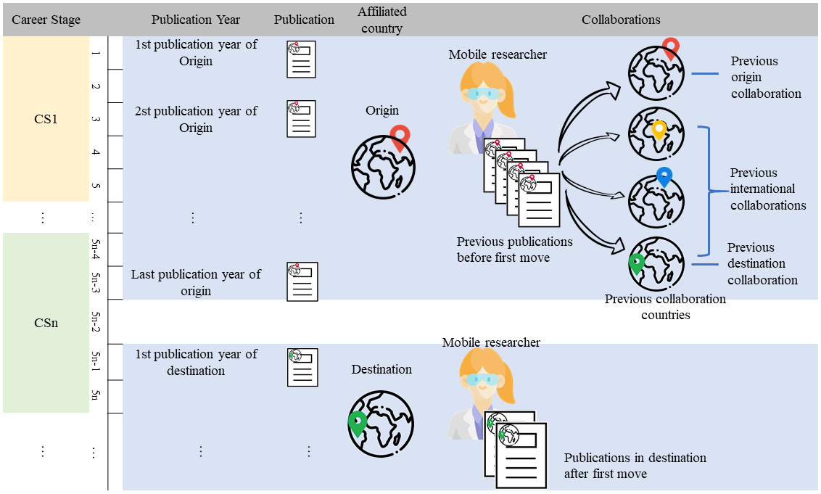

In Figure 1 Country of origin is represented by the red location; destination of first mobility is represented by the green location; Previous publications before first mobility is represented by papers with the red location. In these previous publications, collaboration countries that were not their original country are considered previous international collaborations (represented by no-red locations), and collaborations with their destination are considered previous destination collaborations.

We only focus on the relationship between a researcher’s previous international collaboration (i.e., the international collaboration experience of a researchers before moving for the first time) and her first mobility flow (see Figure 1 for a visual representation). Researchers’ country of origin is defined as the country of affiliation in their first publication(s) in their entire publishing career as captured in our database. When the researcher is affiliated with a new country (different from the country of origin) for the first time in a publication, we consider the researcher to have had the first career mobility flow, the new country is the researcher's first destination, and the year is the first publication year of destination. If a researcher has more than one new country in the first publication year of destination, we consider all these countries as the researcher’s first destinations and there are more than one mobility flows in the profile of that researcher.

In those cases when a researcher has simultaneously publications affiliated with their country of origin and at the same time with their destination were still counted as publications in the country of origin before first mobility. This is to account for potential publication delays (e.g., a researcher may get a publication published after moving due to publication delays). Previous international collaboration is defined as the international co-authorships of researchers in their publications with their country of origin before their first mobility flow. As a result, our dataset comprises 1,396,287 (15.8% of all researchers) mobile researchers, 1,545,886 mobility flows and 9,433,151 publications before their first mobility.

Researchers' international mobility flows cover a total of 208 countries, and they belong to 6 continents: Africa, Asia, Australia, Europe, North America, and South America. This study defined the career stage at which researchers first moved based on the time span between the last publication year in their country of origin and the year of first publication of their entire publishing career. The specified career stages include: CS1 First Career Stage (between 1 and 5 years), CS2 Second Career Stage (between 6 and 10 years), CS3 Third Career Stage (between 11 and 15 years), and so on (see also Figure 1).

3. Results
To explore the associations underlying international mobility and previous collaborations, Table 1 presents the numbers and percentages of researchers who had previous international collaborations and those who had collaborations with their destination before their first mobility flow, segmented by the continent of origin. For simplification reasons we have aggregated the data at the continent-level, although the underlying flows refer to country mobility flows.

On average, the number of researchers and mobilities with Europe as the continent of origin is much higher than other continents, followed by Asia, North America, South America, Oceania and Africa. Correspondingly, there is a similar trend in the number of researchers who have had previous international collaborations and those who have collaborated with their destination before their first mobility across different continents of origin. On different continents of origin, around 30% of researchers have had previous collaborations with the destination, while 49-60% of researchers have had previous international collaborations. Among the six continents studied, the proportion of previous international collaborations was highest for mobility flows originating from Europe (60.5%), while it was lowest for those originating from Asia (49.5%).

Table 1. Number and percentage of mobilities by continent of origin from 1990-2020.

Continents of origin | Mobile researchers | Mobility flows | Mobile researchers with previous international collaboration |  | Mobile researchers with previous international collaboration with their destination
 | Number | Number | Number | Percentage | Number | Percentage
Europe | 604554 | 677750 | 365643 | 60.5% | 181305 | 30.0%
Asia | 377544 | 392530 | 186826 | 49.5% | 109462 | 29.0%
North America | 301296 | 328197 | 153974 | 51.1% | 81751 | 27.1%
South America | 54119 | 57004 | 29546 | 54.6% | 16748 | 30.9%
Oceania | 44964 | 48106 | 24865 | 55.3% | 12449 | 27.7%
Africa | 39643 | 42299 | 23620 | 59.6% | 12808 | 32.3%
Total | 1422120 | 1545886 | 784474 | 55.2% | 414523 | 29.1%

To further explore the associations underlying first international mobility and previous collaboration with destination among different continent pairs of origin and destination, we collected information on all mobility flows and identified the country of origin and destination for each researcher. Then we collected the number of mobile researchers between each country pair of origin-destination and calculated the proportion of mobile researchers who had previous collaborations with the country of destination for each pair. These proportions were used to draw boxplots grouped by continents, as shown in Figure 2 (country pairs of origin-destination with fewer than 10 mobile researchers are omitted).

Figure 2. Percentage of mobile researchers who have collaborated with the destination before moving across origin-destination country pairs, grouped by continent of country and origin-destination continent pairs. The Red diamond indicates the mean of each boxplot. The red baseline line represents the percentage at the global level.
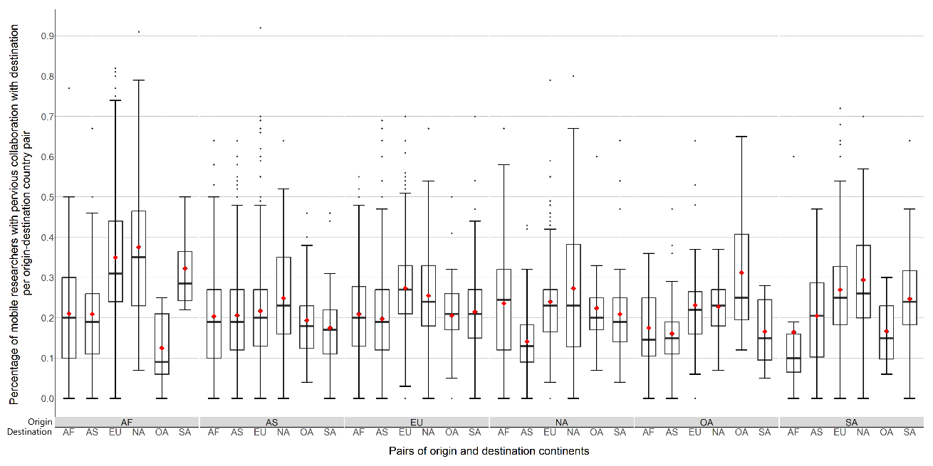
Movements towards North America and Europe typically have higher percentages of researchers with previous collaborations with the country of destination. Conversely, first movements towards Africa and Asia are often associated with lower levels of previous collaboration. Cross-border movements within continents of Europe, Australia and North America tend to have a higher proportion of prior cooperation.

The next section analyzes whether the career stage of researchers is associated to previous collaboration and mobility flows. As Figure 3 demonstrates, 770,362 (55.2%) of the first mobility flows occurred at researchers’ CS1 (within the first 5 years of their publishing career), 447,724 (32.1%) at CS2, 121,519 (8.7%) at CS3, 40,176 (2.9%) at CS4, 13,243 (0.9%) at CS5, and 3,263 (0.2%) at CS6 and CS7.

Figure 3. Number of mobile researchers by career stage of researchers, broken down by number of researchers collaborating with country of destination before first move (Left). Percentage of mobile researchers with previous collaboration with destination (Right).
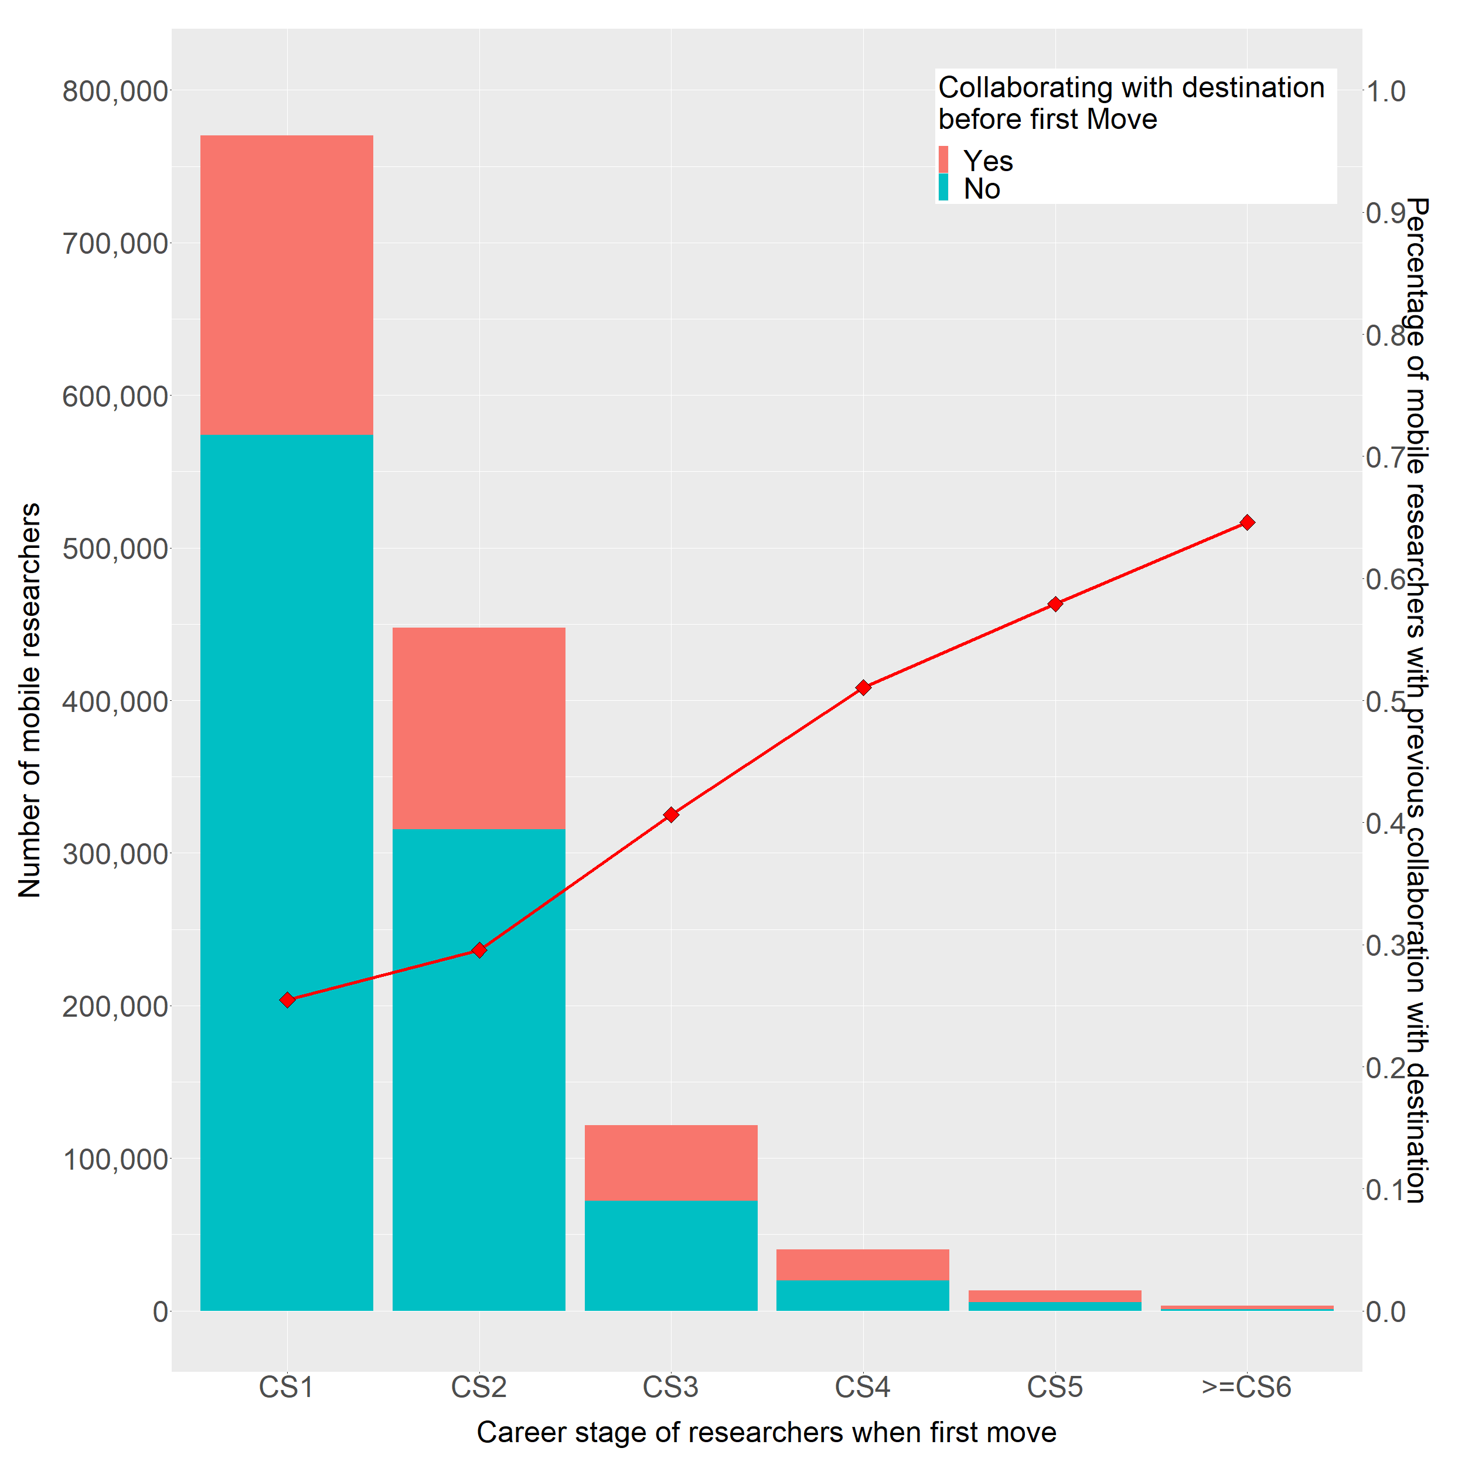

In general, the first mobility flow is associated with 28.6% (442,377) of researchers who have previous collaborations with their destination. However, this percentage increases with the career stage of researchers. At the CS1 stage, the proportion drops to 25.5% (196,272 out of 770,362), while it increases to 29.6% and 40.1% at career stages CS2 and CS3, respectively, reaching 64.6% at CS6 and CS7. The findings indicate that early-career researchers are more likely to move than those who are later in their careers, and they do it more often to countries with whom they haven’t collaborated before they move. Conversely, later-career movers tend to select as their first destination countries they have previously collaborated with. This finding suggests that there may be different motivations and considerations for researchers at different stages of their careers when it comes to international mobility. A potential hypothesis is that early-career researchers may prioritize the acquisition of new knowledge, experiences, and connections, while later-career researchers may focus more on maintaining and strengthening existing collaborations.

4. Discussion and Conclusion
In this study, we examined the relationship between previous collaborations and future mobility of researchers. Our analysis showed that, globally, only 29.1% of mobility researchers had previous collaborations with the country of destination before moving. However, this proportion varied with the direction of movement between countries and continents, and increased with the career stage of researchers. Furthermore, we found that early-career researchers were less likely to have previous collaborations with a destination before moving, which may be due to the desire to gain new experiences and expand their professional networks.

While previous collaborations with a destination may not be a major factor in attracting mobile researchers, our results suggest that mid-career researchers with previous collaborations may be more likely to move to a country of destination. Additionally, our findings highlight the need to support early-career researchers in building collaborations with international partners.

This study provides preliminary understanding of the relationship between previous collaborations and future mobility of researchers. Our analysis was based on a large dataset of international collaborations and mobility events, which allowed us to explore the relationship across different career stages. However, our study also has some limitations. Firstly, our work did not provide a comprehensive view of the mobility patterns of researchers beyond their first international movement. Future work could track the movement trajectories of researchers over time to provide a more complete understanding of mobility patterns and their association with previous collaboration. Secondly, our analysis only considers the existence of previous collaborations without considering the closeness or intensity of these collaborations. Future research could explore the impact of the intensity and closeness of previous collaborations on researchers' mobility decisions and outcomes.

Overall, our findings contribute to the understanding of the relationship between international research collaboration and mobility, providing early insightful information for policymakers and institutions seeking to attract and retain international research talent.

Open science practices

We used the database Dimensions, which is a licensed database available at the CWTS SQL server. The scripts to process the data can be found in the Github of the first author [gehl0921 (github.com)].

Acknowledgements

We thank Clara Calero.

Author contributions

Huilin Ge: Conceptualization, Methodology, Data curation, Visualization, Formal Analysis, Writing – original draft. Rodrigo Costas: Conceptualization, Methodology, Writing –review& editing, Supervision.

Competing interests
The authors have no relevant financial or non-financial interests to disclose.

Funding information
Huilin Ge is financially supported by the China Scholarly Council (202106340045).

References
Borjas, G. J., Doran, K. B. (2015). Prizes and productivity how winning the fields medal affects scientific output. Journal of human resources, 50(3), 728-758.

Dahlander, L., McFarland, D. A. (2013). Ties that last: Tie formation and persistence in research collaborations over time. Administrative science quarterly, 58(1), 69-110.

De Filippo, D., Casado, E.S., Gómez, I. (2009). Quantitative and qualitative approaches to the study of mobility and scientific performance: a case study of a Spanish university. Research evaluation, 18, 191–200.

He, Z., Zhen, N., Wu, C. (2019). Measuring and exploring the geographic mobility of American professors from graduating institutions: Differences across disciplines, academic ranks, and genders. Journal of Informetrics, 13, 771–784.

Dudek, J., Van Hoed, M., Núñez, López, L., Costas, R. (2022).Mobility footprints: A notation method for studying researcher moves. In N. Robinson-Garcia, D. Torres-Salinas, & W. Arroyo-Machado (Eds.), 26th International Conference on Science and Technology Indicators, STI 2022 (sti22229). https://doi.org/10.5281/zenodo.6957327

Lee, S., Bozeman, B. (2005). The impact of research collaboration on scientific productivity. Social studies of science, 35(5), 673-702.

Liu, M., Hu, X. (2022). Movers’ advantages: The effect of mobility on scientists’ productivity and collaboration. Journal of Informetrics, 16, 101311.

Netz, N., Hampel, S., Aman, V. (2020). What effects does international mobility have on scientists’ careers? A systematic review. Research evaluation, 29(3), 327-351.

Ronda-Pupo, G. A. (2023). Mexico: a bridge in Cuba–US scientific collaboration. Scientometrics, 1-15.

Royal Society (2011). Knowledge, Networks and Nations: Global Scientific Collaboration in the 21st Century. London: Elsevier.

Sugimoto, C., Robinson-Garcia, N., Murray, D. et al. (2017). Scientists have most impact when they're free to move. Nature, 550, 29–3.

