Higher Productivity and Lower Work Satisfaction? Work-family Conflict of Foreign-born versus U.S.-born Faculty

Luyu Du*, Julia Melkers** and Mayra M. Tirado**

*luyudu@asu.edu
ORCID: https://orcid.org/0009-0008-2127-8251
School of Public Affairs, Arizona State University, United States

** Julia.Melkers@asu.edu; mmtirado@asu.edu
ORCID: http://orcid.org/0000-0001-5045-4068; ORCID: https://orcid.org/0000-0003-0332-8784
School of Public Affairs, Arizona State University, United States

Abstract

The proportion of faculty in the U.S. who are foreign-born has increased significantly in recent decades. These faculty make considerable contributions to the U.S. science system, consistently shown to be more productive in research. Yet, multiple studies have found foreign-born faculty to be less satisfied with their work environments than their U.S.-born counterparts. One possible explanation for some of this dissatisfaction may lie in work-family balance and related conflicts, yet this has been unexplored specifically to foreign-born faculty. Using the U.S. NSF-funded NETWISE II survey of academic scientists, we examine how and why work-family functions differently for foreign-born and U.S.-born faculty in U.S. doctoral-serving institutions. Findings show that foreign-born are generally more likely to experience work-family conflict than U.S.-born faculty, though the effects of work and family demands are mixed. Overall, further research on the multiple roles of foreign-born faculty is needed for a deeper understanding of their experiences in the U.S. academe.

Higher Productivity and Lower Work Satisfaction? Work-family Conflict of Foreign-born versus U.S.-born Faculty

1. Introduction
In the era of globalization, U.S. higher education institutions have become increasingly diversified with the growing presence of foreign-born faculty (NSF, 2022). As of 2021, foreign-born faculty account for around 33% of science and engineering faculty members employed in U.S. universities, increasing from 12% in 1973 (NCSES, 2021). As the scholarly community grows more diverse, the importance of foreign-born faculty has been recognized more than ever before. However, a paradox is emerging: foreign-born faculty are found to be more productive (e.g., Kim et al., 2012) but less satisfied with work (e.g., Sabharwal, 2011a) than U.S.-born faculty. These disparities require further examination: what is behind the productivity and dissatisfaction of foreign-born faculty in U.S. universities?
Like many immigrants, foreign-born faculty face multiple challenges in integrating professionally and personally in a new cultural setting (Feeney et al., 2023; Kim et al., 2020). Specific to faculty experiences, how one balances home and work life, and the challenges in each setting, matters for a range of personal and professional experiences (Fox et al., 2011). As foreign-born faculty establish their professional lives in the U.S., they also establish their personal lives with the support of U.S. immigration policy, which often sponsors their families to come to the U.S. (Batalova, 2012). Like any working professional, work-family conflicts may present themselves due to the interaction and interference between their work and home-life roles. While work-family conflict is likely to negatively affect the work satisfaction of faculty members (Sarwar et al., 2021), particularly women (Carr et al., 1998), how this functions for foreign-born faculty has been unexplored. Drawing upon role conflict theory and job-demands resources theory, we address the following research questions:
1) How and why does work-family conflict function differently for foreign-born faculty and U.S.-born faculty?
2) Given the known gender disparities of work-family conflict in general, are foreign-born women more likely to experience work-family conflicts than their male counterparts?
Using data from an NSF-funded national study of science and engineering faculty (NETWISE II) in the U.S., we examine the work-family experiences of foreign-born faculty. Work-family balance is known to matter for a range of work-related experiences of faculty, including overall well-being. Foreign-born faculty face considerable challenges in relocating and adapting to what is often a very different social and workplace setting. Understanding how the relationship of work and family experiences figure into this experience is important for improving the support and retention of these scientists. Given the increasing proportion of foreign-born faculty in the U.S., it also examines factors specific to this population relevant to understanding work-family balance and conflict. This may inform universities to not only recruit and retain foreign-born faculty but also ensure that they are able to thrive and succeed in the U.S. academic setting. Finally, this study will provide implications for higher education institutions to manage diversity in academic science.

2. Literature Review and Hypotheses

2.1. Foreign-born Identity in U.S. Academic Science
Existing literature has consistently found that foreign-born faculty are more productive in publications, grants, and patents than U.S.-born faculty (Corley & Sabharwal, 2007; Kim et al., 2012; Mamiseishvili & Rosser, 2010). Yet, they have also faced several challenges in the U.S. academic workplace, including lower salary and work satisfaction (Corley & Sabharwal, 2007; Sabharwal, 2011b), as well as fewer career advancement opportunities (Kim et al., 2020) than their U.S.-born counterparts.
The challenges faced by foreign-born faculty can be partially attributed to their foreignness—the degree of social, linguistic, and cultural differences between groups of people from different cultural backgrounds (Berry, 1980). Social identity theory also posits that individuals are often categorized into different social groups based on their perceived group memberships, such as gender and nativity (Ashforth & Mael, 1989). As such, foreign-born’s cultural differences and language barriers often hinder their workplace interactions as some U.S.-born may perceive their relationship with foreign-born as “us versus them” (Elder, 2005, p. 11). That said, foreign-born faculty tend to be considered out-group members by their U.S.-born peers (Manrique & Manrique, 1999), and thus feel marginalized in the workplace (Kim et al., 2020; Marvasti, 2005).

2.2. A Role Conflict Perspective
In academic science, a faculty member must fulfill multiple roles at work and family domains. While studies on foreign-born faculty have focused on their work roles, one missing piece is their family roles and work-family conflicts, which may also affect their work satisfaction. As role conflict theory indicates, work-family conflict refers to “interrole conflict in which the general demands of, time devoted to, and strain created by the job interfere with performing family-related responsibilities” (Netemeyer et al., 1996, p. 401). Understanding this issue is important because work-family balance is one of the key determinants of faculty members’ work satisfaction (Ambrose et al., 2005; Sarwar et al., 2021).
The capacity of faculty members to balance work and family is especially crucial in academic science, where work expectations are highly demanding and do not allow much interference from family (Fox, 2005). Existing literature has demonstrated that family responsibilities would negatively impact academic scientists’ productivity (Derrick et al., 2021), career development (Fox & Gaughan, 2021), and work satisfaction (Carr et al., 1998). Earlier research also calls for further investigation into the personal experiences of foreign-born faculty to help explain their high productivity and low work satisfaction (Kim et al., 2011). Given the lower work satisfaction of foreign-born faculty, we expect that they are more likely to experience work-family conflict than their U.S.-born colleagues.
Hypothesis 1: Controlling for other factors, being foreign-born predicts a higher probability of work-family conflict.
Generally, family demands that require individuals to spend much time taking care of family will result in work-family conflict. Aligned with this proposition, Fox et al. (2011) found that the presence of young children is a significant predictor of work-family conflict for academic scientists. Nevertheless, having positive childcare options predicts less work-family conflict as academic scientists can spend more time on work (Derrick et al., 2021). Further, cultural differences exist in family patterns between foreign-born and U.S.-born professionals. The U.S. family culture emphasizes independence and the nuclear family (Fields et al., 2011). In contrast, people raised in countries with collectivist culture (e.g., Asia, South and Central America) tend to rely on their family for childcare (Sallee & Hart, 2015). Given the different family structures of foreign-born and U.S.-born faculty, we expect that family demands are more likely to lead to work-family conflict for U.S.-born faculty than foreign-born faculty.
Hypothesis 2: Family demands are positively associated with work-family conflict, and the effect is stronger for U.S.-born faculty than for foreign-born faculty.
Existing literature on work-family conflict has primarily focused on gender differences, highlighting that women are disadvantaged in academic science for their greater family responsibilities than men (Derrick et al., 2021; Feeney et al., 2014; Perna, 2005). Yet, it is unclear whether such gender differences are also present among foreign-born faculty due to the differences between foreign-born women and U.S.-born women. According to a study by Mamiseishvili (2010), as compared with female U.S.-born faculty, female foreign-born faculty are more productive in publications and devote more time to research and less time to teaching and service. This indicates that while female foreign-born are concentrated on research as general male scientists do, they are also more likely to be constrained by greater family demands than their male counterparts. Therefore, we expect that work-family conflict is more pronounced among female foreign-born faculty than male foreign-born faculty.
Hypothesis 3: Female foreign-born faculty are more likely to experience work-family conflict as compared with their male counterparts.

2.3. A Job Demands-Resources (JD-R) Perspective
JD-R theory offers a theoretical framework for analyzing the effects of work characteristics on individuals’ well-being (e.g., work-family conflict). The key assumption is that individuals have job demands and job resources obtained within the workplace, which are two underlying psychological processes that simultaneously generate job strain and motivation (Bakker & Demerouti, 2007).
Studies by Newton (2013) and Sarwar et al. (2021) indicate that work demands are positively related to work-family conflict for academic faculty. Moreover, foreign-born faculty are subject to additional complexities arising from the intricacies of family interactions and the inevitable need for trade-offs. As one of the geographer interviewees in a study by Theobald (2009) said, “International faculty takes all opportunities to work almost any place…willing to commute, to leave children and spouses” (p. 25). This can be explained that academic scientists are highly responsive to work demands as the success of their scientific research work is a key factor in how they define themselves (Fox & Gaughan, 2021). This tendency is particularly pronounced among foreign-born faculty, who face additional barriers to career advancement compared to their U.S.-born peers, and they may therefore work harder to succeed in academic careers. Given the strong work commitment of foreign-born, we expect that they are more likely to experience work-family conflict due to job demands compared to their U.S.-born peers.
Hypothesis 4: Job demands are positively associated with work-family conflict, and the effect is stronger for foreign-born faculty than for U.S.-born faculty.
Another key factor in the JR-D framework is job resource, which refers to the physical, psychological, or organizational aspects of a job that help reduce the physiological and psychological expenses associated with job demands (Bakker & Demerouti, 2007). Previous research has illustrated the importance of an uncompetitive/welcoming work climate in reducing work-family conflict for academic scientists (Fox et al., 2011). As for foreign-born faculty, they may have fewer of these job resources than their U.S.-born colleagues due to workplace marginalization. Since these job resources are crucial for academic scientists to deal with strain problems, we expect that U.S.-born faculty who have more access to these resources are less likely to experience work-family conflict compared to their foreign-born colleagues.
Hypothesis 5: Job resources are negatively associated with work-family conflict, and the effect is stronger for U.S.-born faculty than for foreign-born faculty.

3. Data and Method
This study uses data from the 2011 NETWISE II project, an NSF-funded national survey of academic scientists and engineers in four STEM fields: biology, biochemistry, mathematics, and civil engineering. The survey was designed to focus on female and underrepresented minorities in STEM fields and explore their careers, work environments, and professional networks. The stratified sample includes 9,925 academic faculty members from 521 academic institutions: all Carnegie-classified research-extensive and research-intensive universities, and selective teaching institutions (Carnegie Foundation, 2000; NETWISE, 2012). The survey had a total of 4,196 valid responses (40.4% response rate). Since we focus on the experience of academic scientists in research institutions, the final sample used for this study includes 1,917 responses from 259 doctoral-serving institutions. Given the oversampling approach of women, all the statistics reported here are weighted by the inverse of the probability of selection.
As we are interested in the factors predicting the work-family conflict of foreign-born and U.S.-born faculty, this study uses logistic regression models with interaction terms of foreign-born status and key variables. The dependent variable is a binary variable indicating the reported work-family conflict, which is generated from a scale developed by Netemeyer et al. (1996) (a = .93). Moreover, the two main variables of interest for this study are foreign-born status (foreign-born = 1, native-born = 0) and gender (women = 1, men = 0). Additionally, the key explanatory constructs for this study include job demands, job resources, and family demands. Job demands are operationalized as the physical demands of faculty work (weekly work hours) and psychological demands of work stress (a = .69). We focus on informal job resources, including a supportive work climate (a = .84) and faculty’s satisfaction/perception of their faculty rewards (a = .78). In terms of family demands, two variables are included: marital status (married = 1, otherwise = 0), and a binary variable indicating the presence of children in the household. Finally, several variables that may affect work-family conflict are controlled, including race/ethnicity, academic rank, discipline, and institutional types. A full description of measurements will be provided in our longer version of the paper.

4. Results
Table 1 displays descriptive and bivariate statistics of the sample. Among the respondents, 29% are foreign-born. This is consistent with the general representation of foreign-born in U.S. academic institutions (NSF, 2022). As shown in the bivariate comparison statistics, foreign-born academics have different profiles from their U.S.-born colleagues. Foreign-born faculty are significantly more likely to be male, Asian, and Hispanic, while being less likely to be White. Family characteristics are also quite different among the two groups: foreign-born faculty are more likely to be married and have dependent children than their native-born counterparts. Moreover, foreign-born faculty are concentrated relatively more in the assistant professor rank but less likely to have attained full professor rank. They are also more likely to be biochemists, civil engineers, and mathematicians but less likely to be biologists, as compared with U.S.-born faculty. Further, foreign-born faculty are more likely to work in research-extensive than research-intensive institutions compared to native-born faculty. Additionally, we present the differences between the two groups in key variables of this study. First, foreign-born faculty are more likely to experience work-family conflict than U.S.-born faculty. Although their work demands and work stress do not differ significantly, foreign-born faculty are less satisfied with their rewards and have a less supportive work environment when compared to their U.S.-born counterparts.

Table 1. Weighted descriptive and bivariate statistics by nativity
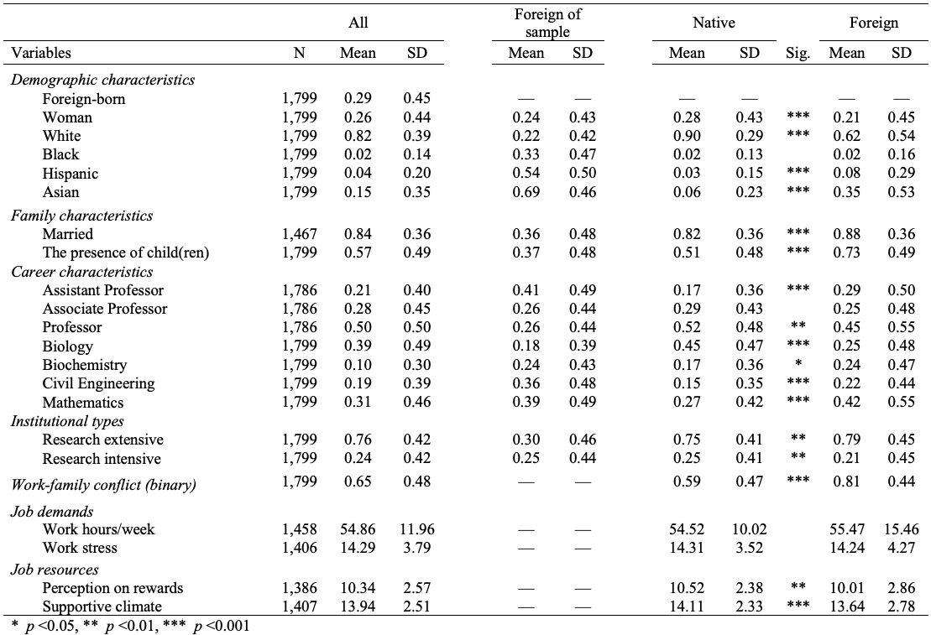

The logistic regression analyses in Table 2 focus on direct effects, indicating the predictors of work-family conflict. As expected, controlling for other factors, being foreign-born (p < .1) and women (p < .01) are positively linked to work-family conflict (hypothesis 1 is supported). Moreover, while marriage has no significant effect on work-family conflict, having dependent children in the household is a significant predictor of work-family conflict (p < .01). Further, workload and work stress are positively related to work-family conflict (p < .01). Additionally, a supportive work climate as an informal job resource can significantly reduce the likelihood of experiencing work-family conflict (p < .01).
The model also includes some demographic and academic career controls known to be influential in work-family conflict. Black and Hispanic professors are more likely to experience work-family conflict than their White counterparts (p < .01). Full professors are less likely to have work-family conflict than assistant professors but are more likely to experience conflict than associate professors. This finding is consistent with previous studies (e.g., Fox et al., 2011), which can be explained by the fact that junior faculty spend more time on research for tenure and thus experience more work-family conflict. Finally, biologists, biochemists, and civil engineers are less likely to have work-family conflict than mathematicians.

Table 2. Logistic regression on work-family conflict, direct effects
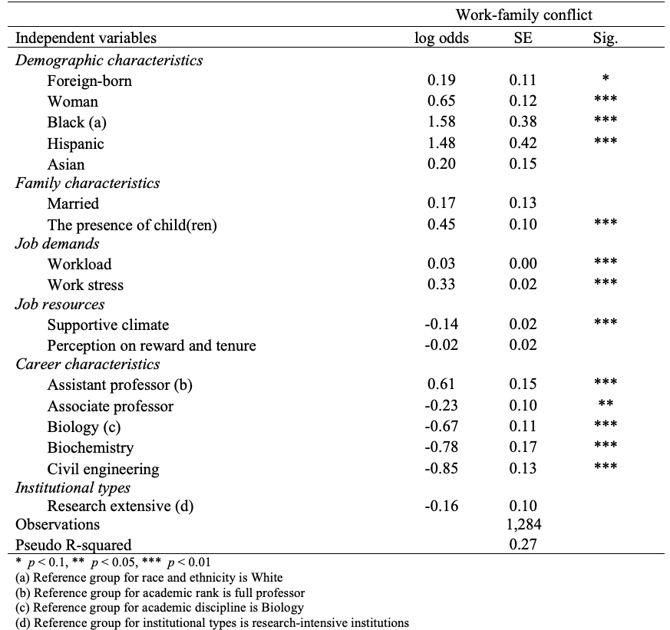

Because our interest lies in how work-family conflict functions differently for foreign-born and U.S.-born faculty, the interaction terms of foreign-born status. by key variables of interest are present in Table 3. The results show that there is no significant difference in work-family conflict between female and male foreign-born faculty (hypothesis 2 is rejected). As for the interaction effects of foreign-born and family demands, the presence of children is positively related to work-family conflict (p < .1), and the effect is stronger for U.S.-born than foreign-born (hypothesis 3 is supported).
In terms of work-related factors, workload as a physical work demand is positively associated with work-family conflict (p < .01), and the effect is stronger for foreign-born than U.S.-born (hypothesis 4 is supported). Surprisingly, although a supportive work climate is negatively related to work-family conflict, foreign-born faculty who work in a more supportive work climate are more likely to have work-family conflict compared to their U.S.-born counterparts. How might we account for this pattern? A possible explanation is that foreign-born faculty, in this case, are more willing to stay in the workplace rather than spend more time at home and caring for family, thus leading to work-family conflict. Further, while faculty’s perception of rewards is not significantly linked to work-family conflict, foreign-born faculty who are more satisfied with rewards and tenure are less likely to experience work-family conflict, as compared with their U.S.-born counterparts. This suggests that the perception of fairness in the workplace matters for academics’ well-being, especially for foreign-born faculty who often have fewer career advancement opportunities.

Table 3. Logistic regression on work-family conflict, interaction effects
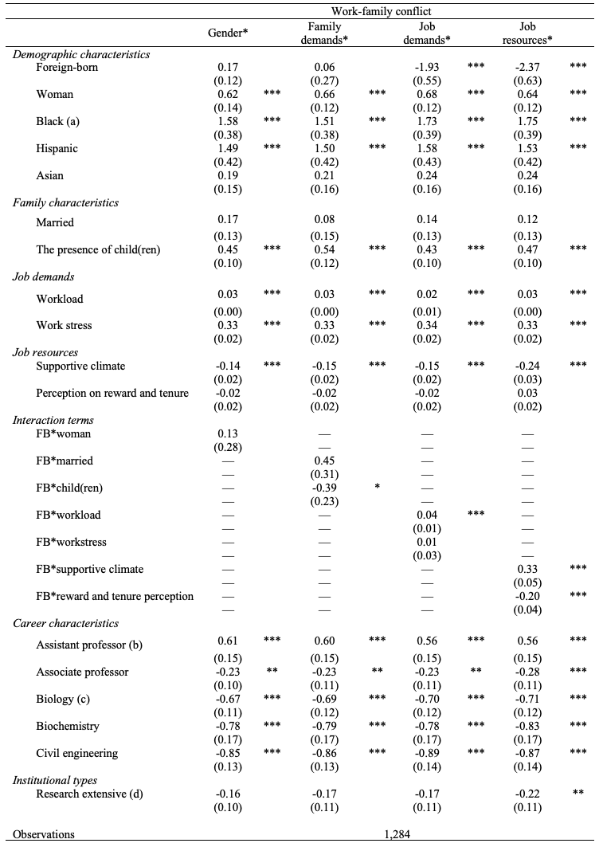
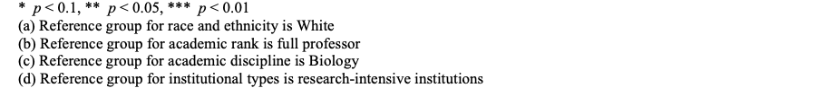

5. Discussion and Conclusion
In this study, we have investigated how work-family conflict functions differently for foreign-born and U.S.-born faculty. Findings suggest that foreign-born identity interacts with work and family demands to influence work-family conflict among academic scientists. Controlling for other factors, being foreign-born predicts a higher likelihood of work-family conflict, though no significant difference is found between female and male foreign-born. Moreover, work demands are more likely to cause work-family conflict issues for foreign-born faculty than U.S.-born faculty, but not for family demands. This can be attributed to the strong work commitment of foreign-born to compensate for their disadvantages of career advancement in the U.S. academic setting, which also explains why they care so much about rewards and tenure and work harder in a supportive work climate.
Overall, the study sheds light on a possible reason why foreign-born faculty are more productive but less satisfied with work. Their high productivity could come at the expense of their family, which may lead to work-family conflict and in turn affect their work satisfaction. Further, the study offers insights for higher education institutions to manage diversity in the scientific workforce. It is not enough to simply create a representative workforce. More importantly, policymakers and practitioners should better understand the needs of faculty members who have different identities to foster an equitable, inclusive work environment where all academics can succeed without sacrificing their family life.

Open science practices
This study U.S.es data from the NSF-funded NETWISE II survey that is not publicly available due to the funding source. We use this dataset for our paper because we hope to have a more nuanced understanding of how different factors (e.g., gender, family, career, and departmental characteristics) predict work-family conflict of foreign-born faculty, which is aligned with the design purpose of the survey to focus on women and underrepresented minorities. The dataset is selected for its unique advantage that one-third of the faculty respondents are foreign-born, and our main interest in this paper lies in the experiences of foreign-born academics in U.S. higher education institutions.

Acknowledgments
Data presented in this article come from the National Science Funded Project: “Netwise II: Empirical Research: Breaking through the Reputational Ceiling: Professional Networks as a Determinant of Advancement, Mobility, and Career Outcomes for Women and Minorities in STEM,” a project funded by the National Science Foundation (grant no. DRL-0910191; co-principal investigators: Julia Melkers, Eric Welch, and Monica Gaughan).

Author contributions
Conceptualization and methodology: Luyu Du, Julia Melkers
Data analysis: Luyu Du
Writing – original draft: Luyu Du
Writing – review & editing: Julia Melkers, Mayra M. Tirado
Supervision: Julia Melkers

Competing interests
The author(s) declared no potential conflicts of interest with respect to the research, authorship, and/or publication of this article.

Funding information
The author(s) received no financial support for the research, authorship, and/or publication of this article.

References

Ambrose, S., HU.S.ton, T., & Norman, M. (2005). A qualitative method for assessing faculty satisfaction. Research in Higher Education, 46, 803–830.

Berry, W. (1980). Acculturation as varieties of adaptation. In A. M. Padilla (Ed.), Acculturation, theory, models, and some new findings (pp. 9 –25). Boulder, CO: Westview Press.

Bakker, A. B., & Demerouti, E. (2007). The job demands-resources model: State of the art. Journal of Managerial Psychology, 22(3), 309–328.

Bozeman, B., & Gaughan, M. (2011). Job satisfaction among university faculty: Individual, work, and institutional determinants. The Journal of Higher Education, 82(2), 154–186.

Batalova, J. (2012). Senior Immigrants in the United States in 2010. Migration Policy Institute. https://www.migrationpolicy.org/article/senior-immigrants-united-states-2010

Carr, P. L., Ash, A. S., Friedman, R. H., Scaramucci, A., Barnett, R. C., Szalacha, L., Palepu, A., & Moskowitz, M. A. (1998). Relation of family responsibilities and gender to the productivity and career satisfaction of medical faculty. Annals of Internal Medicine, 129, 532–538.

Carnegie Foundation. (2000). Classification of Higher Education. https://www.carnegiefoundation.org/our-work/postsecondary-innovation/carnegie-classifications/

Corley, E. A., & Sabharwal, M. (2007). Foreign-born academic scientists and engineers: Producing more and getting less than their U.S.-born peers? Research in Higher Education, 48, 909–940.

Chen, C. C., Rao, A., & Ren, I. Y. (2013). Glass ceiling for the foreign born: Perspectives from Asian-born American R&D scientists. Asian American Journal of Psychology, 4(4), 249–257.

Caldarulo, M., Olsen, J., Frandell, A., Islam, S., Johnson, T. P., Feeney, M. K., Michalegko, L., & Welch, E. W. (2022). COVID-19 and gender inequity in science: Consistent harm over time. PLOS ONE, 17(7).

Demerouti, E., Bakker, A. B., Nachreiner, F., & Schaufeli, W. B. (2001). The job demands-resources model of burnout. The Journal of Applied Psychology, 86(3), 499–512.

Derrick, G. E., Chen, P.-Y., van Leeuwen, T., Larivière, V., & Sugimoto, R. (2021). The academic motherload: Models of parenting engagement and the effect on academic productivity and performance. 25.

Elder, B. (2005). The H-1B visa: Is this the answer to staffing problems? Technical Support, 13, 9–12.

Fox, M. F. (2005). Gender, Family Characteristics, and Publication Productivity among Scientists. Social Studies of Science, 35(1), 131–150.

Fox, M. F., Fonseca, C., & Bao, J. (2011). Work and family conflict in academic science: Patterns and predictors among women and men in research universities. Social Studies of Science, 41(5), 715–735.

Fields, J., O'Connell, M., & Downs, B. (2011). Grandparents in the United States, 2001. U.S. CensU.S. Bureau, Economic Statistics Division.

Feeney, M. K., Bernal, M., & Bowman, L. (2014). Enabling work? Family-friendly policies and academic productivity for men and women scientists. Science and Public Policy, 41(6), 750–764.

Fox, M., & Gaughan, M. (2021). Gender, Family and Caregiving Leave, and Advancement in Academic Science: Effects across the Life Course. SU.S.tainability, 13(12), 6820.

Feeney, M. K., Jung, H., Johnson, T. P., & Welch, E. W. (2023). U.S. Visa and Immigration Policy Challenges: Explanations for Faculty Perceptions and Intent to Leave. Research in Higher Education. https://doi.org/10.1007/s11162-023-09731-0

GreenhaU.S., J. H., & Beutell, N. J. (1985). Sources of conflict between work and family roles. Academy of Management Review, 10(1), 76–88.

Kim, D., Wolf-Wendel, L., & Twombly, S. (2011). International faculty: Experiences of academic life and productivity in U.S. universities. The Journal of Higher Education, 82, 720–747.

Kim, D., Twombly, S., & Wolf-Wendel, L. (2012). International faculty in American universities: Experiences of academic life, productivity, and career mobility. New Directions for Institutional Research, 2012(155), 27–46.

Kim, D., Twombly, S. B., Wolf-Wendel, L., & Belin, A. A. (2020). Understanding Career Mobility of Professors: Does Foreign-Born StatU.S. Matter? Innovative Higher Education, 45(6), 471–488.

Marvasti, A. (2005). U.S. academic institutions and perceived effectiveness of foreign-born faculty. Journal of Economic Issues, 39,151–176.

Manrique, C. G., & Manrique, G. G. (1999). The multicultural or immigrant faculty in American society. Lewiston, NY: Edwin Mellen Press.

Mamiseishvili, K. (2010). Foreign-born women faculty work roles and productivity at research universities in the United States. Higher Education, 60(2), 139–156.

Mamiseishvili, K., & Rosser, V. J. (2010). International and citizen faculty in the United States: An examination of their productivity at research universities. Research in Higher Education, 51, 88–107.

Mamiseishvili, K. (2011). Teaching workload and satisfaction of foreign-born and U.S.-born faculty at four-year postsecondary institutions in the United States. Journal of Diversity in Higher Education, 4(3), 163–174.

Mamiseishvili, K., & Lee, D. (2018). International Faculty Perceptions of Departmental Climate and Workplace Satisfaction. Innovative Higher Education, 43(5), 323–338.

Mamiseishvili, K., & Stuckey, A. (2022). Foreign-born academic leaders in U.S. higher education. Journal of Diversity in Higher Education, 15(5), 657–667.

Netemeyer, R., Boles, J. & McMurrian, R. (1996). Development and validation of work–family conflict and family–work conflict scales. Journal of Applied Psychology, 81, 400–410.

NETWISE. (2012). Netwise Project Overview. Georgia Institute of Technology.

Newton, S. H. (2013). Gender Differences in STEM Academic Career Paths [Dissertation]. Georgia Institute of Technology.

National Center for Science and Engineering Statistics (2021). Survey of Doctorate Recipients. https://ncses.nsf.gov/pubs/nsf23319

National Science Foundation (NSF). (2022). International S&E Higher Education. https://ncses.nsf.gov/pubs/nsb20223/international-s-e-higher-education

Perna, L. W. (2005). Sex differences in faculty tenure and promotion: The contribution of family ties. Research in Higher Education, 46(3), 277–307.

Skachkova, P. (2007). Academic careers of immigrant women professors in the U.S. Higher Education, 53, 697–738.

Sabharwal, M. (2011a). Job satisfaction patterns of scientists and engineers by statU.S. of birth. Research Policy, 40, 853–863.

Sabharwal, M. (2011b). High-skilled immigrants: How satisfied are foreign-born scientists and engineers employed at American universities? Review of Public Personnel Administration, 31(2), 143–170.

Sallee, M., & Hart, J. (2015). Cultural navigators: International faculty fathers in the U.S. research university. Journal of Diversity in Higher Education, 8(3), 192-211.

Sarwar, F., Panatik, S. A., Sukor, M. S. M., & RU.S.badrol, N. (2021). A Job Demand–Resource Model of Satisfaction With Work–Family Balance Among Academic Faculty: Mediating Roles of Psychological Capital, Work-to-Family Conflict, and Enrichment. SAGE Open, 11(2).

Theobald, R. (2009). New faces in academic places: Gender and the experiences of early-career foreign-born and native-born Geographers in the United States. Journal of Geographical Science, 57, 7-32

