On epistemic properties and field-specific logics in the study of knowledge transfer:
Empirical evidence on researchers’ productive interactions from a nationwide survey in Germany.

Melike Janßen* and Annika Just**

*janssen@dzhw.eu; ** just@dzwh.eu
Research Area Research System and Science Dynamics, German Centre for Higher Education Research and Science Studies (DZHW), Germany

1. Introduction
Research is regarded a key contributor to the resolution of relevant social, economic, or ecological problems such as the so-called "Grand Challenges". Along these lines, accounts directed at researchers to engage more strongly in researching acute social problems can be increasingly observed in recent years. Against this backdrop, the question arises how research can find answers to practical relevant questions occurring in society, which is now, as some scholars stress, focused on the deficits of science in tackling collective and complex problems in an efficient and precise way (Stirling, 2008). Thus, the current relationship between science and society is characterised by concrete expectations of responsiveness, which is identified as a crucial criterion for ‘Responsible Research and Innovation’ (RRI) (Stilgoe, Owen & Macnaghtan, 2013; Glerup & Horst, 2014). This policy-driven and thus normative discourse emphasises the notion of moving “from science in society to science for society, with society” (Owen, Macnaghten & Stilgoe, 2012), whereby the legitimacy of science is explicitly acquired through its problem-solving and development-promoting functions. RRI should be aligned to societal needs and encompass a stronger integration of non-academic audiences on knowledge production and problem solution. Consequently, knowledge transfer (KT) gains relevance as a new core mission for academic researchers expected to contribute to societal impact. However, its underlying mechanisms – the causal links between researchers’ collaborative efforts with their stakeholders, KT, and societal impact – are not sufficiently researched (de Jong, Barker, Cox et al., 2014). As a somewhat fuzzy concept, KT – like impact – is hardly used in a consistent, precise way (Hayden, Petrova & Wutti, 2018). KT may refer to different research activities, objectives, and interactions with academic and non-academic actors, resulting in a spectrum of activities and attributes that hampers to make KT visible, measurable, and assessable. While there is established evidence of successful KT in the sciences, technology, engineering, and mathematics (STEM), e.g., patents, the social sciences and humanities (SSH) still lack a common understanding and accepted standards of KT in their field. Consequently, STEM research is often claimed to be more ‘useful’ to society than SSH research, emphasising the existence of disciplinary stereotypes and thus SSH research’s struggle for relevance (Olmos-Penuela, Benneworth & Castro-Martinez, 2013; Pedersen, Grønvad & Hvidtfeldt, 2020).
We conceive of KT as a broad, reflexive concept that includes linear ideas of KT and knowledge utilization (e.g., science communication; technology transfer & patenting); yet, beyond this also entails the production of the scientific knowledge, with the production of knowledge characterised by reciprocal, multidimensional interactions (e.g., translational research; co-creation). We argue that a sound study of these iterative processes, the ways in which academic researchers accept and manage these new demands, and the barriers involved must consider the diversity of epistemic cultures, understood as „those amalgams of arrangements and mechanisms...which...make up how we know what we know” (Knorr-Cetina, 1999:1), and which are cultures that create and warrant knowledge (ibid.). To deepen our understanding of knowledge exchange practices, the analysis of KT activities (KTA) must integrate research questions that address the role of epistemic diversity (diversity of empirical objects, methods, problems, and approaches to problem solving, Gläser, Heinz & Havemann, 2015) in evaluating research activities and their outcomes. It further needs to address how researchers reconcile disciplinary norms (scientific goals, epistemic values) with transdisciplinary needs and expectations for societal impact (societal goals, non-epistemic values).
In this paper, we present initial results of our ongoing research project DiTraP, which explores the differences of KTA against the background of field-specific logics. The project draws on STS concepts linking epistemic properties of research to the impact of governance on research content and practice (Gläser, 2019). This research stream is motivated by the observation that field-specific epistemic conditions are significant for the comparative assessment of the exercise of authority over research content, and that underestimating this relationship results in unintended effects when governance instruments are applied uniformly across disciplines (ibid.). Referring to the notion of epistemic cultures, we elaborate on the interconnectedness of KTA and disciplinary logics. Further, to analyse field-specific KTAs we deploy the ‘productive interaction’-approach (Molas-Gallart & Tang, 2011; Spaapen, van Drooge, Propp et al., 2011; de Jong et al., 2014) as an analytical concept to delineate researchers’ productive interactions and KT efforts as preconditions for the emergence of societal impacts. These interactions are defined as “encounters between researchers and stakeholders in which both academically sound and socially valuable knowledge is developed and used.” (de Jong et al., 2014:92) In this vein, both knowledge production and transfer are considered as interactions and not as the actual impact itself. This approach recognises that causal links between researchers’ actions and societal impact are hardly possible as research dynamics are intertwined with social and political developments, and since a time lag between research and impact exists (Spaapen et al., 2011). While disciplinary logics and epistemic conditions serve as causal factors for the specific forms of KTA, we measure the latter by researchers’ current interactions with societal stakeholders.
Our paper is motivated by two research goals:
First, we aim to reconstruct researchers’ interactions with different stakeholders. These may be direct or indirect and serve as proxies for productive interactions in which knowledge is transferred. By shifting the analytical focus to researchers’ collaborative effort and its contribution to possible long-term societal impact, the methodological impossibility of attributing – and evaluating – societal impacts to certain research processes is circumvented. The following research questions will be discussed:
- Are there differences between scientific fields’ productive interactions and what implications do these (field-specific) patterns have for societal impact assessment?
- Fields differ in terms of their research practices. Does this heterogeneity between and within fields result in different patterns in scientists' interactive relationships?
Second, we analyse field-specific differences in KTA to deepen our understanding of the underlying mechanisms of these processes and to identify potential barriers to KTA. Two research questions will be discussed:
- How can field-specific productive interactions be explained? Can we identify links between research characteristics and interaction patterns?
- Which epistemic conditions seem to yield distinct patterns of productive interactions? Which challenges might derive from certain epistemic properties or disciplinary peculiarities?
While DiTraP combines statistically representative methods (survey) and qualitative in-depth analyses (narrative & expert interviews, document analyses), this paper presents major findings of our preliminary study, in which we conducted a secondary analysis of the “Science Survey 2019/2020” dataset. This analysis provides a first overview of field-specific differences with respect to research practice, collaboration, and KTA.

2. Empirical approach
The Science Survey is a triennial representative trend study designed to provide a long-term barometer for the German science landscape “to gain insight into the working conditions at German universities as well as opinions on the state and long-term developments of the German science system” (DZHW-Science Survey, 2023). The multi-topic survey is conducted by the German Centre for Higher Education Research and Science Studies (DZHW) aiming at scientists of all career stages throughout Germany. Almost 9,000 people took part in the 2019/20-survey in a modularized design. Access to data for not-for-profit purposes is granted via the Research Data Centre of the DZHW (FDZ). For our analysis, however, we used raw data from the 2019/20-survey data set. Data analysis was conducted using the open-source software R and the tidyverse collection.
The Science Survey provides data to approach KTA from both disciplinary and research practice perspectives supporting first explorations contrasting these views. Researchers indicated their discipline in a multiple-choice selection with 40 options, allowing an allocation to five scientific fields: Humanities, Social Sciences, Life Sciences, Natural Sciences, and Engineering. Further, the respondents characterised their current research practice in four dimensions. The dimensions indicated how theoretical, empirical, or team-based their research was and its’ dependence on infrastructure (4-point Likert scale, scores ‘mostly applies’ and ‘fully applies’ were pooled).
The basis for our considerations is depicted in Figure 1: By plotting the mean values of research practice by field, each field indicates a specific profile. The humanities require little infrastructure, are less likely to work in teams, and their research practice is more theoretical than empirical. This contrasts with, for example, the life sciences, which rely heavily on infrastructure and teamwork and work empirical rather than theoretical. However, the mean scores of research practices at the discipline level indicate considerable variance within fields. Notably SSH research shows a wide dispersion in the research profiles. Their diversity of objects, problems, and approaches is reflected in the field’s variance of epistemic practices. This is less striking for the STEM fields and the life sciences. The outliers in the natural sciences are mathematics and theoretical physics, which operate strongly theory based while relying less on infrastructure and team-based research than other natural sciences.

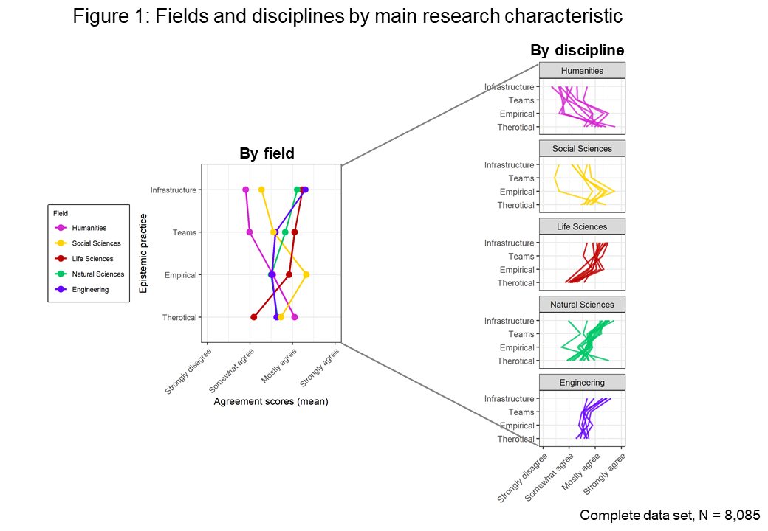

An analysis that focuses only on the field-level will not do justice to this diversity. In the following, we therefore juxtapose the examination from the field, the disciplinary, and the research perspective while making use of the ‘productive interactions’-terminology for data interpretation. Since this approach originally refers to qualitative investigations, it does not provide a predefined operationalisation, but represents "proof of concept". We selected variables of the Science Survey related to KTA which provide proxy measures for direct interactions (e.g., collaboration), indirect interactions (e.g., usage/sharing of knowledge), and stakeholder diversity in both interaction dimensions as formulated within the ‘productive interactions’-framework (Spaapen & van Drooge, 2011).

3. Results
The following section presents findings on the three areas direct interactions, stakeholder diversity, and indirect interactions.

3.1. Direct interactions: Collaboration within and outside of academia
Approaching the notion of productive interactions by examining direct interactions, we first consider the scientists’ frequency of collaboration within disciplines, across disciplines, and outside academia. When examined by field, all fields share a similar trend: they mostly collaborate within their discipline but only rarely outside academia (Fig. 2). The frequency of non-academic collaborations has the most spread for all fields, indicating greater variance among the disciplines in a field. However, differences between fields exist. Within academia (including interdisciplinary collaboration), the life sciences maintain the most frequent collaborations. Outside academia, SSH and life sciences collaborate equally rarely and natural sciences the least. Engineers collaborate strongly with non-academic agents, which could be attributed to industry collaborations that are common in this field.
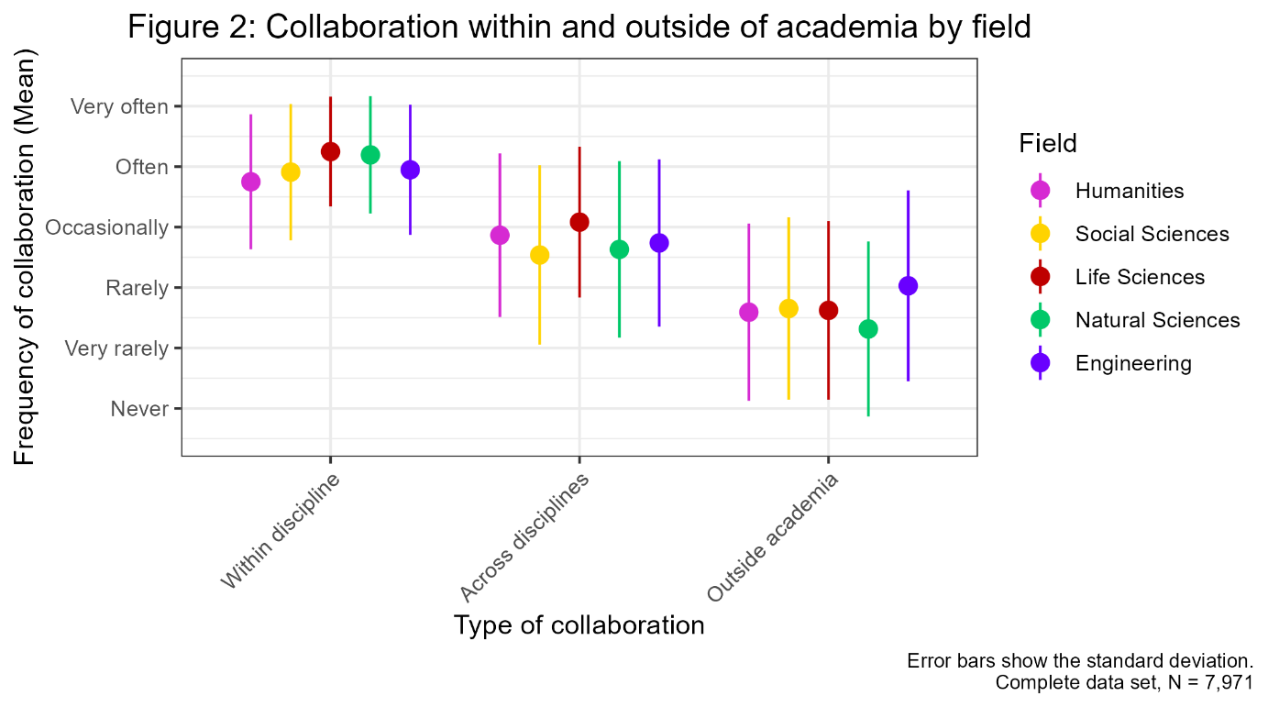

Splitting collaboration by research practice follows the same trajectory (Fig 3.). Researchers whose research is team-based show higher collaborative efforts in all three collaboration types. Yet the differences between research practices are smaller than for the fields.

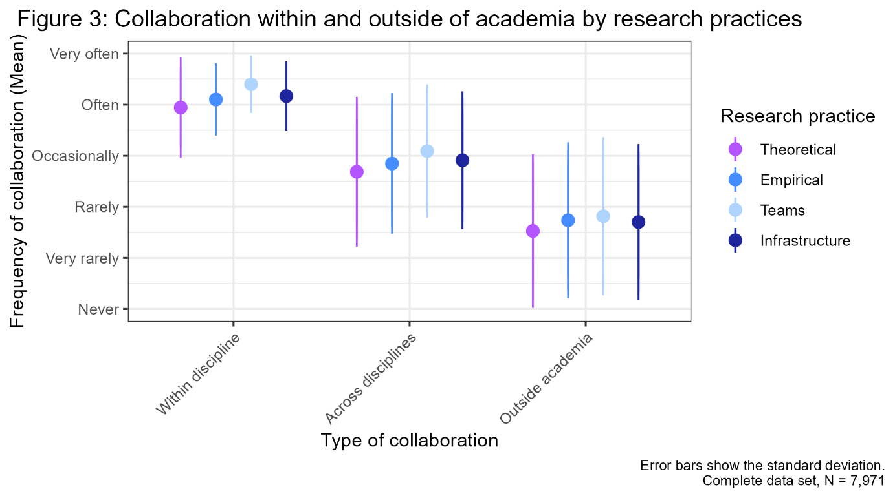

3.2. Stakeholder diversity: Relevance, Usage, Interaction
To examine the different stakeholder profiles, we selected three variables: (1) Researchers indicated how relevant their research findings were to specific stakeholders (Relevance). (2) They were asked which stakeholders were known to use their research findings (Usage), and (3) whether they interacted with them (Interaction). The plots display profiles for each variable depicting the selection of respective stakeholders as proportion. Usage and Interaction were collected dichotomously. For Relevance, the values ‘relevant’ and ‘very relevant’ were combined.
At field level (Fig. 4), we see a decrease from Relevance to Usage to Interaction in all fields. Overall, SSH show a noticeable stakeholder diversity in all three dimensions. SSH research is perceived relevant to all target audiences except for economy, whereas engineers clearly identify economy as their main stakeholder in all three dimensions. As Figure 5 illustrates for Relevance, a field variance exists though. Humanities and natural sciences indicate great differences between their disciplines whereas engineering shows less within-field variance, and most disciplines feature a similar pattern. Architecture, however, deviates from this field-specific pattern.

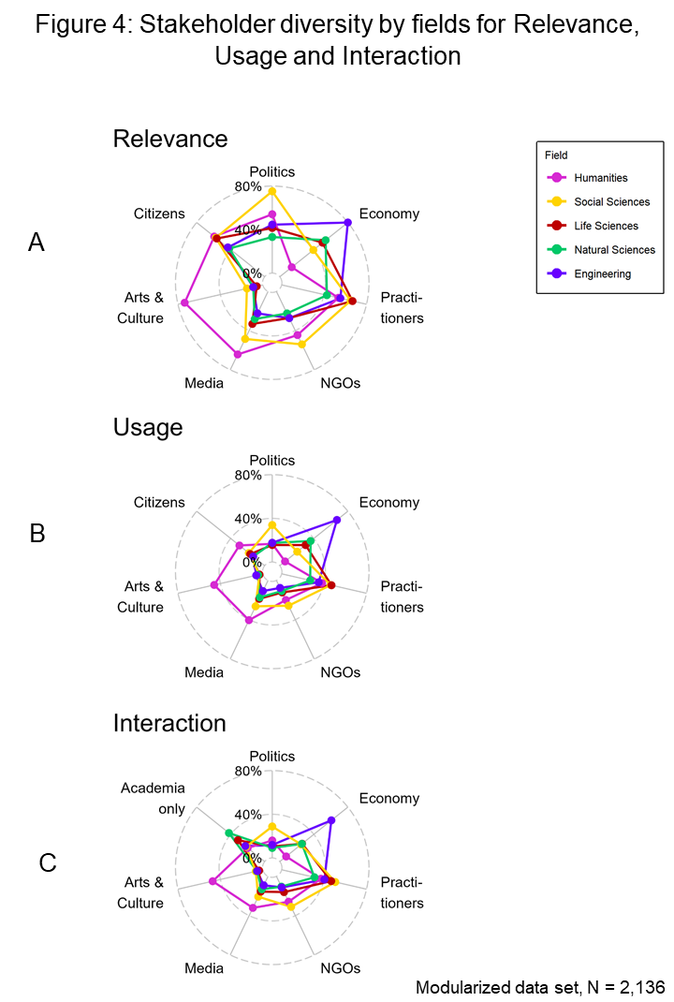

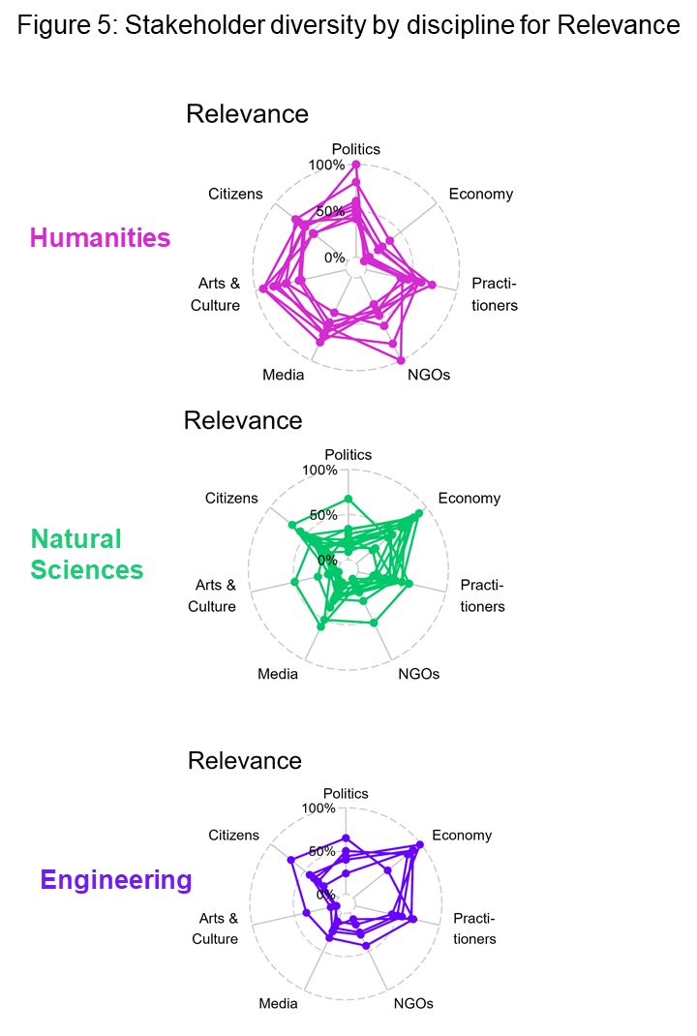

3.3. Indirect interactions: Data Sharing and non-scientific publication
Considering the indirect ways scientists engage with their stakeholders, e.g., through publications, also helps to assess the potential for societal impact of research. The following section provides data about scientists’ data sharing behaviour and their engagement in non-scientific publications serving as proxies for indirect interactions. Both variables refer to impact by demonstrating the ways in which researchers reinforce the possibility of behavioural change based on research findings by enabling their stakeholders to either adopt or further develop knowledge.
Researchers indicated how they share their research data. Ways of sharing included, for instance, public release (e.g., through repositories), providing data as part of scientific publications, personal exchange, sale, or licensing. Figure 6 plots field differences in the average number of ways scientists share their data, Figure 7 differentiates by research practice. Social sciences have the highest percentage of researchers not sharing data, natural sciences the lowest and the most diverse sharing behaviour.
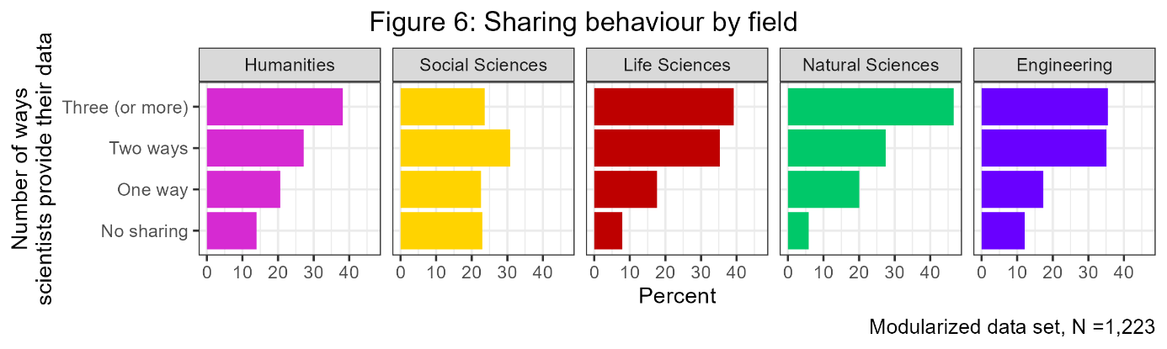
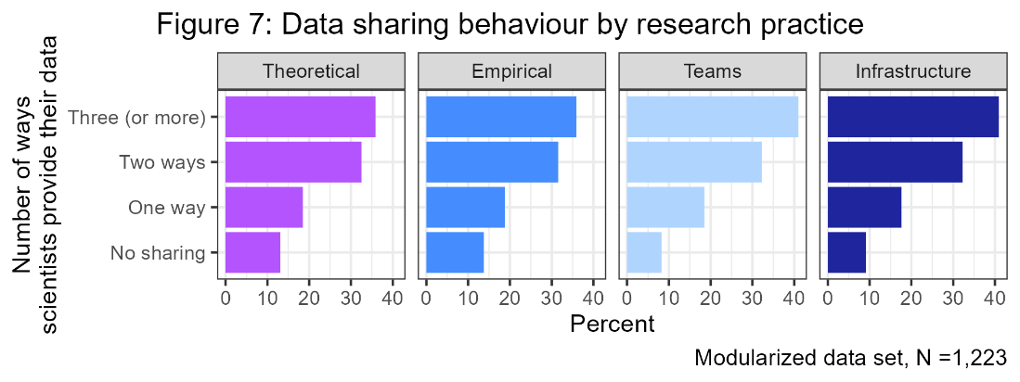

Researchers were asked whether they publish in non-scientific formats. Transfer publication types included practice journals, policy reports, newspapers, online media, expert opinion statements, guidelines, and project reports. Figure 8 presents the average number of formats used by field, contrasted with those who do not publish any transfer publications. The natural and life sciences have the highest percentage of scientists without any transfer publications. Figure 9 displays the engagement in transfer publications by research practice. Differences in sharing or publication behaviour by research practice are minimal. However, team-based research features most diverse publication types, infrastructure least. This is interesting in that it contrasts with sharing behaviour, being most diverse in research fields relying on infrastructure.
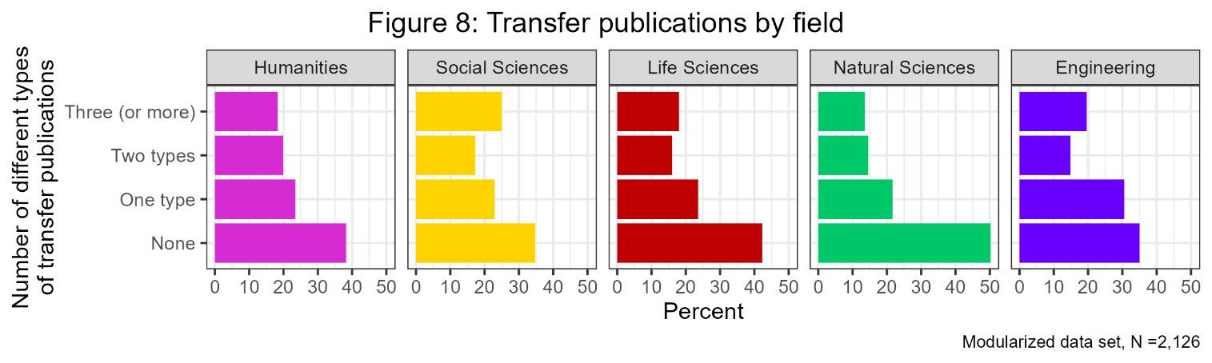
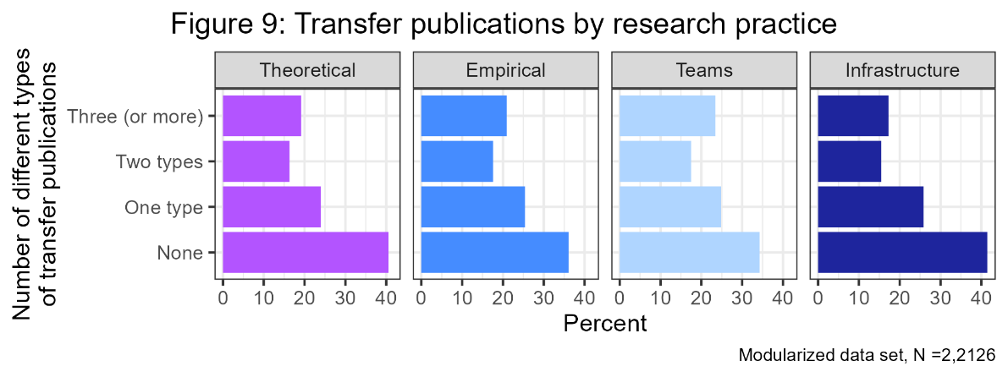

4. Discussion
Using the Science Survey-dataset, we were able to map researchers’ KTA based on their productive interactions compared by field, discipline, and research practice. In the following, we discuss our findings and relate them to current debates on KT research.
Our analysis showed distinct patterns of field-specific productive interactions. This mostly related to researchers’ interactions with different stakeholders. In this vein, SSHs’ status as “fragmented adhocracies” (Whitley, 2000) became evident showing the highest stakeholder diversity but also the highest difference scores between Relevance, Usage, and Interaction (measured by differences between mean values). Thus, the gap between relevance, actual use, and interaction was biggest in these fields. In contrast, the overall difference scores were lowest in STEM, demonstrating the unambiguousness of their target group. STEM fields could easily map their relevant target group, enabling them to better assess their societal significance and thus to gain legitimacy. The potential for KTA in SSH, however, seems to be not fully exploited and links between the three interactive dimensions could be strengthened. Further, this stakeholder diversity may result in difficulties mapping the fields’ target audiences. As a result, societal benefit and impact assessment is not directly possible in these disciplines. It may be due to this ambiguousness that SSH show lower overall satisfaction scores with the scientists’ role in society, which was measured in the 2019/2020-Science Survey by societal appreciation of scientific work and its perceived relevance in general (Ambrasat & Heger, 2020).
These results are in line with the SIAMPI-project (Spaapen et al., 2011) in which productive interactions were first used as an analytical approach. While higher diversity rates may result in difficulties as just described above, paying attention to the mapping of productive interactions may help researchers to reflect on their engagement with users and society (ibid.).
We therefore agree with the authors to put productive interactions at the centre of impact assessment and thus to focus on analysing the processes that generate socially valuable applications rather than identifying and assessing impacts (Molas-Gallart & Tang, 2011:225). In this sense, shifting the focus to the quality of interactions and KTA to assess the likelihood of future contributions to societal impact (ibid.) seems appropriate.
Finally, establishing links between research practices based on the research dimensions recorded in the Science Survey and interaction patterns did not achieve clear results. Although researchers with a stronger team orientation unsurprisingly showed a tendency to collaborate more frequently and to share their data, the other research dimensions showed no distinct pattern and appear to be less relevant to differences in productive interactions. Thus, differences between fields could not be explained by research practice. More fine-grained approaches seem to be necessary. We will elaborate on this in the concluding section below.

5. Conclusions
Since productive interactions prove to be field-specific, comparative approaches that pay particular attention to field differences are essential. However, the differences both between and within fields call for a necessary integration of epistemic properties into the analysis, which systematically integrates characteristics of research processes and social structures that can be empirically operationalised. The data provided by the Science Survey just gave hints to these differences, but no explanations since the scientific fields’ epistemic properties were only reflected by four major dimensions of research characteristics. Even though we could identify reasonable differences in KTA also within fields, we could not explain them by sub-disciplinary peculiarities because we lack detailed data on these aspects in the current dataset. To fully exploit the potential of causal explanations, integrating field-specific peculiarities in the analysis of KTA therefore seems inevitable. We contend that knowledge about epistemic conditions of knowledge production enabling the characterisation of differences between scientific disciplines, as provided by STS approaches, is helpful in designing KTA and could cater more to the specific needs of individual epistemic cultures. Thus, it seems promising to further explore the potential of comparative science studies in the study of KT. To deepen our preliminary findings, we currently design an own survey on KTA. This survey with a representative sample of scientists in Germany (all status groups and disciplines) will explicitly address a wide spectrum of KTA, target audiences, scientists’ individual characteristics (e.g., career status, disciplinary affiliation), and their scientific environment (e.g., research practice by type of evidence generation, resource intensity, links to contexts of application) according to the approach of “epistemic regimes” (Gläser, Laudel, Grieser et al., 2018). However, survey designs feature limitations in terms of detailed descriptions of research processes, which need to be complemented by qualitative in-depth investigations. Hence, by following a multi methods-approach in the DiTraP-project, we aim to map causal relationships between types of knowledge production and KT.

