The academic age of researchers by SDG and region – in which region more early career researchers are needed to advance SDGs related science?

Gali Halevi *, Nemanja Milicevic**, Ryan Fry*, Wenceslao Arroyo-Machado***, Daniel Torres-Salinas*** and Nicolas Robinson-García***

**Gali.halevi@clarivate.com; ryan.fry@clarivate.com
0000-0003-3478-8804; 000-0002-2388-7359
Institute for Scientific Information, Clarivate, United States

** Nemanja.Milicevic@clarivate.com
0009-0005-9674-8842
Institute for Scientific Information, Clarivate, Serbia

*wences@ugr.es; torressalinas@ugr.es; elrobin@ugr.es
0000-0001-9437-8757; 0000-0001-8790-3314; 0000-0002-0585-7359
Department of Information and Communication Sciences, University of Granada, Spain

The median age of scientists and engineers in the US has increased from 40.3 years in 2003 to 42.4 years in 2017, while the proportion of those aged 55 and over has risen from 19% to 27%, according to a report by the National Science Foundation. Factors contributing to the trend include longer life expectancy and decreased numbers of younger people entering the workforce due to high education costs and a lack of job opportunities. The aging workforce risks losing the expertise and knowledge of older scientists, and this could hamper scientific progress and innovation. The United Nations' Sustainable Development Goals (SDGs) are universal goals for sustainable development adopted by all member states. Considering the challenges of an aging scientific workforce seen in the NSF data on the one hand, and the global importance of SDGs-related science on the other, this study demonstrates the academic age of researchers in Africa, Asia, Europe, Latin America, and North America based on their regional SDG priorities. Researchers have been categorized by their academic age, as measured by their years of experience in academia and their publication records, to identify which countries need more early-career researchers and in which areas of SDGs research. Our preliminary findings show an aging scientific workforce in the Global North with differences in prioritizing SDGs by region and the average academic age of scholars working in each SDG. As a result, we have developed an interactive dashboard that allows users to explore the complete dataset: https://compare-project.eu/tool/academic-age-and-sdgs-worldwide/

1. Introduction
There is evidence to suggest that the scientific workforce is getting older. According to a report from the National Science Foundation, the median age of scientists and engineers in the United States was 42.4 years in 2017, up from 40.3 years in 2003. The same report also found that the proportion of scientists and engineers aged 55 and over increased from 19% in 2003 to 27% in 2017 (Science and Engineering Labour Force | NSF - National Science Foundation, n.d.). There are several reasons for this trend. One reason is that people are living longer and staying in the workforce longer. Another reason is that there has been a decrease in the number of younger people entering the scientific workforce. This could be due to a variety of factors, such as the high cost of education and a lack of job opportunities. The aging of the scientific workforce has implications for the future of science and technology. As older scientists retire, there is a risk that their expertise and knowledge will be lost, particularly if there are not enough younger scientists to take their place. This could have negative consequences for scientific progress and innovation. Therefore, efforts should be made to encourage more young people to pursue careers in science and to provide support for mid-career scientists to continue to be productive and engaged in their fields.

The United Nations Sustainable Development Goals (SDGs) are a set of 17 goals adopted by the UN General Assembly in 2015 as part of the 2030 Agenda for Sustainable Development (THE 17 GOALS | Sustainable Development, n.d.). The SDGs aim to address the global challenges of poverty, inequality, environmental degradation, and other pressing issues facing the world today. While the United Nations Sustainable Development Goals (SDGs) are universal goals adopted by all UN member states, there have been efforts to prioritize and localize the goals based on each country's unique needs and circumstances. In 2016, the UN launched the "Voluntary National Reviews" (VNRs) to encourage countries to report on their progress towards the SDGs and to identify areas where more action is needed (Voluntary National Reviews.:. Sustainable Development Knowledge Platform, n.d.).

Through the VNR process, countries have been able to tailor the SDGs to their specific contexts and identify priority areas for action. Many countries have developed their own national plans or strategies for achieving the SDGs, which consider the country's development priorities, challenges, and opportunities. Additionally, the UN has developed regional sustainable development frameworks and agendas to address specific challenges and opportunities facing different regions of the world. For example, the African Union developed the agenda 2063 (Agenda 2063 | African Union, n.d.), which is a strategic framework for the socio-economic transformation of Africa over the next 50 years, and the Asia-Pacific region developed the Asia-Pacific SDG Partnership, which is a platform for sharing knowledge and best practices for achieving the SDGs in the region (Partnership, 2022).Overall, while the SDGs provide a universal framework for sustainable development, the implementation and prioritization of the goals are tailored to each country's unique context and development priorities.
Considering the challenges of an aging scientific workforce seen in the NSF data on the one hand, and the global importance of SDGs-related science on the other, this study demonstrates the academic age of researchers in Africa, Asia, Europe, Latin America, and North America based on their regional SDG priorities. While not a chronological age, academic age typically refers to the number of years that a person has been actively involved in academic pursuits, such as research, teaching, and publishing. It is often used as a measure of a person's experience and expertise in their field. Academic age can be calculated based on a person's educational attainment, their years of experience in academia, and their publication record. By calculating the academic age for researchers around the world, by country, and for each SDG, we can observe in which countries the scientific workforce has longer academic age versus shorter academic age by SDG, in order to discover in which countries more early career researchers are needed and in which areas of SDGs research.

2. Methodology
To capture the current output for each area of SDGs, we retrieved all 2021 publications indexed in InCites per SDG. According to Clarivate Analytic the methodology for create ODS is a schema type based on Category-to-category mapping where Sustainable Development Goals are mapped to sets of related Micro Citation Topics. Individual goals of the ODS were compared to Micro Citation Topics. We extracted all authors from those papers. Each author responds to the WOS profile with its own DaisngID. For each author (each profile/DaisngID), we found the year of their first published paper. For the last published paper, we took the SDG paper (year 2021) because we were interested in the academic age of the author at the time of publication of the SDG paper. Therefore, we calculated the academic age for each author as the difference between 2021 and the year of their first publication.

From the 2021 SDG papers, we extracted authors' addresses. If an author did not have an address listed on the 2021 papers, we retrieved the address from their latest paper with an address (2020, 2019, 2018...). Authors with an address older than 2017 were excluded, as well as authors for whom no address was found. Authors who had affiliations (addresses) in multiple countries/regions on their latest papers were considered to have contributed equally to those countries/regions. For example, if an author stated on the 2021 SDG paper that their affiliations were the University of Madrid and the University of Lisbon, they were considered to be both a Spanish and a Portuguese researcher, and their academic age entered into the distribution for both countries. With each author's academic age and country/region, we created a distribution of academic age by country/region for each SDG. In this paper, we include some preliminary findings, although more information is available on the following interactive dashboard where the complete dataset could be explored:
https://compare-project.eu/tool/academic-age-and-sdgs-worldwide/.

3. Findings
Figure 1 plots the SDGs by the number of researchers working on them and their average academic age. In general terms, the average academic age of scholars ranges between ~8.5 and ~10 years. The largest scientific workforce working towards achieving an SDG is related to SDG 3 – Good Health and Well-being, with a total of almost 3.5 million scholars. The next SDG with the highest scientific workforce is SDG 5 – Gender Equality, although it is important to note that researchers affiliated with more than one country are double-counted. SDG 1 – No Poverty is the goal with the oldest population, with an average slightly above 10 academic years. It is also the SDG with the lowest number of researchers focusing on it (~45,000 researchers). On the opposite end, we find SDG 8, for which the scientific workforce averages an academic age of 8.4 years.

Figure 1: Scatterplot of Sustainable Development Goals (SDGs) by average number of researchers per country and academic age.
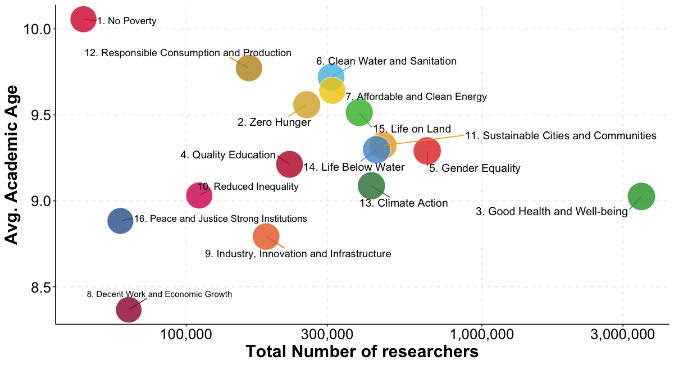
When looking at differences by countries, we observe that not only the distribution of researchers, but also their age varies greatly by regions. Figure 2 illustrates the case of SDG 3 – Good Health and Well-being, but a similar pattern is observed for all SDGs, that is, we observe an aging population in the Global North and a younger population in the Global South. Although we must note that differences in terms of the size of the scientific workforce are noticeable between the two regions. This is especially clear in the case of the African continent.

________________________________________________________________

Figure 2. Global heatmap based on the academic age of researchers working on SDG 3. Good Health and Well-being.
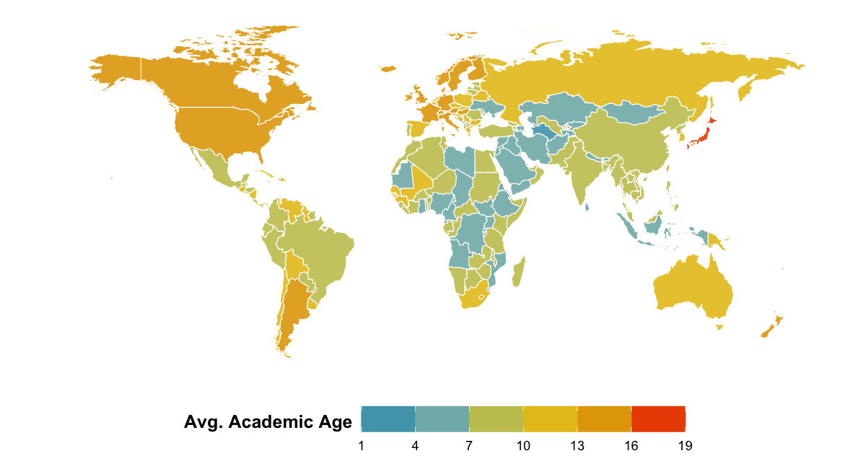
________________________________________________________________

Figure 3. Age differences with world baseline of academics in China and the United States by SDG.
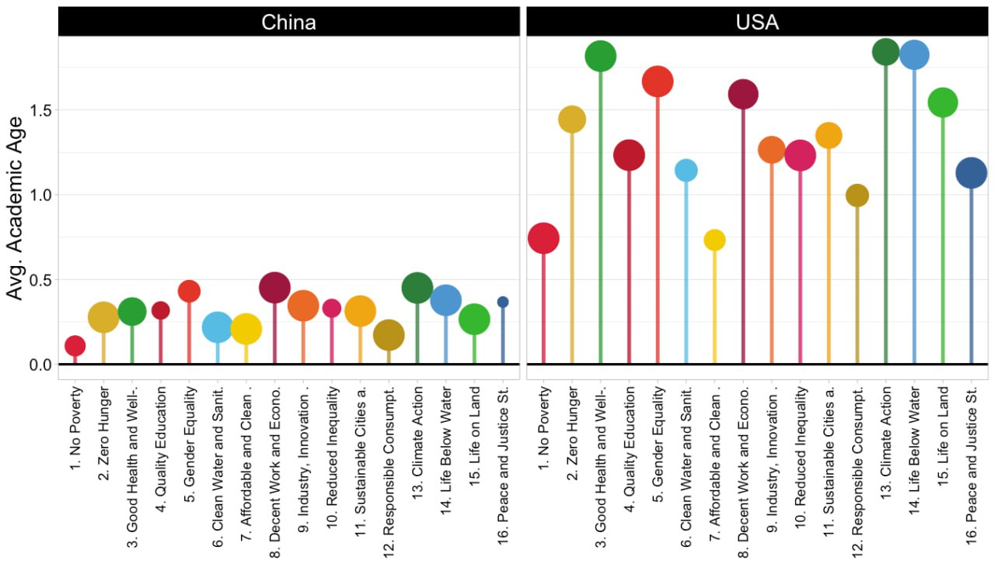

Check the complete online dashboard “Academic age and SDGs worldwide” > http://sl.ugr.es/stiobj

Finally, we benchmark countries’ average academic age per SDG using the world average as a baseline. In Figure 3 we show, for instance, the cases of China and the United States. The scientific workforce of these two countries contributes to 16 SDGs. The size of the dots represents the number of researchers. Positive values in the y-axis indicate that the average age of researchers is above the world average, while negative values indicate that they are younger. While the interactive dashboard allows comparisons between countries and regions as well as country profiles, here we showcase only two countries. In both cases we observe that their scientific workforce is older than the world average. In the case of China this difference is quite small (roughly older than the average by 0.5 years). In the case of the United States, this difference is much larger, of more than 1.5 years older on average for 6 of the 16 SDGs, between 1 and 1.5 years older for 8 SDGs, and less than 1 year older for the remaining 2 SDGs.

4. Discussion and concluding remarks
In this paper, we present preliminary results of a study on the aging of the academic workforce worldwide based on the Sustainable Development Goals (SDGs). We analyzed all publications indexed in InCites in 2021 and identified all researchers based on their Web of Science researcher profile. We calculated their academic age by subtracting the number of years between 2021 and the date of their first publication and assigned researchers to countries based on their last known affiliation. Our preliminary findings indicate that the scientific workforce in the Global North is aging, with differences in the prioritization of SDGs by region and the average academic age of scholars working in each SDG. For instance, we observed that the greatest number of researchers are working on SDG 3 – Good Health and Well-being, while SDG 1 – No Poverty has the oldest scientific workforce on average. Further steps include analyzing a larger time series and examining the age distribution of scholars within countries, as well as the leading roles of countries for each SDG.

Funding information
Nicolas Robinson-Garcia acknowledges funding from the Spanish Ministry of Science for the project COMPARE (REF: PID2020-117007RA-I00/SRA/10.13039/501100011033). Nicolas Robinson-Garcia is currently supported by a Ramón y Cajal grant from the Spanish Ministry of Science (REF: RYC2019-0278876-I).

References

Agenda 2063 | African Union. (n.d.). Retrieved April 20, 2023, from https://au.int/en/agenda2063
Partnership, S. A.-P. (2022, March 28). Asia-Pacific SDG Partnership. UNESCAP. http://sdgasiapacific.net/home
Science and Engineering Labor Force | NSF - National Science Foundation. (n.d.). Retrieved April 20, 2023, from https://ncses.nsf.gov/pubs/nsb20198/
THE 17 GOALS | Sustainable Development. (n.d.). Retrieved April 20, 2023, from https://sdgs.un.org/goals
Voluntary National Reviews .:. Sustainable Development Knowledge Platform. (n.d.). Retrieved April 18, 2023, from https://sustainabledevelopment.un.org/vnrs/

To understand the creation of the ODS categories, we advise consulting the Clarivate Analytics help section, where the OD-Citation Topics mapping is clearly explained and detailed: https://incites.help.clarivate.com/Content/Research-Areas/sustainable-development-goals.htm

