Tracing the Evolution Patterns of Patent Cooperation: Taking the OECD Members and Their Key Partners as a Case Study

Yiwen Tang*, Ying Huang**

* tangyiwen2211@ruc.edu.cn
0009-0001-6848-5310
School of Information Resource Management, Renmin University of China, China

** ying.huang@whu.edu.cn
0000-0003-0115-4581
School of Information Management, Wuhan University, China
Center for Science, Technology & Education Assessment (CSTEA), Wuhan University, China
Centre for R&D Monitoring (ECOOM) and Department of MSI, KU Leuven, Belgium

Abstract
The globalization of science and technology has brought unprecedented opportunities and challenges. Based on large-scale granted international cooperation patent data, this study adopts the social network analysis and tech mining approach to present the network structure and stage characteristics of 44 countries (38 OECD member countries, 5 key partners, and Russia) from 1980 to 2019. The results show that: (1) cooperation is characterized by broadening and deepening in the overall trend but loosening at individual stages; (2) The core-periphery structure runs throughout all stages, but the core layer of countries changes, from the dominance of European countries to the absolute dominance of the United States; (3) A cooperation relationship centered on the United States and closely linked among European countries was formed at each stage. Scientific and technological strength, geopolitical relations, and political interests were several factors that influenced the partner selection. The results provide data support for understanding the historical situation and evolution of global cooperation.

Keywords
International Cooperation; Patent Cooperation; Social Network Analysis

1 Introduction
In the era of the knowledge economy, patents have become one of the core elements to measure the innovation ability of a country or an enterprise (Kogan et al., 2017). Patent cooperation is an important part of scientific and technological cooperative research, and the act of international cooperation in patents reflects the process of technology globalization (Guellec & Pottelsberghe, 2001), providing a new perspective for judging the global innovation situation and reflecting the national science and technology strength.

To accurately diagnose international patent cooperation, most researchers mainly use patent measurement and social network analysis methods to study patent data. Among the existing studies on patent collaboration networks, researchers have focused on the following themes: regional development (Gao, Guan & Rousseau, 2011; Choe & Lee, 2017); domain development such as new energy products (Sun et al., 2018; Lei et al., 2013) and nanotechnology (Zheng et al., 2012; Ozcan & Islam, 2014); enterprise innovation, especially industry-academia-research cooperation (Chang, 2017; Crescenzi, Filippetti & Iammarino, 2017); the influence of network structure on innovation (Fleming, King & Juda, 2007; Guan, Zhang & Yan, 2015); the form factors of cooperation networks (Crescenzi, Nathan & Rodriguez-Pose, 2016; Cassi & Plunket, 2014). These research results fully reflect the important role of patent cooperation in studying science and technology development and measuring regional science and technology levels. However, relatively few studies are oriented to international patent cooperation worldwide, and there are few studies on the evolutionary characteristics of patent cooperation in the whole stage. Therefore, this study attempts to study the evolution of international patent cooperation and tries to provide a historical basis for global governance and innovation.

Therefore, this study extends the geographical scope of the research object to 44 international representative countries (38 OECD member countries, 5 key partners, and Russia.), extending the time scope to 1980 to 2019, taking five years as a research phase. Specifically, this study aims to answer the following three questions: (1) What are the overall characteristics of the international patent cooperation network over the past forty years? (2) What has been the structure of the international patent cooperation network over the past forty years? What is the structural position of different countries in the network? (3) What is the association of the nodes in the international patent cooperation network over the past forty years? What kind of association is more likely to establish higher cooperation intensity?

2 Data and Methodology
This study uses the granted cooperation invention patents by the USPTO and the EPO from 1980- 2019, which have patentees from two or more countries or regions, as the data source. After determining the data source, the patent information that met the requirements was downloaded from the Derwent Innovation Platform, and 79,967 valid data were finally obtained after eliminating the non-compliant ones.

Then, this study constructs a cooperation network based on the frequency of international patent cooperation, focuses on the structure of the network and the evolution characteristics of nodes, calculates the key measurement indicators, observes and analyzes the evolution of the network in stages, as well as the different roles played by different countries in it and the relationship between them. The research framework is illustrated in Figure 1.

Figure 1: The Research Framework
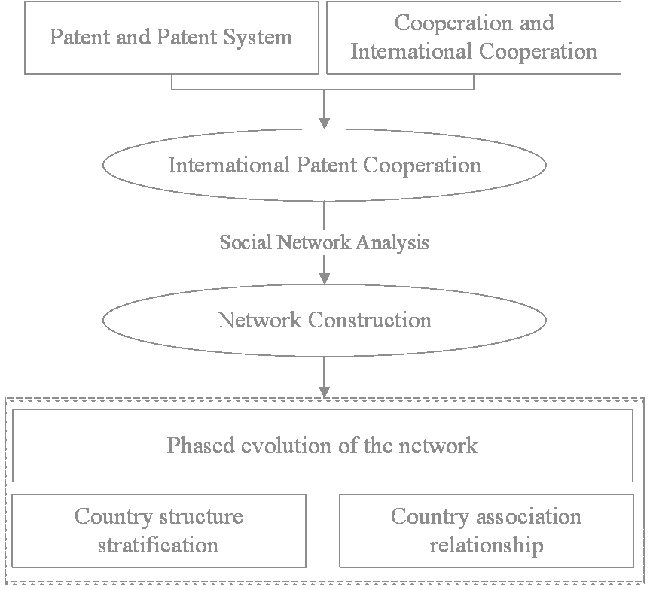
The key indicators are as follows:

- Core-periphery structure
Core-periphery structure abstracts all nodes into two categories to stratify the overall structure. Calculating the core degrees of different countries in the network, core countries, and edge countries can be distinguished. The former has a greater influence on the overall situation, while the latter is more influenced by other nodes (Gao, Guan & Rousseau, 2011).

- Cooperation intensity
Cooperation intensity considers the relative amount of cooperation between countries. It incorporates the total number of cooperation into the index, which helps to find out the country pairs with high dependence and high correlation in a specific phase. Ochiai coefficient is a form of cosine similarity, which plays an important role in the transformation of the non-dualized matrix to the correlation matrix.

This study uses the Ochiai coefficient to convert the co-occurrence matrix into a correlation matrix. The larger the number, the closer these two countries are and the greater the intensity of cooperation. According to the context of international patent cooperation and the meaning of the Ochiai coefficient, the calculation of cooperation intensity between country/region A and country/region B is shown in Equation 1. Quantity(A∩B) means the total cooperation number between these two countries, and Quantity(A OR B) means the total number of a single country.

Cooperation intensity(A, B)=$\frac{Quantity(A∩B)}{\sqrt{Quantity(A)∗Quantity(B)}}$（Equation 1）

3 Network Construction
The downloaded patent data are pre-processed to further count the frequency of cooperation between two countries or regions. Thus, eight cooperation quantity matrices are obtained in a five-year period. Then data are imported into Gephi or Ucinet for plotting and analysis. After doing so, the co-occurrence network can be constructed, as shown in Figure 2.

From Fig (a) to Fig (h), the network shows a complex character, and the relative sizes of nodes and the relative thicknesses of the edges between two nodes are in constant dynamic change.

Figure 2: International patent cooperation network under different stages, 1980-2019
- Year 1980-1984  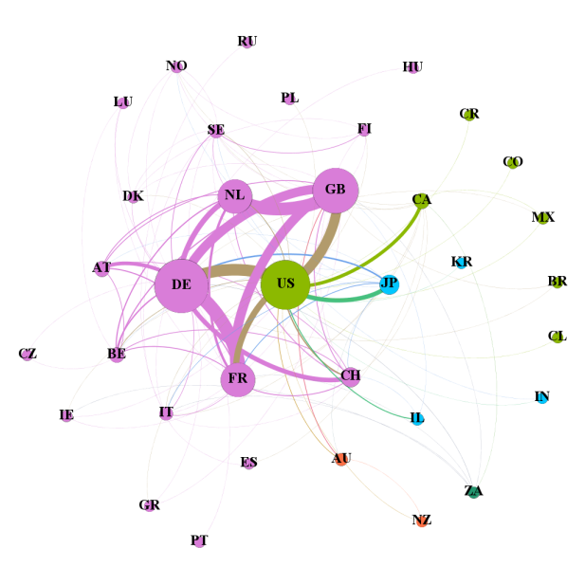 | - Year 1985-1989  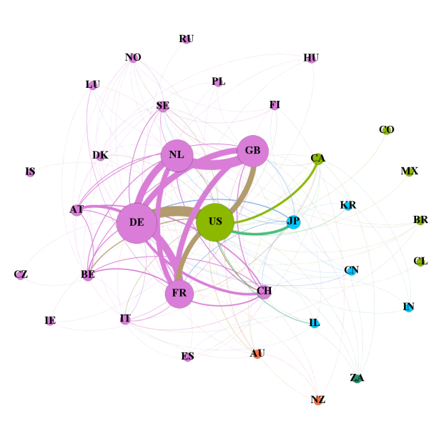
- Year 1990-1994  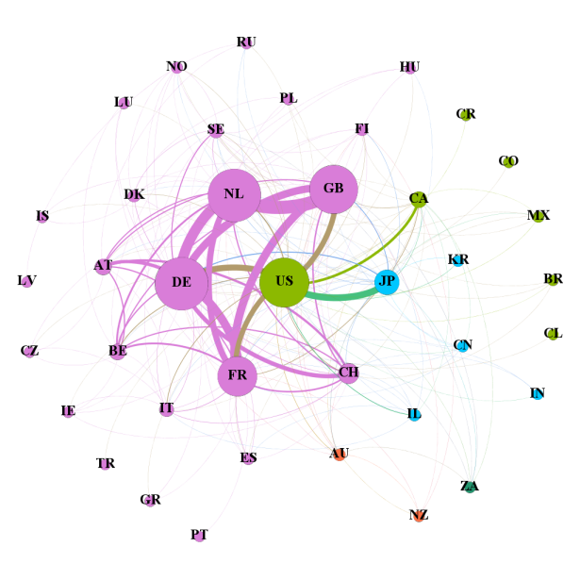 | - Year 1995-1999  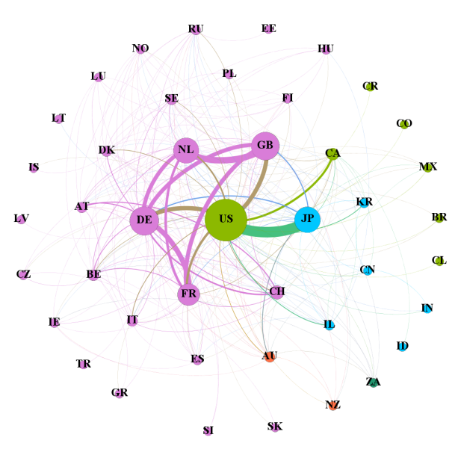
- Year 2000-2004  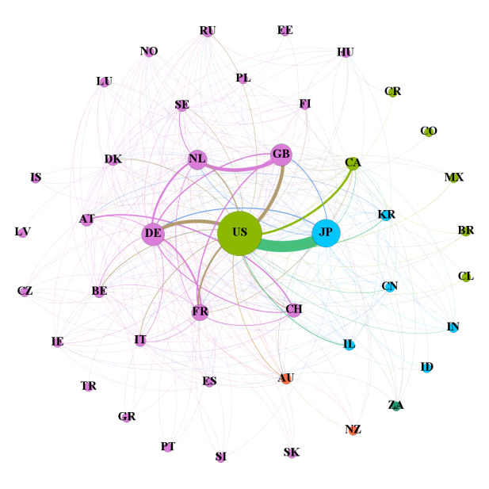 | - Year 2005-2009  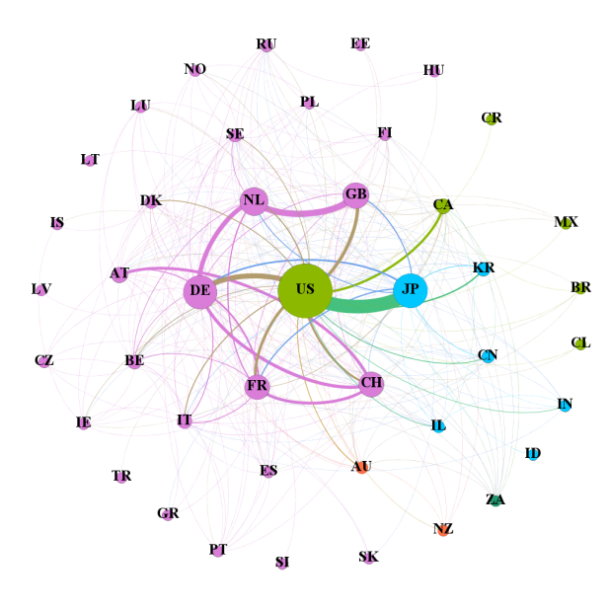
- Year 2010-2014  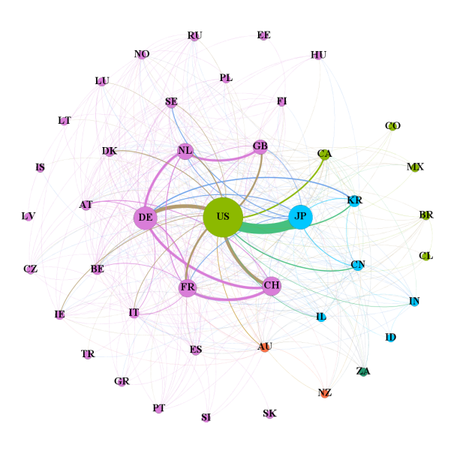 | - Year 2015-2019  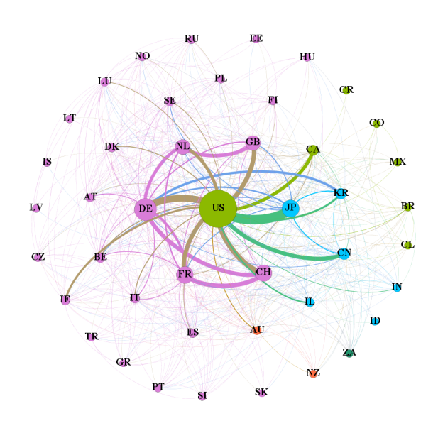

Table 1 presents some network characteristics at different time stages. From the dynamic perspective, the network size shows an overall trend of expansion. After 1995, there were 43 or 44 countries involved in international cooperation. The number of network edges is continuously increasing in general, but between 2005 and 2009, the number decreases. At the same time, the network density also has a low point, indicating a loose of cooperation at this stage. After 2010, both the number of network edges and network density increased at a faster rate, showing a closer cooperation relationship. With the development process of each country, the network scale is expanding, and the network structure is more complex. In the process of patent cooperation, more and more countries have established patent partnerships.

Table 1. Network characteristics under different Stages,1980-2019

Stages | Network Size | Number of network edges | Network Density | Average clustering coefficient | Average path length
1980-1984 | 35 | 112 | 0.188 | 0.729 | 2.005
1985-1989 | 34 | 145 | 0.258 | 0.714 | 1.818
1990-1994 | 39 | 188 | 0.254 | 0.76 | 1.842
1995-1999 | 43 | 227 | 0.251 | 0.775 | 1.852
2000-2004 | 43 | 282 | 0.312 | 0.796 | 1.732
2005-2009 | 43 | 265 | 0.293 | 0.769 | 1.773
2010-2014 | 43 | 338 | 0.374 | 0.81 | 1.695
2015-2019 | 44 | 444 | 0.469 | 0.808 | 1.539
1980-2019 | 44 | 516 | 0.545 | 0.832 | 1.457

4 Results and Discussion

4.1 Country structure stratification

As can be seen in Figure 2, a typical core-periphery structure exists at every stage, with a small number of countries residing at the core. With the help of the analysis method provided by Ucinet, the core degree of each node is calculated to obtain the core nodes recommended by the algorithm so that the country nodes in the network at each stage can be stratified and presented visually. The results are shown in Figure 3. In the diagram, the countries in the inner circle represent the core countries in this stage, which have an important strategic position in the network and can have a greater impact on the overall situation, while the countries in the outer circle represent the periphery countries. Besides, the countries that are not involved in the cooperation are uniformly listed in the bottom left of the diagram.

Figure 3: Core-periphery structure under different stages, 1980-2019
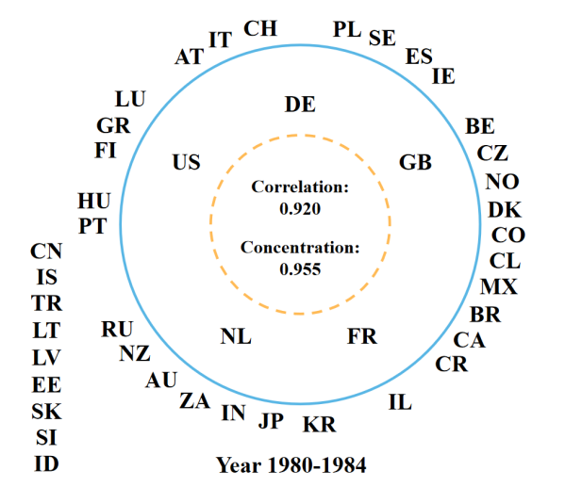 | 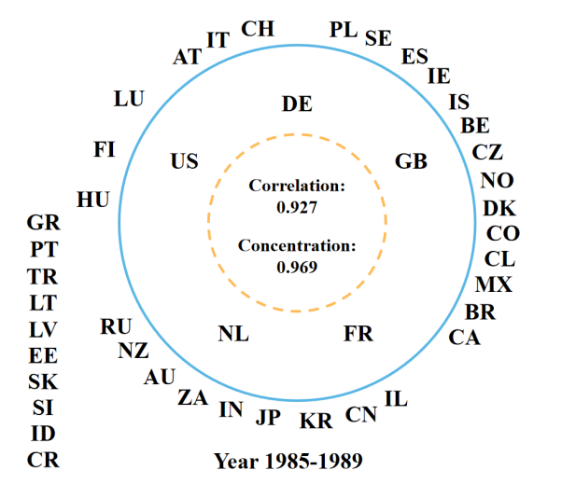
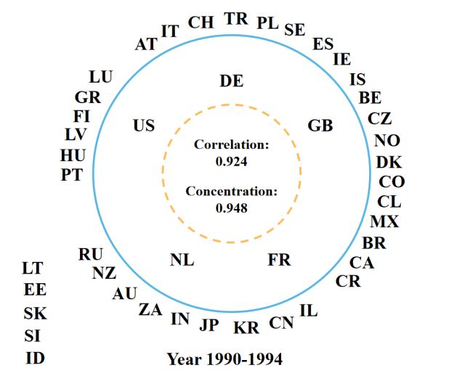 | 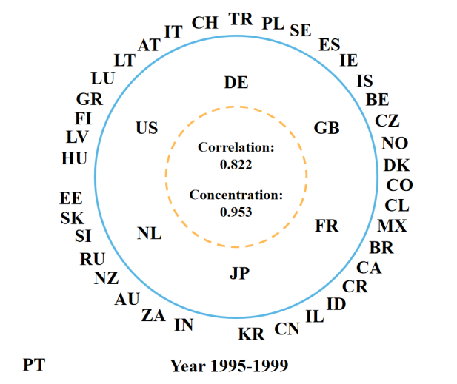
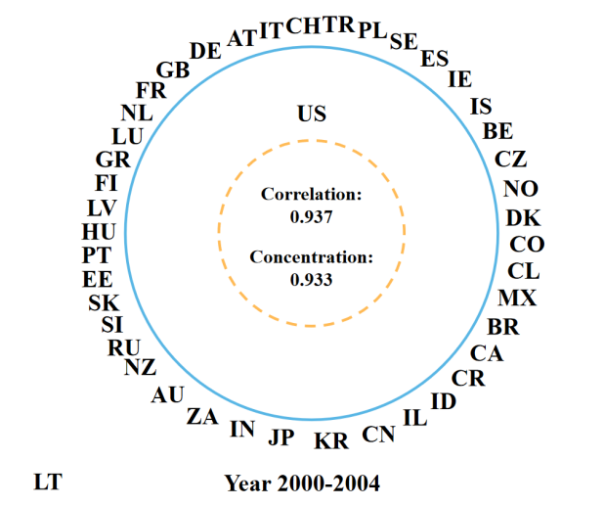 | 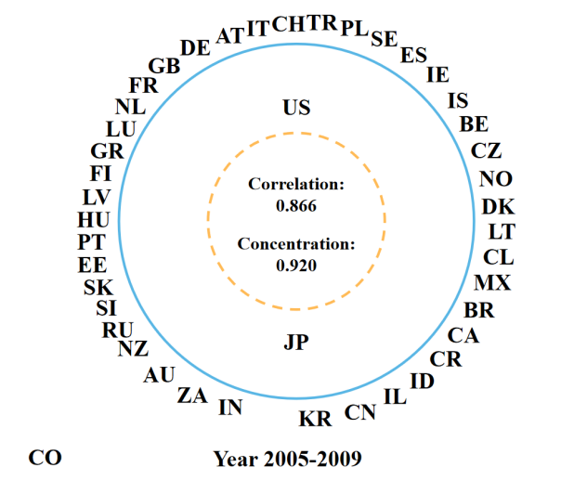
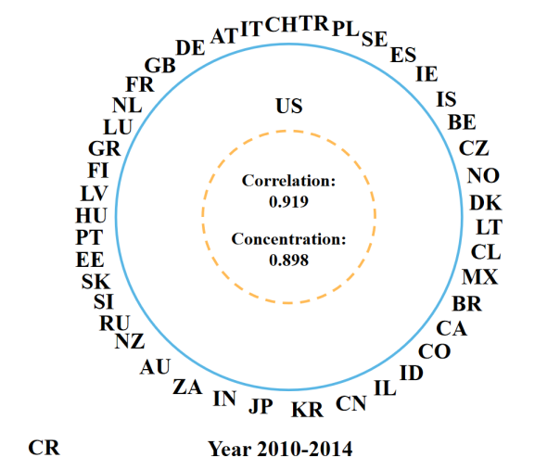 | 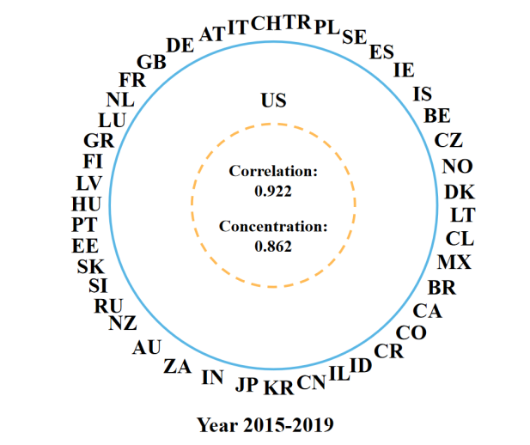

From 1980 to 1994, the United States and the four major European countries, Germany, France, the UK, and the Netherlands, always resided at the core level. During these three time periods, the core degree of the United States was lower than that of the other four European countries, forming a network pattern dominated by the major European powers. 1995 to 1999 saw an increase in the number of core countries and further development of innovation cooperation networks. During this period, Japan entered the ranks of core countries for the first time and surpassed France and the Netherlands in terms of core degrees. After 2000, no more European countries entered the core circle, and the United States was the only country in the core circle in all three of these phases, distancing itself greatly from other countries in terms of core degree. Japan ranked second among all countries after 2000, only after the United States. In the subsequent period, although no other Asian countries entered the core tier, their core degree also showed a steady increase. From 2005 to 2009, Japan again became one of the core countries, and during this period, each country was hit hard by the financial crisis to varying degrees, which also had an impact on the world economic order.

In general, the core-periphery structure has been present, in which the United States has always been in the position of the core countries, with dominant influence and control over the cooperative relationship between countries. In the past forty years, the United States has always played the role of a link and bridge in the network and influenced the overall direction. In the first twenty years, the major European countries had a higher core degree; Japan made continuous efforts actively to participate in international patent cooperation and gradually entered the core circle. In the second twenty years, the United States developed at high speed and high quality and became the global center of science and technology; Japan also occupied a sub-important position in the network, surpassing European countries. The countries in the peripheral circle failed to show their relative individual advantages, but from the overall trend, the core degree value is generally increasing, reflecting the positive trend of participation in global patent cooperation.

4.2 Country association relationship
Using Equation 1 for calculation, the cooperation frequency matrix can be converted into a cooperation intensity matrix. It can be imported into Gephi software to draw a network diagram as shown in Figure 4. In order to highlight those countries with high cooperation intensity more visually, Figure 4 only shows the nodes and edges with cooperation intensity greater than 0.1.

Figure 4: Countries with cooperation intensity greater than 0.1 under different stages, 1980-2019
- Year 1980-1984  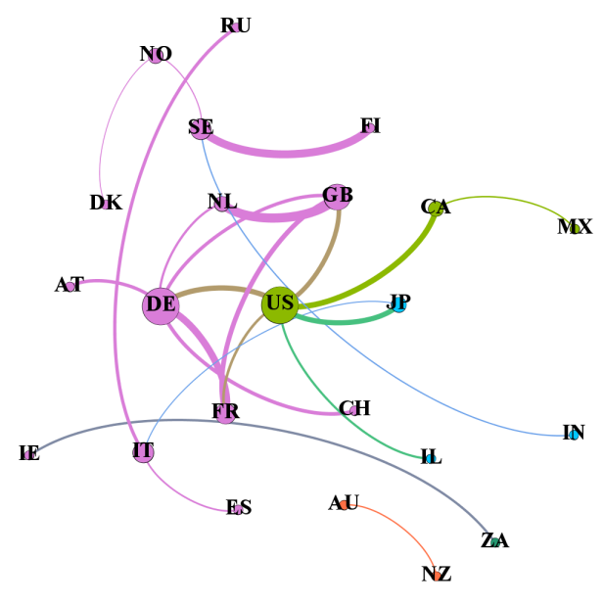 | - Year 1985-1989  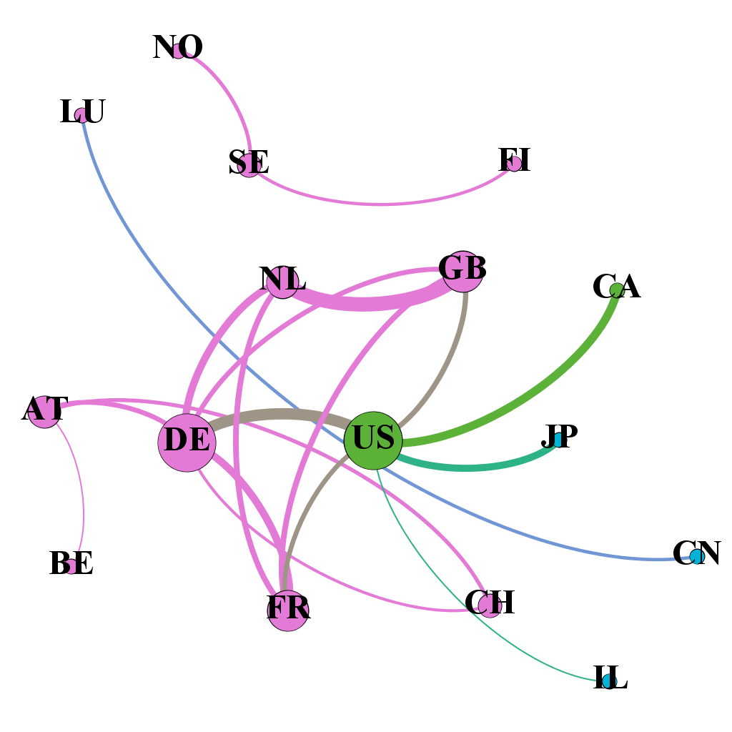
- Year 1990-1994  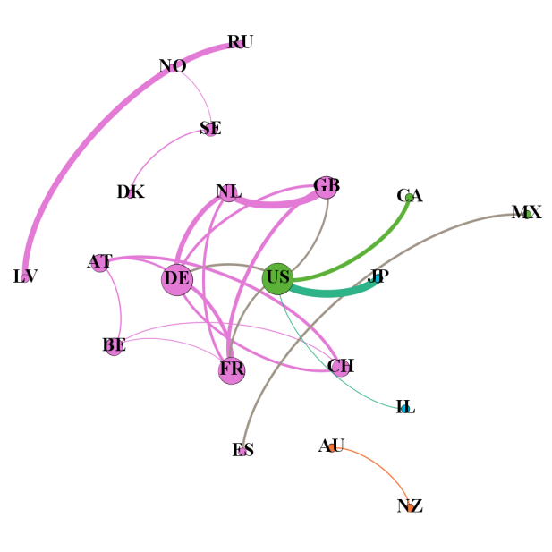 | - Year 1995-1999  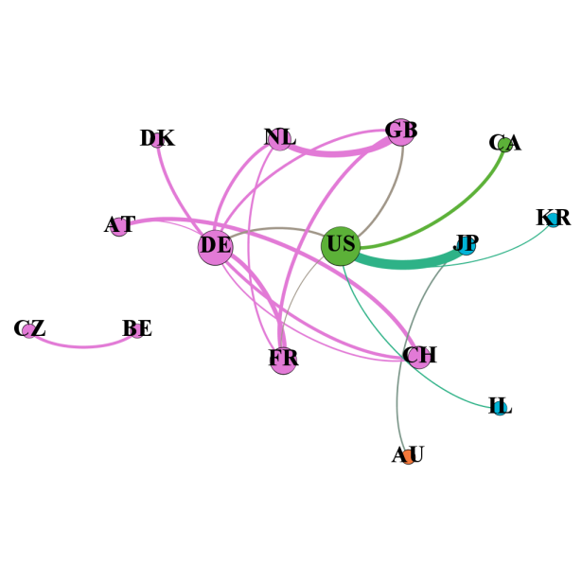
- Year 2000-2004  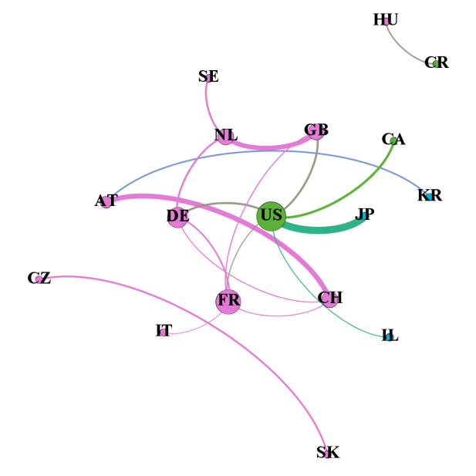 | - Year 2005-2009  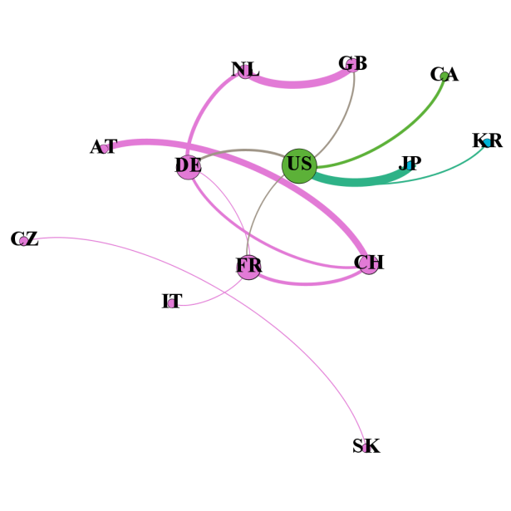
- Year 2010-2014  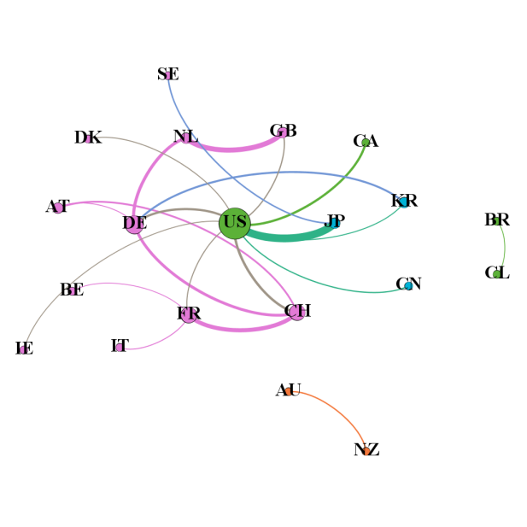 | - Year 2015-2019  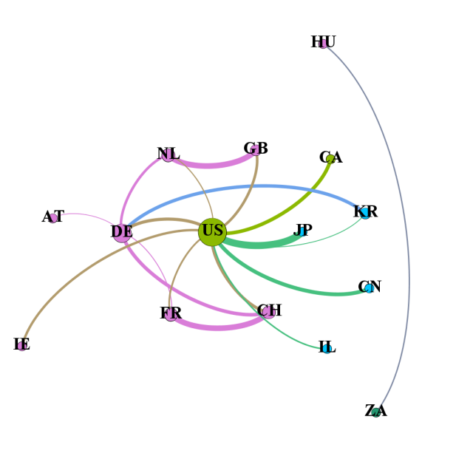

In a comprehensive view, countries with high intensity of cooperation mainly have the following characteristics: (1) The cooperation intensity between the United States and Japan has maintained a high level, they have always been the two countries with the highest intensity after 1990.The intensity between the United States, Canada, Israel, and some great European countries such as Germany is also higher. It is worth mentioning that its intensity with China has been enhanced in the past ten years. (2) The intensity among European countries is high, especially the ties between some countries are very close. From 1980 to 1999, the cooperation relations with high intensity are mainly concentrated in the European region, especially the intensity of two-by-two cooperation between four countries: Germany, France, the Netherlands and the UK. However, the network diagram also shows a weakening of the intensity among European countries. (3) At different periods, there are also partnerships with high cooperation intensity but with a contingent nature, such as Russia and Latvia from 1990 to 1994. It can be speculated that the reason for this is that the total number of cooperation patents in both countries is small. It can be seen that this relationship is very unstable and does not have long-term and regularity.

Countries that are closer in terms of scientific and technological strength, geopolitical relations, and political interests are more likely to establish cooperation relations with higher intensity. Scientific and technological strength is always one of the key elements in choosing patent partners, and countries with strong scientific and technological strength are more inclined to choose each other. For example, the United States, Japan, and Germany have established stronger cooperation at various stages. Geographical proximity has prompted mutual influence and integration, and it facilitates the exchange and resource sharing among scientific research subjects. For example, the European countries have established stronger cooperative relations among themselves. In addition, Australia and New Zealand have a close relation, but the intensity among Asian countries is not high. It is worth noting that the importance of geographical proximity varies at different stages and in different geographical areas. Comprehensive strength and geopolitical relations will bring about connections in political interests, but countries or regions with certain differences in development levels and geographical location may also have far-reaching industrial penetration and communication due to political interests. For example, Israel is in the world's leading position in science and technology, but it has only established a higher intensity with the United States, reflecting the role of intertwined interests in promoting exchanges between the two countries.

5 Conclusion and Discussion
This study analyzes the network structure and stage characteristics of international patent cooperation in 44 countries from 1980 to 2019 based on large-scale granted international cooperation patent data. On the basis of this, this study analyzes country stratification and country associated relationship using patent metrics and social network analysis. It can be found that: (1) From the network itself, the cooperation shows a broad and deepening character in the overall trend. The number of countries involved in cooperation becomes larger, the number of patents also rises gradually, the overall scale expands and the connectivity of the network increases. However, during the period from 2005 to 2009, the network reflected a loosening trend, which was also inseparable from the international situation in that period. (2) From the country structure stratification, the core-periphery structure runs through all stages of the network, with a few countries influencing the overall network. In the background of the overall growth of core degree, the core layer countries show the following stage characteristics: From 1980 to 1999, Germany, the UK, France and the Netherlands always located in the core. The UNITED STATES has also always been within the core layer, and its core degree, although inferior to the four European countries in the first fifteen years, achieved overtaking from 1995 to 1999, and has maintained the first core degree position in the subsequent. From 1995 to 1999, Japan entered the core layer for the first time, reflecting the progress of its innovation. From 2000 to 2019, the UNITED STATES was the only country in the core layer, leading the global scientific and technological development with an absolute advantage. (3) From the intensity of cooperation to see the connection between countries, various stages have formed a cooperation relationship with the UNITED STATES as the center and European countries with close ties as the main characteristics. Scientific and technological strength, geopolitical relations, and political interests are key factors affecting cooperation intensity.

Despite the reference to the relevant research results, there are still the following shortcomings: (1) The reasons for the formation of cooperation characteristics at different stages are not scientifically and thoroughly explained. (2) The perspective of scientific and technological strength measurement is relatively single, without the citation analysis of patents and the location of patentees. (3) The dynamic competitive relationship between states is not described. They do not exist independently but are a pair of inseparable organic wholes (Yoon, Jee & Sohn, 2021).

In response to the above three shortcomings, this study proposes three future research ideas: (1) Combine the real situation and professional knowledge in the field of international relations, and explore the profound reasons for the formation of features in the international patent cooperation networks to make an accurate and concise description of the cooperation. (2) Introduce indicators under different perspectives of measuring patent quality, select the part with measurement value and practical significance, construct a patent quality measurement model, and make a more accurate measurement based on patent quality. (3) International patent cooperation is a business strategy based on the combination of cooperation and competition to obtain a win-win situation, which is different from the zero-sum game. The research results will be more in-depth if the cooperation and competition perspectives can be combined to study the competition relationship in patents.

Author contributions
Yiwen Tang: Conceptualization, data curation, methodology, writing-original draft, and writing-review & editing
Ying Huang: Conceptualization, funding acquisition, methodology, writing-original draft, and writing-review & editing

Competing interests
No competing interests.

Funding information
This work was supported by the National Natural Science Foundation of China (grant no. 72004169).

Reference
Cassi, L. & Plunket, A. (2014). Proximity, network formation and inventive performance: in search of the proximity paradox. Annals of Regional Science, 53(2), 395-422.

Chang, S. (2017). The technology networks and development trends of university-industry collaborative patents. Technological Forecasting and Social Change, 118, 107-113.

Choe, H. & Lee, D. H. (2017). The structure and change of the research collaboration network in Korea (2000-2011): network analysis of joint patents. Scientometrics, 111(2), 917-939.

Crescenzi, R., Filippetti, A. & Iammarino, S. (2017). Academic inventors: collaboration and proximity with industry. Journal of Technology Transfer, 42(4), 730-762.

Crescenzi, R., Nathan, M. & Rodriguez-Pose, A. (2016). Do inventors talk to strangers? On proximity and collaborative knowledge creation. Research Policy, 45(1), 177-194.

Fleming, L., King, C. & Juda, A. (2007). Small worlds and regional innovation. Organization Science, 18(6), 938-954.

Gao, X., Guan, J. & Rousseau, R. (2011). Mapping collaborative knowledge production in China using patent co-inventorships. Scientometrics, 88(2), 343-362.

Guan, J., Zhang, J. & Yan, Y. (2015). The impact of multilevel networks on innovation. Research Policy, 44(3), 545-559.

Guellec, D. & Pottelsberghe, B. (2001). The internationalisation of technology analysed with patent data. Research Policy, 30(8), 1253-1266.

Kogan, L., Papanikolaou, D., Seru, A. & Stoffman, N. (2017). Technological innovation, resource allocation, and growth. Quarterly Journal of Economics, 132(2), 665-712.

Lei, X., Zhao, Z., Zhang, X., Chen, D., Huang M., Zheng, J., Liu, R., Zhang, J. & Zhao, Y. (2013). Technological collaboration patterns in solar cell industry based on patent inventors and assignees analysis. Scientometrics, 96(2), 427-441.

Ozcan, S. & Islam, N. (2014). Collaborative networks and technology clusters - The case of nanowire. Technological Forecasting and Social Change, 82, 115-131.

Sun, H., Geng, Y., Hu, L., Shi, L. & Xu, T. (2018). Measuring China's new energy vehicle patents: A social network analysis approach. Energy, 153, 685-693.

Yoon, S. Y., Jee, S.J. & Sohn, S.Y. (2021). Mapping and identifying technological coopetition: a multi-level approach. Scientometrics, 126(7), 5797-5817.

Zheng, J., Zhao, Z., Zhang, X., Chen, D., Huang, M., Lei, X., Zhang, Z. & Zhao, Y. (2012). International scientific and technological collaboration of China from 2004 to 2008: a perspective from paper and patent analysis. Scientometrics, 91(1), 65-80.

