Following those who follow seabirds. Mapping collaborations in the field using a mixed-method approach

Mayline Strouk*

*m.strouk@sms.ed.ac.uk
ORCID: 0000-0002-9164-4578
Science, Technology and Innovation Studies (STIS), University of Edinburgh, Scotland, United Kingdom
Centre for Science and Technology Studies (CWTS), Leiden University, The Netherlands

Abstract: How do researchers choose their field sites? In the case of seabird research, this question is all the more complex, because the birds themselves choose remote sites for which access and living conditions are strongly limited for the researchers. In this paper, I describe the use of a mixed methodology within my doctoral research to identify what access to the field site really means for researchers and how sites are connected together. This research contributes to the geography of science, examining the spatial dynamics behind scientific research. Here, I identify that some sites are more attractive for seabird researchers, and discuss why. While some sites are attractive to many research teams, they can also be a personal space for one researcher and thus the network between sites is a network of collaborations between single or teams of researchers.

1. Introduction
How do researchers choose their field site? In the case of seabird research, this question is all the more complex, because birds themselves chose to breed on remote sites, which are often islands that resemble rocky cliffs or flat grasslands. Thus, their access and living conditions are strongly limited for researchers who wish to study the colonies. Additionally, the distribution of seabirds tends to be concentrated in polar areas, subpolar climates, Atlantic islands exposed to the wind and unpredictable sea, or in tropical, warm and remote islands in the Indian Ocean (Bernard et al., 2021). The issue of access to a colony is therefore a major concern for researchers.
My PhD project, on which this paper is based, focuses on the specific case of researchers working in the European Arctic and North-Atlantic. The region forms a network of sites and researchers, united in a regional charity called The Seabird Group or collaborating in a Norwegian-lead program, SEATRACK. It offers a great variety of sites and related conditions of research but also reveals how seabird research is a matter of networks of collaborations at a regional or even broader level, because of the great mobility of the seabirds. Within this community of researchers, I seek to understand the many factors and dynamics at play with the choice – or absence of choice – of a field site. How did a researcher end up studying this specific colony? What makes some colonies more or less attractive for researchers? Because of the remoteness of seabirds’ breeding sites, access is a major issue. It remains however to define and determine what is accessibility for seabird researchers and how it evolves over time. Indeed, I wonder how researchers constantly renegotiate this accessibility of seabird colonies when the matter is not only to come but also to come back? In this context, how are some sites privileged by the scientists and how are some ignored? A key answer is by looking at collaborations with a mixed-method approach.
2. Using a mixed-method approach to understand the geography of seabird research
This project aims to contribute to geography of science, which is marginally developed in STS. Like there is a history of science, philosophy of science, and sociology of science, some contributions such as that of David Livingstone (2003) argue that there is also a space for a “geography of science”. This geography of science aims at studying how science is a spatial activity, notably how it travels across space and scales, how spatial settings influence scientific knowledge and simply, where is scientific research conducted (Livingstone, 2003; Powell, 2007; Maisonobe, 2015; Mahony, 2021). Geography of science is however not a united field of research as Powell (2007) and later Mahony (2021) highlight, with contributions from historians of geography, historians, geographers, and STS scholars. Most publications do not involve the major contribution of geographers: “drawing maps” (Despret, 2016: p. 204). Furthermore, as historians of science were the most eager to develop geography of science as a field of research, most accounts of the role of space in the production of scientific knowledge involve historical case studies (Livingstone, 2003; Matless, 2003; Withers and Finnegan, 2003; Naylor, 2005). Thus, contemporary case studies that use a geographical perspective are scarcer in the literature. More recently, contributions from a French team of geographers in the Geoscience project (2010-2013) added a quantitative and mapping layer to such analysis. They developed a method for geocoding bibliometric data from the Web of Science to produce a geography of scientific production based on the urban area unit. In addition to this methodology, which provides a precise mapping of scientific publications (based on the cities of origin of publications), they have demonstrated that there is a phenomenon of deconcentration of science on a global scale (Eckert et al., 2014; Grossetti et al., 2016; Maisonobe et al., 2017).
My project aims at contributing to this development of a mixed-method geography of science, to understanding where fieldwork is done and why there, focusing on the specific case of seabird research in a defined geographical area, the European Arctic and North Atlantic. Indeed, mapping the home institutions of publications does not necessarily reveal where science is actually being done (Maisonobe, 2021), meaning where data is collected. Thus, my project relies on quantitative mapping of field sites, completed by a series of interviews conducted with researchers, as well as ethnographic fieldwork.

The very first approach I explored was mapping the sites of seabird research and examining what that says about the hotspots and gaps in this scientific field. The goal was to identify some key dynamics, such as a high occurrence of specific sites in publications, or collaborations between sites. Relying on the metadata of publications as available on bibliometric databases such as Web of Science or Scopus was too limiting, because researchers, at least in seabird research, tend not to specify their field site in the title, abstract or keywords of their publications. This location is generally however mentioned in the “method” section of the paper, with the precise geographical coordinates, which makes them more easily identifiable. Thus, I have developed a method to extract these locations from papers and report them into the GIS software, QGIS. I am currently only relying on a defined set of publications from the Norwegian SEAPOP program and its international extension SEATRACK, as they list the publications resulting from the programs on their website. This small set of around 400 publications (excluding the commissioned scientific reports) makes it easier to identify how often researchers provide the coordinates of the sites in the publications, how they report these coordinates, and how it would be then possible to automatically identify them. The following steps would be to expand this method to more seabird research publications and there, the challenges are to identify a reliable search query on Web of Science, and to be able to combine this with other sources of data which are specifically relevant to a mapping of field sites. I am also working with the Seabird Tracking Database developed by BirdLife International to collect data on the location of sites where birds have been tracked. The following Figure 1 shows the very first attempt from 152 papers affiliated with SEAPOP and SEATRACK, showing 145 different locations.
Figure 1. Mapping the location of field sites from 152 papers affiliated with the SEAPOP and SEATRACK research programs
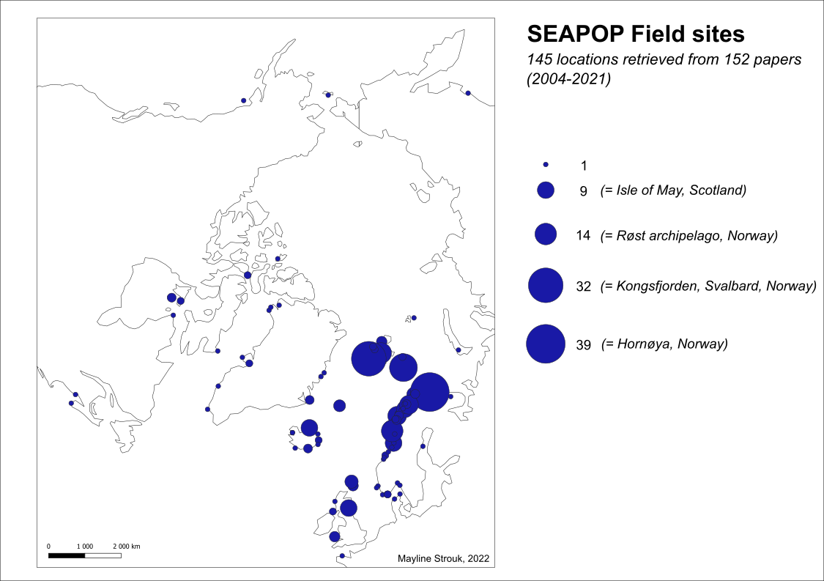
Although I started this mapping to identify the hotspots and gaps of data, showing how some sites are more studied than others, this geography of field sites provides more meaningful information in what it does not represent. Indeed, because SEAPOP is a Norwegian program which then extended to international partners through the SEATRACK program, most sites on the map are Norwegian, and the most cited sites are also Norwegians. Thus, it mostly shows how Norway is a key area in the specific context of seabird research through SEATRACK. However, it also highlights how Norwegian sites might be central for regional collaborations, and make it interesting to investigate how these sites are connected. Indeed, there are 145 locations in Figure 1 mapping, whereas SEAPOP and SEATRACK respectively formally gather only 24 and 56 key monitoring sites. How come other sites figure on the map? For example, there is the island of Rouzic located in Brittany, France whereas both SEATRACK does not expand to French sites. This map opens up the idea of investigating the collaborations behind the location of a site.
To do so, it was crucial to also gather qualitative data. I conducted so far a series of 21 interviews with seabird researchers across the Arctic and North Atlantic area. This sample of researchers is based on encounters, for example at The Seabird Group conference, which is a European-level conference on seabirds, but my mapping of sites was also a help to identify which people would be interesting to interview. As such, the interviews were semi-structured and focused on open discussions about the researchers’ career path in connection with the site where they have been doing fieldwork. I collected narratives of the quotidian of fieldwork, the challenging accessibility of colonies, living conditions, and what lead the researchers to go to a specific site, to leave, or to come back. These interviews were crucial to understanding what is not on the map and what cannot be represented by such a method: notably how difficult it is to access a site and live there, and how researchers move from site to site throughout their academic careers. These discussions revealed how setting up monitoring work on a colony and making it last over years and decades is crucial to researchers.
3. The key role of collaborations in and around the field
Seabird researchers have to deal with an apparent paradox in their work. They study highly mobile birds that can cover distances from the North Pole to the South Pole each year (e.g. Arctic terns) and take advantage of the birds’ strong loyalty to their colonies. Thus, they are dependent on these remote sites, which often located as far away from human presence as possible. At the same time, their research questions focus on studying the behaviour of the birds and the health of a colony, which, if it declines, means that the colony will disappear or move elsewhere, perhaps to an even more remote location. From my interviews, I was able to identify the complexity of finding a good field site, meaning one that is accessible, geographically first, but also where the birds are accessible. And of course, one that requires as little funding as possible. Accessibility is thus a key determinant in the choice of a site. A major question raised by Figure 1 is whether the sites that are most mentioned in the literature are the most accessible and whether other factors do not come into play to make a colony a field site, which lasts over time, such that it appears in many publications.
Through the interviews with the researchers, an ambivalent dimension of the field emerges, as being both a deeply individual and collective site. Individual, first of all, because the colonies are so numerous but so difficult to access that researchers have a limited capacity to multiply field sites. At the same time, because the monitoring of seabirds is also limited, the researchers stay as long as possible with the birds when they are on the colony, a fieldwork period that generally amounts to about four months per year. Researchers thus tend to develop a deep and personal relationship with their field site, which they visit in some cases for several months a year, over decades-long careers. Even though generational changes are taking place which call into question this personal investment in the field, and even though the development of new technologies makes it possible to collect certain data at a distance; fieldwork remains a main component of the seabird researcher’s work.
But fieldwork is also and above all a collective work in which collaboration is essential. Firstly, no researcher can be alone in the field, for security reasons. Fieldwork is often led by an individual, or a small core group, with the help of volunteers, students or field technicians. Above all, because of logistical and financial challenges, repeated access to the field site is limited and researchers seek to establish networks of collaborations. These collaborations occur as a network of trust, to know which site is accessible, relying on the researchers’ experience to judge the accessibility which is, once again, complex and varied. This role of collaboration in the choice of a field site was mentioned many times by the researchers I interviewed, especially in regions with particularly difficult conditions, such as Greenland. One French researcher, who initially had limited knowledge of the country, told me that his choice of field site (which he then has been returning to every year with his team for the past twenty years) was mainly based on the advice of a local researcher whom he held in high esteem. Similarly, collaborations allow fieldwork to be maintained over the years. Researchers who are aware of the difficulty of fieldwork, but who are also curious about discovering new sites, enter into collaborations to help each other in the field, and to learn new methods. Fieldwork is first and foremost a matter of adaptation, and each researcher develops their own strategies, which make up their know-how and are a source of learning and transmission. For example, the seabird ecologist Michael P. Harris shared how a team of Japanese researchers, doing fieldwork in Japan, travelled to the Isle of May in Scotland to learn from him and his team about their bird monitoring methods. His colleague Mark, who has been working on the island for nearly twenty years also later had the opportunity, with the limitation of fieldwork in Scotland during the covid crisis, to go and help a Danish colleague (who used to work on the Isle of May) on his Greenland site for a few weeks. This was his only field trip outside Scotland for many years.
Collaboration takes place before fieldwork, during fieldwork and after fieldwork. Indeed, seabird researchers must form networks to share data collected on the colonies, to cover the high mobility of the birds they study. This imperative is far from new, but it is growing with the new possibilities offered by the development of bird-tracking technologies. Indeed, the very principle of bird ringing relies on the observation of a bird ringed at point A, and at another point B, to determine that it has travelled. This system, therefore, requires communication between teams around these points and is not restricted to the professional and academic practice of ornithology. The development and mostly, the miniaturization of tracking technologies, primarily through geolocators (GLS) and GPS, now make it possible to track the movements of birds much more reliably and easily when they are no longer on the colony site. Researchers therefore no longer solely rely on being in the field, although this is still important to implement loggers on birds and collect other types of data at the same time. The international SEATRACK programme was developed on this principle in 2014. SEAPOP, a Norwegian programme designed to coordinate the monitoring of some twenty key colony sites in Norway, had already been in place since 2005, adopting a uniform methodology for sharing and comparing data. This national coordination system for seabird research is still unique in the world. In 2014, the programme was extended to an international dimension to study the winter migration of Norwegian seabirds across the Arctic and Atlantic, now including 56 sites in eight countries. The SEATRACK model is based on the challenges of having the logistical means to track birds’ movements at sea, also because GPS loggers can cost several hundred or even thousands of euros per unit, depending on the model. SEATRACK is funded by 2 Norwegian governmental institutions but also by 9 energy companies or organisations involved in offshore oil and gas or offshore windfarms, which rely on bird tracking data collected to inform their mandatory environmental impact assessments. Thanks to this funding scheme, SEATRACK provides its partners with free tracking loggers, which they should then implement on birds in the colony where they work anyway. This saves the network members’ equipment costs, increases the justification for their presence in the field, and amortizes logistical costs. In addition, the data collected is shared and displayed on a common website, which allows for big data studies.
4. Conclusion
Studying collaborations before, during and after the fieldwork is therefore essential for understanding how the geography of field sites is structured. These collaborations guide researchers’ field site choices, and their ability to go, stay and return to the field, through the sharing of means, knowledge and funding, and the subsequent sharing and gathering of these data. The case of SEATRACK interestingly shows how the geography of sites integrated into the network is based on colonies monitored before the programme, but the financial and logistical support it provides to researchers makes it possible to maintain these field sites. One question that arises is to what extent this model of cooperation can be expanded to other sites, and structure the geography of sites in the long term. Similarly, while more than a third of SEATRACK’s funding is provided by energy companies, it is interesting to ask what structuring role they also play in the choice and possibility of doing fieldwork. At last, this paper emphasises the need to combine quantitative and qualitative data collection and analysis to understand where research is being done, and why. Mapping allows us to identify spatial dynamics in the choice of fieldwork, to reveal hotspots and gaps, but above all raises several questions that can be answered through in-depth discussions with the researchers themselves. These reveal the ambivalence of accessibility to the field and the key role of collaborations.
5. References
Bernard, A., Rodrigues, A., Cazalis, V., & Grémillet, D. (2021). “Toward a global strategy for seabird tracking”. Conservation Letters. https://doi.org/10.1111/conl.12804
Despret, V. (2016). What Would Animals Say If We Asked the Right Questions?. University of Minnesota Press, p.204
Eckert, D., Grossetti, M., Jégou, L. & Maisonobe (2014). “Les villes de la science dans le monde”, Mappemonde 116, 4. mappemonde-archive.mgm.fr/num44/articles/art14401.html
Grossetti, M., Eckert, D., Maisonobe, M. & Jégou, L. (2016). “Four commonly held beliefs about the geography of scientific activities”. In Shearmu, R., Carrincazeaux, C. and Doloreux, D. (Eds.), Handbook on the Geographies of Innovation (pp. 223-240). Cheltenham: Edward Elgar Publishing.
Livingstone, D. N. (2003). Putting Science in Its Place: Geographies of Scientific Knowledge. Chicago: University of Chicago Press.
Mahony, M. (2021). “Geographies of science and technology I: Boundaries and crossings”. Progress in Human Geography 45, 3 (pp. 586-95).
Maisonobe, M. (2015). Étudier la géographie des activités et des collectifs scientifiques dans le monde: de la croissance du système de production contemporain aux dynamiques d’une spécialité, la réparation de l’ADN. Université Toulouse le Mirail - Toulouse II.
Maisonobe, M. (2020). “Regional Distribution of Research: The Spatial Polarization in Question”. In Ball, R. (Ed.), Handbook Bibliometrics (pp. 377-396).
Maisonobe, M., Grossetti, M., Milard, B., Jégou, L. & Eckert, D. (2017). “The global geography of scientific visibility: a deconcentration process (1999-2011)”. Scientometrics 113 (pp. 479-493).
Matless, D. (2003). “Original theories: science and the currency of the local”. Cultural Geographies 10 (pp. 354-78).
Naylor, S. (2005). “Introduction: Historical Geographies of Science – Places, Contexts, Cartographies”. The British Journal for the History of Science 38, 1 (pp. 1-12).
Powell, R. C. (2007). “Geographies of Science: Histories, Localities, Practices, Futures”, Progress in Human Geography 31, 3 (pp. 309–29).
Withers, C. W.J., & Finnegan, D.A. (2003). “Natural History Societies, Fieldwork and Local Knowledge in Nineteenth-Century Scotland: Towards a Historical Geography of Civic Science”. Cultural Geographies 10, 3 (pp. 334–353).
6. Open science practices
This paper is based on an ongoing PhD project, thus I am still considering how I could make my data accessible, especially by combining quantitative mapping and qualitative analysis. The conference will thus be useful in helping me through this issue.
7. Competing interests
The author declares no conflict of interest.
8. Funding
This research is supported by a University of Edinburgh/Leiden University studentship.

https://seapop.no/en/ny-publikasjoner/

