To Preprint or Not to Preprint: Experience and Attitudes of Researchers Worldwide

Rong Ni*, Ludo Waltman**

*r.ni@cwts.leidenuniv.nl
https://orcid.org/0000-0003-2455-4545
Centre for Science and Technology Studies (CWTS), Leiden University, Leiden, the Netherlands
School of Public Economics and Administration, Shanghai University of Finance & Economics, Shanghai, China

**waltmanlr@cwts.leidenuniv.nl
https://orcid.org/0000-0001-8249-1752
Centre for Science and Technology Studies (CWTS), Leiden University, Leiden, the Netherlands

Abstract
The pandemic has underlined the significance of open science and spurred further growth of preprinting. Nevertheless, preprinting has been adopted at varying rates across different countries/regions. To investigate researchers’ experience with and attitudes toward preprinting, we conducted a survey of authors of research papers published in 2021 or 2022. We find that respondents in the US and Europe had a higher level of familiarity with and adoption of preprinting than those in China and the rest of the world. Respondents in China were most worried about the lack of recognition for preprinting and the risk of getting scooped. US respondents were very concerned about premature media coverage of preprints, the reliability and credibility of preprints, and public sharing of information before peer review. Respondents identified integration of preprinting in journal submission processes as the most important way to promote preprinting.

Keywords: preprinting, scholarly publishing, open science, survey

Introduction
Posting preprints is an open science practice that helps to make scholarly publishing faster and more transparent. Preprint servers enable research papers to be shared openly prior to peer review by an academic journal. Posting papers on a preprint server is a fairly common practice in some disciplines. In other disciplines preprinting is less common, and in some disciplines preprinting is hardly done at all.

The adoption of preprinting varies around the world. In the life sciences, for instance, Abdill et al. (2020) showed that the US and UK contribute a disproportionally large number of preprints to bioRxiv compared to other countries. This could be due to a variety of reasons, such as differences between countries in the level of awareness of preprinting or in the implementation of open science policies. In the past few years, however, there seems to be an increasing interest in preprinting in other regions as well, as shown for instance by the emergence of regional preprint servers such as ChinaXiv, Jxiv, and AfricArXiv (Chaleplioglou & Koulouris, 2023).

Preprinting may offer several benefits to authors, readers, and potentially also to other stakeholders, such as reviewers and editors. It enables immediate publication of research papers and may help to avoid duplicate work and to prevent other researchers from pursuing unproductive research directions (Puebla et al., 2021). Preprinting also allows authors to receive fast feedback on their work (Malički et al., 2021), to claim priority for their work (Ginsparg, 2016; Vale & Hyman, 2016), and to get “scoop protection” (Pulverer, 2016). In addition, as permanent citable records, preprints can be used as proof of productivity, especially for early-career researchers and researchers who do not intend to publish their work in journals (Vale, 2015; Malički et al., 2021). Preprints also offer a way to attract early attention from readers and editors (Barrett, 2018; Barsh et al., 2016). This may help authors to make their work more visible, which may also increase the number of citations their work receives (Fraser et al., 2020; Fu & Hughey, 2019).

However, preprinting also faces some challenges, which may slow down the adoption of preprinting. The most common concerns include scooping risks, reliability and credibility, public access and media coverage, compatibility with journals, and disparities in adoption (Sever et al., 2019; Puebla et al., 2021; Fraser et al., 2022). A survey carried out in 2020 showed that the concern about getting scooped was stronger among authors who had never posted a preprint than among those who did have experience with preprinting. In addition, journals’ policies for posting and citing preprints vary across disciplines. Klebel et al. (2020) found that 91% of the journals in the life and earth sciences allow preprinting, while this is the case for only 45% of the journals in the humanities.

Our goal in this paper is to better understand researchers’ experience with and opinions on preprinting. Specifically, we conducted a global online survey of authors of research papers asking them about their familiarity with preprinting and their experience with reading and posting preprints. We also used the survey to study researchers’ views on the benefits of preprinting, concerns about preprinting, and ways in which preprinting can be promoted.

We aim to address the following research questions:
- What is the level of adoption of preprinting and how does this differ across countries/regions?
- What do researchers see as benefits of preprinting and what are their concerns?
- What do researchers see as ways to encourage preprinting?

2. Methods

2.1 Survey overview
To learn about researchers’ experience with and attitudes toward preprinting, we surveyed corresponding authors of papers that were published in 2021 and 2022 and that are indexed in the Web of Science database. The survey was carried out using the Qualtrics software. Respondents were asked to answer ten questions about their experience with and attitude toward preprinting and five demographic questions. The questions in the survey were grouped into three parts:
- Experience with preprinting – including level of familiarity with preprinting, ways of learning about preprinting, frequency of reading preprints, experience with posting preprints, and willingness to post preprints in the future.
- Opinions on preprinting – including benefits of preprinting, concerns about preprinting, and ways to encourage preprinting.
- Demographic questions – including gender, country/region in which a respondent’s organization is based, number of years of research experience, occupation/career stage, and research area.

The survey form and the raw survey data are available in Zenodo (Ni & Waltman, 2023). The survey is in English, except for the survey that was sent to researchers in China, which was both in English and in Chinese. Ethical approval to carry out the survey was granted by the Ethics Review Committee of the Social Sciences at the Faculty of Social and Behavioural Sciences of Leiden University.

2.2 Survey data collection
We ran our survey separately for researchers in four parts of the world: China, the US, Europe, and the rest of the world (‘Other’). Researchers were selected as follows:
- All publications in Web of Science in 2021 and 2022 were selected.
- For the selected publications, corresponding authors with an affiliation in a particular country/region (i.e., China, USA, Europe, Other) were identified and the email addresses of these authors were selected.
- The email addresses were deduplicated.
- A random sample of the deduplicated email addresses was taken and an invitation to participate in our survey was sent to these addresses.

We sent the survey invitations in batches between November 2022 and March 2023. The survey was fully anonymous. For each country/region, we first sent a small number of survey invitations to test the survey process. We then sent another 30,000 survey invitations. Table 1 summarizes the number of survey invitations that were sent and the number of responses that were received. In total, we received 3506 completed responses to our survey. The response rate was highest for researchers in Europe (4.7%) and lowest for researchers in China (1.2%).

Table 1. Survey data collection
Country  /region | # invitations | # bounced or failed | # responses (response rate) | # completed responses  (response rate) | Period
China | 31100 | 4677 | 395 (1.5%) | 321 (1.2%) | Nov-Dec 2022
US | 31000 | 1935 | 985 (3.4%) | 901 (3.1%) | Jan 2023
Europe | 31000 | 2636 | 1447 (5.1%) | 1326 (4.7%) | Feb 2023
Other | 31000 | 2832 | 1143 (4.1%) | 958 (3.4%) | Mar 2023

2.3 Survey participants
Fig. 1 provides an overview of the demographics of the survey participants.

66% of the survey participants identified as man and 29% as woman. About 5% chose "prefer not to say" or "prefer to self-describe". More than half of the survey participants reported to have at least 15 years of research experience, revealing a strong overrepresentation of senior researchers among the participants. Only 2% of the participants had less than 3 years of research experience. Full professors accounted for the largest proportion of survey participants (29%), followed by associate professors (21%) and assistant professors (15%). Respondents were active in different research areas, including medical and health sciences, which accounted for the largest proportion of respondents (19%), but also life sciences (17%), social sciences (11%), physics and astronomy (8%), engineering (8%), etc. Responses were received from a total of 114 countries/regions.

Fig. 1. Demographics of survey participants (N=3506)

A | B
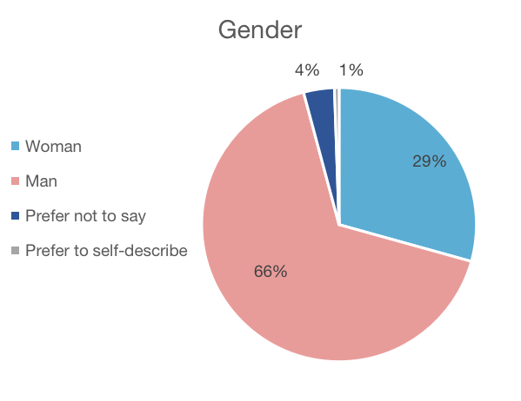 | 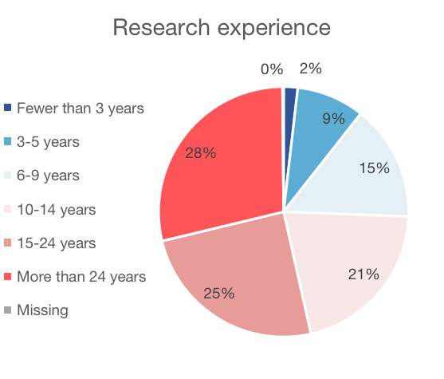
C  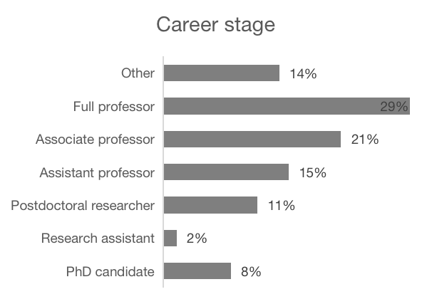 | D  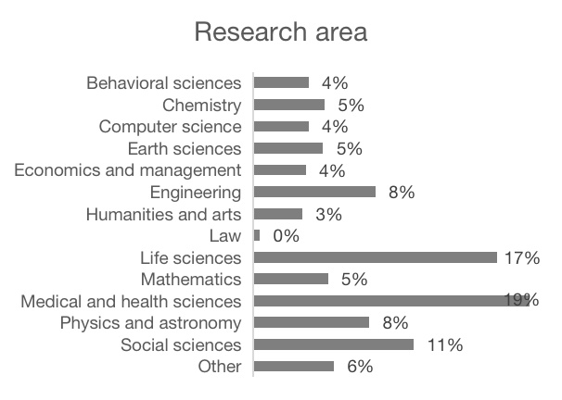

3. Results

3.1 Familiarity with preprinting
Participants were asked to report their familiarity with preprinting. Fig. 2 shows the results by country/region. On average, 8% of the respondents were not familiar with preprinting at all, while 15% were extremely familiar with preprinting. Participants in the US showed the highest familiarity with preprinting, with 5% stating that they were not familiar with preprinting at all and 22% saying they were extremely familiar. European respondents also indicated a high level of familiarity with preprinting, with 7% not being familiar with them at all and 17% being extremely familiar. Among participants in China, only 6% were extremely familiar with preprinting while 13% reported that they had no knowledge about preprinting at all.

Respondents who answered that they were not familiar with preprinting at all (N=283) skipped the remaining questions about preprinting and went directly to the demographic questions at the end of the survey.

Fig. 2. Familiarity with preprinting (N=3506)
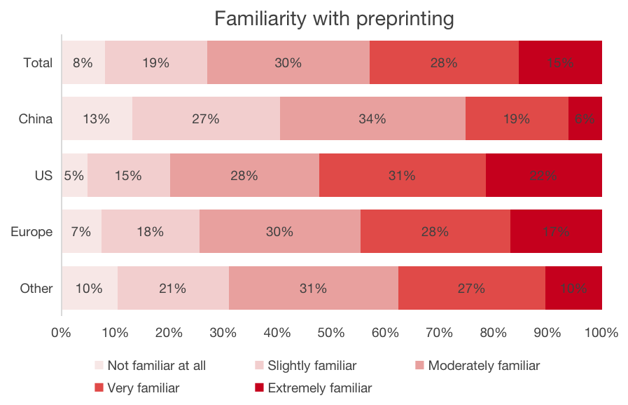

In terms of sources of learning about preprinting (Fig. 3), in all countries/regions, more than half of the participants expressed that they learned about preprinting by reading preprints. Overall, training was the least important source of learning about preprinting, mentioned by only 4% of the respondents. 58% of the respondents in China said they learned about preprinting when they submitted a paper to a journal. This percentage is much lower for respondents in other countries/regions. When asked if they learned about preprinting from a colleague, far fewer respondents in China (17%) chose that answer than in other countries/regions.

Fig. 3. Sources of learning about preprinting (N=3223)
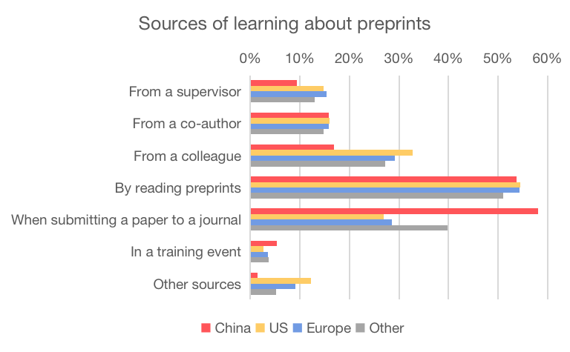

3.2 Experience with preprinting
We also asked survey participants how often they read and post preprints. Countries/regions do not show major differences in the frequency of reading preprints (Fig. 4-A). But in terms of posting preprints, the US and Europe show a higher level of adoption than China and the rest of the world. About 18% of the participants in the US reported that they had posted all or most of their papers on a preprint server, and 21% of participants in Europe said the same, but the figures were only 11% for China and 13% for the rest of the world.

Fig. 4. Frequency of reading and posting preprints (N=3223)
A | B
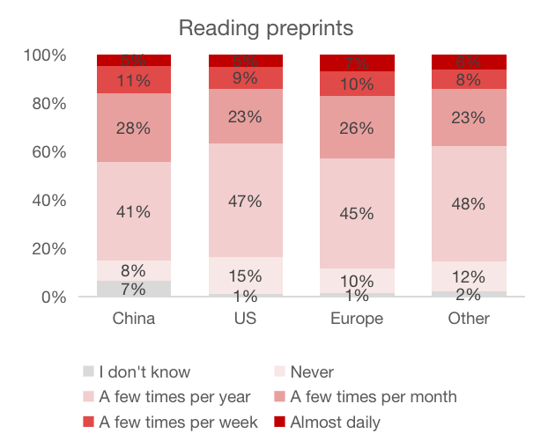 | 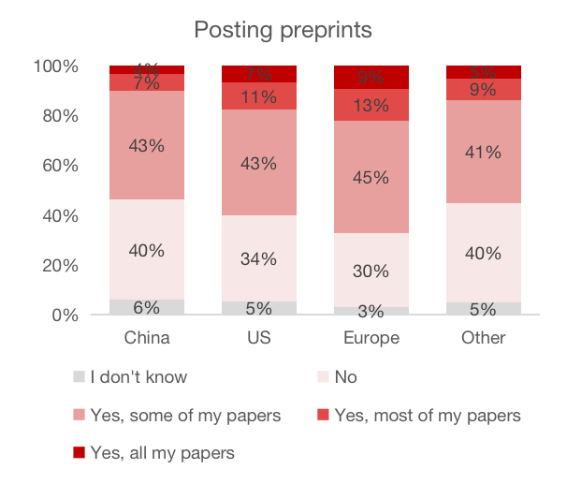

Survey participants who reported that they had posted papers on preprint servers were asked which preprint servers they had used and at what stage they posted preprints. In terms of preprint servers (Fig. 5-A), many participants, especially in the US and Europe, stated that they had used arXiv (39%) or bioRxiv (24%). ChinaXiv, a preprint server based in China, is primarily used by respondents in this country. Additionally, a relatively high share of respondents in China use Research Square (16%) or SSRN (15%). Presumably, most papers are posted on these preprint servers when authors submit a paper to a Springer Nature or Elsevier journal. PsyArXiv, a preprint server for psychological sciences, and SocArXiv, a preprint server for social sciences, are used more often by respondents in the US and Europe than by their colleagues in China and the rest of the world.

In terms of the stage of posting preprints (Fig.5-B), many survey participants responded that they had posted preprints before submitting their work to a journal (over 20%) or when submitting it to a journal (nearly 30%). Nearly 20% of the participants had posted preprints after their work had been accepted by a journal. Such preprints should actually be referred to as postprints.

Fig. 5. Use of different preprint servers and stage at which preprints are posted (N=2112)
A | B
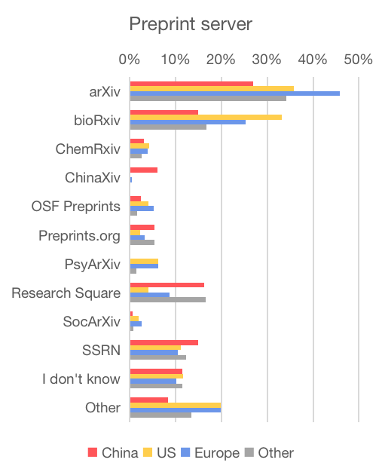 | 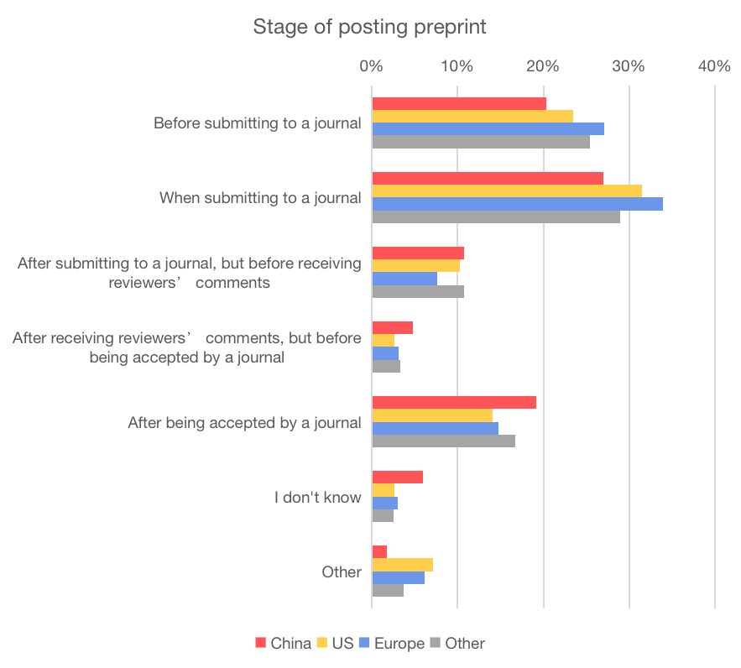

3.3 Willingness to post preprints
Survey participants were also asked to report their willingness to post preprints in the future (Fig. 6). Similar patterns were found for participants in the US and Europe. 11% of the US respondents and 13% of the European respondents expect to post all their future papers on a preprint server, while this is the case for only 2% of the respondents in China However, while the US has a relatively high percentage of respondents that expect to preprint all their future papers, it also has the highest percentage of respondents that expect not to preprint any of their future papers (39%). This percentage is substantially lower in China and Europe (30%).

Fig. 6. Willingness to post preprints in the future (N=3223)
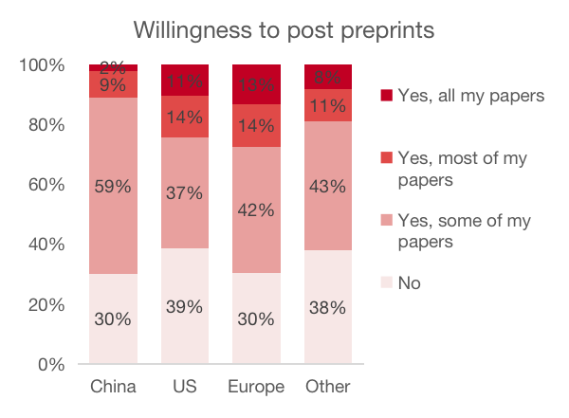

3.4 Attitudes toward preprinting
Fig. 7 shows the attitudes of respondents toward nine statements about the potential benefits of preprinting. The attitudes of respondents from different countries/regions are quite similar. Being free to read is seen as the most beneficial feature of preprints. Approximately half of the respondents regarded this as very beneficial. Nearly 45% of the respondents considered the increase in the speed of research communication to be very beneficial. In comparison, about one-fifth of the respondents stated that preprints are very beneficial because they enable authors to receive early feedback, receive more citations, demonstrate progress in the context of evaluation for grants or
jobs, and to share results that do not fit in journals.

Fig. 7. Attitudes toward benefits of preprinting
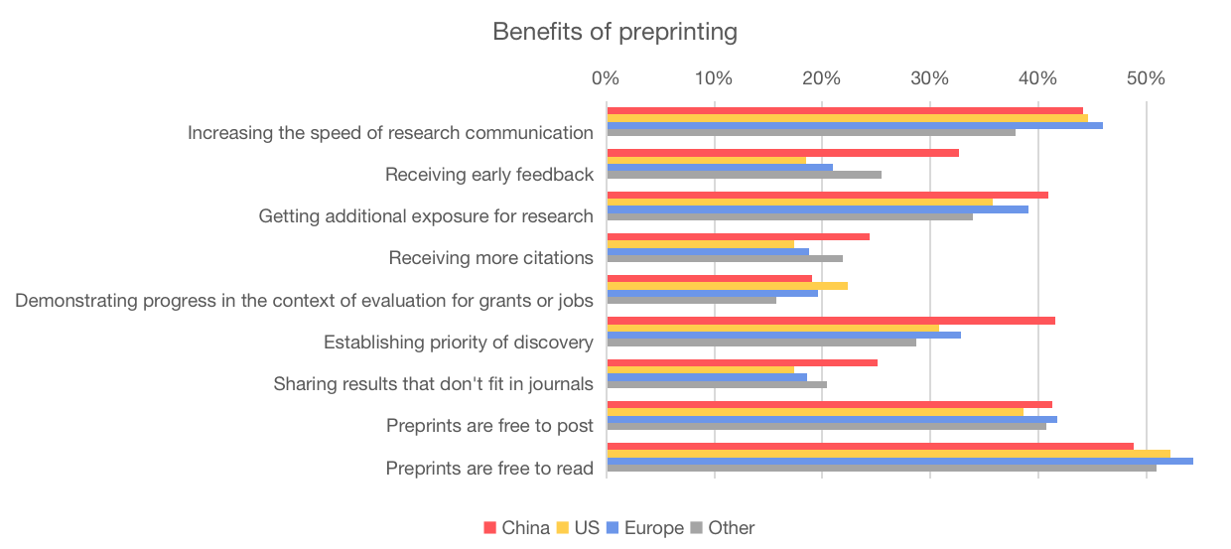
Note: For each item respondents were asked whether they consider it not beneficial at all, somewhat beneficial, or very beneficial, or whether they do not know. The chart shows the percentage of ‘very beneficial’ responses.

Fig. 8 shows respondents' attitudes toward eleven statements on potential concerns about preprinting. Compared to respondents in other countries/regions, US respondents were more concerned about publicly sharing information before peer review, the reliability and credibility of preprints, and premature media coverage of preprints. Respondents in China were more concerned about the lack of recognition for posting preprints and the risk of preprint authors getting scooped. Only a small share of the respondents expressed concerns about harmful comments on preprints and information overload.

Fig. 8. Attitudes toward concerns about preprinting
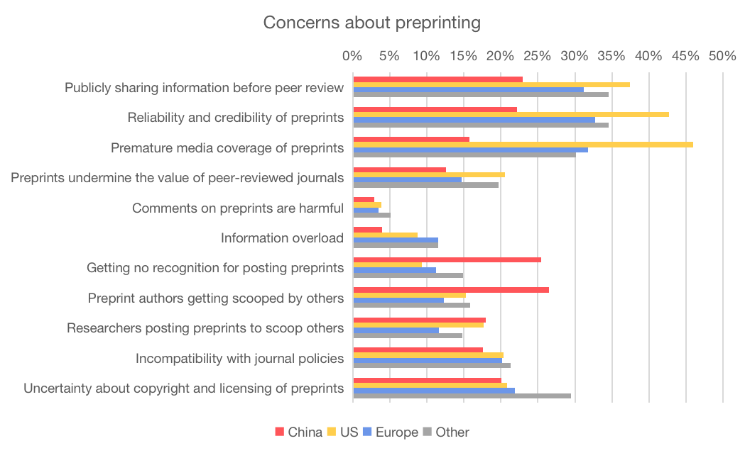
Note: For each item respondents were asked whether they are not concerned at all, somewhat concerned, or very concerned, or whether they do not know. The chart shows the percentage of ‘very concerned’ responses.

3.5 Encouraging preprinting
Finally, respondents were asked to indicate the importance of different ways to encourage preprinting. According to the respondents, integrating preprinting in journal submission processes is very important to encourage preprinting. Over one-third of the respondents regarded this as very important. Respondents also considered providing recognition to researchers for preprinting their work to be of high importance. Approximately a quarter of the respondents stated that encouraging or mandating preprinting by research funders, research institutions, and journals is very important. Respondents in China and in other countries/regions also emphasized the importance of making preprint servers easier to use. This was perceived as somewhat less important by the respondents in the US and Europe.

Fig. 9. Importance of different ways to encourage preprinting
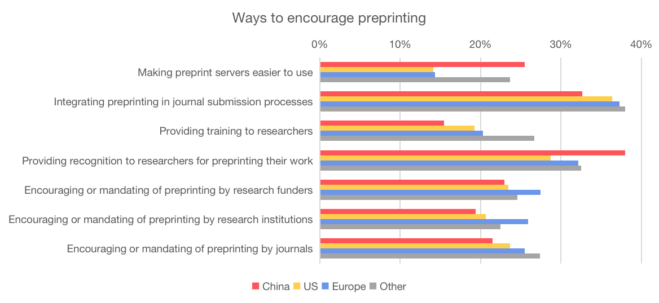
Note: For each item, respondents were asked whether they consider it not important at all, somewhat important, or very important, or whether they do not know. The chart shows the percentage of ‘very important’ responses.

Conclusion and discussion
We conducted a survey to investigate researchers’ experience with reading and posting preprints and to study researchers’ views on benefits of preprinting, concerns about preprinting, and ways in which preprinting can be promoted. We focused in particular on analyzing differences between countries/regions.

At a basic level, the survey results show that the US and Europe lead the way in terms of familiarity with and adoption of preprinting. For example, more than half of US respondents reported that they are very familiar or extremely familiar with preprinting. This was the case for 45% of the respondents in Europe, but only for 25% of the respondents in China. In addition, approximately one-fifth of the respondents in the US (18%) and Europe (21%) reported that they had posted most or all of their papers on preprint servers, while this was the case for only 11% of the respondents in China.

The survey respondents perceived the free accessibility of preprints as the most important benefit of preprinting. Speeding up research communication was identified as another major benefit. A third benefit emphasized by the respondents was that preprints are free to post. Respondents in China also strongly valued preprinting as a way to establish priority of discovery. Respondents in other countries/regions showed less interest in this benefit.

Survey respondents in different countries/regions showed major differences in their concerns about preprinting. Respondents in the US were very concerned about premature media coverage of preprints, the reliability and credibility of preprints, and public sharing of information before peer review. Compared to respondents in other countries/regions, respondents in China were more concerned about the lack of recognition for posting preprints and the risk that authors who post preprints may get scooped.

Integrating preprinting in journal submission processes was identified as the most important way to promote preprinting. Providing recognition to researchers for preprinting their work is another important way in which preprinting can be encouraged, emphasized in particular by survey respondents in China.

A number of limitations of our study need to be acknowledged. First, our survey results may overestimate the support for preprinting. Researchers who are familiar with preprinting and have a positive attitude toward it may have been more likely to complete the questionnaire. Additionally, we received emails from researchers informing us that they decided not to participate in the survey because they had no knowledge of preprinting. Furthermore, senior researchers with extensive research experience are overrepresented among survey respondents. Finally, the survey showed large differences in response rates across countries. The number of responses in Europe for instance was much higher than in China. This is likely to affect comparisons across countries.

Open science practices
The survey form and the raw survey data are available in Zenodo (Ni & Waltman, 2023). We decided to make all survey data openly available except for the free-text responses, which may contain sensitive information. We also prepared a data management plan for the research reported in this paper.

Author contributions
Conceptualization: RN, LW; Data curation: RN, LW; Formal analysis: RN; Investigation: RN; Methodology: RN, LW; Project administration: LW; Supervision: LW; Validation: RN, LW; Visualization: RN; Writing – original draft: RN; Writing – review & editing: NR, LW.

Competing interests
Rong Ni has no competing interests. Ludo Waltman is advocating for the use of preprints, for instance as a member of the ASAPbio Board of Directors, as co-organizer of the ASAPbio Publish Your Reviews initiative, and as one of the initiators of a new publication platform in the field of research on research.

Data availability
The data analyzed in this paper is available in Zenodo (Ni & Waltman, 2023).

References
Abdill, R. J., Adamowicz, E. M., & Blekhman, R. (2020). International authorship and collaboration across bioRxiv preprints. eLife, 9, e58496.
https://doi.org/10.7554/eLife.58496.

Barrett, S. C. H. (2018). Proceedings B 2017: The year in review. Proceedings of the Royal Society B: Biological Sciences, 285(1870), 20172553. https://doi.org/10.1098/rspb.2017.2553.

Barsh, G. S., Bergman, C. M., Brown, C. D., Singh, N. D., & Copenhaver, G. P. (2016). Bringing PLOS Genetics editors to preprint servers. PLOS Genetics, 12(12), e1006448. https://doi.org/10.1371/journal.pgen.1006448.

Chaleplioglou, A., & Koulouris, A. (2023). Preprint paper platforms in the academic scholarly communication environment. Journal of Librarianship and Information Science, 55(1), 43-56. https://doi.org/10.1177/09610006211058.

Fraser, N., Momeni, F., Mayr, P., & Peters, I. (2020). The relationship between bioRxiv preprints, citations and altmetrics. Quantitative Science Studies, 1(2), 618–638. https://doi.org/10.1162/qss_a_00043.

Fraser, N., Mayr, P., & Peters, I. (2022). Motivations, concerns and selection biases when posting preprints: A survey of bioRxiv authors. PLOS ONE, 17(11), e0274441. https://doi.org/10.1371/journal.pone.0274441.

Fu, D. Y., & Hughey, J. J. (2019). Releasing a preprint is associated with more attention and citations for the peer-reviewed article. eLife, 8, e52646. https://doi.org/10.7554/eLife.52646.

Ginsparg, P. (2016). Preprint déjà vu. The EMBO Journal, 35(24), 2620–2625. https://doi.org/10.15252/embj.201695531.

Klebel, T., Reichmann, S., Polka, J., McDowell, G., Penfold, N., Hindle, S., & Ross-Hellauer, T. (2020). Peer review and preprint policies are unclear at most major journals. PLOS ONE, 15(10), e0239518. https://doi.org/10.1371/journal.pone.0239518.

Malički, M., Malički, M., Costello, J., Alperin, J. P., Alperin, J. P., & Maggio, L. A. (2021). Analysis of single comments left for bioRxiv preprints till September 2019. Biochemia Medica, 31(2). https://doi.org/10.11613/BM.2021.020201.

Ni, R., & Waltman, L. (2023). To preprint or not to preprint: Experience and attitudes of researchers worldwide [Data set]. Zenodo. https://doi.org/10.5281/zenodo.7845666.

Puebla, I., Polka, J., & Rieger, O. Y. (2021). Preprints: Their evolving role in science communication. https://doi.org/10.3998/mpub.12412508.

Pulverer, B. (2016). Preparing for preprints. The EMBO Journal, 35(24), 2617–2619. https://doi.org/10.15252/embj.201670030.

Sever, R., Roeder, T., Hindle, S., Sussman, L., Black, K. J., Argentine, J., Manos, W., & Inglis, J. R. (2019). bioRxiv: The preprint server for biology. bioRxiv, 833400. https://doi.org/10.1101/833400.

Soderberg, C. K., Errington, T. M., & Nosek, B. A. (2020). Credibility of preprints: An interdisciplinary survey of researchers. Royal Society Open Science, 7(10), 201520. https://doi.org/10.1098/rsos.201520.

Vale, R. D., & Hyman, A. A. (2016). Priority of discovery in the life sciences. eLife, 5, e16931. https://doi.org/10.7554/eLife.16931.

Vale, R. D. (2015). Accelerating scientific publication in biology. Proceedings of the National Academy of Sciences, 112(44), 13439–13446. https://doi.org/10.1073/pnas.1511912112.

Preprint authors optimistic about benefits: preliminary results from the #bioPreprints2020 survey: https://asapbio.org/biopreprints2020-survey-initial-results

