Thematic research funding and the entry of researchers into prioritized areas: the case of green energy technology in Korea

Soohong Eum *

*s.eum@cwts.leidenuniv.nl
0000-0003-3807-3128
Centre for Science and Technology Studies (CWTS), Leiden University, Netherlands

Thematic funding schemes have been implemented to encourage researchers to participate in prioritized areas by providing focused resources and to incentivize shifts in research topics. This study investigates how government funding led to new entrants in the field of green energy technologies, which were targeted by Green Growth mission of the Korean government, and the extent to which it influenced changes in publications. Although many researchers entered the field through the mission, a significant proportion of them subsequently left. The impact of new entrants on publications and research topics was not clearly discernible, as their contribution to the number of publications was negligible and their research topics were not significantly different from those of existing researchers. These findings highlight that attempts to influence topic choices of researchers through thematic funding instrument have not been successful.

1. Introduction
In response to the need for science and technology to contribute to driving economic growth and addressing societal challenges, governments have increasingly implemented research policies aimed at encouraging researchers to conduct research activities that align with public policy goals. One common policy instrument used by governments is thematic funding, which provides funding opportunities for prioritized areas where research efforts should be focused. The intention behind this is to stimulate researchers to develop timely solutions to pressing issues and achieve meaningful results that can have a positive impact on society.

The scarcity of research resources has prompted researchers to actively search for external funding opportunities to support their research activities. This has led to a heightened dependence on securing financial resources, with a particular emphasis on competitive funding schemes. As governments become more active in their use of funding instruments to attract talented researchers and new brains, this trend is having a significant impact on choices of research topics and their shift (Foster et al., 2015; Gläser & Laudel, 2016).

The trend of incentivizing researchers to focus on research that aligns with national priorities is apparent in the rise of green missions that aim to address the escalating effects of climate change, as well as targeted funding programs. In 2008, the Korean government made green growth a national mission and set priorities for green technologies that aid in addressing climate change and transforming the industrial structure into a more eco-friendly one. This led to a significant increase in investment in these areas. Furthermore, research funding for green R&D programs has also increased, resulting in a rise in publications by researchers (Eum 2022).

The aim of this study is to explore the trends of increasing funding and publication in the context of researchers entering thematic areas. Firstly, the study seeks to investigate the changes that have occurred in the number of researchers participating in green energy technology research. The government’s efforts to allocate more resources to prioritized areas with the aim of achieving policy goals and encouraging researchers to conduct research in those areas are expected to have an impact. Secondly, this study aims to examine the impact of researchers who have recently entered the field of green energy technology on their publication output. By attracting new researchers, the government hopes to stimulate the publication of research findings and encourage the creation of new discoveries by introducing new methodologies and approaches and integrating them with existing research topics. To address these two inquiries, this study will utilize project-based funding data distributed before and after the Green mission to examine the characteristics of authors involved in funded papers and the contributions to publications by new entrants and the research topics they selected.

Figure 1: Project funding of Korean government for green energy technology

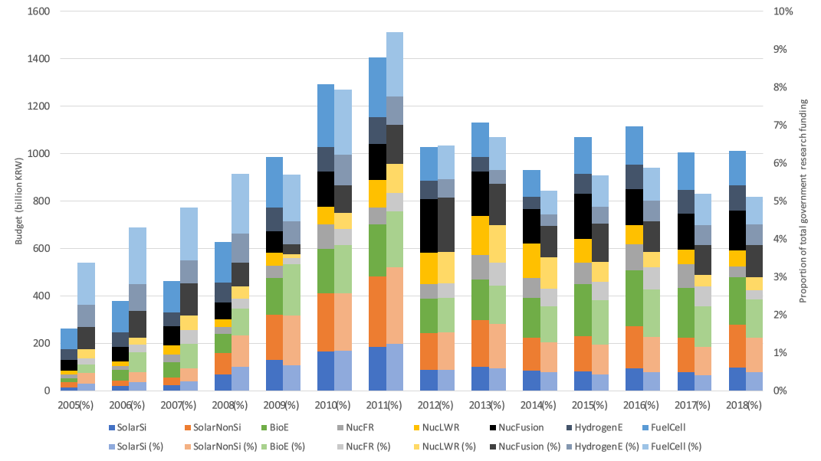
Source: Eum (2022)

2. Formatting Layout

2.1. Korean funded publications of green energy technology
This study followed the procedure outlined by Eum (2022) to acquire records of publications funded by the Korean government on green energy technologies. First, this study used the National Science & Technology Information Service (NTIS) database of Korean government funding and funded publications. Search strings were constructed based on combinations of unique terms for each technology field and used to search the titles, abstracts, and keywords of the records. Projects were also retrieved using codes describing the National Science and Technology Classification System and the Green Technology Classification System.

Since the Green Growth mission began in 2008 and ended in February 2013, the period of funding and publications was limited to 2017, five years after the mission ended. The bibliographic information of journal articles reported as research outcomes by the projects was obtained from the CWTS in-house version of the Web of Science (WoS), resulting in the acquisition of 63,708 publications from 2007 to 2017. (NTIS provides data on publication outcomes from 2007.)

2.2. Authors and topics information for publications
As NTIS does not offer information about funding recipients, the study relied on authors of funded papers as a proxy measure to compile the list. Given that each funded researcher is responsible for producing research outcomes, authors who published funded papers can be regarded as recipients of the funding. Author information was obtained from the records identified by the CWTS from the WoS author data based on the author name disambiguation algorithm developed by Caron and van Eck (2014).

And information on the research topic of papers was obtained using existing classification of publications in the WoS created by the CWTS. This classification was algorithmically constructed based on direct citation relations between articles, using the methodology by van Eck, Waltman & Noyons (2010) and Traag, Waltman & van Eck (2019), and each article indexed in the WoS was algorithmically assigned to one of 4159 clusters which represent micro-level scientific topics.

2.3. Categorizing funded authors
This study categorized funded authors according to the following criteria. The publication year of each paper was partitioned into three intervals: Papers published from 2007 to 2008, corresponding to the ‘before’ period, represent research outcomes funded with green energy technologies prior to the mission. The ‘during’ period from 2009 to 2013 refers to papers published during the mission. The ‘after’ period from 2014 to 2017 covers papers funded and published with green energy technology after the end of the mission.

The funded papers that the authors published were sorted into seven categories, depending on the periods to which they corresponded. The Continuous type consisted of researchers who had consistently published papers on green energy technology from before to after the mission. The “Stop” group consisted of researchers who had not written any papers during the mission (“During”) or after the mission (“After”). The “Entrant” type included authors who started publishing papers after receiving funding during the mission, and the “Newcomer” type referred to those who received funding for the first time after the mission. The “Transient” comprised authors who received funding for green energy technology only during the mission. Finally, the “Reentrant” type consisted of authors who received funding before and after the mission but not during the mission.

Table 1. Categorizing funded authors

Author type |  | Publication of funded papers by period
 |  | Before (2007-2008) | During (2009-2013) | After (2014-2017)
Continuous |  | Yes | Yes | Yes
Stop | During | Yes | No | No
 | After | Yes | Yes | No
Entrant |  | No | Yes | Yes
Newcomer |  | No | No | Yes
Transient |  | No | Yes | No
Reentrant |  | Yes | No | Yes

3. Findings

3.1. Overall trends in funded authors
The number of authors of funded papers has shown a steady increase over time. The total number of authors increased from 5,180 in 2007 to a peak of 42,615 in 2015. Notably, between 2008 and 2009, the number of authors increased almost threefold from 7,701 to 22,512. This trend can be attributed to a significant influx of researchers who had not previously received funding for green energy technologies before the mission. Prior to the mission, 12,020 authors published funded papers, but during the mission, 91,781 new authors appeared and entered the field of green energy technologies.

Figure 2: Number of funded authors (index = 100 in 2008)
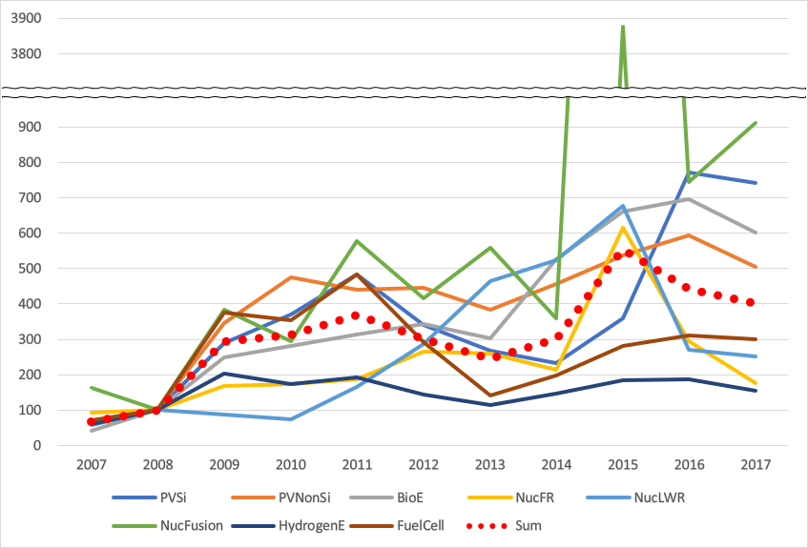

The increase in authors of funded papers was because of the significant increase in funding and publications during the Green mission. The government launched the mission and expanded the scale of Green R&D programs, which resulted in a rapid increase in the scale of green technology projects. In 2007, the scale of green technology projects was 463.4 billion KRW (4.8% of total R&D government expenditure), but it rapidly increased with the launch of the mission and peaked in 2011 at 1,405.5 billion KRW (9.5% of the total). This expansion of thematic funding provided researchers with more opportunities to secure resources and incentivized them to publish papers on green energy technologies.

However, among the new entrants, only 9,595 published funded papers after the mission (Entrant), while the others did not (Transient): Around 90% of new funding recipients during the mission found funding opportunities in other fields after the mission. Instead, 97,217 new authors of funded papers were identified after the mission, compensating for the number of departed authors (Newcomer). This trend suggests that even after the mission's end, new researchers continue to be introduced into the field of prioritized thematic area.

Table 2. Number of authors by type

Author  type | PV  Si | PV  NonSi | BioE | Nuc  FR | Nuc  LWR | Nuc  Fusion | HydrogenE | Fuel  Cell | Sum
Continuous | 69 | 429 | 193 | 35 | 31 | 117 | 272 | 354 | 1,500
Stop  (during) | 592 | 1,694 | 1,031 | 294 | 181 | 642 | 2,101 | 2,261 | 8,796
Stop (after) | 97 | 275 | 151 | 39 | 16 | 101 | 415 | 379 | 1,473
Entrant | 690 | 3,021 | 1,761 | 184 | 186 | 775 | 1,069 | 1,909 | 9,595
Newcomer | 8,031 | 23,511 | 19,558 | 2,151 | 2,120 | 18,006 | 9,250 | 14,590 | 97,217
Transient | 6,405 | 23,615 | 10,958 | 1,623 | 1,309 | 4,777 | 11,262 | 22,237 | 82,186
Reentrant | 21 | 41 | 45 | 8 | 11 | 31 | 55 | 39 | 251
Sum | 15,905 | 52,586 | 33,697 | 4,334 | 3,854 | 24,449 | 24,424 | 41,769 | 201,018

3.2. Author contributions to publications by type
Despite an increase in the number of publications, there was no significant change in the average ratio of publications to authors, which was 0.24 papers per author. However, when analyzing the number of publications per author for each type of author, clear differences were found. The Entrant and Transient types, which constituted the largest proportion of authors, had only 0.3 papers per author, whereas the Continuous type, who had published funded papers before, during, and after the mission, had 16.3 papers per author on average. Even when controlling for publication year, Continuous type authors had a publication rate of 7 or more per author, indicating that researchers who continuously studied green energy technology published a considerable number of papers, while newly entrant researchers made a relatively small contribution.

Table 3 Number of publications by author type

Author  type | PV  Si | PV  NonSi | BioE | Nuc  FR | Nuc  LWR | Nuc  Fusion | HydrogenE | Fuel  Cell | Sum
Continuous | 892 | 9,229 | 2,930 | 398 | 272 | 953 | 3,562 | 6,162 | 24,398
Stop  (during) | 188 | 596 | 339 | 116 | 56 | 178 | 752 | 873 | 3,098
Stop (after) | 380 | 1,238 | 505 | 144 | 51 | 280 | 1,506 | 1,592 | 5,696
Entrant | 3,003 | 13,935 | 6,968 | 651 | 755 | 1,598 | 4,465 | 8,696 | 40,071
Newcomer | 2,711 | 8,905 | 6,834 | 462 | 755 | 1,339 | 3,246 | 5,466 | 29,718
Transient | 2,093 | 8,144 | 3,725 | 618 | 495 | 1,136 | 4,195 | 7,194 | 27,600
Reentrant | 78 | 199 | 150 | 25 | 40 | 82 | 223 | 179 | 976
Sum | 9,345 | 42,246 | 21,451 | 2,414 | 2,424 | 5,566 | 17,949 | 30,162 | 131,557

More than half of the papers published by Entrant and Transient type authors were co-authored with Continuous type authors, indicating that new researchers in the field of green energy technology heavily relied on collaboration with experienced researchers. This is because most senior researchers play the role of rainmakers to secure funding, lead research teams consisting of junior collaborators, and oversee and supervise their research activities. Furthermore, based on these relations, new entrants tend to select predetermined topics by existing researchers, resulting in a high degree of similarity in research topics between the two groups.

Table 4 Co-authorship and topic-similarities between new entrants and continuous authors

Area | Transient |  |  | Newcomer
 | # of paper | Co-author with Continuous | Topic-similarity | # of paper | Co-author with Continuous | Topic-similarity
PVSi | 2,093 | 1,660 (79.3%) | 0.85 | 2,711 | 2,375 (87.6%) | 0.78
PVNonSi | 8,144 | 4,115 (50.5%) | 0.98 | 8,905 | 4,839 (54.3%) | 0.98
BioE | 3,725 | 2,649 (71.1%) | 0.89 | 6,834 | 5,448 (79.7%) | 0.84
NucFR | 618 | 444 (71.8%) | 0.94 | 462 | 332 (71.9%) | 0.92
NucLWR | 495 | 412 (83.2%) | 0.82 | 755 | 633 (83.8%) | 0.85
NucFusion | 1,136 | 783 (68.9%) | 0.96 | 1,339 | 955 (71.3%) | 0.94
HydrogenE | 4,195 | 2,654 (63.3%) | 0.91 | 3,246 | 1,881 (57.9%) | 0.94
FuelCell | 7,194 | 4,356 (60.6%) | 0.94 | 5,466 | 3,122 (57.1%) | 0.96
Note: Similarity was calculated as the cosine similarity between the distributions of micro-level clusters in the CWTS publication classification system.

4. Discussions and future work
This study examined the inflow of researchers entering prioritized areas through funding and their effect on publications by type through the case of green energy technology in Korea. There were two main trends in the authorship of funded papers on green energy technology. The first trend was that the number of researchers on green energy technology has increased, including a large influx of newly entrant researchers. However, most of the researchers initially funded during the mission did not carry out projects on green energy technology after the end of the mission. This suggests that the Green mission was only partially successful in attracting and retaining new talent and expanding the pool of researchers in this field.

Second, the impact of new entrants on the number of papers and research topics was not significant. Although a large number of researchers have been involved in research on green energy technology since the mission, their contributions in terms of published papers were not as substantial as those of experienced researchers. Additionally, the new researchers tended to collaborate with researchers who have had long careers in the field, and this resulted in research topics that were similar to those already being studied.

In future studies, it is important to consider the following aspects. Firstly, the current methodology for identifying authors did not differentiate between PIs and other participating researchers, and thus the impact of their roles on research topic selection was not fully explored. Secondly, the proportion of papers funded for green energy technology in the overall research portfolio of authors was relatively small, which means that the funded papers may not fully represent their entire research interests. Therefore, the effects of these factors should be examined in conjunction with the influx of researchers and their influence on research outcomes.

Open science practices
Data from the National Science & Technology Information Service and Web of Science used in this study are not publicly available.

Author contributions
The author is solely responsible for all scientific production processes.

Competing interests
The author has no competing interests.

Funding information
No funding was received for this study.

References
Caron, E., & van Eck, N. J. (2014). Large scale author name disambiguation using rule-based scoring and clustering. 19th International Conference on Science and Technology Indicators (STI2014), 79–86.

Eum, S. (2022). Project-based funding for green energy technology by the Korean Green Mission and its changes and characteristics. 26th International Conference on Science, Technology and Innovation Indicators (STI 2022).

Foster, J. G., Rzhetsky, A., & Evans, J. A. (2015). Tradition and Innovation in Scientists’ Research Strategies. American Sociological Review, 80(5), 875–908.

Gläser, J., & Laudel, G. (2016). Governing Science: How Science Policy Shapes Research Content. European Journal of Sociology, 57(1), 117–168.

Traag, V. A., Waltman, L., & van Eck, N. J. (2019). From Louvain to Leiden: guaranteeing well-connected communities. Scientific Reports, 9(1), 5233.

Waltman, L., van Eck, N. J., & Noyons, E. C. M. (2010). A unified approach to mapping and clustering of bibliometric networks. Journal of Informetrics, 4(4), 629–635.

