Internationalisation of Russian medical research – its main drivers and future prospects through the lens of publications

Ekaterina Dyachenko*, Iurii Agafonov** and Katerina Guba***

*edyachenko@eu.spb.ru, cathydyachenko@gmail.com
0000-0002-4036-6723
Center for Institutional Analysis of Science & Education, European University at Saint Petersburg, Russian Federation

**yagafonov@eu.spb.ru
0000-0002-1494-7540
Center for Institutional Analysis of Science & Education, European University at Saint Petersburg, Russian Federation
University of Helsinki, Finland

***
kguba@eu.spb.ru
0000-0002-4677-5050
Center for Institutional Analysis of Science & Education, European University at Saint Petersburg, Russian Federation

Abstract
Decades after the fall of the Iron Curtain, medical research in Russia is poorly integrated into global science. In this study we analyze how the presence of Russian medical research in international journals have changed in recent years (2010-2020). We collected the data from different sources – Web of Science, Scopus, Medline, Russian Science Citation Index. Although the articles in international journals still make up a smaller part of all Russian medical publications, it has grown significantly in recent years. Among these publications, articles in high impact journals account for about a third of the total flow. International cooperation is one of the main drivers of top-level Russian medical publications. Considering how many ties and collaborations with foreign scientists have been cut or suspended recently, we can assume a significant reduction in Russia's presence in core medical journals in the nearest future.

Introduction
Russian medical science appeared on the pages of academic journals and global media in 2020 thanks to the publications about the Covid-19 vaccine, Sputnik-V. However, this global success is a tip of an iceberg of heterogeneous and multifaceted research system. There is a wide spread belief that medical and health sciences in Russia are poorly integrated into international science, which is largely due to historical reasons. During the Soviet period, connections with the international scientific community were barely maintained and specific local culture in medicine and medical research had been formed (Goldberg et al., 1997; McKee, 2007; McKee et al., 2012).
After the collapse of the Soviet Union, one could observe a growing integration of Russian science into international knowledge production system. Access to international scientific literature increased radically. Contacts and collaborations with foreign scientists were no longer restricted in most areas and started being encouraged by the government. Researchers started going abroad for all kinds of professional activities. Many Russian universities and institutes started hiring foreign researchers. Probably no less than the fall of the Iron Curtain, Russian science was affected by the spread of the ideology of new public management and the use of scientometric indicators for research performance assessment, (Guskov et al., 2016; Moed et al., 2018; Kanev, 2021).
In this study we analyze how the presence of Russian medical research in international journals have changed in recent years. Our goal was to understand whether Russian medical science became more integrated into international science in the period 2010-2020. We focus particularly on foreign (non-Russian) journals where Russian researchers publish their findings, and among them – on the high impact journals, because they publish research most demanded by international community.
The previous studies of medical sciences have shown that small number of countries produce the vast majority of research results that are internationally visible and validated (Paraje et al., 2005; McKee et al., 2012). As one of the works based on Pubmed data showed, just thirty countries accounted for 95.1% of 1995 world publications indexed in the database, and by the 2015 this share was almost the same, 94.6% (Fontelo & Liu, 2018). In core and elite journals, this concentration was even higher (Sumathipala et al., 2004; Fontelo & Liu, 2018).
The fact that majority of countries barely participate in internationally visible medical and health research seems problematic to some experts (McKee et al., 2012). If we believe that "national scientific outputs reflect not only new knowledge, but also capacities to adapt and benefit from research conducted globally" (Paraje et al., 2005), and that major national outputs can be found in international databases, then we see a great disparity in national capacities. From this point of view, if a country manages to strengthen positions in the internationally acclaimed core it could indicate its general progress in dealing with health issues.
There also exist critical views on the core-periphery structure of knowledge production system. According to those, the dominance of Western countries in the core is not the result of winning in a free global competition of ideas, and this dominance prevents researchers from other countries from promoting their work on a global arena (Gomez et al., 2022). Whatever point of view on the international core we choose, understanding the presence and dynamics of the country in this core is valuable.
For researchers from non-Western countries, international projects are one way to gain access to the core. Studies show that international collaboration in medical and health research is on the rise (Fontelo & Liu, 2018). For some countries, their presence in the international core is almost entirely through such projects, while others strive to conduct national-level projects according to international research standards and present them to the world. We aimed to understand to what extent Russian researchers have made their way to high-impact journals "on their own", and to what – as the participants of international projects.
Analyzing the patterns for Russia, we think that they may be changing in the near future. The military actions of Russia towards Ukraine and the reaction to them have affected Russian science as well as all other areas of life in the country. Some scientists have left the country, and there are no estimates yet of the scale of the migration. Scientists who stay in Russia faced restrictions on access to information resources, equipment and reagents, on publishing in some journals, participation in international events and applying for grants. Many ties and collaborations with foreign scientists have been cut or suspended. We suppose our analysis will be useful for forecasting the development of medical science in Russia in the coming years.

Methodology
We collected the data from four databases – Web of Science, Scopus, Medline, and Russian Science Citation Index. Many scientometric studies use just one source of data. However, it has been argued that the result of analysis can differ significantly depending on the choice of the source (for example, Moed et al., 2018).
To obtain publications related to medical and health sciences indexed in Web of Science the following query was used: (wc=category1 or wc =category2 or wc=category3 ...) and py=(2010-2020) and cu=russ*. The list of categories was compiled of those which relate to "Medical and Health Sciences" in "OECD Category to Web of Science Category Mapping 2012". Similar approach was used with Scopus. The query was based on ASJC codes assigned to journals and ASJC-OECD Mapping.
The reason for including Medline as a separate data source is that in Web of Science and Scopus the attribution of a paper to a field is mediated by subject categories assigned to a journal. In our case, we saw that some journals have medical categories even while they publish few papers in this area. On the other hand, some other journals with no medical categories can publish medical research (Science, Nature, PLOS One, to name a few). Using Medline helped to fill the set with relevant papers from multidisciplinary journals, and filter out papers from some journals assigned to medical categories on dubious grounds. The data from four sources were matched to compile one set containing bibliographic data on publications in academic journals with at least one author affiliated with Russian organization and published between 2010 and 2020.
We stratified all the publications according the impact and reputation of journals. The researchers challenge the assumption that journal metrics are a strong indicator of paper quality (Larivière & Sugimoto, 2019). However, due to the limited data availability, we relied on the quartile-ranking as it was the most easily accessible data for the publications. In this regard, we followed the strategy Gyorffy et al. (2020), who received reliable results by using quartile-rankings in studying Hungarian researchers. The following levels were elaborated:
- Level A – papers published in journals with Q1 by both SJR and JCR in a corresponding year.
- Level B – papers in journals not in level A, and at least Q2 by either SJR or JCR in a corresponding year.
- Level D – papers in journals included in Bealls’ list (except those listed in DOAJ) or discontinued from the Scopus database.
- Level C – papers in journals not included in levels A, B, D.
The whole set consists of 266 241 papers with at least one of the authors affiliated with Russia. The subset of papers published in foreign journals – the one we will focus on – has 54128 publications. Journal was labeled as foreign if it’s publisher address was not in Russia.

Open science practices
For the analysis of internationally recognized publications, the Web of Science, Scopus, and Medline seemed to be the best sources of data because of their journal selection policies, the variety of available metadata, and analytical tools. When the project started in February 2022, all three sources were available in Russia, and there were not many reasons to explore other openly available databases. However, the situation has since changed. Since April 2022, most of our team has not had access to Web of Science, and since January 2023, we have not had access to Scopus. We managed to compile the dataset as planned because one of our researchers is affiliated with a Western university. Our initial plan was to make a dataset compiled from different sources available to anyone interested. Now, the chances of negotiating this opportunity with Clarivate and Elsevier are negligible.

Results
The number of publications of Russian researchers in foreign journals have been steadily growing and almost reached 10,000 publications per year in 2020, while the percentage almost reached 25% of the entire pool of journal articles of Russian authors, registered in four databases (Figure 1). The total number of Russian publications was calculated with the use of national citation database, Russian Science Citation Index.
Figure 1. Number (left) and percentage (right) of publications in Russian and foreign journals
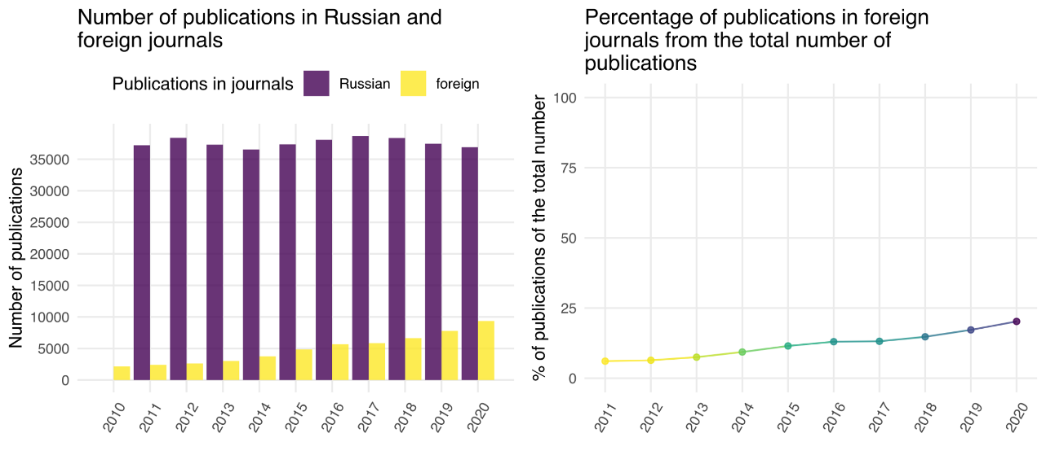
When put in a broader historical perspective, this growth is unprecedented. Figure 2 shows the dynamics of publications in medical and health fields in the USSR and Russia in the period from 1966 to 2022 according to WoS Core Collection. While we can observe an impressive growth of USSR papers in 1972-1989, its main driver was the inclusion of Soviet journals in Science Citation Index. The share of publications in foreign journals of all papers indexed in the Web of Science for the Soviet period (1972-1991) averaged 9%. In the post-Soviet period (1991-2022), this share averaged 45%. It has grown from 8% in 1991 to 74% in 2022.

Figure 2. Dynamics of publications in medical and health sciences in the USSR and Russia, 1966-2022 according to WoS Core Collection
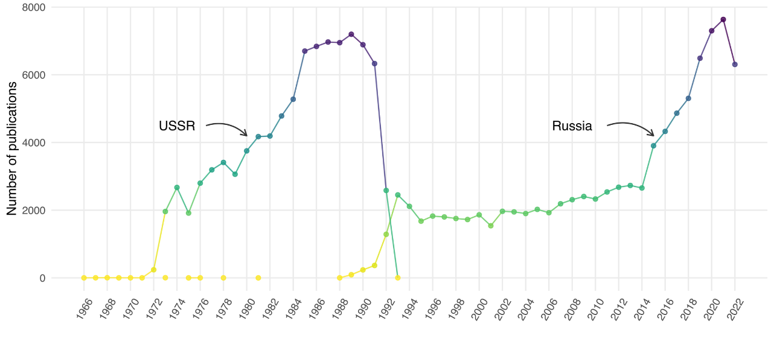
Despite the increase in the number of Russian medical publications in foreign journals, the stratification of these publications did not change significantly. Share of publications in the most influential journals (Level A), in 2010-2020 accounted for about a third of the total flow and changed little over the years.
During 2010-2020 there was both an increase in the number of publications and an increase in the number of journals in which Russian scientists published their papers. The growth in the number of journals was mainly in levels A, B, and C (see Figure 3). This two-dimensional expansion (publications + journals) is related to different factors. Government programs aiming to improve the international competitiveness of Russian science not only meant the growth of resources for research, but also imposed KPI for organizations and individual researchers. An urgent need to have publications indexed in Web of Science and Scopus Russian scientists to look for easy publication channels. Often this search led them to journals of deliberately low quality or with a conscious dishonest publishing strategy. On the other hand, good practices were stimulated too.

Figure 3. The number of foreign journals where Russian authors publish, by level of a journal
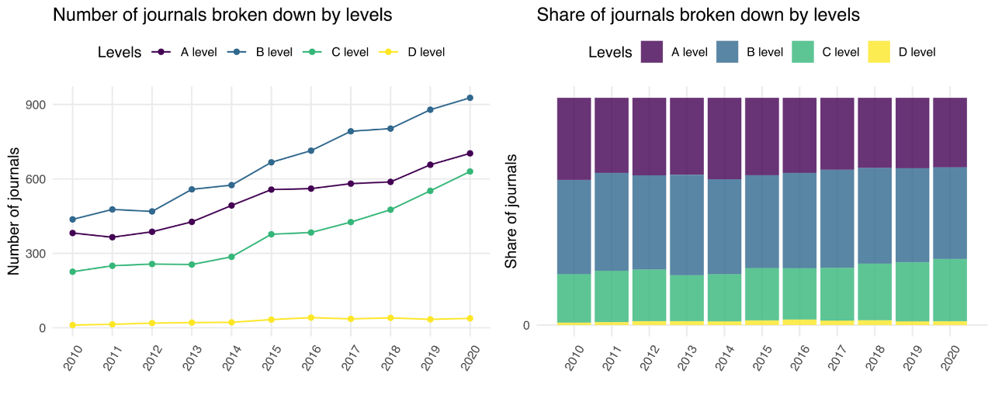
One of the most significant drivers of the growth of Russian medical publications was international collaboration. If we come back to the comparison of the Soviet-era growth of medical publications to the recent one, the difference in the patterns of international collaboration will also be remarkable. InCites data shows that the percentage of papers of medical scientists with international co-authors in the Soviet period amounted to only 2%.. The average percentage of such papers for the period from 1991 to 2023 is 37%. A role of international collaborations is especially important in the production of publications in high impact journals.

Figure 4. Distribution of publications of Russian authors with Russian-only and mixed affiliations
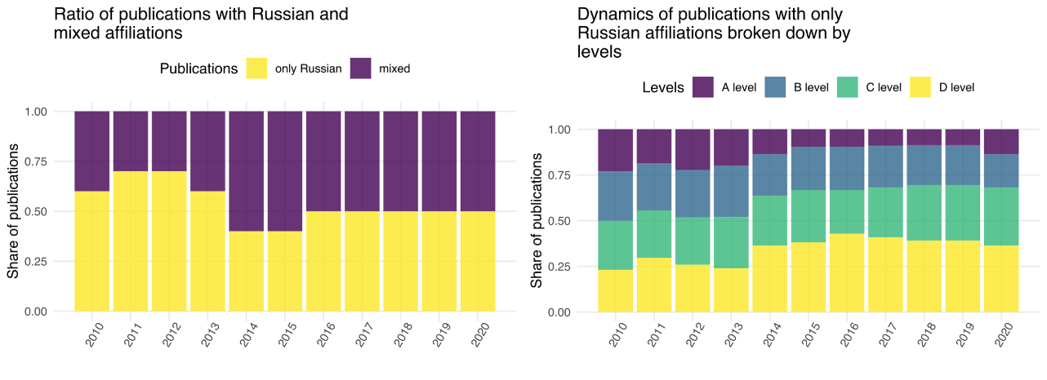
In the combined dataset the share of papers produced in international collaboration of all papers of Russian authors in foreign journals after some fluctuations stabilized at about 50% (Figure 4, left). Figure 4, right shows the distribution of publications with Russian affiliations only. While in 2010 each level (A, B, C, D) accounted for approximately 25% of such publications, by 2020 the share of publications at Levels C and D has increased significantly. In other words, by 2020 teams of authors consisting only of Russian published mostly in journals of low or moderate impact and in low quality journals.
We have also analyzed how often Russian researchers are labelled as corresponding author in collaborative papers. This piece is omitted due to space limits.
According to publications in non-Russian journals, most often Russian researchers collaborate with scientists from the countries constituting top producers of high-quality publications in medical and health sciences (Figure 5). Those very countries – USA, UK, Italy, Germany, and France – now are considered and officially labelled “unfriendly” by the Russian government. The same countries are top collaborators for the publications in A level journals.

Figure 5. Publications of Russian authors with international collaboration
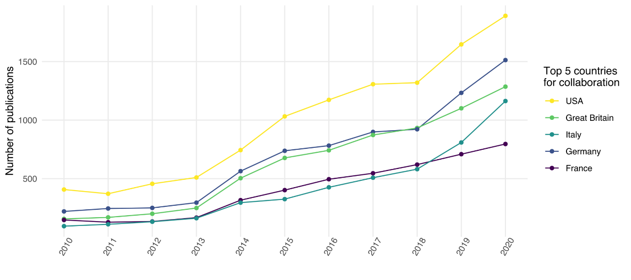
The fact that significant share of publications in high impact journal is the result of international collaborations is not unique to Russia. We were interested to compare this indicator for Russia and some other countries. For those countries, we do not have a dataset compiled of different data sources, that is why the comparison is based on one source. Figure 6 shows for 16 countries the dynamics of international collaboration in the publications in Web of Science Core Collection journals which have Q1 in JCR.
A comparison of the trends leads to three conclusions. First, the increase in the share of international collaborations is a global trend, although the share of collaborations in the world papers is not so big. Second, Russia has the highest share of international collaborations; this share slowly increased from 2010 to 2017 and then stabilized at 70-80%. A comparable share of international collaborations in the papers in high impact journals is observed only for South Africa and the UK. Third, a decline in the share of international collaborations is observed only for China.
We also plan to add the analysis of dynamics of publications of Russian researchers in the elite medical journals (BMJ, Lancet, NEJM, Annals of Internal Medicine, JAMA), as well as collaboration patterns of Russian authors.

Figure 6. International collaborations in medical and health publications of 16 countries in Q1 JCR journals, 2010-2020
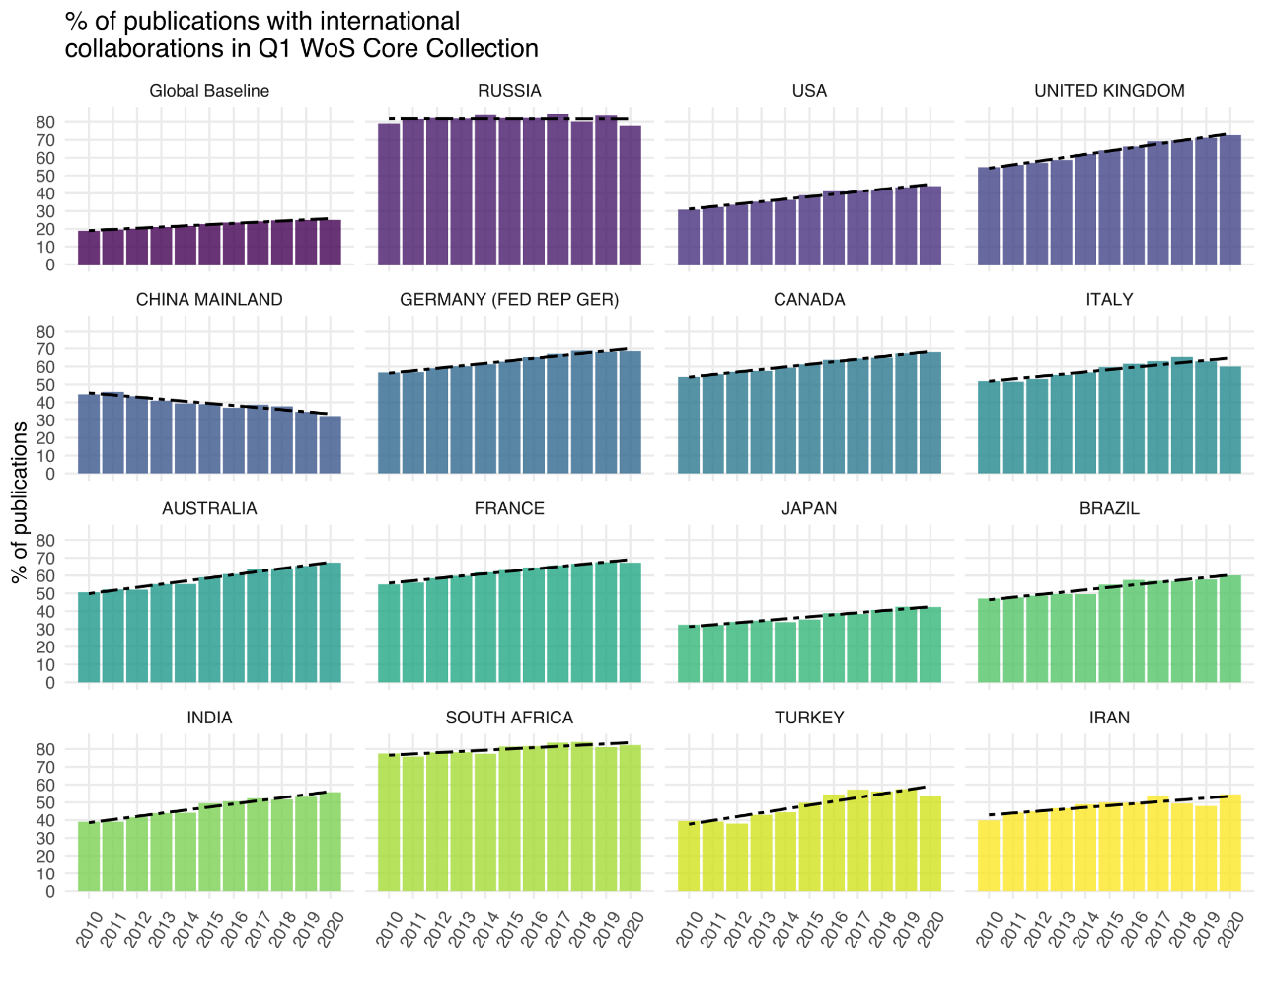
Note. The graph is based on the data from Web of Science Core Collection delivered through InCites tool.

Conclusion
The analysis of data on publications from four databases, three international and one local, showed that the articles in foreign journals make up a smaller part of all Russian medical publications, but they have grown significantly in recent years. Most papers of Russian authors in the core of global medical and health science present the results of international collaborations. If in 2010 almost a third of the publications of Russian authors in foreign journals were written in international co-authorship, by 2020 this share has increased to 50%. It is especially high in the segment of high impact journals – 70% of publications of Russian authors include foreign co-authors.
Thus, it can be said that although the Russian example is not unique – the share of international collaborations is growing in many countries – in the segment of high impact journals the share of international collaborations is one of the highest for Russia. In other words, international cooperation is one of the main drivers of top-level Russian medical publications.
We are planning to extract the list of Russian authors with Russian affiliations and for the sample to track their trajectories in 2022-2023. We are interested to learn how many of them changed their affiliations and how this change could impact the production of Russian medical publications in the top journals in the nearest future.

References
Fontelo, P., & Liu, F. (2018). A review of recent publication trends from top publishing countries. Systematic reviews, 7(1), 1-9.

Goldberg, A., Oigenblick, L., & Rubin, A. H. (1997). Scientific articles and national medical cultures: A comparison of Russian and American medical journals. Scientometrics, 39(1), 57-75.

Gomez, C. J., Herman, A. C., & Parigi, P. (2022). Leading countries in global science increasingly receive more citations than other countries doing similar research. Nature Human Behaviour, 6(7), 919-929.

Guskov, A., Kosyakov, D., & Selivanova, I. (2016). Scientometric research in Russia: impact of science policy changes. Scientometrics, 107, 287-303.

Kanev, A., Kulikov, E., & Fedorova, O. (2021). Scientific Research Publications in Medical Universities of Russian Federation. A 24-Year Perspective. Publishing Research Quarterly, 37, 458-483.

McKee, M. (2007). Cochrane on communism: the influence of ideology on the search for evidence. International Journal of Epidemiology, 36(2), 269-273.

McKee, M., Stuckler, D., & Basu, S. (2012). Where there is no health research: what can be done to fill the global gaps in health research?. PLoS medicine, 9(4), e1001209.

Moed, H. F., Markusova, V., & Akoev, M. (2018). Trends in Russian research output indexed in Scopus and Web of Science. Scientometrics, 116, 1153-1180.

Paraje, G., Sadana, R., & Karam, G. (2005). Increasing international gaps in health-related publications. Science, 308(5724), 959-960.

Sumathipala, A., Siribaddana, S., & Patel, V. (2004). Under-representation of developing countries in the research literature: ethical issues arising from a survey of five leading medical journals. BMC medical ethics, 5(1), 1-6.

Larivière, V., & Sugimoto, C. R. (2019). The Journal Impact Factor: A brief history, critique, and discussion of adverse effects. In W. Glänzel, H. F. Moed, U. Schmoch, & M. Thelwall (Eds.), Springer Handbooks. Springer Handbook of Science and Technology Indicators (pp. 3–24). Cham: Springer International Publishing, from https://doi.org/10.1007/978-3-030-02511-3_1

Data was collected in April – September 2022 by Yuri Agafonov.
http://help.prod-incites.com/inCites2Live/filterValuesGroup/researchAreaSchema/oecdCategoryScheme.html
https://supportcontent.elsevier.com/RightNow%20Next%20Gen/Scival/FORD%20to%20ASJC%20mapping_May2019_Pub_C6D4.xlsx
We used the version of the original Beall’s list last updated on December 31, 2016 available at https://beallslist.net/
The list of titles discontinued from Scopus was obtained in August 2022 version of Scopus Source list.

