The Journal Observatory – Connecting information on scholarly communication

Bram van den Boomen*, Nees Jan van Eck*, Ludo Waltman*, Tony Ross-Hellauer** and Serge Horbach***

* b.van.den.boomen@cwts.leidenuniv.nl; ecknjpvan@cwts.leidenuniv.nl; waltmanlr@cwts.leidenuniv.nl
[no ORCID]; https://orcid.org/0000-0001-8448-4521; https://orcid.org/0000-0001-8249-1752
Centre for Science and Technology Studies (CWTS), Leiden University, the Netherlands

** ross-hellauer@tugraz.at
https://orcid.org/0000-0003-4470-7027
Institute of Interactive Systems and Data Science, TU Graz, Austria

*** s.horbach@ps.au.dk
https://orcid.org/0000-0003-0406-6261
Danish Centre for Studies in Research and Research Policy, Aarhus University, Denmark

As the scholarly communication community is quickly moving towards more diverse and transparent modes of working, there is an increasing need for reliable information on different platforms’ policies. To address this need, we present the outcomes of the Journal Observatory project. This project aims to connect information from a scattered landscape of resources, thereby building toward systematic high-quality information on scholarly communication platforms.

1. Introduction
The scientific community is moving towards a more transparent way of conducting and reporting research. Scientific publications are becoming more and more openly accessible but openness should also extend to peer review, preprinting, preregistration, data sharing, metadata availability, and related issues.

Research funders and other stakeholders are putting a significant effort into promoting open science practices in scholarly communication. But there is a lack of high-quality infrastructure that provides information on the openness, policies and procedures of scholarly journals and other publication outlets. Consequently, it can be challenging to answer questions like: How do journals organize quality assurance and peer review? How do journals support open access publishing? How do journals or preprint servers support preregistration, preprinting, and data sharing? How diverse are the editorial teams of journals?

This information can be crucial to various stakeholders, as illustrated in Figure 1. The Journal Observatory project aims to contribute to making available the information needed by these stakeholders.

Figure 1. Stakeholders that need information on scholarly journals and other publication outlets.
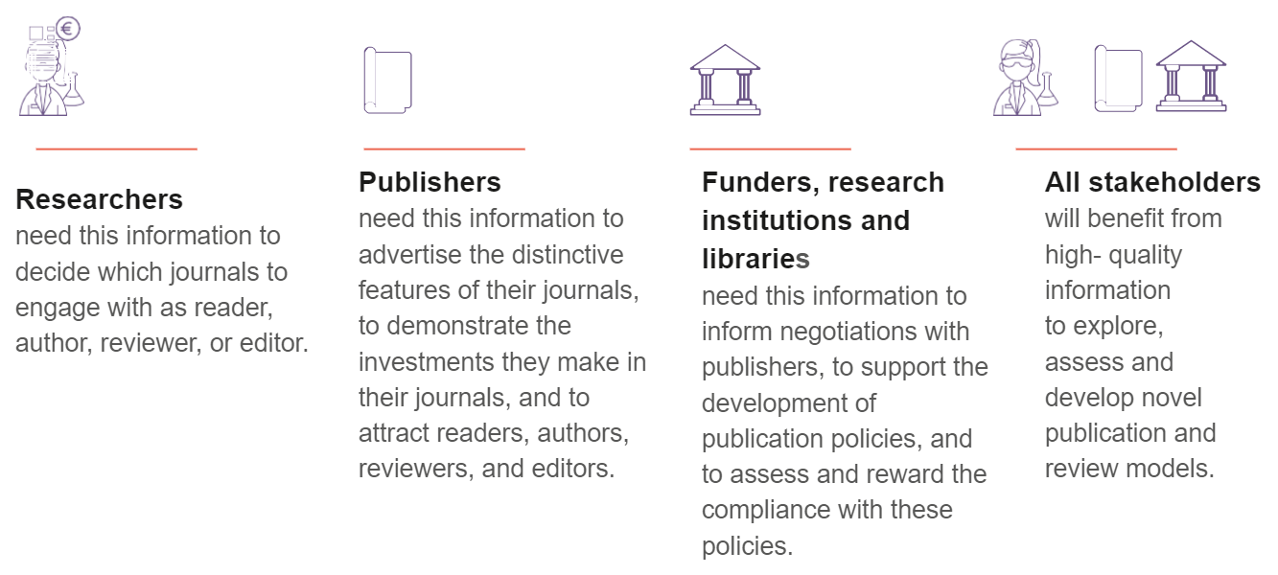

In this paper, we introduce the Journal Observatory project and we briefly present the main outcomes of the project.

2. The current landscape, and its shortcomings
There are numerous initiatives and platforms providing some part of the puzzle, but information is scattered, incomplete, and difficult to compare. For example, tools and databases are available that help researchers understand how to make their research openly accessible (DOAJ), whether their work can be posted in a repository or on a preprint server (Sherpa Romeo), how to ensure compliance with funder requirements (Plan S Journal Checker Tool), and how to pick a publication platform that offers particular peer review approaches (Transpose), open science practices (TOP factor), or that is considered to have a sufficiently high citation impact (Journal Citation Reports).

Given this complexity, it seems unrealistic to expect stakeholders to know which tools or databases to use to obtain specific information.

As new models of publishing such as Publish-Review-Curate, publication as you go, preprint review and others emerge, distinct publishing functions like dissemination and evaluation are increasingly decoupled. This creates the need for different platforms to interact and at least to be aware of each other’s policies and requirements. At present, there are minimal standards to enable the systematic interoperability of these platforms. At the research output level, standards like DocMaps and the COAR Notify protocol are under development. However, to empower further innovation in scholarly communication, a shared way to describe these different platforms and their possibilities of interaction is required.

3. Aims and approach
To address this challenge, the Journal Observatory project aims to:
- define an extensible, machine-readable and traceable way to describe the policies and practices of the various platforms involved in disseminating and evaluating scholarly works: the Scholarly Communication Platform Framework;
- demonstrate the value of this new framework by building a demonstration prototype called the Journal Observatory, a resource which combines data on journals and other publication platforms from various sources to clarify policy information for authors, reviewers and others.

3.1 Scholarly Communication Platform Framework
The Scholarly Communication Platform Framework is a new, high-level, structured language that enables the exchange of information about platforms for scholarly communication. To date, we have focused on enabling description of platforms for the dissemination and/or evaluation of research articles, such as scientific journals, preprint servers, and peer review platforms. However, the Framework can fairly easily be extended in the future to describe platforms performing other scholarly communication functions (e.g., archiving via platforms like LOCKKS/CLOCKKS or Portico), or to describe dissemination/evaluation of other types of scholarly outputs (books, datasets, software, code, methods, materials). The detailed inner-workings and rationale of the Framework are described in a technical report that can be accessed via the project website.

3.2 Journal Observatory prototype
The Journal Observatory prototype is a proof-of-concept demonstrator which integrates journal information from diverse open sources including DOAJ, Sherpa Romeo and others, as well as directly from publishers themselves (see Figure 2). It shows the power of being able to combine information to support three primary use-case areas: open access publishing, preprinting, and peer review procedures. The prototype comes with both a machine-accessible API and a user-friendly interface to allow for human access to relevant data.

Figure 2. The Journal Observatory – Information included and not yet included.
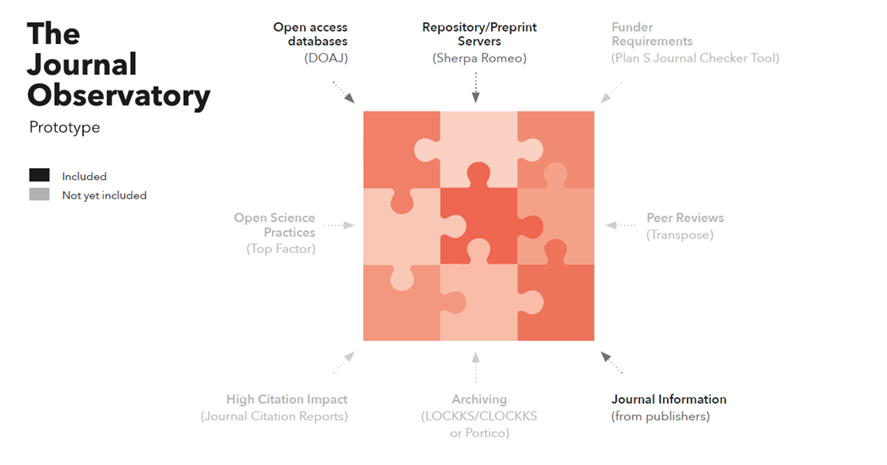

4. Next steps
The Journal Observatory project has achieved its main aims. We see our project and its outputs as the start or continuation, not the end, of a much larger conversation. We hope our work will provide a base for a more ambitious long-term agenda, co-shaped with the wider scholarly community, and aimed at working toward open and interoperable infrastructure for providing systematic and reliable information on scholarly journals and other scholarly communication platforms.

We call upon all within the scholarly communications community to work collaboratively to advance these aims. If you are interested to discuss potential collaboration with us or have ideas about how to take this forward, please contact us.

Open science practices
All data used in this project is open. The source code of the software developed in this project is open as well, under the MIT license.

Acknowledgments
We thank Melanie Imming and Mathijs van Woerkum (im-studio) for their contributions to the illustrations in this paper. We are grateful to the members of the project’s advisory group for their very helpful input during the project.

Author contributions
All authors contributed to the conceptualization of this project. The technical work was done by Bram van den Boomen and Nees Jan van Eck. Community engagement was managed by Ludo Waltman, Tony Ross-Hellauer, and Serge Horbach. Project coordination was done by Ludo Waltman.

Competing interests
The authors have no competing interests.

Funding information
The Journal Observatory project was supported by the Open Science Fund of the Dutch Research Council (NWO).

