Do female academics submit fewer  
grant applications than men?

Torger Möller

*moeller@dzhw.eu*

ORCID 0009-0003-9753-8295

Research Area “Research System and Science Dynamics”,  
German Centre for Higher Education Research and Science Studies (DZHW), Berlin, Germany

The state of the research on grant application behaviour is that female academics submit fewer proposals than men. This study points out that it is methodologically challenging to draw this conclusion. We know a lot about applicants, but little about the pool of potential applicants as the underlying population. We use a random sample of academics as potential applicants to investigate the grant application activity of male and female researchers. The results show that when an appropriate benchmark is applied (in this case, controlling for academic status and research area), no significant gender differences in grant applications can be found.

## 1. Introduction

A common finding on gender disparities in research funding is that there are no gender differences in grant success rates, but differences in application behaviour. Rissler et al. wrote that “women are as likely to be funded as men, but the percentage of women submitting proposals was less than expected” (Rissler et al. 2020, 814). Almost a decade earlier, Ranga, Gupta, and Etzkowitz (2012) came to a similar conclusion in their review on gender aspects in research funding: “Significant gender differences exist in grant application behaviour (…), but not in the male or female faculty success in acquiring grant funding” (Ranga, Gupta, and Etzkowitz 2012, 18).

The conclusion that women submit fewer applications than men is demanding and not easy to determine. In 2009, the European Commission had pointed out that “most funding organisations do not monitor the pool of potential applicants by gender. Much more attention should be paid to this point” (Commission 2009, 71). Little has changed in this situation to date. Research funding agencies know a lot about their applicants, but little about the pool of potential applicants.

A common approach to study gender differences in application behaviour is to compare the gender ratios of applicants and potential applicants. For potential applicants, data from national statistical offices can be used to provide information on the number of academics by gender and discipline. But comparing data from different sources involves several challenges. For instance, research funding programmes cannot easily be assigned to individual disciplines or a group of disciplines. Research fields could be part of a discipline or transcend the traditional disciplinary boundaries. Moreover, the data from statistical offices are not based on disciplinary research practices but often on employment relationships in departments. For example, not only medical academics work in medical departments, but also biologists, biochemists, epidemiologists, psychologists, sociologists, and others. Thus, comparing the gender ratio of applicants in a cardiology research programme with the gender ratio in medical departments bears various sources of distortions and errors.

## 2. Data and method

The above problems can be avoided by collecting the grant application activity directly from academics as (potential) applicants.

In the literature review (Cruz-Castro and Sanz-Menéndez 2019) of our research project “Grant Allocation Disparities from a Gender Perspective” we found an earlier study took this approach. Blake and la Valle (2000) investigated applicant behaviour based on a random sample of academics in 44 higher education institutions in the United Kingdom. They concluded that “women were as successful as men in getting the grants they applied for but were less likely to apply for grants” (Blake and la Valle 2000, 3). Reasons for the lower application activity among women are the academic status and the institutional support they received.

In collaboration with the DZHW Scientist Survey (Ambrasat and Heger 2020) we have taken a similar path. The DZHW Scientist Survey is a representative survey of academics employed at German Universities and has been conducted regularly since 2010. It is a multi-topic survey to which we have contributed some questions on research funding and application behaviour. The following analysis refers to the latest survey from 2019 and includes 8,198 completed questionnaires after data cleaning for our purposes (especially exclusion of outliers and missing values).

In this paper we mainly focus on grant application activity. We asked academics at German universities how many funding applications they had submitted to external funding bodies in the last five years (2015-2019). All applications with a volume of more than € 25,000 should be indicated, regardless of whether they are approved, rejected or still undecided.

The number of grant applications per researcher is the dependent variable in our models. The variable based on overdispersed count data: the unconditional mean and the conditional means are lower than the respective variances. In this case, a negative binominal regression is a better choice than a Poison regression. We successfully checked whether the data were negatively binomially distributed.

## 3. Results

According to the state of research outlined above, women are expected to submit fewer grant applications than men. Figure 1 shows the average number of grant applications and its 95% bootstrap confidence interval differentiated by academic groups (professor, postdoc, predoc) and gender (female, male). There are significant and expected differences in application activity between the academic groups. Professors have submitted on average more grant applications in the last five years than postdocs and predocs.

Whether postdocs and predocs only collaborated on proposals or submitted some themselves as principal investigators cannot be conclusively clarified based on the survey data. Some German funding agencies do not allow researchers to submit their own proposals until they have completed their doctorate. For this reason and as the number of submitted proposals for the predocs are very small, we exclude them in further steps of our analysis. In some funding lines even, professors are not eligible to apply for grants, but only research organizations, for instance in the German Excellence Initiative / Strategy.

Figure 1: Average number of grant applications by academic group and  
gender (95% bootstrap confidence intervals)

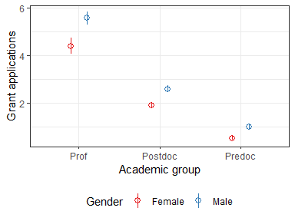

Figure 1 shows that there are not only significant differences between the academic groups, but also between gender. In each academic group, men submit significantly more grant applications than women. Could we conclude that there is an overall gender difference in grant activity? This conclusion seems to be reasonable, but an analysis of the same data differentiated by research fields yields a contrary result.

Figure 2: Average number of grant applications by academic group,  
gender, and research field (95% bootstrap confidence intervals)

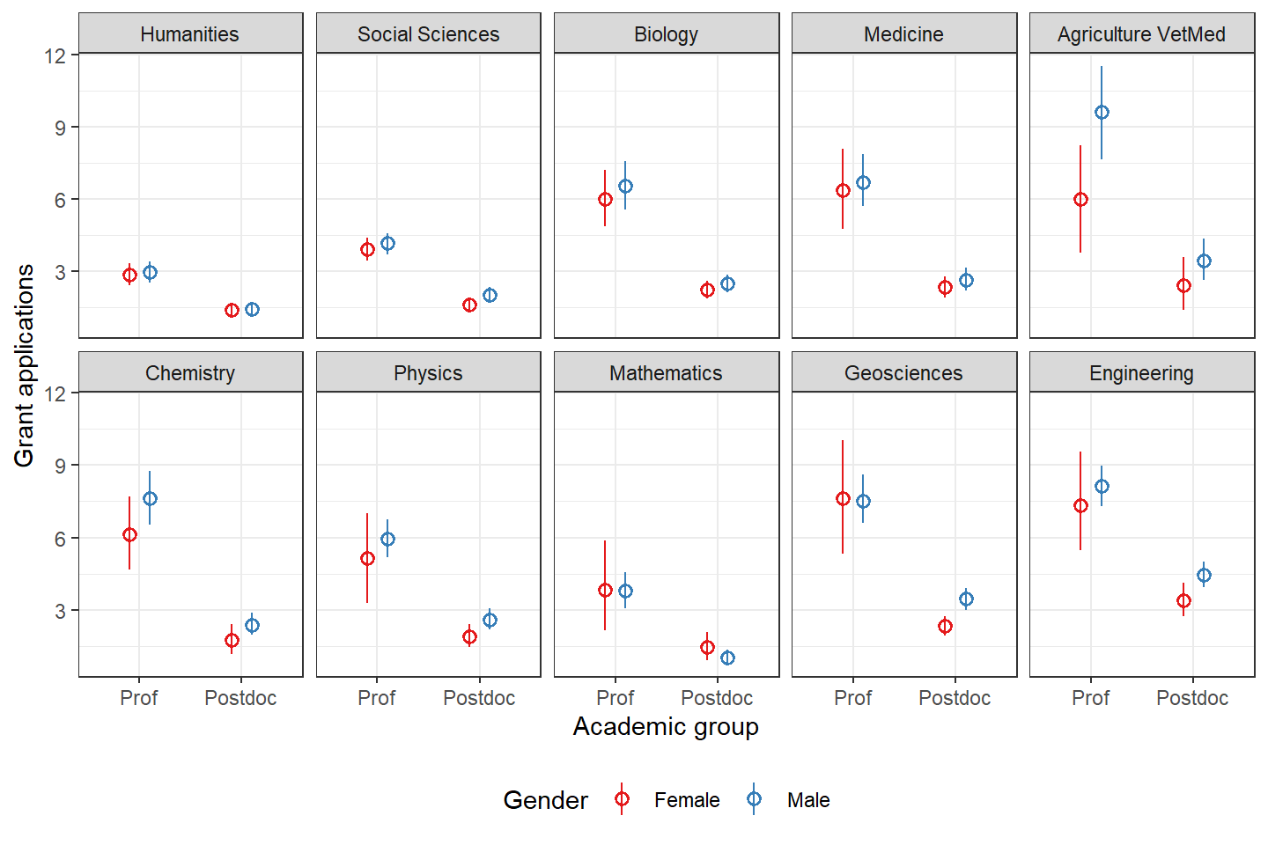

Figure 2 reveals that the significant differences between the academic groups persist within research fields, here differentiated by ten categories. The application activity among professors is higher than those of the postdocs, but the obvious gender differences in application activity presented in Figure 1 are either diminishing or even reversing. By comparing the average number of grant applications by gender for ten research fields in two academic groups we have twenty comparisons. In most cases, men submit on average more applications than women, but in three cases women are slightly ahead of men (Mathematics (Prof & Postdocs) and Geosciences (Prof)). The overall application differences are small, and the important question is, are they statistically significant.

We get a quick answer by comparing the confidence intervals shown in Figure 2. However, there are some challenges: The means are close to each other, in some cases it is difficult to see to what extent the confidence intervals overlap and whether this overlap is statistically significant for overdispersed count data. Robust results are obtained from negative binomial regression analyses.

Table 1: Negative binominal regression models for Professors and Postdocs  
(Grant applications = gender * research field)

|  |  |  |
| --- | --- | --- |
|  | **Prof** | **Postdoc** |
| (Intercept) | 1.792 (0.140) *** | 0.799 (0.083) *** |
| genderMale | 0.086 (0.170) | 0.109 (0.118) |
| fieldsHumanities | -0.739 (0.157) *** | -0.471 (0.110) *** |
| fieldsSocial Sciences | -0.429 (0.154) ** | -0.322 (0.109) ** |
| fieldsMedicine | 0.060 (0.190) | 0.045 (0.125) |
| fieldsAgriculture VetMed | 0.000 (0.299) | 0.079 (0.244) |
| fieldsChemistry | 0.021 (0.243) | -0.243 (0.178) |
| fieldsPhysics | -0.154 (0.258) | -0.161 (0.197) |
| fieldsMathematics | -0.448 (0.245) + | -0.430 (0.220) + |
| fieldsGeosciences | 0.241 (0.216) | 0.041 (0.157) |
| fieldsEngineering | 0.202 (0.207) | 0.421 (0.156) ** |
| genderMale × fieldsHumanities | -0.054 (0.195) | -0.086 (0.158) |
| genderMale × fieldsSocial Sciences | -0.025 (0.189) | 0.123 (0.155) |
| genderMale × fieldsMedicine | -0.035 (0.229) | 0.017 (0.179) |
| genderMale × fieldsAgriculture VetMed | 0.384 (0.357) | 0.248 (0.307) |
| genderMale × fieldsChemistry | 0.134 (0.277) | 0.204 (0.219) |
| genderMale × fieldsPhysics | 0.057 (0.288) | 0.203 (0.231) |
| genderMale × fieldsMathematics | -0.097 (0.282) | -0.454 (0.271) + |
| genderMale × fieldsGeosciences | -0.101 (0.257) | 0.292 (0.204) |
| genderMale × fieldsEngineering | 0.015 (0.235) | 0.160 (0.190) |
| Num.Obs. | 1593 | 3714 |
| AIC | 8366.1 | 14632.1 |
| BIC | 8479.0 | 14762.7 |
| Log.Lik. | -4162.067 | -7295.053 |
| RMSE | 4.00 | 2.89 |

The cells show the estimate, the standard error in parentheses  
and the significance level (+=.1, *=.05, **=.01, ***=0.001).

Table 1 shows the results of two negative binomial regression models, one for the professors and one for the postdocs. The dependent variable is the number of grant applications. The independent variables – modelled with interaction effects – are gender and research field. Since biology is closest to the mean of all research fields, we chose it as the reference category. In this respect, the proposal activity for professors and postdocs in humanities and social sciences is statistically significantly smaller than in the reference category. This also applies for postdocs in engineering. In mathematics weak evidence for fewer grant applications appears. Overall, grant application activity is lower in the humanities, social sciences, and mathematics, comparable to the mean in the life sciences and natural sciences, and higher in the geosciences and engineering.

Regarding the question of gender disparities: The first finding (Figure 1) indicates that female academics submit on average significant less grant applications than men, but the second finding (Figure 2 and Table 1) showed that significant gender difference disappear after taking the research field into account. This type of paradoxical result is called the Simpson's paradox in statistics (see Sprenger and Weinberger 2021). The Simpson’s paradox is a statistical phenomenon where an association between variables, here number of grant applications and gender, disappear or even reverse when the data set is divided into subgroups, here the fields of research. The result highlights the importance of setting the right comparison frame (in this case, the academic group and especially the research field), otherwise illusive significant gender differences are found.

## 4. Discussion

How can these different results be explained in relation to the object of this study? First, the proportions of women and men at German universities are not equal. At the time of the survey (2019), 43.1% of predocs and postdocs were women (Destatis 2020). Among professors, only 25.6% were female, and among the higher grades (comparable to full professor) only 21.2%.

Second, the proportion of women differs considerably between research fields. It is higher in the humanities and social sciences and lowest in engineering, followed by physics, chemistry, mathematics, and geosciences. As we can see in Figure 2 and Table 1, the application activity in the humanities and social sciences is lower than in other research fields, except mathematics. So female academics are overrepresented in fields (humanities and social sciences) where researchers submit on average less grant applications than in male dominated research fields. If we do not differentiate between research fields, as demonstrated in Figure 1, the result is that the grant application rate of women is significantly lower in each academic group. After controlling for research field, the significant gender difference disappeared (Figure 2 and Table 1).

Third, the application activity has mainly to do with resource needs and not with gender. We have asked the professors to what extent the basic funding covers their research expenses (personnel and material). For example, if a professor has indicated that 40% of research expenses are paid by basic funds, that person needs 60% external funding. Figure 3 illustrates the relationship between the need for external funding and the number of research proposals submitted by each research field on average. The humanities, social sciences, and mathematics have the lowest external resources needs and the lowest grant activity (bottom left). In contrast, the external resources needs and grant activity are higher in natural sciences, life sciences, and engineering (upper right). In short, some only need a computer for writing and a library, while others also need a laboratory, measuring instruments, chemical, biological, or physical material and a mainframe computer for calculations. The demand for resources differs between research field and is related to the research practice of the respective field and not to gender.

Figure 3: Average number of grant applications and share of external funding  
for research by fields (only professors)

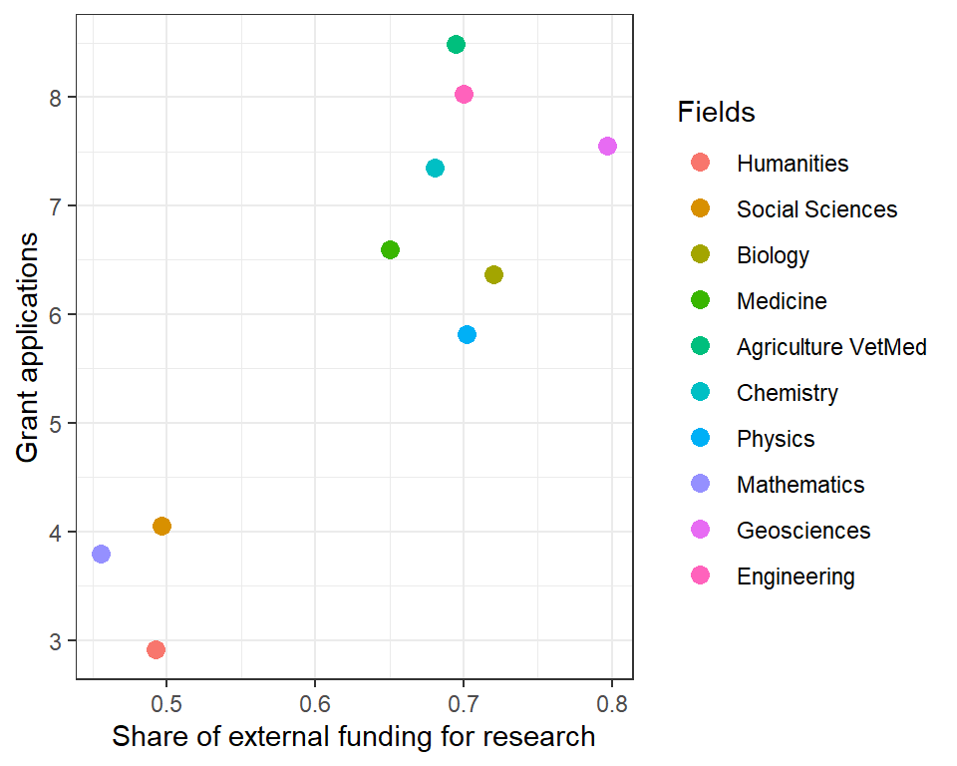

## 5. Conclusion

The average number of grant applications submitted by men is higher than that submitted by women, if one does not control for research field. As men work to a greater extent in research areas where the need for external resources is higher, they also submit more applications for research funding. In contrast, women are more represented in research fields with lower demand for external resources, which leads – independent from gender – to a lower application activity. Comparing women and men from the same research field, no significant differences can be found in the number of grant applications.

In this regard, the answer to the question of this paper of whether female academics submit fewer funding applications than men is: No, women submit an equivalent number of grant applications as their male colleagues in the same research field.

## Acknowledgments

I would like to thank my colleagues from the DZHW Scientists Survey (Jens Ambrasat, Christophe Heger und Gregor Fabian) for the collaboration. Many thanks to Peter van den Besselaar for his comments on an earlier version of this paper.

## Competing interests

I declare that I have no conflict of interest.

## Funding information

This work has received funding from the European Union’s Horizon 2020 research and innovation programme under grant agreement No 824574 (Project “Grant allocation disparities from a gender perspective”).

## References

Ambrasat, Jens, and Christophe Heger. 2020. “Barometer für die Wissenschaft. Ergebnisse der Wissenschaftsbefragung.” Berlin: Deutsches Zentrum für Hochschul- und Wissenschaftsforschung (DZHW). <https://www.wb.dzhw.eu/downloads/wibef_barometer2020.pdf>.

Blake, Margaret, and Ivana La Valle. 2000. “Who Applies for Research Funding?” Edited by Wellcome Trust. <https://wellcome.org/sites/default/files/wtd003209_0.pdf>

Commission, European. 2009. *The Gender Challenge in Research Funding: Assessing the European National Scenes*. Luxembourg: Publications Office of the European Union. <https://data.europa.eu/doi/10.2777/36195>.

Cruz-Castro, Laura, and Luis Sanz Menéndez. 2019. “Grant Allocation Disparities from a Gender Perspective: Literature Review. Synthesis Report.” <https://digital.csic.es/handle/10261/200024>.

Destatis. 2020. “Bildung und Kultur. Nichtmonetäre hochschulstatistische Kennzahlen. Fachserie 11 Reihe 4.3.1.” Statistisches Bundesamt. <https://www.statistischebibliothek.de/mir/receive/DEHeft_mods_00137319>.

Ranga, Marina, Namrata Gupta, and Henry Etzkowitz. 2012. “Gender Effects in Research Funding. A Review of the Scientific Discussion on the Gender-Specific Aspects of the Evaluation of Funding Proposals and the Awarding of Funding.” Bonn: Deutsche Forschungsgemeinschaft. <https://www.dfg.de/download/pdf/dfg_im_profil/geschaeftsstelle/publikationen/studien/studie_gender_effects.pdf>.

Rissler, Leslie J., Katherine L Hale, Nina R Joffe, and Nicholas M Caruso. 2020. “Gender Differences in Grant Submissions Across Science and Engineering Fields at the NSF.” *BioScience* 70 (9): 814–20. <https://doi.org/10.1093/biosci/biaa072>.

Sandström, Ulf, and Peter van den Besselaar. 2020. “Bittersweet Emotions Replicating Wennerås and Wold GRant AllocatioN Disparities.” <https://www.granted-project.eu/blogpost-2-bittersweet-emotions-replicating-wenneras-and-wold/>.

Sprenger, Jan, and Naftali Weinberger. 2021. “Simpson’s Paradox.” In *The Stanford Encyclopedia of Philosophy*, edited by Edward N. Zalta, Summer 2021. Metaphysics Research Lab, Stanford University. <https://plato.stanford.edu/archives/sum2021/entries/paradox-simpson/>.