How networked are Medical Schools? Evidence from Portugal

Lígia Ernesto*, Bruno Damásio** and Sandro Mendonça**

* lmgeo@iscte-iul.pt
0000-0001-8115-4586
Business Research Unit, ISCTE Business School, Portugal

** bdamasio@novaims.unl.pt; sfm@iscte-iul.pt
0000-0002-2289-3087; 0000-0001-7276-9626
NOVA IMS, Portugal; Business Research Unit, ISCTE Business School, Portugal

Abstract
Institutional collaboration between universities and other actors is crucial to generate new knowledge and for advancing innovation. But, how important is this for the healthcare sector? This work analyses 441 institutional collaborations between Portuguese Medical Schools and other entities (pharmaceutical industry, funding organisations, hospitals, other universities, non-profit organisations, other private for-profit organisations, public bodies and public research organisations). We identify, validate, disambiguate, classify and analyse evidence available from a variety of sources. Our original database reveals that most of the partnerships of Portuguese Medical Schools are with academic institutions. A sectoral failure regarding partnerships with other type of actors (e.g. industry, other research organisations) is suggested. As for future policy objectives, we argue that a systems building view could be considered.
Keywords: Institutional collaboration; Portuguese Medical Schools; collaboration networks; data visualisation

1. Introduction
Institutional collaboration between universities and other institutions (e.g., industry, other universities, public bodies, research organisations) is crucial to generate new knowledge and for advancing innovation. This is particularly relevant in healthcare, a sector characterised by complex and evolving challenges (Cheng et al., 2020). Establishing strong global collaboration networks plays a critical role in helping Medical Schools to move their knowledge closer to clinical practice and health industries to become more competitive (Mascarenhas et al., 2018; Santos et al., 2023).
This paper sets out to map, characterise and understand the connections of Medical Schools to their sectoral systems of innovation (Malerba, 2005; Daesh et al., 2020). Partners and linkages can cut across geographical lines, public/private boundaries, and disciplinary fields (Powel and Grodal, 2004; Soda et al., 2021). The way to map and measure knowledge networks is not always straightforward, and often contingent on the knowledge base and the institutional frameworks of the sector (Gault, 2018). Mapping collaboration networks can provide insights into knowledge flows and into how organisations can leverage their strengths to achieve greater impact. In the context of the health sector, where emergent health needs require interdisciplinary solutions, it is crucial to examine the nature and scope of research and innovation collaborations. By providing a comprehensive overview of the current landscape of Medical Schools' relationships with other organisations, this paper can help identify areas for improvement, potential synergies, and opportunities for cooperation. These insights can be used to inform strategies that promote innovation, knowledge transfer and competitiveness in the health sector.
Under Portuguese legislation (Decree-Law 155/92 and Decree-Law 183/96), public agents such as public universities should issue Annual Reports, reporting the activities and objectives achieved throughout the year. In this work, we propose to make use of this available source published by Portuguese Medical Schools to examine their patterns of behaviour regarding knowledge networks.
We here report the results of a preliminary analysis of 441 research and innovation collaborations between 2019 and 2021. We are unaware of this effort to have been carried out before. A major effort of data validation and consolidation was invested, in particular the triangulation of observations by drawing from a variety of unrelated sources (portals reporting research funding, for instance) as well as direct contact with the Schools.

Our analysis of the partnerships established by Portuguese Medical Schools reveals that the majority of their partners are located in Portugal. Most of the partnerships of Portuguese Medical Schools were with other academic institutions. When abroad the links are within the European Union (EU), with Spain being the most frequent international partner country. These findings highlight the potential for Portuguese Medical Schools to expand their sectoral and international collaboration networks, particularly with non-academic players and with institutions outside of the EU.

A systems failure regarding partnerships with other type of actors (e.g. pharmaceutical industry, research organisations) is thus identified. It is important to broaden the scope of partnerships by diversifying rapports with other types of institutions and geographies.

This paper is organised as follows. Section 2 provides an overview of the importance of collaboration and partnerships between different actors in the healthcare sector and highlights the need for empirical research to examine the patterns of collaboration. Section 3 details the methodology used in this paper. Section 4 presents the main findings. Finally, Section 5 discusses the implications of our findings and proposes future research.

2. Theoretical background
Innovation, as viewed by the sectoral systems of innovation (SSI) perspective, is not just a matter of individual actors, but rather a systemic process that involves interactions among firms, universities, research institutions, government agencies, and other organisations within a given learning base and regulatory perimeter (Malerba, 2005). These interactions are key for the generation and exchange of knowledge. From an SSI perspective, the processes of innovation production, and commercialisation are the result of rich and rewarding relationships between a diverse range of actors. Therefore, networks play a crucial role in facilitating knowledge-intensive development processes.
Medical Schools play a critical role in generating new knowledge through research, while other organisations such as hospitals, pharmaceutical companies, and government agencies provide the infrastructure and resources needed to translate that knowledge into practical applications (Melese et al., 2009; Lessl et al., 2011). By collaborating and sharing resources, expertise, and ideas, Medical Schools can help to drive advance practice, bring about new technologies and instruments, treatments and therapeutical approaches that can benefit patients and society (Hopkins, et al., 2007). Partnerships and collaborations with different organisations can create a dynamic and serendipitous-friendly environment that fosters problem-solving, creativity, and entrepreneurship (Melese et al., 2009; Lessl et al., 2011; Costa, 2022; Ma et al., 2022; Mendonça et al., 2022).
By analysing the patterns of collaboration among these different actors, it is possible to gain insights into the factors that facilitate or inhibit innovation within the healthcare sector. For example, the SSI framework suggests that strong links between research activities and manufacturing capabilities are important for promoting the commercialization breakthrough ideas that are fit for real-world trials (Malerba, 2005).
Evolutionary theories of organisations suggest that organisations need endogenous mechanisms of learning but also depend on each other for complementary assets, such as production facilities or distribution set-ups (Hillman et al, 2009). Medical Schools and other organisations such as pharmaceutical companies may collaborate to access each other's specialised resources and achieve mutual benefits (Lim, 2014; Sunyoto, 2020; Thomas et al., 2014). On the one hand, Medical Schools typically provide expertise in basic and applied research, as well as access to research infrastructure. On the other hand, other organisations such as pharmaceutical companies often have access to resources such as funding, sophisticated equipment, drug development and commercialisation expertise, and regulatory approval experience (De Carolis, 2003; Henderson et al. 1994). By collaborating, these organisations can pool their resources and expertise to advance innovation and bring new products and services to market (Santos et al., 2023).
Institutional collaborations between Medical Schools and other organisations, are critical for the generation and exchange of knowledge and resources. The literature has shown that such collaborations can yield mutual benefits for the parties involved. However, despite their significance, there is a lack of research that aims to systematically map, characterize, and understand the dynamics of these interactions. We are unaware of this effort to have been carried out before for Portuguese Medical Schools. It is important to address this knowledge gap as it limits our ability to leverage the full potential of these collaborations and design effective policies to encourage them. Therefore, there is a need for more empirical research that examines the various types, forms, and outcomes of institutional collaborations between Medical Schools and other actors.

By analysing the institutional collaboration networks between Portuguese Medical Schools and other organisations, this paper aims to map, characterise and understand the dynamics of these interactions and to inform policy and practice aimed at promoting the growth and competitiveness of the Portuguese healthcare sector.

3. Methods
According to Portuguese Decree-Law 183/96, the Annual Reports issued by public organisms shall be made available to all potential stakeholders. These Annual Reports should convey the activities and objectives achieved throughout the year (Decree-Law 155/92 and Decree-Law 183/96), including research and innovation activities. Therefore, we looked for the Annual Reports issued by the individual Portuguese Medical Schools to identify research and innovation collaborations.
We searched and combed Annual Reports for a three-year period (2019-2021). We checked the webpages of the eight public Schools of Medicine in Portugal to confirm the availability of the Annual Reports for the selected period (2019-2021). This scan was performed on 05/02/2023.
When these reports were not available on the institution’s webpage, we requested them by email to the Medical Schools relevant contacts. The Annual Reports for the three years considered (2019, 2020 and 2021) were available or made available only for four Medical Schools: University of Algarve, University of Beira Interior, University of Lisbon and University of Minho. For Nova Medical School only the 2019 and 2020 Annual Reports could be retrieved.
Our sample is thus five out of eight Medical Schools and 58% of all possible reports. Table 1 provides an overview of the available Annual Reports for each one of the eight Portuguese Medical Schools over the three years in question (2019, 2020 and 2021). It must also be said that from the analysis of the Annual Reports of the University of Algarve, it was not possible to identify any research and innovation collaborations between this University and other institutions.
In total, 11 Annual Reports from four Portuguese Medical Schools yielded results: they enabled the identification of 441 institutional collaborations between Portuguese Medical Schools and other actors.

Table 1. Overview of available Annual Reports

 | 2019 | 2020 | 2021
ICBAS - School of Medicine and Biomedical Sciences
Nova University - Nova Medical School
University Beira Interior - Faculty of Health Sciences
University of Algarve - Faculty of Medicine and Biomedical Sciences
University of Coimbra - Faculty of Medicine
University of Lisbon - Faculty of Medicine
University of Minho - School of Medicine
University of Porto - Faculty of Medicine
Annual Report available; Annual Report not available

Further diligences were set forward. We consulted the Portuguese Transparency Portal and the European Commission CORDIS database to gather missing information on institutional collaborations whenever applicable. Although the Annual Reports allowed us to identify the projects involving Portuguese Medical Schools, the information was often incomplete, with missing partner names or insufficient data to determine the research area. Therefore, we turned to the Portuguese Transparency Portal for EU-funded projects managed at the national level, and the European Commission CORDIS database for projects managed by the European Commission. The Portuguese Transparency Portal is a website of the Portuguese government that provides detailed information on projects financed with EU funds, including project objectives and beneficiaries. CORDIS (Community Research and Development Information Service) is the European Commission's primary database for EU-funded research and innovation projects, offering users details on project objectives, funding, partners, and outcomes. In the case of projects not funded with EU funds, we consulted the websites of the involved institutions to obtain missing information on institutional collaborations in each project.
The procedure for data collection is outlined below (Figure 1). Data from the 441 institutional collaborations identified in the Annual Reports were organized into a database including the following information for each institutional collaboration: Medical School name, Partner name, Partner type of institution, Partner nationality and Research/Disease area.
Institutional partners were categorised by type of Institution following the activity type classification used by the European Commission CORDIS database (with some adaptations).

Research/Disease areas were categorised using a combination of the Health Research Classification System (HRCS) from the UK Clinical Research Collaboration (UKCRC, 2023) and the Research, Condition, and Disease Categorization (RCDC)” from the National Institutes of Health (NIH, 2023).

A Network graph for visualizing connections between Portuguese Medical Schools and partners was created using Flourish. Interactive ‘dot’ visualisations to visualise partnerships grouped by partner type of institution, partner nationality and Research/Disease areas were also created using Flourish.

Figure 1: Data collection procedures

Collection of Annual Reports

- Timespan: 2019-2021
- Sources: webpages of the eight public Medical Schools in Portugal
- Collection date: 05/02/2023
Request missing Annual Reports

Emailed Medical Schools where Annual Reports were not available in the webpages
11 Annual Reports
14 Annual Reports
(Table 1)
Analysis of Annual Reports

- Identification of institutional collaborations
- Analysis date: 27/02/2023
441 institutional collaborations from 4 Medical Schools*
Triangulating Data Sources

Consulted Portuguese Transparency Portal, European Commission CORDIS database and websites of the involved institutions to complete missing information about collaborations in Annual Reports

* From the analysis of the Annual Reports of the University of Algarve, it was not possible to identify any institutional collaborations.

4. Results
Of all the partners of Portuguese Medical Schools, 56% were international and 44% were national. As illustrated in Figure 2, Portugal was the most frequent country of origin for partners (193 partners), followed by Spain (28 partners). Notably, the international partners of Portuguese Medical Schools were primarily situated within the EU (179 partners), with additional partners located in Anglo-Saxon countries (39 partners), Switzerland (11 partners), the European Economic Area (10 partners), and other regions (9 partners).
The Faculty of Medicine of the University of Lisbon showed the largest collaboration network (Figure 3) with 295 partners, followed by the Faculty of Health Sciences of the University of Beira Interior (69 partners).
Forty percent of the collaborations are with higher education institutions. Partnerships with the Pharmaceutical Industry represents only 7% of the total partnerships (Figures 4 and 5).
Table 2 lists the Top 10 institutions that have collaborated with Portuguese Medical Schools, ranked by the number of collaborations. The top partners consist mainly of Higher Education Institutions, with eight out of the top ten belonging to this category, highlighting a focus on academic collaborations. Research and technology institutions are also represented, although only two are included. Other types of institutions, such as pharmaceutical industry and other private for-profit organisations are absent from the Top 10. This suggests that there is room for diversification of partnerships, which may enable Medical Schools to access a wider range of resources and expertise. Furthermore, all of the institutions listed are based in Portugal, except for Heidelberg University, Germany. This suggests that there may be opportunities for Portuguese Medical Schools to expand their collaborations beyond national borders.

Table 2. Details of the Top 10 partners (2019-2021)
Name | Type of institution | Nationality | No. of collaborations
University of Aveiro | Higher Education | Portugal | 10
Faculty of Medicine - University of Porto | Higher Education | Portugal | 7
Faculty of Pharmacy - University of Lisbon | Higher Education | Portugal | 6
iMM-Instituto de Medicina Molecular | Research & Technology | Portugal | 6
University of Coimbra | Higher Education | Portugal | 6
Nova Medical School | Higher Education | Portugal | 5
CINTESIS | Research & Technology | Portugal | 4
Heidelberg University | Higher Education | Germany | 4
IST- Instituto Superior Técnico | Higher Education | Portugal | 4
Nursing School of Porto | Higher Education | Portugal | 4

Table 3 shows the proportion of institutional collaborations by partner type for the Medical Schools of Nova University, University of Beira Interior, University of Lisbon, and University of Minho.
Higher Education institutions are a significant partner type for all Medical Schools, with University of Beira Interior and University of Lisbon having the highest proportion of collaborations with Higher Education institutions at 49% and 39%, respectively. Partnerships with Research and Technology organisations are a significant component of institutional collaborations for Nova University and University of Beira Interior, with proportions of 33% and 32%, respectively. Partnerships with the Pharmaceutical Industry range from 1% to 14% across the four Medical Schools, with Nova University having the highest percentage and University of Beira Interior having the lowest. The results of the study suggest there is scope for further collaboration between Portuguese Medical Schools and the Pharmaceutical Industry or indeed other industries such as information technology.

Table 3. Distribution of institutional collaborations by Partner type of institution for each Medical School

 |  | Medical School
Partner type of institution | Nova  University |  | University of  Beira Interior | University of Lisbon |  | University of Minho
Funding organisations | 24% |  | 1% | 0% |  | 9%
Higher Education Institutions | 10% |  | 49% | 39% |  | 23%
Hospitals | 0% |  | 9% | 8% |  | 5%
Non-profit organisations | 5% |  | 3% | 5% |  | 5%
Other Private for-profit entities | 14% |  | 1% | 12% |  | 30%
Pharmaceutical Industry | 14% |  | 1% | 8% |  | 9%
Public bodies | 0% |  | 3% | 9% |  | 0%
Research & Technology | 33% |  | 32% | 20% |  | 18%

Regarding the Research/Disease areas, “Information Technology R&D” registered the largest number of collaborations (75 collaborations), followed by the “Oral and Gastrointestinal” research area (68 collaborations). The research area “Treatment Development” registered 26 collaborations and the partners in this area were 100% national (Figure 6).
Table 4 displays the percentages of different Research/Disease areas in the institutional collaborations for the Medical Schools of Nova University, University of Beira Interior, University of Lisbon, and University of Minho.
An interesting observation from the table is the variation in Research/Disease areas across the Medical Schools. For instance, Nova University had the highest percentage of partnerships in the Coronavirus research area (62%), while University of Lisbon had the highest percentage in Oral and Gastrointestinal research area (22%). On the other hand, University of Beira Interior had a high percentage of partnerships in Biomedical Imaging (29%) and Diet, Obesity and Nutrition (20%), while University of Minho had a relatively high percentage of partnerships in Information Technology R&D (41%). The percentage of collaborations in the Aging research area was the highest for Nova University (10%), followed by University of Lisbon (3%), while the other two medical schools did not have any partnerships in this area.
These findings suggest that the research focus of each medical school is diverse and varied, likely reflecting the different strengths and interests of each institution. Additionally, the high percentage of partnerships in the Coronavirus research area for Nova University indicates the relevance and urgency of research in this area, particularly during the ongoing COVID-19 pandemic.

Table 4. Percentages of different Research/Disease areas in institutional collaborations for each Medical School

 |  |  | Medical School
Research/Disease area |  | Nova  University |  | University of Beira Interior |  | University of Lisbon |  | University of  Minho
Aging |  | 10% |  | 0% |  | 3% |  | 0%
Alzheimer's Disease |  | 5% |  | 1% |  | 0% |  | 0%
Biomedical Imaging |  | 0% |  | 29% |  | 0% |  | 2%
Cancer |  | 14% |  | 7% |  | 4% |  | 5%
Cardiovascular |  | 0% |  | 0% |  | 15% |  | 0%
Clinical trials |  | 0% |  | 0% |  | 0% |  | 11%
Coronaviruses |  | 62% |  | 4% |  | 0% |  | 11%
Diet, obesity and nutrition |  | 5% |  | 20% |  | 10% |  | 0%
Health and Environment |  | 0% |  | 0% |  | 12% |  | 0%
Health apps development |  | 0% |  | 0% |  | 2% |  | 0%
Infection |  | 0% |  | 3% |  | 0% |  | 0%
Inflammatory |  | 0% |  | 0% |  | 2% |  | 0%
Information Technology R&D |  | 0% |  | 0% |  | 18% |  | 41%
Medical Devices |  | 0% |  | 7% |  | 0% |  | 7%
Neurological |  | 0% |  | 6% |  | 2% |  | 0%
Not available |  | 5% |  | 0% |  | 4% |  | 11%
Oral and gastrointestinal |  | 0% |  | 4% |  | 22% |  | 0%
Pain |  | 0% |  | 0% |  | 0% |  | 13%
Treatment development |  | 0% |  | 12% |  | 6% |  | 0%
Virus |  | 0% |  | 6% |  | 0% |  | 0%

Figure 2: Distribution of partners by country. n=441

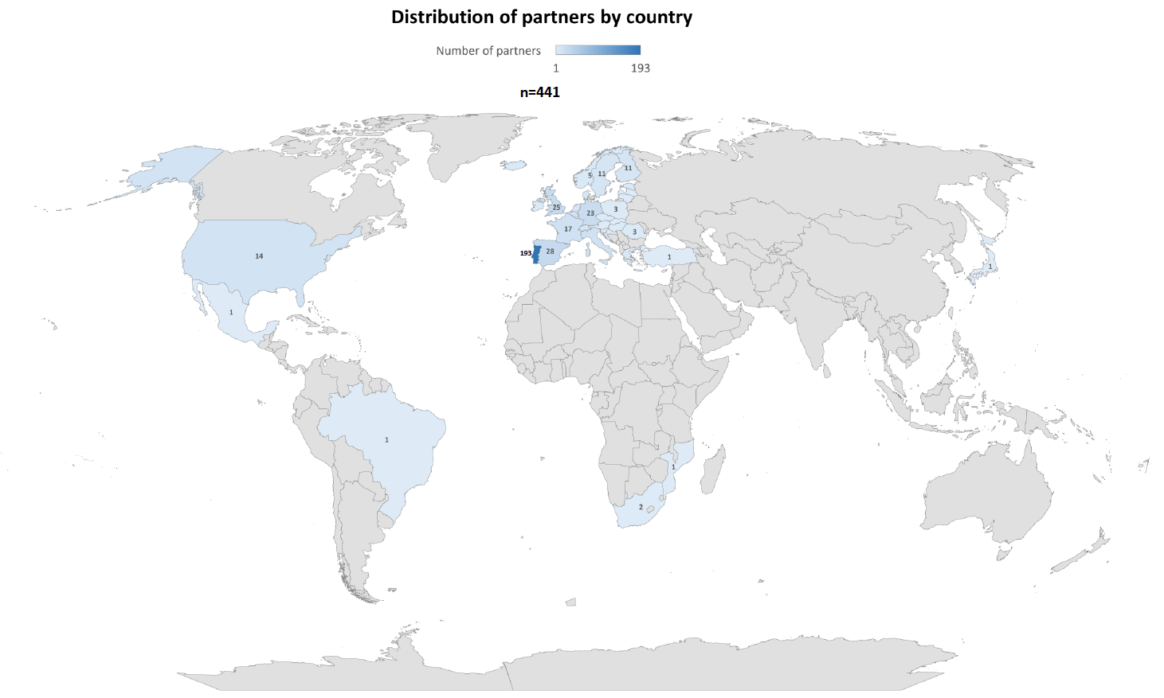

Note: Figure 2 is also available at the end of this document.

Figure 3: Institutional collaboration network of 4 Portuguese Medical Schools (2019-2021)

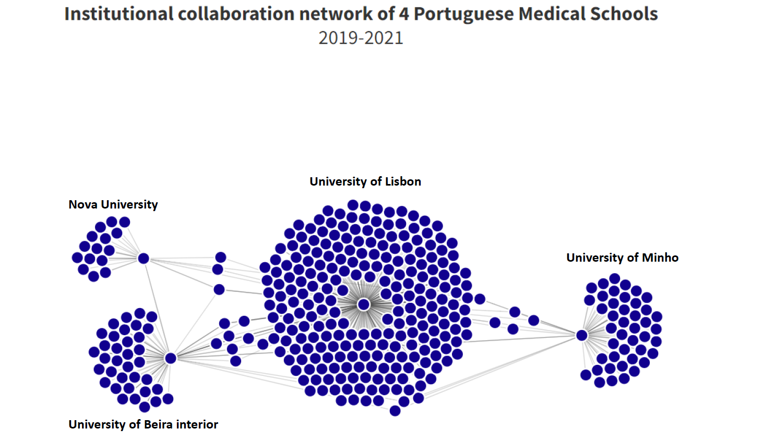

Note: Figure 3 is an interactive data visualisation available on this link: https://public.flourish.studio/visualisation/12890095/

Figure 4: Institutional partners grouped by categories (partner type of institution)

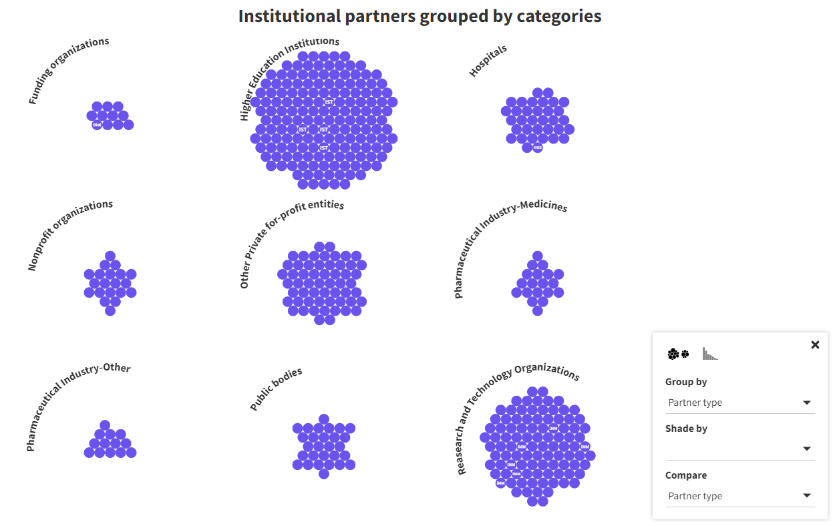

Note: Figure 4 is part of an interactive data visualisation available on this link: https://public.flourish.studio/visualisation/12898192/

Figure 5: Institutional partners grouped by categories (partner type of institution and partner nationality)

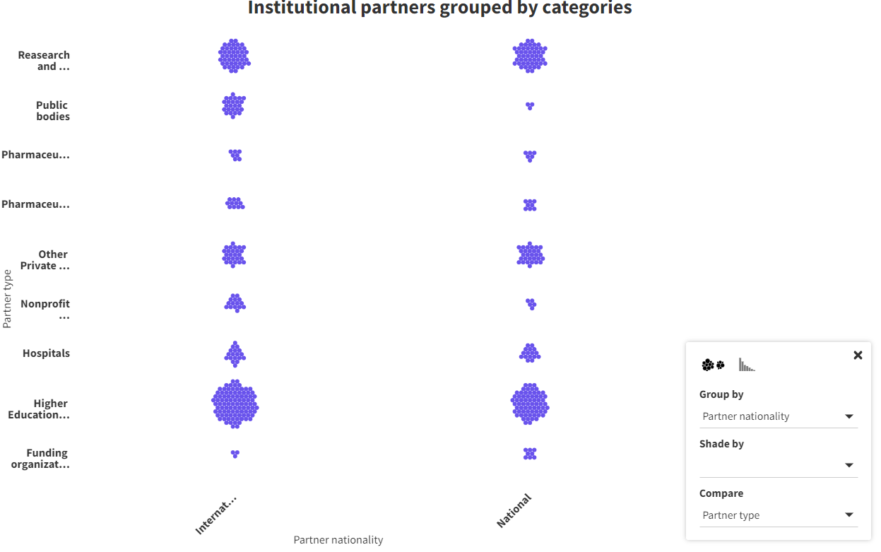

Note: Figure 5 is part of an interactive data visualisation available on this link: https://public.flourish.studio/visualisation/12898192/

Figure 6: Institutional partners grouped by categories (Research/Disease area and partner nationality)

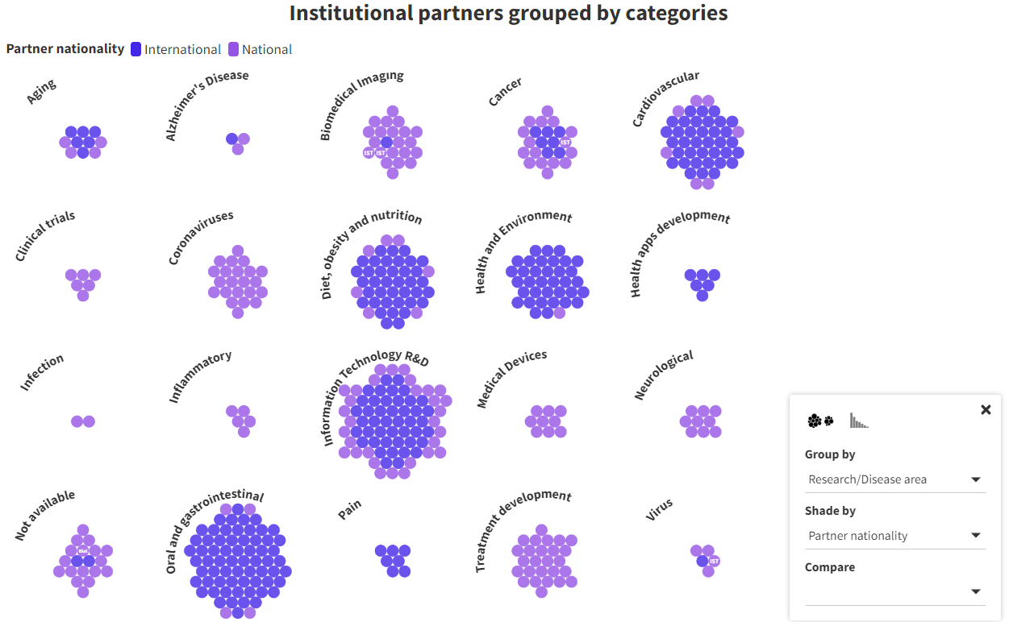

Figure 6 is part of an interactive data visualisation available on this link: https://public.flourish.studio/visualisation/12898192/

5. Discussion and conclusions
The Faculty of Medicine of the University of Lisbon showed the largest number of partnerships, which may relate with the fact of being the oldest School of Medicine among the four analysed.
Most of the partners of Portuguese Medical Schools are located in Portugal or in the EU which may relate with the European Commission Programs to encourage research and cooperation in the EU such as the Horizon 2020. Indeed, most of the partnerships analysed outside Portugal were grants from the European Commission.
It is recommended to enhance the support provided by the Portuguese Government to promote and facilitate research collaborations with international institutions, particularly those outside the EU.
Furthermore, most of the partnerships of Portuguese Medical Schools were with other Universities. A need to increase the partnerships with other type of institutions (e.g. pharmaceutical industry, research organisations) is identified.
As a future objective, we intend to extend this analysis to all the Medical Schools in Portugal and to other areas such as Pharmacy and Nursing.

References

Cheng, F., Ma, Y., Uzzi, B., & Loscalzo, J. (2020). Importance of scientific collaboration in contemporary drug discovery and development: a detailed network analysis. BMC biology, 18(1), 1-9.
Dahesh, M. B., Tabarsa, G., Zandieh, M., & Hamidizadeh, M. (2020). Reviewing the intellectual structure and evolution of the innovation systems approach: A social network analysis. Technology in Society, 63, 101399.
De Carolis, D. M. (2003). Competencies and imitability in the pharmaceutical industry: An analysis of their relationship with firm performance. Journal of management,, 29(1), 27-50.
European Commission. (2023). Projects and Results. Retrieved February 28, 2023, from CORDIS EU: https://cordis.europa.eu/projects/en
Gault, F. (2018). Defining and measuring innovation in all sectors of the economy. Research policy, 47(3), 617-622.
Henderson, R., & Cockburn, I. (1994). Measuring competence? Exploring firm effects in pharmaceutical research. Strategic management journal, 15(S1), 63-84.
Hillman, A. J., Withers, M. C., & Collins, B. J. (2009). Resource dependence theory: A review. Journal of management, 35(6), 1404-1427.
Hopkins, A. L., Witty, M. J., & Nwaka, S. (2007). Mission possible. Nature, 449(7159), 166-169.
Lessl, M., Schoepe, S., Sommer, A., Schneider, M., & Asadullah, K. (2011). Grants4Targets–an innovative approach to translate ideas from basic research into novel drugs. Drug Discovery Today, 16(7-8), 288-292.
Lim, M. D. (2014). Consortium sandbox: building and sharing resources. Science Translational Medicine, 6(242), 242cm6-242cm6.
Ma, Z., Augustijn, K., de Esch, I. J., & Bossink, B. (2022). Collaborative university–industry R&D practices supporting the pharmaceutical innovation process: Insights from a bibliometric review. Drug Discovery Today, 27(8), 2333-2341.
Malerba, F. (2004). Sectoral systems of innovation: concepts, issues and analyses of six major sectors in Europe. (2004 ed.). (C. U. Press., Ed.)
Mascarenhas, C., Ferreira, J., & Marques, C. (2018). University–industry cooperation: A systematic literature review and research agenda. Science and Public Policy, 5(45), 708-718.
Melese, T., Lin, S. M., Chang, J. L., & Cohen, N. H. (2009). Open innovation networks between academia and industry: an imperative for breakthrough therapies. Nature medicine, 15(5), 502-507.
National Institutes of Health (NIH). (2023, February 20). The Research, Condition, and Disease Categorization Process. Retrieved February 20, 2023, from https://report.nih.gov/funding/categorical-spending/rcdc
Nova University - Nova Medical School. (n.d.). Annual Reports 2019 and 2020. Retrieved February 27, 2023, from https://www.nms.unl.pt/en-us/nms/nova-medical-school/legislation-and-management-documents/management-documents
Portuguese Government. (2023). Tranparency Portal. Retrieved February 28, 2023, from European Funds: https://transparencia.gov.pt/pt/fundos-europeus/tema/
Portuguese Government, Ministry of Finance. (1992, July 28). Decree-Law 155/92 of 28 July. Retrieved March 1, 2023, from https://dre.pt/dre/detalhe/decreto-lei/155-1992-275619
Portuguese Government, Presidency of the Council of Ministers. (1996, September 27). Decree-Law 183/96 of 27 September. Retrieved March 1, 2023, from https://dre.pt/dre/detalhe/decreto-lei/183-1996-213805
Powell, W. W., & Grodal, S. (2006). Networks of innovators.
Santos, T. N., Dias, J. G., & Mendonça, S. (2023). University–industry cooperation: a taxonomy of intermediaries. Science and Public Policy, scac078.
Soda, G., Zaheer, A., Sun, X., & Cui, W. (2021). Brokerage evolution in innovation contexts: Formal structure, network neighborhoods and knowledge. Research Policy, 50(10), 104343.
Sunyoto, T. (2020). Partnerships for better neglected disease drug discovery and development: how have we fared? Expert Opinion on Drug Discovery, 15(5), 531-537.
Thomas, C. J., & McKew, J. C. (2014). Playing well with others! Initiating and sustaining successful collaborations between industry, academia and government. Current topics in medicinal chemistry, 14(3), 291.
UK Clinical Research Collaboration. (20, February 2023). UKCRC Health Research Classification System. Retrieved from https://hrcsonline.net/
University Beira Interior - Faculty of Health Sciences. (n.d.). Annual Reports 2019, 2020 and 2021. Retrieved February 28, 2023, from https://www.ubi.pt/entidade/Docs_Estr
University of Algarve - Faculty of Medicine and Biomedical Sciences. (n.d.). Annual Reports 2019, 2020 and 2021. Retrieved February 28, 2023, from https://fmcb.ualg.pt/relatorios-e-planos-de-atividades-5
University of Lisbon - Faculty of Medicine. (n.d.). Annual Reports 2019, 2020 and 2021. Retrieved February 28, 2023, from https://www.medicina.ulisboa.pt/en/node/727
University of Minho - School of Medicine. (n.d.). Annual Reports 2019, 2020 and 2021. Retrieved February 28, 2023, from https://www.med.uminho.pt/pt/Escola/Apresentacao/Paginas/Relatorios-EM.aspx

Open science practices
Open science practices were followed in this research, as all of our data sources were publicly available. In accordance with Portuguese Decree-Law 183/96, the Annual Reports issued by public organisations are made available to all potential stakeholders. To identify research and innovation collaborations between Portuguese Medical Schools and other institutions, we searched for Annual Reports from the eight public Schools of Medicine in Portugal for the three-year period of 2019-2021. This scan was performed on February 5, 2023. However, the information in the Annual Reports was often incomplete, so we consulted the Portuguese Transparency Portal and the European Commission CORDIS database to gather missing information on institutional collaborations whenever applicable. The Portuguese Transparency Portal provides detailed information on projects financed with EU funds, including project objectives and beneficiaries, and was accessed on February 28, 2023. CORDIS (Community Research and Development Information Service) is the European Commission's primary database for EU-funded research and innovation projects, offering users details on project objectives, funding, partners, and outcomes. It was accessed on February 28, 2023. The CORDIS database may be found here: https://cordis.europa.eu/projects/en and the Portuguese Transparency Portal may be accessed here: https://transparencia.gov.pt/pt/fundos-europeus/tema/.

Acknowledgments
The authors have no acknowledgments to make.

Author contributions
The authors’ contributions to this research were in accordance with the CrediT (Contributor Roles Taxonomy) standard. Lígia Ernesto contributed to the Conceptualization, Data curation, Formal Analysis, Methodology, Visualization and Writing – original draft of the manuscript. Sandro Mendonça contributed to the Writing – review & editing, Validation, Supervision, Conceptualization of the study. Bruno Damásio contributed to the Supervision, Conceptualization and Methodology of the research.

Competing interests
The authors declare that they have no competing interests.

Funding information
The authors received no specific funding for this work.

