Leadership and international scientific collaboration in COVID-19 research: bridging the North-South divide?

Danilo Silva Carvalho*†, Lucas Lopes Felipe**†, Priscila Costa Albuquerque*, Fabio Zicker* and Bruna de Paula Fonseca*

dscufrj@gmail.com, lucaslopesf2@gmail.com
0000-0002-8124-9224, 0000-0002-6500-9749
*Center for Technological Development in Health (CDTS), Oswaldo Cruz Foundation (Fiocruz), Brazil
**Department of Computer Science, Federal University of Rio de Janeiro (UFRJ), Brazil

priscila.costa@fiocruz.br, fabio.zicker@fiocruz.br,bruna.fonseca@fiocruz.br
0000-0001-8185-024X, 0000-0002-9751-7430, 0000-0002-8795-2578
*Center for Technological Development in Health (CDTS), Oswaldo Cruz Foundation (Fiocruz), Brazil

Abstract: The COVID-19 pandemic triggered unprecedented scientific efforts worldwide and launched several initiatives to promote international cooperation. Because international scientific collaborations between high-income countries (HICs) and low- and middle-income countries (LMICs) are not always balanced, analyzing research leadership helps to understand the global dynamics of knowledge production during COVID-19. In this study, we focused on HIC-LMIC collaborations on COVID-19 research in 469,937 scientific publications during the first two years of the pandemic (2020-2021). Co-authorship and authors' affiliation were used to identify international collaborations, according to country income level. The leadership analysis considered the countries of the first and last authors. The results show that i) most publications with international collaborations (49.3%) involved researchers from HICs and LMICs; ii) collaborative research between HICs and LMICs addressed relevant public health needs; iii) most HIC-LMIC publications (44%) had shared leadership, with research interests linked to national expertise and global interests.

Introduction
Scientific research collaboration is an important part of science, with one in five published articles being the result of international collaboration (NSF, 2019). International collaborations enable scientists to acquire complementary expertise that transcends national borders and internationalize their research, leading to greater impact (Wagner & Jonkers, 2017). International health challenges such as the COVID-19 pandemic have encouraged scientific collaboration, with research results being widely and freely available, and datasets created and shared (Maher & Van Noorden, 2021). Participation in scientific collaboration networks enables the development and strengthening of national research capacities in low- and middle-income countries (LMICs), which are critical to addressing health problems (Thorsteinsdóttir et al., 2011). However, recent studies have shown that LMICs have low participation in international collaborations on COVID-19 (Fry et al., 2020) and a small contribution towards the advancement of knowledge in the field (Pamplona da Costa et al., 2021).

Scientific leadership in research can be understood as the responsibility for conducting and/or coordinating research development. In biomedical and health science publications, the order of authors usually expresses research leadership, often positioned as the first and last author (Abramo et al., 2013). Economics and power asymmetries may influence authorship and leadership relationships, affecting the representation of LMIC researchers in scientific publications, particularly when their coauthors are from high-income countries (HICs) (Hedt-Gauthier et al., 2019). Recent studies have been published on COVID-19 research collaboration (Cai et al., 2021; Fry et al., 2020), but they have not examined the scientific contributions of these efforts, nor have they addressed authorship or leadership in these publications. Because international scientific collaboration between HICs and LMICs is not always a balanced process, analysis of leadership is critical to understanding the global dynamics of knowledge production.

This study examined international research collaborations on COVID-19 during the first two years of the pandemic, focusing on HIC-LMIC collaborations. Our goal was to assess the scope of HIC-LMIC research on public health and map scientific leadership.

Method
  - Data selection, extraction, and processing
COVID-19 scientific articles and preprints published from January 1, 2020, to December 31, 2021, were retrieved from the Dimensions database using the Google BigQuery interface in standard SQL language. A dataset containing the selected publications was created on GBQ and only records informing the DOI, authors' institutional affiliation, and country were included.

  - Characterization of international collaboration
Co-authorship in scientific publications was considered a proxy for scientific collaboration. The country of institutional affiliation of all authors, classified by the World Bank as LMICs and HICs (World Bank, 2020), was used to identify international collaborations. Three groups were considered: i) HIC-HIC (all authors affiliated with HIC institutions); ii) LMIC-LMIC (all authors affiliated with LMIC institutions); iii) HIC-LMIC (at least one author affiliated with a HIC institution and at least one other author affiliated with an LMIC institution).

  - Identifying research leadership
Leadership analysis considered publications co-authored by countries of different income groups (HIC-LMIC publications). The countries of the first and last authors were used as indicators of scientific leaders. Therefore, in each publication, the two leading scientists and their respective affiliation countries were profiled. Leadership was identified as: i) HIC leadership - both the first and last authors were affiliated with HIC institutions, ii) LMIC leadership - both the first and last authors were affiliated with LMIC institutions, and iii) Shared leadership - the first and last authors were alternately affiliated with either an LMIC or HIC.

  - Thematic mapping and clustering
Term maps were created with the VOSviewer 1.6.18 software (CWTS, Leiden University, the Netherlands). Terms were extracted from titles and abstracts of all HIC-LMIC collaborative publications and clustered according to their similarity. The closer two terms are positioned to each other, the stronger their relationship. Terms were represented by circles, with the diameter and label size proportional to their frequency in the dataset. Terms related to "SARS-Cov2" and "coronavirus" were removed to improve visualization. Clusters of terms were classified by two independent researchers. Discordant classifications were reviewed by a third researcher and a final classification was agreed upon by consensus.

- Results
  - Collaboration between HIC and LMIC accounted for nearly half of all international collaborations
A total of 469,937 publications, 432,814 articles (92.2%), and 37,123 preprints (7.8%) were analyzed. Most publications were produced by a single HIC (n=248,596 - 52.9%) or LMIC (n=129,232 - 27.5%), without international collaboration (Figure 1A). International collaborative publications accounted for 19.6% of the total articles analyzed. Almost half of all international collaborations (49.3%, n=45,397) were jointly published by HIC-LMIC authors. HIC-HIC collaborations accounted for 43.5% (n=40,056) of publications and LMIC-LMIC collaborations accounted for just 7.2% (n=6,630). (Figure 1B).

Figure 1: Scientific publications on COVID-19 and international collaboration (2020-2021). A) Total number of publications. IC: International collaboration; B) International collaboration by country income level

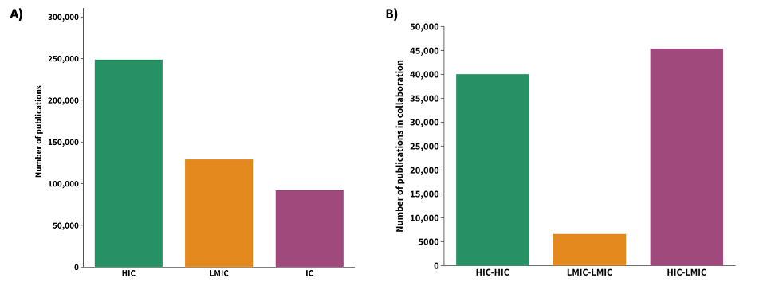
  - Research interests varied by type of collaboration
The term map shows 2,688 terms extracted from the titles and abstracts of 45,115 HIC-LMIC publications. It revealed 11 key research themes (Figure 2): Clinical Medicine (red), Clinical trials (gray), Mental Health (green), Education (yellow), Economy, investments, and sustainability (blue), Artificial intelligence, technology, and the Internet of things (IoT) (pink), Transmission dynamics (brown), Biomedical engineering (turquoise), Drug R&D and Repurposing (salmon), Immunopathology (orange), and Diagnostic assays (purple).

The dynamics of research interests over the study period are shown by an overlay visualization of the most common themes each year (Figure 2B-C). In the first year of the pandemic (2020), studies in clinical aspects, mental health, and drug discovery scored the highest (Figure 2B). In the second year (2021), clinical trials, and research in the fields of education, economics, artificial intelligence, transmission dynamics, and biomedical engineering were the most common (Figure 2C).

Figure 2: COVID-19 research themes in HIC-LMIC publications. (A) Different colors distinguish clusters of research themes. (B and C) Colors indicate the degree of occurrence of a term during the first (B) and second (C) year of the pandemic, relative to the overall period. Blue represents a low occurrence and red a high occurrence.
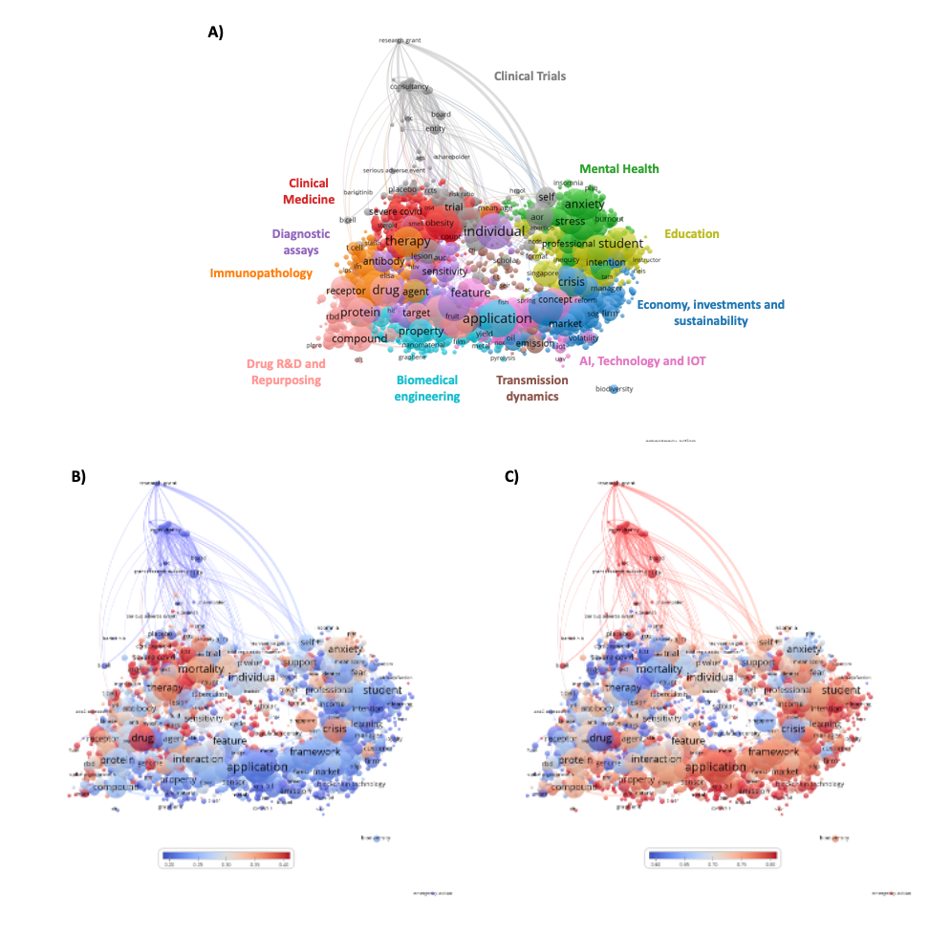
  - Most HIC-LMIC collaborations resulted from a shared leadership between countries
Most HIC-LMIC publications (n=45,397) were the result of shared leadership between countries, with the first and last authors distinctly affiliated with HIC or LMIC institutions (n=19,974 - 44%) (Figure 3A). The growth rate of shared leadership publications increased more than a thousandfold in the study period (Figure 3B). HIC-LMIC collaborative publications were led exclusively by HICs in 26.0% (n=11,806), and by LMICs in 29.9% (n=13,576).

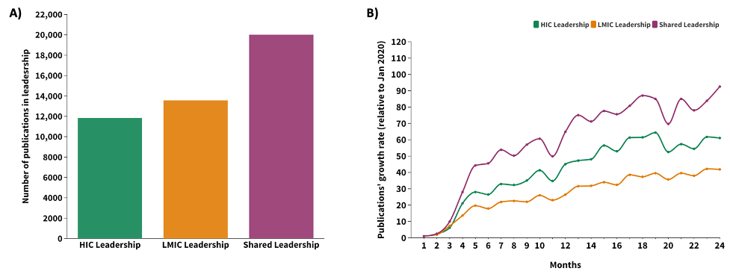
Figure 3: Leadership in COVID-19 publications co-authored by HIC and LMIC researchers (2020-2021). A) Total number of publications. B) Monthly growth rate (%) relative to publications indexed in January 2020.

  - Research interests were influenced by the leading authors’ profile
Research interests varied by leadership profile (Figure 4), with HIC-led publications focused on clinical trials, clinical medicine, and diagnostic assays (Figure 4A), while LMIC-led publications focused on drug discovery and drug repurposing (Figure 4B). Shared leadership publications presented different themes, such as economics, investments and sustainability, education, artificial intelligence, technology and the Internet of things, and mental health (Figure 4C).

Figure 4: Dynamics of COVID-19 research themes according to the type of leadership in HIC-LMIC publications. Colors indicate the degree of occurrence of a term in publications led by HIC (A), LMIC (B), or under shared leadership (C)

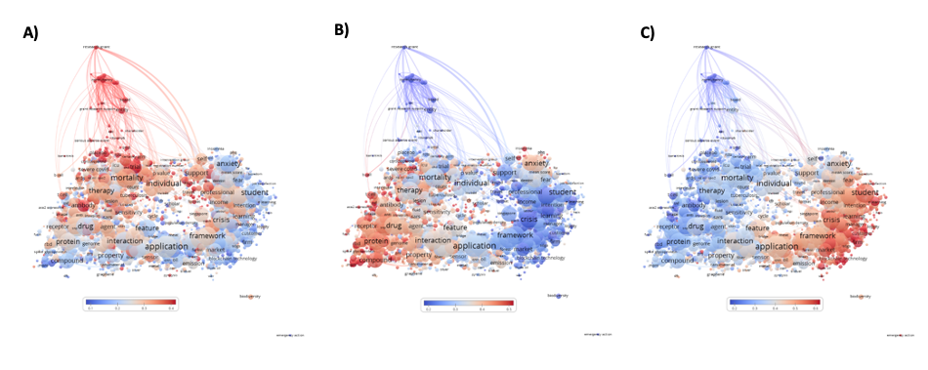

Discussion

This study provides a more detailed look at international scientific collaborations resulting from the COVID-19 pandemic. During the first two years of the COVID-19 pandemic, international collaborations accounted for a limited share of publications. International collaborations are usually low in the initial years of epidemics but increase with time, as seen in previous epidemics (Wu et al., 2021). When scientifically advanced countries respond to non-local public health emergencies, international collaboration with less scientifically advanced countries is to be expected (Wu et al., 2021). Early research on COVID-19 involved less international collaboration and smaller teams than pre-pandemic coronavirus research (Fry et al., 2020). Despite calls for greater collaboration, researchers seemed to prefer smaller, multidisciplinary teams to avoid the coordination costs associated with international research (Cunningham et al., 2021).

Our results show that HIC-LMIC collaborations accounted for a large proportion of international collaborations. HIC-LMIC collaborations have facilitated the initiation and execution of COVID-19 research in LMICs, including better access to funding, knowledge, and experimental treatments (Bassi et al., 2020). They also supported studies on the impact of sociocultural beliefs that have compromised the sustainability of social distancing or lockdown in some countries and wider dissemination of research results in LMICs' local newspapers and open-access journals (Fanning et al., 2021).

The research topics addressed by HIC-LMIC collaborations provided a scientific view of the pandemic and revealed how research responded to the COVID-19 challenge. Our findings suggest an important contribution to public health. Topics related to medical education, treatment, prevention, and work protection (Hou et al., 2021), educational disruptions in schooling, and learning (Seetal et al., 2021), effectiveness, and attitudes toward online education for children (Ma et al., 2021) and university students (Pelikan et al., 2021), emerged in these publications. These collaborations also discussed socioeconomic disparities affecting access to healthcare services (Khanijahani et al., 2021), and the economic impact of restrictive measures (Lasaulce et al., 2021). The willingness of LMICs to engage in vaccine and safety, immunogenicity, and efficacy trials (Kitonsa et al., 2021; Pu et al., 2021) is well documented in joint HIC-LMIC publications. Discussions on the ethical aspects of conducting placebo-controlled trials in LMICs (Torres, Lopez-Cevallos, et al., 2021; Torres, Profeta, et al., 2021) and the need to strengthen LMIC’s clinical testing capability and infrastructure to regulate, manufacture, and distribute medical products (Yamey et al., 2021) were subject of HIC-LMIC collaborations with a significant impact in the global scientific community.

Although authorship alone does not ensure inclusive and fair collaborations, it is an important indicator of who benefits from research efforts. There fact that most HIC-LMIC publications were the result of shared leadership between HICs and LMICs suggests that authorship relationships were more balanced, possibly because research motivations and questions on COVID-19 transcend national interests. The pandemic highlighted existing inequalities between countries and created conditions for further inequity (Abimbola et al., 2021), but the research community has improved over the power asymmetries and favored scientific globalism to respond to one of the most complex global health challenges the world has faced.

Authorship of COVID-19 publications seemed to be more balanced between HICs and LMICs, but research interests varied by leadership type. Clinical trial publications were largely dominated by HIC authors, possibly related to the high cost and infrastructure needed for such trials (COVID-19 - ClinicalTrials.Gov, [s.d.]). The LMIC’s interest in assessing the therapeutic potential of existing drugs is in line with China’s and India’s leadership in drug repurposing research. Shared leadership publications mostly focused on global issues brought on by the pandemic, with economic, educational, and mental health implications for HICs and LMICs (Kumar et al., 2021).

A more equitable engagement of HIC and LMIC authors is desirable and would benefit global health at large by (i) addressing global health challenges and improving health outcomes worldwide: many of the most pressing public health problems in the world (infectious diseases, malnutrition, maternal and child mortality, etc.) disproportionately affect LMIC; ii) diversifying research perspectives: LMIC researchers can offer unique insights and perspectives that are often overlooked in research conducted primarily by HIC scientists; iii) increasing research capacity: fair cooperation and partnership can help establish or increase the scientific capacity of LMICs, and ultimately create a more sustainable global research ecosystem.

- Conclusion

This study shows that HIC-LMIC collaborations enabled a rapid scientific response to the COVID-19 public health emergency. Collaborative research between HICs and LMICs addressed relevant public health needs and authorship relationships between HICs and LMICs were more balanced, with research interests aligned with national expertise and global interests. The COVID-19 pandemic triggered new strategies, scientific approaches, and collaborations, but also highlighted the technological and scientific capacity gaps between HICs and LMICs. Advancing global health diplomacy is urgently needed to create a more equitable and scientifically collaborative world.

Bibliographic references

Abimbola, S., Asthana, S., Montenegro, C., Guinto, R. R., Jumbam, D. T., Louskieter, L., Kabubei, K. M., Munshi, S., Muraya, K., Okumu, F., Saha, S., Saluja, D., & Pai, M. (2021). Addressing power asymmetries in global health: Imperatives in the wake of the COVID-19 pandemic. PLOS Medicine, 18(4), e1003604. https://doi.org/10.1371/journal.pmed.1003604

Abramo, G., D’Angelo, C. A., & Rosati, F. (2013). The importance of accounting for the number of co-authors and their order when assessing research performance at the individual level in the life sciences. Journal of Informetrics, 7(1), 198–208. https://doi.org/10.1016/j.joi.2012.11.003

Bassi, G. L., Suen, J., Barnett, A. G., Corley, A., Millar, J., Fanning, J., Lye, I., Colombo, S., Wildi, K., Livingstone, S., Abbate, G., Hinton, S., Liquet, B., Shrapnel, S., Dalton, H., & Fraser, J. F. (2020). Design and rationale of the COVID-19 Critical Care Consortium international, multicentre, observational study. BMJ Open, 10(12), e041417. https://doi.org/10.1136/bmjopen-2020-041417

Cai, X., Fry, C. V., & Wagner, C. S. (2021). International collaboration during the COVID-19 crisis: Autumn 2020 developments. Scientometrics, 126(4), 3683–3692. https://doi.org/10.1007/s11192-021-03873-7

COVID-19—Map results—ClinicalTrials.gov. ([s.d.]). Recuperado 27 de outubro de 2022, de https://clinicaltrials.gov/ct2/results/map?cond=COVID-19&map=

Cunningham, E., Smyth, B., & Greene, D. (2021). Collaboration in the time of COVID: A scientometric analysis of multidisciplinary SARS-CoV-2 research. Humanities and Social Sciences Communications, 8(1), 1–8. https://doi.org/10.1057/s41599-021-00922-7

Fanning, J. P., Murthy, S., Obonyo, N. G., Baillie, J. K., Webb, S., Dalton, H. J., & Fraser, J. F. (2021). Global infectious disease research collaborations in crises: Building capacity and inclusivity through cooperation. Globalization and Health, 17(1), 84. https://doi.org/10.1186/s12992-021-00731-2

Fry, C. V., Cai, X., Zhang, Y., & Wagner, C. S. (2020). Consolidation in a crisis: Patterns of international collaboration in early COVID-19 research. PLOS ONE, 15(7), e0236307. https://doi.org/10.1371/journal.pone.0236307

Hedt-Gauthier, B. L., Jeufack, H. M., Neufeld, N. H., Alem, A., Sauer, S., Odhiambo, J., Boum, Y., Shuchman, M., & Volmink, J. (2019). Stuck in the middle: A systematic review of authorship in collaborative health research in Africa, 2014–2016. BMJ Global Health, 4(5), e001853. https://doi.org/10.1136/bmjgh-2019-001853

Hou, X., Hu, W., Russell, L., Kuang, M., Konge, L., & Nayahangan, L. J. (2021). Educational needs in the COVID-19 pandemic: A Delphi study among doctors and nurses in Wuhan, China. BMJ Open, 11(4), e045940. https://doi.org/10.1136/bmjopen-2020-045940

Khanijahani, A., Iezadi, S., Gholipour, K., Azami-Aghdash, S., & Naghibi, D. (2021). A systematic review of racial/ethnic and socioeconomic disparities in COVID-19. International Journal for Equity in Health, 20(1), 248. https://doi.org/10.1186/s12939-021-01582-4

Kitonsa, J., Kamacooko, O., Bahemuka, U. M., Kibengo, F., Kakande, A., Wajja, A., Basajja, V., Lumala, A., Ssemwanga, E., Asaba, R., Mugisha, J., Pierce, B. F., Shattock, R., Kaleebu, P., & Ruzagira, E. (2021). Willingness to participate in COVID-19 vaccine trials; a survey among a population of healthcare workers in Uganda. PLOS ONE, 16(5), e0251992. https://doi.org/10.1371/journal.pone.0251992

Kumar, V., Alshazly, H., Idris, S. A., & Bourouis, S. (2021). Evaluating the Impact of COVID-19 on Society, Environment, Economy, and Education. Sustainability, 13(24), Article 24. https://doi.org/10.3390/su132413642

Lasaulce, S., Zhang, C., Varma, V., & Morărescu, I. C. (2021). Analysis of the Tradeoff Between Health and Economic Impacts of the Covid-19 Epidemic. Frontiers in Public Health, 9. https://www.frontiersin.org/articles/10.3389/fpubh.2021.620770

Ma, Z., Idris, S., Zhang, Y., Zewen, L., Wali, A., Ji, Y., Pan, Q., & Baloch, Z. (2021). The impact of COVID-19 pandemic outbreak on education and mental health of Chinese children aged 7–15 years: An online survey. BMC Pediatrics, 21(1), 95. https://doi.org/10.1186/s12887-021-02550-1

Maher, B., & Van Noorden, R. (2021). How the COVID pandemic is changing global science collaborations. Nature, 594(7863), 316–319. https://doi.org/10.1038/d41586-021-01570-2
NSF. (2019). National Science Foundation. Publications Output: U.S. Trends and International Comparisons. https://ncses.nsf.gov/pubs/nsb20206/executive-summary

Pamplona da Costa, J., de Campos, A., Cintra, P., Greco, L., & Poker Junior, J. (2021). The nature of rapid response to COVID-19 in Latin America: An examination of Argentina, Brazil, Chile, Colombia and Mexico. Online Information Review, ahead-of-print. https://doi.org/10.1108/OIR-09-2020-0391
Pelikan, E. R., Korlat, S., Reiter, J., Holzer, J., Mayerhofer, M., Schober, B., Spiel, C., Hamzallari, O., Uka, A., Chen, J., Välimäki, M., Puharić, Z., Anusionwu, K. E., Okocha, A. N., Zabrodskaja, A., Salmela-Aro, K., Käser, U., Schultze-Krumbholz, A., Wachs, S., … Lüftenegger, M. (2021). Distance learning in higher education during COVID-19: The role of basic psychological needs and intrinsic motivation for persistence and procrastination–a multi-country study. PLOS ONE, 16(10), e0257346. https://doi.org/10.1371/journal.pone.0257346

Pu, J., Yu, Q., Yin, Z., Zhang, Y., Li, X., Yin, Q., Chen, H., Long, R., Zhao, Z., Mou, T., Zhao, H., Feng, S., Xie, Z., Wang, L., He, Z., Liao, Y., Fan, S., Jiang, R., Wang, J., … Li, Q. (2021). The safety and immunogenicity of an inactivated SARS-CoV-2 vaccine in Chinese adults aged 18–59 years: A phase I randomized, double-blinded, controlled trial. Vaccine, 39(20), 2746–2754. https://doi.org/10.1016/j.vaccine.2021.04.006

Seetal, I., Gunness, S., & Teeroovengadum, V. (2021). Educational disruptions during the COVID-19 crisis in Small Island Developing States: Preparedness and efficacy of academics for online teaching. International Review of Education, 67(1–2), 185–217. https://doi.org/10.1007/s11159-021-09902-0

Thorsteinsdóttir, H., Ray, M., Kapoor, A., & Daar, A. S. (2011). Health biotechnology innovation on a global stage. Nature Reviews Microbiology, 9(2), Article 2. https://doi.org/10.1038/nrmicro2492

Torres, I., Lopez-Cevallos, D., Artaza, O., Profeta, B., Kang, J., & Machado, C. V. (2021). Vaccine scarcity in LMICs is a failure of global solidarity and multilateral instruments. The Lancet, 397(10287), 1804. https://doi.org/10.1016/S0140-6736(21)00893-X

Torres, I., Profeta, B., Machado, C. V., Artaza, O., Lopez-Cevallos, D., & Kang, J. (2021). COVID-19 research in LMICs – Authors’ reply. The Lancet, 398(10307), 1213. https://doi.org/10.1016/S0140-6736(21)01598-1

Wagner, C. S., & Jonkers, K. (2017). Open countries have strong science. Nature, 550(7674), 32–33. https://doi.org/10.1038/550032a

World Bank. (2020). World Bank Country and Lending Groups. https://datahelpdesk.worldbank.org/knowledgebase/articles/906519-world-bank-country-and-lending-groups

Wu, L., Yang, J., Wang, D., Cheng, Q., & Lu, W. (2021). Scientists’ response to global public health emergencies: A bibliometrics perspective. Journal of Information Science, 01655515211030866. https://doi.org/10.1177/01655515211030866

Yamey, G., Gordon, R., & Gray, G. E. (2021). Pandemic Vaccine Trials in Low- and Middle-Income Countries and Global Health Security. JAMA Network Open, 4(11), e2134455. https://doi.org/10.1001/jamanetworkopen.2021.34455

Open science practices
All data used in the study is freely available from the Dimensions database (see https://www.dimensions.ai/covid19/)

Author contributions
DSC and LLF were responsible for data curation, validation and methodology; PCA was responsible for formal analysis and visualization; FZ was responsible for writing- review and editing; BPF was responsible for project conceptualization and administration, supervision, writing – original draft, review, and editing.

Competing interests
The authors have no competing interests to declare.

Funding information
Funding was provided by the Oswaldo Cruz Foundation (Fiocruz, Brazil), grant # 48401635128590 to BPF.

