Should the Government invest more money in research to develop better treatments for cardiovascular disease or should the focus be on preventive measures to reduce the prevalence of the disease?
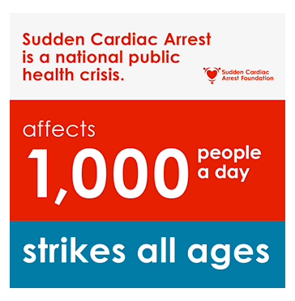  Figure-1: Poster issued by Sudden Cardiac Arrest Foundation on World Heart Day, October 16, 2022 | As per the update published by the American Health Association in 2022, the number of deaths due to cardiac arrest has increased from 347,322 cases in 2015 to 356,000 cases in 2022. This has made cardio vascular diseases a major fatal disease all across the world ranging from death at home, at public places as well as in hospitals.

Cardiovascular diseases (CVD) refer to a group of disorders that affect the functioning of the heart and creates complications in the transport of blood through arteries and veins from the heart to different parts of the body and vice versa. It includes medical situations like-coronary artery disease caused due to deposition of fats on the walls of artery resulting in decrease in lumen of artery, increase in muscle mass of heart and thereby decreasing its ability to contract and relax, dysfunction of the S-A node (Sino-Atrial node) and A-V node (Atrio Ventricular node).

CVD is primarily caused by a combination of lifestyle factors and genetic predisposition. Unhealthy habits like smoking, poor diet, physical inactivity, excessive alcohol consumption, and obesity contribute to the development of CVD. Additionally, factors like high blood pressure, high cholesterol levels, and diabetes also increase the risk of developing CVD.
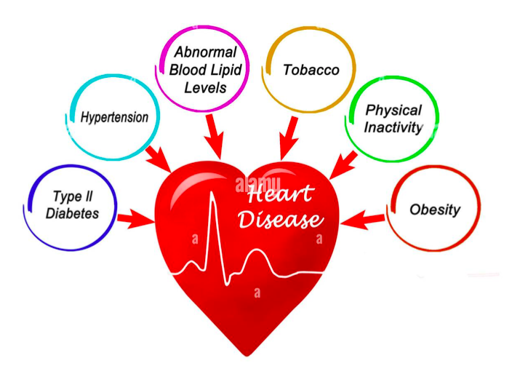
Figure-2: Causes of cardio vascular diseases
The treatment methods for cardiac diseases vary depending on the severity of the condition. Common treatment approaches include medications to manage symptoms, surgical interventions like bypass surgery or angioplasty to restore blood flow to the heart, and the use of medical devices like pacemakers or stents. Lifestyle changes are also crucial in managing and preventing cardiac diseases. These preventive measures include adopting a healthy diet, engaging in regular physical activity, quitting smoking, managing stress levels, and controlling conditions like high blood pressure and diabetes.
The field of cardiac disease research has seen significant advancements in recent years. Scientists are exploring innovative treatment options such as gene therapy, stem cell therapy, and tissue engineering to regenerate damaged heart tissues. Research is also focused on developing more effective medications, such as novel antiplatelet drugs and anticoagulants, to prevent blood clotting and reduce the risk of heart attacks and strokes. Additionally, advancements in diagnostic tools like non-invasive imaging techniques and genetic testing have improved the early detection and management of cardiac diseases.
However, the research process for developing new treatments for cardiac diseases faces several economic challenges. Conducting clinical trials and carrying out extensive research requires substantial financial resources.
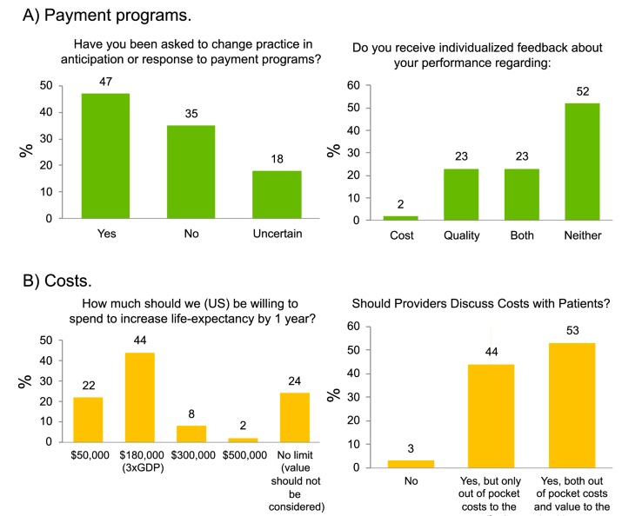
Figure-3: Infographic published in a symposium report based on the conference organized by Heart Failure Society of America on September14, 2019 in regard to the issue of economic challenges in treatments of heart diseases and research related to that
Securing funding for cardiac disease research can be challenging, especially when competing with other health priorities. To overcome these challenges, governments can allocate increased funding for cardiovascular research, establish partnerships with private industries, and encourage philanthropic support. Collaborations between researchers, healthcare institutions, and pharmaceutical companies can help streamline the research process and make it more cost-effective.
Implementing preventive measures for cardiac diseases poses its own set of challenges. One major challenge is changing people's behaviors and promoting lifestyle modifications. Encouraging individuals to adopt healthier habits, such as quitting smoking or making dietary changes, can be difficult due to ingrained habits and societal influences. Additionally, implementing policies and regulations to support preventive measures, such as tobacco control or food labeling, can face resistance from industries or encounter barriers in the legislative process. Public health campaigns, education programs, and community initiatives are essential in raising awareness, providing support, and fostering a culture of prevention.
In conclusion, addressing the issue of cardiac diseases requires a comprehensive approach that combines both research for better treatments and preventive measures. While research advancements can lead to improved treatment options and patient outcomes, preventive measures are crucial in reducing the burden of cardiac diseases on society. Governments should prioritize funding for cardiac disease research, collaborate with stakeholders, and implement policies that promote healthy behaviors. By striking a balance between treatment and prevention, we can strive to reduce the prevalence of cardiovascular disease and improve the overall health and well-being of the population.
----------------------------------------------------------------------------------------

References:
- Cardiac Arrest - Treatment | NHLBI, NIH. 19 May 2022, https://www.nhlbi.nih.gov/health/cardiac-arrest/treatment.
- “Latest Statistics.” Sudden Cardiac Arrest Foundation, https://www.sca-aware.org/about-sudden-cardiac-arrest/latest-statistics. Accessed 8 May 2023.
- Limited, Alamy. Six Causes of Heart Disease Stock Photo - Alamy. https://www.alamy.com/six-causes-of-heart-disease-image352959978.html. Accessed 8 May 2023.
- Murphy, Travis W., et al. “Cardiac Arrest: An Interdisciplinary Scoping Review of Clinical Literature from 2020.” Journal of the American College of Emergency Physicians Open, vol. 3, no. 4, July 2022, p. e12773. PubMed Central, https://doi.org/10.1002/emp2.12773.
- Piña, Ileana L., et al. “Managing the Economic Challenges in the Treatment of Heart Failure.” BMC Cardiovascular Disorders, vol. 21, no. 1, Dec. 2021, p. 612. BioMed Central, https://doi.org/10.1186/s12872-021-02408-5.
- “Restart a Heart Day.” British Heart Foundation, https://www.bhf.org.uk/how-you-can-help/how-to-save-a-life/cpr-training-in-schools/restart-a-heart-day. Accessed 8 May 2023.

“Restart a Heart Day.” British Heart Foundation, https://www.bhf.org.uk/how-you-can-help/how-to-save-a-life/cpr-training-in-schools/restart-a-heart-day. Accessed 8 May 2023.
“Latest Statistics.” Sudden Cardiac Arrest Foundation, https://www.sca-aware.org/about-sudden-cardiac-arrest/latest-statistics. Accessed 8 May 2023.
Limited, Alamy. Six Causes of Heart Disease Stock Photo - Alamy. https://www.alamy.com/six-causes-of-heart-disease-image352959978.html. Accessed 8 May 2023.
Cardiac Arrest - Treatment | NHLBI, NIH. 19 May 2022, https://www.nhlbi.nih.gov/health/cardiac-arrest/treatment.
Murphy, Travis W., et al. “Cardiac Arrest: An Interdisciplinary Scoping Review of Clinical Literature from 2020.” Journal of the American College of Emergency Physicians Open, vol. 3, no. 4, July 2022, p. e12773. PubMed Central, https://doi.org/10.1002/emp2.12773.
Piña, Ileana L., et al. “Managing the Economic Challenges in the Treatment of Heart Failure.” BMC Cardiovascular Disorders, vol. 21, no. 1, Dec. 2021, p. 612. BioMed Central, https://doi.org/10.1186/s12872-021-02408-5.

