Abstract
This reflection of practice is based on a case that has been carried out on four sessions of music therapy with client L, in the medical clinic area of the San Jose hospital in Buenos Aires, Argentina, 2022. The cause of hospitalisation was an ischemic stroke, which resulted in a left-sided hemiplegia. The Neurologic Music Therapy (NMT) technique Patterned Sensory Enhancement known as (PSE), is used in order to provide rehabilitation for the left arm, promoting, in addition to the motor rehabilitation process, a safe space to rebuild her own recovery narrative, in a favourable way, through a comprehensive person-centred approach.
Keywords: Music therapy, culture, emotion, NMT, PSE.

Music Therapy, NMT and emotional support
The study is framed within the Dynamic Music Therapy Model (MTD) (Ferrari, 2013), proposed by the music therapist Karina Ferrari, addressed toward the singular and comprehensive perspective of the client possibilities and its environment.
However, in order to provide a real centred-person approach, from music therapy, it is necessary to have a broad theoretical and practical perspective of the discipline as well. There are perspectives that could seem far away from each other but they could find a common ground if the focus is on the client as well as all the inherent subjective context.
The process had four sessions, of which VIM (Initial Assessment of Music Therapy) was carried out in the first session and PSE was provided in the other three sessions, as well as a support space for listening and reflecting on the process, until the client was discharged.
Materials and methods
As part of the NMT protocol, it is necessary to make pre and post session assessments, in this case, the evaluation was provided from the diagnosis itself. PSD it is designed for the rehabilitation of functional movements that are not intrinsically rhythmic, using acoustic elements that allow spatial, temporary and force cues, producing the “sonification” effect, where music is not used as an accompaniment of the movement, but, a facilitator of it, through the underlying perceptual analogies of sound and musical characteristics, favouring motor organisation and response. (Thaut & Hoemberg, 2014). There are two types of application of this technique. The first one, is doing separated exercises, following the musical and verbals cues, these last gradually disappear, leaving only the music cues, in order to get to the second way of the application, that would be creating sequences from the previous exercises. In this case, only the first application was done.
Instruments
Keyboard and autoharp are the suggested instruments for this technique, due their wide dynamic and pitch range, duration of the sound, and because they allow to play accompanied melodies with musically complex harmonic movements that analogically help with the functional sequences of the motor movements. (Thaut & Hoemberg, 2014).
Metronome: This tool is important in order to ensure that the sound is facilitating the movement and not accompanying it, because these are not rhythmically natural movements, so the constant rhythmic repetition could cause rhythmic entertainment. (Thaut & Hoemberg, 2014).
Passive mobilisation: The client helped herself to carry out the movements with her right hand, and at times received assistance from the co music therapist.
Technique
To carry out the protocol of the technique, it is important to musically facilitate the movement, by manipulating the variables of the sound elements in order to produce the movement. The first steps are to determine the movement, timing with the metronome, and choose the appropriate time signature.

Description and analysis of PSE application
Figure 1 Arm elevation
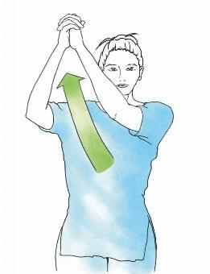
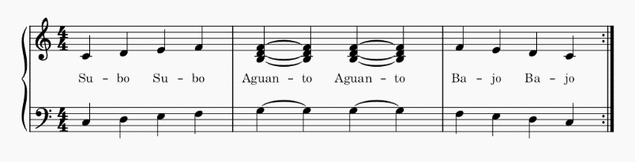

Table 1
Description and analysis of figure 1
Cues | Music elements | Description
Spatial | Pitch | Through an increasing and decreasing sequence of successive notes.
Temporal | Timing | Metronome
 | Form | Divided beats in quarter-notes for elevation movements and half-note for maintaining the arm elevated.
Strength | Harmony | Through a tension chord while elevating the arm.

Figure 2
External and internal arm rotation
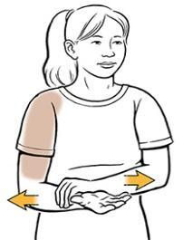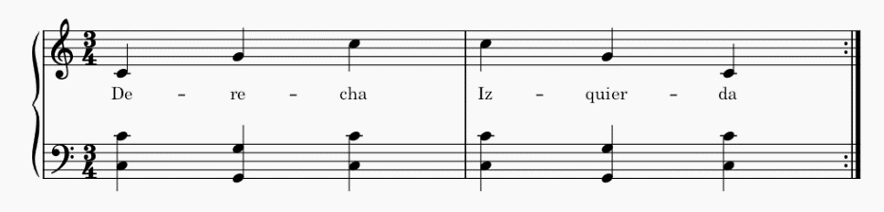
Table 2
Description and analysis of figure 2
Cues | Music | Description
Spatial | Pitch | Through an increasing and decreasing sequence of non successive notes.
 | Harmony | Open
Temporal | Timing | Metronome
 | Form | Ternary rhythm to facilitate movement and the syllables that go with it.
Strength | Velocity | Gradually increase of the velocity.

Figure 3
Arm flexion and extension
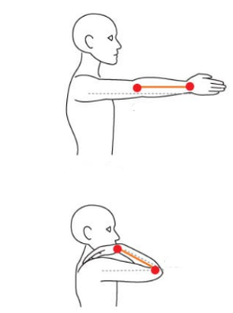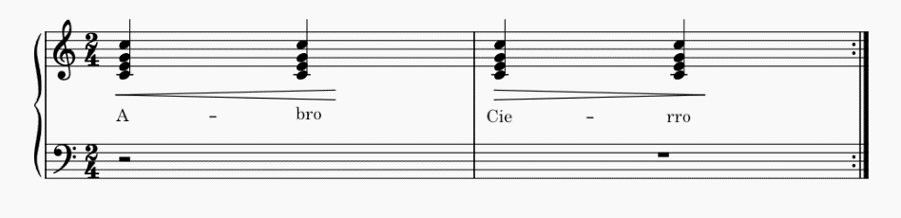
Table 3
Description and analysis of figure 3
Cues | Musical element | Description
Spatial | Harmony | Close
Temporal | Timing | Metronome
Strength | Dynamic | Volume (as the keyboard does not have sensitivity, it is done (in the same gradual manner) with the volume button).

Case Study
L is a 80 years old client, who suffered an ischemic stroke on the right side of the brain, resulting in a left-side hemiplegia. She was clinically referred to the music therapy area due her discouragement about the recovery process. In the VIM stage the client refers to being discouraged. A space for emotional support was proposed to her, however, she insisted on doing physical rehabilitation. In the next session she was better because with physiotherapy she recovered a little movement in her face and leg, but no in her arm.
Despite the age and her clinical situation, she conserves her cognitive functions in perfect condition. Showing high reflexive and comprehensive understanding.
She was a teacher for neurodivergent people, and manifested the ironic situation that she was going through, because now even at her age, she is having a situation similar to that of her students, in terms of working on things that might be simple for other people. That's why she insisted on doing "physical" rehabilitation. It decided to write physical between quotation marks, because from DMT the understanding of the person is in a comprehensive way, that is why if the work is in a specific area, others areas are involved and affected by consequence. Indeed, also if she was talking about rehabilitation, the music therapy space provided a reflexive moment about her past life and actual situation, an important action in order to enhance the state of mind, which in turn generates a commitment to the rehabilitation process.
This might imply the need to regain some kind of autonomy and control over the situation. Highlighting as a common sign, the tendency to frustration experienced by clients with neurological conditions, underlining the importance of providing a space for emotional support, reflection and information.
An explanation about the possibilities in the music therapy area was provided to her: describing how besides the emotional impact, music is a complex activity in the brain, so it might help her with the rehabilitation process, because music activates many parts of the brain at the same time, helping in the brain rewiring process. Furthermore, she was offered the possibility of a motor rehabilitation on the left arm with the PSE technique. This explanation encouraged her to sing the song La Llave, by Abel Pinto, requested by herself, inaugurating her disposition to the music therapy space. Consequently the foundations for a link with the music therapy space were established. This was the first session considered for the case study.
In the following three sessions, the protocol technique described above was carried out as part of the session, which also offered a flexible framing, to provide the possibility of a space for listening, expression, and emotional support. Doubts arose that could be dispelled, as well as reflections that could be enriched by being shared, favouring the reconstruction of their own recovery narrative in a consistent and salutogenic way.
In the following section it is considered appropriate pointed out, in a summarising way, every reflection arose from the next three session respectively, due to the importance that has listening the client needs in order to provide coping and adherence to treatment skills, because in the recovery process, the active participation and commitment of the person, are essential, thus promoting motivation as a creation of meaning or purpose.
-The client reflected about how the sound allowed her to do more exercises and repetitions, noticing less physical tiredness.
-She expressed concern about the difference in recovery time between the leg and the arm. It was explained to her that, due to plasticity of daily use, in general, the leg has greater mobilisation than the arm, causing it to take longer to recover.
-She reflect about the importance of the daily improvement, sometimes more obvious from the external view, than the proprioceptive view (maybe cause the expectative), as well as she was experimented with her students.
Discussion
Authors as Alvin (1977), o Benenzon (1989) refer to the musical instrument as an intermediary object, as a shield or a catharsis vehicle, however, music therapy, could be an expressive and communicational bridge, as an intermediate object itself, an excuse (a good one, due all the evolutive and anthropological context). So that, in a space such as motor rehabilitation, there is still the possibility for things to emerge that, perhaps, do not emerge in any other way, which does not determine that it must always be this way, but rather that, it is about generating possibilities. This is why it is important not to generalise, even less from a single case study. However, it might add evidence to the rest of the publications in the field, favouring its study and thus highlighting the importance of the interaction of the environment, the client, the music therapists and the context, because in the hospital context, the fact that musical instruments appear is already a paradigmatic breaker, enabling spaces to play and sing, generating other health approaches.
On the other hand, it is important to highlight that during the development of the case, there were supervisions by the music therapist Karina Ferrari, director of the music therapy area of the San José hospital, from which conclusions were also arose such as: the importance of contextualising clinical practice in cultural terms, among other things, due to the proxemics of emotional links according to the different latitudes and the approaches of music therapy that are involved on this. Methods, techniques and protocols also respond to the contexts where they were proposed, so transferring them to other spaces, including the linguistic space, might represent a challenge that entails modifications and/or adaptations, this can be both at a technical and cultural level. To give a basic example of technical level, within NMT, the syllabic division with which the movements of some techniques are usually accompanied, because they are designed in English, and it is important to consider this when using them in another language.
Also was highlighted the importance of surrounding the pathology as a strategy, in order to get into the person's world and their subjective complexity, because many times the clients are identified with their pathology as well as hide behind it.
Conclusions
A constant open discussion within Music Therapy has been the fact of framing its theoretical-practical limits as a scientific discipline, due to the need to recognition within the academic and professional territory, key factors that allow the dignified exercise of the profession. It is true that much can be debated about what "competes or not" to music therapy, but, if each human being limited them self to following what their labels or contracts dictate, society could not be sustained. More than once, especially within the hospital context, it is about opening a humanising the context, because music as art can allow that, without neglecting the scientific perspective that is also part of it and which also allows to coexist in that context. Above all, the music therapist is a human being at the service of another, is a qualified therapist who, through their listening, sensitivity and knowledge, makes them self and also the music available and in favour of clients and always according to their needs.
However, the form that this encounter between human beings will take will depend on the decisions that are made according to the perspectives, contexts and ethics, highlighting the importance of the comprehensive, reflective and flexible training of the music therapist, in conjunction with the active listening.
In order to have different resources and ways of understanding situations and people, it is possible to recognise music therapy as an open element or system that is completed and exists as long as the interaction take place.
Bibliography
Benenzon, R. (2008). La nueva musicoterapia. Madrid: Lumen.
Bruscia, K. (2014). Defining Music Therapy, Third Edition. Chicago: Barcelona Publishers.
Ferrari, K. (2013). Musicoterapia. Aspectos de la sistematización y la evolución de la práctica clínica. Buenos Aires: ED MTD.
Ferrari, K. (2022). Musicoterapia hospitalaria: Voces de la práctica clínica. Buenos Aires: Libro digital.
Thaut, M., & Hoemberg, V. (2014). Handbook of Neurologic Music Therapy. Oxford: Oxford University Press.

