HOLA15 - 195

Sustainable Development of New Opportunities in Zuata Field. Orinoco Oil Belt
Luis Lara; Daniela Ávila, PDVSA

This paper has been selected for presentation and/or publication in the proceedings for the 2015 Heavy Oil Latin America Conference & Exhibition. The authors of this material have been cleared by all interested companies/employers/clients to authorize dmg::events (Canada) Inc. the congress producer, to make this material available to the attendees of HOLA2015 and other relevant industry personnel.

ABSTRACT
The new developments of extra heavy crude oil in Orinoco Oil Belt (OOB) will have to affront important challenges. Assuring the resource extraction without impact negatively the original environment will be the most important investment in these remote areas. Restricted access due topographical irregularities, environmental restrictions and lack of production facilities are typical problems in new exploitation OOB areas.

The study is based on the technical and economic viability evaluation for the development of new opportunities in Zuata Field; considering volumetric milestones for next 6 years, the new areas and thermal projects represent the most important production booster.

Using diagnostic and planning resources as probabilistic analysis, economic evaluations, geologic configurations, possible projected sceneries were obtained to find solutions, in order to achieve the best cost-benefits relationship in exploitation schemes for new fields. As principal results we can mention:

- Most optimistic probabilistic prediction allows drilling 36 wells per year. This scheme represent an accumulate increase of 53724 b/d in six years.
- Less optimistic probabilistic prediction allows drilling 16 wells per year. This scheme represent an accumulate increase of 35904 b/d in six years.
- Six year field development contemplating temporal facilities is not technically viable.
- Data acquisition strategies, focus in decreasing the uncertainty in the geological model must be taken into account in the aggressive exploitation schemes.
The results of this study could be used as a decision support and background for others similar business in Orinoco Oil Belt. Since all new ventures are looking for earlier solutions in order to reduce costs and improves profits without having a negative incidence on the environment and the reservoir properties.

KEY WORDS
Reservoir development, Economic evaluations, Zuata.

INTRODUCTION
Oil markets are fluctuating constantly and oil prices are governed for external factors generally. In order to maintain competitiveness with other suppliers, petroleum companies must assure better quality products at low cost.

In on shore developments is usual have more benefits with cold barrel than EOR projects, because secondary recovery methods require investments and implementation time superior.
New developments must be evaluated by technical – economic factors to warrant the profitability and time to investment recover, it’s an important parameter to measure profits and benefits on all projects.

Santa Clara and San Diego Norte blocks represent a huge opportunity for increase the production levels, by taking advantage of facilities and consolidate systems installed in near fields. Unused capabilities and location advantage could reduce costs and minimize the investments required for expand the new developments potential.

FIELD DESCRIPTION
The fields San Diego Norte and Santa Clara are located at south of the states Guárico, Anzoátegui and Monagas. Specifically, San Diego Norte field is limited at north with Junín Norte and at south with Petro Junín, Petro San Félix and Santa Clara.

Santa Clara Field is limited at north with Petro San Félix, San Diego Norte, at east with Petro Cedeño and at south with Junín 9 block.
The figure 1 shows graphically the study zone location into Junín division scheme of development.

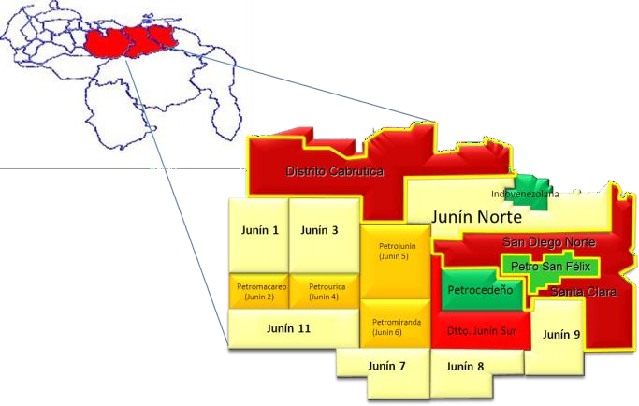

Figure 1. Geographic location for study zone

Project Magna Reserva information refers “The section producer is represented for the Formación Oficina of Miocene Inferior age, in the medium tertiary, which is included into de regional geological column of the Oriental Basin of Venezuela. The reservoirs depth range between 2700 and 3200 feet under sea level”.

(Maraven, 1981). Hedberg et al. (op. cit.) describe the Formación Oficina as “alternating gray shale, dark gray to brown, interspersed and inter-stratified sandstone and siltstone with light colored and fine to coarse grain. Minor but important components are the thin layers of lignite and shale, claystone and green light gray, with siderite spherules, siderítico-thin glauconite sandstones and limestones”.

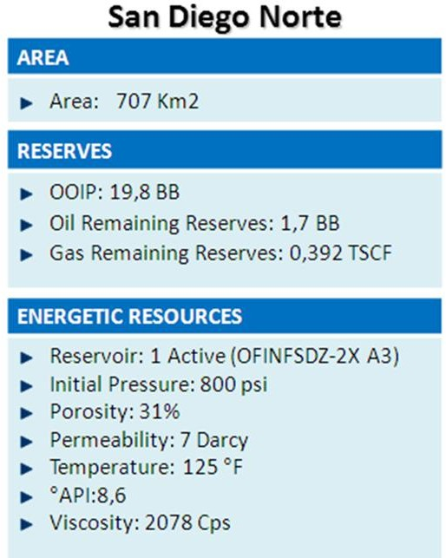

Table 1. General information of San Diego Norte Field.

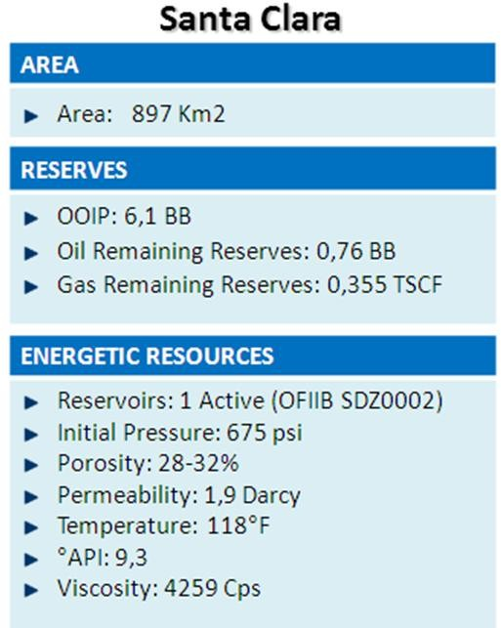
Table 2. General information of Santa Clara Field.

The extensive original oil in place volume contained in San Diego Norte and Santa Clara fields convert them in two great prospects towars develop a profitable project at long term. Even if properties of the fluid as API gravity and viscosity could make us doubt, the possibilities to get great results in a explotation scheme based in two fields with original pressure between 650 and 800 psi, permeability (revisar SDN 7Darcy)

PROBABILISTIC PLANNING
The Manual of the Quality Juran give us an excellent reference about this issue “The distribution of probability is a mathematical formula that relation the values of a characteristic with his probability of occur in a population”.

The probabilistic analysis was built based in statistics references since 2012. Mathematics model include calculations of cumulative production per year assuming variation in parameters as:
Drilling rig moving time. Drilling wells time
Drilling rig effectiveness Volumetric success
For software running was used triangular distribution as best fit, due we have statistic information to support it. A minimum, maximum and expected was set with historical information.
“The triangular distribution shows the number of successes when you know the minimum, maximum, and most likely values… The most likely number of items falls between the minimum and maximum values, forming a triangular shaped distribution, which shows that values near the minimum and maximum are less likely to occur than those near the most likely value” (Reference from Crystal Ball User Manual).

The variables used for built this forecast in the model were analyzed under the following ranges:

  - Volumetric Success: 50% -150%

  - Rig Moving: 10 – 40 days.

  - Operational: 14 – 40 days

  - Delay connection: 7 – 40 days
After a this evaluation, we get a figure 2 that represent the probabilistic opportunity to increase extra heavy oil production in a range of sceneries, taking in consideration
typical operational situations that could affect normally development of operations.
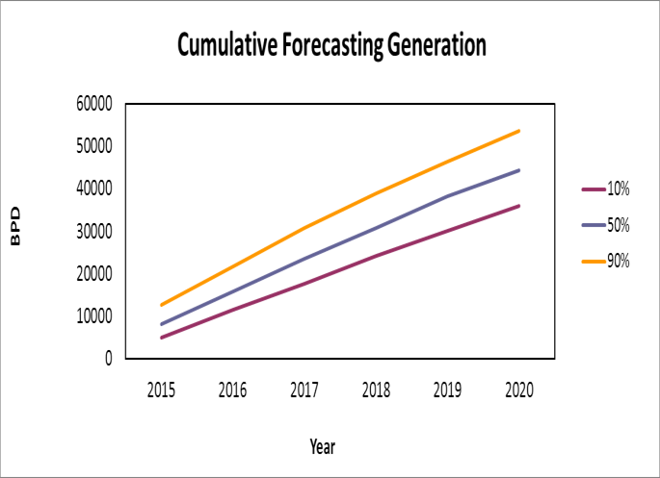

Figure 2. Graphic of forecasting for cumulative

A similar graph is shown in the figure 3, and represents the well distribution for drilling in each year, in order to complete production generation requirements. As can see, the distribution of wells will change from 16 to 35 wells. Assuming that each cluster is integrated for 8 wells, we will need between 2 and 5 cluster for year. This scenario will be affected for drill rig availability and investments analysis.
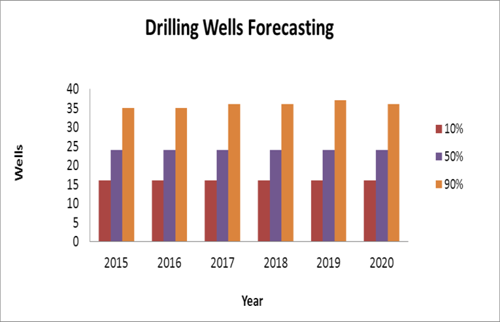

Figure 3. Graphic of forecasting for drilling wells generation.

Initial calculations and references give us possibility to use 350 BPD as potential for new wells in this area. For this study only cold production was considered, but in San Diego Norte field existed in the 80’s a thermal project cluster for research that got encouraging results in CSS.

Assuming P50 results, we made a cluster distribution based in information wells campaign and extrapolation of stratigraphic sequences of Petro San Félix borders wells. The Figure 4 is a map of interest areas and it shows how will be development each field by year in the next 5 years. This information is very

important for investments and future operational considerations.

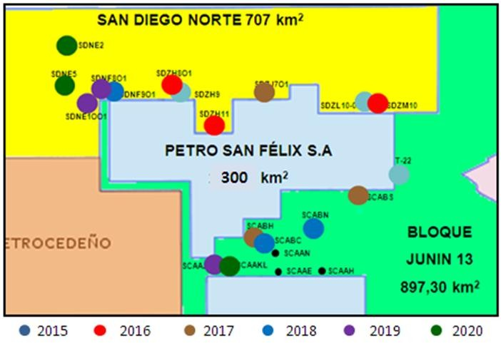

Figure 4. Map of location for development of new blocks.

In order to support development of the new blocks, was necessary design an information wells campaign, because there aren’t available seismic or "hard information" to define with details the cluster configuration. Figure 5 is referential of a drilling sequence proposed for take information of sub- surface parameters in San Diego Norte and Santa Clara’s interest areas. This sequence was planned to one drill rig and it is required complete 03 wells by year in order to validate clusters candidate and potential production.
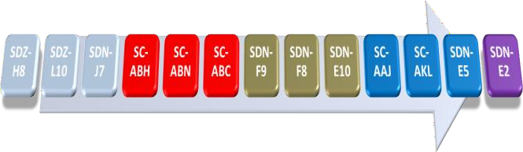

Figure 5. Proposal of sequence for information campaign.

Initial development is based in investigation holes taken from producer wells in near zones, this strategy allow us define clusters in the border of two blocks and represent an important saving because we take advantage of logistic for development wells in traditional areas.

The investments profile is shown in the figure 6. For percentiles case (P10 to P90) is maintained stable during 6 years forecasting, because we only consider investments for drill and complete wells including surface facilities. In the sky
– blue bar is represented investments associates to definitive
facilities for manage the production, in this case, there are important expenses since 2017 to 2019, oriented to reduce OPEX profile increases for temporal facilities used for early production requirements.
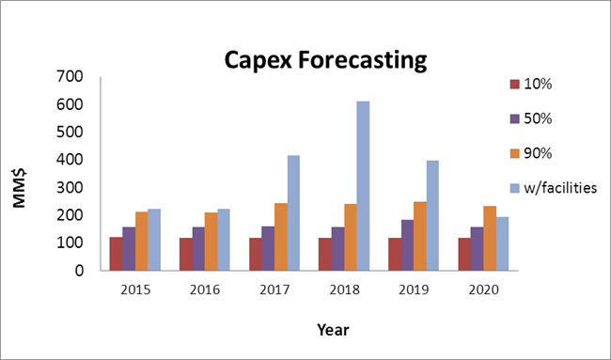

Figure 6. Graphic of forecasting for CAPEX.

The OPEX forecasting is strongly influenced for the incorporation of definitive facilities. As can see in the figure 7, this expenses profile is increasing yearly because the requirements of vacuums and frac tanks for support all the field development is growing around 6.0 to 8.0 thousand barrels average per year.

This situation is highly accentuated in the cost per barrel indicator, as seen in the figure 8, barrel cost fluctuate between
20 and 40 $/Bl. considering early production facilities for different percentiles. However, an important reduction is shown if it is applicable the definitive facilities strategy for cost reduction. In this case, 13 $/Bl. is the average range of cost necessary for maintain a P50 development profile.
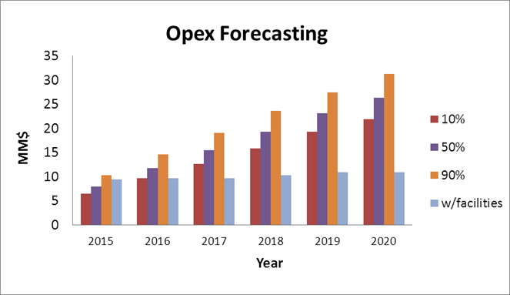

Figure 7. Graphic of forecasting for OPEX.

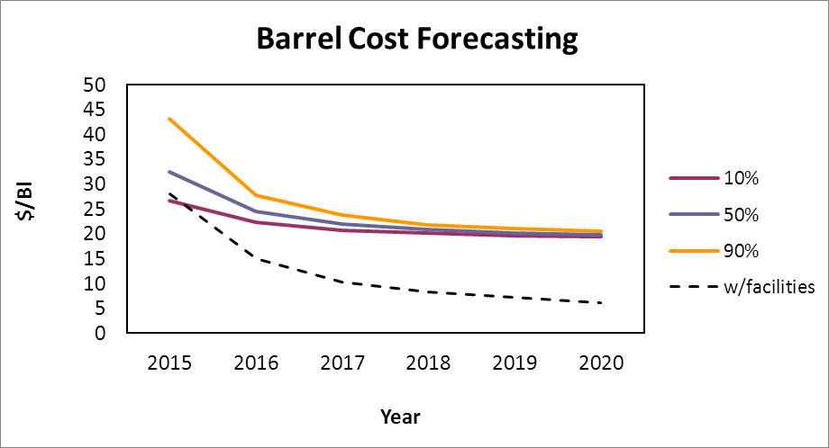Figure 8. Graphic of forecasting for barrel cost.

supported for temporal facilities. This strategy is beneficial only in the initial stage of the project, in order to allow obtain cash flow and knowledge. However, the practice of early production could be self-defeating at long period because the expenses and material requirements are untenable.

Sensibility analysis for economic factors is an important parameter for a decision tree scheme. In this particular case could be the most important because the technical feasibility is not enough to get profitability in the oil and gas business.

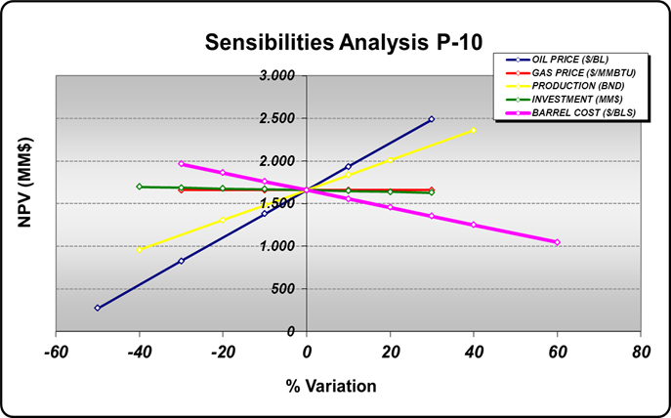

Figure 9. Graphic of sensibilities analysis for P-10 scenario.

The graphs of economics sensibility for temporal facilities were built under following premises:

- Oil Price ($/Bl.): 36.2 to 187.0

- Production (%): -40 to 40.

- Investments (%): -40 to 50

- Barrels Costs: 18.4 – 41.9 $/Bl.
In the figures 9, 10 and 11, is observed the important influence of the “oil price” over NPV. This parameter turns the profitability into negatives values under 36 $/Bl. for sceneries

Figure 10. Graphic of sensibilities analysis for P-50 scenario.

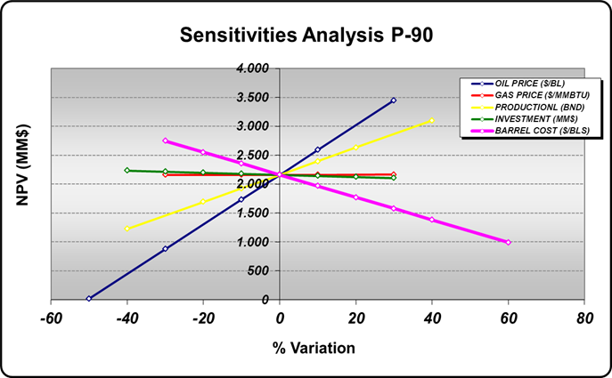
Figure 11. Graphic of sensibilities analysis for P-90 scenario.

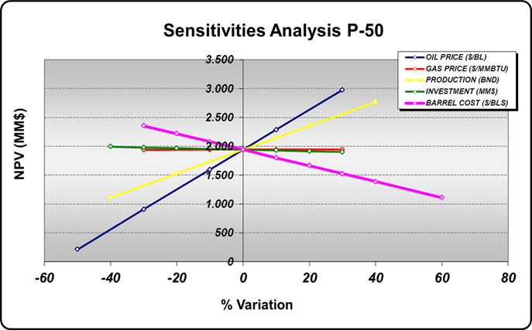
In order to ensure the correctly transport of produced fluids is required a proposal for surface facilities in the zones with a increasing development of production. The project is oriented to incorporate two stations for booster the transportation of crude oil produced in clusters 2017-2020. South station must be operative in 2018 and North station is required in 2019. Each one will be composed of two multiphase pumps capable to transport between 20000 and 40000 bls of liquid, one liquid-gas separator to reduce initial gas fraction directed to the pump intake, one knock out drum in order to avoid liquid

into the gas system and one gas flare while transport gas facilities are finished.
The graphs of economics sensibility for definitive facilities were built under following premises:

Oil Price ($/Bl.): 36.2 to 187.0

Production (%): -40 to 40.

Investments (%): -40 to 50 Barrels Costs Average: 13 $/Bl.

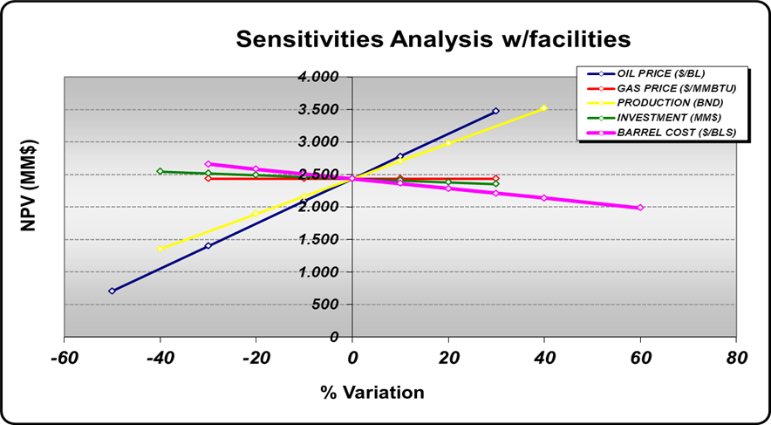

Figure 12. Graphic of sensibilities analysis for scenario with definitive facilities.

The Figure 12 shows the behavior of the parameters including definitive facilities, in this case there is a clearly improvement for barrel cost considerations and the result is a more profitable scenario. If we compare this situation against other, we could get a profitability even with barrel costs upper 21
$/Bl and the investment is returned in 3 years excluding government taxes and refining cost.

OPERATIONAL RESULTS
Actual situation in new developments of Junín is closely adjusted with planning. The information wells SDZ-L10O1 and SDZ-H8O1 were drilled successfully providing valuable information about sand thickness, porosity, permeability, fluid properties and others. Moreover, maps sequences and structural section are development with this information.

As is shown in the figure 13, resistivity logs for vertical section of the first information wells present interesting sand
thickness. These characteristics give us the possibility to validate initial parameters as productivity and well distribution for cluster proposal.
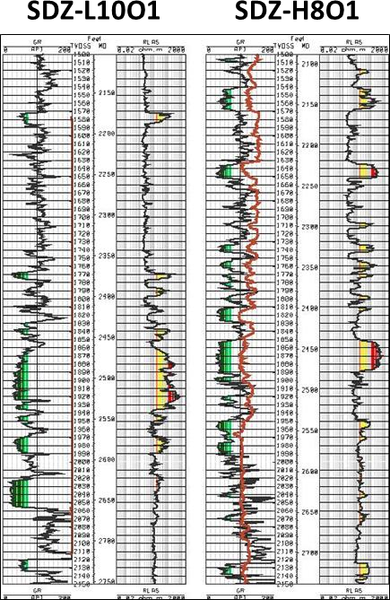

Figure 13. Electric logs for information wells SDZ-L10O1 y SDZ-H8O1.
After review all the information acquired through SDZ L10O1 and SDZ H8O1 information wells, we got definitively proposals for clusters SDZ-H8 and SDZ-L10. In the table 3 is indicated an average of 12 wells for cluster and 500 Barrel per well as initial potential.
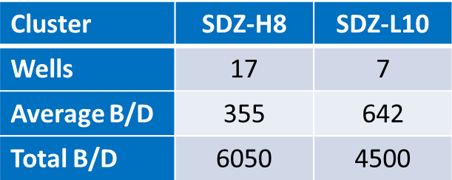

Table 3. Proposal after results of information wells SDZ- L10O1 y SDZ-H8O1.

Nowadays, the information well SDZ J7O1 is being drilled in the last stage and is expected found encouraging results for

this area. The drilling program was designed to build four slant holes oriented towards prospective zones in order to perform accurately the geological situation. In the first stages, 30 – 50 feet net pay zones was logged and excellent rock properties in three different sequences of sand.

CONCLUSION

Most optimistic probabilistic prediction allows drilling 36 wells per year. This scheme represent an accumulate increase of 53724 b/d in six years.
- Less optimistic probabilistic prediction allows drilling 16 wells per year. This scheme represent an accumulate increase of 35904 b/d in six years.

Six year field development contemplating temporal facilities is not technically- economically viable.
- Data acquisition strategies, focus in decreasing the uncertainty in the geological model must be taken into account in the aggressive exploitation schemes

ACKNOWLEDGMENT

We should express our gratitude to PDVSA Managers, Mr. Edward Pérez and Mr. Gregorio Gómez for support us to present this work.
Also special thanks to all those people who were invaluable contributed some way to achieving this goal Mrs. Diliana Rigaud, Mr. Irving Marquez, Mr. Eric Sampson and Miss Luz Duran.
Reservoir development department deserves a special recognition for support us in this proposal.

NOMENCLATURE
  - OOB: Orinoco Oil belt.

  - EOR: Enhanced Oil Recovery

  - CSS: Cyclic Steam Stimulation.
  - NPV: Net Present Value.

REFERENCES
- Vukelic M, Pescara R, Franco A. Economic Evaluation of a Multi-Prospect Exploratory Block. SPE 69615. LACPEC 2001.

- Vivas Y, Lezama E. Validation of the permeability equation from San Diego Norte area, based on core data, by using a probabilistic approach with production history from different well configurations in the Junín Block of the “Faja Petrolífera del Orinoco”. HOLA14-172. 2014.

- Hidalgo C, Muñoz S F, Oliveros L R, Naranjo C E. “Technical and financial evaluation of cyclic steam injection using horizontal wells”. SPE 165297. 2013.

- Guevara C, Ochoa G, Presilla M, Vivas Y. “Modelo de Producción del Yacimiento OFI INF SDZ 2X-A3, Campo San Diego Norte, Bloque Junín de la FPO” PLC 2012.

- Fraser D. “Fundamentos y Técnicas de la inferencia estadística” Editorial Limusa. Mexico. 1976.

- Juran J, Godfrey B. “Manual de Calidad Juran” Volumen III. Editorial McGraw-Hill. España. 2001.

- Crystal Ball User Manual. Refer material inside software help tools.

- “Revisión de la Información del Cluster de San Diego Norte y su Factibilidad para Reactivación”. Internal document of PDVSA Magna Reserva Project.

