## ­­­

**Study between the relationship of the volume that a gas occupies with its mass at ambient conditions**

TITLE: “How is the volume occupied by a gas related to its mass at ambient conditions? “

**Physics**

Words: 3831

### Index

INTRODUCTION 2

1. Chapter 1. THEORETICAL FUNDAMENTALS 4

1.1. Atmospheric pressure 4

1.2 Volume of a gas 4

1.2. Mol 4

1.4 Universal Gas Constant. 4

1.5 Temperature 4

1.6 Ideal gas 5

1.7 Proof of the ideal gas equation 5

1.8 Environmental conditions 8

2. CHAPTER II. experimental methodology 9

2.1 Goals 9

2.2 Hypothesis 10

2.3 Determination of variables 11

2.4 Materials and measuring instrument 12

2.5 Procedure for system assembly and data collection 12

2.6 Diagram 13

.7 Procedure for data collection 13

3. CHAPTERS III. RESULTS AND ANALYSIS 15

3.1. Relationship between volume and mass 15

3.2 Relationship between volume and molecular mass 16

4. Capítulo IV. CONCLUSIONES 16

4.1. Conclusions 19

4.2. Assessment 20

4.3. Improvements 20

5. References 22

# INTRODUCTION

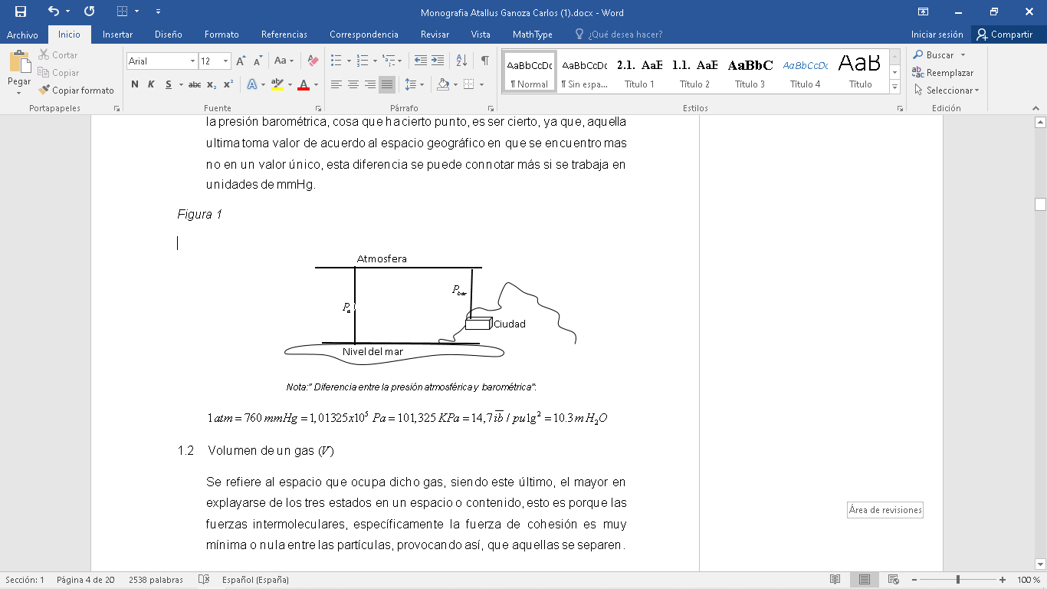The chosen theme was born through an experience from my childhood, since I accidentally dropped a butane lighter from the roof of my house, which exploded upon impact with the ground, causing the gas to dissipate, this aroused my enthusiasm to direct my project toward the subject of ideal gases, likewise, I consider that this subject differs from the others, in the aspect of the free construction of the methodological design, that is to say, what; to develop the question, there are several paths by which one can advance, which left the way of elaboration of the experimental field to my criteria. In this way, a rigorous process was developed to answer the following question: How is the volume occupied by a gas related to its mass at ambient conditions? For this, the use of the scientific method will be carried out since, it will help answer the question.

After the experimentation, calculations developed and data obtained, the research question was answered satisfactorily, since the relationship between the volume occupied by a gas with its mass was found, thus verifying the direct relationship between these variables.

The objective covered by the following work is to verify the relationship that exists between the volume that a gas can occupy with its mass in grams, it is in this way that the scientific method will be used to extract the data, likewise it will be contrasted and analyzed with values theoretical to observe the plausibility of the work carried out regarding environmental facings; In the same way, with the data found, it is intended to determine the Volume-Molecular Mass relationship, in order to support the answer, since the gas tested will be the same and that theoretically the relationship between one and the other is constant, that is, that its graph is a line parallel to the axis of the abscissas

The importance of studying the issue of gases is mostly presented with respect to the environment, this issue being an aid to clarify and project the pollution emanating from certain power plants. Physics intervenes by showing the amount of gas that can build up a substance in a solid and liquid state when transformed into a gaseous state, the latter thanks to the ideal gas equation.

# Chapter 1. Theoretical fundamentals

## 1.1 Atmospheric pressure

It is the average pressure exerted by the gaseous layer that surrounds the earth at sea level, that is standardized with a quantitative value of 1 atmosphere and abbreviated to 1 atm, (CEPRE UNI, 2004, p.96)

**Figure 1**

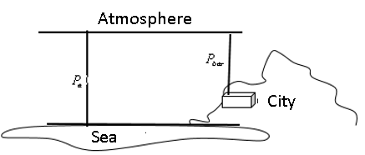*Difference between Atmospheric and Barometric Pressure*

## 1.2 Volume of a gas

## It refers to the space that a gas occupies in a certain contour, being the gaseous state the largest to expand since its cohesive force between its particles is minimal.

## 1.3 Mol

According to the Bureau International des Poids et Mesures (BIPM) the mole is a type of unit, which presents a number of specified entities (atoms, molecule, ion, electron, etc.), also has a numerical value of , in turn, this number is also known as Avogadro's number (2019, p.134)

$1mol=(\frac{6,022x{10}^{23}}{N_{A}})$

The number of moles is:

$$n=\frac{m}{MM}$$

## 1.4 Universal Gas Constant

## It is a physical constant that defines the behavior of a gas at theoretical conditions. On the other hand, according to Alum and Talbot. (2015), is defined as the portion of energy necessary to increase the temperature of 1 mol of an ideal gas to 1 kelvin (p.162)

## 1.5 Temperature

Temperature is a relative measure of the degree of agitation possessed by the particles that make up a body. If this body is compressed, the temperature will increase (Centro de Estudios Preuniversitarios de la Universidad Nacional de Ingeniería, 2004, p. 94)



## 1.6 Ideal gas

It is a theoretical gas that is subject to certain conjectures and assumptions for the best understanding of the scientist, its value is similar to the real one (Boles, A. and Cengel, A. 2005, p.164)

## 1.7 Proof of the ideal gas equation

**Figure 2**

*Piston Schematic*

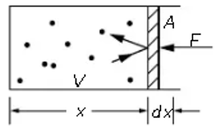

$P=\frac{F}{A}…..(1)$

As evidenced by the piston, the force times the maximum distance equals the maximum work.

$$dW=F\left(-dx\right)…..(2)$$

Substituting equation (2) in (1)

$$-PAdx=PdV=dW$$

The area A times dx is the change in volume, the negative sign is because the volume decreases due to the compression of the force. On the other hand, the movement of the atoms at a certain time will cause them to collide with the piston, implying that it tends to move, and therefore, to maintain equilibrium, the same force must be applied in a certain area. For its calculation, we will start with something simple, that is, if the velocity in the x component of an atom is $v_{x}$, the impulse would be $mv_{x}$. However, in Figure 2 it is evident how a collision implies a before and after; this means that the impulse of an atom is reflected, obtaining the following equation $2mv_{x}$. To find how many collisions they make in a time t, the following equality will be made, if there are N atoms in a volume. So

$$n=\frac{N}{V}…..(3)$$

in each unit of volume. Now to find out how many atoms hit the piston, we establish a time t, in which with a certain speed of the atom, it will hit the piston, however, not all of them will be able to do so given the far distance. Thus the number of collisions in a time is equal to the number of atoms that are in the region within the distance $v_{x}t$ (constant) and since the area of ​​the piston is A, the volume occupied by the atoms that are going to hit the piston is given by the formula $v_{x}tA$. But the number of atoms hit by the ratatouille is that times the number of atoms per unit volume ${nv}_{x}tA$ and since it is wanted the number that it hits in a second, divide the following by t result: ${nv}_{x}A$. Thus

$$F={nv}_{x}A.2mv_{x}$$

$$P=nv_{x}^{2}2m$$

However, there is a flaw in the analysis, and that is that the molecules do not have the same speed or go in the same direction; it is from this that the average $nv_{x}^{2}2m$ since each makes a contribution

$$P=nv_{x}^{2}m…..(4)$$

This happens since half the amount of atoms does not go towards the piston, in turn, after the collision, the atoms do not necessarily return to their same position. This means that

$$〈v_{x}^{2}{=v}_{y}^{2}{=v}_{z}^{2}〉$$

This alone is a rather difficult matter to notice, therefore each of them is equal to one third

$$v_{x}^{2}=\frac{1}{3}〈v_{x}^{2}{=v}_{y}^{2}{=v}_{z}^{2}〉=\frac{v^{2}}{3}…..(5)$$

A big advantage is that one no longer has to worry about any particular direction. Likewise, equation (3) is replaced in the following:

$$P=n(\frac{2}{3})〈\frac{mv^{2}}{2}〉$$

$$PV=N\left(\frac{2}{3}\right)〈\frac{mv^{2}}{2}〉…..(6)$$

We replace by the number of atoms multiplied by the average kinetic energy of each $U$

$$PV=\frac{2}{3}U$$

Although for conventional reasons, it is usually written this way: $PV=\left(γ-1\right)U$. In turn, knowing that: $PdV=-dU$ and that: $γPdV= -VdP$

$$\frac{PV}{\left(γ-1\right)}=U$$

$$\frac{d\left(PV\right)}{\left(γ-1\right)}=dU$$

$-\frac{1}{\left(γ-1\right)}\left(PdV+VdP\right)=PdV$

$$\left(\frac{γdV}{V}\right)+\left(\frac{dP}{P}\right)=0$$

$$\int{\left(\frac{γdV}{V}\right)}+\int{\left(\frac{dP}{P}\right)}=\int{0}$$

$$PV^{γ}=C…..(7)$$

At another point, the pressure can be found by understanding the radiation, for example, if it exists in a box with photons from a very hot star, these have a momentum, which, as with the previous analysis, will also hit the container twice to the axis $x$, It is then that the momentum is $2p_{x}$, in other terms $2mv_{x}$. It is so:

$$2p_{x}=2mv_{x}….(8)$$

$$\frac{p_{x}}{v_{x}}=m…..(8)$$

Replacing formula (8) in (4)

$$P=2np_{x}v_{x}…(9)$$

Furthermore $p_{x}v_{x}=\frac{1}{3}pv$ given that, Since the amount of movement is a vector, it will have directions $X,Y;Z$, that is why through the same process of equation (5), this result comes out $\frac{1}{3}pv$. Also, replacing equation (3) in (9), would result in

$$PV=N\frac{〈p.v〉}{3}$$

$$PV=N\frac{〈m.v.v〉}{3}$$

$$PV=N\frac{〈m.v^{2}〉}{3}$$

$$∴PV=\frac{U}{3}$$

$\frac{1}{3}$ is rewritten in the conventional way $\left(γ-1\right)$ and replaced in the equation (7)

$$PV^{4/3}=C$$

Now, the temperature is a variable that happened unexpectedly in the whole equation. However, its calculation is important, for this, this image will be analyzed first

**Figure 2**

*Gas in the piston*

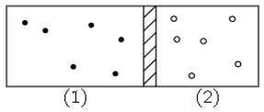

The impulses of the particles will push the piston, thus causing the other particles of the different gas to increase their temperature, this sequence being repetitive, but there will be a certain time in which the piston will not move, the pressures of the two gases being are not equal and the energy is unbalanced.

$$n_{1}〈p_{1}v_{1}〉=n_{2}〈p_{2}v_{2}〉$$

$$n_{1}〈\frac{m_{1}v_{1}^{2}}{2}〉=n_{2}〈\frac{m_{2}v_{2}^{2}}{2}〉$$

However, this equilibrium is not constant, since being different particles, the movement and density of the particles influence to a great extent, making the piston tend to move, this implies that the pressure is different, due to this it will be assumed that the particles of both gases are the same and their masses are specific, since in this way it would imply that both the energy and the pressure are constant for the relationship to exist $\frac{m_{1}v_{1}^{2}}{2}= \frac{m_{2}v_{2}^{2}}{2}$, this is mostly known as average kinetic energy, in the same way, this comes to be a thermal equilibrium since if the energy does not compress the other gas, its atoms do not obtain greater speed. This is how the absolute temperature and the molecular energy have a conversion factor called kelvin. Then, If $T$ is the absolute temperature, by definition it says that the average molecular kinetic energy is $\frac{3}{2}kT$ ( $\frac{3}{2}$ is for convenience, which will be removed later). and so subtitutting into equation (9) it is obtained the following:

$$PV=NKT$$

So equal volumes of different gases, at the same pressure and temperature, have the same number of molecules, due to Newton's laws. This last equation is equal to the ideal gas equation since it can also be written as follows where $R=KN_{A}$, the latter is known as Avogadro's number.

$$PV=NKT=RTN$$

## 1.8 Environmental conditions

Working at environmental conditions means working as a reference at the instant in which the researcher performs the experiment.

# Chapter II. Experimental methodology

## 2.1 objectives

General Objective

* Determine and analyze the relationship between the volume that a gas occupies in the gaseous state with its mass at ambient conditions

Specific Objectives

* Design an experimentation methodology that helps to identify the relationship that exists between the volume and the mass of a flammable substance.
* Propose an analytical model for the direct relationship between the volume occupied by a gas with its molecular mass.
* Quantitatively analyze the values ​​of the mass of the gas with the different values ​​that the volume takes, when that increases proportionally.
* Analyze the variations that the mass present.

## 2.2 Hypothesis:

* • The graph of the liquid of a gas with respect to the volume it occupies in the gaseous state is directly proportional, since formula shows what has been mentioned
* As long as there is much more mass of x liquid $m_{1}>m_{2}$, the volume to be occupied by the gas will be much greater $V_{1}>V_{2}$, It is therefore that, if the latter one wants to occupy a certain space, it will depend a lot on the amount of substance that exists.
* The relationship between volume and molecular mass must not vary, that is, it will be parallel to the axis “x”, since the mass-volume relationship is directly proportional

## 2.3 Determination of variables

**Table 1**

*Independent, dependent variables*

|  |  |
| --- | --- |
| Variable type | Variable |
| Independent | Volume |
| Dependent | Molecular mass |
| Dependent | Mass |

**Table 2**

*Controlled Variables*

|  |  |  |
| --- | --- | --- |
| Variable | Why do you have to control it? | How will it be controlled? |
| Test tube position | Because in that way, the gas from the lighter will be able to float in its entirety inside the test tube, preventing an error from happening if it is held manually | Positioning the tube test downwards by means of two nails that serve as hooks |
| Room temperature | As a precaution against an accident, since you are working with a flammable substance and in a space with a very high temperature. | Carrying out the experimentation in an environment without disturbances and that the measured temperature is adequate to work |

## 2.4 Materials and measuring instrument

**Table 3**

*Materials and measuring instruments*

|  |  |  |
| --- | --- | --- |
| **Material / Instrument** | **Characteristics** | **Quantity** |
| **Water** | 18° C | 13-16 Liters |
| **Test Tube** | Made of plastic  Capacity (1000+-10) ml | 5 |
| **Fishbowl** | Made of Glass  Height (25+-0.1) cm  Width (28+-0.1) cm  Length (40+- 0.1) cm | 1 |
| **Bowl of plastic** | Height (200+-0.1) cm  Width (4+-0.1) cm  Diameter (2+-0.1) cm | 1 |
| **Pressure lighters** | Substance’s mass  Capacity =2,42 g | 19 |
| **Nails** | 8 | 2 |
| **Pliers** | - | 1 |
| **Hammer** | - | 1 |
| **Scale** | Capacity  (0.00+-0.02) g | 1 |
| **Ruler** | Height (7+-0.1) cm  Width (30+-0.1) cm | 1 |

## 2.5 Procedure for system assembly and data collection

At first, with the help of pliers, the hooks placed on the wooden bar will be removed, instead two nails will be placed, whose purpose is to hold the test tube in a balanced way so that there are no errors. In the experimentation, therefore, that the rule will be used to measure the distance and position to which it must be established, whose last action will be carried out with the hammer.

**Figure 2**

*System scheme*

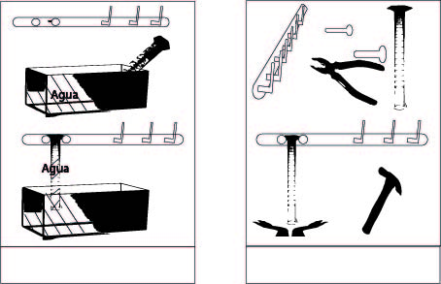Likewise, the fish bowl will be positioned near the bar where the nails are placed and a large part of the volume will be filled with the use of the bowl, consequently, we will hold the test tube and submerge it under water so that it fills completely, to which it will be taken out with the nozzle pointing downwards so that the water does not spill so that, in such a way, it can be placed between the nails placed. On the other hand, the position of the lighters will be placed inside a drawer so that they do not tend to fall or an accident occurs, in the same way with the electronic scale.

**Figure 3**

 *System scheme*

## 2.6 Diagram

**Figure 4**

*System scheme*

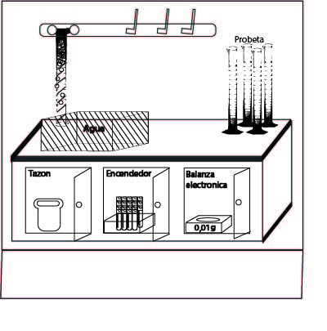

*Note. All the instruments were disinfected, in addition, for the care of the experimenter, the test tubes were washed after each repeatable test since the gas remained inside them.*

## 2.7 Procedure for data collection

A lighter will be held and submerged to establish it inside the mouthpiece of the test tube, by pressing the button of the pressure lighter, the gas will begin to emerge in the form of bubbles, this action being carried out until the occupied volume is 200 ml. after that process, it will be removed to be cleaned with a cloth and left to rest for 1 minute. Once the mentioned time has elapsed, the mass consumed in that process will be calculated, for this we will subtract the mass of the initial lighter from the mass of the lighter with which it was experimented, after the mass of the gas consumed will be noted and the procedure will be carried out again, the same process sequentially, that is, after that, it would correspond to occupying from 200 ml to 400 ml, and so on until the entire test tube was filled, thus collecting 5 data. After the latter, another test tube is taken and the same procedure will be carried out, except that the proportion to be used will no longer be 200 ml, but will be 400 ml, and although the 5 repeated tests cannot be carried out in one test tube, the quantity will be carried out. maximum to change to another test tube and continue with the experimental process, doing it until the proportion reaches the value of 1000ml, obtaining a total of 25 data for the 25 repeated tests.

**Figure 5**

*Data collection*

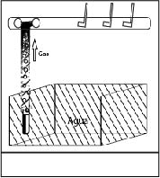

# CHAPTERS III. RESULTS AND ANALYSIS

## Relationship between volume and mass

**Table 4**

*Relationship between volume and mass*

|  |  |  |  |  |  |  |  |
| --- | --- | --- | --- | --- | --- | --- | --- |
|  |  | | | | | |  |
|  | $$Try 1$$ | $$Try 2$$ | $$Try 3$$ | $$Try 4$$ | $$Try 5$$ | $$Average$$ |
| $$(0-200)$$ | $$0,46$$ | $$0,44$$ | $$0,44$$ | $$0,48$$ | $$0,43$$ | $$0,450$$ | $$0,1$$ |
| $$(0-400)$$ | $$0,88$$ | $$0,9$$ | $$0,92$$ | $$0,93$$ | $$0,94$$ | $$0,914$$ | $$0,1$$ |
| $$(0-600)$$ | $$1,31$$ | $$1,36$$ | $$1,34$$ | $$1,31$$ | $$1,35$$ | $$1,334$$ | $$0,1$$ |
| $$(0-800)$$ | $$1,75$$ | $$1,79$$ | $$1,84$$ | $$1,72$$ | $$1,82$$ | $$1,784$$ | $$0,1$$ |
| $$(0-1000)$$ | $$2.23$$ | $$2,39$$ | $$2,26$$ | $$2,27$$ | $$2,28$$ | $$2,286$$ | $$0,1$$ |

Average:

=

= 

= 

Total uncertainty: At the top of the chart you can see the uncertainty  this is due to the uncertainty of the measuring instrument, in addition the uncertainty of the average mass is  which is due to the dispersion of the data. Finally, the total uncertainty would be the sum of the uncertainty of the instrument plus the uncertainty of the average. ,turning out in this way, and since it is worked with two significant figueres 

Porcentage uncertainty



This result indicates that the dispersion of the data is within the tolerable range.

**Figure 6**

*Mass vs volume graph*

It is observed that the line of best fit is a straight line, in addition, the line of maximum slope and the line of minimum slope can be observed, from which we will obtain the following data: the equation of the "recta de mejor ajuste” , the theoretical equation  the equation of the “recta de máxima pendiente” , and the equation of the “recta de mínima pendiente” , from these last two, the uncertainty of the slope of the line of best fit can be obtained , therefore the gradient, that is, the measure of the inclination of the line of best fit is . On the other hand, it is observed how the line of best fit does not pass through the origin, which is why the uncertainty of the independent value  has as quantitative value, Given what was found and the graph shows the mathematical model , which quantitatively relates the variables of mass and volume. Likewise, the horizontal error bars, unlike the vertical ones, are not evident since the numerical values ​​are extremely small.

## 3.2 Relationship between volume and molecular mass

**Table 5**

*Relationship between volume and molecular mass*

|  |  |  |  |  |  |  |  |
| --- | --- | --- | --- | --- | --- | --- | --- |
|  |  | | | | | |  |
|  |  |  |  |  |  | $$Average$$ |
| $$(0-200)$$ | $$57,0$$ | $$54,6$$ | $$54,6$$ | $$59,5$$ | $$53,2$$ | $$55,8$$ | $$16,1$$ |
| $$(0-400)$$ | $$54,6$$ | $$55,8$$ | $$57,0$$ | $$55,7$$ | $$58,3$$ | $$56,3$$ | $$14,3$$ |
| $$(0-600)$$ | $$54,2$$ | $$56,2$$ | $$55,4$$ | $$54,2$$ | $$55,8$$ | $$55,2$$ | $$13,4$$ |
| $$(0-800)$$ | $$54,3$$ | $$55,5$$ | $$57,0$$ | $$53,3$$ | $$56,4$$ | $$55,3$$ | $$14,3$$ |
| $$(0-1000)$$ | $$55,3$$ | $$59,3$$ | $$56,1$$ | $$56,3$$ | $$56,5$$ | $$56,7$$ | $$14,4$$ |

Molecular Mass:







.

In which, after operating the division between the mass  and the volume whose result has been the density, is obtained as a quantitative result , being this way, as happens to multiply with the ideal gas constant and the temperature , thereby obtaining the Molecular Mass with its respective uncertainty , thus implying that the numerical value of the uncertainty is variable since it depends on both the dependent and independent variable, that is, on the mass and volume

Average:

=

= 

= 

Total uncertainty: It is obtained after adding the average of the varying uncertainties of the Molecular Mass with, the uncertainty of the average between the highest value and the lowest value,  thus obtaining the total uncertainty of the first repeated set $16,1$

Porcentage Uncertainty



**Figure 7**

*Volume vs molecular mass graph*

 It is possible to appreciate how the line of best fit is linear, likewise, it is noteworthy the line of maximum slope and minimum slope, from which the equation of the “recta de mejor ajuste”, the equation of the “recta de máxima pendiente ” and the equation of the “recta de mínima pendiente “ from this the uncertainty of the slope of the line of best fit can be obtained , it is then that the measure of steepness of the line of best fit is . Also, the horizontal error bars are not noticeable since the numerical value is very small.

## Chapter IV. CONCLUSIONS

## Conclusions

### In summary, after the two graphs obtained, we can justify the research question. This is evidenced in figure 6, where it can be seen how the "linea de mejor ajuste" tends to show a directly proportional relationship between the independent and dependent variable. Likewise, after the experimentation, what was deduced in the hypothesis is confirmed since, by releasing more gas from the lighter, it would occupy a greater volume, it is from this that the proportional relationship is untied. In turn, figure 7 supports what has been explained since the Molecular Mass must be invariant in the face of a relationship with the volume; This can be appreciated by observing how its "linea de mejor ajuste" tends to be parallel with the abscissa axis. In addition, through the Molecular Mass values ​​that address the error bars, the gas used can be discovered, which is effectively Butane.

### Regarding the gradient of figure 6, it shows an inclination whose slope value is $0,0023$, which shows a positive inclination, in the same way, it is argued that this numerical value has been the density, since its units are $g/ml$, that is why it could be contrasted with the theoretical value of butane gas, being a minimal difference, which may exist the latter since the theoretical value is worked at normal conditions and not at environmental conditions like the present work. In turn, the line of best fit does not intersect at the origin. Similarly, the mathematical model of the line of best fit $0,0023x-0,009$, is reliable since it passes close to the points represented in the graph, proving that the range of validity is high since the coefficient of determination $R^{2}=0,9991$ tend to $1$, likewise, This can be reinforced when comparing with the formulation of the theoretical Mass-Volume graph, which in this case is $0,0024x,$ whose coefficient of determination is $R^{2}=1$. This shows how both equations differ in the existence of the independent value, in addition to one ten thousandth in the slopes, so that the gradients of the “line de mejor ajuste” $0,0023 ±0,0006$ and the theoretical gradient $0,0024$ are relatively equivelant, It is therefore that the precision and accuracy of the value obtained after the experience is reliable. On the other hand, with respect to figure 7, the equation $0,0006+55,538$, presents an uncertainty close to number 0, being favorable given that, when developing the experimentation, the type of gas was not changed, thus being the independent value $55,538$ whichever represents the molecular mass of the gas, in the same way, when contrasting with the theoretical value of butane which is $58,2$, a certain distinction can be appreciated. However, the latter could have been affected since the experimentation is carried out at ambient conditions and not at normal conditions, as is the theoretical value..

### The main inconsistency that stands out in the Mass-Volume graph is the non-intersection at the point of origin, in the same way with the second Volume-Molecular Mass graph, which, unlike the previous one, should be clearly parallel to the axis $x$. The main inconsistency that stands out in the Mass-Volume graph is the non-intersection at the point of origin, in the same way with the second Volume-Molecular Mass graph, which, unlike the previous one, should be clearly parallel to the axis $22,2\%$ with the error of the dependent variable $26,1\%$ differs in $3,9\%$

## Assessment

### Regarding the evaluation, it is considered that the only error that was made by the researcher was the frequent elaboration of the repeated experimentation, that is, since there was not a prudent time to carry it out with stability, it implied that the data could contain errors. being that, although there has been a minute of rest so that the lighter can be used again and in this way obtain a better precision of the dependent variable, it does not clearly imply that all the water in which it had been submerged has dissipated given that it felt humid, quite a lot, letting it rest in a not so warm place would affect the time necessary for it to dry completely, which factor was not taken into account and this possibly caused the dependent variable to have errors, which resulted when restoring the initial value of the igniter that contained the mass of the gas by default with the new mass reduced after the experimental process, being the water the one that could have increased in weight, given that even if it is minimal, it is remembered that minimum values ​​were also being worked on. However, it is considered that this error caused by the investigator is not so relevant due to the fact that the uncertainties justify its validity.

### In turn, the theoretical straight line reinforces and justifies the work to a great extent since the slopes: theoretical and experimental, have a similar value. This can also be shown graphically by observing that both lines are very close. And while they are not parallel, this could be because the work was done experimentally, where inherently mistakes are made or exist.

### Improvements

### It is considered that, in the construction of the experimental design, detailed points should be taken that may affect the data collection, and it is on this that the amount of materials available depends, so that, as long as the experimental field is built at base or with great support of devices obtained, the final result will be much more reliable, an example of this is the limitation of a software that indicates the exact volume that was occupied with a certain mass used, and it is given that by not obtaining that device, the researcher made use of qualitative perception by observing and trying to determine the amount of volume that could have been filled; so such mentioned point should be changed to get better results. Likewise, evidencing that they were working with minimum units, the devices should have a very exact precision. However, the latter was a limitation since the work was done with an electronic scale with a minimum capacity of one hundredths of a gram, which could be improved by changing such a device for another with a much smaller measurement such as atomic scales.

# References

Allum, J. y Talbot, J. (2015). *Física* (2 ed.). Lima: Vicens Vives. Consultado el 22 de diciembre de 2021. https://www.scribd.com/document/382284620/PhysicsIB-John-Allum-y-Christopher-Talbot-2-E-Vinces-Vices-2015

Bureau International des Poids et Mesures. (2019). *The international system of utnits.* Pariz, Francia. Consultado el 2 de febrero de 2021. https://www.bipm.org/documents/20126/41483022/SI-Brochure-9-EN.pdf/2d2b50bf-f2b4-9661-f402-5f9d66e4b507

Cengel, A. &. (2009). *Termodinámica* (6 ed.). (V. G. Sarmiento, Trad.) Mexicana: McGRAW-HILL/. Consultado el 22 de enero de 2021. https://www.academia.edu/35703679/Termodin%C3%A1mica_6ta_Edici%C3%B3n_Yunus_A_%C3%87engel_y_Michael_A_Boles_FREELIBROS_ORG_pdf

Centro de Estudios Preuniversitarios de la Universidad Nacional de Ingeniería. (2004). *Química* (Vol. edic. 3). (P. Lic. Huaman, Ed.) Lima, Perú. Consultado el 22 de diciembre de 2020.

Feynman, R., Leighton, R. y Sands, M. (1963) The Feynman Lectures on Physics (Vol. 1). New York: Basic Book. Consultado el 16 de mayo de 2021. https://www.academia.edu/28997045/The_Feynman_Lectures_on_Physics_VOL1?fbclid=IwAR1VcVQWKTwpnVbs02ZkHaOqKm_MLSkBxUhkyUhjC-ycCN9obG0wdN9f-qo