Do original tweets and retweets differ in indicating research impact across various subject areas in multidisciplinary papers published in PLoS?
Ashraf Maleki* and Kim Holmberg**

*ashraf.maleki@utu.fi
https://orcid.org/0000-0002-8223-4833
Department of Social Research, University of Turku, Finland

** kim.j.holmberg@utu.fi
https://orcid.org/0000-0002-4185-9298
Department of Social Research, University of Turku, Finland

Twitter.com (recently known as X) is a popular platform to discuss and share scientific articles. Earlier altmetrics studies have often focused on investigating whether the number of tweets mentioning scientific articles could be used as an indicator of scientific impact or attention, with results showing weak to moderate correlations with citation counts and some disciplinary differences. But all tweets may not be equal, as original tweets and retweets may reflect different levels of engagement and, with that, impact. This research analyzed whether the correlation between citations and original tweets differs from that between citations and retweets and whether there is any disciplinary difference between the two. For this purpose, the relationship between original tweets and retweets and Scopus citations was analyzed for a total of 330,022 PLoS publications and compared over time and across subject fields. The findings showed that the correlations were strongest between citations and original tweets, and the relationship was stronger in Social Science and Humanities subject fields than in Natural Science, Engineering and Medicine. The results showed that tweets and retweets are very different, and thus they should be considered two different metrics and analyzed separately.

1. Introduction
Twitter.com (recently known as X) is a popular social media platform where users (often called tweeters) can publish and share content to their network of followers. Through retweeting tweeters can easily disseminate content that someone else has originally published. While creating an original tweet can take a bit of effort, retweeting can easily be done just by clicking or tapping on a button, thus it seems fair to say that retweeting doesn’t require as much effort as tweeting does. Because of that we can also argue that retweeting signals less engagement than creating and publishing an original tweet does. In altmetrics, i.e., the measuring of engagement or attention that scientific outputs have received online, Twitter is one of the main data sources, as there is significant activity around scientific articles on the platform (Costas et al., 2015; Haustein et al., 2015). Often in altmetrics research tweets and retweets are counted as one measure, without making any distinction between them. We argue that because the two acts are fundamentally different, indicating different levels of engagement and possibly attention or impact, combining them in statistical analyses can potentially yield different outcomes than each separately. The goal of this research is to investigate whether this is true, and whether original tweets and retweets should be analyzed separately in altmetric research.

2. Background
Much of early altmetrics research focused on examining whether altmetrics could be an alternative to traditional citation-based measures of impact. The research focused on testing for correlations between tweets and citation counts, providing some mixed results with large scale studies (e.g., Barthel et al., 2015; Costas et al., 2014, 2015) showing lower correlations between tweets and citations than studies with more focused, journal or discipline specific samples (e.g., Eysenbach, 2011; Shuai et al., 2012). Earlier research has also discovered disciplinary differences in how scientific articles get tweeted, as scientific articles from social sciences and biomedical and health sciences tend to attract more attention on Twitter than articles from mathematics and computer science, and natural sciences and engineering (Costas et al., 2015; Haustein et al., 2015). Other characteristics too, such as the length of the article (Haustein et al., 2015), OA status (Holmberg et al., 2020), and research funding (Didegah et al., 2018), may be connected to the attention scientific articles receive on Twitter. A more recent study investigated how different types of user engagement behaviors on Twitter, i.e., liking, retweeting, quoting, and replying, were used in connection to scholarly content (Fang, Costas, & Wouters, 2022). The results showed that while likes (44%) and retweets (36%) were frequently used, quotes (9%) and replies (7%) were less frequent. While earlier research has already shown disciplinary differences in the uptake of scientific articles on Twitter (e.g., Haustein, Costas, & Lariviére, 2015), and how researchers use Twitter (Holmberg & Thelwall, 2014), the results by Fang, Costas, and Wouters (2022) showed that there are disciplinary differences also in the ways with which users engage with scientific content on Twitter. But do the disciplinary differences extend to both tweeting and retweeting? Or are the possible differences evened out if tweets and retweets are treated as same? This research investigates possible disciplinary differences between tweeting and retweeting, as well as if there are any differences in how citation counts correlate with the number of tweets and retweets.

3. Method

3.1. Data
A total of 330,022 PLoS publications published between 2003-2023 were extracted from Scopus in April 2023. The extracted publications were published in nine PLoS journals and eight proceedings, with majority of the papers (94%) being journal articles. Altmetric.com was used to extract separate datasets of 1) all tweets and 2) original tweets, which were then used to count the number of retweets for each paper.

3.2. Subject fields
As all PLoS papers are only classified as multidisciplinary in Scopus, we used the classification made by Dimensions and used by altmetric.com (Australian and New Zealand Standard Research Classification 2020 (ANZSRC)) to assign subject fields to each article. For the analysis we used the first subject field assigned to each paper.
Table 1 shows the number of publications when counting only with the first subject field assigned. The first 11 fields in Table 1 are from Natural Science, Engineering and Medical and Health Sciences (STEM) and the second 11 fields are from Social Science and Humanities (SS&H). Of all the publications about 19% have not been assigned to a field; these mostly were Erratum and non-tweeted.

Table 1. Number of PLoS papers according to first subject field assigned to publications.

Broad field | Fields of Research (FoR) | First field
STEM | Mathematical Sciences | 7,787
 | Physical Sciences | 1,506
 | Chemical Sciences | 2,855
 | Earth Sciences | 2,142
 | Environmental Sciences | 8,631
 | Biological Sciences | 92,008
 | Agricultural and Veterinary Sciences | 1,637
 | Information and Computing Sciences | 6,984
 | Engineering | 2,555
 | Technology | 851
 | Medical and Health Sciences | 123,711
SS&H | Built Environment and Design | 27
 | Education | 818
 | Economics | 1,984
 | Commerce, Management, Tourism and Services | 498
 | Studies in Human Society | 1,854
 | Psychology and Cognitive Sciences | 10,496
 | Law and Legal Studies | 123
 | Studies in Creative Arts and Writing | 84
 | Language, Communication and Culture | 529
 | History and Archaeology | 792
 | Philosophy and Religious Studies | 100
No subject assigned |  | 62,050
Total |  | 330,022

3.3. Analysis
To analyze the possible relationship between citations and all tweets, original tweets and retweets, comparisons across fields and over time were conducted. For this purpose, proportion non-zero and Geometric mean of citations, tweets and retweets were calculated and normalized for comparisons between subject fields and with the world average (here, all PLoS publications). The data was first prepared (Thelwall, 2017) and then the calculations were conducted with Webometric Analyst (lexiurl.wlv.ac.uk).
- Normalized Proportion non-zero was used as an estimate for publications with non-zero Scopus citations, tweets and retweets, with a 95% confidence interval.
- World normalised proportion non-zero of metrics (EMNPC) were used for comparisons. EMNCP values for fields are compared for any variation from the world average (=1).
- Geometric mean was calculated based on the logarithm of raw metric counts + 1 or ln(1+raw data), as proposed by Thelwall (2017) and all calculation were in 95% confidence interval.
- World normalised mean metrics (MNLCS) were calculated on log-transformed data of ln(1+raw data) and calculated in 95% confidence interval. MNLCS values also need to be compared with value one which represents the world average.
The calculations for world normalization are detailed in Thelwall (2017).

4. Findings

4.1. Normalized Proportion Cited
Figure 1 shows that the total publication frequency of PLoS had significantly increased from 87 in 2003 to just below 35,000 in 2013, after which the level drops and remains at around 20,000 annually. The proportion non-zero citations show a cumulative increase over time, the number of publications mentioned in tweets rose from about 20% in 2010 (about the time when altmetric.com started to collect tweets) to 76% in 2016 and then a fall to about 65% in 2022. The proportion non-zero retweets shows a delayed rise since 2013, rising to 40% by 2018, levelling off after that, while proportion tweeted has slightly dropped in the same period.

Figure 1: Frequency of total publications, publication cited, tweeted and retweeted and normalized proportion non-zero in the metrics

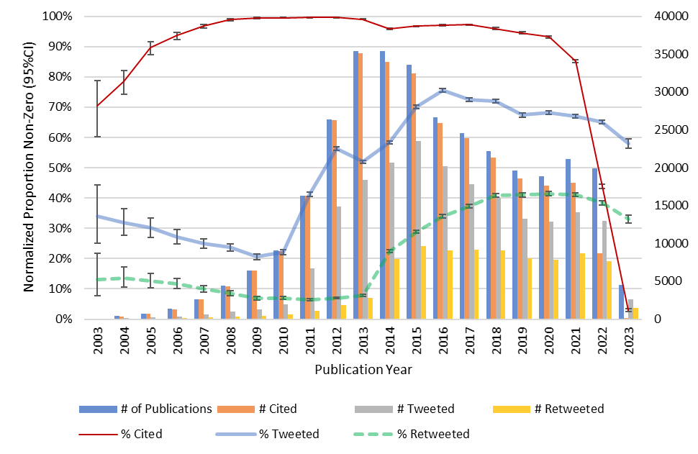

Presenting the results from the normalized proportion non-zero of metrics, Figure 2 shows that on average 92% of publications in STEM fields had been cited, while only 82% in SSH fields had received citations. On average, 75% of articles in STEM had been tweeted, compared to 85% in SSH, while only 35% of STEM articles and 50% of SSH articles had been retweeted.

Figure 2: Normalized proportion cited, tweeted and retweeted across fields.

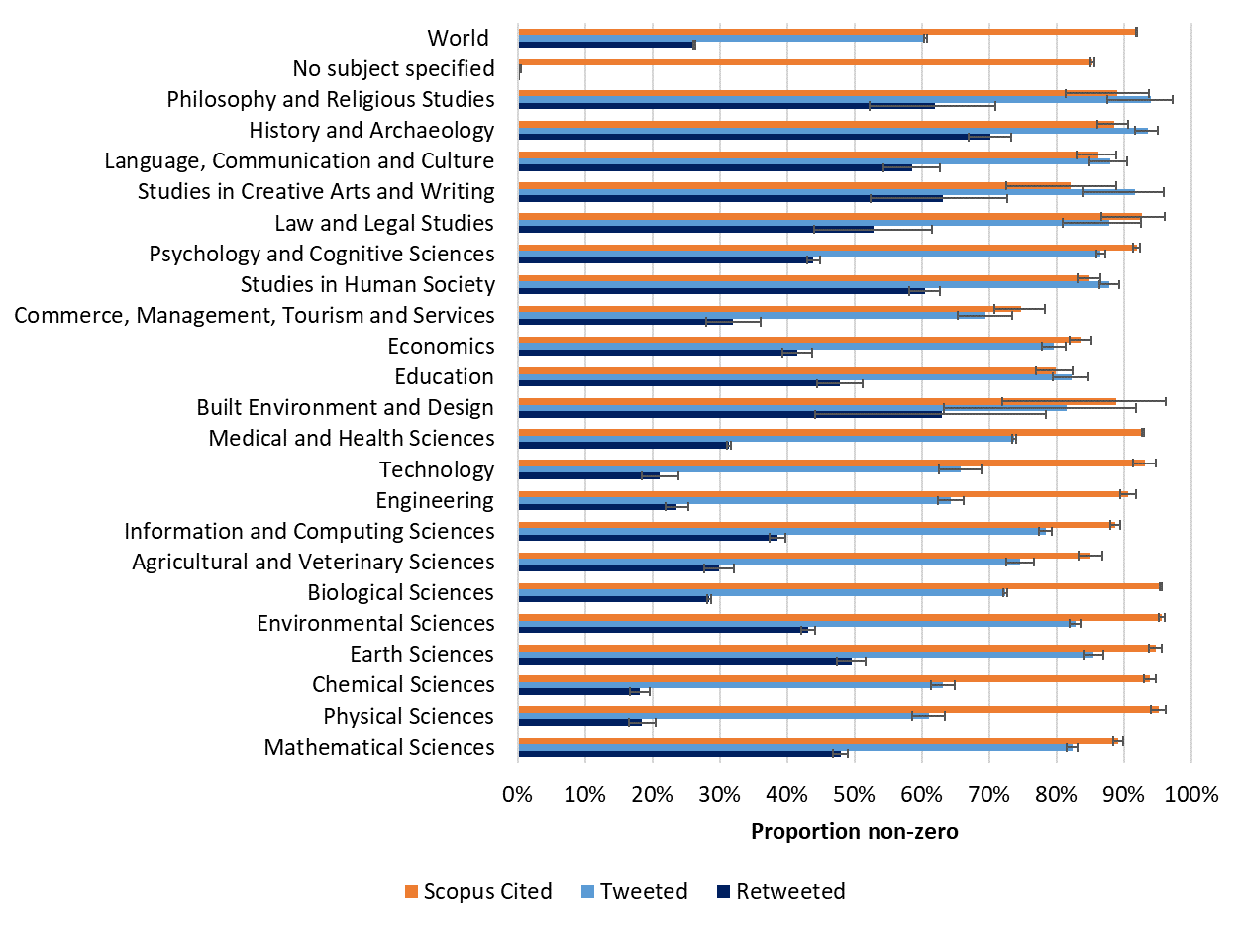

4.2. World normalised proportion non-zero for metrics or EMNPC
Figure 3 shows that after world normalization of proportions non-zero, both tweets and retweets appear significantly above world average in SSH fields for STEM the results are mixed both below and above the world average. Mathematical Science, Earth Science, Environmental Science and Information and Computing Sciences all show EMNCP >1 for tweets and > 1.5 for retweets, while all the other STEM fields remain below the world average. The results also showed that the diversion from the world average for retweets is at higher magnitude than for original tweets across all fields; for above world average counts, the proportion non-zero retweets was significantly higher than for tweets, and for below world average counts, the proportion non-zero retweets was significantly lower than for tweets. This may suggest a greater discrepancy across fields in terms of retweeting behaviour.

Figure 3: World normalized proportion cited, tweeted and retweeted across fields.

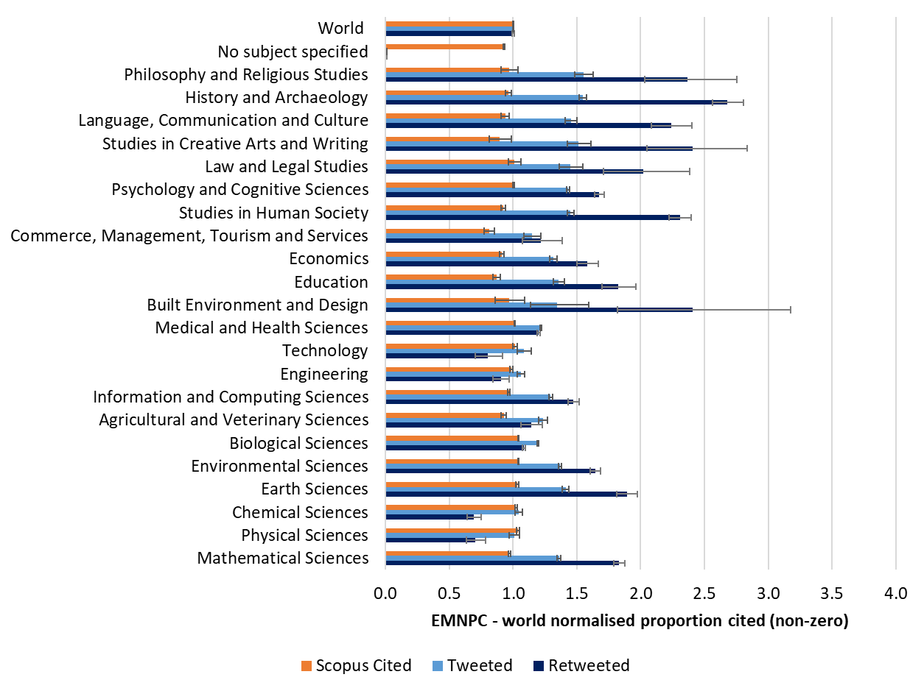

4.3. Geometric mean Citations vs. Original tweets and Retweets
Figure 4 illustrates the changes in geometric mean metrics over time, showing that the geometric mean for citations peaked at about 49 in 2008 before gradually dropping over years. The trend is, however, almost reversed for the metrics from Twitter, showing a slow drop between 2003 and 2009 (<1) before rising to about 3 for total tweets in 2018 (about 2 for original tweets and 1.25 for retweets), soon after which they too start to fall. The average geometric mean citations across STEM fields is 14, while about 9 across SS&H fields. In contrast, the average geometric mean all tweets, original tweets and retweets across STEM fields (3, 2 and 1, respectively) is approximately half the SS&H fields (6, 4, and 2).

Figure 4: Geometric mean Scopus citations, tweets, original tweets and retweets over years.

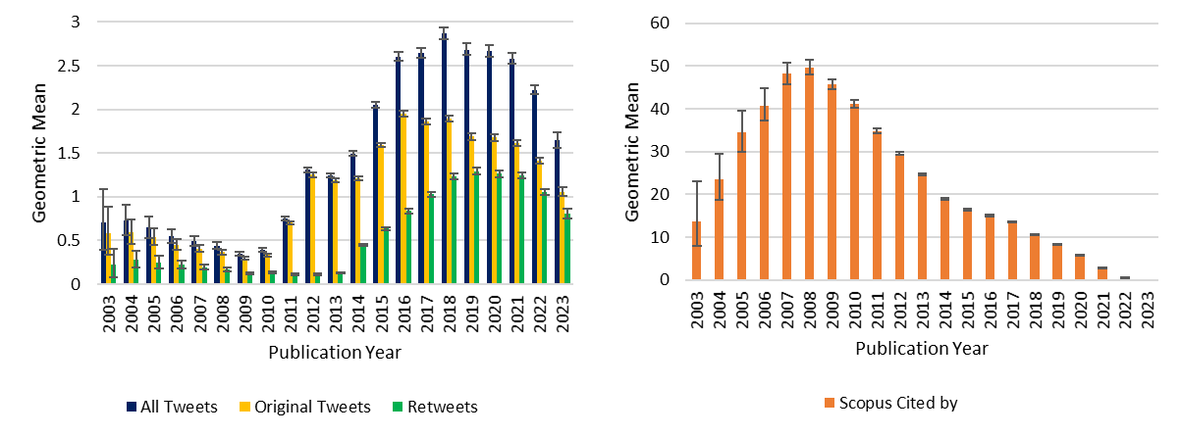

4.4. World normalised mean metrics or MNLCS
The mean of world normalized ln(1+ raw metric values) metrics from Twitter mentions indicate subject bias (Figure 6). In STEM fields, such as Chemical Science, the results are below the world average for tweets and retweets, while slightly above it for citations, but the case is very different for the SS&H fields. A majority of SS&H fields perform below world average in citations, but significantly above the world average in tweets and original tweets (up to 1.5 times the world average) and 3.5 times the world average in retweets (e.g., History and archaeology, and Creative arts and writing).

Figure 6: Mean of world normalized ln(1+raw citation, tweet, or retweet count) across fields.

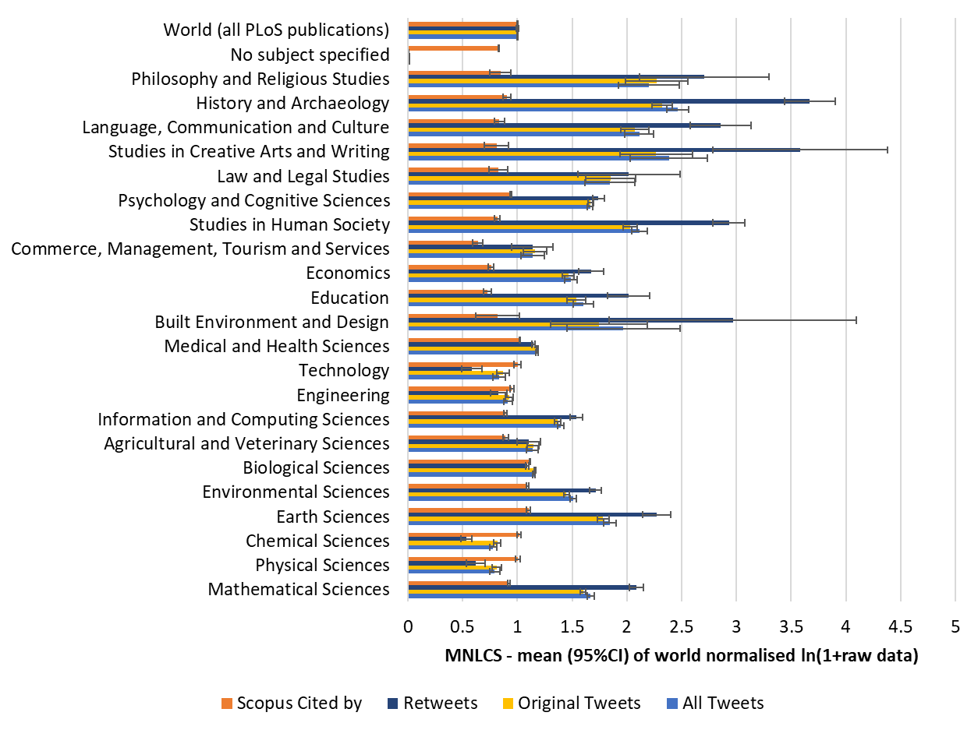

4.5. Spearman’s Correlation between Citations and different types of tweets
Table 2 gives the number of total publications, and publications with at least one citation, original tweet and retweet over the period of 2010-2023. This table helps to figure out the count of papers in the Spearman’s correlation analysis including zeros and only non-zeros in the Figure 7. The correlation coefficients between citations and all tweet metrics showed stronger correlations when the zeros, i.e., articles with no citations or tweets, were included in the calculation (Figure 7). The correlations were weak but significant across the line. The strength of the relationship between citations and tweets has, however, first increased over time and then from 2019 started to fall, suggesting that citation takes time to be accrued and hence the relationships with citations lack strength. Furthermore, as of STEM fields when zero metric counts are included, the correlation coefficients were slightly stronger for all tweets than original tweets from 2011 (r = .157 > .151, respectively) through 2018 (r = .299 > .296), however the trend is reversed since 2019 (r = .299 < .303) when the relationship appears to be slightly stronger between citations and original tweets than for all tweets in both zero-included and non-zero datasets.

Table 2: Count of all publication, and publication with at least one Scopus citations, a tweet, or a retweet over time.

Publication year | STEM |  |  |  | SS&H
 | publications | cited | tweeted | retweeted | publications | cited | tweeted | retweeted
2010 | 6,506 | 6,492 | 1,873 | 585 | 223 | 223 | 124 | 47
2011 | 11,994 | 11,958 | 6,298 | 943 | 539 | 538 | 419 | 113
2012 | 20,849 | 20,794 | 13,842 | 1,657 | 1,050 | 1,046 | 944 | 179
2013 | 26,624 | 26,496 | 17,100 | 2,447 | 1,416 | 1,406 | 1,225 | 317
2014 | 26,094 | 25,762 | 19,186 | 7,244 | 1,426 | 1,407 | 1,248 | 658
2015 | 27,204 | 26,780 | 21,687 | 8,661 | 1,676 | 1,658 | 1,511 | 925
2016 | 22,343 | 21,823 | 18,293 | 8,202 | 1,477 | 1,428 | 1,358 | 811
2017 | 20,246 | 19,813 | 16,260 | 8,345 | 1,357 | 1,320 | 1,252 | 737
2018 | 16,921 | 16,519 | 14,318 | 8,142 | 1,497 | 1,448 | 1,331 | 841
2019 | 14,145 | 13,690 | 11,846 | 7,204 | 1,286 | 1,235 | 1,056 | 751
2020 | 13,506 | 12,917 | 11,319 | 6,880 | 1,328 | 1,242 | 1,066 | 741
2021 | 14,368 | 12,674 | 11,353 | 7,124 | 1,650 | 1,404 | 1,213 | 780
2022 | 14,672 | 6,852 | 5,785 | 3,741 | 1,667 | 705 | 552 | 354
2023 | 2,980 | 104 | 90 | 63 | 427 | 14 | 9 | 7

Figure 8 illustrates a heatmap of the correlation coefficients between Scopus citations and the three metrics of all tweets, original tweets, and retweets across subject fields for zero and non-zero datasets. The findings suggest that the median correlation coefficient of Scopus citations across fields is highest with original tweets (median r = .310), while weak but significant with retweets (median r = .087). However, for the SS&H subject fields the median correlation coefficients between citations and original tweets were at medium level (median r = .409), in contrast to the weak correlation in STEM subject fields (median r = .162).
Including zero metric counts in the datasets resulted in stronger correlation coefficients between citation and all the other metrics in SS&H fields (median r with original tweets = 0.409 in zero-included dataset, 0.329 in non-zero dataset), but weaker in STEM subject fields (median r = 0.175 in non-zero dataset, r = 0.149 zero-included dataset). It would appear that tweets are moderately likely to align with traditional research impact in SS&H, but they indicate only a weak relationship and a limited usage in STEM subject fields.

Figure 7: Spearman’s correlation coefficients between Scopus citations and all tweets, original tweets and retweets over time.

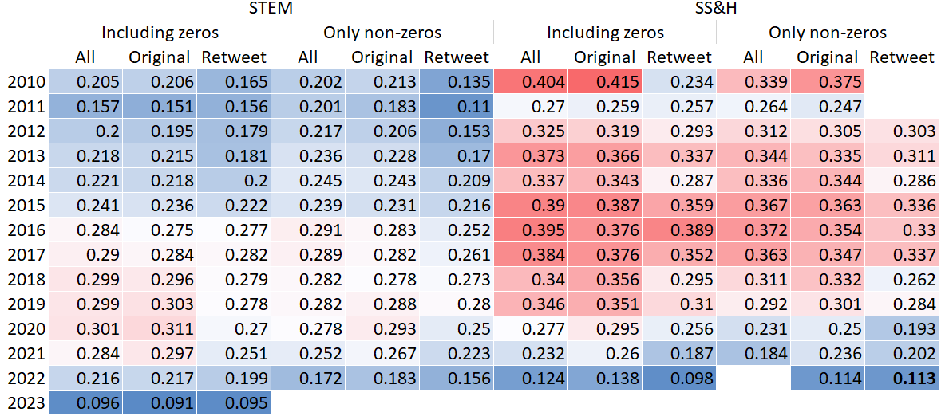

Figure 8: Spearman’s correlation coefficients between Scopus citations and all tweets, original tweets and retweets across fields. The empty cells indicate no statistical significance (p > .05).

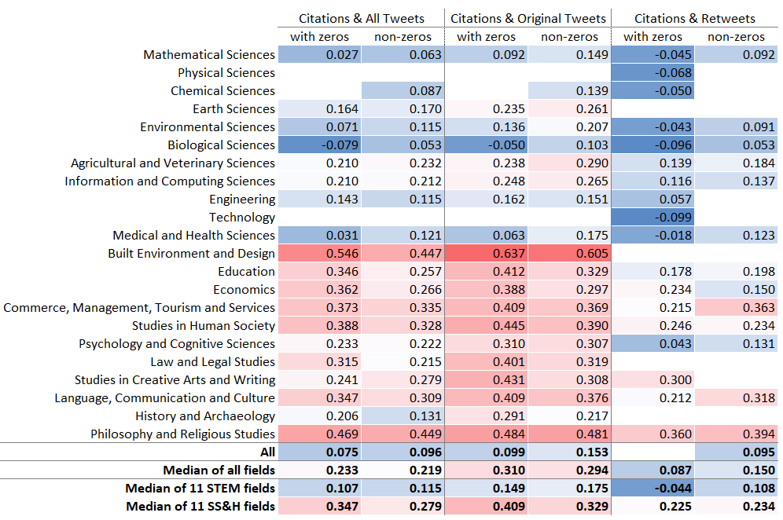

5. Discussion
Current study compared citations, original tweets, and retweets, as measures of impact assessment. The results were in line with some of the findings in earlier research (e.g., Costas et al., 2015; Haustein et al., 2015). The results showed clear disciplinary differences in how scientific articles had been mentioned and shared on Twitter, but it was also discovered that scientific articles in Social Science and Humanities receive up to 2 to 3 times as much retweets as the world average, compared to Natural Science and Engineering which were below the world average. The results also showed the distinct impact implication of Original tweets and retweets as the correlations between citations and original tweets were clearly stronger than between citations and retweets, and the correlations overall were stronger for SS&H subject fields, than STEM subject fields. The results clearly point at the differences between original tweets and retweets, confirming that the two do reflect different types of metric and therefore, should be treated separately, at least when it comes to altmetrics research. Although the differences between original tweets and all tweets is slight, the strength of correlation appear to be slightly more in favour of original tweets at field level and when analysing more recent (past five years) publications. Thus, the recognition of significant disparities between all tweets, original tweets and retweets serves as a foundation for discussing the reconsiderations needed in employing composite metrics such as RG score and Altmetric Attention Score. This observation naturally leads to a need for more research to understand the detailed dynamics of distinct forms of social media interactions and their roles in scholarly communication.

Funding information
This research was funded by the Academy of Finland (funding decision: 332961).

References
Barthel, S., Tönnies, S., Köhncke, B., Siehndel, P., & Balke, W.T. (2015). What does twitter measure? Influence of diverse user groups in altmetrics. In Proceedings of the 15th ACM/IEEE-CE on Joint Conference on Digital Libraries (pp. 119–128). Knoxville, Tennessee, USA: ACM Press. http://doi.org/10.1145/2756406.2756913.

Costas, R., Zahedi, Z., & Wouters, P. (2014). Do “altmetrics” correlate with citations? Extensive comparison of altmetric indicators with citations from a multidisciplinary perspective. Journal of the Association for Information Science and Technology, 66(10), 2003–2019. https://doi.org/10.1002/asi.23309

Costas, R., Zahedi, Z., & Wouters, P. (2015). The thematic orientation of publications mentioned on social media: Large-scale disciplinary comparison of social media metrics with citations. Aslib Journal of Information Management, 67, 260– 288. http://doi.org/10.1108/AJIM-12-2014-0173.

Didegah, F., Bowman, T.D., & Holmberg, K. (2018). On the differences between citations and altmetrics: An investigation of factors driving altmetrics vs. citations for Finnish articles. Journal of the Association for Information Science and Technology, vol. 69, no. 6, pp. 832-843. DOI: 10.1002/asi.23934.

Eysenbach, G. (2011). Can tweets predict citations? Metrics of social impact based on twitter and correlation with traditional metrics of scientific impact. Journal of Medical Internet Research, 13, e123– e123. http://doi.org/10.2196/jmir.2012.

Fang, Z., Costas, R. & Wouters, P. (2022). User engagement with scholarly tweets of scientific papers: a large-scale and cross-disciplinary analysis. Scientometrics 127, 4523–4546. https://doi.org/10.1007/s11192-022-04468-6

Haustein S, Costas R, Larivière V (2015). Characterizing Social Media Metrics of Scholarly Papers: The Effect of Document Properties and Collaboration Patterns. PLOS ONE 10(5): e0127830. https://doi.org/10.1371/journal.pone.0127830

Holmberg, K. & Thelwall, M. (2014). Disciplinary differences in Twitter scholarly communication. Scientometrics, vol. 101, no. 2, pp. 1027-1042. DOI:10.1007/s11192-014-1229-3.

Holmberg, K., Hedman, J., Bowman, T.D., Didegah, F., & Laakso, M. (2020). Do articles in open access journals have more frequent altmetrics activity than articles in subscription-based journals? An investigation of the research output of Finnish universities. Scientometrics, vol. 122, pp. 645-659. DOI : 10.1007/s11192-019-03301-x.

Thelwall, M. (2017). Web indicators for research evaluation: A practical guide. San Rafael, CA: Morgan & Claypool.

https://www.abs.gov.au/AUSSTATS/abs@.nsf/mf/1297.0

