How similar are field-normalized scores from different free or commercial databases calculated for large German universities?

Thomas Scheidsteger *, Robin Haunschild *, and Lutz Bornmann *,**

*t.scheidsteger@fkf.mpg.de; r.haunschild@fkf.mpg.de; l.bornmann@fkf.mpg.de
0000-0001-8351-2498; 0000-0001-7025-7256; 0000-0003-0810-7091
IVS-CPT, Max Planck Institute for Solid State Research, Stuttgart, Germany

**lutz.bornmann@gv.mpg.de
0000-0003-0810-7091
Science Policy and Strategy Department, Administrative Headquarters of the Max Planck Society, Germany

We compared field-normalized citation scores from the freely available bibliographic database OpenAlex with those from three commercial databases (Web of Science, Scopus, and Dimensions). The scores have been calculated for nearly 335,000 publications published by 48 German universities in four OECD subject areas between 2013 and 2017. We found varying but overall strong agreement according to Lin’s concordance coefficient. We also calculated (aggregated) mean normalized citation scores for the 48 universities and found that the agreements across different databases are low. On the one hand, the results suggest that comparisons of universities using field-normalized citation scores across different databases should be avoided. On the other hand, the difference of the concordance coefficients on the paper and university level is a good example for the problem of ecological fallacy in bibliometrics: The mean impact is not representative for the single papers’ impact in the set.

1. Introduction
Research evaluation using bibliometric methods is frequently based on commercial bibliographic databases that have similar approaches to select journals for including papers in the database and to ensure the quality of included papers: Web of Science (WoS) and Scopus (Baas, Schotten, Plume, et al., 2020; Birkle, Pendlebury, Schnell, et al., 2020). Dimensions is another commercial bibliographic database that provides an alternative to WoS and Scopus including many more publications (Herzog, Hook, & Konkiel, 2020). With the emergence of Microsoft Academic Graph (MAG) in 2015, a free bibliographic database with an outstanding coverage (Sinha, Shen, Song, et al., 2015; Wang, Shen, Huang, et al., 2020) emerged. Since Microsoft decided to discontinue MAG, the successor database OpenAlex was started by Priem, Piwowar, and Orr (2022). With the many databases that are available in principle for research evaluation purposes, the question arose whether all databases come to similar results in a certain research evaluation situation.

In a first case study, Scheidsteger, Haunschild, Hug, et al. (2018) analyzed the publications of a computer science institute with a well-maintained publication list. They chose a bibliometric standard indicator (a field-normalized indicator) and tested whether the indicator scores are similar across two different databases. Thus, they investigated the convergent validity of field-normalized indicator scores that have been generated based on MAG and WoS data. The results were encouraging (i.e., the values were in a good agreement) and motivated the present study with a significantly enlarged publication set from 48 German universities that cover a broad range of subject areas (and not only computer science, as in the first case study). Field-normalized citation scores were calculated based on data from four different databases – three commercial databases and OpenAlex. In this follow-up study of the case study by Scheidsteger, et al. (2018), we are interested in the convergent validity of the field-normalized scores from the different databases: Do we receive the same or similar field-normalized scores when the same indicator is used or not?

2. Data and Methods

2.1. Selection of data sources
As sources of bibliometric data we used the abovementioned three commercial databases and the free database OpenAlex. The WoS data had been released in October 2021 and the Scopus data in April 2021. From Dimensions we used a data dump from January 2022 and from OpenAlex a snapshot from February 2022.

2.2. Field-normalized citation scores
For the comparison of field-normalized scores across four databases, we used the normalized citation score (NCS) (Waltman, van Eck, van Leeuwen, et al., 2011). It is one of the most popular approaches to field-normalize citation counts (van Wijk & Costas-Comesaña, 2012). In principle, any other field-normalized indicator could have been used in this study such as percentiles (Bornmann & Williams, 2020). The NCS is calculated as follows: The citation count of each paper is divided by the average citation count of similar papers (i.e., the reference set). Similar papers are defined as papers from the same field, publication year, and document type. The NCS is formally defined as
$$NCS_{i}=\frac{c_{i}}{e_{i}}$$
with $c_{i}$ denoting the citation count of a focal paper i and $e_{i}$ denoting the average citation rate of similar papers (Lundberg, 2007; Rehn, Kronman, & Wadskog, 2007). In many cases, papers in the databases are assigned not only to one, but to multiple fields. In this case, we calculated several NCS values for each paper. To obtain a single NCS for each paper, the multiple NCS values were averaged (Haunschild & Bornmann, 2016). Several document types that are treated separately in WoS and Scopus are subsumed in one document type in Dimensions and OpenAlex. Thus, the usually poorly cited letters and editorials decrease the expected citation rates and increases the NCS values in Dimensions and OpenAlex compared to WoS and Scopus.

2.3. Subject classifications
The expected citation rates for the NCS were calculated based on different field categorization schemes in the four databases. In WoS (Birkle, et al., 2020) and Scopus (Baas, et al., 2020), journals are intellectually assigned to 252 WoS Subject Categories (WoSSC) and 335 All Science Journal Classification Codes (ASJC), respectively. In the other two databases, subjects are assigned paper-based using different taxonomies and machine learning algorithms. Dimensions (Herzog, et al., 2020) has a two-level hierarchy of Fields of Research with 22 main categories and 154 sub categories. OpenAlex has a six-level hierarchy of concepts with 19 top-level categories and 284 second-level categories (Scheidsteger & Haunschild, 2023). In the case of Dimensions and OpenAlex, we used the second-level categories for the field-normalization because of their similar granularity compared to the journal-based schemes. Based on the different field categorization schemes in the databases, we received two groups of NCS values: the (1) scores from a journal-based classification with NCS_WoS and NCS_Scopus, and (2) scores from a paper-based classification with NCS_Dimensions and NCS_OpenAlex.

2.4. Publication set
For the comparison of field-normalized scores, it was necessary to have the same institutional publication set from each database. To reach this goal, we started with the WoS database that includes disambiguated publication data for German universities. We focused on the publication years from 2013 to 2017 (to have citation windows of at least five years), and the document types article and review (i.e., only substantial publications). We only considered papers in the following OECD subject categories: Natural sciences, Engineering, Medicine, and Social Sciences. In other subject categories, the use of bibliometrics is questionable because the coverage of the literature in the databases is mainly not given. We restricted the publications only to those with DOIs. This focus simplified the collection of a common data set across the four databases and missed only at most 4% of the initial dataset in each publication year. In order to have reliable data across the publication years, we chose the 48 universities that published more than 3,000 papers in total between 2013 and 2017. The final WoS dataset consisted of 363,020 publications, which were successively matched with the other databases by retaining only available and unique DOIs in the respective database. The match of the WoS data with data from the other databases using the DOI resulted in a common dataset with 334,511 papers. In all databases, citations were counted until the end of 2020.

Of the common dataset, only publications could be considered in the comparisons of NCS values for which a second-level classification had been assigned in Dimensions and OpenAlex. Furthermore, we restricted the dataset to the papers that have at least 10 documents with a mean citation count of at least 1.0 in their reference set as proposed by Haunschild, Schier, and Bornmann (2016). These restrictions led to the publication numbers in Table 1 that were considered in the NCS comparisons of this study.

Table 1. Number and percentage of publications (within the common set of 334.511 DOIs) in the four databases suited for the calculation of field-normalized citation scores

Database | # publications | % publications
WoS | 334,385 | 99.96
Scopus | 334,227 | 99.92
Dimensions | 329,709 | 94.73
OpenAlex | 309,716 | 92.59

2.5. Mutual comparisons of databases
With four databases, we could perform six comparisons of NCS values. Additionally, we can either look at all publications at once or at each university separately. As statistical key figures to assess the similarity between two databases, we use two kinds of correlation coefficients that had already been used in the case study by Scheidsteger, et al. (2018): i) Spearman’s rank correlation coefficient r_s (applicable to monotonous relations), and ii) Lin’s concordance correlation coefficient r_ccc (Lin, 1989, 2000; Liu, 2016), which measures the degree of agreement (with confidence interval). Measures of agreement are needed because even with high correlations agreements can be low. Additionally, we use as an aggregated indicator the mean normalized citation score MNCS (Waltman, et al., 2011), defined as the average over the NCS values of a whole research unit., e.g., a whole university. Although the MNCS is widely used in research evaluation, it is criticized because it is size-independent and susceptible to outliers.

3. Results

3.1. Results based on all publications
Table 2 shows Spearman’s rank correlation coefficients r_s for the six comparisons (and the number of publications considered). The consistently high r_s of at least 0.88 demonstrate high correlations (Cohen, 1988) between NCS values from the databases.

Table 2. Spearman’s rank correlation coefficient r_s (below the diagonal) with respect to NCS values from four databases and numbers of publications considered (above the diagonal).

Database | WoS | Scopus | Dimensions | OpenAlex
WoS | 1 | 334,135 | 316,809 | 309.647
Scopus | 0.93 | 1 | 316.672 | 309.504
Dimensions | 0.88 | 0.89 | 1 | 294.811
OpenAlex | 0.88 | 0.88 | 0.91 | 1

Table 3 displays Lin’s concordance correlation coefficient r_ccc for the comparisons together with the associated confidence intervals (confidence level 95%). According to Koch and Sporl (2007), values of r_ccc between 0.8 and 1.0 mean an almost complete agreement, which is only reached by the comparisons of Dimensions with OpenAlex and Scopus, respectively. The other comparisons reach values between 0.6 and 0.8, pointing to a strong agreement.

Table 3. Lin’s concordance correlation coefficient r_ccc (below the diagonal) together with the respective confidence interval (above the diagonal) with respect to NCS values from four databases (r_ccc values higher than 0.8 are printed in bold).

Database | WoS | Scopus | Dimensions | OpenAlex
WoS | 1 | [0.7567;0.7591] | [0.7703; 0.7723] | [0.6769; 0.6793]
Scopus | 0.758 | 1 | [0.8537; 0.8555] | [0.7842; 0.7866]
Dimensions | 0.771 | 0.855 | 1 | [0.8756; 0.8772]
OpenAlex | 0.678 | 0.785 | 0.876 | 1

Scatter plots allow graphical assessments of comparisons between NCS values from different databases. As an example, Figure 1 shows two scatter plots for the comparison of Scopus with WoS. On the left, all documents are included. The outcomes of a linear regression and the correlation coefficients are also displayed. Two example outlier papers with the highest NCS values in either of the databases WoS and Scopus and with very different NCS values in the respective other database are marked with red dots and labels. These are papers on numerical methods and software tools, a genre that often reaches very high citation counts, and labelled with their abbreviated names: SHELXL (Sheldrick, 2015a) has in WoS an NCS of 983 (WoSSCs Chemistry, Multidisciplinary; Crystallography) and in Scopus an NCS of 508 (ASJC: Physical and Theoretical Chemistry; Inorganic Chemistry; Condensed Matter Physics; Materials Chemistry) whereas SHELXT (Sheldrick, 2015b) has an NCS of only 65 in WoS with the same WoSSCs as SHELXL, but a very different NCS of 721 and a different ASJC with Structural Biology in Scopus. On the right side, these two papers are excluded, which changes the slope of the linear regression as well as Lin’s concordance coefficients.

Figure 1: Scatter plot of the NCS values of Scopus vs. WoS with two outlier papers marked in red in the left panel and without them in the right panel.
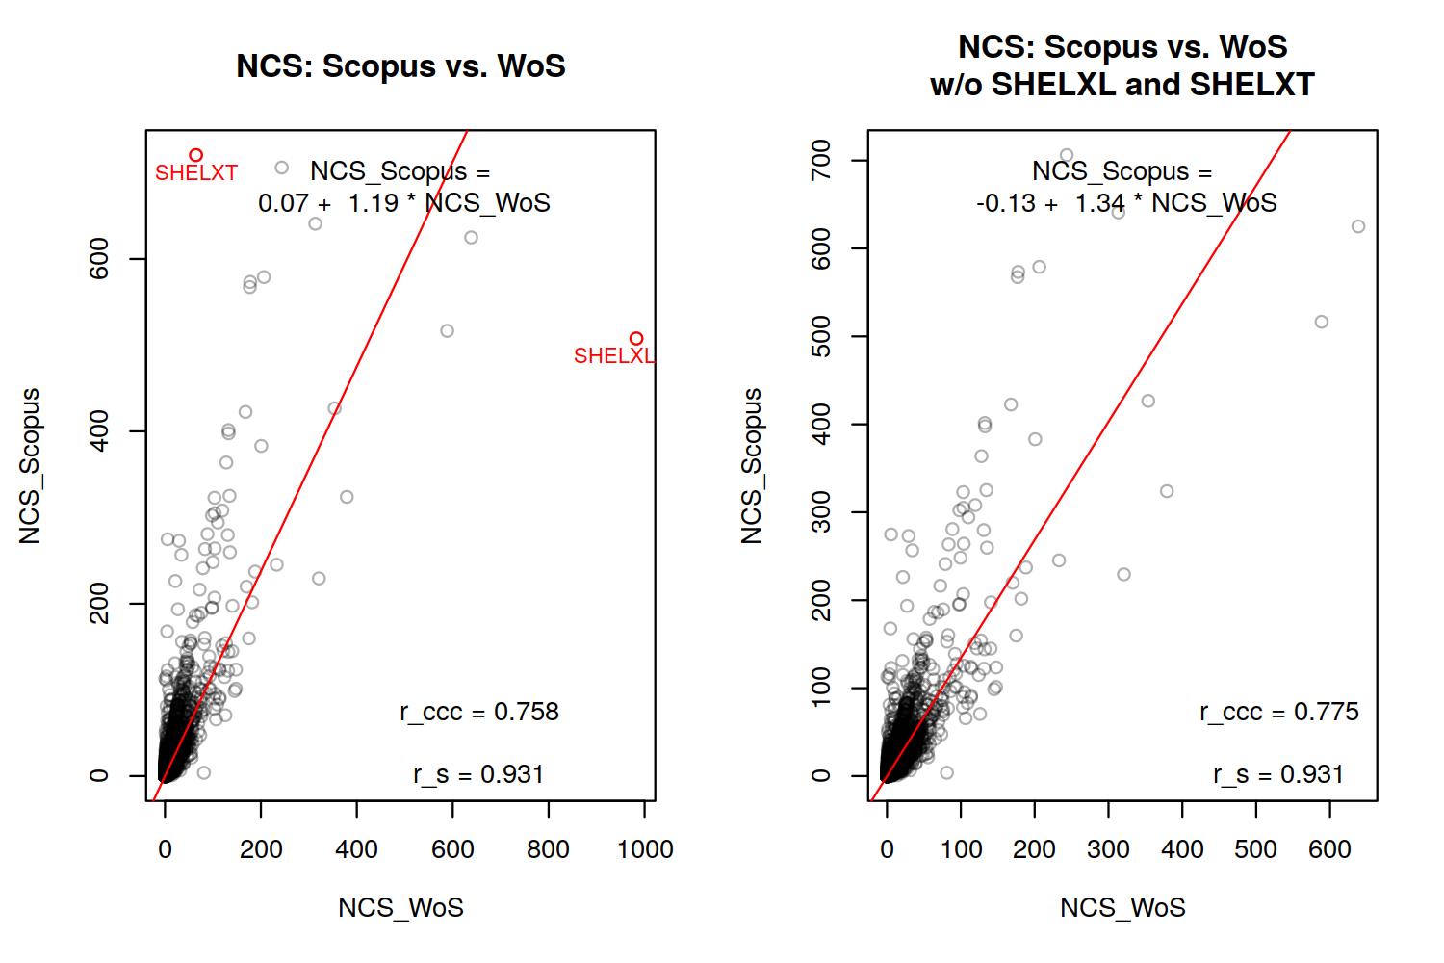
3.2. Analysis of outlier effects
The results for SHELXT and SHELXL point out that outliers may have a significant distorting influence on the correlation between NCS values from different databases. In order to assess this effect, we compared the correlation coefficients for the datasets including all publications against the whole set excluding outliers. We define outliers as papers with NCS values among the top 1% in either database. This process resulted in 1% to 2% of the papers being removed.

Although the outliers have been removed, Spearman’s correlation coefficients remain very similar (as expected): The decrease was less than 0.005. The changes in Lin’s concordance coefficients are more pronounced, as indicated in Table 4.

Table 4: Effect of removing the top 1% NCS values of each database in each comparison on Lin’s concordance coefficient for the six database comparisons indicated by r_ccc, the confidence intervals, and the overall percentage of removed papers (scores above 0.8 are printed in bold face).
 | Scopus vs. WoS | Dimensions vs. WoS | OpenAlex vs. WoS | Dimensions vs. Scopus | OpenAlex vs. Scopus | OpenAlex vs. Dimensions
Lin’s r_ccc for all papers | 0.758  [0.7567;0.7591] | 0.771  [0.7703;0.7723] | 0.678  [0.6769;0.6793] | 0.855  [0.8537;0.8555] | 0.785  [0.7842;0.7866] | 0.876  [0.8756;0.8772]
Lin’s r_ccc without top 1% papers | 0.867  [0.8661;0.8677]  1.28% | 0.704  [0.7032;0.7058]  1.31% | 0.622  [0.6202;0.6230]  1.35% | 0.778  [0.7771;0.7795]  1.35% | 0.716  [0.7149;0.7176]  1.37% | 0.857  [0.8561;0.8579]  1.28%
Change in Lin’s r_ccc | 0.109 | -0.067 | -0.056 | -0.077 | -0.069 | -0.019

All changes are statistically significant as documented by the non-overlapping confidence intervals. Lin’s concordance coefficient increases by 0.1 for the comparison of WoS and Scopus—the two databases with journal-based subject classification. The agreement improves from strong to almost complete. For the comparison of Dimensions and OpenAlex—the two databases with paper-based subject classification—the coefficient decreases slightly by about 0.02. For the comparison of Dimensions and Scopus, the decrease by 0.08 leads to a change from almost complete to only strong agreement. For the other three comparisons, the decrease of Lin’s concordance is smaller and does not change the assessment of agreement.

3.3. Results for the 48 German universities separately
The same evaluations on a per-paper basis have been done for all 48 universities separately. Because of many collaborations between German universities the 334,511 DOIs occur 424,267 times in total in the separate evaluations of the universities. At first, we look at the spread of the correlation coefficients collected in Table 5.

Table 5. Min-max-intervals of the correlation coefficients of the 48 universities separately. Spearman’s r_s is given beneath the diagonal, Lin’s r_ccc above the diagonal.

Database | WoS | Scopus | Dimensions | OpenAlex
WoS | 1 | [0.64; 0.97] | [0.54; 0.97] | [0.18; 0.93]
Scopus | [0.91; 0.95] | 1 | [0.66; 0.96] | [0.29; 0.94]
Dimensions | [0.86; 0.91] | [0.87; 0.90] | 1 | [0.41; 0.97]
OpenAlex | [0.86; 0.90] | [0.86; 0.90] | [0.89; 0.92] | 1

That the values of Spearman’s r_s consistently show a high to perfect correlation in small intervals centered around the overall values from Table 2 comes with no surprise. Lin’s r_ccc displays a more diverse behavior. In order to assess the distribution of r_ccc values across the universities and possibly detect outliers, stripcharts are a helpful means. The left stripchart of Figure 4 compares the three commercial databases with one another: In each case the distributions of r_ccc values are relatively homogeneous. We consistently have a strong to almost complete agreement, with the exception of only two universities in Dimensions vs. WoS (Free University of Berlin with r_ccc=0.54 and University of Cologne with r_ccc=0.56). The stripchart also displays the distributions of r_ccc with each university’s top 1% papers removed. This measure reduced the spread of r_ccc values across the universities drastically. The comparison Dimensions vs. WoS now has no longer r_ccc values below 0.67 and also none over 0.8. For Dimensions vs. Scopus, the values only range between 0.75 and 0.83. Only in case of the journal-based databases Scopus and WoS, the median over the universities increases (by nearly 0.1) and all r_ccc values can be seen as pointing to an almost complete agreement.

The greatest spread of r_ccc values in Table 5 occurs at comparisons including OpenAlex. Comparing OpenAlex with the three commercial databases in the right stripchart of Figure 4 reveals in each case several outliers separated from a more or less homogeneous majority field. Two of them are among the most extreme outliers in each comparison: The University of Mainz and the University of Marburg have very low r_ccc values of about 0.2 (OpenAlex vs. WoS), about 0.3 (OpenAlex vs. Scopus) and about 0.4 (OpenAlex vs. Dimensions). The removal of top 1% papers, however, changes the picture drastically. The median over the universities decreases by 0.03 to 0.07. There are only three universities with values slightly below 0.6 remaining for OpenAlex vs. WoS: Free University of Berlin with r_ccc=0.57, University of Konstanz with 0.58, and Leibniz University Hannover with 0.59. For OpenAlex vs. Dimension, all r_ccc values even point to an almost complete agreement.

Figure 4: Lin’s r_ccc with confidence intervals for 48 universities (ordered by publication output) in mutual comparisons of the three commercial databases on the left and of OpenAlex with the other ones on the right considering either all documents or without the top 1% papers in each database. Vertical lines indicate the median over all universities with all documents (solid) and without the top 1% papers (dashed line), respectively.
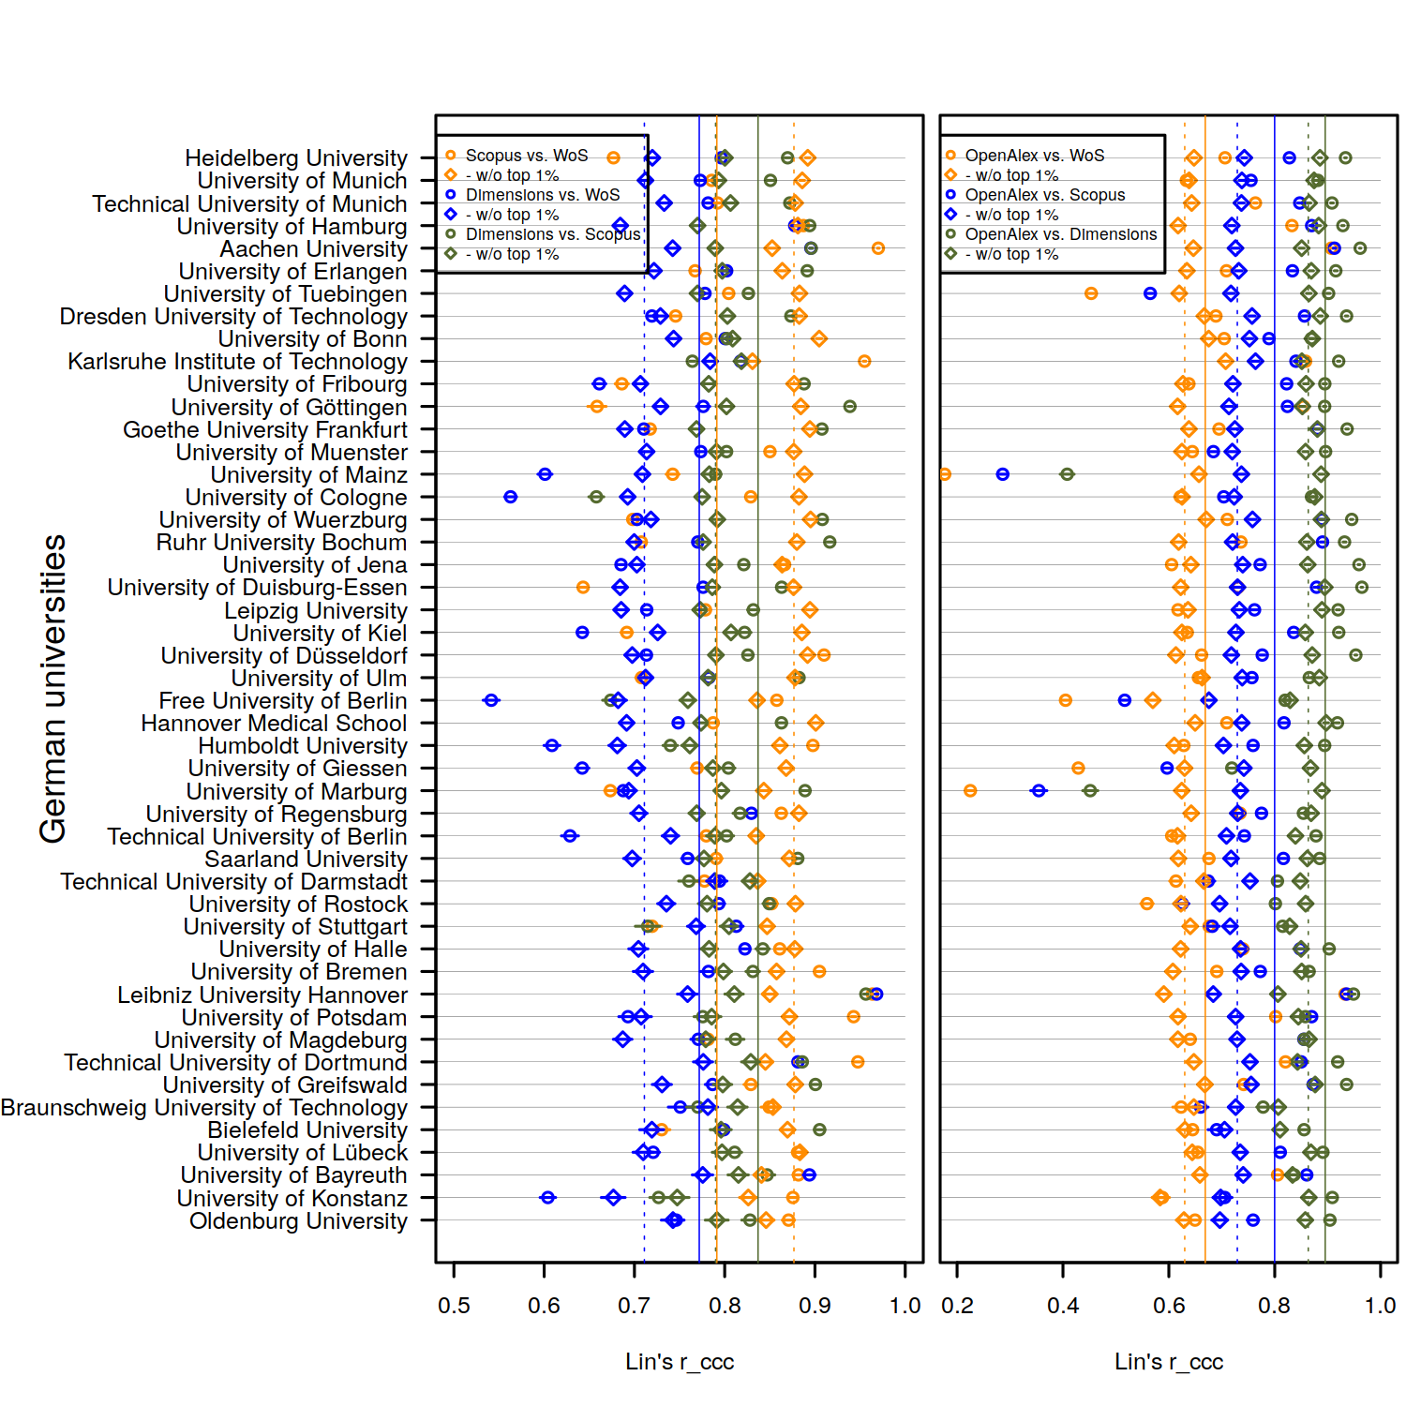

3.4. MNCS across universities
In research evaluation, rankings of universities play an important role, usually sorted by the associated MNCS values. Figure 5 shows the respective values for the 48 universities based on data from the four databases. The visual impression of a high correlation is corroborated by Spearman’s correlation coefficients listed in Table 6. The highest r_s values occur between WoS and Scopus resp. OpenAlex and Dimensions. So, viewed through the MNCS indicator, the differences between the universities are similarly represented in the four databases. However, the concordance coefficients between the MNCS values of the German universities are rather low. Although the concordance coefficients calculated for the single papers are high (they indicate at least a strong agreement), many coefficients for the aggregated values are low.
Figure 5: Mean normalized citation scores across the 48 German universities (ordered by publication output) in the four databases. The vertical solid lines represent the respective mean values across the universities.
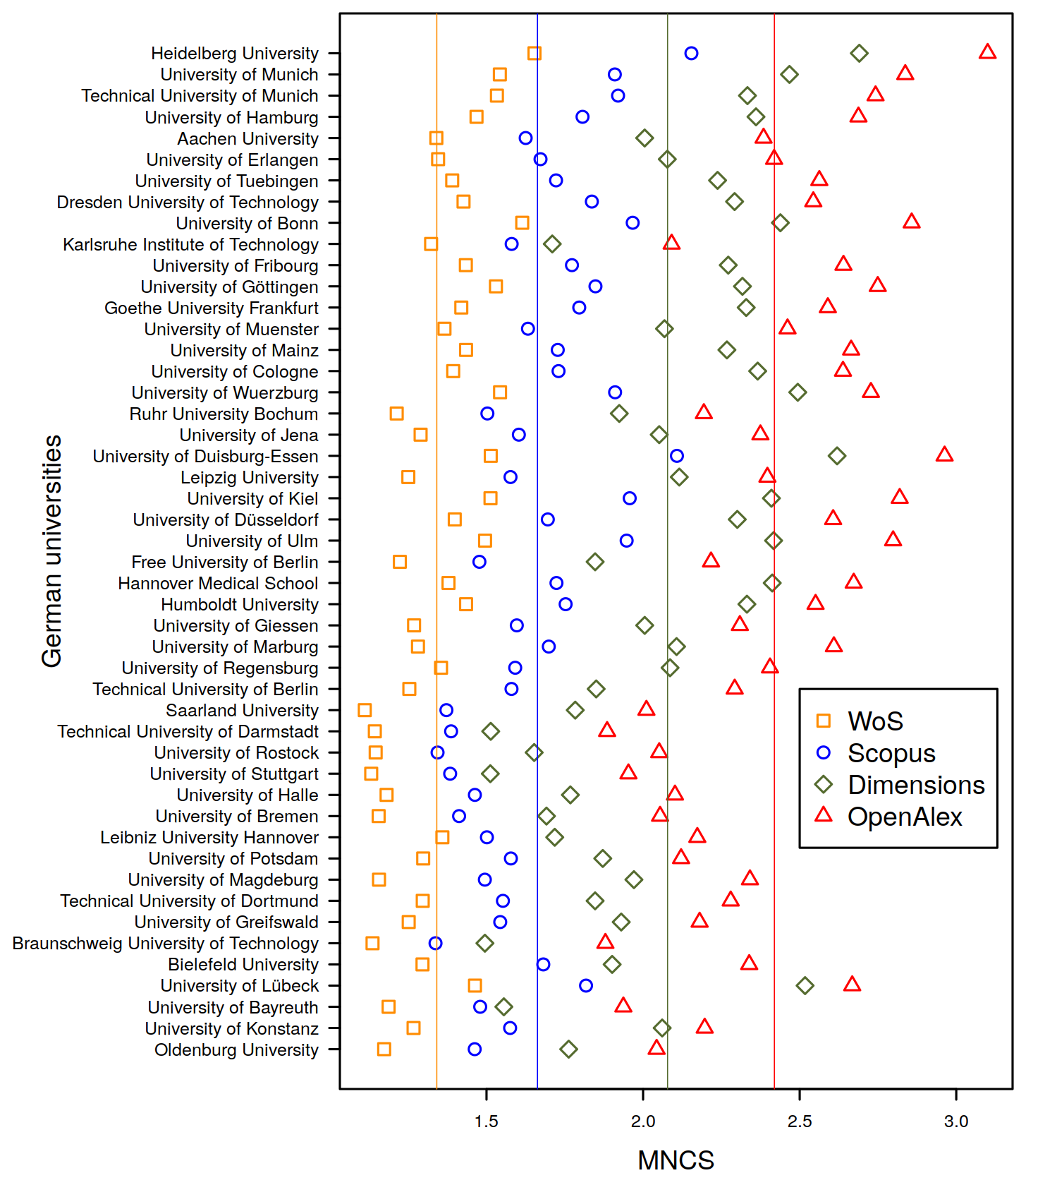
Table 6: Spearman’s r_s and Lin’s r_ccc for the comparison of the MNCS values for 48 German universities between two databases

 | Scopus vs. WoS | Dimensions vs. WoS | OpenAlex vs. WoS | Dimensions vs. Scopus | OpenAlex vs. Scopus | OpenAlex vs. Dimensions
Spearman’s r_s | 0.96 | 0.89 | 0.92 | 0.93 | 0.95 | 0.96
Lin’s r_ccc | 0.32 | 0.12 | 0.06 | 0.37 | 0.16 | 0.60

4. Discussion
We calculated correlation coefficients for six mutual comparisons of NCS values for a common set of nearly 335,000 publications from 48 German universities in four databases. The results for Lin’s concordance correlation coefficient r_ccc show that all comparisons reveal almost complete but at least strong agreement. We tried to assess the distorting effect of outliers by removing the papers within the top 1% of NCS values in the databases. These additional analyses led to a small decrease in most cases with coefficients indicating at least strong agreement.

Looking at the 48 German universities separately, we found in nearly all cases a strong to almost complete agreement between the three commercial databases, but several cases of very low r_ccc values in comparisons of the free database OpenAlex with the three commercial ones. But the removal of the top 1% papers with extreme outliers in most cases led to strong or almost complete agreement. In terms of the aggregated indicator MNCS, we found a highly correlated representation of inter-university differences between all databases. However, the concordance between the MNCS values of the German universities is rather low. Both results indicate that relative comparisons between different universities are valid only within either of the tested databases. On the one hand, the results reveal that MNCS values which have been calculated using data from different databases should not be compared. On the other hand, the difference of the concordance coefficients on the paper and university level is a good example for the problem of ecological fallacy in bibliometrics: The mean impact is not representative for the single papers’ impact in the set.

There are some limitations concerning the generalizability of our results to other countries: (1) We were able to use disambiguated affiliation data for German universities. Institutional data with disambiguations on a very high quality level may be scarcely available for other countries. (2) NCS and MNCS are susceptible to outliers. Further studies may assess the influence of the removal of top 1% papers on the inter-university comparisons (see Fig.5).

We conclude that the suitability of OpenAlex for bibliometric evaluations seems to be similar to that of the established commercial databases—keeping in mind the possibility of stronger distorting effects in the high NCS realm in certain cases—and even more promising if the changes, e.g., of the subject classification, in OpenAlex since the snapshot from January 2022 turn out to be improvements in this regard (Priem & Piwowar, 2022).

Open science practices
As the present study is explicitly a comparison between commercial bibliographic databases and a free one, the data of the first category are per se closed, but the data of OpenAlex are freely available for all purposes (especially the data dumps called snapshots, see https://docs.openalex.org/download-all-data/openalex-snapshot). The software for evaluation and visualization is based on the open source language R (https://www.R-project.org) and can be provided on request.

Acknowledgments
The WoS data used in this study were retrieved from an in-house WoS database developed and maintained by the Max Planck Digital Library and derived from the Science Citation Index Expanded (SCI-E), Social Sciences Citation Index (SSCI), Arts and Humanities Citation Index (AHCI) provided by Clarivate (Philadelphia, Pennsylvania, USA). The database contains disambiguated and unified address information for German research institutes and universities developed by the I²SoS Bibliometrics Team at University of Bielefeld (https://www.uni-bielefeld.de/einrichtungen/i2sos/bibliometrie/index.xml) and provided by the German “Kompetenznetzwerk Bibliometrie” (KB, Competence Centre for Bibliometrics, http://www.bibliometrie.info). The Scopus data produced by Elsevier were also provided by the KB. We thank Digital Science for providing us with Dimensions data for temporary storage in an in-house PostgreSQL database for use in this research. We thank OurResearch for preserving and continually building upon the MAG corpus and providing the OpenAlex freely for all purposes.

Author contributions
T.S.: Conceptualization, Data curation, Formal Analysis, Methodology, Visualization, Writing – original draft, Writing – review & editing
R.H.: Conceptualization, Methodology, Visualization, Writing – review & editing
L.B.: Conceptualization, Methodology, Writing – review & editing

Competing interests
The authors declare that they have no competing interests.

Funding information
The KB database with affiliation information for German research institutions has been sponsored by the German Federal Ministry of Education and Research (BMBF) under the funding code “16WIK2101A”.

References
Baas, J., Schotten, M., Plume, A., Côté, G., & Karimi, R. (2020). Scopus as a curated, high-quality bibliometric data source for academic research in quantitative science studies. Quantitative Science Studies, 1(1), 377-386. https://doi.org/10.1162/qss_a_00019.
Birkle, C., Pendlebury, D. A., Schnell, J., & Adams, J. (2020). Web of Science as a data source for research on scientific and scholarly activity. Quantitative Science Studies, 1(1), 363-376. https://doi.org/10.1162/qss_a_00018.
Bornmann, L., & Williams, R. (2020). An evaluation of percentile measures of citation impact, and a proposal for making them better. Scientometrics, 124(2), 1457-1478. https://doi.org/10.1007/s11192-020-03512-7.
Cohen, J. (1988). Statistical power analysis for the behavioral sciences (2nd ed.). Hillsdale, NJ, USA: Lawrence Erlbaum Associates, Publishers.
Haunschild, R., & Bornmann, L. (2016). The proposal of using scaling for calculating field-normalized citation scores. El Profesional de la información, 25(1), 1699-2407. https://doi.org/10.3145/epi.2016.ene.02.
Haunschild, R., Schier, H., & Bornmann, L. (2016). Proposal of a minimum constraint for indicators based on means or averages. Journal of Informetrics, 10(2), 485-486. https://doi.org/10.1016/j.joi.2016.03.003.
Herzog, C., Hook, D., & Konkiel, S. (2020). Dimensions: Bringing down barriers between scientometricians and data. Quantitative Science Studies, 1(1), 387-395. https://doi.org/10.1162/qss_a_00020.
Koch, R., & Sporl, E. (2007). Statistical methods for comparison of two measuring procedures and for calibration: Analysis of concordance, correlation and regression in the case of measuring intraocular pressure. Klinische Monatsblatter Fur Augenheilkunde, 224(1), 52-57. https://doi.org/10.1055/s-2006-927278.
Lin, L. I. (1989). A Concordance Correlation Coefficient to Evaluate Reproducibility. Biometrics, 45(1), 255-268. https://doi.org/10.2307/2532051.
Lin, L. I. (2000). A Note on the Concordance Correlation Coefficient. Biometrics, 56(1), 324-325. https://doi.org/10.1111/j.0006-341X.2000.00324.x.
Liu, J., Tang, W., Chen, G., Lu, Y., Feng, C., Tu, X.M. (2016). Correlation and agreement: overview and clarification of competing concepts and measures. Shanghai Archives of Psychiatry, 28(2), 6. https://pubmed.ncbi.nlm.nih.gov/27605869/.
Lundberg, J. (2007). Lifting the crown - citation z-score. Journal of Informetrics, 1(2), 145-154. https://doi.org/10.1016/j.joi.2006.09.007.
Priem, J., & Piwowar, H. (2022). openalex-concept-tagging. Retrieved June 27, 2022, from https://github.com/ourresearch/openalex-concept-tagging
Priem, J., Piwowar, H., & Orr, R. (2022). OpenAlex: A fully-open index of scholarly works, authors, venues, institutions, and concepts. Paper presented at the 26th International Conference on Science, Technology and Innovation Indicators (STI 2022), Granada, Spain. https://doi.org/10.5281/zenodo.6936227.
Rehn, C., Kronman, U., & Wadskog, D. (2007). Bibliometric indicators – definitions and usage at Karolinska Institutet. Stockholm, Sweden: Karolinska Institutet University Library.
Scheidsteger, T., & Haunschild, R. (2023). Which of the metadata with relevance for bibliometrics are the same and which are different when switching from Microsoft Academic Graph to OpenAlex? Profesional de la información, 32(2). https://doi.org/10.3145/epi.2023.mar.09.
Scheidsteger, T., Haunschild, R., Hug, S., & Bornmann, L. (2018). The concordance of field-normalized scores based on Web of Science and Microsoft Academic data: A case study in computer sciences. Paper presented at the 23th International Conference on Science, Technology and Innovation Indicators (STI 2018), Leiden. The Netherlands. https://hdl.handle.net/1887/65358.
Sheldrick, G. M. (2015a). Crystal structure refinement with SHELXL. Acta Crystallographica Section C: Structural Chemistry, 71(1), 3-8. https://doi.org/10.1107/S2053229614024218.
Sheldrick, G. M. (2015b). SHELXT – Integrated space-group and crystal-structure determination. Acta Crystallographica Section A: Foundations and Advances, 71(1), 3-8. https://doi.org/10.1107/S2053273314026370.
Sinha, A., Shen, Z., Song, Y., Ma, H., Eide, D., Hsu, B.-J. P., & Wang, K. (2015). An Overview of Microsoft Academic Service (MAS) and Applications. Paper presented at the 24th International Conference on World Wide Web (WWW ’15 Companion), Florence, Italy. https://doi.org/10.1145/2740908.2742839.
van Wijk, E., & Costas-Comesaña, R. (2012). Bibliometric Study of FWF Austrian Science Fund 2001-2010/11. Leiden, the Netherlands: Center for Science and Technology Studies (CWTS). URL: https://zenodo.org/record/17851.
Waltman, L., van Eck, N. J., van Leeuwen, T. N., Visser, M. S., & van Raan, A. F. J. (2011). Towards a new crown indicator: Some theoretical considerations. Journal of Informetrics, 5(1), 37-47. https://doi.org/10.1016/j.joi.2010.08.001.
Wang, K., Shen, Z., Huang, C., Wu, C.-H., Dong, Y., & Kanakia, A. (2020). Microsoft Academic Graph: When experts are not enough. Quantitative Science Studies, 1(1), 396-413. https://doi.org/10.1162/qss_a_00021.

