Type of the Paper: Keynote Paper
The History of Two-wheeled Vehicle Dynamics in Japan and Subsequent Trends
Ichiro Kageyama¹
¹ Professor Emeritus of Nihon University, Japan; kageyama.ichiro@nihon-u.ac.jp

Name of Editor: Jason Moore
Submitted: 16/09/2023
Accepted: 16/09/2023
Published: 19/09/2023
Citation: Kageyama, I. (2023). The History of Two-wheeled Vehicle Dynamics in Japan and Subsequent Trends. The Evolving Scholar - BMD 2023, 5th Edition. This work is licensed under a Creative Commons Attribution License (CC-BY).

Abstract:
The purpose of this paper is to review research related to motorcycling conducted in postwar Japan, a country that was somewhat closed both linguistically and regionally. After World War II, many aeronautical engineers worldwide lost their jobs and moved on to other fields of study, especially in Japan, where aeronautical engineer jobs, including research, were banned and many aeronautical engineers shifted their research focus on transportation machinery, especially automotive engineering. Against this background, Japanese two-wheeled vehicles-related research has developed in its own unique way, while retaining a strong influence from aeronautical engineering. Because of the wide base of research on motorcycle kinematics, we first presented the literature for each study in the same line of research together. They are summarized in the following four areas：
- Experimental studies dealing with motorcycle motion and problem extraction.
- Research dealing with theoretical aspects such as the construction of equations of motion to solve experimental problems and to look at motion from the aspect of characteristics estimation.
- Research on various human-related issues, such as human control behavior modeling, vibration characteristics of the human body, HMI, and so on.
- Research on motorcycles as control objects and research focused on control systems.
Although there are many studies that straddle these two categories, they were generally grouped into one or the other.

Keywords: Two-wheeled Vehicles, History, Dynamics

1. Introduction
Since Japan was closed off from the rest of the world for about 220 years until 170 years ago, various academic disciplines developed independently. For example, in the field of mathematics, famous mathematician Ko-wa Seki used ``Wasan'' which is Japanese way of Mathematics to derive solutions to simultaneous equations using the process of elimination, 70 years earlier than in Europe. He also showed that pi could be calculated to 26 digits in the 1600s. Furthermore, there are references that use derivatives for analysis, although the method of expression is different. Thus, a unique academic culture developed in Japan, but it was a system of study by a very small number of scholars who constituted a school and was not open for many ordinary peoples. Therefore, while these Japanese historical research materials on “Wasan" have attracted attention in Japan, their results have not received much attention because they were written in the old Japanese script, and in recent years many people have focused on the academic systems established in Western countries. In recent years, Japan's education system has undergone major changes and is becoming increasingly Westernized. However, from the perspective of spreading education widely, most subjects can be studied in Japanese up to higher education, such as graduate school, and when a new academic field starts overseas, such as modern control theory or AI technology, its literature is translated into Japanese at an early stage and specialized books in the field are also published in Japanese. This creates an environment where new and original research is discussed in Japanese and published as papers in Japanese. In recent years, this trend has been greatly improved, and many young researchers have become active abroad and presented their own research results at international conferences, etc. International exchange has progressed, but the fact remains that few academic papers from the early days of vehicle dynamics, including motorcycles, are known abroad.
To turn our attention to the field of two-wheeled vehicles, we focus on history of global technological trends and the relationship between these trends in Japan. It is extremely difficult to accurately determine the history, and it is extremely difficult to accurately determine the starting point of the vehicles in this case about two-wheeled vehicles because of the various factors involved. Therefore, the generally accepted history of two-wheeled vehicles is summarized in Fig. 1. This figure shows the rough sketch that led to the history of motorcycles in Japan.
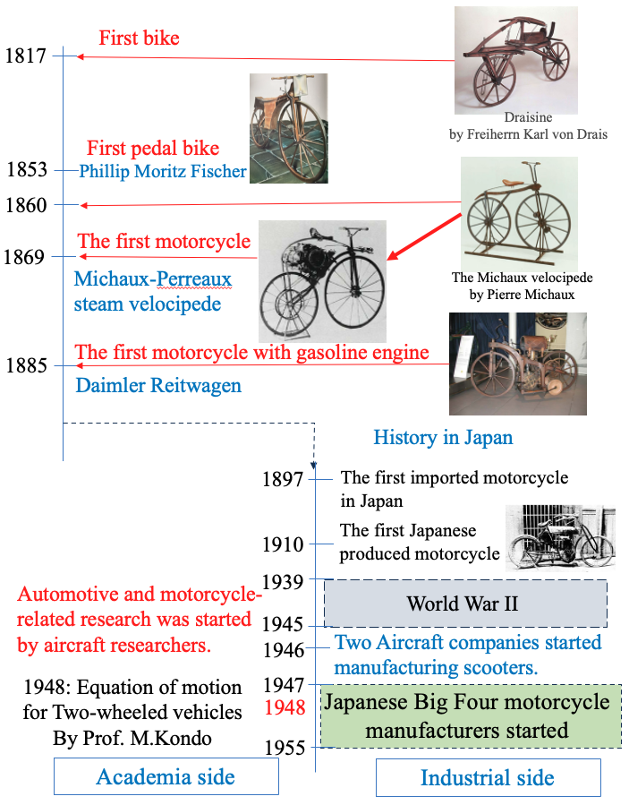
The history of two-wheeled vehicles began in 1817 with the invention of the Draisine by Freiherrn Karl von Drais. This vehicle was driven by a person riding on it and kicking the ground with their left and right feet, but even if the standing stability of such a vehicle was a little low, it could be stabilized by placing your feet on it. A separate drivetrain had to be considered for humans to remain in the vehicle for long periods of time, and in 1853, pedals were installed on the front tires. In other words, it seems that numerous innovations for standing stability were made at this time to some extent. Later, the Michaux-style bicycle, introduced around 1860, became widely popular. In 1869, a steam engine was installed under the seat of this Michaud-style bicycle, creating the first motorcycle with rear-wheel drive. Later, in 1885, a two-wheeled vehicle with a gasoline engine and auxiliary wheels was built by Daimler, which some researchers call the first motorcycle. The history of Japanese motorcycles begins in 1897, when records remain of the first motorcycle being imported to Japan. The first purely domestic motorcycle was a 4-stroke, single-cylinder, 400 cc vehicle built by Narazo Shimazu in 1909. After this, companies were established to manufacture foreign knockdown motorcycles as well as their own vehicles, supplying motorcycles to the market. However, there was little to see in terms of vehicle dynamics during this period. A major historical turning point in this trend was World War II, around which time aeronautical engineering made major advances worldwide, especially in the areas of stability and maneuverability. However, after the end of World War II, many aeronautical engineers and researchers worldwide lost their jobs, especially in Japan, where they were banned from research as well as production of aeronautical engineers, and they had to change direction to other vehicles, especially the automotive field. Therefore, it was introduced scientific perspectives to the two-wheeled and four-wheeled vehicles that had been built empirically. Turning to the flow of motorcycles in Japan, two aircraft manufacturers began prototype production of scooters fitted with airplane tailwheels, which were commercialized in 1946. However, several kinematic problems arose during this development process, and aeronautical researchers initiated various studies to solve these problems. Therefore, the first equation of motion for two-wheeled vehicles was constructed by Prof. M.Kondo and it was published in 1948. This was the starting point for research on the kinematics of two-wheeled vehicles in Japan. In addition, the "Big Four" companies in the Japanese motorcycle industry were successively established between 1947 and 1955. Therefore, when looking at the history of motorcycle research in Japan, it is necessary to consider the year 1948 as a starting point. Therefore, the following chapters will examine the details of the subsequent motorcycle-related studies and provide an overview of them.
Fig. 1 Rough sketch of two-wheeled vehicle history
2. Classification of Two-wheeled Vehicle Dynamics Research
Previous papers on two-wheeled vehicle motion and control need to be categorized to follow the flow. Although this classification needs to be considered from various perspectives, the following approach is used here to classify as broadly as possible. In addition, some papers in the past literature fall into more than one category, so they will be used in duplicate in their respective descriptions.
The first research (Category 1) on the dynamics of two-wheeled vehicles is based on the peculiarities of their motion, and the first studies started by extracting the problem experimentally. When understanding the motion of motorcycles theoretically, certain types of motion may be hidden due to the limitation of degrees of freedom based on various assumptions, and experiments using actual vehicles are very important to clarify various issues. Therefore, we consider one category of research that pioneering researchers have focused on, which is the experimental clarification of the identification of problems that occur in real vehicles.
The next category (Category 2) is theoretical analysis, which is a tool that can be used not only to describe vehicle motion using models, but also to predict vehicle behavior for example at extremely high speeds behavior. Furthermore, it is also important to construct a model for use in control such as stabilization control during stoppage. In addition, multibody dynamics software (hereinafter MBD), which have been used by many engineers in recent years, can be seen as an experiment using a computer, but these softwares use various kinds of models, and it is important to analyze motion in virtual space. Therefore, it is necessary to include this category in the theoretical analysis because it uses a model built based on certain assumptions.
The next category (Category 3)would be as a human-machine system. This classification encompasses a very broad range, including those that focus on the characteristics of the human body itself, those that focus on mental aspects, and even the role of the human controller as a control system. This classification should also be widely considered in papers that examine the evaluation of two-wheeled vehicle dynamics, for example, to evaluate the handling level of each vehicle or to evaluate riding comfort, papers that consider the human body as a dynamic element and examine its effect on two-wheeled vehicle dynamics, papers that examine the role of humans as controllers and their use in autopilot, as well as the construction of rider models for use in software such as CAE, and so on.
The last category (Category 4) is control systems. The role of humans as controllers is placed in the category of human-machine systems, and the construction of systems that directly control vehicle motion, such as upright stability control, etc., are classified in this control system category.
In general, classification by direction of motion axis (horizontal, vertical, up and down, etc.) is often used, but here I classify them as follows according to the above. The next chapter summarizes the main topic, the flow of research on two-wheeled vehicle dynamics in Japan.
3. History of Two-wheeled Vehicle Dynamics Research in Japan
Many studies on two-wheeled vehicles have been conducted in the past in terms of improving their characteristics, but as mentioned above, it was not until aeronautical engineers entered this field after World War II that they began to take shape in the literature. This does not mean to deny the studies conducted prior to World War II, but since there are almost no documents available, this study was conducted based on the results of the literature survey conducted after this period.
3.1 Experimental Approaches
Although an experimental approach is not necessarily the best way to identify and evaluate problems in an object, various filters have been used before various things have been constructed and become commonplace, so the evaluation of products formed at that stage makes sense. This is also true in the direction of the method on Genetic Algorithms, one method of optimization. Numerous studies have been conducted to experimentally evaluate such two-wheeled vehicles and to identify their kinematic problems.
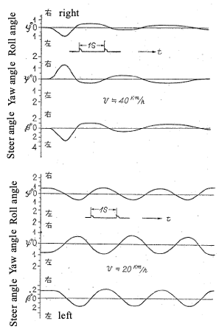
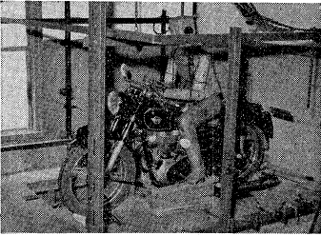
In 1948, "Dynamics of two-wheeled vehicles (2nd Report) - On the stability of two-wheeled vehicles under free control and in steady state turning" by Masaichi Kondo et al. was presented at the Japan Society of Mechanical Engineer, Conference on Applied Mechanics. The society was founded in 1897 and is a prestigious organization in Japan, but due to the period of confusion at the time, I was unable to locate the publication itself, although I could not find that it had been published. Furthermore, since this is the second report, there should have been a first report, but I could not find it. However, these were eventually compiled into an experimental study on the stability and handling on two-wheeled vehicles, and submitted as a journal paper in 1955, so we can know the contents. A very difficult problem in experiments on motorcycles is the measurement of their motion. Today, with the widespread use of various lightweight sensors, data loggers, etc., and especially gyro-sensors using MEMS, it has become relatively easy to record driving data. However, at that time, gyros and other devices were too large and expensive to be used for such experiments. Therefore, Kondo et al. constructed a device in which the front wheel was placed on a drum and rotated, and the rear wheel could rotate in the yawing direction around the position of wheel axle center and was restrained only in the longitudinal and lateral directions. In order to incorporate human elements, a new wooden dummy, the first of its kind in Japan, consisting of six body parts, was made and fixed to the seat as shown in Fig. 2. In this state, the vehicle body could not be maintained in an upright position, springs were placed above the rear axle to prevent collapse, and also to ensure restoring torque in front of the rear wheel, the other springs ware set. These spring settings was very important but were determined based on the relationship between restoring moment and upright moment. With such a device, it was possible to create a simulated running condition for motorcycles, and measurements could be easily made. The experiment shows the results of the free control condition shown in the figure, and the experiment itself was conducted with varying speeds, caster angles and trails. In addition, the paper also showed the results of a running experiment in which the steering angle and force measurement device developed for this research was set to a real vehicle. In addition, the steering angle and steering force measurement device developed in this study was set up on an actual vehicle, and a steady circle turning test using this device was used to show that there are many vehicles that oversteer²⁾. In addition, the Lemniscate experimental method, which is necessary to manipulate constant change, was also performed. The results of these experiments were very significant and had a tremendous impact on subsequent research in this field.
Fig.2 Experimental equipment for motorcycle running and the results of free control
In 1961, K.Kageyama et al. conducted an analysis using an experimental apparatus with a motorcycle on a rotating belt to confirm the effects of center-of-gravity height, front wheel design parameters, and other factors. In addition, this device was used to study the effects of shimmy by a trail that occurs when running straight ahead⁴⁾. These results had a major impact on motorcycle design at the time. In particular, the results discussed the importance of the geometric relationship of the front-wheel system of a two-wheeled vehicle to the stability and advanced the study as information for design specifications ⁶⁾.
M. Kondo's focus on steady-state gains (steady-state turning characteristics) led to research on steady-state circular turning characteristics of motorcycles, which in turn led to research on rider's riding posture (lean-in, lean-with, lean-out) by K. Kageyama et al.³⁾, H.Fu ^{7), 14)}, and others²⁰⁾, and then to test method standards for motorcycles such as JASO-T011 'Standard Test Method for Motorcycles'. Furthermore, for the ordinary riders who use a motorcycle in the speed range up to about 120 km/h, the main criteria for evaluating motorcycles are steady-state gain and immediate response. Therefore, the possibility of using these steady-state characteristics for motorcycle evaluation has been investigated as the subject of JSAE Technical Committee on Motorcycles. It was later compiled and presented by I.Kageyama et al^{32),33)}.
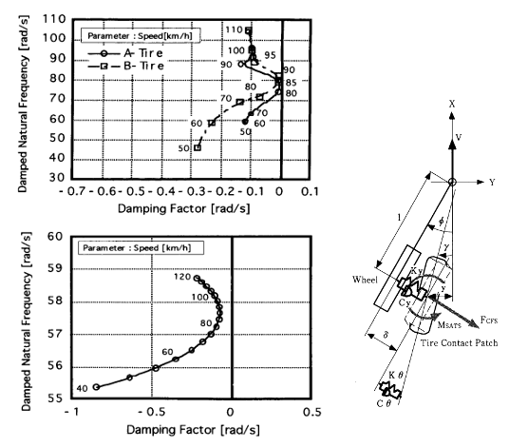
Since motorcycles are usually driven with an upper limit of about 120 km/h, except in Europe and on racetracks and so on, the steady-state gain and response mentioned earlier are problems, but another major issue is the shimmy that usually occurs in the handlebar system at 80 km/h. This is a vibration that generally appears as a vibration of 6 to 8 Hz in a very narrow speed band around 80 km/h. The solution has been to include friction or oil dampers around the steering shaft, but the effects of these dampers can appear as a problem at high speeds.A description of this vibration can be found in the Reference (2) on the first experiment shown here. Systematic verification of this vibration problem had to wait until the systematic experiments conducted by I. Kageyama et al. in 1995^{49),50)}. In this study, the frequency, amplitude, and other parameters at the steering system were measured against changes in speed by running on a proving ground and on a drum-type bench-top test apparatus. As a result, it was confirmed that this vibration with low stability appears around 80 km/h. It was also confirmed that the cause of this vibration was approximately the same frequency as that generated when an impact was applied to the handlebar while stopped, and it was clear that this vibration was related to the lateral rigidity of the front tire. Furthermore, in this study, a new model of the steering system that considered the lateral stiffness of the front tires was constructed, and its vibration modes were described using characteristic root loci, showing that the stability of the system was most reduced at around 80 km/h as shown in Fig.3. In 2010, the results of incorporating this tire model into a full vehicle model were presented, showing the importance of considering the lateral stiffness of the front wheels in vehicle model constructing⁶⁴⁾.
An important point in research on two-wheeled vehicles is to find and analyze problems based on actual vehicle behavior. But unfortunately, two-wheeled vehicles have limited space for measuring instruments, and in each paper our predecessors have shown how to measure characteristics under such limited space^{2),4),7),14),41),27),28),35)}. Furthermore, it is very difficult to obtain fundamental data such as the center of gravity, moment of inertia, individual human characteristics, tire characteristics, and so on in the human-motorcycle system. There are still several papers that have boldly attempted to obtain these data, but due to space limitations, I just described to confirm them with references^{9),11),29),76),78),80),82),83)}.
Fig.3 Experimental data and model output⁴⁶⁾

3.2 Theoretical Approaches
Theoretical research is as important as experimental research in mechanical systems. Particular attention needs to be paid to the modeling of two-wheeled vehicles and the results of such modeling, as the use of equations of motion and other approaches are important for the prediction of possible phenomena. However, the biggest problem in theoretical studies is that the equations of motion for high degrees of freedom cannot be solved directly, and even if the equations of motion can be constructed, their solutions cannot be obtained. The solution to these problems was greatly advanced by the personal computer, which was developed in the 1970s and became popular in the 1980s. These digital computer techniques have made it possible to obtain the equations of motion for these multiple degrees of freedom using approximate numerical analysis methods. Because such tools were not available in the late 1940s, when the equations of motion for two-wheeled vehicles were constructed, researchers have primarily used mechanical calculators and analog computers as well as huge digital computers to perform the analysis.
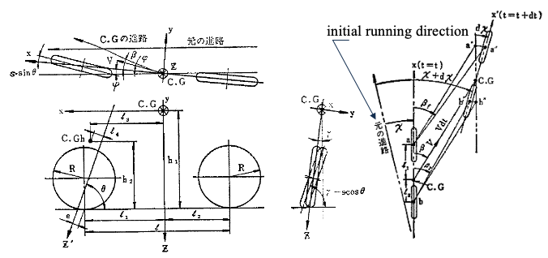
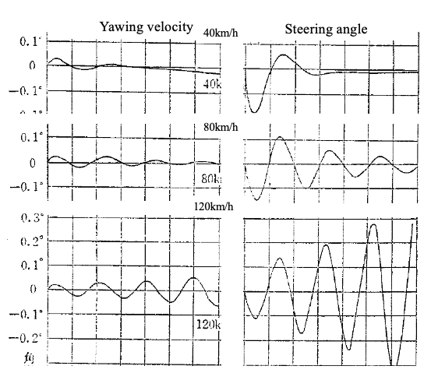
As mentioned above, aeronautical engineers and researchers contributed greatly to the theoretical study of two-wheeled vehicles, and the equations of motion for motorcycles were constructed by Prof. M. Kondo in 1948 based on their method of describing the dynamics of the vehicles^{39),40),41)}. In using a dynamic coordinate system to analyze vehicles, they adopted the coordinate system used in aircraft in both US and Japan (called the SAE coordinate system in Japan) to construct the equations of motion for not only four-wheeled vehicles but also two-wheeled vehicles. Fortunately, this coordinate system was a convenient way to describe motorcycles because their basic motion is to roll inward in a turn, just like an aircraft. As an aside, afterward, in the analysis of the motion of a four-wheeled vehicle, a coordinate system is then used by the ISO with the z-axis facing up, oriented to the characteristics of the vehicle. Next, the equations of motion for this two-wheeled vehicles are described. The degrees of freedom are around the y-axis, x-axis (roll motion), z-axis (yawing motion), and steering axis, and the equations were derived for a hands-off state with constant speed and fixed rider body as shown in Fig.4. The forces to be considered, including inertia forces, were (1) cornering force for each tire due to the angle of lateral slip, (2) camber thrust for each tire, (3) running resistance and driving force, (4) road reaction forces on the front and rear wheels, (5) weight of the steering system, (6) centrifugal force, (7) gyro moment, (8) related to yawing angular acceleration, (9) related to rolling angular acceleration, (10) related to steering angular acceleration, (11) aerodynamic forces and moments. The first half of the paper calculated a time series analysis from the induced equations of motion, while the second half obtained a sixth-order characteristic equation, from which periodic (conjugate complex roots) and non-periodic (real roots) oscillations were obtained as period and 1/10 damping time with respect to velocity. Furthermore, analysis was conducted on the differences between the six different specifications to determine which specification was preferred, up to 120 km/h, the practical speed range at the time. The time series analysis shows that divergent motion appears in the steering wheel system at 120 km/h, indicating the presence of the currently discussed wobble oscillation. Fig. 5 is a partial excerpt of the results of this time response. It follows that the equations of motion presented until 1963 are the results of the four-degree-of-freedom equations of motion that are in common use today, and this is the excellence of this study.
Fig. 4 Two-wheeled vehicle model^{37),38)}
Subsequent dynamics research can be divided into two directions. One is to increase the number of degrees of freedom to take into account frame stiffness and other human considerations, and the other is to examine ways to find the causes of low instability.
One such analysis was conducted by N. Tsuta et al. in 1996, in which they constructed a model with 10 degrees of freedom for the vehicle system, including frame stiffness, and 2 degrees of freedom for the human body, for a total of 12 degrees of freedom, and analyzed their coupled motions as shown in Fig.6⁸⁸⁾. The equations of motion were induced using the Lagrange equations, and eigenvalue analysis was performed using the obtained equations of motion. The results of the weave and wobble analysis were relatively well represented by the experimental results, and the parameters of the human arm were examined to find that the stability limit could be improved at high speeds. Regarding the effect of frame stiffness, a separate study on straight running was conducted by Aoki et al. and these effects were examined as eigenvalue and eigenvector analyses^{48),49),50)}.
Fig. 5 Response of the model^{40),41)}
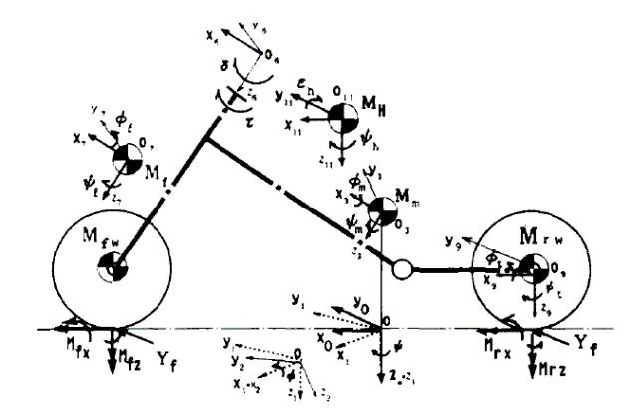
In general, the analysis of multi-degree-of-freedom systems is mostly done by parameter studies, since it is not possible to identify the cause of instability by direct mathematical analysis, and the same approach is used in the above³⁷⁾. In contrast, Katayama et al. proposed in Ref. 45) to verify destabilization by examining the energy flow to each response using the energy flow method. It has been used in subsequent papers because of its effectiveness in this type of analysis^{65),69)}.
Next, since this classification also includes considerations using MBD, papers in that area are described. In the late 1980s, MBDs were developed around the world and used for analysis in many fields. When constructing equations of motion for motorcycles, four degrees of freedom has been the minimum, and various attempts have been made to describe more than four degrees of freedom, but the use of MBD has become widely used in development because it is easy to analyze nonlinear multi-degree-of-freedom systems. Its effectiveness has been demonstrated in the analysis of human-motorcycle systems, which have multiple degrees of freedom, in 1997, Imaizumi et al. modeled the human-motorcycle system and conducted a series of subsequent analyses^{90),92),95),96),97),98)}. Through these series of analyses, an overview of the influence of various design parameters on dynamics, the influence of frame stiffness, the influence of raider and payload, the influence of vibration control, and the analysis of rider's behavior was obtained.
Fig. 6 12 degrees of freedom model ⁸⁸⁾

3.3 Human-Vehicle systems
As noted in the classification, human-motorcycle systems research has been studied from various aspects, but first the rider model as the controller of the control system is focused on. The modeling of humans manually controlling an object was analyzed using transfer functions by Arnold Tustin, a British electrical engineer during World War II. Therefore, many human operator studies since then have been described in terms of transfer functions. However, operator models that use such transfer function representations to human-vehicle system are not always easy to use in terms of understanding their algorithms. Therefore, in 1958, the creation of a model that based on such an algorithm construction was proposed by M. Kondo⁷¹⁾. The inspiration for this model is said to have come from the field of aeronautical research, as it is said to have originated from the behavior of pilots during dogfights with fighters. The algorithm of this model, called the preview model, which uses forward information to steer, was proposed as a driver model for 4-wheeled vehicles. The basic idea is to steer according to the deviation between the target course at the gazing point and the extension of the vehicle center. The distance to the position where the driver gazes is called the gazing distance, and the deviation of that position from the target course is called the preview model because it is directly visible. The tracking performance changes according to the preview distance, which is consistent with ordinary driver behavior, and thus has become widely used in Japan. Later, a new model was proposed by K. Yoshimoto in 1982 to address the shortcomings of this model, which could not be corrected for steady state disturbances⁷⁵⁾. This model was a modification of Kondo's preview model, which used a method of determining the deviation from the current vehicle motion to the vehicle's position in the gazing point using up to a quadratic prediction term of Taylor expansion, rather than corrective action for the direction the vehicle was facing. Because the model involves predictive behavior, it is called the preview-prediction model and has been used in many subsequent studies of human-vehicle systems. This model was adopted for motorcycle riders by Katayama et al⁹¹⁾. In this case, Katayama et al. divided the rider's upper and lower bodies and adopted a model in which the upper body performs lean motion, and the lower body performs lateral motion. The basic control algorithm was the quadratic prediction model described above, but Gaussian distributed weight coefficient with the gazing point as the peak position was introduced. The results showed that the model represents the rider's control behavior well. These rider preview and second-order prediction models have since been used in models for CAE and for autonomous motorcycles. In 1995, Y. Owada et al. used neural networks (hereafter NNS) to model what kind of information a person controlling a motorcycle obtains from the environment and how it leads to driving behavior⁸⁷⁾. The results of experiments on straight lines and curves were used for sufficient learning, and it was confirmed that the results were almost the same as the rider output. Using the trained NNS, they followed the flow of neurons from the input layer to the output layer one by one and performed factor analysis on the output values by each input to conclude which input was dominant for steering torque. Similarly, in 2004, S.Fujii et al. used a genetic algorithm (hereafter GA) to construct a model of motorcycle maneuvering. In this model, a preview model was used, and GA was used to identify the optimal parameters for deviation at the gazing point and rider's input¹⁰¹⁾. The resulting model was used to simulate arbitrary course running in the speed range of 1-15 m/s, and stable results were achieved. A similar approach was implemented in 2007 by Inoue et al. as other-input, multiple-output adjustment of motorcycles using Fuzzy logic¹⁰⁸⁾. As a result, it was possible to incorporate the knowledge of a human expert and showed that it was suited to control motorcycles.
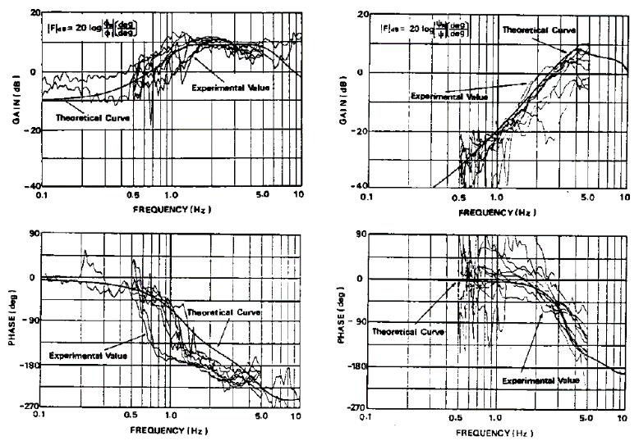
Similarly, humans exert various influences on motorcycles, which can be not only a disturbance but also an input to the control of the motorcycle. Therefore, it is necessary to clarify the relationship between human behavior and vehicle response. An early study focusing on these responses and others was conducted by Katayama et al. in 1985⁸⁰⁾. In this paper, a 2-DOF lean model and a 2-DOF yaw model of the rider's body were constructed and examined, including how they were modeled. In order to study these effects, a vibration measurement device in the form of a motorcycle was constructed to confirm these from the frequency characteristics as shown in Fig.6. From these, they finally examined how the rider's body affects the motion of the motorcycle, and the results showed that the transverse direction of the lower body and the lean angle of the upper body had a significant effect. This was shown as the input to the motorcycle given by the rider. A similar experiment using an actual motorcycle was conducted by I. Kageyama et al. in 1989⁸³⁾. They fabricated a device to fix the rider's body to the chassis, restrained all movements, and then opened it up one by one for frequency analysis based on the pulse response test results. The results showed that the largest effect of the response by the human body was the lean angle, followed by the yaw motion of the human body in the frequency band around 1 Hz, which had a significant effect on the motorcycle motion. From these results, the inputs that the rider provides to the motorcycles were identified. In 1984, Tomita et al. analyzed a man two-wheeled vehicle integrated movement used in trial competitions: jumping over a projection on a flat surface⁷⁷⁾. Since this is not a common movement, this section is limited to description only.
Roll angle excitation results Yaw angle excitation results
(output: upper body lean angle) (output: upper body yaw angle)

Fig. 7 Response of the model⁸⁰⁾
The next section deals with the information recognition ability of humans operating motorcycles. This is called Human Machine Interface (hereafter HMI) and is a study of the extent to which humans can acquire information, including meters and alarms. Such studies have been conducted as one of the various items to be considered for motorcycles. Although there have not been many such studies, this is an important characteristic as vehicles become more information-oriented.
Finally, we focus on the results of the study of the relationship between elements of the human body and motorcycles. In 1985, T.Katayama et.al. conducted measurements on the center of gravity and moment of inertia of riders⁷⁹⁾. These obtained the human parameters that were the basic data to be used in the human-motorcycle system to be used in the future. In 1984, Kageyama et al. measured the frequency characteristics of the human arm using vibrations received from the handlebars. This analysis was used to identify the equivalent mass of the human arm (the mass of the arm that moves with the handlebar), the equivalent damping factor, and the equivalent spring constant that are given to the steering system^{76),78)}. In addition, the effects of human grip force and pushing on the handle were examined, and the mechanical equivalent of these factors was studied. Finally, the degree to which these mechanical factors affected the motion of a motorcycle was shown by the characteristic root locus using a 4-DOF model.

3.3 Control Technology
As a final section, control techniques are summarized. Although the introduction of control systems has been slower for two-wheeled vehicles than for four-wheeled vehicles, research has been conducted to introduce support systems and for experiments and other purposes.
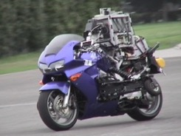
The first such control was presented by Nagai in 1983 for upright control of a lightweight bicycle¹¹⁶⁾. Since lightweight sensors such as MEMS and lightweight controllers were not available in this era, a belt-driven road surface was fabricated, on which a small bicycle was mounted and controlled by a wire. Control was performed by steering, and lateral and upright directional control was examined, while front/rear directional control was performed with restraints on the belt. As a result, it was confirmed that upright stability and directional stability were maintained on the belt. A similar study on self-supporting systems was developed by S. Miyagishi et al. in 2003¹²³⁾. The system was constructed for autonomous driving, and used a video camera called “rider robot” to recognize the road ahead with camera and second order prediction model^{124),126),127)}. Furthermore, the arms were constructed with a spring and damper system set up based on the equivalent dynamic elements of the rider constructed in references 76) and 78), and the system was designed to steer with this system. The system was constructed for test operation during the development of new vehicles or when a new support system is built. As shown in Fig. 8, the robot was able to drive a two-wheeled vehicle autonomously. Similarly, a self-supporting system using a model motorcycle was constructed by H. Sato et.al. in 2006, showing self-supporting running results¹²⁵⁾. Furthermore, in 2011, E.Tsujii et al. constructed a system with front and rear wheel steering system to ensure stability, including autonomy in a stopped state¹³⁵⁾.
Fig. 8 Rider Robot
In 1990, a reverse control system for motorcycles was introduced by A. Ota et al.¹²⁰⁾ This was a control system that verified the conditions of large motorcycles when reversing and was incorporated to enable stable reversing. Other control system research has been presented as a support system and is expected to spread in the future128),129),130),131),133),134),136).

4. Postscript
Summarizing the research conducted in Japan on bicycling relations, Japan’s uniqueness and other characteristics that were initially pointed out have not necessarily been maintained in recent years, that the problems of interaction with other countries and language are being resolved mainly by young researchers, and that these interactions have recently begun to influence each other internationally and move toward similar research topics. The total number of references listed here is 136, but I am sure I have missed quite a few. The majority of these 136 references are written in Japanese, and from viewpoint of an overseas researchers, the research environment may still be considered closed. Since there are not so many motorcycle researchers in the world, I hope that they will take advantage of these BMD opportunities to gradually eliminate the language barrier and interact with each other.

References
Experimental Approaches (Category 1)
- Masaichi Kondo et.al.: Dynamics of Two-wheeled vehicles (2nd Report) – On the stability of two-wheeled vehicles under free control and in steady state turning (in Japanese) , the Japan Society of Mechanical Engineer, Conference on Applied Mechanics, 1948.11
- Masaichi Kondo et.al.: Experimental study of stability and maneuverability of two-wheeled vehicles (in Japanese), Journal of the JSME, Vol.58, No.442, (1955) ,p.5-11
- Katsumi Kageyama et.al.: Experiments on the effects of maneuverability, especially lean-in and lean-out, on steady-state turning of two-wheeled vehicles (in Japanese), Journal of JSAE No. 13, No.10, (1959)，p41-45
- Katsumi Kageyama et.al.: Experimental study of the stability of two-wheeled vehicles (in Japanese), Journal of JSME, Vol.64, No. 508, 1961-05, p746-753
- Katsumi Kageyama et.al.: A prototype towing force gauge for motorcycles and its two or three applications (in Japanese), Journal of JSAE, Vol. 16, No.10, (1962)
- Katsumi Kageyama et.al.: Geometry of the front wheel system of a two-wheeled vehicle (in Japanese), Journal of JSAE, Vol. 18, No.11, (1964)
- Hiroyasu Fu (Nagae): Basic Characteristics of Motorcycles in Steady State Turning (in Japanese), Transaction of JSME (Category1), Vol.31, No. 229 (1965),p1305-1314
- Katsumi Kageyama et.al.: A prototype flat tire tester and a couple of experiments (in Japanese), Journal of JSAE, Vol. 20, No.5,(1966), pp426-430
- Hideo Sakai: Cornering characteristics of motorcycle tires (in Japanese), Journal of JSAE, Vol. 21, No.11,(1967), pp.1115-1121
- Keigo Yoshida et.al.: Stability and Handling on Motorcycles (in Japanese), Journal of JSAE, Vol. 26, No.7,(1972), pp.866-872
- Seichi Motomiya et.al.: The mechanical properties of the components of motorcycles (3rd report: Tire characteristics) (in Japanese), Proceedings of JSAE, No.772, (1972), pp577-580
- Y. Watanabe et.al.: Motorcycle handling performance for obstacle avoidance, Second International Congress on Automotive Safety, Paper No. 73033, (1973), pp101-123
- Hiroyasu Fu (Nagae): Research on Motorcycle Dynamics (in Japanese), Doctoral Thesis at Nihon University, (1976) , pp1-306
- Hiroyasu Fu (Nagae): Steer moment of motorcycle in steady state turning (in Japanese), Transaction of JSME, Vol.43, No.367, (1977),pp.46-54
- Katsumi Kageyama et.al.: Motorcycle Dynamics (in Japanese), IATSS Review, Vol. 3, No.1,(1977), pp15-21
- Keigo Yoshida: Motorcycle maneuverability and stability tests (in Japanese), Journal of JSAE, Vol. 31, No.5,(1977), pp.385-390
- Akira Aoki et.al.: Basic characteristics of motorcycles (in Japanese), JARI Research Journal, No.62, (1977),pp.1-36
- Akira Aoki et.al.: Aerodynamic characteristics of motorcycles (in Japanese), JARI Research Journal, No.63, (1977),pp.1-36
- Hiroyasu Fu (Nagae): Analysis of two-wheeled vehicles on free control (in Japanese), Transaction of JSAE, No.5, (1978),pp.51-58
- Akira Hasegawa: Characteristics of Motion of Motorcycles (in Japanese), Journal of JSAE, Vol. 32, No.4,(1978), pp.300-304
- Akira Aoki et.al.: Steer Dynamics of Motorcycle Tires (in Japanese), Automotive Research, Vol.2, No.6 (1980), pp.167-171
- Hiroyasu Fu (Nagae) et.al.: Inertia Equivalent Mass of Engine and Driving System of Motorcycle -Estimation Result from Gyro Effect during Steady State Turning- (in Japanese), Transaction of JSAE, No.22, (1981),pp.51-56
- Hiroyasu Fu (Nagae): Stability and Handling on Two-wheeled Vehicles - Turning Characteristics of Motorcycles - (in Japanese), Journal of JSAE, Vol. 36, No.3,(1982), pp.298-304
- Hiroyasu Nagae: Stability and Handling on Two-wheeled Vehicles (in Japanese),IATSS Review, Vol.8, No.2,(1982), pp.45-52
- Tadashi Kikuchi: Motorcycle behavior and tire characteristics (in Japanese), Journal of JSAE, Vol. 38, No.3,(1984), pp.332-336
- Akira Aoki et.al.: On Directional Stability of Motorcycles (in Japanese), Journal of JSAE, Vol. 40, No.3,(1986), pp.305-310
- Ichiro Kageyama: On a Testing Method for Two Wheeled Vehicle Handling, Technical Papers of SETC '93,Vol.2, No.931554,(1993) pp679〜684
- Tomoo Nisimi et.al.: Cross wind characteristics of Motorcycles (in Japanese), Journal of JSAE, Vol. 48, No.12,(1994), pp.59-65
- Akira Aoki et.al.: Measurement of motorcycle frame stiffness (in Japanese), Automotive Research, Vol.19, No.9 (1997), pp.362-367
- Tsuyoshi Katayama et.al.: Influence of Frame Stiffness on Wobble Mode of Motorcycle - Analysis by Eigenvector Method-. Automotive Research, Vol.20, No.9 (1998), pp.404-407
- Akira Aoki et.al.: Analysis on Influence of Frame Stiffness on Straight-running Stability of Motorcycles (in Japanese), Transaction of JSME (Category C), Vol.64, No.625 (1998), pp.3555-3562
- Akira Aoki et.al.: Investigation of the validity of the basic motion model for motorcycles (in Japanese), Transaction of JSME (Category C), Vol.65, No.636 (1999), pp.3142-3148
- Akira Aoki: Study on Motorcycle Dynamics (in Japanese), Doctoral Thesis at Nihon University (2000) pp.1-199
- Eichi Yagi: Research on the kinematic characteristics of motorcycles (in Japanese), Doctoral Thesis at Osaka University (2005)
- Ichiro Kageyama el.al.: Study on Evaluation Method of Motorcycle using Steady-State Characteristics (in Japanese), Transaction of JSAE, Vol.41, No.6, (2010),pp.1255-1230
- Ichiro Kageyama el.al.: Steady-state turning characteristics of motorcycles considering equivalent compliance (in Japanese), Transaction of JSAE, Vol.50, No.5, (2019),pp.1402-1408
- Ichiro Kageyama el.al.: Study on Motorcycle Dynamics at Extremely Low Speeds (in Japanese), Transaction of JSAE, Vol.51, No.2, (2020),pp.385-391
- Akinori Shinagawa etl.al.: Development and application of simple measurement and analysis techniques for motorcycle motion (in Japanese), Yamaha Motor Technical Review (2021-12) pp.131-136

Theoretical Approaches (Category 2)
- Masaichi Kondo et.al.: Fundamental Equations of Motion for Two-wheeled Vehicle Running Stability and Their Application to Bicycles (in Japanese) , JSME Meeting, 1948.11
- Masaichi Kondo et.al.: Theoretical Study on Two-wheeled Vehicle Stability (in Japanese) , Journal of JSAE, Vol.17, No.1,(1963), pp.8-18
- Masaichi Kondo: Mechanics of motorcycles (bicycles, mopeds, scooters, motorcycles) (in Japanese) , Bicycle Production Technology, No.93-94 (1975)pp.1-94
- Hiroyasu Fu (Nagae):Study on Motorcycle Dynamics (in Japanese), Doctoral Thesis at Nihon University (1976) pp.1-306
- Ichiro Kageyama et.al.: The human element in the hand system of motorcycles (in Japanese), Transaction of JSME (Category C), No.458 (1984), pp.2037-2045
- Takao Tomita et.al.: Measurement and simulation of rider/motorcycle system jump behavior (in Japanese), Journal of JSAE, Vol. 38, No.12,(1984), pp.1463-1471
- Ichiro Kageyama et.al.: Human Factors in the Steering System of Two-wheeled vehicle, Bulletin of the JSME,Vol.28,No.240, (1985)
- Akira Hasegawa: Prediction Technology and CAE for Motorcycle Stability and Handling (in Japanese), Journal of JSAE, Vol.40, No.3,(1986), pp.324-330
- Nobuyasu Endo etl.al.: Study on Dynamics of motorcycles at running-Equations of motion in finite motion (in Japanese), Yamaguchi University Faculty of Engineering Research Report, Vol.39,No.1 (1988),pp.169-175
- Tsuyoshi Katayama et.al.: Energy flow method for the study of motorcycle wobble mode, Vehicle System Dynamics No.19, (1990), pp151-175
- Ichiro Kageyama el.al.: Study on shimmy Phenomenon on motorcycles (in Japanese), Transaction of JSME (Category C), Vol.61, No.582, (1995),pp.227-232
- Ichiro Kageyama el.al.: On a Modeling of Shimmy Phenomenon for Two Wheeled Vehicle, Proceedings of SETC'95, USA (1995) pp387-392
- Tsuyoshi Katayama et.al.: Analysis of wobble modes of motorcycles using eigenvectors (in Japanese), Automotive Research, Vol.20, No.4 (1998), pp.137-140
- Hiroyasu Nagae: Turning Behavior of Motorcycles - Actual Riding Based on Calculation- (in Japanese), Motor Ring (JSAE), Vol. 9 (1999), p4-5
- Tsuyoshi Katayama: On Equation of Motion for Stability Analysis on Two-wheeled Vehicle(in Japanese), Bicycle Technical Information, No.77 (2000), pp.1-16
- Yoshitaka Tezuka et.al.: Application of the Magic Formula Tire Model to Motorcycle Dynamic Performance Analysis(in Japanese), Honda R & D Technical Review, Vol.12, No.1 (2000),pp145-150
- Tsuyoshi Katayama: Weave Mode Analysis of Motorcycles (Report 1) (in Japanese), Automotive Research, Vol.23, No.10 (2001), pp.538-541
- Yoshitaka Marumo et.al.: Weave Mode Analysis of Motorcycles (Report 2) (in Japanese), Automotive Research, Vol.24, No.2 (2002), pp.63-66
- Ichiro Kageyama et.al.: A Study on tire modeling for camber thrust and camber torque, JSAE Review Vol.23,No.3,(2002)pp325〜331
- Yoshitaka Marumo et.al.: Analysis on Influence of Frame Stiffness on Weave Mode of Motorcycles (in Japanese), Transaction of JSME (Category C), Vol.69,No.684, (2003),pp.2142-2149
- Eiich Yagi: Research on the kinematic characteristics of motorcycles (in Japanese), Doctoral Thesis at Osaka University 乙No.9035 (2005)
- Tetsuya Kubota et.al.: Analysis of Turning Characteristics of Motorcycles Using Multi-body Dynamics Language (in Japanese),Transaction of JSAE, Vol.38,No.2, (2007),pp.31-35
- Shu Shoho et.al.: Motion Analysis of Motorcycles Using Multibody Dynamics Theory (in Japanese), Transaction of JSME (Category C), Vol.73,No.728, (2007),pp.1067-1074
- Ichiro Kageyama et.al.: Influence of Braking Force on Motorcycle Turning Performance (in Japanese), Transaction of JSAE, Vol.40,No.6, (2009),pp.1411-1416
- Ichiro Kageyama et.al.:Study on Motorcycle Behavior at Braking using Quasi Steady State Method, Proc. of IAVSD'09 (Stockholm) (2009)
- Yuya Aikawa et.al.: Study on Dynamic Characteristics of Motorcycles Considering Tire Degree of Freedom ( in Japanese), Proceedings of the 19th the Transportation and Logistics JSME (2010), pp117-120
- Yoshitaka Marumo et.al.: Analysis on Motorcycle Weave Mode by Using Energy Flow Method (in Japanese), Transaction of JSME (Category C), Vol.77,No.781, (2011),pp.287-298
- Ichiro Kageyama et.al.: Study on stability of motorcycles at standstill and at extremely low speeds (in Japanese), Transaction of JSAE, Vol.50,No.3, (2019),pp.789-795
- Sharad Shinghania et.al.: Study on Low-Speed Stability of a Motorcycle, Applied Sciences (2019)
- Takahiko Yoshino et.al.: Compatibility issues between weave and wobble modes for motorcycles (in Japanese), Kurume Institute of Technology Research Report No.41,(2019), pp.59-64
- Takahiko Yoshino et.al.: Energy flow method for the study of motorcycle wobble mode(in Japanese), Transaction of JSAE, Vol.50,No.5, (2019),pp.1372-1376
- Ichiro Kageyama et.al.: Study on Tire Model for Motorcycle Motion Analysis (in Japanese), Transaction of JSAE, Vol.52,No.1, (2021),pp.43-50

Human-Vehicle systems (Category 3)
- Masaichi Kondo: Fundamental relationship that exists between vehicle steering and motion. (in Japanese) , Transaction of JSAE, No.5,(1958),pp.40-43
- Masaichi Iguchi: Dynamics of Two-Wheeled Vehicles (1) - Analysis of Basic Characteristics by Linear Theory (in Japanese), Mechanical Research, Vol.14,No.7,(1962),pp.890-894
- Masaichi Iguchi: Dynamics of Two-Wheeled Vehicles (2) - Analysis of Basic Characteristics by Linear Theory (in Japanese), Mechanical Research, Vol.14,No.8,(1962),pp.1009-1017
- Tadataka Kobayashi: Man-Motorcycle Dynamics (in Japanese), Journal of JSAE, Vol. 28, No.4,(1974), pp.310-314
- Ken-ichi Yoshimoto: Modeling the driving behaviors of an automobile driver, Human Factors Vol.18, No.6 (1982) pp.301-305
- Ichiro Kageyama et.al.: The riders element in the handlebar system of motorcycles (in Japanese), Transaction of JSME (Category C), No.458, (1984),pp.2037-2045
- Takao Tomita et.al.: Measurement and simulation of rider/motorcycle system jump behavior (in Japanese), Journal of JSAE, Vol. 38, No.12,(1984), pp.1463-1471
- Ichiro Kageyama et.al.: Human Factors in the Steering System of Two Wheeled vehicle, Bulletin of the JSME,Vol.28,No.240, (1985)
- Tsuyoshi Katayama et.al.: Measurement of Rider's Center of Gravity and Moment of Inertia (in Japanese), Automotive Research, Vol.7, No.12 (1985), pp.519-522
- Tsuyoshi Katayama et.al.: Measurement of Rider Vibration Characteristics (in Japanese), Automotive Research, Vol.7, No.1 (1985), pp.422-425
- Masanori Motoki: Motorcycle Rider's Eye Range (in Japanese), Automotive Research, Vol.8, No.1 (1986), pp.15-18
- Tsuyoshi Katayama et.al.: Measurement of Rider Vibration Characteristics (in Japanese), Transaction of JSAE, No.35, (1987),pp.147-153
- Ichiro Kageyama et.al.: Kinematic characteristics of human-motorcycle systems and various control inputs (in Japanese), Report from CIT, Nihon University, Vol.22, No.2 (1989),pp.7-15
- Tsuyoshi Katayama et.al.: Steer characteristics of motorcycle rider during lane change (in Japanese), Transaction of JSAE, No.41, (1989),pp.45-50
- Motomu Yokomori etl.al.: Steering characteristics with motorcycle rider during low-speed straight running (in Japanese), Transaction of JSME (Category C), Vol.57, No.535, (1991),pp.2621-2626
- Ichiro Kageyama: The relationship between rider and two-wheeled vehicle, IATSS Research, Vol.19, No.1 (1995)
- Katsuyuki Owada et.al.: An Analysis of A riding Control Algorithm for Two Wheeled Vehicle Using a Neural Network Modeling, 14th IAVSD Symposium (1995)
- Norio Tsuta et.al.: Analysis of high-speed running stability of coupled human-motorcycle systems(in Japanese), Transaction of JSME (Category C), Vol.62, No.593, (1996),pp.76-82
- Ichiro Kageyama, et. al.: On Development of Two Wheeled Vehicle Riding Simulater, SETC'97(1997)
- Hirohide Imaizumi et.al.: Study on Motorcycle-Rider System Dynamics using Multi-body Dynamics Language: Effects of Frame Stiffness and Tire Characteristics on Weave, Transactions of JSAE, Vol. 28, No. 3, (1997), p131-136
- Tsuyoshi Katayama et.al.: Simulation model for motorcycle rider maneuvering behavior (in Japanese), Transaction of JSAE, Vol.28, No.3 (1997),pp.137-142
- Hirohide Imaizumi et.al.: Study on Motorcycle-Rider System Dynamics using Multi-body Dynamics Language (2nd report): Analysis of Parameter Effects on Wobble Motion Characteristics by Running Experiments and Simulations (in Japanese), Transactions of JSAE, Vol. 28, No. 3, (1997), p131-136
- Hajime Uchiyama et.al.:Riding Simulator for Two-wheeled Vehicle Handling, Proc. of AVEC '98、(1998) pp349〜354
- Akira Aoki et.al.: Effects of Rider's Vibrational Characteristics on Straight-Running Stability of Motorcycles (in Japanese), Transaction of JSME (Category C), Vol.65, No.634, (1999),pp.134-141
- Hirohide Imaizumi et.al.: Study on Motorcycle-Rider System Dynamics using Multi-body Dynamics Language (3rd report): Analysis of the Influence of Loaded Weight and Rider on Motorcycle Dynamics and its Vibration Damping Method (in Japanese), Transactions of JSAE, Vol. 30, No. 3, (1999), pp99-104
- Hirohide Imaizumi et.al.: Study on Motorcycle-Rider System Dynamics using Multi-body Dynamics Language (4th report): Analysis of Rider's Maneuvering Behavior and Motorcycle Kinematics (in Japanese), Transactions of JSAE, Vol. 30, No. 3, (1999), pp99-104
- Hirohide Imaizumi et.al.: Study on Motorcycle-Rider System Dynamics using Multi-body Dynamics Language (6th report): Analysis of Motorcycle-Rider System Kinematics Using Parametric Model (in Japanese), Preprint of JSAE, (2000)
- Hirohide Imaizumi et.al.: Study on Motorcycle-Rider System Dynamics using Multi-body Dynamics Language (7th report): Motorcycle Stability and Handling Analysis (in Japanese), Preprint of JSAE, (2001)
- N.Tagami et.al.: Development of a riding simulator for two-wheeled vehicles, Elsevier, JSAE Review Vol.23,No.3,(2002) pp347〜352
- Yoshitaka Marumo et.al.: Analysis of Influence on Rider Vibration Characteristics on Motorcycle Weave Modes (in Japanese), Transaction of JSME (Category C), Vol.70, No.699, (2004),pp.3001-3008
- Shigeru Fujii et.al.: A Model for Motorcycle Rider Operation Based on Genetic Algorithms (in Japanese), Yamaha Motor Technical Review (2008-08)
- Yoshitaka Marumo et.al.: Examination of Influence of Tandem Riding on Weave Mode in Motorcycles (in Japanese), Transaction of JSAE, Vol.36 No.6, (2005),pp.199-204
- Eichi Yagi et.al.: Acceleration and Jump Motion Analysis of Motorcycles and Human Systems (in Japanese), Transaction of JSME (Category C), Vol.72, No.715, (2006),pp.816-822
- Shuhei Kawasaki et.al.: Directional control by weight shift of motorcycle rider including vehicle speed control (in Japanese), Transaction of JSAE, Vol.37 No.5, (2006),pp.45-50
- T. Kishida et.al.: Development of riding Simulator for two wheeled vehicles and fundamental study on HMI for advanced safty vehicle, Proc. of Driving Saturation Conference (2007)
- M.Kusakari et.al.: Fundamental Study on HMI for Advanced Safety Vehicles: Information Presentation Method for Active Safety of Motorcycles (in Japanese), Transaction of JSAE, Vol.38 No.2, (2007),pp.237-242
- Shu, Shoho et.al.: Modeling of a Rider-Motorcycle System and Optimal Motion Control for Lane Change (in Japanese), The 50th Automatic Control Union Lecture Meeting, (2007),pp785-790
- Genta Inoue: Proposal of an intelligent multi-input, multi-output control scheme for motorcycles, The 28th Fuzzy Workshop (2007),pp65-68
- Shu, Shoho et.al.: Rider assisted control for optimum steering and obstacle avoidance (in Japanese), JSAE Annual Conference 2009, 2009-05
- Ichiro Kageyama: Motorcycle Rider's Behavior from a viewpoint of rider robot design, AVEC-Workshop'09
- Hiroshi Daimoto et.al.: Case studies on Ergonomic Methos based on Human Centered Design for Motorcycles, IATSS Review Vol. 36, No.1 (2011), p14-23
- Atsushi Watanabe et.al.: Construction of Riding Simulator for Two-wheeled Vehicle Handling, Proc. of DSC 2012 (2012)
- Atsushi Watanabe et.al.: Study on Construction of Riding Simulator with Stereoscopic Vision for Two-Wheeled Vehicle (in Japanese), Transaction of JSME (Category C), Vol.79, No.806, (2013),pp.343-352
- Wataru Ishii et.al.: Development of Measuring method for Riding Motion of Motorcycles during Actual Riding, Yamaha Motor Technical Review No.53, (2017), pp102-109
- Ichiro Kageyama et.al.: Study on Motorcycle Dynamics at Extremely Low Speeds (2nd Report) -Influence of rider's body-, Transaction of JSAE, Vol.52, No.1, (2021),pp.154-159

Control Technology (Category 4)
- Masao Nagai et.al. : Analysis of Rider and Single-Track-Vehicle System, its Application to Computer- Controlled Bicycle, Automatica, Vol.19, No.6, (1983) pp.737-740
- Masakazu Iguchi et.al.: Fundamental Study on the Stability of Two-Wheeled Vehicles with Front and Rear Wheel Steering (in Japanese), Transaction of JSAE, No.32, (1986),pp.106-112
- Masao Nagai: Control on motorcycle running at low speeds (in Japanese), Transaction of JSAE, , No.32, (1986),pp.113-118
- Atsushi Matsuda et.al.: Introduction of the application of front and rear wheel steering systems to motorcycle (in Japanese), Jarnal of JSAE, Vol.41, No.3, (1987),pp.411-417
- Atsurou Ohta et.al.: Reverse control system for motorcycles(in Japanese), HONDA R&D Technical Review Vol.2 (1990),p49-58
- Takio Ohya et.al.: Stability control circuit for motorcycle driving(in Japanese), Transaction of JSME (Category C), Vol.69,No.688, (2003),pp.3191-3197
- Yutaka Kamata et.al.: System identification and front-wheel steering control of motorcycles (in Japanese), Transaction of JSME (Category C), Vol.69,No.688, (2003),pp.3191-3197
- Shun-ichi Miyagishi et.al.: Study on construction of a rider robot for two-wheeled vehicle, JSAE Review Vol.24,No.3,(2003)pp321-326
- Ichiro Kageyama et.al.: Construction of robot to control two-wheeled vehicles (in Japanese), Journal of JSAE, Vol.58,No.5, (2004)
- Takumi Sato et.al.: Modeling and Robust Attitude Control of Self-Sustaining Motorcycles at Standstill (in Japanese), Transaction of JSME (Category C), Vol.72, No.719, (2006),pp.2130-2136
- K.Kuriyama et.al.: Construction of Rider Robot System for Two-Wheeled Vehicle, Proc. of AVEC’06 (2006)
- S.Suzuki et.al.: Study on construction of Rider Robot for Motorcycles, Proc. of AVEC’08,(2008)
- Shu, Shoho: Analysis of cornering characteristics and stabilized control for two-wheeled vehicles (in Japanese), JSME D&D Conference (2009)
- Nozomi Katagiri et.al.: Evaluation of Lane-Keeping Assistance System for Motorcycles using Rider Control Model (in Japanese), Transaction of JSAE, Vol.40,No.3, (2009),pp.635-640
- Shintaro Murakami: Design of a rider assist control system for motorcycles during braking (in Japanese), Keio Associated Repository of Academic resources, (2009) Doctoral Thesis
- Genta Inoue et.al.: An Intelligent Two-wheeled Vehicle Driving Support System Based on Operation Knowledge of Skilled Rider (in Japanese), Intelligence and Information, Vol. 21, No.1 (2009),p24-31
- Shu Shoho et.al.: Model-based design of front-steering assist control system for motorcycles (in Japanese), Keio Associated Repository of Academic resources, (2009) Doctoral Thesis
- Hidekazu Nishimura: Cornering characteristics and stabilization control of two-wheeled vehicles (in Japanese), Journal of JSAE), Vol. 64, No.2, (2010-12), p241-246
- Shintaro Murakami: Validation of Front-Wheel Steering Assist Control for Motorcycles (Simulation considering nonlinearity of cornering force )(in Japanese), Journal of JSAE), Vol. 64, No.2, (2010-12), p241-246
- Eichiro Tsujii et.al.: Development of a two-wheel steering system (evaluation of stability of motorcycles at low speeds) (in Japanese), Yamaha Motor Technical Review, No.47 (2011), pp.67-73
- S.Shinghania et.al.: Steering control to balance a motorcycle at low speeds based on riders’ input, I Mech E Part D: J. of Automobile Engineering, (2021)pp.1-13

