THE EFFECT OF METHANOL EXTRACT OF PUERARIA PHASEOLOIDES (KUDZU ROOT) ON
THE SPERM PARAMETERS OF WISTAR RATS

BY

BABALOLA, RAPHAEL KEHINDE

MATRIC NO: 02/47KA020

BEING A PROJECT WORK PRESENTED TO THE DEPARTMENT OF ANATOMY, FACULTY OF BASIC MEDICAL SCIENCES, COLLEGE OF MEDICINE, UNIVERSITY OF ILORIN, NIGERIA.

IN PARTIAL FULFILLMENT OF THE REQUIREMENTS FOR THE AWARD OF BACHELOR OF SCIENCE (HONS) IN ANATOMY

TABLE OF CONTENTS

Abstract

CHAPTER ONE

1.1 Introduction |  | … | 6
1.2 Organ of Study |  | … | 7
1.2.1 Testicular Histology |  | … | 9
1.2.2 Spermatogenesis |  | … | 11
1.3 Kudzu Plant |  | … | 12
1.3.1 Phytochemical Components |  | … | 13
1.3.2 Antifertility Effects |  | … | 15
1.3.3 Therapeutic Effects |  | … | 16
1.4 Literature Review |  | … | 18
1.5 Rationale for Study  CHAPTER TWO |  | … | 21
2.1 | Material and Methods | … | 23
2.1.2 Materials Used |  | … | 23
2.1.3 Preparation of Extract |  | … | 25
2.1.4 Experimental Animals |  | … | 26
2.1.5 Semen Analysis |  | … | 27

2.1.6 Assay Procedure |  | … | 28
2.1.7 Histological Staining |  | … | 29
2.1.8 Statistical Analysis  CHAPTER THREE |  | … | 30
3.1 | Results | … | 32
3.1.2 Physical Observation |  | … | 33
3.1.3 Average Body Weight |  | … | 33
3.1.4 Sperm Count |  | … | 34
3.1.5 Sperm Motility |  | … | 35
3.1.6 Relative Testes Weight |  | … | 36
3.1.7 Testosterone Assay |  | … | 36
3.1.8 Histological Observation |  | … | 37
CHAPTER FOUR
4.1 | Discussion | … | 41
4.2 | Conclusion | … | 44
4.3 | Recommendation | … | 45
 | References | … | 47
 | Appendix

LIST OF TABLES

Fig 1 - Genistein

Fig 2 - Daidzein

Plate 1 - 3 - Historical Sections

Table 1 - Average Body Weights of Rats Table 2 - Mean Body Weights of Rats Table 3 - Mean Sperm Count
Table 4 - Mean Sperm Motility

Table 5 - Mean Relative Testes Weight Table 6 - Testosterone Analysis Results

ABSTRACT

The effects of oral administration of pueraria phaseoloides on the reproductive characteristics of male wistar rats for 53 days were investigated in this research. The experimental animals were randomly sorted into three groups (two test groups and one control group) of four rats each.
The two test groups were orally administered 384µg/g/d and 1536µg/g/d of the crude extract of the plant (pueraria phaseoloides) respectively on a daily basis. The control group was treated like the test groups, except that they were administered with 1.75ml of normal saline daily. Compared with the control group, pueraria administration resulted in a slight decrease (P<0.05) in the mean sperm motility, mean relative testes weight and the mean testosterone concentration of the test groups throughout the experimental period. These findings suggest that pueraria phaseoloides has adverse effects on sperm parameters of male wistar rats. Pueraria phaseoloides which contain phytoestrogens that are estrogen mimicking chemicals with estrogenic activities might have altered the hormone receptor expression due to the binding affinity they have for estrogen receptors α and β and androgen receptors.

CHAPTER ONE

  - INTRODUCTION

In the 1940s, it was first realized that some plant-derived compounds could cause an estrogenic effect (Bennets et al, 1946). Sheep that were grazing on pastures containing red clover have multiple fertility problems. Immature animals were showing signs of estrous, ewes were unable to get pregnant and those that were pregnant often miscarried. The clover in these pastures had high amounts of phytoestrogens (Rossiter and Beck, 1966).
Phytoestrogens are molecules with estrogenic activities that are found in plants. Several classes of molecules have been identified as phytoestrogens so far; these are not identical to human estrogens, but have some structural similarities that allow them to interact with estrogen receptors in human cells. Plant phytoestrogens, bind weakly to estrogen receptors α and β and are able to induce weak estrogenic and anti-estrogenic actions in mammalian tissues (Kuiper et al, 1997).
Currently, four different families of phenolic compounds produced by plants are considered phytoestrogens: the isoflavonoids, stilbenes, lignans and coumestans. Different classes of phytoestrogens and diverse compounds
within each class affect the estrogen-mediated response in different ways.

Isoflavones came along as flowering plants developed about 120 million years ago. Acting as phenolic phytoalexins, they were synthesized for defense against bacteria, fungal, or viral infection. Some also served as insecticides because their steroid mimicking structures could disrupt growth and development in insects. Their hormone-like structures allow isoflavones to have estrogenic activity in animals (Mazur et al, 1998).

ORGAN OF STUDY

The testes (G. Orchis) are the male gonads – Paired ovoid male reproductive glands that produce the male germ cells (sperms, or spermatozoa) and male hormones, primarily testosterone. The testes are suspended in the scrotum by the spermatic cord with the left testis (testicle) usually suspended (hanging) more inferiority than the right testis. The testes have a tough fibrous outer surface, the tunica albuginea, that thickens into a ridge on its internal, posterior aspect as the mediastinum of the testis. From this internal ridge, fibrous septa extend inward between lobules of minute but long and highly coiled seminiferous tubules in which sperms are produced. The seminiferous tubules are joined by straight tubules to rete testis, (L. rete, a net), a network of canals in the mediastinum of the testis.

The surface of each testis is covered by the visceral layer of the tunica vaginalis, except where the testis attaches to the epididymis and spermatic cord. The tunica vaginalis is a closed peritoneal sac partially surrounding the testis, which represents the closed-off distal part of the embryonic processus vaginalis. The visceral layer of the tunica vaginalis is closely applied to the testis, epididymis and inferior part of the ductus deferens. The slit-like recess of the tunica vaginalis, the sinus of the epididymis is between the body of the epididymis and posterolateral surface of the testis. The parietal layer of the tunica vaginalis, adjacent to the internal spermatic fascia, is more extensive than the visceral layer and extends superiorly for a short distance into the distal part of the spermatic cord. The small amount of fluid in the cavity of the tunica vaginalis separates the visceral and parietal layers, allowing the testis to move freely in the scrotum (Moore and Dalley, 2006).

TESTICULAR HISTOLOGY

Each testis is surrounded by a thick capsule of dense connective

tissue, the tunica albuginea. The tunica albuginea is thickened on the posterior surface of the testis to form the mediastinum testis, from which fibrous septa penetrate the gland, dividing it into about 250 pyramidal compartments called the testicular lobules. These septa are incomplete and there is frequent inter- communication between the lobules. Each lobule is occupied by one to four seminiferous tubules enmeshed in a web of loose connective tissue that is rich in blood and lymphatic vessels, nerves and interstitial cells, also known as leydig cells.
Each testis has 250-1000 seminiferous tubules that measure about 150- 250µm in diameter and 30-70cm in length. The combined length of the tubules of testis is about 250m. Each seminiferous tubule is lined with a complex stratified epithelium. Seminiferous tubules consist of a tunic of fibrous connective tissues, a well-defined basal lamina and a complex germinal, or seminiferous epithelium. The fibrous tunica propria enveloping the seminiferous tubule consists of several layers of fibroblasts, the innermost layer adhering to the basal lamina consist of flattened myoid cells which have

characteristics of smooth muscle. The epithelium consists of two types of cells

– sertoli and the cells are elongated pyramidal cells that partially envelope cells of the spermatogenic lineage called germ cells. The spaces between the seminiferous tubules in the testis are filled with accumulation of connective tissues, nerves, blood vessels and lymphatic vessels.
The interstitial or leydig cells of the testis are developed at puberty. It is polygonal or rounded in shape and has the characteristics of steroid secreting cells. They produce male hormone, testosterone that is responsible for development of secondary male characters.
The seminiferous tubules are convoluted and have the form of loops at whose ends the lumen narrows and continues in short segments, knows as straight tubules, or tibuli recti. These tubules connect the seminiferous tubules to an anastomosing labyrinth of epithelium-lined channels, the rete testis. About 10-20 ductuli efferentes connect the rete testis to the cephalic portion of the epididymis (Luiz and Jose, 2005).

SPERMATOGENESIS

Spermatogenesis is the process by which spermatozoids are formed or is the term used to denote all the sequences involved in the transformation of a spermatogonium into spermatozoa. It begins with a primitive germ cell, the spermatogonium. At sexual maturity, spermatogonia begin dividing by mitosis, producing successive generation of cells. The newly formed cells can follow one or two paths: they can continue dividing as stem cells, also called type A spermatogonia, or they can differentiate during progressive mitotic cycles to become type B spermatogonia. Type B spermatogonia are progenitor cells that will differentiate into primary spermatocytes. The primary spermatocyte has 46 chromosomes and 4N of DNA. Soon after their formation, these cells enter the prophase of the first meiotic division. Because this prophase takes about 22 days, the majority of spermatocytes seen in sections will be in this phase. From this first meiotic division arise smaller cells called secondary spermatocytes with only 23 chromosomes (22+x or 22+y). This decrease in number is accompanied by a reduction in the amount of DNA per cell. Division of each secondary spermatocytes results in two cells that contain 23 chromosomes, the spermatids. The amount of DNA per cell in
the second division is reduced by half, forming haploid cells. The meiotic

process therefore results in the formation of cells with haploid number of chromosomes. With fertilization, the normal haploid number is again attained. (Luiz and Jose, 2005).

KUDZU PLANT

Kudzu which has other names such as Ge Gen, Pueraria, Pueraria root, Japanese arrowshoot, Pueraria lobata, pueraria Montana, Pueraria thumbergiana or Yege has its local species used for this experiment as pueraria phaseoloides. Kudzu is a climbing perennial vine in the pea family (fabaceae). Its vine may extend 32 to 100 feet in length, with stems up to 4 inches in diameter. Its roots are fleshy, with massive tap roots 7 inches or more in diameter, 6 feet or more in length, and weigh as much as 400 pounds; 30 vines may grow from a single root crown. It has a deciduous leaf that are compound with three broad leaflets up to 4 inches across; leaves alternate along stem; leaflets may be entire or lobed with hairy margins. Its individual flowers are about ½ inch long, are purple, fragrant and borne in upright Clusters during late Summer. Fruits if present are brown, hairy, flattened seedpods, each of which may contain up to ten hard seeds. It is mainly vegetative through expansion by runners and rhizomes and by vines that roots at the nodes to
form new plants.

It is tolerant of drought, low soil fertility and various soil acidity. Its propagation is by seed, cuttings and root divisions. It is a thick ground covering vine to 60cm high, known for its plentiful nitrogen-fixing bacteria, its rapid growth and for this reason it has been called “a mile minute” or “a foot a night” vine. It has been used to great advantage; to improve soil, strengthen dams, restore worn out land; for erosion control, animal forage, mulching and green manure, human food and medicine.

PHYTOCHEMICAL COMPONENTS

Chemicals extracted from Kudzu include Isoflavones such as daidzein, daidzin, genistein, puerarin, genistin, tectorigenin, glycitin, tectoridin, 6”-0- Xylosyltectoridin, 6”-0-xyloglycitin (Lee, et al, 2001; Boue, et al, 2003).
Genistein is one of the major isoflavones found in Kudzu plant and other legumes. It consists of the basic isoflavone skeleton with -0H groups attached at positions 5, 7 and 4.

H0

0H
0
0H
0

Fig 1: Genistein
Genestein is protective against breast, prostate and colon cancers and can help with hot flashes and osteoporosis (Masur et al, 1998). The isoflavone daidzein is very similar to geinstein only that it lacks the -0H group at position 5. It’s found in the same kinds of plants as genistein and acts in much the same way.
(Mazur et al, 1998).
H0

0H
0
0H
0

Fig 2: Daidzein

Both of these isoflavones are anti-inflammatory and show cardioprotective and mild antioxidant activities.

Daidzein has been found to act as an estrogen receptor agonist and induces receptor-mediated estrogenic responses both in invivo and in vitro assay for estrogenicity. (Mazur et al, 1998).

Antifertility Effects

Studies have shown that oral administration of pueraria tuberosa extract which is a specie of kudzu plant to male rats for a period of 60 days has caused a significant reduction in the weight of their testes, epididymis, seminal vesicle, and ventral prostate. The production of step-19 spermatids, was reduced by 63.7% in pueraria tuberosa – treated rats. The population of preleptotene spermatocytes and secondary spermatocytes were decreased by 61 and 72% respectively. The seminiferous and leydig cell nuclear area were reduced significantly. A significant fall in the total protein and sialic acid contents of the testes, epididymes, seminal vesicle, and ventral prostate as well as glycogen contents of testes were also observed. (Gupta et al, 2004).
Kudzu plant contain a class of phytoestrogens called isoflavones such as genistein and daidzein which are structurally similar to endogenous estrogens and demonstrate both estrogenic and weak anti-estrogenic activities and these

activities may underlie the impaired facility and reproductive tract disorders reported in animals exposed to high doses of isoflavones (Kuiper et al, 1997).

Therapeutic Effects

Kudzu is a plant used in Chinese medicine to treat alcoholism, menopausal symptoms, diabetes mellitus, fever, common cold, and neck or eye pain. There are species of kudzu and both the flowers and root extract are used for their medicinal properties. Isoflavones, the major components of kudzu, are thought to be responsible for its beneficial effects. This herb has purported use for cancer treatment because studies have shown that kudzu has anti- proliferative effect (Lee, et al, 2001). It also has anti-inflammatory effects (Kim, et al, 2004). Kudzu also demonstrated antiapoptotic properties against ethanol-induced apoptosis and suppressed alcohol intake (Benlhabib et al, 2004, Lukas et al, 2005). Data from clinical trials suggested that Kudzu could improve symptoms such as hot flashes and sweats in premenopausal women (Lamlertkittikul et al, 2004). It also improves cognitive functions in postmenopausal women (Woo, et al, 2003).
Tectorigenin, an isoflavone present in Kudzu, demonstrated anti-proliferative activity against human cancer (HL-60) cells. The proposed mechanisms are

induction of differentiation in the cells and a reduction in the expression of Bel-2, an antiapoptotic protein (Lee, et al, 2001). The Isoflavones present in kudzu root extract are also thought to suppress alcohol intake and alcohol withdrawal symptoms in mice although the mechanism is unclear (Benlhabib et al, 2004). The anti-inflammatory property of Kudzu is attributed to its ability to decrease prostaglandin E2 and tumor necrosis factor (TNF) – alpha release, both of which are involved in inflammatory process (Kim, et al, 2004). The flowers of Pueraria thumbergiana exhibit protective effects against ethanol- induced apoptosis in human neuroblastoma cells by inhibiting the expression of a protease, caspase-3 that is responsible for proteolytic cleavage of many proteins (Jang et al, 2001).
Kudzu can have additive effects when used with antidiabetic drugs. Because kudzu has estrogenic effects, individuals with hormone-sensitive cancers and those taking tamoxifen should avoid it.

LITERATURE REVIEW

Kudzu is one of the earliest medicinal plants, used in traditional Chinese medicine, with many profound pharmacological actions, including anti- dipsotropic (anti-alcohol abuse) activity. Research and pilot studies at various Universities, found that two isoflavones in Kudzu, daidzin and daidzein, taken orally, may reduce the craving for alcohol, and be of assistance in suppressing the appetite of patients with chronic alcoholism. Kudzu influences areas of the central nervous system that control the desire for alcohol. Researchers at Jiwaji University, India, reported that Kudzu extract helps stimulate regeneration to areas damaged by toxins. Kudzu has many healing properties. The isoflavones in kudzu plant are plant hormones having fundamental effects on immune function and the reproductive system. These compounds mimic the hormones produced and regulated by the body’s dedicate hypothalamal – hypophyseal-gonadal axis (Biggs, 1995).
Many scientists have reported a number of consequences associated with elevated estrogen levels. In men who ingest these estrogen mimicking compounds, common symptoms include low semen concentrations, poor semen quality, lack of sperm motility and eventually a reduced sexual appetite

which are problems that can usually be reversed when exposure to estrogens is terminated (DeRosa, 1998).
Over the years, several researchers have attempted to investigate the extent to which estrogen mimicking chemicals affect the development of male children in utero (Gill, 1976). Their findings included increased unilateral and bilateral epididymal cysts, increased unilateral and bilateral testicular hypertrophy, decreases in flaccid penis length, slight decrease in FSH and testosterone levels, and significantly low sperm count and motility (Gill, 1976).
Ferguson (2000) also showed that low level of genistein decreased sexual dimorphism in rats. Recent findings show that the numbers of functional sperm cells are lower in males now. The scientific explanation for this reduction in sperm quality has to do with an overall reduction in androgens that occurs when there is a significant level of estrogen in the body. The reduction in androgens causes sertoli cell function to be disturbed leading to impaired germ cell differentiated (O’Donnel, 2001).
Males exposed to genistein have a shorter ano-genital distance and testis size, and delayed preputial separation (Julie et al, 2001).

In mate rats, neonatal exposure to genistein reduced LH secretion and plasma testosterone concentrations in adulthood (Faber et al, 1991). Genistein exposure in adult mice caused decrease in testicular and serum testosterone concentrations as well as pituitary LH content and prostate weight (Strauss et al, 1998).
Consumption of phytoestrogen-rich diets could cause impaired fertility and reproductive tract disorders in some animals; the apparent decline in human sperm quality over recent decades may be related to increased exposure to environmental endocrine disruptors (Julie et al, 2001). Environmental data has it that oral administration or pueraria tuberosa root extract to male rats for a long period did not cause body weight loss, whereas the weights of the reproductive tract organs were significantly reduced. The seminiferous, leydig cell nuclear area and sperm parameters were significantly reduced (Gupta et al, 2004).

RATIONALE FOR STUDY

Previous investigations on Kudzu plant have shown that it contains compounds called isoflavones that have estrogen-like properties called phytoestrogens. Most but not all isoflavones have phytoestrogenic properties. Isoflavones have a molecular structure that resembles that of estradiol closely enough that they have agonist or antagonist effects on estrogen receptors in humans.
Recent studies have shown that the consumption of phytoestrogen-rich diets can cause impaired fertility and reproductive tract disorders in some animals and the apparent decline in human sperm quality over recent decades may be related to increased exposure to environmental endocrine disruptors (Julie et al, 2001).
Recent findings also showed that oral administration of Pueraria tuberose root extract to male rats for the period of 60 days causes a reduction in the sperm parameters and also the weight of the reproductive organ was significantly reduced. A significant reduction was also recorded in the seminiferous and leydig cell nuclear area (Gupta, et al, 2004).

This study was designed to study the effect of kudzu root extract on the sperm motility, sperm count, body weight, testosterone level and the testicular histology of male wistar rats.

CHAPTER TWO

  - MATERIALS AND METHODS

Materials Used

- Kudzu root

- Male wistar rats

- Standard rat pellets

- Water bowl

- Plastic plate

- Calibrated syringe

- Cannula

- Surgical blades

- Dissecting set

- Cotton wool

- Heparinized sample bottle

- Petri dish

- Round bottom flask

- Flat bottom flask

- Boiling ring

- Reflux condenser

- Microscope slides

- Cover slips

- Haemocytometer

- Electric weighing balance

- Water bath

- Beaker

- Methanol

- Cages

- Disposable gloves

- Weighing scale

- Pipette

- Microscope

- Chloroform

- Desiccator

- Dissecting board

- Normal saline

- Distilled water

Preparation of Extract

Fresh roots of kudzu plant (Pueraria Phaseoloides) were collected from the research farm of the faculty of Agriculture, University of Ilorin. Botanical identification of the plant was done at the herbarium of Botany Department of the University of Ilorin. The Kudzu root was sun dried for 3 days to reduce the water content and it was later over dried for 2 days at 90⁰C to completely remove the water content. The root was ground to powdery form using mortar and pestle to increase its surface area for extraction. 500grams of the powdery form was put in a round bottom flask and 2 litres of methanol was poured into it and it was refluxed using a refluxing condenser (Pyrex, London) with methanol acting as the solvent for dissolution. The purpose of the reflux was to help in getting the constituents in the kudzu root to dissolve in the solvent of which isoflavones are part of them. The reflux was done at a temperature below 100⁰C at the Chemistry Department of the University of Ilorin. After the reflux, the powdered roots were sieved to recover the solvent, methanol which is now colored with the dissolution of the roots components in it. The recover solvent was distilled using a distillation column at a temperature above 100⁰C for 4 hours, and this process eventually led to the obtaining of methanol as the
distillate and the kudzu root extract as the residue which contain the

isoflavones needed for the experiment. The distillation process was also carried out at the Chemistry Department and 27.89kg of the extract was obtained and it was used to prepare an aqueous solution of the extract.

Experimental Animals

The animals were purchased at Homemade Ventures, Tanke Ilorin. The experimental animals were 12 adult male wistar rats weighing between 60 and 110kg. These animals were kept in animal house of the Department of Anatomy, University of Ilorin for a period of one week for them to acclimatize to the new environment after which they were randomly grouped into three with each group comprising four rats. The table below gives the average weights of the rats.
Table 1

Groups | A | B | C
Average weight (g) | 94.75 | 86.50 | 95.25

Group A served as the control experiment with each rat receiving 1.57ml of normal saline daily. Group B, which consisted of 4 rats, served as the low

dose group with each rat receiving 348µg/g of extract daily. Group C which consisted of 4 rats also served as the high dose group with each rat receiving 1536µg/g of extract daily.

Semen Analysis

The three groups of the animals were all sacrificed the same day after the fifty-three days of administration of the extract. Humane method of killing was used. The animals were anaesthetized using cotton wool soaked with chloroform. The lower anterior abdominal wall was dissected and caudal epididymis was excised. This was further cut into small units to open up the tubules and then it was placed in 0.5ml of physiological saline (0.85% NaCl). A pipette was used to draw the solution of semen; this was placed on a slide for light microscopy. Various motility of the spermatozoa was observed with magnification of 200X.
For the sperm count, the solution of semen was drawn into the white cell pipette to a mark of 0.5 and filled up to the 11 mark on the pipette by the diluting fluid [1% phenol; 4% NAHC03(g); 35% formalin (1ml) and distilled water to make up to 100ml. This was thoroughly mixed, and was dropped at

an edge between the counting chamber (haemocytometer) and cover slip. Counting was done under light microscope.

Assay Procedure

Blood samples were taken from all the rats in each group. These blood samples were spinned to obtain the serum samples which were used for this assay procedure; this was conducted in the following manner: -
- Desired number of coated wells were secured in the holder

- 10µl of standards, specimens and controls were dispensed into appropriate wells.
- 100µl of Testosterone-HRP conjugate reagent was dispensed into each well.
- 50µl of rabbit anti-Testosterone reagent was dispensed into each well and it was thoroughly mixed for 30 seconds.
- The microwells were incubated at 37⁰C for 90 minutes.

- The microwells were rinsed and flicked 5 times with distilled water.

- 100µl of TMB reagent was dispensed into each well and it was gently mixed for 5 seconds.

- The microwells were incubated at room temperature (18-25⁰C) for 20 minutes.
- The reaction was stopped by adding 100µl of stop solution to each well.
- The microwells were gently mixed for 30 seconds.

- The absorbance was read at 450nm with a micro-titer well reader within 15 minutes.

Histological Staining

The lower anterior abdominal wall was dissected, the testis was taken out and fixed in 10% formalin for about 24 hours after which the tissue was dehydrated with ascending grade of alcohol (70%, 90% and absolute alcohol). The dehydrated tissue was cleared in xylene. It was later impregnated and embedded in paraffin wax after which H & E staining was done.
Staining procedures are as follows:

- The section was free from paraffin wax by immersing the slide in xylene for 3 minutes.
- The slide was transferred to absolute alcohol for 30 seconds.

- Step (ii) was repeated to ensure absolute removal of xylene.

- The slide was transferred to 90% and 70% alcohol for 30 seconds each.

- It was then washed thoroughly in distilled water.

- It was stained in enrhich’s haemotaxylin for 30 minutes.

- It was the washed thoroughly in tap water.

- It was differentiated in acid-alcohol.

- It was blued in running tap water for 10 minutes.

- It was counter-stained in eosin for 2 minutes.

- It was washed in running water until the excess eosin was removed.

- It was dehydrated, cleared and mounted in neutral balsam.

Statistical Analysis

The statistical significance of the difference between the experimental and control groups were determined by using the student’s t-test.
X̅a − X̅B
t =
√SEM2 + SEM2
A B

The t-value has degrees of freedom equal to (nA + nB – 2) where

̅Xa = Mean of the first group

X̅B = Mean of the second group

SEMA = Standard error of mean of the first group SEMB = Standard error of mean of the second group nA = Number of animals in the first group
nB = Number of animals in the second group

CHAPTER THREE

3.1 RESULTS

Physical Observation

The physical appearance of the experimental groups (B, C) and control group animals was carefully observed. Both the control and experimental groups initially show resistance to the doses administered to them but subsequently took the doses with ease. The animals were all active and the rate of consumption of their food was high with no left over. Death was not recorded in any group during the period of administration.

Average Body Weight

Table 2: Mean Body Weights of Adult Male Wistar Rats

Mean weight/week(g) | Group A | Group B | Group c
1  2  3  4  5  6  7  8 | 94.75 ± 10.13  109.25 ± 8.48  116.00 ± 9.46  129.25 ± 9.76  132.5 ± 10.34  129.25 ± 9.81  136.00 ± 11.38  134.00 ± 12.85 | 86.50 ± 5.61  100.75 ± 7.50  109.25 ± 10.05  124.50 ± 12.67  127.00 ± 11.68  127.00 ± 10.90  123.50 ± 10.33  142.50 ± 9.90 | 95.25 ± 4.42  110.00 ± 5.34  119.50 ± 6.74  136.25 ± 8.39  141.75 ± 8.96  139.25 ± 10.16  135.50 ± 10.02  148.50 ± 13.36
Mean ± SEM

Various changes in the body weights of the animals were observed in the course of administration. There was an increase in the mean body weights of the control group in the first five weeks of administration while a slight decrease in the mean weights was recorded for the last 3 weeks of administration. An initial increase in mean weights loss was also recorded for the other 2 treated groups in the first five weeks of administration with a slight decrease in the sixth and seventh weeks while there was an increase in their mean body weights at the last week of administration.

Sperm Count

Table 3: The Mean Sperm Count

Groups | Mean Sperm Count (x10⁶/ML)
Group A  Group B Group C | 49.00 ± 9.75  34.00 ± 12.41  46.00 ± 17.93
Mean ± SEM

No differences were observed in the morphology of the spermatozoa in both control and treated groups, the head of the spermatozoa showed crescent shape and attached to it is the flagellum. No significant difference (p>0.05) was recorded in the number of sperms stored in the caudal epididymis between the control and treated groups.

Sperm Motility

Table 4: The Mean Sperm Motility (%) of the Adult Male Wistar Rats

 | Group A | Group B | Group C
Motile  Non-motile | 69.88 ± 13.53  30.13 ± 13.53 | 40.75 ± 19.48  59.25 ± 19.48 | 4.00 ± 1.49*  96.00 ± 1.49*
Mean ± SEM. *Statistical significant; p<0.05

It was observed that the percentage of motile spermatozoa was high compared to the non-motile spermatozoa in control. There was no significant difference (p>0.05) in the percentage of the motile spermatozoa in group B when compared to the control group, while a significant difference (p<0.05) existed between the percentage of the motile spermatozoa in group C when compared to the control group.

Relative Testicular Weight

Table 5: The Mean Relative Testes Weight(g) of Adult Male Wistar Rats

Groups | Mean Relative Testes Weight(g)
Group A  Group B Group C | 1.19 ± 0.06  0.99 ± 0.07*  1.16 ± 0.09
Mean ± SEM. *Significantly different; p<0.05

There was a significant decrease (p<0.05) in the mean testes weight of group B compared to the control group, while no significant difference (p>0.05) was recorded between Group C and the control group.

Testosterone Assay

Table 6: Testosterone Analysis Results of Adult Male Wistar Rats

 | Mean Value (ng/ml) | Mean Absorbance
Standard Group A Group B  Group C | 4.43 ± 2.86  0.30 ± 0.00  0.08 ± 0.00  0.13 ± 0.03* | 0.41 ± 0.12  0.54 ± 0.01  0.70 ± 0.02  0.61 ± 0.01
Mean ± SEM. *Significantly different; p<0.05

There is a significant difference (p<0.05) between the mean testosterone concentration of Group C and the control group (with the group C having a low mean testosterone concentration). There is no significant difference (p>0.05) between the mean testosterone concentration of Group B and the control group.

Histological Observation

The testicular histology showed the various degree of the effect of kudzu root extract on the 2 treated groups and also the testicular histology of the control group. Only one magnification (400X) was used for each of the tissues. The histology observation revealed the following:

Plate 1

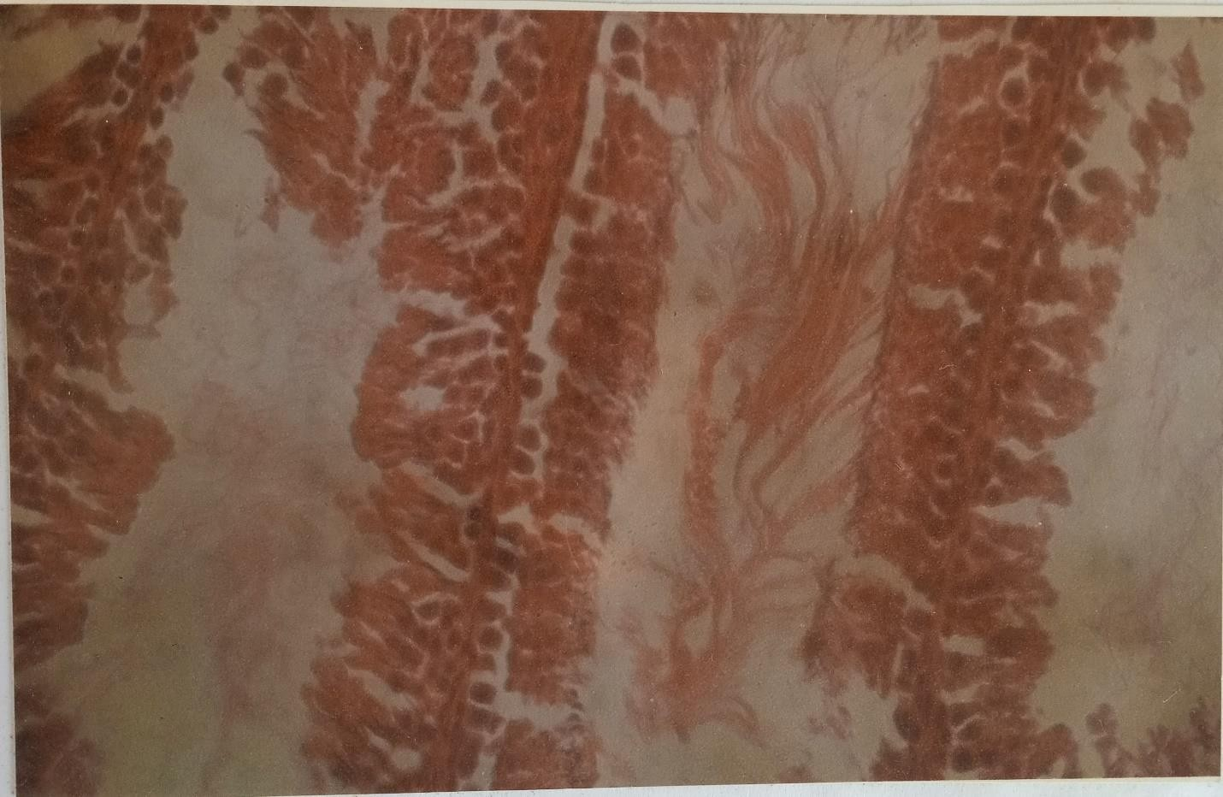

Plate 1:

A photomicrograph showing the transverse section of the seminiferous tubules of control group. H & E stains. 400X.
Examination of the section of seminiferous tubules showed well connected seminiferous tubules containing connective tissues with epithelial lining well surrounded by myoid cells. The tubules were densely populated with sperm cells. Sertoli cells were interspersed with them.

Plate 2

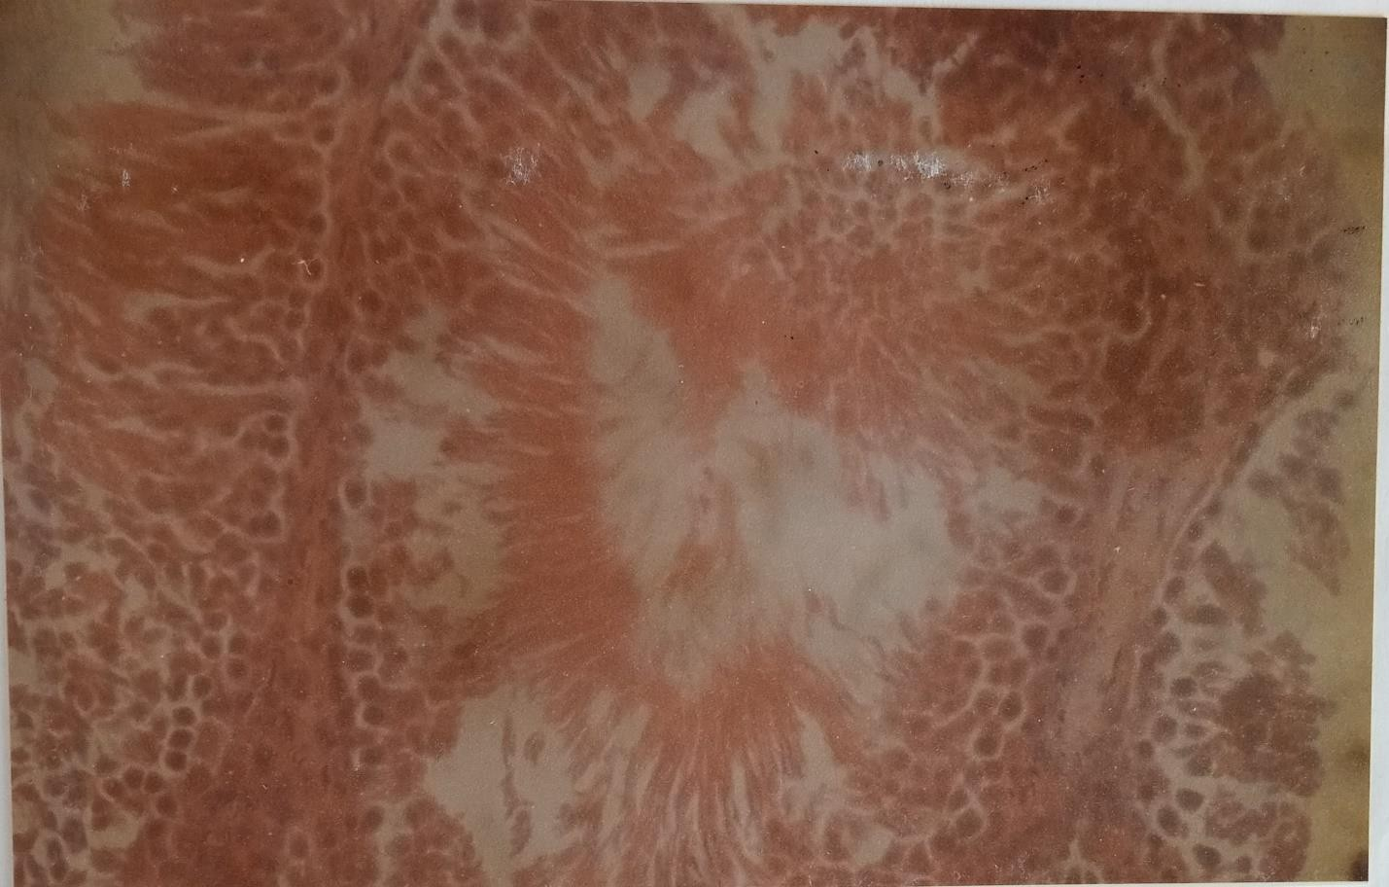

Plate 2:

A photomicrograph showing the transverse section of the seminiferous tubules of rats fed with 1536µg/g/d of kudzu root extract. H & E stains. 400X.
The study of the seminiferous tubules showed no distinct difference from that of the control group but fewer sperm cells were seen at the walls of the tubules with fewer Sertoli cells interspersing with them when compared to the control group.

Plate 3

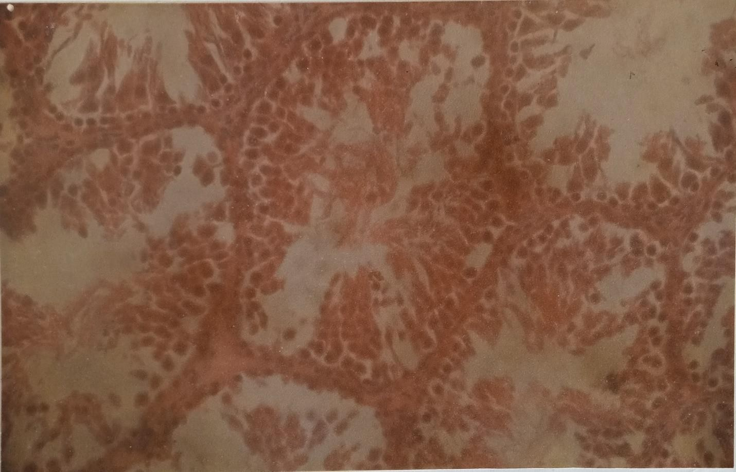

Plate 3:

A photomicrograph showing the transverse section of the seminiferous tubules of rats fed with 384µg/g/d of kudzu root extract. H & E stains. 400X.
The seminiferous tubules showed few sperm cells with many of them found to be degenerated at a low concentration of the extract. The connective tissues of the interstitial spaces still remain intact.

CHAPTER FOUR

4.1 DISCUSSION

The aim of this study was to investigate the effect of methanol extract of kudzu root on the sperm parameters of wistar rats.
In the first five weeks of administration, there was a progressive increase in the weight of all the groups of the experimental rats. A slight weight decrease was recorded in the 6th and the 8th week of administration for the control group while in the treated group a weight loss was recorded in the 6th and 7th week with a final weight gain at the 8th week. This report suggests that exposure of the treated groups to this plant extract induce no gross toxicity or alterations in body weight gain. This was in agreement with the previous report that oral administration of pueraria tuberosa root extract which is a specie of kudzu plant to male rats for the period of 60 days did not cause body weight loss (Gupta et al, 2004).
The mean sperm count was high in the control group compared to group B while there was no significance difference (p>0.05) between that of the group C and the control group. This can be supported with the previous that the administration of pueraria tuberosa root extract to male rats reduce by

63.7% the production of step-19 spermatids and also the population of preleptotene spermatocytes and secondary spermatocytes were decreased by 61 and 72% respectively (Gupter et al, 2004). The decrease in the mean sperm count at a low dose of administration compared to high dose in this research work is possible due to the toxicity of the weak estrogenic activities of Isoflavones present in the plant extract at a low concentration in the experimental animals’ bodies for a long period of time.
A very significant (p<0.05) high percentage of non-motile sperm cells was recorded in group C compared to the control group and group B. No significant difference was recorded between group B and the control group.
The finding suggested that high percentage of immotility recorded due to high dose of administration might have caused a serious depletion in the production of adenosine triphosphate in the sperm cells, thus their metabolism does not proceed normally, rendering them immotile. Previous report on oral administration of pueraria tuberosa root extract suggested that a significant fall in the total protein and sialic acid contents of testes, epididymis, seminal vesicle, and ventral prostate as well as glycogen contents of testes was

observed which thus gives support to the high percentage of immotility recorded.
A low mean relative testes weight was recorded for group B while a non- significant difference was observed between group C and the control group. This result was supported by a reduction in testes weight of male rats orally administered with pueraria tuberosa root extract for the period of 60 days. The reason for this observation cannot be ascertained in this experiment.
The testosterone analysis showed a significant decrease (p<0.05) in the level of serum testosterone in group C with a non-significant difference in the level of testosterone concentration in group B compared to the control group. In male rats, neonatal exposure to genistein reduced LH secretion and plasma testosterone concentrations in adulthood (Faber et al, 1991). Genistein exposure in adult mice caused decreases in testicular and serum testosterone concentrations as well as pituitary LH content and prostate weight (Strauss et al, 1998). With these reports, conclusion can be made that the phytoestrogens present at a particular concentration in the plant root extract have caused a decrease in the plasma testosterone level of the treated groups.

The testicular histology of the treated groups showed an increase in the toxicity level of the plant root extract on the group administered with the low dose of the extract. The few sperm cells found in transverse section of their seminiferous tubules with many of them already degenerated supported a low sperm count (Oligospermia) in this treated group. On distinct difference was recorded in the histological section of the seminiferous tubules of group C compared to the control group whereby the seminiferous tubules remained intact. This observation may be as a result of an increase in the toxicity and destructive level of the plant root extract at a low concentration.

CONCLUSION

In conclusion, the result of this investigation suggested that long-term exposure of wistar rats to the extract of pueraria Phaseoloides root that is a species of kudzu plant, has an adverse effect on sperm parameters done on this. Effect of this particular species of kudzu plant on man is yet to be studies. Thus, there is room for more work and the potential benefits of this plant extraction on man and animals.

RECOMMENDATION

We hereby recommend for those who wish to further carry out a resourceful research on this work, the following:
- Research should be made to find out the effect of kudzu root extract on other organs of the body apart from the reproductive system.
- Experiment should be done to find out the exact mechanism of action of phytoestrogens in the reproductive system.
- Research should be done to see the effect of kudzu root extract on the plasma follicle stimulating hormone (FSH) and leutinizing hormone (LH) levels in the body system.
- Its short-term effects in the similar research to this should be carried out.

- Research should be carried out to see the effect of this plant in a neonatal exposure of it in male rats.
- Research should be carried out to use the effect of this plant in a neonatal exposure of it in male rats.
- Research work should be carried out to see its long-term exposure on mating in animals.

- Experiment should be carried out to know the beneficial and the adverse effects of this plant on different organs of the body at various concentrations.

REFERENCES

Banlhabib E, Tyunlmenkoy, V.V., Jernigan, S.C., Klinge C.M. Kudzu root extract suppresses voluntary alcohol intake and alcohol withdrawal symptoms in P rats receiving free access to water and alcohol. J. Med. Food 2004; 7:168-179
Bennetts H.W., Underwood E.J., Shier F.L. A specific breeding problem of sheep on subterranean clover pastures in Western Australia. Aust. Vet J. 1946; 22:2-12.
Biggs J.H., A sea of estrogens Alive. Canadian Journal of Health and Nutrition. 1995; 149:28-30.
Boue S.M., Olson R.D, Cusack B.J. Evaluation of the estrogenic effects of Legume extracts containing phytoestrogen. J Agric Food Chem 2003; 51:2193-2199.
DeRosa C. Environment exposures that affect the endocrine system: Public health implications. Journal of toxicology and environmental health

1998; 1:3-26.

Faber K.A., Hughes C.L. The effect of the neonatal exposure to diethylstilbestrol, genistein and zearalenone on pituitary responsiveness and sexually dimorphic nucleus volume in the castrated adult rat. Boil. Reprod. 1991; 45:649-653.
Ferguson S.A. Development neurotoxicity of endocrine disruptors: Focus on estrogens. Neurotoxicology 2000; 21:947-956
Gill W. M. Structural and functional abnormalities in sex organs of male offspring of mothers treated with Diethylstilbestrol (DES). The journal of reproductive medicine 1976; 16:147-153.
Gupta R. S., Rakhi S, Aruna S, Rakesh C, Bhatnager A. K, Joshi Y. C. Antifertility effects of pueraria tuberosa root extract in male rats. Pharmaceutical Biology 2004; 42:603-609.
Jang M. H, Dwyer T, Hynes K, Dalais F.S, Greenway T.M. Puerariaeflos against ethanol-induced apoptosis on human neuroblastoma cell line

SK-N-MC. Jpn J. Pharmacol 2001; 87:338-342.

Julie H.M. Elizabeth C, David K, Anne P, Andrew R.C, Irvine D.S. Effect of a phytoestrogen food supplement on reproductive health in normal males. Journal of Chemical Science 2001; 100:613-618.
Keith L.M, Arthur F.D Clinically Oriented Anatomy. 5th edition.

Lippincott Williams and Wilkins. Philadelphia. 2006.
Kim I.T, Chung B.C, Yu V.Y, Nam J.H, Lee H.C. Anti-inflammatory and antinociceptive effects of the extract from Kalopana pictus, pueraria thumbergiana and Rhus verniciflua. J Ethnopharmacol 2004; 94:165-
173.

Kuiper G.G. Carlsson B, Granchen K, ENmark E, Haggblad J, Nilsson S. Comparison of the ligand binding specificity and transcript tissue distribution of estrogen receptors α and β. Endocrinology 1997; 138:863-870.
Lamlertkittikul S, Chandeying V. Efficacy and safety of pueraria mirifica

(Kwaokruea Khao) for the treatment of vasomotor symptoms in

perimenopausal women: Phase II study. J. Med Assoc Thai 2004; 87:33-40.
Lee K.T, Jin Y, Lin W, Ji S, Choi S, Jang S. Tectorigenin, and isoflavone of pueraria thumbergiana Benth; induces differentiation and apoptosis in human promyelocytic leukemia HL-60 cells. Boil pharm Bull 2001; 24:117-1121.
Lukas S.E, Wild R.D, Hammond L.J, Khalil D.A, Juma S. Extract of the Chinese Herbal root kudzu reduces alcohol drinking by heavy drinkers in a naturalistic setting. Alcohol chin Exp. Res. 2005; 29:756-762.
Luiz C.J, José S. Basic Histology, 11th edition. McGraw-Hill companies, Inc.

2005.

Mazur W, Adlercrentz H. Naturally occurring estrogens in food. Pure and Applied chem. 1998; 70:1759-1776.
O’Donell L. Phytoestrogens and Infant formulas Endocr Rev 2001; 22:289- 318.

Rossiter R.C, Beck A.B. Physiological and ecological studies on the estrogenic isoflavones in subterranean clover (Trifolium subterraneum). Effects on temperature. Aust. J. Agric. Res. 1966; 17:29-37.
Strauss L, Makela S, Joshi S, Huhtaniemi I, Santti R. Genistein exerts estrogen-like effect in male mouse reproductive tract. Mol cell. Endocrinol. 1998; 144:83-93.
Woo J, Lau E, Ho S.C, Cheng F, Chan C, Chan A.S.Y., Haines C.J, Chan T.Y.K, Li M, Sham A. Comparison of pueraria lobata with hormone replacement therapy in treating the adverse health consequences of menopause. Menopause. 2003; 10:352-361.

APPENDIX

RAW DATA OF VALUES

Rats | Group A Weight(g) | Group C Weight(g) | Group B  Weight(g) | Weeks
1  2  3  4 | 99  109  65  106 | 100  100  82  99 | 91  70  95  90 | 1
1  2  3  4 | 115  118  84  120 | 110  116  95  119 | 109  80  114  100 | 2
1  2  3  4 | 121  127  88  128 | 121  129  100  128 | 118  82  129  108 | 3
1  2  3  4 | 139  140  100  138 | 139  144  112  150 | 138  91  149  120 | 4
1  2  3  4 | 140  148  102  140 | 149  150  115  153 | 140  95  148  125 | 5
1  2  3  4 | 137  142  100  138 | 141  152  110  154 | 140  98  147  123 | 6
1  2  3  4 | 145  150  102  147 | 136  149  107  150 | 135  96  143  120 | 7
1  2  3  4 | 140  159  98  139 | 156  167  109  162 | 155  116  160  139 | 8

4.1 SPERM COUNT

Rats | 1 | 2 | 3 | 4
Group A Group B Group C | 42  26  32 | 48  4  12 | 76  62  96 | 30  44  44

SPERM MOTILITY

 | Rats | Right Testis |  | Left Testis
Group A |  | Non-Motile(%) | Motile(%) | Non-Motile(%) | Motile(%)
 | 1 | 20 | 80 | 35 | 65
 | 2 | 5 | 95 | 40 | 60
 | 3 | 75 | 25 | 60 | 40
 | 4 | 3 | 97 | 3 | 97
Group B | 1 | >99 | <1 | >99 | <1
 | 2 | 95 | 5 | 93 | 7
 | 3 | 93 | 7 | 94 | 6
 | 4 | 96 | 4 | 97 | 3

Group C | 1  2  3  4 | >99  98  40  25 | <1  2  60  75 | 75  96  30  10 | 25  4  70  90

TESTES WEIGHTS

 | Rats | Right Testis WT(g) | Left Testis WY(g)
Group A | 1 | 0.861 | 0.861
 | 2 | 0.925 | 0.938
 | 3 | 0.493 | 0.515
 | 4 | 0.922 | 0.891
Group B | 1 | 0.800 | 0.800
 | 2 | 0.900 | 0.887
 | 3 | 0.774 | 0.784
 | 4 | 0.882 | 0.879
Group C | 1 | 0.800 | 0.752
 | 2 | 0.467 | 0.500
 | 3 | 0.772 | 0.742
 | 4 | 0.826 | 0.807

TESTOSTERONE ANALYSIS RESULTS

 | Rats | Value (ng/ml) | Absorbance
Standard | 1 | 0 | 0.86
 | 2 | 0.1 | 0.628
 | 3 | 0.5 | 0.398
 | 4 | 2 | 0.305
 | 5 | 6 | 0.166
 | 6 | 18 | 0.107
Group C | 1 | 0.2 | 0.589
 | 2 | 0.1 | 0.621
 | 3 | 1.2 | 0.352
 | 4 | 0.1 | 0.610
Group B | 1 | 0.8 | 0.380
 | 2 | <0.1 | 0.724
 | 3 | <0.1 | 0.655
 | 4 | <0.1 | 0.728
Group A | 1 | 0.3 | 0.535
 | 2 | 0.3 | 0.546
 | 3 | <0.1 | 0.717
 | 4 | 1.6 | 0.335

