Why do we do science?
Article type
DOI
Navigating the paths of individual excellence and team science
dr. ir. Steven Flipse & dr. Eva Kalmar
Faculty of Applied Sciences, Delft University of Technology, Lorentzweg 1, 2628 CJ Delft, The Netherlands
S. Flipse Email: S.M.Flipse@tudelft.nl
E. Kalmar Email: E.Kalmar-1@tudelft.nl

Abstract
In this whitepaper, we address an issue that has been emerging within the academic community: how do we align our personal career perspectives with ideas of democratic, open and inclusive research and innovation strategies? We address this issue and voice our concerns regarding the governance of this alignment within our lovely institution in the hope that it provides a starting point for further deliberation amongst our scholars and students.
Keywords: fundamentals of science, collaboration, team science, science communication

Research Highlights
- We are convinced that our staff and students currently do not pay enough attention to the implications of choosing individual excellence and collaborative science endeavours. Making choices on how we see our academic study programs and careers is based on different interpretations and assumptions around personal and institutional values.
- There are different perspectives between scholars in research fields that are more discipline-oriented and widely socially oriented in starting points for their scholarly work, but often without explicit consideration of how it influences how collaborative science plays out in practice.
- We observe a difference in how collaboration is integrated into student curricula. If we want to change the educational system to be more about inclusive science, we have to start by making more explicit choices about this in our research agendas.
- If we move towards more collaborative science, discipline-oriented scientists should stop hiring future clones.
- The current (lack of) initiative by our collective management to discuss these and related issues does not do justice to the value of making explicit governance-related choices on the supposed role of the Delft University of Technology in society

"Millions saw the apple fall, but Newton was the one who asked why."
Bernard Baruch

1. Getting started: perspectives on our knowledge society

We live in a knowledge society. In addition to mineral resources, capital and physical activity, knowledge is an increasingly important resource. It contributes to the functioning of democracies and innovation and helps countries to be globally competitive. However, the academic world, which contributes significantly to knowledge production, is confronted with new challenges. Classical, single-disciplinary approaches slowly make way for multi-, inter- or transdisciplinary groups, projects and educational programmes. Is this a movement for the better?
Perspectives on this topic within the TU Delft differ. Some argue that the key to 'good science' starts from solid disciplinary knowledge; starting from anywhere else leads to sub-optimally academically grounded solutions. Nonsense, others say, starting from the perspective of societal problems embedded in complex social systems is the best way forward: science is not there for science; it is there for society.
We observe the same combination of perspectives within our institution: fundamental physics education (AS faculty) exists next to broader and more socially embedded programs such as Complex Systems Engineering and Management (TPM faculty). Or, even within one faculty, the Master programme Architecture, Urbanism and Building Sciences offers technical tracks on architecture and more broadly socially embedded tracks on management in the built environment.
Simultaneously, in research, we observe fundamental and disciplinary quantum science projects, as well as technical multidisciplinary collaborations such as the E-Refinery. And even transdisciplinary collaborations that transcend all disciplinary boundaries within the Resilient Delta Convergence Initiative, where public social, technical and economic actors and humanities scholars work together to address real-world challenges.
What does this development in disciplinary fields mean to an institution like the TU Delft? What impact does it have on our educational and research programmes? And are we sufficiently equipped to accommodate this movement? In this article, we address these and other questions, starting from the perspective: what makes us 'tick' as scientists at an academic institution?

Why become a scientist?
Citing from the Vision statement of TU Delft: "One important characteristic of TU Delft is that we not only strive to be good at what we do but also that we want to be good for something. At TU Delft, we strive to balance our pursuit of world-class academic excellence on the one hand and providing high-quality education and expert solutions to societal problems on the other hand."
Apparently, our leaders recognize that TU Delft has to excel academically as a research institution, and we also have to provide education and solve societal problems. But by presenting this as on the one hand and the other hand, the question arises if and where we can make these two hands' shake'; whether we can make them support something central that they both support. The current situation appears to be a non-strategically grown mix of single disciplinary research fields – represented as groups within sections within faculties and some discipline-focused educational programmes, and multi- (or inter- and perhaps trans-) disciplinary research fields – represented as wide collaborative, inter-faculty, or inter-institutional research projects and broader educational programmes. But the question is if this combination of what appears to be naturally grown initiatives can develop into a strategic choice with active governance and managerial guidance.
Regardless of which of the two perspectives is or becomes leading, the question remains in which direction this will be moving in the near future. This movement dramatically impacts how we view education, what our roles and responsibilities are as researchers, and what are the reasons behind our commitment to being academics in the first place. In the following sections, we will present our views on collaborative science, what this means for future education, and how future collaborative science might be institutionally supported.

2. Opening up the way we do science by asking questions
Science and innovation are tightly related. We need scientific results for technological innovations, and these technologies have – or at least should have – an effect on how we do science. Yet, at times when policymakers would like to figure out which factors could increase the innovativeness of a given region or country, we rarely hear about innovations that reform science itself. The first scientific revolution in the 17th century laid the foundations of various scientific disciplines and the principles that guide how science is performed. The basis of the publication system, for example, was founded in the 1660s, and apart from slight adaptations to digitalisation in the last decades, it has not changed much since; we still download articles in the format of a printed journal due to historical rather than rational reasons. Scientific publishing shaped and, at the same time, limited how science is performed by determining how ideas and results are shared within the scientific community.

Open and responsible science
With the spread of the novel European Commission plans for Open Science, more and more academics question the current ways of scientific publishing. Most of us find that results of scientific studies funded by governmental grants ("citizen's money") should be available for everyone without a subscription to the journal or paying for the individual article.
Open Science shouts for transparency in various aspects of scientific inquiry, not just at the level of publishing. They argue that data should be gathered, stored and made available for other scientists to check and reuse. Other movements also point out weak points in the scientific life cycle. For example, Public Engagement in Science (PES) campaigns for including non-scientific stakeholders in distinct aspects of research: citizens collecting scientific data via citizen science projects or lay people's local and contextual knowledge in discussing technological risks and research policies to democratise science-related decision-making. Responsible Research and Innovation principles were formulated to involve external stakeholders in the research process to start talks on the ethical aspects of science.
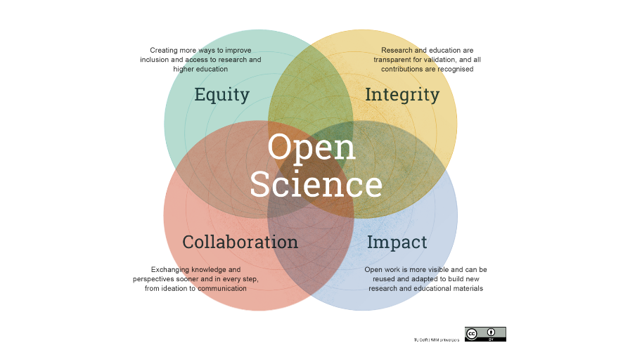
Figure 1 : Open science goes beyond publishing– it is a redefinition of scientific collaboration and output (source: https://www.tudelft.nl/open-science)
These different movements challenge the current ways of performing science. Who should be part of the data collection? Who should have a word in the way a given research is conducted? Who should read scientific results? Who should decide which projects should be performed and who should grant these? How do we measure scientific excellence? If the publication system is old-fashioned and biased, as Open Science advocates say, is it reliable to judge how good scientists are based on their publication list? NWO signed the San Francisco Declaration on Research Assessment (DORA) in 2019 and implemented its principles in the assessment procedures, taking a big step towards changing the measurement aspects. This shows that we need to start a discussion about these issues and figure out a potential solution also within our own institution.
These different movements challenge the current ways of performing science. Who should be part of the data collection? Who should have a word in the way a given research is conducted? Who should read scientific results? Who should decide which projects should be performed and who should grant these? How do we measure scientific excellence? If the publication system is old-fashioned and biased, as Open Science advocates say, is it reliable to judge how good scientists are based on their publication list? NWO signed the San Francisco Declaration on Research Assessment (DORA) in 2019 and implemented its principles in the assessment procedures, taking a big step towards changing the measurement aspects. This shows that we need to start a discussion about these issues and figure out a potential solution also within our own institution.

Asking ourselves why we do science
We believe that asking such questions, such as "Why do we do science?" can help us to see what the issues are, and what needs to be changed. The choice between science done to gather fundamental knowledge and science done to solve societal problems has consequences on how we make decisions about how we organise our research projects. The two answers might not seem that far apart, but they put you on two different paths when you need to set up a collaboration. Namely, if the focus lies on deepening scientific understanding or creating new technology, one might choose collaboration partners with similar backgrounds but with access to different methodologies or instruments. In contrast, if someone sets solving societal problems central, the collaboration needs to contain diverse collaborating partners to cover different values, perspectives, knowledge fields and interests. This is because complex societal problems have multiple definitions, are viewed differently from different stakeholder perspectives, and, unfortunately, cannot be solved straightforwardly. Teams that are trying to come up with a solution need to tackle the complexity through inter- or transdisciplinarity.

Change requires different systems and skills
Yet, the classical scientific life cycle and the research support systems are based on and further support fundamental knowledge creation. Classical disciplinary university education focuses on individual performance; universities and research institutions evaluate and reward researchers individually. Next to big collaboratory projects, grant providers still publish calls for excellent individuals to persuade their own dream projects (ERC, VENI, etc), and PhD candidates are hired individually. In universities and research institutions, researchers are part of their research team with several other scientists, PhD students, Bachelor/Master students and assistants, usually led by a principal investigator (PI). In these "home teams", researchers need to cooperate but also compete with fellow PhDs and post-docs to get recognition within and outside of their own institution.
Scientific collaborations are often formed outside of these home teams, between different faculties and universities, often with industrial partners, governmental organisations and (representatives of) users. Working in such project-based temporary teams means stepping out of the hierarchical home institution and learning or creating new social rules. Managing projects, negotiating expectations and desired outcomes, sharing knowledge, and creating new methods and theories in these kinds of multi-, inter- or transdisciplinary collaborations require specific skills not covered by classical university education. Inter- and transdisciplinary teams set up to solve societal or complex problems have specific team dynamics. At the beginning of these projects, partners bring their own purpose, knowledge, definitions of concepts and interpretations of the problem. These partners also have different ways of approaching the problem and negotiating with each other on how to move further. One of the greatest challenges of these interactions is to bring the different perspectives, problem definitions and potential ways to solve the problem close to each other.

Social learning to address grand challenges
The convergence of these differences could be seen as social learning, as this leads to shared mental models and the generation of new knowledge. Science communication, social science, and team science provide us with theories, models and methods to understand how such teams function, what methods or interventions can be used to support the desired team processes, and why other methods should be avoided when communicating with diverse stakeholders, especially in situations when the interests are conflicting.
Sustainability, energy transition, resilient cities, rising sea level, health care reforms. Projects highlighted at TU Delft's main homepage. These are all complex societal challenges which have technical perspectives but cannot be solved without engaging versatile stakeholders, listening to their ideas, and integrating their knowledge and interests. For these, we need specific scientific knowledge, but also communication, collaboration and social skills. Then why don't we teach these specific skills together with rigorous scientific methodologies and theories? In our next section, we will discuss the topic of how we (should) educate our students.

3. Education as preparation for multidisciplinary global problem solvers
Within the TU Delft, we pride ourselves on offering good quality and positively evaluated academic education on BSc, MSc and post-master (PhD) level. And perhaps rightfully so. Nevertheless, a valid question remains: what are we actually preparing our current and future students for?
According to the vision statement in the current strategic plans, the "Delft University of Technology contributes to solving global challenges by educating new generations of socially responsible engineers and expanding the frontiers of the engineering sciences." We acknowledge that this requires deep content knowledge of (one or multiple) disciplinary fields channelled and also a wider view of the social-economic and technical ecosystem in which such deep content knowledge can be channelled into useful (and possibly also socially responsible) contributions to solving global challenges.

T-shaped profiles for all our students?
This 'T-shaped profile'( where the deep disciplinary or content knowledge is represented as the vertical part of the T, while the horizontal line corresponds to competencies that are crossing disciplinary boundaries) is also acknowledged within the strategic plan, through which "[…] our graduates acquire a thorough and in-depth disciplinary knowledge, while at the same time (usually in the minor and MSc programme) familiarising themselves with other disciplines and developing competences in the application of technical expertise to 'real world' complexities."
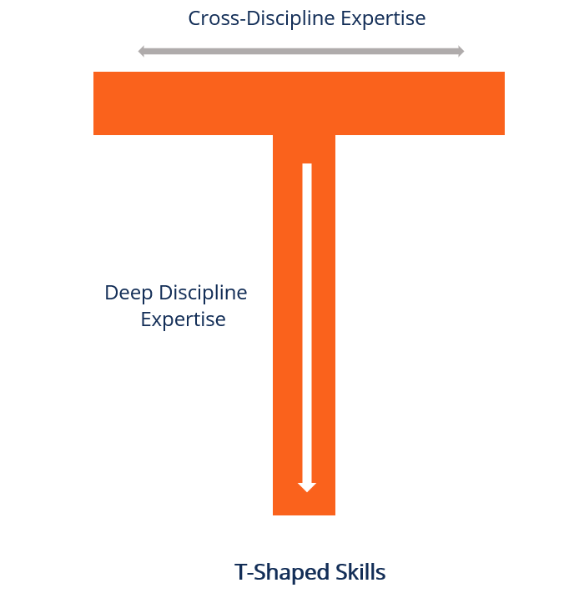
Figure 1 : The T-shaped profile (source: https://corporatefinanceinstitute.com/resources/management/t-shaped-skills/)
We can discuss to what extent this is the case, but more reliable is perhaps a short overview of student perspectives on this matter. We quote experiences from five students who were enrolled in the Communication Design for Innovation MSc program at the time of writing the first version of the article. Most students followed the CDI Master track as a double degree MSc program in conjunction with another engineering program at the TU Delft. This program focused on teaching theories from various fields, including responsible research and innovation, science communication, team science, and competencies such as design, teamwork and social science research skills, but more importantly, to take into account societal aspects in designing new solutions. Therefore after finishing this Master track as a double degree, engineers had a deep disciplinary and a broad inter- or transdisciplinary knowledge and skills. These quotes were collected from the students ironically just before the Faculty decided to close this Master's track.
- I've become significantly more open to a wider spectrum of viewpoints in my work as an engineer. No longer am I only focused on the solution to a problem but also on the process, the people involved and how those people feel and interact.
- I have only been in the program for a month and it already recontextualises so much of my previous experiences within and outside academia. I am of the opinion that certain parts of this master's program should be included in every other master's program as well.
- Having technical skills does not always mean that you know how to put these skills to use. When I talk about the CDI programme to other students of TU Delft, the only reaction I get is that they wish they knew this programme existed.
- In short, the added value of the CDI programme lies not only in the addition of an important skill set but also in a way of thinking and behaving when working in the scientific field.
- I'd say it's by far the most complete education I've received so far because it not only taught me valuable knowledge and communicative skills but also improved my creativity and confidence and showed me how to use all this to initiate change in complex systems.
By extension, these descriptions all imply that in their technical / engineering programs, such broadening modes of thinking are largely lacking. But they also imply that if you don't know that you miss these broadening mindsets and skills, you are also not likely to go look for them.

Deep or wide profiles?
Still, while we think such T-shaped profile development is recommendable, the question is how deep and wide such Ts should be for students to best be able to address the global challenges that lie ahead. Since there is limited time and capacity within any curriculum, depth may come at the expense of width and vice versa.
Different perspectives seem to exist. There are those who argue that our task as educators is primarily to train content experts, and the focus in education should be to cover as much content-relevant knowledge as possible (possibly at the expense of a wider societal view). We find this 'empty vessel theory' for example at the Applied Physics master which contains advanced math, general advanced physics electives and specific MSc Track related electives, an internship and a thesis project; and to widen the T, an ethics and engineering course (and possibly some room for other electives if the student so chooses).
Yet, there are others who argue that our task is to train experts who are open to the social-ethical and economic complexity of problem-solving associated with addressing global challenges. They offer programs like the MSc in Architecture, Urbanism and Building Sciences, with e.g. a track in Management of the Built Environment, that contains content-related courses around economics, management and law, but also courses that cover content against a wider societal background, around redesigning complex (urban / infrastructure) projects and much room for free electives.
The question is then what the 'top of the T-shape' actually is. Does it comprise an overview of different sub-disciplines (Physics of Energy Materials, Chemistry and Physics of Solar Cells, Energy Storage in Batteries, Molecular Electronics, Nuclear Reactor Physics, and Materials Chemistry for the Nuclear Fuel Cycle, as part of an Applied Physics track) to help students develop a broader view on the discipline? Or an overview of different disciplines related to a wider global problem-solving perspective, like courses on actor and strategy models, intercultural relations and project management, ethics and impacts of global interventions and macroeconomics for policy analysis, as part of the MSc program in Engineering and Policy Analysis.

Science communication and team science: connecting the different disciplines
To solve complex societal challenges which have technical perspectives, we need to engage various stakeholders, listen to their ideas, and integrate their knowledge and interests. For these, we need specific scientific knowledge, but also communication, collaboration and social skills.If we need to master these skills, amongst other 21st-century skills, such as problem-solving, design thinking and so on, we need to incorporate these into the education programmes.
Science communication is often counted as a skill to communicate scientific results to the wider public. We think differently. We believe that Science Communication is (or should be) a team project, an interdisciplinary collaboration of different stakeholders, such as communication experts, researchers, policymakers, librarians, artists, curators of musea, and representatives of diverse citizen groups. People who are communicating with these stakeholders need to master social scientific research methods to gain information on their target groups. What is important for them? How do they make decisions? Why are they against or for some improvements? Then they also need methodological knowledge on how to perform good public engagement, citizen science or participatory design projects. Science communication is therefore not just a skill on how to talk to a wider public. Although there are science communication tracks or specifications at several universities, science communication should be incorporated into every academic BSc and MSc programmes.
Teamwork is already part of several BSc and MSc programmes. But do the students who are asked to perform teamwork learn how to do that? Are they coached properly? Or do we just let them do it, expecting that they learn it by doing? How do we help them when they consider difficulties if the lecturers or teaching assistants do not have any background in team science?
Project- and challenge-based education is trending over technical universities. TU Eindhoven won the Dutch Higher Education Awards for this type of education. In project-based courses or programmes, student teams work on a project for a client, defining their own learning path, and creating a prototype as a solution for the actual problem. It provides the possibility to learn and practice the skills needed for inter- and transdisciplinary collaborations. Setting up such programmes or courses requires a lot of effort from the education designers, and giving such education demands another perspective of teaching: coaching teams. It is a special expertise with special knowledge in the science of team science. This new scientific discipline collects knowledge basis on team dynamics, important factors that determine the effectiveness of teams. We do not have to reinvent the wheel, just apply the knowledge collected on teams.

Reinforcing loops
Some might argue that students know 'what they're getting themselves into' when they apply for a program; that physics students are just possibly more inherently interested in the content, while students who study at the faculty of Technology, Policy and Management are just more interested in the wider societal context. And that might be fine. But, does that mean that students with a more technology-focused engineering degree are better or worse possible contributors to later global problem-solving? The easy answer is that perhaps we need both. But is that a good reason to let curricula remain the way they are?
Yet, before we can answer that question, there is another dichotomy that is worthwhile to address: the role of individual excellence vs group collaboration skills. We seem to observe that with a content focus comes a focus on individual excellence: those who do very well in the technological content-knowledge courses (which are almost without exception graded through an individual exam) score high individual grades and can earn a 'cum laude' on their technical diplomas, to pave the road for a technical PhD that is also valued individually, to continue to a post-doc for another individual technical research project, to continue to a content-focused Tenure Track, etc. On the other side, there are programs in which there is more attention to group work, more eye for wider interdisciplinary knowledge, and more general knowledge. But the lack of individual focus makes it more difficult to 'stand out' or 'shine' as an individual in the individual-focused evaluation systems that a (technical) university offers.
And there are also other consequences of this system of rewarding individual excellence. Suppose those who originate from a program that focuses on individual excellence continue to develop such programs. In that case, this leads to a self-fulfilling prophecy: what has worked for them earlier will also work for future students and that's that. The same applies to programs that focus on collectivism. However, the consequence is that people trained in individuality-focused programs will be more likely to hire new colleagues with a similar profile and less likely to hire colleagues with a wider perspective (and similar for colleagues in the more social and group thinking fields). If anything, this only widens the gap between the two perspectives.

Shooting stars vs. the dinosaurs
In other words, our own staff population with its own normative (implicit and explicit) values, lies at the origin of the current situation. And then the real question becomes how change can be realised within an organisation that builds on academic freedom and (frequently) quite solitarily operating faculties, departments and sections. A cynic might argue that those who value collaborative perspectives and are not quite keen on individual excellence leave the academy as soon as they get their degrees and start their careers elsewhere. Does this mean that we cultivate our own population of PhD candidates, post-docs and tenure trackers as individualists, or is it the case that more collaborative and multidisciplinary 'shooting stars' are in fact, killing the old, individualistic and domain-centred dinosaurs?

Figure 3: Shooting stars vs dinosaurs (source: https://www.justpo.st)

The possibly required change in our programs is also indicated by the fact that most of our hired PhD candidates (and other staff for that matter) are explicitly not alumni of our own programs. One can wonder, what makes other candidates more suitable for positions within our faculties? While we certainly do not opt for the selection or preference of just our own students for the sake of “being our own students”, it is still interesting to explore what (implicit and explicit) reasons might be at play with regard to the preference of other students, other than selection criteria determined by grant organisations (for example for the Marie Curie PhD positions). What skills are ”we” looking for that we cannot seem to find in our own candidates? And, most importantly, how do we change our own programs to align better with these presumably preferred profiles?

Data availability statement (if applicable)
Sed iaculis est non mattis elementum. Ut nec feugiat justo. Vivamus at lorem pulvinar, faucibus est et, sagittis leo. Pellentesque eros ipsum, consectetur vitae orci ac, luctus vulputate urna. Maecenas sed mollis felis. Pellentesque sit amet tellus imperdiet, malesuada nunc nec, viverra nulla. Vivamus finibus accumsan lorem quis vulputate.
Suspendisse ultrices felis ut ante pretium tincidunt. Vestibulum orci turpis, tincidunt a diam vitae, tincidunt pellentesque ante. Nunc tempor accumsan interdum. In non dui quis urna porttitor pretium. Integer quis nulla dapibus quam luctus commodo. Pellentesque ut turpis quis nibh vulputate fermentum at id orci. Mauris eu ligula volutpat, eleifend diam vitae, tincidunt turpis. Donec a dolor malesuada, feugiat eros non, pharetra urna. Integer pellentesque urna vulputate justo placerat tempor. Ut varius, lorem vitae cursus tempor, mauris nibh volutpat felis, quis efficitur tortor elit feugiat eros. Donec imperdiet pellentesque eros. Donec efficitur diam nulla, at fermentum eros lobortis eget. Sed auctor nec metus nec finibus.

Contributor Statement (Describe properly all author contributions and all types of contribution)
Suspendisse ultrices felis ut ante pretium tincidunt. Vestibulum orci turpis, tincidunt a diam vitae, tincidunt pellentesque ante. Nunc tempor accumsan interdum. In non dui quis urna porttitor pretium. Integer quis nulla dapibus quam luctus commodo. Pellentesque ut turpis quis nibh vulputate fermentum at id orci. Mauris eu ligula volutpat, eleifend diam vitae, tincidunt turpis. Donec a dolor malesuada, feugiat eros non, pharetra urna. Integer pellentesque urna vulputate justo placerat tempor. Ut varius, lorem vitae cursus tempor, mauris nibh volutpat felis, quis efficitur tortor elit feugiat eros. Donec imperdiet pellentesque eros. Donec efficitur diam nulla, at fermentum eros lobortis eget. Sed auctor nec metus nec finibus.

Acknowledgment
Etiam id urna quam. Donec semper in quam in ornare. Nullam convallis ultricies nisl, sed finibus nunc ultricies quis. Nam interdum purus sapien, non volutpat ante suscipit et. In ac eleifend eros. Etiam sit amet porta nulla. Quisque nec vestibulum velit.

Reference
Nulla facilisi. Proin luctus ligula a felis placerat, nec aliquam ante sagittis. Morbi faucibus euismod egestas. Phasellus dapibus, massa quis dictum sollicitudin, lectus justo egestas eros, et facilisis tellus nisl nec ligula. Nam placerat nunc lorem, at euismod erat porta eu. Aenean pulvinar varius magna eu placerat. Fusce vestibulum nunc quis nibh venenatis porttitor. Nulla consectetur est sit amet egestas sollicitudin. Fusce laoreet non orci sed fringilla. Etiam tincidunt suscipit ex scelerisque convallis. Aliquam viverra ultricies ante, vitae auctor nibh feugiat at. Maecenas ullamcorper metus vel augue eleifend lacinia.
Nulla facilisi. Proin luctus ligula a felis placerat, nec aliquam ante sagittis. Morbi faucibus euismod egestas. Phasellus dapibus, massa quis dictum sollicitudin, lectus justo egestas eros, et facilisis tellus nisl nec ligula. Nam placerat nunc lorem, at euismod erat porta eu. Aenean pulvinar varius magna eu placerat. Fusce vestibulum nunc quis nibh venenatis porttitor. Nulla consectetur est sit amet egestas sollicitudin. Fusce laoreet non orci sed fringilla. Etiam tincidunt suscipit ex scelerisque convallis. Aliquam viverra ultricies ante, vitae auctor nibh feugiat at. Maecenas ullamcorper metus vel augue eleifend lacinia.
Nulla facilisi. Proin luctus ligula a felis placerat, nec aliquam ante sagittis. Morbi faucibus euismod egestas. Phasellus dapibus, massa quis dictum sollicitudin, lectus justo egestas eros, et facilisis tellus nisl nec ligula. Nam placerat nunc lorem, at euismod erat porta eu. Aenean pulvinar varius magna eu placerat. Fusce vestibulum nunc quis nibh venenatis porttitor. Nulla consectetur est sit amet egestas sollicitudin. Fusce laoreet non orci sed fringilla. Etiam tincidunt suscipit ex scelerisque convallis. Aliquam viverra.

Based on Sa'ad Medhat, & Peers, S. (2012). White paper: T-shaped learning for the new technologist. NEF.
In this theory, in short, students are considered empty vessels that need to be filled with content knowledge before they can functionally participate in society; in contrast to students being considerate human beings with their own normative frameworks, perfectly capable of functioning in a social system, improving on their contributory capacity to help society as their academic paths progress.
Kalmár, É., & Stenfert, H. (2020). Science Communication as a design challenge in transdisciplinary collaborations. Journal of Science Communication, 19(4), C01.

