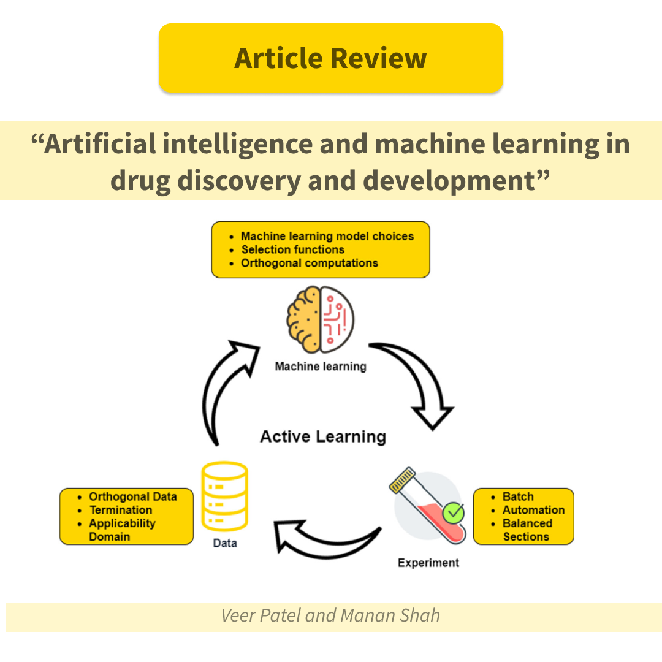

The amount of work done by humans was greatly decreased by the Industrial Revolution and the related mechanization. To lessen workloads in a manner like to that of the Industrial Revolution, numerous researchers are attempting to incorporate Artificial Intelligence (AI) and Machine Learning (ML) into various intellectual job processes. To explore the successes of various research groups from around the world in this craft, Veer Patel and Manan Shah conducted their in-depth research work and presented the results in an article titled "Artificial intelligence and machine learning in drug discovery and development".
To find 973 publications, they ran a keyword search of the biggest databases of scientific papers published in the last 5-8 years. After additional screening based on specific criteria, only 36 articles that best fulfilled the search's objective were chosen. All the papers were carefully analyzed and the results of the review were presented in three categories: “Advanced technologies in drug discovery”, “Machine learning in drug discovery” and “Artificial intelligence in drug discovery”.
So let's briefly analyze the results of their work in the relevant categories.
- «Advanced technologies in drug discovery»:
A literature search has shown that there are several technologies and techniques used in the pharmaceutical industry for Drug Discovery. Among them, the in silico Absorption, Distribution, Metabolism, Excretion and Toxicity (ADMET) platforms (Bayer, Leverkusen, Germany, for example) occupies a special place. This technology models pharmacokinetic and physicochemical endpoints for the manufacturing of new pharmaceutical substances. With the use of Artificial Intelligence, such technology can be used in a variety of ways, such as gathering secondary data for different compounds used in protein synthesis and compiling it according to the previously mentioned parameters. From this data, complex/hybrid deep learning models can be created.
Another technology used in the pharmaceutical industry is blockchain. A blockchain is a type of data structure based on collecting and collating records and converting them into blocks, which are then attached in chronological order to form a chain. Many different characteristics of blockchain make it suitable for use in the pharmaceutical industry. These are permanence, decentralization, straightforwardness, and recognizability.
- «Machine learning in drug discovery»:
The majority of the papers included in this study claim that Machine Learning will eventually reduce if not completely remove, the necessity for animal testing. For example, one of the studies demonstrating the use of this kind of technology in Drug Development examines how ML can be used to identify highly bitter molecules in the early stages of drug development. The goal of the study was to determine which ML algorithm could be used as a substitute for animal testing to predict the bitterness of various molecules used in medicines. Overall, 80% of the identified bitter molecules matched those obtained in the Brief Taste Aversion Test (BATA) experiment, indicating that this study was successful.
- «Artificial intelligence in drug discovery»:
Predicting drug attributes is the primary use of AI in drug discovery. This can minimize the need for human subjects in clinical trials, which is advantageous from both a financial and ethical standpoint. Thus, Veer Patel and Manan Shah reviewed many papers that show that software packages using AI give better results in predicting certain properties of compounds, such as solubility, compared to conventional software packages. In addition, some of the papers demonstrate that AI not only increases procedural accuracy and efficiency but also allows for discoveries.
Throughout the review of this article, we can see that AI can indeed facilitate the research process at various stages of drug discovery.
Chemspace provides Machine Learning solutions for your discovery research projects because of this. We have integrated large chemical spaces (REAL & Freedom spaces), machine learning, and DNA-encoded libraries of molecules to expedite the first steps of Drug Discovery, reduce costs, and maintain a high success rate. This feature saves the researcher a great deal of time and simplifies the procedure considerably.
More information can be found here .

