The explaining of how the plot shape “Cinderella” got preferred by readers
Author: Serhii Yaremko
Showshenk1@gmail.com

Abstract
In 2016, the team of mathematicians with the help of powerful computers and advanced methods of research discovered that the emotional arcs of stories are dominated by six basic plot shapes – and it is interesting that under these circumstances more simple stories (which are often preferred by authors) are not to be so popular among readers. The aim of the current manuscript is to explain such paradox with the help of Analogy method doubled by using Chaos theory.
Keywords: Digital text mining, Emotional story arcs, Narration arcs, Plot shape “Cinderella,” Six basic plot shapes.

Introduction
The team of researchers have shown with their article “The emotional arcs of stories are dominated by six basic shapes” (Reagan, Mitchell, Danforth & Sheridan Dodds, 2016) that “Cinderella” (Fig. 1, a) and doubled “Man in a hole” (Fig. 1, b), the plot archetypes, as well as their negations (we are talking about such plot shapes as “Oedipus” and doubled “Man on hill” with regard to) are the most popular among the readers (Fig. 2, red frameworks) although they are not to be so preferred by authors (Fig. 2, blue frameworks). The aim of this research is to provide the explanation of such situation.
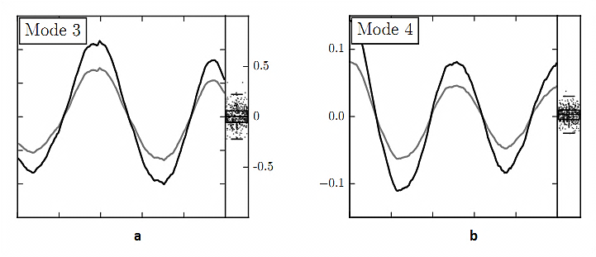
Figure 1 (Credits: ResearchGate; Reagan, Mitchell, Danforth & Sheridan Dodds)

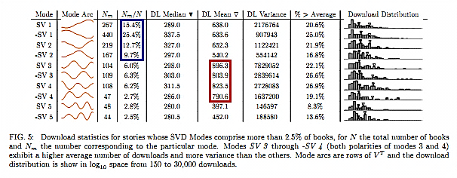
Figure 2 (Credits: ResearchGate; Reagan, Mitchell, Danforth & Sheridan Dodds)
Referring to the fact that the authors of works are interested in the plot shapes to be simplified – well, the cause is clearly seen: The law of economy, or the Occam’s razor; the “Tragedy” and “Comedy" are the leaders when we talk about numbers of works of each type, as consequence. But while discussing the wish of most of the readers/listeners/watchers to have a deal with less simple story shapes we will obtain at least two explanations of such thing:
The power of plot twist – it is very realizable that both the “Cinderella” and doubled “Man in a hole” are less predictable than such plot archetypes as the classic “Man in a hole” or the “Man on hill”;
It appears that two aforementioned plot shapes have an important advance over simpler ones: the balance between the trueness reflection of how many different processes going on in the Universe and the opportunity for such tale to be understood, that the reader needs [the opportunity is meant].

Methods

The using of the Analogy method
I used the Analogy method (its essence lays in seeking similarities between unknown things and the things we are accustomed to (Birta, Burgu, Floka, & Goryachova, 2020)) for analyzing the set of major crises that seemed to have different natures: the Great annihilation after which we do not observe anti-matter, the explosion en masse of the first generation of stars which were super-massive, the fall of the Chicxulub asteroid, and the eruption of the Toba volcano. After that, I realized that ways in which many processes going on in the Universe can be described with sinusoid the simplest shape of which the “Cinderella” is in our case. Additionally, after I had seen such picture, conclusion that the plot shape “Man in a hole,” after doubling, can be presented as a simplified version of the “Cinderella” was made (see Appendix 1).

The achievement of Chaos theory
In order to provide the diversification of research methods, I used also the achievement of Chaos theory – the fractals (these objects (one of them can be seen in Fig. 3), which consist of parts that, at the same time, are the reduced copies of objects observed, were given this name by the French mathematician Benoit Mandelbrot (Mandelbrot, 2021)) are meant (to be correct, the fractal related to the paradoxes of Zeno was observed). Thanks to that I could have shown that many of the crises in the Universe are able to be presented as reflections of the chaotic state of singularity, which is the starting point of the Big Bang (see Appendix 2).
Figure 3

Results
At this moment, thanks to the methods of research we have such things are known to us:
“Cinderella” as well as doubled “Man in a hole,” the plot shapes, are not considered to be only less predictable (and much more interesting thus) in comparison with the plot archetypes that have a greater measure of simplicity (such are: “Tragedy,” “Comedy,” “Man in a hole,” and “Man on hill”), but they belong with ones that keep the necessary balance between a sharp reflecting and ability to be realized during principal describing the ways in which various things and processes going on in the Universe;
The concept of two sequenced “Man in a hole” arcs with a high probability is the descendant of the “Cinderella,” a simpler variation of the latter (the cause of this, certainly, is the Law of economy);
There is a deep similarity is set up for many things in the Universe which [things] do not have the identical nature at the same moment – I mean such processes: Cosmological, astrophysical, historical, social, and so on; in all of these cases the struggle between the order and chaos can be identified.

Discussion
There is weakness in the current research – the mostly used Analogy method is not to be considered quite reliable during observing the things or processes which do not have the identical nature (indeed, elementary particles, stars, and alive cells which were partially observed in this work in common do not have such nature) – we can read about this in the book “Methodology and Organisation of Science Researching” (Birta, Burgu, Floka, & Goryachova, 2020). But this sad moment is equalized by the diversification of research methods – I am talking about the additional using of Chaos theory’s achieving or about the fractals if to be more correct.

Conclusion
The practical value of this work lays in the possibility for the results obtained during exploring the causes for the four mentioned plot shapes to be so preferred by readers to be able extrapolated with a certain approximation on the development of human society – in this case such research is very useful (first) for the countries that pay respect to justice when not having the great economy, number of population, territory, etc. (such condition is established by the Law of equilibrium).

Appendix 1: The using of the Analogy method
First of all, the Analogy method can be used for analyzing the set of events that seemed as not to be related to each other: the Baryon asymmetry (Hocking, 1998), the Mass explosion of the Stars of the first generation (so-called the Stars generation III (Glover & Klessen, 2023)), the Extinction of the dinosaurs after the falling of the Chicxulub asteroid, the mass extinction of humans caused by the eruption of the Toba volcano (Zalizniak, 2012); I must add that the data must be noted into table in order more convenient realizing to be achieved (Fig. 4).
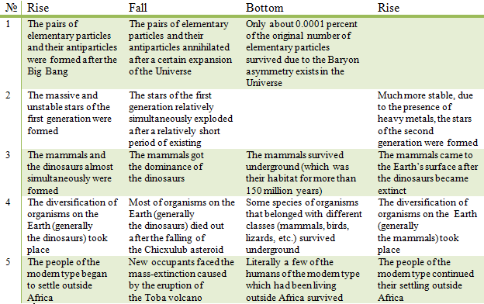Figure 4
After analyzing Fig. 4, we will see that the fight of the order, that born during the Big Bang, with primordial chaos is reflected through the development of many things and processes in the Universe; and this fight, as it seen, in general can be described with sinusoid (the moments of glorious wins and hard defeats must turn out one another in this case) – most of the plot shapes, that placed in the aforementioned article (Reagan, Mitchell, Danforth & Sheridan Dodds, 2016), show such picture (Fig. 5).
Occam’s razor demands that the explanations of the ways in which things and processes going on in the Universe must be as simple as possible, thus, we need the “Cinderella” (Fig. 6, a) since it is the simplest representing of sinusoid in this case. I want to add, that I think that, after using the Analogy method one more time, it can be shown that the “Cinderella” is the combination of the “Man on hill” and “Man in a hole” (Fig. 6, b) – like there are combinations of the functions of dramatis personae in fairytales (they were described by Vladimir Propp in “Morphology of the Folktale” (Propp, 1968)).
Completing this passage, I want to say that two sequenced “Man in a hole” arcs (Fig. 6, c) probably is just a simpler variation of the being told “Cinderella,” and it points first on the frequency of crises occurring (Fig. 6, d) without mentioning the essence of thing in each case.
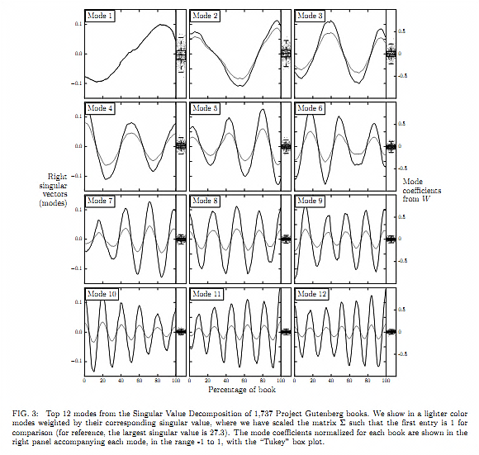
Figure 5 (Credits: ResearchGate; Reagan, Mitchell, Danforth & Sheridan Dodds)
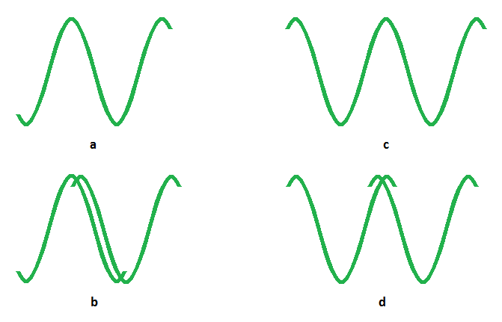
Figure 6

Appendix 2: the connection between the Dichotomy paradox, fractals, and the plot shape “Cinderella”
If the Dichotomy paradox (Britannica, T. Editors of Encyclopaedia, 2023) is presented with a graphic scheme (Fig. 6), then we obviously will see fractal structure after the reverse of the initial graph had been made.
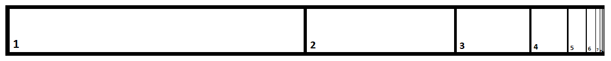
Figure 7
As it can be seen, each number in this case marks not only a reduced (except first one) fractal structure but also the non-divided (which is the biggest at the same time referring to square) part of each mentioned structure. Next, if we assume that the biggest, marked by number 1, square in our case points on the state of singularity (in such state any classic scientific theory is not allowed, and absolute temperature T with matter density ρ both get closely to infinity), which is the beginning of the Big Bang, then the biggest part of every fractal structure will point on the first phase of a certain grandness, a big scale of revealing, etc. of one of the processes in the Universe - and such stage must be ended only with a major collapse – like these mentioned: A great number of pairs “elementary particle-anti-particle” which had place until the Great annihilation, the first generation of super-massive stars (so-called the Star generation III), the Age of the dinosaurs, the Age of the Mega-fauna, the Age of great empires, etc. Thus, it can be stated that the fall the “Cinderella” includes reflects the unsuccessful, characterized by a great scale, first phase of, probably, any process in the Universe.

References
Birta, G., Burgu, Y., Floka, L. & Goryachova, O. (2020). Methodology and Organisation of Science Researching [Metodologiya i Organizatsiya Naukovyh Doslidzhen’]. GlobeEdit.
Britannica, T. Editors of Encyclopaedia (2023, August 21). Paradoxes of Zeno. Encyclopedia Britannica. https://www.britannica.com/topic/paradoxes-of-Zeno.
Glover, S. C. O. & Klessen, R. S. (2023). The First Stars: Formation, Properties, and Impact. Annual Review of Astronomy and Astrophysics, (61), 65-130. http://doi.org/10.1146/annurev-astro-071221-053453.
Hocking, S. (1998). A Brief History of Time: From the Big Bang to Black Holes. Random House Publishing Group.
Mandelbrot, B. B. (2021). The Fractal Geometry of Nature. Echo Point Books & Media, LLC.
Propp, V. (1968). Morphology of the Folktale. Texas University Press.
Reagan, A. J., Mitchell, L., Danforth, C. L. & Sheridan Dodds, P. (2016). The Emotional Arcs of Stories are Dominated by Six Basic Shapes. EPJ Data Science, 5 (1). https://doi.org/10.1140/epjds/s13688-016-0093-1.
Zalizniak, L. (2012). The Ancient History of Ukraine [Starodavnia Istoriia Ukrainy]. Темпора.

In order to avoid the confusion, only the positive variations of the major plot shapes were considered to observation.
See: Yaremko, S. (2023). Literary Clichés and the Age of Revolution (1.2.13). Zenodo. https://doi.org/10.5281/zenodo.10065012.
“Hero brings down the enemy, and then the latter rises,” “A gymnast wins in a fight at the beginning, and then he/she is beaten or dies,” and other simplest episodes (such are the episodes which consist of only the two of the character actions; for more information, see: Yaremko, S. (2023). One of the Ways the Functions of Propp to be Interpreted (2.4.6). Zenodo. https://doi.org/10.5281/zenodo.10030546) are the manifestations of this phenomenon.
If we analyze the positive variations of the basic plot shapes, then “Comedy” obviously demonstrates the maximum level of simplifying, as it only provides the statement of order’s triumph over chaos.
In the currently observed conception, the first crisis is the established by the Second law of thermodynamics (the aforementioned order, essentially) a higher probability of spontaneous realization for chaos in comparison with the order under the equal initial terms in a system (this is the cause for singularity to be the beginning of the Big Bang).

