Carbon labeling food and personal traits: A virtual experiment

Abstract

Purpose: The nutrition industry is characterized by a high impact on human-made climate change, accounting for as much as 25-30 % of all worldwide greenhouse gas emissions. Deploying eco-labeling to increase people's awareness about the pollution caused by their dietary choices is being introduced in various contexts to promote more sustainable consumption.
Design: This experiment aimed to explore the effectiveness of different eco-labeling approaches and quantify the expected effect on consumer behavior. 144 participants was randomly assigned to four groups: a) no label, b) climate-friendly icon for low-emitting choices, c) the CO2 equivalent emissions per meal for all items, and d) a combination icon and numbers.
Findings: This survey showed a 9 % reduction in average CO2 equivalent per meal with the certificate alone, 4 % with label and number, but no reduction in the group using only the CO emissions number. Female gender and green attitudes were associated with making a green dietary choice, and the graphical approach was more effective than providing the report as a pure number.
Originality: Our results are unique in the sense of comparing impact of the type of labeling realm with an existing commercial label and matching to personal traits with causal modeling.
Keywords: Carbon labels, sustainability, food choices,
Plain language Summary: There are multiple ways to steer consumption in the direction to less climate damaging, and a special climate label on restaurant meals was tested in this online survey. A graphical icon had more impact than writing the CO number, leading to a nine percent drop in greenhouse gases. While survey was online and not real, it provides some hints as to the best design and what types of persons are willing to change their purchases.
1. Background

Carbon dioxide is one of the important greenhouse gases (GHG) arising mainly from human behavior and makes a significant negative impact on the Earth (Kellogg & Schware, 1981). The food sector contributes through activities like agricultural-, industrial- and transportation operations, accounting for 25-35 % of total emissions (Crippa et al., 2021). Consumers are increasingly interested in decreasing the emissions of GHGs released during the production, processing, retailing, and consumption of food and beverages (Edwards-Jones et al., 2009; Kolk et al., 2008). To stimulate consumers to make informed choices, one should consider placing a label that reveals the report of CO2 pollution associated with the product lifecycle. In this regard, Röös and Tjärnemo (2011) emphasize that showing the CO2 footprint of a product could be an example of a viable approach (Cohen and Viscusi 2012).
While many variations among these labels exist, scholars still need to collect more facts about the impact and effectiveness of each kind of carbon label. For example, a traffic-light-colors approach is one of the most popular types (Sacks et al., 2009), but other options exist, including a picture of a footprint with messages like 'lower/medium/higher CO2' (Vanclay et al. 2011). Labels may also state 'reduced carbon emission,' 'zero footprints,' etc. (Röös and Tjärnemo 2011). The report could be either a quantitative text-based message or a visual stimulus.
This study aims to deepen currently available knowledge about the effectiveness and patterns of use of the most popular eco-labeling paradigms deployed in the modern nutrition industry. This article presents an online virtual trial, a simulation of a restaurant visit to test different eco-labeling approaches. Users were presented with a fictitious choice of six main courses and three desserts and asked to pick one of each. Participants were randomized into four groups based on the usage of climate labels on the menu. The outcome was measured as share selecting climate-certified and average CO2 emissions per meal.
Research by van Herpen and van Trijp (2011) has shown that ordinal traffic light labels and single logo certificates (a green tick) enhance sustainable choices. Even if consumers rated a nutrition value table (numerical label) more positively than a traffic light label and a green tick logo, the numerical label appeared to obtain little attention and did not stimulate healthy choices. More evidence supports the preference for traffic light and single logo labels over a score label in studies conducted by van Herpen et al. (2014) and Strasser et al. (2012). Labels with a reference point, such as a traffic light and a checkmark label, are more effective in consumers' product evaluation than labels lacking reference point information. A numerical score is an example of a label lacking a reference point. Given the previous evidence on effective eco-labeling paradigms, we assume that a graphic label (certificate) will be better recalled than a score label.
According to Jin et al. (2021), pro-environmental behavior varies based on individuals' demographics and opinions. Based on this premise, we assume that females make different choices than males, and individuals with various attitudes on environmental and social issues react differently to carbon labeling. Based hereon, we have developed the following hypotheses:
H1: A visual carbon report persuades restaurant visitors to make more sustainable choices
H2: The average CO2 emissions per kg of the selected menu item will be lower with the visual eco-label than with the quantitative carbon label.
H3: Food choice depends on gender, social norms, and individuals' green attitudes.

2. Literature Review

2.1 Labeling Design Principles

Kaljonen et al. (2020) stress 'the critical role of diet in climate change', claiming that CO2 emissions can be significantly mitigated if people refine their dietary choices and patterns following environmentally friendly considerations. The approaches to CO2 labeling should be picked based on psychological characteristics, behavioral patterns, and consumers' responses. Shewmake et al. (2015) emphasize that 'knowing how consumers subside away from high carbon goods and what they choose as substitutes are essential for understanding which goods are likely to result in meaningful reductions in carbon emissions.' Nevertheless, customers' behaviors are complex because they depend on external and internal factors. Apart from the fact that individuals' behavior can be impacted by their unique sociocultural characteristics and lifestyle, people mutually influence each other. For example, having dinner with a friend may influence food choices (Spaargaren et al., 2013).
Eco-labeling could be a strategy for manufacturers to communicate this information about environmental friendliness or other product features such as healthiness, energy usage, ozone-friendliness, and used packaging material to consumers. Learning how to ensure effective persuasive communication with the customers is challenging because they need to feel tangible and immediate outcomes of the GHGs. Carbon labels focus more on externalities, which may only be apparent many decades after the purchase, rather than other direct costs and benefits for individuals, which are generally emphasized by product labels. To be effective, a broad audience must understand the information (Cohen &Viscusi 2012).

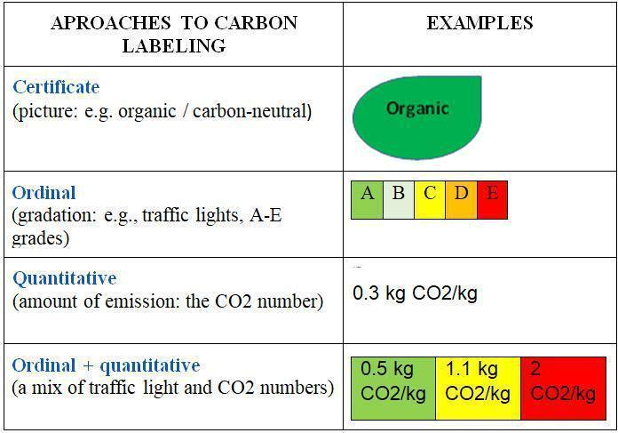

Fig 1. Most Popular Approaches to Carbon Labeling in the Nutrition Industry.

As Fig 1 indicates, there are four main approaches to carbon labeling of food: a) Certificate: Dichotomic rating of fulfilling a specific limit or not; b) Ordinal: Rating in 3 or more categories; c) Quantitative: CO2 emissions number; and d) A combination of ordinal and quantitative information (Taufique et al. 2022). The numbers are derived from a life cycle assessment (LCA) of the GHG emissions from all phases of the product's production, transport, and consumption. The CO2 equivalent term comes from a summation of all the accrued GHG emissions, each compound weighted by its impact on trapping heat through the greenhouse effect (Taufique et al., 2022).
2.2 Consumer Response

Information regarding carbon dioxide on labels is expected to help consumers by increasing the salience of environmental sustainability (Upham and Bleda 2009). It should stimulate consumers to contribute to the fight against climate change by consciously selecting their consumer goods (Kimura et al. 2010).
However, there are mixed conclusions regarding their actual effect on purchasing behavior. Unclear labels may need to be clarified for consumers or ignored (Upham and Bleda 2009). Cohen and Vandenbergh (2012) conclude that this approach generates environmental benefits, directly or indirectly influencing customers' purchase decisions. Kimura et al. (2010) found that carbon footprint labels contribute to creating value for consumers about food products, and several other trials show that consumers are interested in carbon labeling and willing to pay more for products labeled as 'green products' (Vanclay et al. 2011; Young et al. 2010). However, on the other hand, Young et al. (2010) found that consumers would be willing to pay more for products labeled as 'green products,' Upham et al. (2011) found that consumers needed help making sense of carbon-labeled grocery products. They are rarely affected by claims of sustainability (Valor 2008; Weightman and McDonagh 2004; Röös and Tjärnemo 2011; Carrington et al. 2010),
The gap between intentions and behavior can have several reasons, such as too much information (Sheeran 2002, Kimura et al. 2010). Information overload negatively influences decision quality, which might lead consumers to pay more attention to the message (Eppler and Mengis 2004; Hwang and Lin 1999). High product prices, accustomed purchase habits, lack of marketing, lack of trust in the labeling system, and low perceived consumer effectiveness have all been quoted as further flaws (Röös and Tjärnemo 2011). It has also been mentioned that too many labels exist, which confuses consumers (Upham and Bleda 2009) and makes it nearly impossible for consumers to understand all the different meanings (Hawthorne et al. 2006).
Consumers are exposed to multiple external factors, including peer pressure or unique sociocultural factors (Sheeran 2002). The low perceived quality of a ‘green’ product and the price of this product are mentioned as variables that influence the gap between intentions and behavior (Griskevicius et al. 2010). The product will likely be picked if customers focus on it for a prolonged interval (Castro et al. 2018). Carbon reports should be inserted in a place that can draw consumers' attention and hold it for a long time to make a well-informed choice of meals and drinks. Persuasive communication of different kinds can reach its goals only if and when customers understand the meaning of labels, and people must have environmental literacy.
2.3 Green and Pro-Social Scales

While common attitudes to climate change vary among the population, an objective, quantified measure of how 'green' an individual's behavior can be in real life remains challenging. The set of activities contributing to environmental degradation is vast, and one might condone some harmful activities while disapproving of others. Mancha and Yoder (2006) created and validated a set of green scales called Green Attitudes (GA) and Green Subjective Norms (GN). Caprara et al. (2015) constructed two scales for benchmarking general mindsets and actions relating to altruism and pro-social intentions: General Pro-social attitudes (GPA) and Pro-social Behaviour (PS). The fifth scale used in the trial is called Buying Behaviour (BB) and quantifies how individuals engage in sustainable purchases. Taking pro-environmental actions reduces personal comfort (Tolppanen and Kang 2021). European citizens are generally not ready to limit flying, driving, and consuming animal-based food to preserve nature (Dechezleprêtre et al., 2022). Schwirplies et al. (2019) claim that people's willingness to pay more for environmentally-friendly goods increases with increased income but is also associated with younger age and stronger environmental and social preferences. On the other hand, other studies found no connection between income and green attitude (de Silva and Pownall 2012; Jin et al. 2021). Some authors point to cognitive dissonance theory and balance theory (Thøgersen and Ölander, 2003; Penz et al., 2018).
A review of previous results was made through a review of published articles rom leading search databases. Only quantitative studies that conducted virtual or field experiments over the last ten years that measured the difference in consumption patterns between CO2e labels and no labels in a grocery store / market setting were included. Studies without statistical findings on the level of change between customer purchasing choices with (experimental) and without (control) carbon labelling were excluded. Acceptable outcomes were defined as CO2e emissions per purchase, CO2e emissions per kg, or the average ecological score of purchases
The literature search was conducted based on keyword searches 'carbon labelling' and 'food' in three web based tools: Articles were screened and selected based on the above-stated inclusion and exclusion criteria. After manual examination, the six articles that met the criteria were included to be reviewed. The summary of these articles can be found in Table I.
3. Methodology
3.1 Data gathering

We developed a web-based simulation of a visit for a lunchtime meal in a canteen with the PsyToolkit software (Stoet 2010; Stoet 2013)—the online menu comprised six main courses (three vegetarian meals) and three desserts. Four main courses and one dessert were classified as climate-friendly with the 'Klimateller' special label (Fig. 2).

Fig 2. Klimateller Certificate (www.klimateller.de).

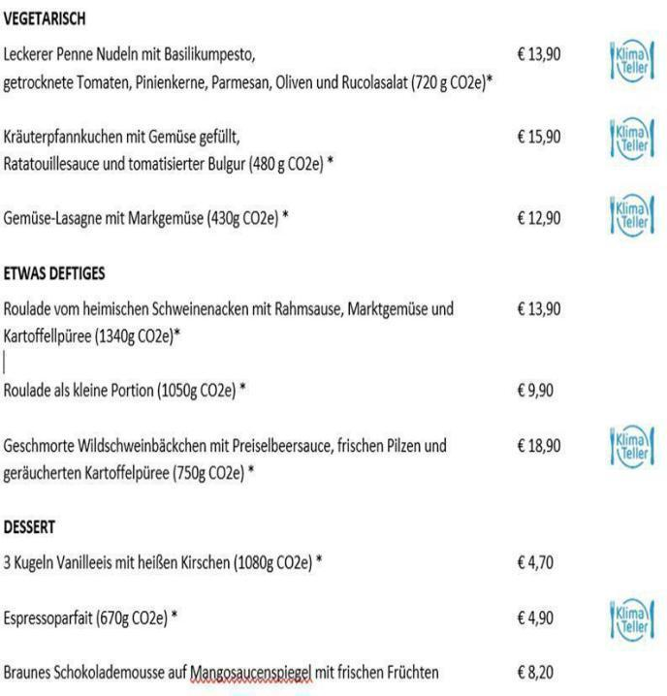
The certificate is based on a life cycle analysis and awarded to meals emitting less than 1 kg of CO2 equivalent per kg of food. The actual CO2e number can also be added to the menu item's description and the entire base menu used for the simulations in Fig. 3.

Fig 3. Klimateller Certificate Menu (www.klimateller.de)

Based on the menu items in Fig 3, four groups were created showing various stimuli: a)

Group 1: No label; b) Group 2: Certificate icon; c) Group 3: Quantitative number; d) Group 4:

Certificate icon + quantitative number (used in Fig 3).

3.2 Causal graph inference

The PC (Peter Clark) algorithm is a ubiquitous method for learning causal relationships among features from observational data. It was developed by Peter Spirtes, Clark Glymour, and Richard Scheines and is widely employed in causal discovery. It is a score-based approach that combines conditional independence tests and graph search to estimate a causal graph, also known as a Bayesian network or directed acyclic graph (DAG). The algorithm assumes that all variables are causally independent, represented by an empty graph. Then, it tests conditional independence among variables and adds or removes edges. The PC algorithm is known for its ability to learn the underlying causal structure from observational data. However, it assumes no unmeasured confounders and that the data adheres to the faithfulness assumption.
3.3 Statistics

The causal graph was augmented by factor analysis, reducing the dimensions and finding the main components among the combined matrix with sociodemographic, green, and pro-social attitude data. This was then combined with the total CO2 of each respondent's choices (main course + dessert) and two dummy variables for Icon (0=no icon; 1=icon) and Number(0=no CO2e number; 1=CO2e number presented) for regression with interaction terms. The goal was to establish which subgroups were more affected by each respective type of labeling and in what direction.
4. Results

4.1 Descriptives
A convenience sample was gathered from various online sites and randomly divided into four groups with sociodemographic backgrounds. A total of 144 persons were recruited for the survey, with demographics in Table II.
The four groups' descriptions are presented in Table 3, together with p values for hypothesis tests (one-way ANOVA tests for numeric and chi-squared for categorical) of differences between groups.are shown in Table III.

There were no significant differences between the groups; the software's randomization was accepted as independent.
Each scale's reliability was assessed with the Cronbach Alpha measure: a - Green Atttiudes GA 0.80; b -Green Subective Norms 0.81, c General Pro-social Attitude GPA 0.90 d Buying Behaviour BB 0.87, Pro Social Behaviour PS 0.906. As values above 0.7 in general have been established to guarantee internal consistency (Nunnally & Bernstein, 1994), all scales were accepted as proper measures.
4.2 Label Choices - CO2e

The percent reduction in average CO2e compared to the no-label baseline is shown in Fig. 5.
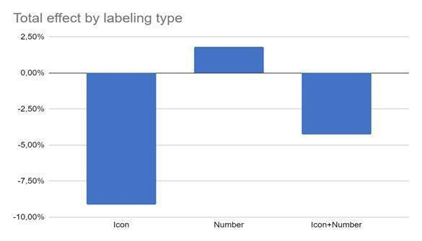

Fig 5. CO2 Equivalent Emissions Compared to No Label Baseline.

Showing the label alone showed a significant reduction compared to no label (t-test; p=0.050) and displaying the CO2e number alone (t-test; p=0.049). The number gave no reduction compared to the standard menu, nor did the label and number together.
4.3 Gender, social background and attitudes

The connection between the measured scales and the background values is presented in Fig. 6.

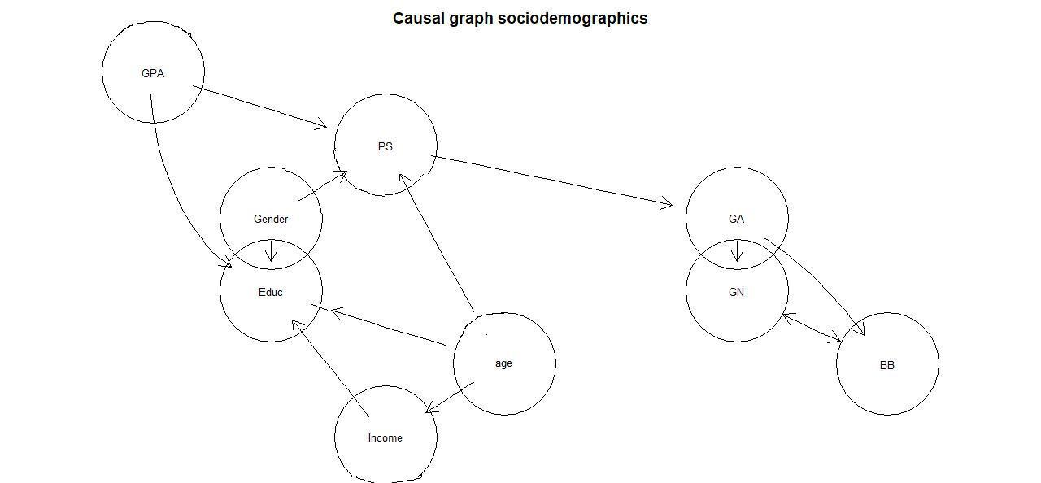

Fig. 6. Causal graph of measured personal traits.

It could be inferred that:

- Green measures GA, BB, and GN are connected.

- Females have higher education and more indulgence in pro-social behaviour.

- Age, income, and education were associated, indicating progression career-wise

- General Pro-social Attitude was lower for higher education.

- Pro-Social attitude and Pro-Social Behaviour were positively related.

- Higher ages led to less Pro-social behaviour.

- More Pro-social behaviour was correlated with a higher green attitude.

4.3 Effects of Labeling Based on Personality and Demographics

All the explanatory measures of personality scales and demographic values were combined into an explorative factor analysis with three factors and maximum variance rotation. Loadings in Table 4.

The leading variables in each of the dominating factors are a) GA, GN, BB (green), b) Age, Family, and Income (age), c) PS, and GPA (social). By using the factor scores for each person, the sample was split according to their scores in each of these dimensions: a) Greens: FA1 > 0, Non-greens: FA1 < 0; b) Young: FA2 < 0, Old: FA2 < 0; c) Social: FA3 > 0, Non-social: FA3 < 0. Table V displays the aggregated selections for each of these cohorts.
Those classified into the green attitudes and norms category selected more plant-based, leading to a lower carbon footprint, while age and social attitudes had no significant effect.
The impact on subgroups that each respective label type achieved is displayed in Table VI.
The only proven effects among the subgroups were that the icon moved those with less of a “green” conviction to align their purchases with their more sustainable-thinking counterparts, while those having high values of GA, BB, and GN reduced their CO2 impact when the number was used. The effect for each subgroup is shown in Fig. 7 - 9.
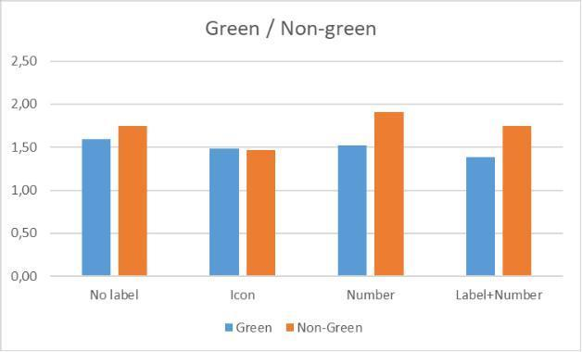

Fig. 7. CO2e by type of label and green factor.

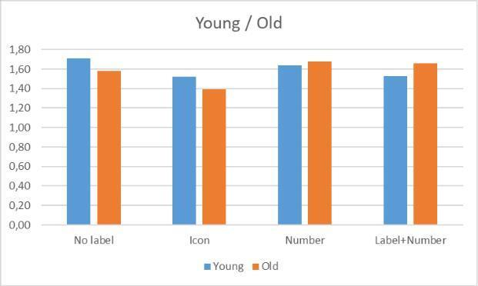

Fig. 8. CO2e by type of label and age/career factor.

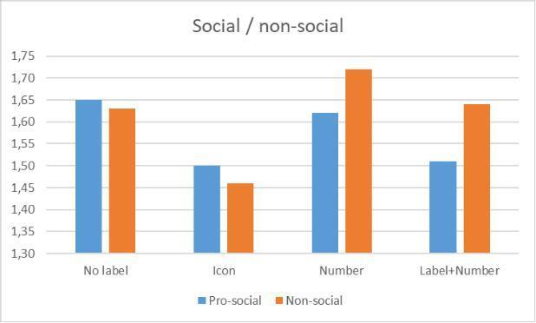

Fig. 9. CO2e by type of label and age/career factor.

The pattern was apparent overall factors, where the number labeling leads to the opposite effect for the less engaged groups, while the icon has a similar effect on all subgroups. In order to quantify the most important, the linear regression model:
CO2 ~ FA1 + FA2 + FA3 + Gender +Icon + Number

Results in terms of beta regression constants have been presented in Table VII.

The significant effects came from a) the green dimension, b) the Female gender, and

- Using a graphic label. All with negative coefficients, implying lower emission choices.
Next, the interaction between labeling and green attitude was examined through a regression model:
CO2 ~ FA1 + Icon + Number + Icon*FA1 + Number*FA1

The beta values in Table VIII show that the effect of using a number varies depending on the green attitude. The negative value indicates that showing the number has a stronger effect on reducing CO2 for those with high green scale results, while it leads to increasing emissions for the opposite side.

Connection labeling and green attitude were examined through a regression model with two interaction terms:
CO2 ~ Gender + Icon + Number + Icon*Gender + Number*Gender

As Table IV indicates, there were no interaction effects based on gender.

5. Discussion
Results of the label assessment show an overall advantage with a sole certificate icon. While results are based on a small sample size, Upham et al. (2011) state that the numerical account suffers from a lack context. People understand that a high score differs from a low score, but more is needed to engage meaningfully with this information (Upham et al. 2011). As a result, labels containing a comparing graphical element (Fig 2) make more sense to the participants.
Other studies explored the effects of eco-labeling implemented within real life trials or virtual simulations. Neumayr and Moosauer (2021) detected a 3.1 % reduction in CO2 emissions when eco-labeling was implemented in a real online supermarket, while Vlaeminck et al. (2014) saw a 5.3 % decrease also with a graphical icon in the grocery setting. Similar results between 1 and 5 % have been reported for field trials in restaurants or canteens (Brunner et al., 2018; Lohmann et al., 2022; Pechey et al., 2022; Visscher & Siegrist, 2015). On the other hand, a higher level of decarbonization has been a consistent outcome when carbon labeling was studied in fictitious web-based environments. Babakhani et al.(2019) found a 16.4 % lower carbon footprint in the labeling group, Betz et al. (2022) identified a 10.3 % reduction in CO2 emissions, while the estimates were a respective 16.7 % (Hallez et al., 2021) , 10.9 % (Muller et al., 2019) and 17.3 % (Osman & Thornton, 2019) when fictitious virtual choices was the method. The levels reported in this survey when the icon alone was used are thus in line with previous results for online trials. The disparity between meal choices for in person and virtual settings can be caused by social desirability (reported vs. actual behaviour).It has been discussed how much impact should be ascribed to this trait, but there are few studies with a direct connection to choices and sustainability (Vesely & Klöckner, 2020) and carbon footprint related to consumption of food (Cerra et al., 2019). When looking closer at the causes of this imbalance, it has been found that self deception is the primary driver (Wheeler et al., 2019). This implies that respondents estimate themselves to have more altruism-directed purchasing habits than what they really do in the real selection. While real life data using the tested signal is not present, it can be assumed that the effect would be clearly lower in an authentic restaurant setting.
The combined factor analysis and regression revealed that green attitudes, female gender, and the icon label determined sustainable food selection. Only those with green beliefs reacted to the CO2e number in the intended manner, while those less green decreased their CO2 emissions strictly when the graphical icon was used. One possible way to interpret these results is that graphic labeling leads to a perception that the product has a higher value regardless of the context on climate messaging, while the CO2e number does not serve to draw the attention in the same way. Only those with higher knowledge and care for climate related issue can relate to the meaning of the CO2 number. With regards to connections between different socio-demographics, it was expected that green attitudes are connected to green social norms and sustainability in buying practices and that females are more conscious in their consumption (Aguirre-Sanchez et al., 2021), the inverse connection between education, age and pro-social habits might be more surprising.
6. Conclusions
The general findings of this study are a 9% reduction in average CO2 equivalent per meal with the eco-labeling icon alone and a 4 % reduction in average CO2 equivalent per meal with label and number. There was no CO2 reduction, and even a slightly increased level of CO2, when only a quantitative report was applied, confirming the first two hypotheses. The average CO2 emissions per kg are lower when a visual labeling approach is applied than a number. We also found that women and people with green attitudes were more prone to sustainability in their choices and that the numeric label only worked for people with green beliefs.
Ethics

Permission was obtained through the ethics board the Brandenburg Medical School Theodor Fontane.

Funding

No funding was obtained for survey.

References

Babakhani, N., Lee, A., & Dolnicar, S. (2020). Carbon labels on restaurant menus: Do people pay attention to them? J. Sustain, 28(1), 51–68.
Betz, A.-K., B. T, S., & Nieding, G. (2022). How can carbon labels and climate-friendly default options on restaurant menus contribute to the reduction of greenhouse gas emissions associated with dining? PLOS Clim., 1(5), 1–28.
Brunner, F., Kurz, V., Bryngelsson, D., & Hedenus, F. (2018). Carbon label at a university restaurant – label implementation and evaluation. Ecol, 10(1016), 658–667.
Hallez, L., Qutteina, Y., Boen, F., & Smits, T. (2021). The ABC. S of Ecological and Nutrition Labels, 13(2474), 1–29.
Hawthorne, K. M., Moreland, K., Griffin, I. J., & Abrams, S. A. (2006). An educational program enhances food label understanding of young adolescents. Journal of the American Dietetic Association, 106(6), 913–916. https://doi.org/10.1016/j.jada.2006.03.004
Jin, Y., Yang, J., & Hu, J. (2021). Zoom in the attitude-behaviour gap: Low carbon travel behaviour. E, 3, 1–5.
Kellogg, W. W., & Schware, R. (1981). Climate change and society: Consequences of increasing atmospheric carbon dioxide (No. DOE/EV/, 10281-T3. https://doi.org/10.4324/9780429048739
Kimura, A., Wada, Y., Kamada, A., Masuda, T., Okamoto, M., Goto, S. I., Tsuzuki, D., Cai, D., Oka, T., & Dan, I. (2010). Interactive effects of carbon footprint information and its accessibility on value and subjective qualities of food products. Appetite, 55(2), 271–278.
Kolk, A., Levy, D., & Pinkse, J. (2008). Corporate responses in an emerging climate regime: The institutionalization and commensuration of carbon disclosure. European Accounting Review, 17(4), 719–745.
Lohmann, P., Gsottbauer, E., Doherty, A., & Kontoleon, A. (2022). Do carbon footprint labels promote climatarian diets? Evidence from a large-scale field experiment. Journal of Environmental Economics and Management, 114(10269), 1–21. https://doi.org/10.1016/j.jeem.2022.102693
Mancha, R. M., & Yoder, C. Y. (2015). Cultural antecedents of green behavioral intent. Ournal of Environmental Psychology, 43, 145–154.
Muller, L., Lacroix, A., & Ruffieux, B. (2019). Environmental labelling and consumption changes: A food choice experiment. Environmental and Resource Economics, 73(3), 871-897. https://doi.org/10.1007/s10640-019-00
Neumayr, L., & Moosauer, C. (2021). How to induce sales of sustainable and organic food: The case of a traffic light eco-label in online grocery shopping. Journal of Cleaner Production, 328, 129584. https://doi.org/10.1016/j.jclepro.2021.129584
Nunnally, J. (1994). Psychometric theory.
Osman, M., & Thornton, K. (2019). Traffic light labeling of meals to promote consumption and healthy eating. Appetite, 10(1016), 60–71. https://doi.org/j.appet.2019.03.015
Pechey, R., Bateman, P., Cook, B., Potter, C., Clark, M., Stewart, C., Piernas, C., & Jebb, S. (2022). Testing the effectiveness of eco-labels to reduce the environmental impact of food purchases in worksite cafeterias: A randomised controlled trial. Appetite, 179(106277), 1–6. https://doi.org/10.1016/j.appet.2022.106277
Penz, E., Hartl, B., & Hofmann, E. (2019). Explaining consumer choice of low carbon footprint goods using the behavioral spillover effect in German-speaking countries. Journal of Cleaner Production, 214, 429–439. https://doi.org/10.1016/j.jclepro.2018.12.270
Roos, E., H. &. Tjarnemo. (2011). Challenges of carbon labelling of food products: A consumer research perspective. British Food Journal, 113(8), 982–996.
Sacks, G., Rayner, M., & Swinburn, B. (2009). Impact of front-of-pack `traffic-light’ nutrition labelling on consumer food purchases in the UK. Health Promotion International, 24(4), 344–352. https://doi.org/10.1093/heapro/dap03
Schwirplies, C., D"utschke, E., Schleich, J., & Ziegler, A. (2019). The willingness to offset CO2 emissions from traveling: Findings from discrete choice experiments with different framings. Ecological Economics, 165(10638), 4.
Stoet, G. (2010). PsyToolkit - A software package for programming psychological experiments using Linux. Behavior Research Methods, 42(4), 1096–1104.
Stoet, G. (2017). PsyToolkit: A novel web-based method for running online questionnaires and reaction-time experiments. Teaching of Psychology, 44(1), 24–31.
Strasser, A. A., Tang, K. Z., Romer, D., Jepson, C., & Cappella, J. N. (2012). Graphic warning labels in cigarette advertisements: Recall and viewing patterns. American Journal of Preventive Medicine, 43(1), 41–47. https://doi.org/10.1016/j.amepre.2012.02.026
Taufique, K. M., Nielsen, K. S., Dietz, T., Shwom, R., Stern, P. C., & Vandenbergh, M. P. (2022). Revisiting the promise of carbon labelling. Nature Climate Change, 12(2), 132–140.
Thøgersen, J. and. (2011). & "Olander, F. (2003). Spillover of Environment-Friendly Consumer Behavior, 23(3), 348–355. https://doi.org/10.1016/S0272-4944(03)00018-5
Tolppanen, S., & Kang, J. (2020). The effect of values on carbon footprint and attitudes towards pro-environmental behavior. Journal of Cleaner Production, 282(12452), 4. https://doi.org/10.1016/j.jclepro.2020.124524
Valor, C. (2008). Can consumers buy responsibly? Analysis and solutions for market failures. Journal of Consumer Policy, 31, 315–326.
van Herpen, E., Hieke, S., & van Trijp, H. (2014). Inferring product healthfulness from nutrition labelling. The Influence of Reference Points, 72, 138–149.
van Herpen, E., & Trijp, H. (2011). Appetite. Front-of-Pack Nutrition Labels, Their Effect on Attention and Choices When Consumers Have Varying Goals and Time Constraints, 57(1), 20–31. https://doi.org/10.1002/sd.394
Vanclay, J. K., Shortiss, J., Aulsebrook, S., Gillespie, A. M., Howell, B. C., Johanni, R., & Yates, J. (2011). Customer response to carbon labelling of groceries. Journal of Consumer Policy, 34(1), 153–160. https://doi.org/10.1016/j.amepre.2012.02.026
Vesely, S., & Kl"ockner, C. A. (2020). Social Desirability in Environmental Psychology Research: Three Meta-Analyses. Frontiers in Psychology, 11. https://doi.org/10.3389/fpsyg.2020.01395
Visschers, V. H., & Siegrist, M. (2015). Does better for the environment mean less tasty? Offering more climate-friendly meals is good for the environment and customer satisfaction. Appetite, 10(1016), 475–483. https://doi.org/j.appet.2015.08.013
Vlaeminck, P., Jiang, T., & Vranken, L. (2014). Food labeling and eco-friendly consumption: Experimental evidence from a Belgian supermarket. Ecological Economic, 108(180–190), 91–101. https://doi.org/10.1016/j.ecolecon.2014.10.019
Wheeler, S. A., Gregg, D., & Singh, M. (2019). Understanding the role of social desirability bias and environmental attitudes and behaviour on South Australians’ stated purchase of organic foods. In F. Q. and (Ed.), and Preference (Vol (pp. 125–134). 74. https://doi.org/10.1016/j.foodqual.2019.01.007
Woo, E., & Kim, Y. G. (2019). Consumer attitudes and buying behavior for green food products: From the aspect of green perceived value (GPV). British Food Journal, 121(2), 320–332. https://doi.org/10.1108/BFJ-01-2018-002

